VECTO Air Drag V3.3.3

User Manual

By order of
EUROPEAN COMMISSION
DG CLIMA

Air Drag Tool
VECTO Air Drag V3.3.0
Technical Documentation
Written by: | Martin Rexeis, TUG (Methodology)  Martin Dippold, TUG (Software)  Konstantinos Anagnostopoulos, JRC (Software) | 2025/03/12

Content
1. Structure of the software 5
2. Input data and file structures 5
2.1. Input/Output files conventions 5
2.2. Overview of Input files 6
2.3. Vehicle file (*.csveh) 7
2.4. File with ambient conditions measured by the stationary weather station (*.csamb) 9
2.5. Files with configuration of measurement sections (*.csms) 10
2.6. Files with measurement data recorded at the vehicle (*.csdat) 13
2.7. File with altitude profile (*.csalt) 17
2.8. Job-File 18
2.9. Criteria-File 18
3. Evaluation algorithms 19
3.1. Processing of data for vehicle position 19
3.2. Assignment of measurement data to measurement sections 19
3.3. Calibration of input signals 20
3.4. Evaluation of the constant speed tests 24
4. Parameter settings in VECTO Air Drag Declaration Mode 35
5. Output files 39
5.1. The Air Drag main result file 40
5.2. The “measurement section” (ms-)files 43
5.3. The Hz-files 46
5.4. The VECTO input file for “AirDrag” component (XML) 47
6. User Manual 49
6.1. General 49
6.2. First program start 49
6.3. Graphic User Interface 49
6.4. How to evaluate a constant speed test in VECTO Air Drag 52
6.5. How to export a XML input file for VECTO 53
6.6. Direct start 53
7. Support 54
7.1. CITnet's JIRA platform 54
7.2. Direct contact to VECTO support 56
8. Developers Guide 57
8.1. Main structure of the VECTO Air Drag code 57

Structure of the software
The VECTO Air Drag tool is written in VB.Net and delivered as executable file and Visual Studio 2010 project with commented source code. The tool is a portable application, i.e. it is not necessary to run a setup procedure for installation. The executable file can be run from any place on a computer or in a network.
VECTO Air Drag can be operated in two different modes:
- “Declaration Mode”:
The evaluation parameter and model settings are fixed to the provisions as specified in the HDV CO₂ legislation. In this mode VECTO Air Drag only calculates the final C_{d}·A values from the constant speed test if all validity criteria have been fulfilled. The “Declaration Mode” has to be used in order to generate official C_{d}·A values.
- “Engineering Mode”:
All evaluation settings can be edited by the user. VECTO Air Drag calculates the C_{d}·A value for the given settings whenever mathematically possible.
More details on how to operate VECTO Air Drag can be found in section 6.

Input data and file structures
This section gives a detailed description of the input data and the file structure required for VECTO Air Drag.

Input/Output files conventions
The files read and written by VECTO Air Drag are either JSON or CSV files. In the CSVs are the following separator’s allowed as list- and decimal separator which can be defined under Tools/preferences:
- Dot “.”
- Comma “,”
- Colon “:”
- Semicolon “;”
Lines starting with `#` are interpreted as comment-lines and ignored by the input routines, but are not preserved through read/written cycles. Such comments can be placed at any line of a CSV file.

JSON files do not support comments, but help can be provided by their accompanying json-schemas (see below). They are split in two sections,
- The Header, which contains administrational fields and fields related to the actual parsing of the file. This section accepts arbitrary content which is preserved when read/written, so it can be used instead of comments.
- The Body, which contains the actual content of the file, and has a rather strict format, according to each file type (see below).
Here is an extract from a typical JSON-file:
{
"Header": {
"Title": "vecto-Air Drag JOB",
"FileVersion": "1.0.0",
"AppVersion": "2.0.1-pre2",
"ModifiedDate": "2014/06/04 17:42:29 +02:00",
"CreatedBy": "JRC(lic: 04c137c0-24df-4d90-a3e2-b02fe3dba8ea)",
"StrictBody": null,
"BodySchema": null
},
"Body": {...}

Of interest are the following two header properties:
- /Header/StrictBody: Controls whether the application will accept any unknown body-properties while reading the file. Set it to true to debug malformed input-files, i.e. to detect accidentally renamed properties.
- /Header/BodySchema: The JSON-schema of the body will be placed HERE on the next save. When true, it is always replaced by the Body's schema on the next save. When false, it overrides application's choice and is not replaced ever.
The software uses different extensions for certain file-types. This approach allows for quick browsing for specific data. However, any kinds of extensions can be used for input files as long as they are correctly specified in the Job file.

Overview of Input files
Table 1 gives an overview on all input files handled by VECTO Air Drag.
Table 1: Overview input files

File type | Default  extension | Explanation
vehicle | *.csveh | contains relevant information on the tested vehicle configuration (e.g. vehicle test mass, anemometer height)
ambient conditions | *.csamb | contains ambient conditions as measured by the stationary weather station
configuration file for measurement sections  (“ms config”) | *.csms | contains the configuration of the measurement sections (coordinates, driving directions etc.) on the test track. The measurement sections can be configured for the calibration run and the measurement runs separately.
measurement data | *.csdat | contains the measurement data recorded at the vehicle consolidated in 100Hz.  Separate input files are required by Air Drag for:  - the calibration run (during warm up of the vehicle)  - the first low speed run  - the high speed run  - the second low speed run  Similar file formats are used for i.) to iv.)
altitude profile (optional) | *.csalt | contains the altitude profile on the measurement sections. This data is used for the correction of traction force for gradient influence in the evaluation if the related feature is activated in the VECTO Air Drag GUI
job | *.csjob | contains all information for a test evaluation (evaluation settings, paths to input data). The job file is automatically created if VECTO Air Drag is operated via the user interface but can also be generated or edited e.g. by means of a text editor. After a successful calculation VECTO Air Drag also writes the main evaluation results into the job-file.
criteria (optional) | *.cscrt | can be used to save or import a set of evaluation parameters (e.g. validity criteria or settings for correction functions). For reasons of traceability for each calculation the used parameters are in any case also stored in the Jobfile.

Vehicle file (*.csveh)
The vehicle file contains the relevant information on the vehicle configuration. The file follows the JSON format. Figure 1 shows the structure of the vehicle file.
{
"Header": {
"Title": "VECTO-Air Drag VEHICLE",
"FileVersion": "1.0.2",
"AppVersion": "3.0.0",
"ModifiedDate": "2022.01.26 14:36:59",
"Strict": true,
"BodySchema": null,
},
"Body": {
"classCode": "4",
"configuration with trailer": "no",
"TPMLM": 16000,
"vVehMax": 85,
"vehHeight": 3.85,
"anemometerHeight": 4.55,
"testMass": 25000,
"gearRatio_low": "2.500",
"gearRatio_high": "1.000",
"axleRatio": "3.600",
"fixedTransmission": "yes",
"tqDriftLeft": "17",
"tqDriftRight": "-12.4",
"tDriftZero": "44000",
"tDriftCheck": "48000",
}
}
Figure 1: Structure of the vehicle file
The data relevant for the calculations have to be specified in the “body” according to the following conventions:
- "classCode": Vehicle group code according to the HDV CO₂ segmentation matrix (1-17 for trucks, 31b1-40f for heavy busses and 53-54 for lorries), see Annex I to Regulation (EU) 2017/2400; (no unit)
For heavy buses only group codes are accepted, for which air drag testing is applicable, i.e. 31b2, 32a, 32b, 32c, 32d, 32e, 32f, 33b2, 34a, 34b, 34c, 34d, 34e, 34f, 35b2, 36a, 36b, 36c, 36d, 36e, 36f, 37b2, 38a, 38b, 38c, 38d, 38e, 38f, 39b2, 40a, 40b, 40c, 40d, 40e, 40f.
- "configuration with trailer": If the vehicle was measured without trailer (input “No”) or with trailer i.e. as a truck/trailer or tractor semitrailer combination (input “Yes”) (no unit)
The combination the abovementioned parameters is the criteria for allocation of generic data for C_{d}xA dependency on beta.
- "testMass": Vehicle test mass during measurements (unit: [kg]). Please fill in the average value valid for the test sequence from low speed run 1, high speed run and low speed run 2. In VECTO Air Drag the vehicle mass is used for correction of traction forces from road gradient and from acceleration (if these features are activated) and for determination of the vehicle average RRC (rolling resistance coefficient).
- "axleRatio": Axle transmission ratio (no unit). For Declaration Mode a minimum of 3 digits after the decimal separator are required.
- "gearRatio_high": Transmission ratio of the gear engaged during the high speed tests (no unit). For Declaration Mode a minimum of 3 digits after the decimal separator are required.
- "gearRatio_low": Transmission ratio of the gear engaged during the low speed tests (no unit). For Declaration Mode a minimum of 3 digits after the decimal separator are required.
- "anemometerHeight": Height of the measuring point of the anemometer installed at the vehicle (unit: [m]).
- "vehHeight": Maximum vehicle height (unit: [m]). This value is applied in Air Drag for boundary layer correction of the air speed measured with the anemometer.
- “vVehMax”: Maximum speed the vehicle can be practically operated at the test track (unit: [km/h])
- “TPMLM”: Technically permissible maximum laden mass of the rigid lorry or tractor (w/o trailer or semitrailer). All other vehicle types: no entry (unit: [kg])
- “fixedTransmission”: “yes” / “no” (“no” only for vehicles with APT transmissions and torque converter which cannot drive with locked torque converter in the low speed test) (no unit).
- "tqDriftLeft": Torque meter drift reading at the end of the CST - left wheel (unit: [Nm])
- "tqDriftRight": Torque meter drift reading at the end of the CST - right wheel (unit: [Nm])
- "tDriftZero”: Time stamp zeroing of torque meters (unit: [s] since day start of first day)
- "tDriftCheck”: Time stamp drift check torque meters (unit: [s] since day start of first day)

File with ambient conditions measured by the stationary weather station (*.csamb)
Figure 2 shows an example for the structure of the file containing the ambient conditions measured by the stationary weather station. The file follows the CSV-Format.
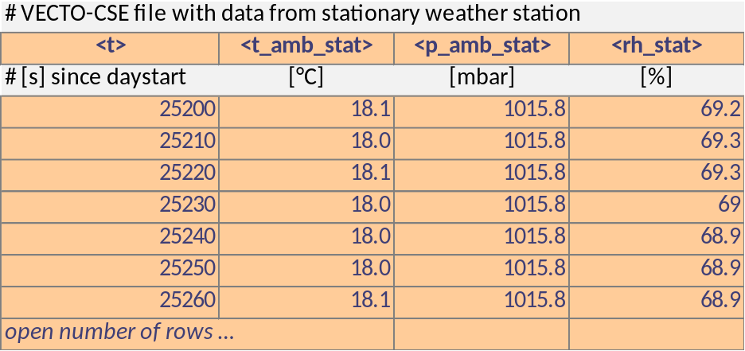
Figure 2: Structure of the ambient conditions file
In the first row the column identifiers have to be specified. In the *.csamb file the order of columns is arbitrary. Row 2 and the following contain the measured values. Table 2 gives the specifications of the data signals to be provided in the ambient conditions file.
Table 2: Signal specifications for the ambient conditions file
signal | column identifier | unit | remarks
time | <t> | [s] since day start (first day) | The time signal is used for consolidation with data measured at the vehicle; any frequency can be specified, minimum requirement from the technical annex is 1 signal per 6 minutes  If a measurement is performed over change of day, the time shall be specified as [s] since day start of the first day. I.e. the second day starts with 86401. This time unit has to be used both in the *.csdat-files and the *.csamb-file.
ambient temperature | <t_amb_stat> | [°C]
ambient pressure | <p_amb_stat> | [mbar]
relative air humidity | <rh_stat> | [%] | e.g. 50% humidity is specified in the file by a value of "50"

Files with configuration of measurement sections (*.csms)
The measurement section files contain the configuration to allocate the recorded data to certain combinations of measurement sections (MS) and driving directions. In VECTO Air Drag the MS have to be configured separately for the calibration test and for the measurement runs. Figure 3 shows the structure of a measurement section file.
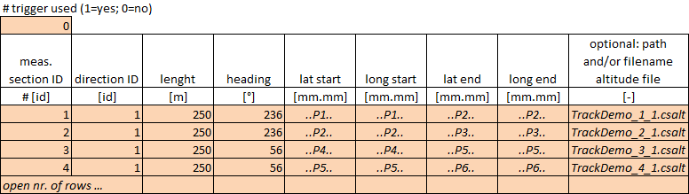
Figure 3: Structure of the measurement section file
The data to be specified is explained below:
Row 1, column 1: specification whether a trigger signal is used to identify the exact moment when the vehicle enters a measurement section (“1” = trigger signal used; “0” = no trigger signal is used). The methods how VECTO Air Drag evaluates the measurement data for these two options are described in section 3.2.
From row 2 on: Specification of the measurement sections according to Table 3. The order of columns in the measurement section file is fixed. The header name definition is needed (as shown in Figure 3) and have to be labelled as non-comment line. The unit definition can be used but always have to be labelled as comment line. The number of measurement sections to be used in the VECTO Air Drag evaluations is free.
Table 3 gives the specifications for the data to be provided in the measurement section files. For further explanation on the following pages two examples for test track layout and related configuration in the *.csms-file are given.

Table 3: Data specifications for the measurement section files (*.csms)
column number | data | column identifier | unit | remarks
1 | measurement section ID | no identifier (position fixed at column = 1) | [-] | user defined identification number
2 | driving direction ID | no identifier (position fixed at column = 2) | [-] | user defined identification number  If on a circular test track only a single sense of rotation is driven, the MS on both straights can be labelled with driving direction “1” (VECTO Air Drag internally validates the criteria for driving directions based on the heading signal).  Measurement sections evaluated for the calibration run have to be configured in two driving directions.
3 | heading | no identifier (position fixed at column = 3) | [°] | heading of the measurement section
4 | length of the measurement section | no identifier (position fixed at column = 4) | [m] | to be determined by distance measuring wheel (or by DPGS). Distance is used for:  - calibration run: calibration of vehicle speed  - measurement runs: verification of valid distance driven inside the measurement sections  see also footnote
5 | latitude start point of section | no identifier (position fixed at columns 5 to 9)  For unit selection specify “(D)” at end of header for [dd.dd] | [mm.mm]  [dd.dd] | The coordinates also have to be provided in case a trigger signal is used for identification of MS (for the purpose of plausibility checks). For standard GPS devices please provide:  [dd.dd]: minimum 5 digits  [mm.mm]: minimum 3 digits  after the decimal separator (refers to an accuracy of better than 1.8 meter). For the DGPS option please provide:  [dd.dd]: minimum 7 digits  [mm.mm]: minimum 5 digits  after the decimal separator (refers to an accuracy of better than 0.18 meter)
6 | longitude start point of section |  | [mm.mm]  [dd.dd]
7 | latitude end point of section |  | [mm.mm]  [dd.dd]
8 | longitude end point of section |  | [mm.mm]  [dd.dd]
9 | path and/or filename of altitude file | no identifier (position fixed at column = 9) | [-] | only required for the constant speed tests (not the calibration test) and if the altitude correction is enabled. If only the filename is specified here, VECTO Air Drag searches in the folder of the *.csms-file.

Examples:
Figure 4 shows the MS file configuration for a circular test track with two measurement sections on both straights and which is driven in a singular sense of rotation.
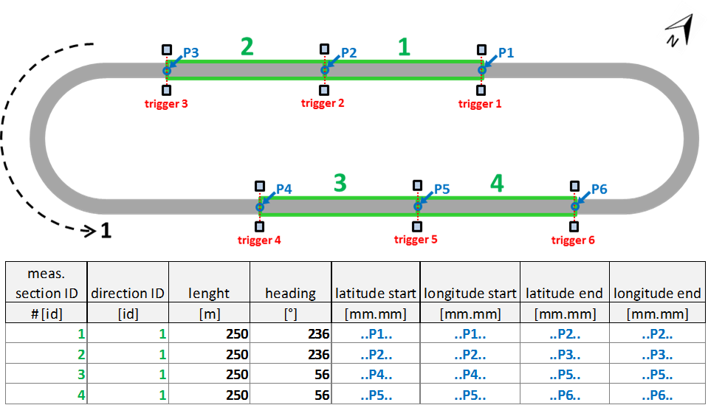
Figure 4: Example 1 for test track layout and MS configuration file (circular test track driven in single sense of rotation)
In Figure 5 the MS file configuration for measurements recorded on a single straight in two measurement sections driven in two driving directions is given. Such a configuration could be used e.g. for the calibration run on a test track as shown above or also for a test track which consists of a single straight with turning points at both ends.
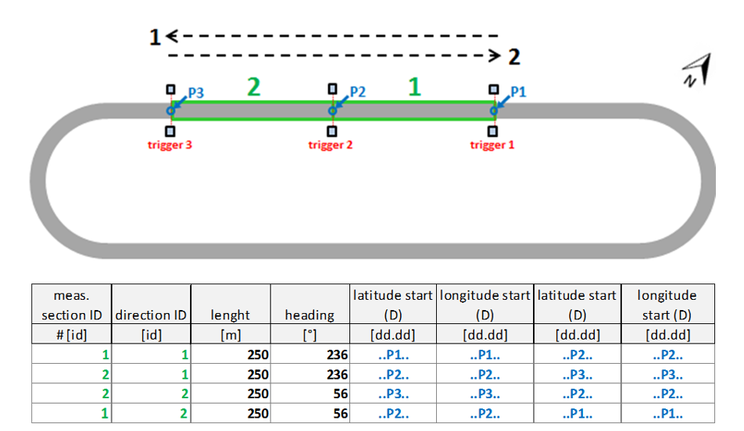
Figure 5: Example 2 for test track layout and MS configuration file (measurement data recorded on two measurement sections on a single straight driven in two driving directions)

Sequence of measurement sections in the *.csms-file
It is a requirement in VECTO Air Drag that successional measurement sections (i.e. the end point of the previous MS is the start point of the next one) are specified in the *.csms-file in the sequence as driven in the measurements.

Files with measurement data recorded at the vehicle (*.csdat)
Figure 6 shows an example for the structure of the file containing the measurement data recorded at the vehicle. VECTO Air Drag requires each a *.csdat-file for
- the calibration test (during warm up of the vehicle)
- the first low speed test
- the high speed test
- the second low speed test

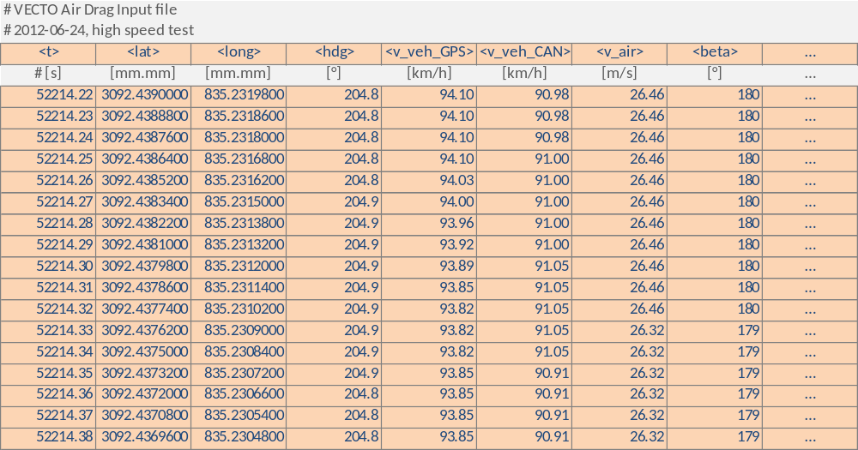
Figure 6: Example structure of the *.csdat file
The order of columns is arbitrary. The program identifies the signals based on the column identifier to be specified in row 1. Row 2 and the following contain the measured values. The temporal resolution of the *csdat files is defined with 100Hz. This frequency is checked by VECTO Air Drag during read-in. It is allowed to cut out driving phases e.g. recorded outside the measurement sections.
The recordings in the *.csdat-file have to start early enough that the meaningful moving averages can be calculated at the point in time when the vehicle enters the measurement section (i.e. >0.5s for the high speed test, >4.5s for the low speed test).
With the Air Drag Version 2.0.4 several coordinate units can be used (See Table 4). For the different units a specific column identifier has to be used.
Table 4 gives the specifications of the data signals to be provided in the measurement data files.

Table 4: Signal specifications for the measurement data file
signal | column identifier | unit | remarks
time | <t> | [s] since day start (first day) | rate fixed to 100Hz; time signal used for correlation with ambient conditions data and for check of frequency  If a measurement is performed over change of day the time shall be specified as [s] since day start of the first day. I.e. the second day starts with 86401. This time unit has to be used both in the *.csdat-files and the *.csamb-file.
(D)GPS latitude | <lat> | [mm.mm] | For standard GPS devices please provide:  [dd.dd]: minimum 5 digits  [mm.mm]: minimum 3 digits  after the decimal separator (refers to an accuracy of better than 1.8 meter). For the DGPS option please provide:  [dd.dd]: minimum 7 digits  [mm.mm]: minimum 5 digits  after the decimal separator (refers to an accuracy of better than 0.18 meter)1° = 111111 m  0.00001° = 1.11 m  0.000001° = 0.11 m
(D)GPS latitude | <lat_D> | [dd.dd]
(D)GPS longitude | <long> | [mm.mm]
(D)GPS longitude | <long_D> | [dd.dd]
(D)GPS heading | <hdg> | [°]
(D)GPS velocity | <v_veh_GPS> | [km/h] | not used in analysis if opto-electronic triggers are used
vehicle velocity | <v_veh_CAN> | [km/h] | raw CAN bus front axle signal
air speed | <v_air> | [m/s] | raw data (instrument reading)  Important definitions for data on inflow angle:  VECTO Air Drag accepts values only in the range from +360° to -360°. After read in these numbers are converted to the +180° to -180° range.
inflow angle (beta) | <beta> | [°]
engine speed cardan speed average wheel speed or electric motor speed | <n_eng>  <n_card>  <n_wheel_ave>  <n_EM> | [rpm] | One out of three options shall be selected:  Option 1: Engine speed based <n_eng>  The CAN engine speed signal together with the transmission ratios (gears for low speed test and high speed test, axle ratio) shall be made available. For the CAN engine speed signal it shall be demonstrated that the signal provided to the air drag pre-processing tool is identical to the signal to be used for in-service testing as set out in Annex I of Regulation (EU) 582/2011.  For vehicles with torque converter which are not able to drive the low speed test with closed lockup clutch in option 1 additionally the cardan shaft speed signal <n_card> and the axle ratio or the average wheel speed signal for the driven axle <n_wheel_ave> shall be provided to the air drag pre-processing tool. It shall be demonstrated that the engine speed calculated from this additional signal is within 1% range compared to the CAN engine speed. This shall be demonstrated for the average value over a measurement section driven at the lowest possible vehicle speed in the torque converter locked mode and at the applicable vehicle speed for the high speed test.  Option 2: Wheel speed based <n_wheel_ave>  The average of the CAN signals for the rotational speed of left and right wheel at the driven axle shall be made available. Alternatively external sensors may be used. Any method shall fulfill the requirements set out in Table 2 of Annex Xa.  Following option 2 the input parameters for gear ratios and axle ratio shall be set to 1, independent of the powertrain configuration.  Option 3: Electric motor speed based <n_EM>  In case of PEV and HEV the CAN speed electric motor speed together with the transmission ratios (gears for low speed test and high speed test and if applicable axle ratio) shall be made available. It shall be demonstrated that the powertrain configuration is such that the wheel speed of the driven axle in the low and high speed test is uniquely defined by these specifications.
torque meter (left wheel) | <tq_l> | [Nm] | Primary torque calibration (y=kx+d) to be done in data capturing system (i.e. before import into VECTO Air Drag!)
torque meter (right wheel) | <tq_r> | [Nm]
ambient temperature on vehicle | <t_amb_veh> | [°C] | to be measured according to the specifications in the technical annex
trigger signal | <trigger> | [-] | Optional signal; required if measurement sections are identified by opto electronic triggers (option "trigger_used=1"). This signal is defined to be an arbitrary integer value which changes at a “trigger event”.
proving ground temperature | <t_ground> | [°C] | Ground temperature (required for the LS and HS, optional in the calibration run)
validity | <valid> | [-] | Optional signal (1=valid; 0=invalid);  This feature shall be used to label invalid data (e.g. due to close passing of another vehicle, technical or driving errors). Invalid data will be excluded by VECTO Air Drag from further analysis.

Any other provided signal in the measurement data file will be also processed by VECTO- Air Drag. For these signals the averages for the driving phases within measurement sections are calculated. Any column identifier (except the predefined ones) can be used. These identifiers are then also used by VECTO Air Drag in the result files. Additional signals to be processed by VECTO Air Drag have to be existent in ALL measurement data files.

File with altitude profile (*.csalt)
Figure 7 gives an example for an altitude file. If the correction of gradient forces is enabled VECTO Air Drag requires each a *.csamb-file for each combination of measurement section and driving direction as specified in the *.csms-file for the low speed – high speed – low speed sequence.
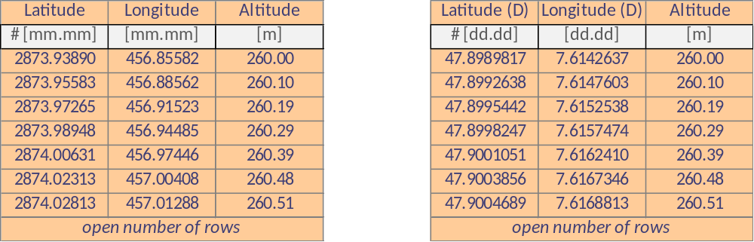
Figure 7: Example structure of the *.csalt file (left for decimal degree, right for decimal minutes as input unit)

Table 5: Input data for VECTO Air Drag – altitude profile file
signal | column identifier | unit | remarks
Latitude | no identifier, position fixed  For unit selection specify “(D)” at end of header for [dd.dd] | [dd.dd]  or [mm.mm] | [dd.dd]: minimum 7 digits after decimal separator  [mm.mm]: minimum 5 digits after decimal separator
Longitude |  | [dd.dd]  or [mm.mm]
Altitude | no identifier, position fixed | [m] | minimum 2 digits after decimal separator

Each altitude profile must meet the following requirements:
- The altitude profile must have a grid distance of lower or equal than 50 m (parameter “dist_grid_ms_max”) in driving direction.
- The first point of the altitude profile must be located before start and the last one after end of the measurement section.
Between the grid points VECTO Air Drag applies linear interpolation for altitudes from the *.csalt file.

Job-File
The Job file contains all information for a VECTO Air Drag test evaluation (settings, paths to input data and a small set of input parameters). The Job file is automatically created by the VECTO Air Drag user interface in the JSON format. After a successful calculation VECTO Air Drag also writes the main evaluation results into the job-file.

Criteria-File
The criteria file can be used to save or import a set of evaluation parameters (e.g. validity criteria or settings for correction functions) as shown in the GUI in the “Criteria”-tab. The criteria file is written in the JSON format.
For reasons of traceability for each calculation the used parameters are in any case also stored in the Jobfile.
The criteria file as used by VECTO Air Drag V3.0.8 is not compatible with the criteria file of previous tool versions as additional parameters have been added.

Evaluation algorithms
This section gives a documentation of the algorithms which are used to evaluate the input data. The complete list of values for evaluation parameters as used by VECTO Air Drag in the Declaration Mode is given in chapter 4.

Processing of data for vehicle position
In a first step VECTO Air Drag converts the (D)GPS coordinates to UTM coordinates. The according results for UTM coordinates can be found in the results files (values: “Lat (UTM)” and “Long (UTM)”). For data inside of measurement sections also the theoretical position of the vehicle projected to the line defined by the start- and end-coordinates of the measurement section (result file values “Lat (root)” and “Long (root)”) is calculated. This coordinate is the reference for the identification of the vehicle position inside the measurement sections and for the allocation of the altitude if the altitude correction is applied.

Assignment of measurement data to measurement sections
For assignment of recorded data to the measurement sections as specified in the *.csms-file two options can be chosen how the point in time is determined when the vehicle enters and exits the predefined measurement sections.
Option 1: Trigger signal
Vecto Air Drag identifies the entry or the exit of the vehicle if the criteria 1. to 3. are met:
- The trigger signal shows a change in integer value
- The position of the vehicle is inside a control area around a start point or an end-point of a MS as defined in the *.csms-file. The square is defined by the (+/-)-range from the parameters “delta_x_max” and “delta_y_max” (unit: [m]).
- The heading of the vehicle is in a (+/-)-range as defined by the parameter “delta_head_max” (unit: [°])

Option 2: DGPS signal
Vecto Air Drag identifies the entry or the exit of the vehicle if both criteria 1. and 2. are met:
- An imaginary line perpendicular to a measurement section going through the start point or the end-point is crossed within the (+/-)-range of the parameter “delta_y_max” (unit: [m]) to the start point or to the end-point
- The heading of the vehicle is in a (+/-)-range as defined by the parameter “delta_head_max” (unit: [°])
Important remarks:
- If a measurement section is specified in the *.csms-file only in a single driving direction, the data recorded on this section during driving in the opposite direction is not evaluated in VECTO Air Drag.
- If the end point of a MS is identical with the start point of the next MS the events for “exit” of the first MS and “entry” into the next MS happen at the same point in time.
- The validity of the allocated data is furthermore checked by comparison of driven distance (determined via the calibrated vehicle speed) inside the measurement section with the distance as specified as in the *.csms-file. If the absolute difference is greater than the parameter “leng_crit”, the particular data is not considered valid.
- DGPS use: According to the technical annex it is only valid to use “option 2” as explained above in connection with use of high accuracy DGPS systems. This factum cannot be verified within VECTO Air Drag.

Calibration of input signals
The signals for:
- vehicle speed
- air speed and
- yaw angle (beta)
are calibrated based on measurement data recorded at high speed. This evaluation is done in VECTO Air Drag automatically in a pre-processing step.

Step 1: Calibration of vehicle speed
In VECTO Air Drag the vehicle speed “v_veh” is determined based on the CAN (front axle) vehicle speed signal “v_veh_can” multiplied by the calibration factor “fv_veh”. The calibration factor “fv_veh” is determined by the average ratio of a reference vehicle speed (“v_ref”) to the CAN (front axle) vehicle speed signal “v_veh_can” for all valid “datasets” recorded during the calibration run or the high speed test respectively.

$$v_{veh}= v_{veh,CAN}*f_{v,veh}$$
where:
v_{veh} = calibrated vehicle speed [km/h]
v_{veh,CAN} = vehicle speed from CAN front axle signal [km/h]
f_{v,veh} = calibration factor for vehicle speed [-]
and:
$$f_{v,veh}= \frac{v_{ref,avrg}}{v_{veh,CAN, avrg}}$$
where:
$v_{ref,avrg}$ = average reference speed for all valid datasets
$v_{veh,CAN,avrg}$ = average CAN vehicle speed for all datasets

The reference vehicle speed is determined depending on the method of assignment of measurement sections as described below:
Option 1: Trigger signal
The reference vehicle speed is calculated by division of the length of the measurement section as specified in the *.csms-file by the driving time in the measurement section as determined based on the trigger signal.
Option 2: DGPS signal
For the DGPS option the vehicle reference speed is determined by division of the length of the measurement section as specified in the *.csms-file by the driving time in the measurement section as determined based on the DGPS coordinates.

Step 2: Calibration of air speed and yaw angle
For calibration of air speed and yaw angle VECTO Air Drag determines the calibration factors “f_{vpe}” (position error of measured air speed) and “β_{ame}” (misalignment factor for measured yaw angle) as specified in the technical annex. The evaluation steps are done as specified below:
- In a first evaluation step it is assumed that all datasets have been recorded in valid conditions assigning the label “valid=1”.
- VECTO Air Drag checks if a minimum set of 5 (parameter “segruns_min_CAL”) valid datasets per measurement section and driving direction (for the calibration test) and a minimum set of 10 (parameter “segruns_min_head_MS”) valid datasets per headings respectively (for the high speed test) are available. Invalid datasets (according to the respective criteria as listed in 3.4 step 3) are labelled with “used=0”. The labels “valid” and “used” assigned to each dataset are also shown in the VECTO Air Drag output file.
- Based on all “used=1” datasets the calibration factors “f_{vpe}” and “β_{ame}” are determined using the formulas as specified below:
$$f_{vpe}={\frac{v_{veh,avrg}}{1/2*(v_{air,ar,avrg,1}+v_{air,ar,avrg,2})}}_{}$$
where:
f_{vpe} = air speed position error correction factor [-]
$v_{veh,avrg}$ = average vehicle speed during test [m/s]
$v_{air,ar,avrg,1}$ = average air speed (anemometer reading) heading 1 [m/s]
$v_{air,ar,avrg,2}$ = average air speed (anemometer reading) heading 2 [m/s]

$$β_{ame}=\frac{(β_{ar,avrg,1}+β_{ar,avrg,2})}{2}$$
where:
$β_{ame}$ = angle misalignment error [°]
$β_{ar,avrg,1}$ = average yaw angle (anemometer reading)
in driving direction 1 [°]
$β_{ar,avrg,2}$ = average yaw angle (anemometer reading)
in driving direction 2 [°]

- For the yaw angle an angle correction factor f_{ape} (position error) of 1.0 is applied.
- With these correction factors the undisturbed air flow for air speed and yaw angle are calculated as specified below:
$$v_{UF}=v_{air,ar}*f_{vpe}$$
where:
$v_{UF}$ = air speed in undisturbed flow conditions [m/s]
$f_{vpe}$ = air speed position error correction factor [-]
v_{air,ar} = air speed signal (anemometer reading) [m/s]

$$β_{UF}={(β}_{ar}-β_{ame})*f_{ape}$$
where:
$β_{UF}$ = yaw angle at undisturbed flow conditions [°]
$β$ar = yaw angle signal [°]
$β_{ame}$ = angle misalignment error [°]
$f_{ape}$ = angle position error correction factor [-]

- The boundary layer correction is applied to correct air speed, yaw angle and wind speed as determined for undisturbed flow conditions to average flow conditions as acting on the vehicle.

Wind speed (v_{wind}) at undisturbed flow location at height of anemometer (h_{a}):
$$v_{windx}\left(h_{a}\right)=v_{UF}*cos\left(β_{UF}\right)-v_{veh}$$
$$v_{windy}\left(h_{a}\right)=v_{UF}*sin\left(β_{UF}\right)$$
$$v_{wind}\left(h_{a}\right)={[(v}_{windx}{\left(h_{a}\right))}^{2}{+(v}_{windy}{\left(h_{a}\right))}^{2}]^{0.5}$$

Wind speed variation with height: Assumption for wind profile using the power law boundary layer and δ=0.2:
$$v_{windx}\left(h\right)=v_{windx}\left(h_{a}\right)*{\left(\frac{h}{h_{a}}\right)}^{δ}$$
$$v_{windy}\left(h\right)=v_{windy}\left(h_{a}\right)*{\left(\frac{h}{h_{a}}\right)}^{δ}$$

Air speed and β variation with height:
$$v_{air}\left(h\right)={[(v}_{windx}{\left(h\right)+v_{veh})}^{2}{+(v}_{windy}{\left(h\right))}^{2}]^{0.5}$$
$$β\left(h\right)=atan⁡[\frac{v_{windy}\left(h\right)}{{(v}_{windx}\left(h\right)+v_{veh})}]$$

Height-averaged values for air speed v_{air} and yaw angle β:
$$v_{air}=\left(\frac{1}{h_{v}}\right)*\int_{0}^{hv}{v_{air}\left(h\right)dh}$$
$$β=\left(\frac{1}{h_{v}}\right)*\int_{0}^{hv}{β\left(h\right)dh}$$

where:
h_{v} = vehicle height [m]
h_{a} = installation height of anemometer above ground
h = height above ground [m]
δ = atmospheric stability coefficient [-]
$v_{windx}$ = wind speed in x-direction [km/h]
$v_{windy}$ = wind speed in y-direction [km/h]
$v_{air}$ = air speed [km/h]

- Based on the values calculated in 6. the validity of the criteria for the single datasets as specified in 3.4 step 3 is checked. If the validity of single datasets has been modified, the evaluation process is started again with point 3. If not, the calibration factors “f_{vpe}” and “β_{ame}” determined in point 3. are considered final.

The air speed position error correction factor f_{vpe} is calculated both for the misalignment test and for the high speed test separately. The evaluation of the low speed – high speed – low speed sequence is performed based on the f_{vpe} factor from the high speed test. The f_{vpe} factor from the misalignment test is needed for the verification of the wind conditions in the misalignment test.
The angle misalignment error factor $β_{ame}$ as calculated from the misalignment test is also applied in the evaluation of the low speed – high speed – low speed sequence.

Important remarks related to the evaluation of the misalignment test:
- For the evaluation of the misalignment test data recorded in both driving directions on a particular measurement section has to be available. This is checked by the software during read in.
- In VECTO Air Drag more than one measurement section can be configured to be evaluated in the calibration test. The overall calibration factors are determined by averaging the results determined in a first step for each specified measurement section. If for a particular measurement section not enough valid datasets are available, the data for this section are completely discarded in the evaluations.
- In “step 1: calibration of vehicle speed” datasets are included in the analysis independent of the wind conditions.

Evaluation of the constant speed tests
This section describes the evaluation steps performed for the measurement data recorded in the low speed – high speed –low speed test sequence to determine the product of drag coefficient by cross sectional area for zero crosswind conditions C_{d} A_{cr} (0).

Step 1: Calculation of air speed, yaw angle and wind speed
VECTO Air Drag calculates the height average values for air speed, yaw angle and wind speed using the formulas as specified in the technical annex. This is done in the 100 Hz time basis.

Step 2: Calculation of forces from driving resistances
VECTO Air Drag determines the forces which apply to the vehicle from the driving resistances in the 100Hz time resolution according to the steps i. to iv.:
- Calculation of total traction force:
The total traction force is calculated as specified below:

Option 1: Engine speed signal available:
$$F_{trac}=\frac{{(T_{L}+T}_{R})∙\frac{n_{eng}∙π}{30∙i_{gear}∙i_{axle}}}{v_{veh}}$$
Option 2: Cardan speed signal available:
$$F_{trac}=\frac{{(T_{L}+T}_{R})∙\frac{n_{card}∙π}{30∙i_{axle}}}{v_{veh}}$$

where:
F_{trac} = total traction force [N]
T_{L}, T_{R} = corrected torque for left and right wheel [Nm]
n_{eng} = engine speed [rpm]
n_{card} = cardan speed [rpm]
i_{gear} = transmission ratio of engaged gear [-]
i_{axle} = axle transmission ratio [-]
v_{veh} = vehicle speed [m/s]

The corrected torque signals in the equations above are calculated from the raw torque signal as follows:

T_{L}(t) = T_{L},_{raw}(t) – T_{Drift,Left} * (t-t_{DriftZero})/( t_{DriftCheck}-t_{DriftZero})
T_{R}(t) = T_{R},_{raw}(t) – T_{Drift,Right} * (t-t_{DriftZero})/( t_{DriftCheck}-t_{DriftZero})

Symbol | Description
t | Time
T_{L}(t), T_{R}(t) | Corrected torque signal left/right
T_{L},_{raw} , T_{L},_{raw} | Raw torque signal left/right
T_{Drift,Left}, T_{Drift,Right} | Torque meter drift left wheel
t_{DriftZero} | Time stamp zeroing of torque meters
t_{DriftCheck} | Time stamp drift check torque meters

- Correction for forces from road gradient and accelerations
From the total traction force the forces from road gradient and accelerations are subtracted gaining the driving resistance force caused by air drag and rolling resistance. This is correction is only done if enabled in the VECTO Air Drag evaluation settings:
$$F_{res}=F_{trac}-F_{grd}∙s_{grd}-F_{acc}∙s_{acc}$$
where:
F_{res} = driving resistances force (air drag and rolling resistance) [N]
F_{trac} = total traction force [N]
F_{grd} = gradient force [N]
s_{grd} = parameter for gradient correction (1=enabled, 0 =disabled) [-]
F_{acc} = force from vehicle inertia [N]
s_{acc} = parameter for acceleration correction (1=enabled, 0 =disabled) [-]

The gradient force is calculated from:
$$F_{grd}=m_{veh}∙g∙\sin\left(α\right)$$
$$α=\arctan\left(\frac{∆alt}{∆dist}\right)$$
where:
m_{veh} = vehicle mass as specified in *.csveh-file [kg]
g = earth gravitational acceleration (9.81) [m/s²]
α = gradient angle
Δalt = altitude difference from next to previous timestep
Δdist = difference of driven distance from calculated from UTM coordinates
next to previous timestep

The force from vehicle inertia is calculated from: $F_{acc}=m_{veh}∙a_{avg}∙1.03$
where:
m_{veh} = vehicle mass as specified in *.csveh-file [kg]
a_{avg} = vehicle acceleration calculated from the moving averaged vehicle speed signal [m/s²]

The averaging period for the signals of vehicle speed and engine speed as used for calculation of vehicle acceleration and wheel speed acceleration is defined by the parameter acc_corr_avg (unit: [s]).

- Calculation of the air density and vapour pressure
The air density is calculated from the air temperature measured on the vehicle and the air pressure and relative humidity as measured at the stationary weather station based on the following equations:

$$p_{v,H2O}=611∙\frac{{RH}_{stat}}{100}∙{10}^{\frac{7.5∙t_{amb,stat}}{(237+t_{amb,stat})}}$$

$$ρ_{air}=\frac{p_{amb,stat}-p_{v,H2O}}{287.1∙(t_{amb,veh}+273.15)}+\frac{p_{v,H2O}}{461.9∙(t_{amb,veh}+273.15)}$$

where:
p_{v,H2O} = H₂O vapour pressure [Pa]
RH_{stat} = relative humidity measured by stationary weather station [%]
t_{amb,stat} = ambient temperature measured by stationary weather station [°C]
t_{amb,stat} = ambient temperature measured on the vehicle [°C]
p_{amb,stat} = ambient pressure measured by stationary weather station [Pa]

- Correction of driving resistance force for the low speed tests
VECTO Air Drag provides the option to consider a systematic change of rolling resistance in the low speed tests compared to the high speed test as driven in the test sequence. In the data evaluation this is done by multiplication of the driving resistance forces from the low speed tests by the correction factor f_{roll,corr}.
$$F_{res,ref}=F_{res}∙f_{roll,corr}$$
For type approval this correction factor is defined with 1.0 (i.e. no such correction).

Step 3: Check of validity criteria for data to be included in the analysis

Misalignment test
VECTO Air Drag accepts datasets as recorded during the misalignment test in case the following validity criteria are met:
- the average vehicle speed is inside 92 km/h (v_veh_avg_max_HS) and 87 km/h (v_veh_avg_min_HS) or 3 km/h (delta_v_avg_min_HS) below maximum vehicle speed
- average wind speed below 4 m/s (v_wind_avg_max_CAL)
- gust wind speed below 7 m/s (v_wind_1s_max_CAL)
- average yaw angle below 5° (beta_avg_max_CAL)
- stability criteria for vehicle speed met:
$${(v}_{hms,avrg}-1^{*} km/h)≤v_{hm,avrg}≤(v_{hms,avrg}+1 km/h)$$
where:
v_{hms,avrg} = average of vehicle speed per measurement section [km/h]
v_{hm,avrg} = 1 s central moving average of vehicle speed [km/h]
* = parameter v_veh_1s_delta_CAL

VECTO Air Drag considers the data as recorded during the misalignment test from a single measurement section invalid in the following cases:
- the average vehicle speeds from all valid datasets from each driving directions differ by more than 2 km/h (v_veh_ave_delta_CAL).
- less than 5 (segruns_min_CAL) datasets per heading available
Vehicle Energy Consumption calculation Tool Air Drag considers the complete misalignment test invalid in case no valid result for a single measurement section is available.

High speed test
Vehicle Energy Consumption calculation Tool Air Drag accepts datasets as recorded during the high speed test in case the following validity criteria are met:
- the average vehicle speed is inside 92 km/h (v_veh_avg_max_HS) and 87 km/h (v_veh_avg_min_HS) or 3 km/h (delta_v_avg_min_HS) below maximum vehicle speed
- the ambient temperature is inside 5°C (t_amb_min) and 25°C (t_amb_max)
This criterion is checked by VECTO Tool Air Drag based on the ambient temperature measured on the vehicle.
- the proving ground temperature is below 40°C (t_ground_max)
- average wind speed below 4 m/s (v_wind_avg_max_HS)
- gust wind speed below 7 m/s (v_wind_1s_max_HS)
- average yaw angle below 3° (beta_avg_max_HS)
- stability criteria for vehicle speed met:
$${(v}_{hms,avrg}-{0.3}^{*} km/h)≤v_{hm,avrg}≤(v_{hms,avrg}+0.3 km/h)$$
where:
v_{hms,avrg} = average of vehicle speed per measurement section [km/h]
v_{hm,avrg} = 1 s central moving average of vehicle speed [km/h]
* = parameter v_veh_1s_delta_HS
- stability criteria for vehicle torque met:
$${(T}_{hms,avrg}-T_{grd})*0.8≤{(T}_{hm,avrg}-T_{grd})≤{(T}_{hms,avrg}-T_{grd})*1.2$$
$$T_{grd}=F_{grd,avrg}*r_{dyn,avrg}$$
where:
T_{hms,avrg} = average of T_{sum} per measurement section [Nm]
T_{grd} = average torque from gradient force [Nm]
F_{grd,avrg} = average gradient force over measurement section
r_{dyn,avrg} = average effective rolling radius over measurement section
(formula see item engine speed check xi..) [m]
T_{sum} = T_{L}+T_{R}; sum of corrected torque left and right wheel [Nm]
T_{hm,avrg} = 1 s central moving average of T_{sum} [Nm]
The related torque tolerance is defined in VECTO Air Drag by parameter tq_sum_1s_delta_HS.

- valid heading of the vehicle during passing a measurement section defined by < 10° deviation from target heading applicable (delta_head_max)
- driven distance inside measurement section calculated from the calibrated vehicle speed does not differ from target distance by more than 3 meters (leng_crit)
- plausibility check for engine speed, cardan speed, average wheel speed or electric motor speed whichever is applicable passed:
Engine speed check
$$\frac{30∙i_{gear}∙i_{axle}∙\frac{(v_{hms,avrg}-0.3)}{3.6}}{r_{dyn,ref,HS}∙π}∙\left(1-{2\%}^{*}\right) ≤{ n}_{eng,1s }≤ \frac{30∙i_{gear}∙i_{axle}∙\frac{\left(v_{hms,avrg}+0.3\right)}{3.6}}{r_{dyn,ref,HS}∙π}∙(1+2\%)$$
$$r_{dyn,avrg}=\frac{30∙i_{gear}∙i_{axle}∙\frac{v_{hms,avrg}}{3.6}}{n_{eng,avrg}∙π}$$
$$r_{dyn,ref,HS}=\frac{1}{n}\sum_{j=1}^{n}{r_{dyn,avrg,j}}$$
where:
i_{gear} = transmission ratio of the gear selected in high speed test [-]
i_{axle} = axle transmission ratio [-]
v_{hms,avrg} = average vehicle speed [km/h]
n_{eng,1s} = 1 s central moving average of engine speed (high speed
measurement section) [rpm]
r_{dyn,avrg} = average effective rolling radius for a single high speed
measurement section [m]
r_{dyn,ref,HS}= reference effective rolling radius calculated from all valid
high speed measurement sections (number = n) [m]
* = parameter delta_n_ec_HS
The plausibility check for cardan speed, average wheel speed or electric motor speed is performed in an analogue way e.g. for cardan speed with n_{eng,1s} replaced by n_{card,1s} (1 s central moving average of cardan speed in the high speed measurement section) and i_{gear} set to a value of 1.
- the particular part of the measurement data was not marked as “invalid” in the Vehicle Energy Consumption calculation Tool Air Drag input file

Low speed test
VECTO Air Drag accepts datasets as recorded during the low speed test in case the following validity criteria are met:
- the average vehicle speed is inside 15 km/h (v_veh_avg_max_LS) and 10 km/h (v_veh_avg_min_LS)
- the ambient temperature is inside 5°C (t_amb_min) and 25°C (t_amb_max)
This criterion is checked by VECTO Tool Air Drag based on the ambient temperature measured on the vehicle.
- the proving ground temperature is below 40°C (t_ground_max)
- stability criteria for vehicle speed met:
$${(v}_{lms,avrg}-{0.5 }^{*}km/h)≤v_{lm,avrg}≤{(v}_{lms,avrg}+0.5 km/h)$$
where:
v_{lms,avrg} = average of vehicle speed per measurement section [km/h]
v_{lm,avrg} = central moving average of vehicle speed with X_{ms} seconds
time base [km/h]
X_{ms} = time needed to drive 25 m distance (parameter dist_float)
at actual vehicle speed [s]
* = parameter v_veh_float_delta_LS
- stability criteria for vehicle torque met:
$${(T}_{lms,avrg}-T_{grd})*0.7≤{(T}_{lm,avrg}-T_{grd})≤{(T}_{lms,avrg}-T_{grd})*1.3$$
$$T_{grd}=F_{grd,avrg}*r_{dyn,avrg}$$
where:
T_{lms,avrg} = average of T_{sum} per measurement section
T_{grd} = average torque from gradient force
F_{grd,avrg} = average gradient force over measurement section
r_{dyn,avrg} = average effective rolling radius over measurement section
(formula see engine speed check viii.) [m]
T_{sum} = T_{L}+T_{R}; sum of corrected torque left and right wheel [Nm]
T_{lm,avrg} = central moving average of T_{sum} with X_{ms} seconds time base
X_{ms} = time needed to drive 25 m at actual vehicle speed [s]
The related torque tolerance is defined in VECTO Air Drag by parameter tq_sum_float_delta_LS.
- valid heading of the vehicle during passing a measurement section defined by < 10° deviation from target heading applicable (delta_head_max)
- driven distance inside measurement section calculated from the calibrated vehicle speed does not differ from target distance by more than 3 meters (leng_crit)
- plausibility check for engine speed or cardan speed whichever is applicable passed:
Engine speed check:
$$\frac{30∙i_{gear}∙i_{axle}∙\frac{(v_{lms,avrg}-0.5)}{3.6}}{r_{dyn,ref,LS1/LS2}∙π}∙\left(1-{2\%}^{*}\right) ≤{ n}_{eng, float }≤ \frac{30∙i_{gear}∙i_{axle}∙\frac{\left(v_{lms,avrg}+0.5\right)}{3.6}}{r_{dyn,ref,LS1/LS2}∙π}∙(1+2\%)$$
$$r_{dyn,avrg}=\frac{30∙i_{gear}∙i_{axle}∙\frac{v_{hms,avrg}}{3.6}}{n_{eng,avrg}∙π}$$
$$r_{dyn,ref,LS1/LS2}=\frac{1}{n}\sum_{j=1}^{n}{r_{dyn,avrg,j}}$$
where:
i_{gear} = transmission ratio of the gear selected in low speed test [-]
i_{axle} = axle transmission ratio [-]
v_{lms,avrg} = average vehicle speed [km/h]
n_{eng,float} = central moving average of engine speed with X_{ms} seconds
time base [rpm]
X_{ms} = time needed to drive 25 m distance (parameter dist_float)
at actual vehicle speed [s]
r_{dyn,avrg} = average effective rolling radius for a single low speed
measurement section [m]
r_{dyn,ref,LS1/LS2} = reference effective rolling radius calculated from all valid
measurement sections for low speed test 1 or low speed
test 2 (number = n) [m]
* = parameter delta_n_ec_HS
The plausibility check for cardan speed is performed in an analogue way with n_{eng,float} replaced by n_{card,float} (moving average of cardan speed with X_{ms} seconds time base in the low speed measurement section) and i_{gear} set to a value of 1.
- the particular part of the measurement data was not marked as “invalid” in the Vehicle Energy Consumption calculation Tool Air Drag input file
VECTO Air Drag excludes single datasets from the evaluation in the case of unequal number of datasets for a particular combination of measurement section and driving direction for the first and the second low speed test. In this case the first datasets from the low speed run with the higher number of datasets are excluded.
Complete exclusion of single combinations of measurement sections and driving directions from the evaluation:
Vehicle Energy Consumption calculation Tool Air Drag excludes single combinations of measurement sections and driving directions from the evaluation if:
- no valid dataset is available from low speed test 1 or/and low speed test 2
- less than 2 (parameter segruns_min_HS) valid datasets from the high speed test are available
Remark: In this case VECTO Air Drag aborts the evaluation. In order to try to gain a valid test result with the remaining data this particular measurement section (or combination of measurement section with driving direction) has to be manually removed by the user in the *.csms file.
Step 4: Calculation of C_{d} A_{cr} (β) values for all combination of measurement sections and driving directions
For all applicable combinations of measurement sections and driving directions the following analysis is performed:
- Setup of a linear regression for all used=1 datasets from the high speed tests and the two low speed tests for F_{res} as a function of squared air speed (v_{air}²) achieving an constant term F₀ (unit [N]) and regression coefficient F₂ (unit: [Ns²/m²]). In the regression weighting factors are applied so that the cumulative weighting of all high speed datasets is 50%. The constant term F₀ is interpreted as sum of all constant forces (rolling resistance, side inclination, bearing losses etc.).
- The value for C_{d}∙A_{cr} (β) is calculated for each high speed dataset as follows:
$$C_{d}∙A_{cr}(β)=2∙{\left({F_{res,ref}-F}_{0}\right)}/{\left({v_{air}}^{2}∙ρ_{air,ref}\right)}$$
- The average value for C_{d}∙A_{cr} (β) for the particular combination of measurement and driving direction is calculated from the related values of all used high speed datasets by arithmetical averaging.
- The average absolute yaw angle β is calculated from all high speed datasets
- The rolling resistance coefficient (RRC, unit [kg/t]) is calculated for the first low speed test (LS1) and for the second low speed test (LS2) from
$${RRC}_{LS1/LS2}=\frac{1000∙F_{0 LS1/LS2}}{m_{veh}∙9.81}$$
where:
F_{0,LS1 / LS2} = constant term from the regression of F_{res} as a function of
squared air speed (v_{air}²) using all high speed datasets and
the dataset of the particular low speed test (LS1 or LS2) [N]
m_{veh} = vehicle mass [kg]
Step 5: Calculation of average results over all measurement sections
The result for overall C_{d}∙A_{cr} (β_{avrg}) and the according overall average yaw angle β_{avrg} is calculated from the results for all combinations of measurement sections and driving directions which fulfil the provisions as described in the technical annex capture 3.10.3 as follows:
1. Calculation of results per heading by weighted arithmetical averaging. As weighting factors the numbers of “used” datasets for each measurement section are applied.
2. Calculation of overall result by arithmetical average of results for both headings
Step 6: Check of validity criteria for complete constant speed test
VECTO Air Drag considers the complete constant speed test invalid in the following cases:
- Test track requirements not met, i.e. the headings of the straights differ by more than 20° (delta_parallel_max) from +/-180°
This criterion is already checked during read in of the *.csms-file)
- less than 10 (segruns_min_head_MS) datasets per heading available
- the rolling resistance coefficients (RRC) for the first and the second low speed test differ more than 0.40 kg/t (delta_rr_corr_max)
Step 7: Correction of cross wind influence
The value for product of drag coefficient by cross sectional area for zero cross-wind conditions C_{d}∙A_{cr}(0)_{meas} is then calculated performing the yaw angle correction as specified below:
$$C_{d}∙A_{cr}{\left(0\right)}_{meas}=C_{d}∙A_{cr}\left(β_{avrg}\right)-∆C_{d}∙A_{cr}(β_{avrg})$$
where:
$C_{d}∙A_{cr}\left(β_{avrg}\right)$ = product of air drag coefficient and frontal area from constant speed
tests comprising the average absolute yaw angle of β_{avrg}
$∆C_{d}∙A_{cr}(β_{avrg})$ = yaw angle correction applying the generic curve for $∆C_{d}∙A_{cr}$ as a
function yaw angle for the value of β_{avrg}.

In the correction the applicable generic curve for the particular vehicle class and vehicle configuration (rigid or with trailer) as specified below is used.
$$∆C_{d}∙A_{cr}\left(β\right)=a_{1}∙β+a_{2}∙β^{2}+a_{3}∙β^{3}$$
For the coefficients a₁ to a₃ the following vehicle class specific values are applicable:
Table 6: Coefficients for yaw angle dependency
 | Medium lorries |  | Heavy lorries |  |  | Heavy buses
 | vans | rigids | rigid solo | rigid + trailer | tractor + semitrailer | Heavy buses
a₁ | 0.0032 | -0.0015 | 0.013526 | 0.017125 | 0.030042 | -0.000794
a₂ | 0.00532 | 0.0086 | 0.017746 | 0.072275 | 0.040817 | 0.021090
a₃ | -0.00028 | -0.00029 | -0.000666 | -0.004148 | -0.002130 | -0.001090
Step 8: Correction of air drag to reference vehicle height and for anemometer influence
In a final step the value for C_{d}∙A_{cr} (0) is calculated from the C_{d} A_{cr}(0)_{meas} value as determined above by a correction to the reference vehicle height and by a correction of the influence of the anemometer and the pole:
$$C_{d}∙A_{cr}\left(0\right)=C_{d}∙A_{cr}{\left(0\right)}_{meas}∙\frac{H_{ref}}{H_{meas}}-{C_{d}∙A_{cr}}_{anemo}$$
where:
C_{d} A_{cr}(0) = product of drag coefficient by cross sectional area for zero cross-wind
conditions [m²]
C_{d} A_{cr}(0)_{meas} = product of drag coefficient by cross sectional area for zero
crosswind conditions as determined by the constant speed test [m²]
H_{ref} = reference vehicle height according to Table 7 [m]
H_{meas} = vehicle height [m]
C_{d} A_{cr,anemo} = generic correction for influence of drag of anemometer and pole: 0.15
[m²]
Table 7: Reference vehicle heights
Vehicle group | Reference vehicle height [m]
53 | 3.50
1s and 1 | 3.60
2 | 3.75
3 | 3.90
4 | 4.00
5 | 4.00
9 | similar value than rigid with same maximum gross vehicle weight (class 1, 2, 3 or 4)
10 | 4.00

The correction to the reference vehicle height is not applicable for van medium lorries and heavy buses.

Parameter settings in VECTO Air Drag Declaration Mode

Table 8 gives the full list of parameters settings as applied by VECTO Air Drag in the Declaration Mode. These settings are according to the provisions as specified in the HDV CO2 legislation Technical Annex Air Drag.
Table 8: Parameter settings in VECTO Air Drag Declaration Mode (in alphabetical order)
Parameter name | Parameter group | Value | Unit | Description
AveSecAcc | General | 1 | [s] | averaging of vehicle speed for correction of acceleration forces (central averaging, i.e. +/- 0.5s)
beta_avg_max_CAL | Dataset validity criteria | 5 | [°] | maximum average beta during calibration test
beta_avg_max_HS | Dataset validity criteria | 3 | [°] | maximum average beta during high speed test
delta_CdxA_anemo | Anemometer correction | -0.15 | [m²] | influence of anemometer and pole on measured CdxA
delta_head_max | Identification of measurement sections | 10 | [°] | +/- maximum deviation from heading as read from the csdat-file to the heading from csms-file for a valid dataset
delta_Hz_max | General | 1 | [%] | maximum allowed deviation of timestep-size in csdat-file from 100Hz
delta_n_ec_HS | Dataset validity criteria | 0.02 | [-] | +/- maximum relative deviation of variance of engine/cardan speed compared to variance in vehicle speed (used as plausibility check for engine speed signal) (high speed test)
delta_n_ec_LS | Dataset validity criteria | 0.02 | [-] | +/- maximum relative deviation of variance of engine/card speed compared to variance in vehicle speed (used as plausibility check for engine speed signal) (low speed test)
delta_parallel_max | General | 20 | [°] | maximum heading difference for measurement section (parallelism criteria for test track layout)
delta_rr_corr_max | Dataset validity criteria | 0.4 | [kg/t] | maximum difference of RRC from the two low speed runs
delta_v_avg_min_HS | Dataset validity criteria | 3 | [km/h] | +/- minimum range for average vehicle speed in high speed test (overrules v_veh_avg_min_HS)
dist_float | Dataset validity criteria | 25 | [m] | distance used for calculation of floating average signal used for stability criteria in low speed tests
dist_grid_ms_max | Altitude validity criteria | 1 | [m] | maximum allowed distance between MS center line and altitude grid points.
dist_gridpoints_max | Altitude validity criteria | 50 | [m] | distance between grid points of altitude profile.
leng_crit | Dataset validity criteria | 3 | [m] | maximum absolute difference of distance driven with length of section as specified in configuration
length_MS_max | Identification of measurement sections | 253 | [m] | maximum length of measurement section as specified in *.csms-file
length_MS_min | Identification of measurement sections | 247 | [m] | minimum length of measurement section as specified in *.csms-file
rr_corr_factor | General | 1 | [-] | rolling resistance correction factor
segruns_min_CAL | Requirements on number of valid datasets | 5 | [#] | minimum number of valid datasets required for the calibration test (per combination of MS ID and DIR ID)
segruns_min_head_MS | Requirements on number of valid datasets | 10 | [#] | minimum TOTAL number of valid datasets required for the high speed test per heading
segruns_min_HS | Requirements on number of valid datasets | 2 | [#] | Minimum number of valid datasets required for the high speed test (per combination of MS ID and DIR ID)
segruns_min_LS | Requirements on number of valid datasets | 1 | [#] | minimum number of valid datasets required for the low speed test (per combination of MS ID and DIR ID)
slope_max | Altitude validity criteria | 1 | [%] | maximum +/- gradient over measurement section
t_amb_max | General validity criteria | 25 | [°C] | maximum ambient temperature (measured at the vehicle) during the tests (evaluated based on the used datasets only)
t_amb_min | General validity criteria | 5 | [°C] | minimum ambient temperature (measured at the vehicle) during the tests (evaluated based on the used datasets only)
t_ground_max | General validity criteria | 40 | [°C] | maximum ground temperature, no documentation of tarmac condition is necessary
tq_sum_1s_delta_HS | Dataset validity criteria | 0.2 | [-] | +/- maximum relative deviation of 1s average torque from average torque over entire section (high speed test)
tq_sum_float_delta_LS | Dataset validity criteria | 0.5 for medium lorries and heavy lorries groups 1 and 2.  0.3 for all other groups | [-] | +/- maximum relative deviation of floating average torque from average torque over entire section (low speed test)
trigger_delta_x_max | Identification of measurement sections | 30 | [m] | +/- size of the control area around a MS start/end point where a trigger signal is valid (x=driving direction)
trigger_delta_y_max | Identification of measurement sections | 100 | [m] | +/- size of the control area around a MS start/end point where a trigger signal is valid (y=perpendicular to driving direction)
v_veh_1s_delta_CAL | Dataset validity criteria | 1 | [km/h] | +/- maximum deviation of 1s average vehicle speed from average vehicle speed over entire section (calibration)
v_veh_1s_delta_HS | Dataset validity criteria | 0.3 | [km/h] | +/- maximum deviation of 1s average vehicle speed from average vehicle speed over entire section (high speed test)
v_veh_ave_delta_CAL | Dataset validity criteria | 2 | [km/h] | +/- maximum deviation of average speeds per heading in the misalignment calibration test
v_veh_avg_max_LS | Dataset validity criteria | 15 | [km/h] | maximum average vehicle speed for low speed test
v_veh_avg_min_HS | Dataset validity criteria | 87 | [km/h] | minimum average vehicle speed for high speed test
v_veh_avg_max_HS | Dataset validity criteria | 92 | [km/h] | maximum average vehicle speed for high speed test
v_veh_avg_min_LS | Dataset validity criteria | 10 | [km/h] | minimum average vehicle speed for low speed test
v_veh_float_delta_LS | Dataset validity criteria | 0.5 | [km/h] | +/- maximum deviation of floating average vehicle speed from average vehicle speed over entire section (low speed test)
v_wind_1s_max_CAL | Dataset validity criteria | 7 | [m/s] | maximum gust wind speed during calibration test
v_wind_1s_max_HS | Dataset validity criteria | 7 | [m/s] | maximum gust wind speed during high speed test
v_wind_avg_max_CAL | Dataset validity criteria | 4 | [m/s] | maximum average wind speed during calibration test
v_wind_avg_max_HS | Dataset validity criteria | 4 | [m/s] | maximum average wind speed during high speed test

Output files
The overall results of the test evaluation (list of parameters see Table 9) are written by VECTO Air Drag into the job-file. Additionally, interim results are provided by VECTO Air Drag on three different levels of detail which are written into three kinds of output files:
- The “Air Drag main result file” comprising overall results
- The “MS files” with the results for all single recorded measurement sections differentiated by driving direction if applicable
- Each a “Hz file” (either in 1Hz or in 100Hz, depending on the settings) for the calibration run, the two low speed runs and the high speed test with all input data as well as all calculated values averaged to the specified frequency
If the calculation was done in the declaration mode, it is also possible to generate a VECTO input file (“.xml”).
The sections below give detailed explanations on the result files. All result files are written to the subfolder “\Results” of the folder of the job-file in the CSV-format.

The Air Drag main result file
Filename = filename of the job-file + “Air Drag.csv”
Table 9 and Table 10 show the results as provided by the Air Drag main result file. Only data from "used" datasets are included in the analysis and provided in the Air Drag main result file. This file will is not written in “Declaration Mode” in case no valid final result for CdxA(0) is obtained.
Table 9: Overall results provided in the Air Drag main result file
quantity | unit | description
fv_veh | [-] | calibration factor for CAN vehicle speed (if DGPS option is used in the calibration run: determined based on DGPS velocity signal)
fv_pe | [-] | position error correction factor for measured air speed
fa_pe | [-] | position error correction factor for measured air inflow angle (beta)
beta_ame | [°] | misalignment correction for measured air inflow angle (beta)
t_amb_LS1 | [°C] | average ambient temperature during first low speed test
v_avg_LS | [km/h] | average vehicle speed used datasets low speed tests
v_avg_HS | [km/h] | average vehicle speed used datasets high speed tests
CdxA(ß)_H1 | [m²] | average Cd*A (β) of all combinations of MS ID and direction ID (before yaw angle correction) for HeadID 1
beta_H1 | [°] | average absolute β of all combinations of MS ID and direction ID for HeadID 1
CdxA(ß) _H2 | [m²] | average Cd*A (β) of all combinations of MS ID and direction ID (before yaw angle correction) for HeadID 2
beta_H2 | [°] | average absolute β of all combinations of MS ID and direction ID for HeadID 2
CdxA(ß) | [m²] | average Cd*A (β) of all combinations of MS ID and direction ID (before yaw angle correction)
beta | [°] | average absolute β of all combinations of MS ID and direction ID
delta_CdxA | [m²] | β-influence on CdxA calculated with beta and the generic drag curve
CdxA(0)meas | [m²] | average measured CdxA for zero yaw angle
delta_CdxA_height |  | correction of CdxA to reference vehicle height
delta_CdxA_anemo |  | CdxA influence from anemometer
CdxA(0) | [m²] | CdxA value for zero cross-wind conditions (= CdxA(0)meas + delta_CdxA_height + delta_CdxA_anemo) FINAL RESULT
Validity criteria | [-] | particular error messages on single validity criteria (RRC)

Table 10: Results provided per combination of measurement section and driving directions
quantity | unit | description
SecID | [-] | measurement section ID as specified in the *.csms-file
DirID | [-] | driving direction ID as specified in the *.csms-file
HeadID | [-] | heading ID (internal quantity)
NumUsed | [-] | number of valid/used datasets
F0_singleMS | [N] | result for F0 from linear regression
F0_singleMS_LS1 | [N] | result for F0 from linear regression (low speed data only from first test)
F0_singleMS_LS2 | [N] | result for F0 from linear regression (low speed data only from second test)
CdxA(ß)_avg_singleMS | [m2] | CdxA (β) (= 2* (F_{res,ref}-F₀)/ (v_{air}² * rho_air)
CdxA0_singleMS | [m2] | CdxA converted to zero cross-wind
delta_CdxA_singleMS | [m2] | cross-wind correction
beta_avg_singleMS | [°] | average absolute beta from high speed dataset  (0° refers to air flow from front!)
RRC_singleMS | [kg/t] | rolling resistance coefficient
RRC_singleMS_LS1 | [kg/t] | rolling resistance coefficient (low speed data only from first test)
RRC_singleMS_LS2 | [kg/t] | rolling resistance coefficient (low speed data only from second test)
Valid_RRC | [-] | Validity criteria for maximum difference of RRC from the two low speed runs passed (=1) or failed (=0)
F2_singleMS | [N/(m2/s2)] | result for F2 from linear regression
F2_singleMS_LS1 | [N/(m2/s2)] | result for F2 from linear regression (low speed data only from first test)
F2_singleMS_LS2 | [N/(m2/s2)] | result for F2 from linear regression (low speed data only from second test)

The “measurement section” (ms-)files
VECTO Air Drag writes two MS-files (each one for the calibration test and one for the measurement runs). These files contain all results for the driving phases inside the measurement sections (the “datasets”).
For the calibration test: Filename = filename job-file + “MS_CAL.csv”
For the constant speed test: Filename = filename job-file + “MS_MEAS.csv”
Table 11 gives explanations to the results as provided in the ms-file for the constant speed test sequence. The ms-file for the calibration test contains fewer columns as fewer values are calculated Air Drag -internally.
Table 11: Results provided in the ms-file for the constant speed test sequence
quantity | unit | description
SecID | [-] | measurement section ID as specified in the *.csms-file
DirID | [-] | driving direction ID as specified in the *.csms-file
RunID | [-] | Run ID: "0" = high speed test; "1" = first low speed test; "2" = second low speed test
HeadID | [-] | Heading ID (internal quantity)
delta t | [s] | driving time inside the measurement section
length | [m] | section lenght as specified in the *.csms-file
delta s | [m] | driven distance inside the measurement section derived from vehice speed signal
v (s) | [km/h] | =delta_s/delta_t
v (GPS) | [km/h] | average vehicle speed (GPS signal)
v_veh_CAN | [km/h] | average vehicle speed (CAN signal)
v_veh | [km/h] | average vehicle speed (after calibration)
vair_ic | [m/s] | average air speed (after instrument error correction)
vair_uf | [m/s] | average air speed (undisturbed flow at anemometer height)
beta_ic | [°] | average yaw angle (after instrument error correction)
beta_uf | [°] | average yaw angle (undisturbed flow at anemometer height)
valid | [-] | overall validity of dataset
used | [-] | dataset used in final evaluations ("1"=yes, "0"=no)
val_User | [-] | validity as specified by user input
val_vVeh_ave | [-] | validity: vehicle speed range
val_vVeh_f | [-] | validity: vehicle speed stability (low speed tests)
val_vVeh_1s | [-] | validity: vehicle speed stability (high speed test)
val_vWind | [-] | validity: maximum wind speed
val_vWind_1s | [-] | validity: maximum gust wind speed
val_tq_f | [-] | validity: stability of torque signal (low speed tests)
val_tq_1s | [-] | validity: stability of torque signal (high speed test)
val_beta | [-] | validity: average absolute beta below limit (only for high speed test)
Val_n_eng / val_n_card | [-] | validity: stability of engine / cardan speed (low and high speed test)
val_dist | [-] | validity: difference of distance from vehicle speed signal with lenght of section as specified in *.csms file
val_t_amb | [-] | validity: ambient temperature stability
val_t_ground | [-] | validity: maximum ground temperature
vair | [m/s] | average air speed
v_wind_ave | [m/s] | average wind speed
v_wind_1s | [m/s] | average 1s moving average of wind speed
v_wind_1s_max | [m/s] | maximum of 1s moving average of wind speed (=gust)
beta_ave | [°] | average yaw angle
beta_abs | [°] | average absolute yaw angle
v_air_sq | [m2/s2] | squared average air speed (squared in 100Hz, then averaged!)
n_eng / n_card | [rpm] | average engine / cardan speed
n_eng_1s_max / n_card_1s_max | [rpm] | maximum of 1s moving average of engine / cardan speed
n_eng_1s_min / n_card_1s_min | [rpm] | minimum of 1s moving average of engine / cardan speed
n_eng_float_max / n_card_float_max | [rpm] | maximum floating average of engine / cardan speed
n_eng_float_min / n_card_float_min | [rpm] | minimum floating average of engine / cardan speed
r_dyn | [m] | Dynamic tyre diameter
tq_sum | [Nm] | average torque (sum l+r)
tq_sum_1s | [Nm] | average 1s moving average of torque sum
tq_sum_1s_max | [Nm] | maximum 1s moving average of torque sum
tq_sum_1s_min | [Nm] | minimum 1s moving average of torque sum
tq_sum_float | [Nm] | average floating average of torque sum
tq_sum_float_max | [Nm] | maximum floating average of torque sum
tq_sum_float_min | [Nm] | minimum floating average of torque sum
tq_grd | [Nm] | Gradient torque
t_float | [s] | averaging floating period ("floating" refers to averaging as defined for stability for low speed tests)
F_trac | [N] | average total traction force
F_acc | [N] | average acceleration force
F_grd | [N] | average gradient force
F_res | [N] | average force from driving resistances
F_res_ref | [N] | average force from driving resistances at reference conditions
v_veh_1s | [km/h] | average 1s moving average of vehicle speed
v_veh_1s_max | [km/h] | maximum 1s moving average of vehicle speed
v_veh_1s_min | [km/h] | minimum 1s moving average of vehicle speed
v_veh_acc | [km/h] | average “averaged” vehicle speed (as calculated for acceleration correction)
a_veh_avg | [m/s2] | average acceleration calculated from “averaged” vehicle speed
v_veh_float | [km/h] | average floating average of vehicle speed (“floating” refers to averaging as defined for stability for low speed tests)
v_veh_float_max | [km/h] | maximum floating average of vehicle speed
v_veh_float_min | [km/h] | minimum floating average of vehicle speed
t_ground | [°C] | Average ground temperature
t_amb_veh | [°C] | average ambient temperature measured on the vehicle
t_amb_stat | [°C] | average ambient temperature from stationary measurement
p_amb_stat | [mbar] | average ambient pressure from stationary measurement
rh_stat | [%] | average relative humidity from stationary measurement
vp_H2O | [Pa] | average H2O vapour pressure
rho_air | [kg/m3] | average air density
CdxA(ß)_singleDS | [m2] | CdxA value for single high speed dataset with all low speed datasets from similar MS and Dir ID
t_tire | [°C] | average tire temperature
Satellites | [-] | Number of satellites
Additionally average values for all additional signals included in the *.csdat-files are written in the ms-file.

The Hz-files
VECTO Air Drag writes each a “Hz”-File (either in 1Hz or in 100Hz, depending on the settings) for each provided measurement data file (i.e. for the calibration run, the two low speed runs and the high speed run). The Hz files comprise all input data and all quantities calculated by VECTO Air Drag in 100Hz time resolution arithmetically averaged to the specified frequency.
Filename = filenames csdat-file + “1Hz.csv”
Table 12 gives explanations to the results as provided in the Hz-file for the constant speed test sequence. The Hz-file for the calibration test contains fewer columns as fewer values are calculated Air Drag -internally.
Table 12: Results provided in the Hz-file for the constant speed test sequence
quantity | unit | description
First columns |  | all quantities as read from *.csdat-file
Zone (UTM) | [-] | UTM zone ID
Lat (UTM) | [m] | UTM Y-value (refers to latitude) of the actual vehicle position
Long (UTM) | [m] | UTM X-value (refers to longitude) of the actual vehicle position
Sec_ID | [-] | measurement section ID as specified in the *.csms-file
Dir_ID | [-] | driving direction ID as specified in the *.csms-file
Lat (root) | [m] | UTM Y-value (refers to latitude) of the reference point on the line defining the measurement section
Long (root) | [m] | UTM X-value (refers to longitude) of the reference point on the line defining the measurement section
dist_root | [m] | distance driven inside the measurement section (length on the reference line)
slope_deg | [°] | slope angle (=0 if altitude corrections is disabled)
altitude | [m] | altitude (=0 outside the measurement sections and if altitude corrections is disabled)
v_veh | [km/h] | vehicle speed (after calibration)
dist | [m] | cumulative value of driven distance
vair_uf | [m/s] | air speed (undisturbed flow at anemometer height)
vair | [m/s] | air speed (after boundary layer correction)
beta_uf | [°] | yaw angle (undisturbed flow at anemometer height)
beta | [°] | yaw angle (after boundary layer correction)
vwind_ha | [m/s] | wind speed at anemometer height
vwind | [m/s] | wind speed (after boundary layer correction)
Vwind_1s | [m/s] | 1s moving average of wind speed
omega_wh | [rad/s] | wheel rotational speed
tq_sum | [Nm] | torque sum (left+right)
tq_sum_1s | [Nm] | 1s moving average of torque sum
tq_sum_float | [Nm] | "floating" average of torque sum ("floating" refers to averaging as defined for stability for low speed tests)
t_float | [s] | floating period ("floating" refers to averaging as defined for stability for low speed tests)
F_trac | [N] | total traction force
F_acc | [N] | acceleration force
F_grd | [N] | gradient force
F_res | [N] | force from driving resistances
v_veh_1s | [km/h] | 1s moving average of vehicle speed
v_veh_acc | [km/h] | averaged vehicle speed (as calculated for acceleration correction)
a_veh_ave | [m/s2] | acceleration calculated from "averaged" vehicle speed
v_veh_float | [km/h] | floating average of vehicle speed ("floating" refers to averaging as defined for stability for low speed tests)
t_amp_stat | [°C] | ambient temperature from stationary measurement
p_amp_stat | [mbar] | ambient pressure from stationary measurement
rh_stat | [%] | relative humidity from stationary measurement
vair_sq | [m/s] | squared average air speed

The VECTO input file for “AirDrag” component (XML)
The VECTO input file for “AirDrag” component (XML) can be generated by VECTO Air Drag if the evaluation was run in the declaration mode and a valid CdxA value has been obtained. For user instructions how to export the file see section 6.5.
The information provided in the XML as shown in Table 13 matches with the provisions as stated in Annex VIII Appendix 9 of the HDV CO2 legislation. The XML file also contains the cryptographic hash as demanded by the legislative provisions.

Table 13: Information provided in the VECTO input file for “AirDrag” component (XML)
Parameter name | Param ID | Type | Unit | Description/Reference
Manufacturer | P240 | token
Model | P241 | token
CertificationNumber | P268 | token |  | Identifier of the component as used in the certification process
Date | P243 | date |  | Date and time when the component hash is created.
AppVersion | P244 | token |  | Number identifying the version of the air drag pre-processing tool
CdxA_0 | P245 | double, 2 | [m²] | Final result of the air drag pre-processing tool.
TransferredCdxA | P246 | double, 2 | [m²] | CdxA_0 transferred to related families in other vehicle groups according to Table 16 of Appendix 5 in Annex VIII. In case no transfer rule was applied CdxA_0 is provided.
DeclaredCdxA | P146 | double, 2 | [m²] | Declared value for air drag family

User Manual

General
The VECTO Air Drag -Tool is written in VB.Net and delivered as executable file and Visual Studio 2010 project with commented source code. It is a portable application, i.e. it is not necessary to run a setup procedure for installation. The executable file can be run from any place on a computer or in a network.

First program start
Copy the folder “VECTO Air Drag _Vx.x.x” as delivered to the computer or the network place. When the program is started for the first time, the folders “FileHistory” is generated in the application folder. Then the user interface of the VECTO Air Drag -Tool is shown. If no license file (license.dat) is available in the folder of the executable, VECTO Air Drag generates an “activation file”. This file then has to be sent to the VECTO user support ( in order to gain the license file.
After the first start it is recommended to adjust the settings for standard working directory and to check the path to the executable file of a text editor (e.g. notepad.exe). These settings can be adjusted in the menu item “Tools\Preferences”.

Graphic User Interface
Figure 8 shows the VECTO Air Drag main user interface. The main elements are:
- Input fields for file specifications (“…”-button to the right opens the file-browser, button to the left opens selected file in Excel or in the text editor)
- “Calibrate”-button to start the evaluation of the calibration test
- Result fields for evaluated factors from the calibration test and the high speed test
- “Evaluate”-button to start the evaluation of the low speed – high speed – low speed test sequence (this button is disabled if no valid results from calibration test are available)
- “Generate VECTO input”-button to generate the VECTO input “*.xml” file.
- Output window for messages, warning and errors. During the calculations the main evaluation steps are stated. Main evaluation results are also shown in the message window.
- Menu bar:
  - Items for handling of job-file (“New”, “Load”, “Reload”, “Save” and “Save as”)
  - Item “Tools” for
    - Log-file handling
    - Settings (working directory, JSON settings etc.)
    - Creation of activation file
  - Item “Help” for opening of the user manual
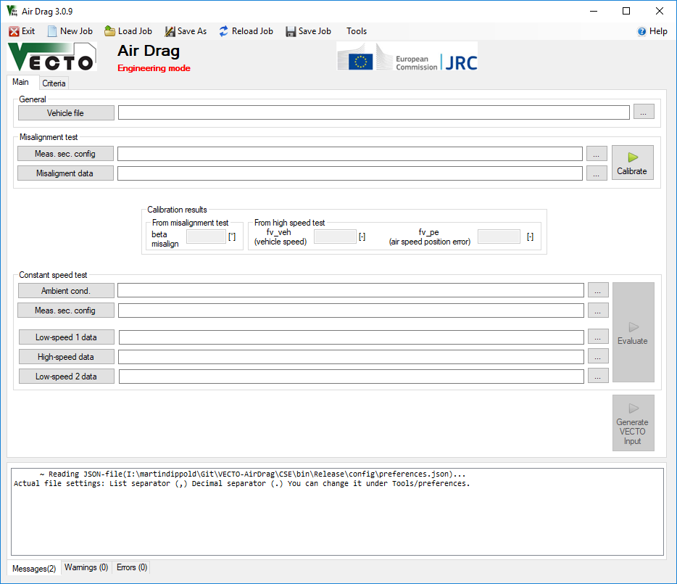
Figure 8: VECTO Air Drag main user interface
Figure 9 shows the VECTO Air Drag “Criteria” tab. There all evaluation parameters (validity criteria, enabling / disabling of correction functions etc.) can be edited. An explanation to each parameter is provided if the curser is moved to the related input field.
A set of parameters can imported and exported via the criteria-file (buttons at the middle right). The default settings for evaluation parameters as defined in the technical annex will be set if the “Declaration” button (Declaration Mode) is pressed.
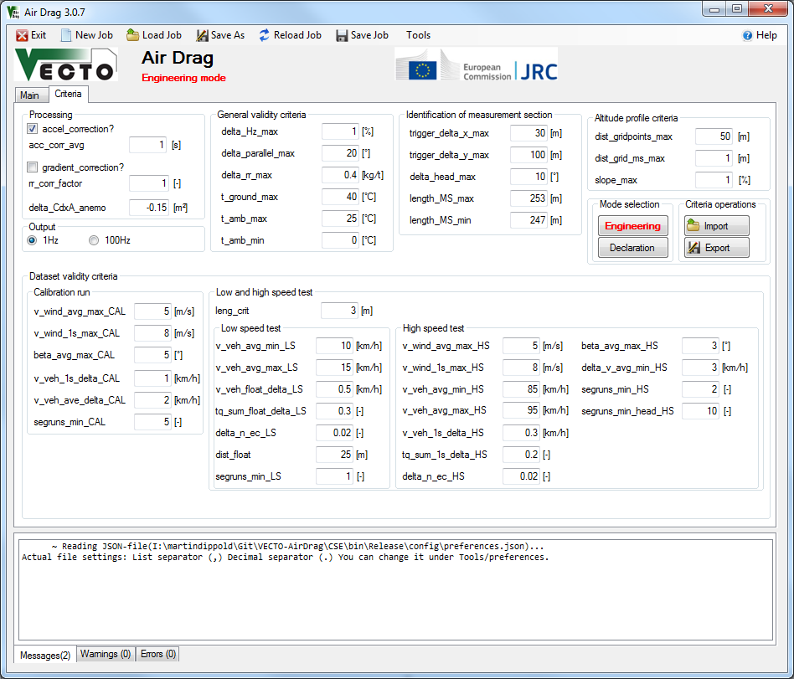
Figure 9: VECTO Air Drag options tab

How to evaluate a constant speed test in VECTO Air Drag
Below the single steps for the evaluation of a test series comprising a calibration test and the low speed – high speed – low speed test sequence are explained.

Step 1
Select the relevant VECTO Air Drag Mode (“Declaration Mode” for evaluations according to the HDV CO2 legislation, “Engineering Mode” for evaluation with user defined settings).

Step 2
Specify all input files using the browse-button (“…”).

Step 3
Check or modify evaluation parameters in the “Criteria”-tab. Modifications only allowed in “Engineering” Mode. In “Declaration” Mode the criteria are set to the default parameters defined in the technical annex and cannot be changed.

Step 4:
Save the job-file via the “save”-button.

Step 5:
Press the “Calibrate” button to start the evaluation of the misalignment test. The progress of the evaluations and potential warnings or errors is shown in the message windows. When the evaluation of the misalignment test is finished successfully, the resulting calibration factors are shown in the GUI. The output files are written into the subfolder “\Results” of the folder where the job-file is located.

Step 6:
Press the “Evaluate” button start the evaluation of the low speed – high speed – low speed test sequence. The progress of the evaluations and potential warnings or errors is shown in the message windows. When the evaluation of the calibration test is finished successfully, the main results are shown in the message window. The output files are also written into the “\Results” subfolder.

Further important remarks
- A full set of evaluation settings (file-paths and options) can be reloaded by opening an existing job-file.
- Before start of evaluations (either of a misalignment test or of a LS-HS-HS sequence) VECTO Air Drag always saves the current settings into the job-file (name and path as specified the last time). If the user does not want to overwrite the existing job-file the job-file has to be saved under a different name using the menu bar “Job\Save as”.
- A misalignment test can also be evaluated without data specified for the LS-HS-LS sequence.
- If a complete measurement section in combination with a driving direction becomes invalid (e.g. because less than 2 valid HS datasets are available) VECTO Air Drag aborts the evaluation. In order to try to gain a valid test result with the remaining data, this particular measurement section (or combination of measurement section with driving direction) has to be manually removed by the user in the *.csms file.

How to export a XML input file for VECTO
The VECTO input file for “AirDrag” component (XML) can be generated by VECTO Air Drag tool if the evaluation was run in the declaration mode and a valid CdxA value has been obtained. To export the XML press the “Generate VECTO Input” Button.
The following information has to be provided by user input:
- Manufacturer name
- Model name (name of air drag family)
- Certification number
- delta CdxA value [m²] applied to the C_{d}∙A_{cr} (0) value as calculated by VECTO Air Drag from “transfer rules” to other vehicle groups according to Table 16 of Appendix 5 in Annex VIII (e.g. -0.2 m² if a result measured at a group 4 vehicle shall be applied to a family in vehicle group 3).
- delta_CdxA value [m²] applied to the C_{d}∙A_{cr} (0) value as calculated by VECTO Air Drag from declaration of worst case parent [m²] according to point 3.11 of the main body of Annex III. This input is checked to be in the range of 0 to 0.2 m².

Direct start
VECTO Air Drag provides a direct start option. With this feature the program can be started without the use of the GUI. In this case the jobfile must be generated by an external script. The direct start command can be addessed from any other program and must have the following syntax.

Air Drag.exe Jobfile [Output folder]
Example: C:\Downloads\2015_07_01_VECTO Air Drag_2.0.2-beta6\Air Drag.exe C:\Downloads\2015_07_01_VECTO Air Drag _2.0.2-beta6\DemoData\EvaluationDemo.csjob.json

The specification of the output folder is optional (Path must ending with “\”). If no output folder is given VECTO Air Drag uses the standard output path (Path from the Jobfile\Results)

Support

CITnet's JIRA platform
You may use CITnet's JIRA issues for:
- Any support question on the software or the procedure
- bugs in VECTO-tools, or
- general ideas for discussion.
To submit a new issue, click the "Create" button at the top-bar:
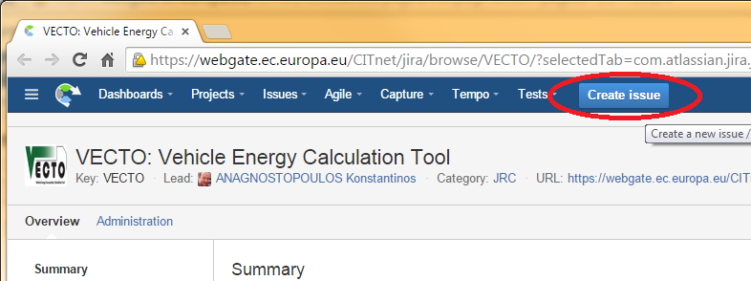
Fields are needed (marked with those required when creating an issue):
- Issue-Id: Created after you save the issue, and it has the form "VECTO-13". It is appended at the beginning of every thread-title,and it is used as a reference throughout external-systems and/or emails.
- Issue-type: Required to select one of the following when creating an issue:
  - BUG (If unsure, select this)
  - Improvement
  - New feature
  - Support - questions about CITnet, user-permissions, administrative
  - Task - non-software related activities (i.e. PilotPhase)
- Summary: A descriptive phrase giving a clear explanation the issue, to be used as Title.
- Description: Detailed description of the issue; rich text formatting maybe used.
- Components: One of: Simulator, Air Drag, Infrastructure, Administrative, ... It is used to select automatically an Assignee.
- JIRA Workflow
The following workflow elements are used to communicate the progress on an issue:
- Status: It may be: DRAFT, OPENED, IN PROGRESS, ..., RESOLVED, INVALID, CLOSED, and others, depending on its Issue-type. Users change it to signify work-progress. For instance, Issues are considered completed when they are Closed.
- Comments: A series of 'Comments', that describe the job performed for accomplishing the bug and ANY user feedback. These correspond to the replies in the mailing-list analogy.
- Files and Screenshots
- The 'People' are different fields specifying users to be notified with emails for all changes and comments on the issue.
- Assignee: The person currently responsible to respond or to make some job for the issue to proceed. After an assignee performs its tasks, he should re-assign the task to whoever should next take charge of the issue. If unsure, assign to the component-owner or to some manager.
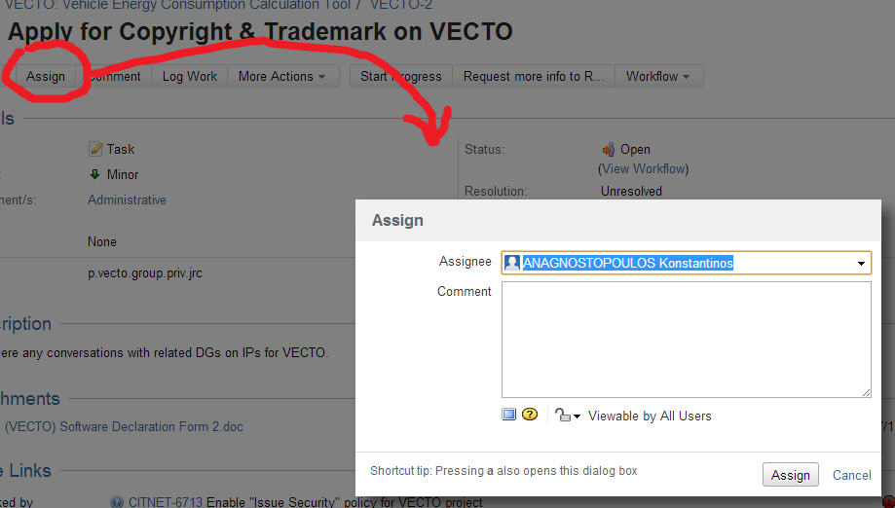
- Reporter: The user that has initially created the issue.
- Watchers: Users who are to receive emails on every change. You can add yourself as a Watcher to any issue.

For more information visit the VECTO wiki:
https://webgate.ec.europa.eu/CITnet/confluence/display/VECTO/JIRA+Overview

Important: You need a user account to create a CITnet issue. If you don’t have CITnet access please contact support according to 7.2.

Direct contact to VECTO support
jrc-vecto@ec.europa.eu
e.g. for registration as VECTO Air Drag user (license) etc.

Developers Guide
This chapter is targeted to be a brief guideline to developers, who are working on the VECTO Air Drag source code.

Main structure of the VECTO Air Drag code
The main routine is Main_calculation_call.calculation() which is launched via a BackgroundWorker from the main GUI form. It returns a status message after the calculation is done:
- Error - The calculation was aborted due to an error
- Abort - The calculation was aborted by the user
- OK - The calculation finished successfully.
The main routine consists of two legs:
- The calibration leg which starts the calculation of the calibration parameters
- The evaluation leg which - after a successful calibration run – determines the CdxA value based on the evaluation of the low speed – high speed – low speed test sequence.
Figure 10 shows the main structure of the VECTO Air Drag code.

Loop LS/HS
Main_calculation_call.Calculation()
Identify the measurement sections
- Signal_identification.fIdentifyMS()
- fvirtMSC()
- DevInSec()
- fCalcroot()
- fSecOverview
Read input files

- input.ReadInputMSC()
- input.ReadDataFile()

Calculate calibration parameters
- Main_calculation_call.fCalcCalib()
- ffv_veh()
- fCalcCorVveh()
- ffvpeBeta()
- fWindBetaAir()
- fMoveAve()
- fWindBetaAirErg()
- fCheckCalib()
Loop
Write modal output file
- Output.fOutDataCalc1Hz()
Read input files
- input.ReadDataFile()

Identify the measurement sections
- Signal_identification.fIdentifyMS()
- DevInSec()
- fCalcroot()
- fSecOverview
Analyse the data inside the MS
- Main_calculation_call.fCalcRun()
- ffv_veh() (only by HS)
- fCalcCorVveh()
- ffvpeBeta() (only by HS)
- fWindBetaAir()
- fMoveAve()
- fWindBetaAirErg()
- fCalcSpeedVal()
- fCalcValidSec()
Write modal output file
- Output.fOutDataCalc1Hz()
Save the results to internal dictionary
- Main_calculation_call.fsaveDic()
Check the validity of the test runs
- Main_calculation_call.fCheckLSHS()
Calculate the linear regression
- Sub_linear_regression.fCalcReg()
- ffillArray()
- linear_regression()
Write overall results
- output.fOutCalcRes()
Calibration leg
Evaluation leg

Figure 10: Main VECTO Air Drag routine
input.ReadInputMSC()
- Reads the measurement section configuration (MSC) file

input.ReadDataFile()
- Reads the data files (Calibration data, Low-speed 1/2 data, High-speed data)

Signal_identification.fIdentifyMS()
- Main routine to identify which data point from the 100Hz data lies inside the given measurement sections

Signal_identification.fvirtMSC()
- Generates virtual reference points for the identification of data inside the measurement sections

Signal_identification.DevInSec()
- Function to label the data recorded inside the measurement sections in the total recorded data.

Signal_identification.fCalcroot()
- For each measured vehicle position inside a measurement section: Calculate a reference coordinate which is located on the connecting line between start and end point of the definition of the measurement section.

Signal_identification.fSecOverview
- Calculates the average values for each detected section

Main_calculation_call.fCalcCalib()
- Main sub for the calculation of the calibration parameter (v_veh, v_air pos error, beta misalign)

Main_calculation_call.fCalcRun()
- Main function for the analysis of the low speed – high speed – low speed test sequence.

Main_calculation_call.ffv_veh()
- Calculates the calibration factor v_veh
Signal_identification.fCalcCorVveh()
- Calculation of the calibrated vehicle velocity with the factor v_veh

Main_calculation_call.ffvpeBeta()
- Calculates the calibration factors for v_air and beta misalign

Main_calculation_call.fWindBetaAir()
- Calculate the calibrated and boundary layer corrected values for wind, beta and v_air

Minor_routines_calculate.fMoveAve()
- Calculate moving averages over a variable time

Signal_identification.fWindBetaAirErg()
- Calculates the averages in the detected sections for wind, beta and v_air

Main_calculation_call.fCheckCalib()
- Check if the detected sections are valid dependant of the given criteria’s.

Signal_identification.fCalcSpeedVal()
- Calculate all needed data for every speed test in 100Hz and afterwards the average inside the detected sections

Main_calculation_call.fCalcValidSec()
- Control the actual speed tests after the given criteria´s.

Main_calculation_call.fCheckLSHS()
- Check if enough valid sections in all speed tests are available.

Sub_linear_regression.fCalcReg()
- Calculates the linear regression.

ffillArray()
- Function to generate the calculation arrays for the linear regression

linear_regression()
- Calculates the linear regression and afterwards the evaluation parameters (CdxA, delta_CdxA, CdxA(0))

Output.fOutDataCalc1Hz()
- Writes the calculated results in 1Hz or 100Hz into a file.

output.fOutCalcRes()
- Writes the average results for the detected sections in a file.

VECTO-Air Drag the length of a measurement section is also calculated internally from the coordinates of start and endpoint. This value is compared with the distance as specified by the user and – if the difference is greater than the parameter “leng_crit” - shown in the message window after read-in of *.csms file. As reference length for calibration of vehicle speed always the value specified directly by the user is used. If the length calculated from the coordinates differs significantly from this value this might result in invalid datasets failing in the validity check where the driven distance inside the measurement section is compared with the length of the MS +/- the parameter “leng_crit
In Air Drag more than a single section can be configured in the calibration run.
A „dataset“ refers to the data recorded within a measurement section.
Before applying this formula 180° are subtracted from the beta angle as read in from the input file (definition of beta in input file: 180° refers to “headwind conditions)
Before applying this formula 180° are subtracted from the beta angle as read in from the input file (definition of beta in input file: 180° refers to “headwind conditions)
The gust wind criteria is evaluated based on the 1Hz average of the calculated wind speed in 100Hz
In further investigations it shall be clarified which of the two calibration methods for vehicle speed based on DGPS data gives more reliable results, see also Error! Reference source not found..
After adoption of the technical annex by the TCMV on the 11th of May it was decided by DG GROW to replace the “TechnicalReportID” as component identifier by the “CertificationNumber“. Furthermore it was decided that both VECTO and the pre-processing tools shall be adapted to this decision immediately. The next update of the technical annex will cover this adaption.

