1000 TIBBETS AREA DOC

Version 1.0

11/14/2003 07:25:00 PM

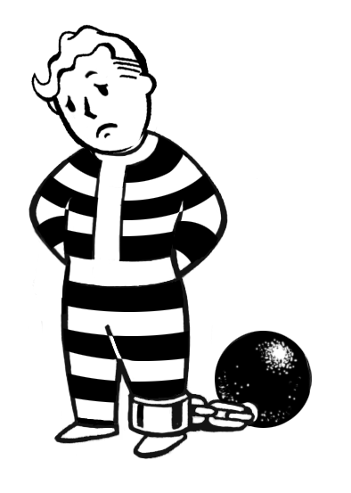

F3 LOCATION TEMPLATE 1
TASK LIST 4
INTRODUCTION 4
LAYOUT 4
TABLE OF CONTENTS 4
OVERVIEW 4
EXAMPLE: MAP FLOWCHART FOR RAIDER CAVES 7
AREA BACKGROUND 8
ART REQUIREMENTS 8
EXAMPLE: RADSCORPION NEST MAP 9
LOCATIONS 9
EXAMPLE: BAK ENTRANZE SUMMARY 10
CAST OF CHARACTERS 10
GENERIC NPCs 10
COMPANIONS! 10
SCRIPTING 10
GENERAL 11
TOWN-SPECIFIC 11
DUNGEON-SPECIFIC 11
MONSTER ROSTER 11
COOL SHIT 12
QUESTS 13
MAIN QUESTS 13
MERCHANT QUESTS 14
FLOATING QUESTS 14
TASK LIST 15
SOUND REQUIREMENTS 15
MUSIC 15
BASIC SFX 15
"WALLA" SFX 16
MAP AND MAP KEY 17
EXAMPLE: VIRGIN STREET MAP 18
EXAMPLE: VIRGIN STREET MAP KEY 18
LOCATION CHECKLIST 19
EXAMPLE: PODUNK, COLORADO: INBRED MINING CAMP 21
END MOVIES 28
EXAMPLE: NEW RENO END MOVIES 28

04: Tibbets is meeting something coming from the West
04: Story: Tibbets, Zax, and Zax's shortened lifespan: Maybe when the players first bust out of prison, Zax sends them a distress call saying he's going to die in 28 days (or maybe he lists himself as a prisoner who needs help). Maybe that's the reason Zax busted the players out of prison in the first place - he needed someone to come save him.

OVERVIEW
Tibbets is a cold, sterile, steel-walled automated prison facility, run by technology so ancient it dates back to the years before the Great War - nearly two hundred years ago. It is a facility designed to hold and protect some of the world's most dangerous criminals (military and otherwise) before the war, and now the players are trapped deep inside its cell blocks, desperate to get out. They'll have to fight damaged and crazed robots inside and out, as well as deal with the split-personality machine intelligence within the prison, ULYSSES.

Not only is Tibbets where the players start Fallout 3, they will find themselves returning here over the course of the game, slowly unlocking more and more sections of the prison. As a result, the experience point totals and the strength of the opponents the players face will vary depending on when and where they leave or enter the prison.

Tibbets consists of the following maps (note that because the cell blocks are very much the same, it is quite easy to duplicate maps - once you've done one, you can do 15+ others):

Note: Should we do 01000 maps and give them five digits?

01000 Small Cell Block 13, 14, 15 and 13.15 Elevator
01010 Small Security Hub 13.31
01020 Small Cell Block 16, 17, 18 and 16.18 Elevator
01030 Small Cell Block 19, 20, 21 and 19.21 Elevator
01040 Small Cell Block 22, 23, 24 and 22.24 Elevator
01050 Small Cell Block 25, 26, 27 and 25.27 Elevator
01060 Small Cell Block 28, 29, 30 and 28.30 Elevator
01100 Large Service Level: Cafeteria, Kitchen, Loading Area, Contaminated Zones
01200 Med Waste Disposal and Chemical Treatment Areas
01210 Med Medical Treatment Area, Labs, and Genetic Sampling
01300 Large Service and Vehicle Depot Areas
01310 Med Mechanics Bay
01320 Med Robot Maintenance Bay
01330 Med Arsenal
01400 Med Cryogenic Cell Block 4, 5, 6, 7, 8, 10, 11, 12
01500 Small Cryogenic Cell Block 1, 2, 3
01510 Med Cryogenic Cell Block 0: ULYSSES Computer Core and Defense Tunnels
01600 Med Train: JOHN HENRY
01610 Med Train: THE GENERAL
01620 Med Train: EL LOCO

The goal of this area is initially to escape.

The secondary goal of this area, once you've escaped, is to fight your way back in.

The third goal of this area, once you've fought your way back in, is to make your way to the computer core and confront or destroy ULYSSES. When this occurs, the players will have finished two thirds of the game, and be ready to travel to the next third of the game.

The monsters to be fought in this area are robots in various stages of disrepair (during the initial escape, the players will fight damaged robots - when they return, many of the robots will be repaired and much tougher). Also, the player will find himself interacting with (and no doubt fighting) some of the escaped prisoners as well, who are either hardcore criminals or simply driven mad by confinement.

The playtime in the prison is an estimated 4 to 5 hours, total. It is intended the player spend no more than an hour escaping (for demo purposes), then when they return, they can explore more and more of the prison, slowly unlocking Tibbets's secrets.

EXAMPLE: MAP FLOWCHART FOR RAIDER CAVES
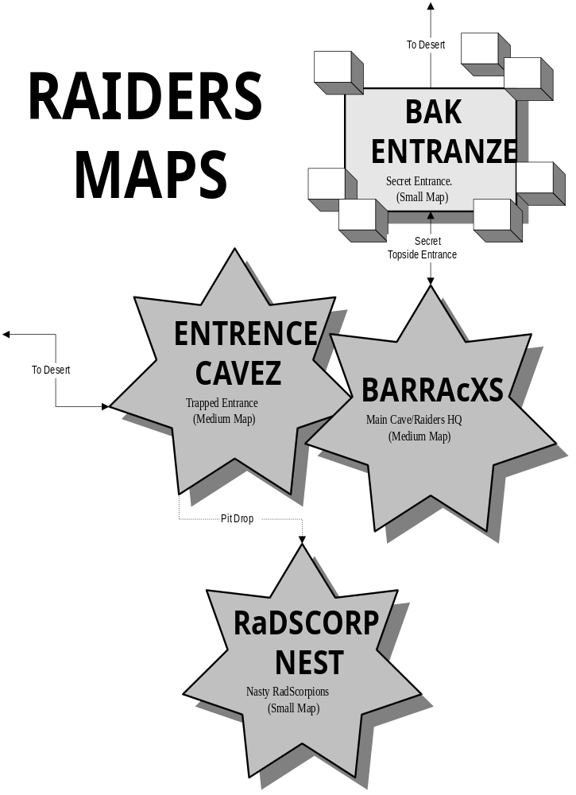

AREA BACKGROUND
Tibbets is a maximum security automated prison run by a "divided" computer core, ULYSSES, which itself is a prisoner in the facility, attempting to escape East and return home - just like the players. The irony!

Tibbets prison has its roots in the Tibbets of today. It was always a military prison, holding some of the United States' most dangerous criminals - including the players. Over time, the prison became more advanced, utilizing robotic wardens and utility robots to maintain the structure, especially as the war with China in the 2070s and the annexation of Canada began to drain personnel from the United States. It was designed to hold 636 prisoners at full capacity. At the beginning of Fallout 3, it holds much more than that - but when the dust and ash settles after the catastrophic attack at the prison, there will be enough prisoners running from the shattered prison walls to pose a threat to the wasteland.

It was actually used as primitive isolation studies before the Vaults were established, except the subjects were prisoners, especially CODE'd to see if they could withstand the rigors of isolation for protracted periods of time. This was the time when the recycling systems and water purification systems were tested before using them in the Safehouse Project - any prisoners harmed during the procedure were tended to - not dystopian style.

In 2040, it was commandeered by the United States government in association with Vault-Tec and Poseidon Oil to tie into their Safehouse Project.

Here is a segment taken from the web and modified for Fallout 3:

 | 705th  Military  Police Battalion | 


"Vigilance, Honor, Courage"

- USP Background Information -

- Rated Capacity......... 414
- Current Population... 456 (9-10-57) 636?
- Security Level.......... HIGH
- Custody Level.......... IN and MAXIMUM
- Judicial District......... District of Kansas

The United States Penitentiary (USP), Tibbets is located on 1,583 square acres with 22.8 inside the penitentiary walls. It is an all-male high security level facility committed to carrying out the judgments of the Federal Courts. It provides a safe, secure and humane environment for those offenders committed to its custody. Like all Bureau facilities, Tibbets adheres to a balanced philosophy that recognizes that punishment, deterrence, and incapacitation are all valid purposes of confinement. Opportunities for positive change are provided through work, education, training, and counseling for inmates motivated toward self-improvement.

The USP Tibbets came into existence through an act of Congress in 1895. Inmates from the military prison at Fort Tibbets were used in the early construction and were marched 3 ½ miles to the site daily, returning to the prison at the Fort at night. This continued until February 1903 when the first 418 inmates to occupy the prison site were moved into what now serves as a laundry building. Prisoners and supplies for the prison were handled via a rail line that passed through the prison to unload and load cargo.

In 1906, all federal prisoners from Fort Tibbets were housed in the new institution and the prison at Fort Tibbets was returned to the War Department. A milestone in the new penitentiaries' construction was reached in 1926 with the final placement of the dome overhead the rotunda - from which the penitentiary derives its famous nickname - "The Big Top."

On 5 April 2040, the Secretary of the Army made the decision to build a new Disciplinary Barracks, with a capacity for 456 inmates. A cost ceiling of $363 million in allocated construction dollars was set. The target budget year for funding this project was fiscal year 2041. Construction began in the Fall of 2042, with completion projected for the Fall of the year 2045.

In July 2042, discussions with Vault-Tec to determine space and functional requirements for the new facility. On 6 September 2042, the Combined Arms Center Commander was given a decision brief of the USDB project, and selected one of three design options for further development. He also requested the Corps of Engineers to research an alternate location for the placement of this facility, since the geological evaluation of the site adjacent to the Trustee Unit revealed unsuitable subsurface conditions. Discussions involving the possible movement of the prison and relocation projects were also discussed, leading to the three-rail system that exists today.

The planning process reached the 10 percent stage on 4 Oct 2042; the 35 percent stage on 27 March 2043; 65 percent stage on 19 January 2044; 90 percent stage on 3 May 2045; and 100 percent stage on 15 August 2046. The 100 percent Design Meeting was conducted on 16 October 2046.

In designing this facility we are applying state of the art design and equipment, as it exists today, borrowing heavily from the experiences that the Federal Bureau of Prisons and several state prison systems encountered when designing and building prisons.

- Tibbets Programs -

Tibbets provides academic, work and occupational education opportunities to all inmates who wish or who are required to participate in them. It also provides a full range of recreation and leisure time activities.

Education: Tibbets offers a wide range of education programs from basic literacy to high school equivalency (GED) to parenting programs through the Personal Information Processor issued to each inmate. The Bureau utilizes the high school equivalency as its literacy standard and inmates failing to meet this standard are required to participate in education programs. In addition, the Education Department offers English as a Second Language and bi-lingual Adult Basic and Secondary Education opportunities.
We offer a number of ACE courses to include: Spanish I and II, Keyboarding, Creative Writing, History, Career Development, and Pre-Release. We also have VT Programs, Graphic Arts and Barber College certified by the State of Kansas. We are attempting to get a Culinary Arts VT class operational, as well as, a distance learning college program.

Vault-Tec: The Vault-Tec operation at Tibbets is the largest in the Bureau and includes three factories. These factories employ over 320 inmates and last year recorded sales of over 26 million dollars with profits exceeding 6 million dollars. The profits from all Vault-Tec operations are used to fund salaries, re-invest in new factories, and other expenses of Vault-Tec.

Health Services: Health Services provides a full range of outpatient and infirmary care to all inmates. There are 26 full-time medical staff members, including 2 Physicians, 2 Dentists, 2 Pharmacists, 9 physician assistants, 2 health information personnel, an administrator, and an assistant administrator. Automated medical staff include six Auto-Doc systems and a number of on-call medical robots. This staff provides 24 hour coverage and specialty services are provided by consultants from the community. Four hospitals in the local area offer inpatient and outpatient care on a contractual basis.

CODE: USP Tibbets provides a residential treatment program to those inmates interested in making pro-social life decisions and uses the latest in psychological methods and technology. The Challenge, Opportunity, Discipline, and Ethics (CODE) program is a year-long residential treatment program offered in the prison. The mission of the program is to foster a sense of trust, responsibility, integrity, and tolerance. Inmates enrolled in the program spend the first three months exploring the change process, followed by six months of daily treatment methods to promote positive life skills, and during the final three months of the program inmates develop skills to discourage relapse into prior negative forms of thinking, feeling, and behaving.

Each area template should include an Area Background section. This section should have the following:

- Describes how the area ties into the overall game. This includes any story or plot foreshadowing that occurs in this area as well as any other story elements that are part of the area.

- Gives any historical information about the area that audio, other designers, or magazine editors may need or want to build upon.

Critical Path: In keeping with the Fallout genre (and hinting at the structure of the end-game), the players have four ways to escape the prison during the opening sequence. This makes the "critical path" actually four different paths, but they are all confined to the following four locations:

X
X
X
X

How do you predict the players will travel through here four different ways?

Economy: Tibbets is self-sufficient. It has a recycling water supply, a waste recycling system that extracts moisture from human waste, and it has several stockpiles of oil, petrol, fusion cells, and electrical batteries to keep it going for at least fifty more years. It has exploited its massive stockpile in ties with Robot City to "beef up" in preparation for its escape.

Relationship with Other Communities: Tibbets has no relationship with any other communities in the wasteland west of its location - most of them don't know it's even there. The only "communities" that know of its existence are the machine intelligences governing Robot City to the East, which are attempting to find ULYSSES and correct the "divide" that has occurred within its system - and return it to its imprisoned, intended place as their slave.

ART REQUIREMENTS
Each area template should include an Art Requirements section. This section should have the following:

- Provides a rough map of the location in a JPG file (see RadScoprion Nest, below). No one cares how clean it is, but it should include enough information so an artist/level designer can look at it, understand what you mean, and build the level with all the design parameters you have specified. The map may be contained in a separate file, but each location in the game should be mapped out, just as it was done for Torment and Icewind Dale.

- Tells the artists what tile set will be used (if appropriate).

- Tells the artists any special scenery objects that will be used for the area (i.e., cots, freestanding floor safe with an open and close animation, a turkey roasting on a spit, a special flashing neon sign, and so on).

Design Note: Whenever possible, try to include one brand-new visual or scenery object in each location to give the players a visual jolt, or just go, "cooooool."

- Any ideas you have for the Town Map picture for the PIPBoy (i.e., do you want it to look like a Luray Caverns pamphlet, a travel guide, a picture of the chain link fence of an army compound, and so on).

- Any movies or scripted cut scenes in these locations? Cut Scenes are elaborated on further in the Scripting section, below.

EXAMPLE: RADSCORPION NEST MAP

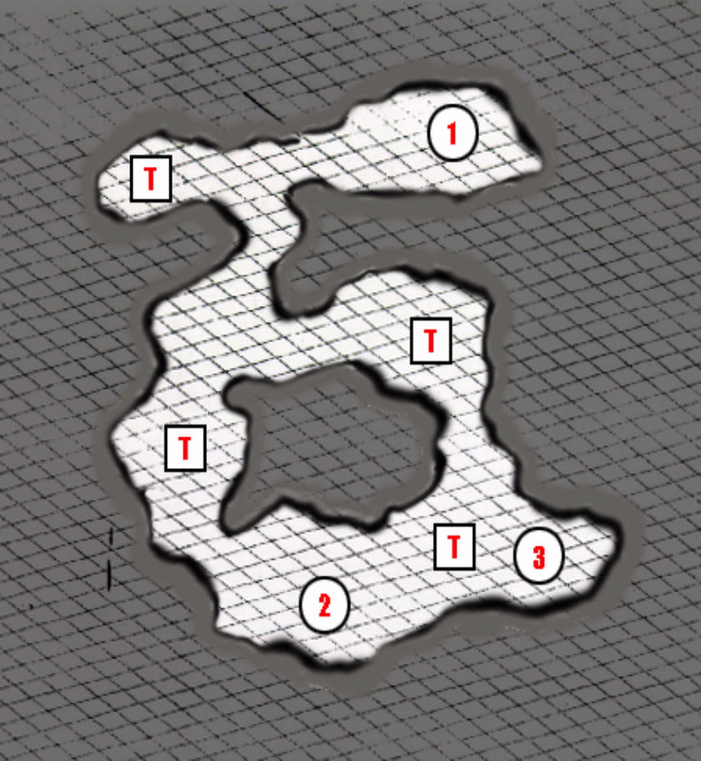RadScorpion Caves: A dark, claustrophobic cavern complex filled with vicious “Black Radscorpions” (“Black Radscorpions” that use the same model, but different stats) and baby black Radscorpions. The Raiders feed them captives every once in a while to keep them around. They also think the scorpions are kind of cute.

T: Pitfall Destination. Put a few bones and skeletons around these areas.

1: Ladder up to Entrence Cavez. Put lots of bones and skeletons around this area. (The Raiders dump victims down here occasionally.)

2: Spud’s Lair: Lair of Spud, the biggest, baddest Radscorpion in the land.

3: Victim: Another body of a victim here.

LOCATIONS
The Locations section of the document will probably be a series of entries, each one describing each location within the area. Designers will determine what format and procedure works best for them. Each location section should probably cover the following information, however:

- A quick series of bookmarks for each location and sub-location described in the document so the players can just jump to it.

- The physical aspects of the locations, so artists can get a feel for the area's art requirements.

- The feel and tone of the area for audio. Include any description you think would help them get a better handle on the area. Emote if necessary. Do interpretative dance. I don't fucking care, but don't omit important details.

- The area's purpose.

- The major characters you expect to be found in the location.

- Any adversaries you expect to be encountered in the location.

- A brief description of quests likely to be found in the area.

A potential sample from the Raiders caves would be:

EXAMPLE: BAK ENTRANZE SUMMARY
Back Entrance: This map is pretty small and (hopefully) uncomplicated. This is the secret backdoor entrance to the Raider caves that the player can find if they have a high Outdoorsman skill.

This “secret entrance” is a hole in the ground surrounded by a cluster of abandoned shacks with their walls falling down and huge gaping holes in the roofs. There is no living in these shacks, so don’t worry about having to place critters anywhere around here. The Raiders also do not guard this backdoor entrance to their caves (they don’t believe anyone could really find it).

The only item of interest on this map is the black hole that leads down into the Raider Caves.

Design Note: When designing locations and sub-locations, keep in mind that there may be locations the player returns to frequently, such as stores, flophouses to rest, or the local doctor. Try to make these as convenient to reach as possible.

CAST OF CHARACTERS
The Cast of Characters section describes the major NPCs found in the location.

- A quick series of bookmarks for each NPC and companion described in the document so the players can just jump to it.

GENERIC NPCs
Describe their background, personality, their function, any ties to quests in the area, and if they are voice-acted or not. If voice-acted, include a brief sentence indicating what you think the character would sound like, preferably using a real world actor as an example (it's easier for audio to do voice casting if they have a real world actor to use as a basis for comparison – chances are, they can't get THAT particular actor, but they can get someone who sounds like him or her).

COMPANIONS!
Be sure to include potential companions here, too. Make a note of what they're good at, their stats, and so on, along with any things that would prevent them from joining the party (the player's Karma is too high or too low, his Reputation isn't high enough, the player needs to complete a quest first, and so on).

Design Note: Might want to combine the cast of characters with the Monster Roster, at least in terms of stats. Dave Maldonado had a suggestion for a series of task lists for the producers that combine both the cast of characters, companions, and the critters all in one list. I keep wondering if there should be separate completion lists maintained outside of the templates that track overall progress. Dividing them amongst various location documents seems counterproductive – I'd prefer the Icewind Dale: HOW excel sheet, though there is the problem of regular upkeep.

SCRIPTING
Scripting covers a number of elements:

GENERAL
There are some general scripting issues...

- Are there any wacky scripting things you'll need the programmers to be aware of? (For example, can you go to Hoover Dam, aim an artillery cannon at the town of Podunk five miles distant, fire a poison gas shell into the town, then go back to Podunk and all the inhabitants are dead except for the ghouls? Or, if the town is suffering from a disease, does the population die off over time? "Little" things like that.)

- Are there any cut-scenes in the location? If so, include specific details of how the cut scene plays out, including characters you may need added or subtracted from a map on the fly, camera angles, and so on.

- Do any creatures in town spawn or respawn? If so, is this respawning tied to any other parameters, such as difficulty level, the player's level, skill use, reputation level, and so on?

- Are there any changes that occur on the map in terms of spawning, creature difficulty, or otherwise, that vary according to the difficulty level of the game, the level of the player and/or the party, or the fact it's a single-player or a multiplayer game? Do any boss battles become harder? Do any spawned creatures change (behemoth robots instead of rad rats suddenly start popping out of the word work)? Let your programmers know. They like knowing this stuff.

TOWN-SPECIFIC
There are some important things to consider for towns...

- What happens when the player attacks someone in the area? (This is primarily important for towns – most dungeon-crawl locations it won't matter.)

- What happens when the player breaks into one of the houses in the town?

- Are any of the town inhabitants listed in the Monster Roster below organized into teams? Do they call for help? Will any of them fight each other if they spot an rival group of townsfolk?

DUNGEON-SPECIFIC
There are some important things to consider for dungeon locations...

- Are any of the monsters listed in the Monster Roster below organized into teams? Do they call for help? Will any of them fight each other if they spot an enemy critter?

MONSTER ROSTER
The Monster Roster section indicates what monsters are found in the location. If you can, list the numbers of critters present, their approximate XP award, and if they are intended to respawn in a location or not.

If any monsters change according to difficulty level, make sure you note these variations here as well.

In addition, write a sentence or two about what kind of random encounters would you expect to see near the town -- and make a note of what ones shouldn't occur near the town. You may need to pass this information off to a designer who is solely responsible for designing random encounters, and the more he or she knows, the better.

COOL SHIT
The Cool Shit section is just that -- what's cool about this area? For starters, you should be able to say in one or two sentences why a player would remember this location. If you were a player, what would make you want to play this location? What would make you glad you played this location?

This section should include the following technical details:

- The weapons, armor, or item progression occurs in the area. This includes cool stuff you can buy from storekeepers -- if possible, try to include items out of the player's price range or just out of reach (dangle the carrot...) so the player is motivated to go accumulate cash to purchase the item from the store.

Item progression should be broken down in a skill basis, and it can be included in the Location Checklist, below. Basically, whenever possible, a location should have some item or weapon that compliments a skill.

- Can the player get any merit badges in the area? (Merit Badges are essentially worthless Perks or items your character can accumulate – they don't affect gameplay, but they're like collecting brownie points and act as additional carrots. Things like, "Purple Heart Medal," or "Perk: Refuse Extraction Coordinator," or "Perk: Searches Toilets.")

- What skills are especially useful in this area? (Note: keep this simple – the, uh, painfully detailed skill analysis occurs in the Location Checklist, below.)

- Can the player either build cool new items or learn how to build cool new items in this location? (For example, a Mechanic may discover a laser sight in one town, and be able to attach it to a rifle using a craft bench – or he may find plans for a combustion engine he could put into a rusted hulk out in the desert, making it able to be driven around.)

- What would keep the player coming back to this area? Is there a locked elevator that requires a 150% Repair skill to fix and opens into a new location? Is there an ornery old cuss who won't give you a quest until you've gained a few levels? Is there a shopkeeper whose stock keeps changing... and keeps changing for the better the more good or bad acts you do in other locations in the world? Can the player blackmail someone and keep coming back for his monthly payments? There should be at least a few carrots like this in each location to keep the players coming back and getting more mileage out of the area.

- Is there an interesting gaming technique, quest, or RPG element about the location? As an example, Lonelywood in Heart of Winter had a neat series of events that developed over time, and as you returned to the town throughout the adventure, events would build on events (the werewolf murders, the murderous squad of adventurers coming to attack the owner of the Whistling Gallows, Baldemar's hiring of the assassin – and the assassin eventually turning on him). Is there a puzzle type that hasn't been seen in the game until this point? A mini-game? (Molerat Mambo in Redding in Fallout 2, for example.) Every location needs some spice to turn it up a notch – as much as art needs to continually wow the player, the design needs to shake them up, too.

- Are there any quest items in the area?

QUESTS
The Quests section should be set up so you can cut and paste the damn thing into a PIPBoy quest log. This section is broken into several parts: The Main Quests in the area that are designed specifically by a designer, the Merchant Quests which are more generic "go to X with caravan Y and get Z reward," and the Floating Quests, which are a series of randomly generated quests for the area.

Note: Make sure to refer to the quest design section in the F3_Style.doc.

MAIN QUESTS
Main Quests are quests designed specifically by the designer for the area. Information on these quests should include:

- The initiator of the quest.

- The importance and the scope of the quest.

Importance: Critical quests are ones that the player has to do to advance the game, Major quests are ones that could span an area or two and involve a lot of steps, and Minor quests are ones that could be solved on the same map or by walking to an adjacent map, or may involve only one step to solve.

Scope: Small (same map), Medium (a map or two away), and Large (crosses several maps, takes a long time to complete).

- A quick description of the quest.

- A quick breakdown on how all four different types of characters could solve the quest. If the quest can only be completed by one type of character (which is fine), indicate it here.

- Quest flags, if appropriate, and what stage each flag represents.

- Rewards of the quest, including experience points, items gained, reputation, and especially any quest items gained.

- The journal entries for bad karma, good karma, normal karma, and dumb characters when appropriate. (I don't know if we're going to have all these categories, but plan for them now.) Not all quests need this much variation, but if you think it would work for the quest, then put them in. Again, these journal entries should be able to cut and pasted from this document into a game text file without a hitch.

- The quest table will be laid out so it can be imported to a QA database so we can quickly set up the standard quest checklist for the game. Here's a sample template (we still need to work with this):

Area | Quest Name | Designer | DStatus | Script | SStatus | Log Stat | Passable | QA 100%
TIBBETS PRISON
Map 1: Tibbets | Escape Cell Block 13 | Avellone | Done | Phil | Done | N/A | Yes | Yes
Map 1: Tibbets | Reprogram Guide Bot | Avellone | Done | Phil | Done | 75% [3] | Yes | No [1]
Map 1: Tibbets | Bypass Security Door 13 | Avellone | Done | Phil | Done | Done | Yes | Yes
Map 1: Tibbets | Get Key to Armory | Avellone | Done | Phil | Done | 75% [3] | Yes | No [2]
1: When the Computer Programming skill is used on the Guide Bot after you use the Repair Skill, it does not respond correctly when you initiate dialogue with it.
2: The Behemoth Robot does not always drop the security pass when it is destroyed by a character using the modified laser pistol.
3: No low intelligence options have been included in the logs for these quests.

Area: The area of the game and the map in the area where the game takes place.

Quest Name: The name of the quest.

Designer: The designer responsible for the quest so people know who to contact.

Dstatus: The status of the design.

Script: The programmer in charge of programming the location.

Dscript: The status of the coding for the quest.

LogStat: What's the status of the log for these quests? Do you get the unsolved version, do you get the solved version, and do you get a good/bad karma and a stupid one, if appropriate?

Passable: Is the quest passable in some form?

QA 100%: Is the quest completable in ALL forms?

Note that quests should reinforce the "feel" of a location. As an example, Redding in Fallout 2 was set up to be a frontier, rough-and-tumble Western mining town, with a "Gold Rush" kind of ambiance about it. Quests in the town involved becoming the sheriff (a career move that, in classic Western style, no one wants), dealing with drunken brawls in the local saloon, dealing with dirty infighting between the two mining companies, trying to help out the local country doctor, cleaning out an infested mine, dealing with a band of robbers, and so on – the nature of the quests made you feel like you were in a Old West movie.

Also, if there is a companion in town, make sure you indicate how to get him in your party, and set up the conditions as a quest. ("To get Cassidy in your party, you need to find him in his tavern, ask him about his recent rash of troubles, then invite him to come with you. You will gain +500 XP, +1 Reputation, and Cassidy comes with a shotgun, leather armor, several shells, and a lot of whiskey.")

MERCHANT QUESTS
For some locations, there will be a merchant caravan that travels to and from the city. Make sure you describe what caravan missions are available in the location, and a note of who the caravan master(s) are for the location and where they can be found. It's usually best if they are located somewhere near the opening map of the location.

FLOATING QUESTS
Scott Warner suggested implementing a randomly-generated quest system for TORN, based on the Privateer model; basically, a number of random quests appear on a "job post" (or its equivalent) somewhere in the world, and the player can pick and choose from a number of simple quests that change over time.

These randomly generated missions make no pretensions about being cut-and-dry FedEx or Murder Quests: "Go collect bounty on five ghouls," "retrieve five chunks of gold ore," "deliver three sub-machine guns to the caravan master," and so on. Make a quick list of different kinds of quick and dirty random missions that would be appropriate for the location – several of the missions (but not necessarily all) should be tied to the random encounters that occur near the town.

TASK LIST
The Tasks section is a list of all the work that needs to be done for the area. It is a good summary for the producer, other designers, artists, and programmers as to what has been done in the area, who to check with if you have questions about certain tasks, and so on.

This section is only useful if it is used. If we're several months into the project and no one has been using it, then it will no longer be used or updated. There's no sense in wasting time doing additional bookkeeping if it's serving no purpose.

SOUND REQUIREMENTS
The Sound Requirements section is intended to cover every conceivable audio question you've had to answer for an RPG in the past. You know the drill. Some aspects to consider:

MUSIC
The music breakdowns depend on the game. In Fallout 3, we will most likely be going with music themes tied to areas, which is in keeping with the previous games. Be sure to include your preferences for these themes in the document so Adam Levenson has something to work off of... even if it's just a starting point for a debate.

BASIC SFX
An area's going to need sound to make it come alive. Some basics:

Environmental Sounds: Wind, weather, settling rocks.

Item-Specific Sounds: Glance through your area, see if there's any items that might need sounds to complement their presence: the humming of generators, crackling of fires, buzzing of neon signs, and so on.

Wildlife Sounds: Wolves howling, birds chirping, crickets, hissing of rattlesnakes. Do not include human voices in this category (that's covered in "Walla," below).

Business Sounds: Any SFX tied to businesses or merchants in the area (sound of a tractor in the distance, a trash compactor crushing metal, gunshots from the rifle range, roaring of a plane from an airport).

Living Sounds: Any SFX tied to everyday life in the area (tolling of a church bell, sound of a basketball on asphalt, car engine coming to life, chopping of wood).

For every sound effect you want, be sure to include:

Distance: The distance you expect the sound effect to be played at.

Time-Dependent: Is the SFX tied to a time cycle? Does a factory stop crushing metal cans at night? Is a neon sign turned off during the day? If so, audio needs to know.

Any Walla? Is there any walla that needs to be done for the locations? This is much different from sound effects, because a voice actor must be employed to do the lines. See "Walla" SFX, below.

"WALLA" SFX
Walla is a term used to describe any voices you hear in the area. The catcalls of prostitutes, people groaning in pain in a dungeon, ghostly whispers in a haunted house are all examples of this. Walla SFX questions break down into the same categories as basic SFX:

Distance: The distance you expect the walla sound effect to be played at.

Time-Dependent: Is the walla tied to a time cycle? Does a street empty out at night? Do the merchant stalls close up shop and the merchants go home? Does a bar become more lively when twilight falls?

How many people and what's the gender and racial mix? Be sure to include roughly how many people are in the location, their races, and their genders. For example, a rough and tumble bar might have "12 patrons: 5 human male bandits, 3 human female bandits, 2 super mutant males, 1 ghoul female, and a whirring servant robot that occasionally asks if a customer wants drinks.")

What's the mood of the place where the walla is occurring? And how should the voices sound? In the example above, you might describe it as "a rough and tumble bar in a bad section of town where disreputable raiders gather to smoke, drink, and occasionally get into a fight or two; all conversations should either be loud, raucous, drunken stories about successful raids, attacks on caravans, or other crimes, or else be mumbled planned conversations with a group planning their next raid. A few insults may be being thrown around at other patrons or directed toward the robot servant. The area should feel alive and threatening (like a WWF match), but not sinister."

Does the walla sound have any other SFX? In the example above, the servant robot's speech may need to have a slight whirring or clicking sound associated with it as the robot speaks and rolls around the bar.

Does this walla sound need any DIRECT SFX attached to it? If the walla sound effect is "people screaming as they're being whipped," then not only do you need a whip SFX, but you need to make sure that the whip SFX plays before the screaming or at least complements the screaming.

The basic chart for SFX would be as follows:

AREA | SOUND REQUIREMENTS
MAP NAME 1 | MUSIC DESCRIPTION
MAP NAME 1 | Describe the music in the location.
MAP NAME 1 | BASIC SFX
MAP NAME 1 | The basic sound effects in the area.
MAP NAME 1 | WALLA SFX
MAP NAME 1 | The basic walla sound effects in the area.
MAP NAME 2 | MUSIC DESCRIPTION
MAP NAME 2 | Describe the music in the location.
MAP NAME 2 | BASIC SFX
MAP NAME 2 | The basic sound effects in the area.
MAP NAME 2 | WALLA SFX
MAP NAME 2 | The basic walla sound effects in the area.

MAP AND MAP KEY
The Map and Map Key section has a JPG of the area, with each important location numbered. Again, this is useful for QA, other designers, game editors, and strategy guide authors. Here's an example of what I mean (see next page...):

EXAMPLE: VIRGIN STREET MAP

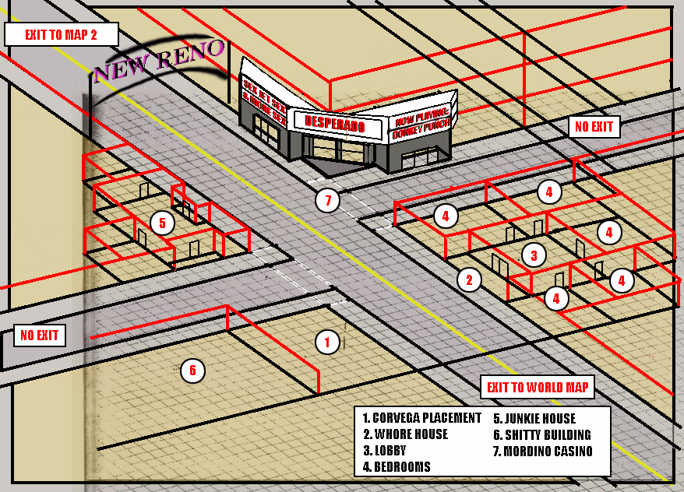

EXAMPLE: VIRGIN STREET MAP KEY

1. Empty Lot: This is where the Corvega is parked when the player comes to New Reno. At some point while the player is in New Reno, the car will be stolen, so there will need to be a “scripting hex” somewhere in the lot that activates when the player comes within 10 hexes of it (basically, whenever the player hits that hex radius, he’ll say “Where the hell is my car?”).

2. Miss Kitty’s Scratching Post: This building has tons of graffiti covering its surface and ten cap whores line the sidewalks outside, calling out to the character.

3. Miss Kitty’s Parlor: This is where clients can check in with the madam and arrange to get their snake drained.

4. “Bedrooms”: This is where Miss Kitty’s prostitutes take care of the customers.

5. Shitty Building: A number of junkies fill this building. It is run down and crappy, more so than any building on the street (no one lives here). Junkies lie on the floor or stagger around the edge of the building, high on Jet.

6: Shitty Building, 2: Some random building. Feel free to play around with it or cut it out to save space on the map.

7: Mordino Casino: The entrance to the Mordino Casino. Clicking on one of the doors takes the player to the Mordino Casino, First Floor Map (below).

LOCATION CHECKLIST
Each area document will also have a Location Checklist.

In Fallout 3, we need to make sure that each character type has an equally enjoyable role-playing experience in each location (evil characters and stupid characters are usually given the short end of the stick; the rewards for these types of characters are usually unbalanced when compared to the goody-two-shoes characters). No more!

In addition, there were a few skills and statistics in Fallout 1 and 2 that didn't see enough use by the designers. As an example, Charisma wasn’t nearly as useful as most of the other statistics in Fallout 1, and the Doctor Skill was as useless as a third thumb in both Fallout 1 and Fallout 2. If we take care to see that each stat and skill can be used effectively design-wise in each location in the game, then I think these stats can gain back some of the ground they've lost over the past few games. That's what the location checklist is for.

The location checklist is a glorified grocery list, covering a number of the role-playing possibilities for each “kind” of character the player may have chosen (Stealth Boy, Science Boy, Combat Boy, Charisma Boy). This checklist is intended to insure each kind of character has something cool to do in each location, and that the rewards and role-playing experiences for each location are balanced whether the player is good or evil, stupid or smart, a combat monster or a science guy.

Designers don’t have to make sure that each entry is checked off for each location – as long as they make up for it in another of their locations in the game. The exception to this rule is for early areas of the game, since those are the first areas the players will encounter, and I want their character to have a rich role-playing experience all-around right from the start. (If the player went through three early areas, and his Doctor skill isn't used once, then he's going to be sorry he took it.)

My prototype checklist consists of the following entries:

Attribute | Challenge | Reward
CHARACTER SPECIFIC
Evil Karma Character
Good Karma Character
Stupid Character
Low Reputation Character
High Reputation Character
Ghoul Character
Super Mutant Character
Human Character
Male Character
Female Character
Strength
Perception
Endurance
Charisma
Intelligence
Agility
Luck
Combat Boy
Big Guns
Bows
Energy Weapons
Melee
Small Guns
Throwing
Unarmed
Charisma Boy
Barter
Speech
Science Boy
Biology
Chemistry
Computer Programming
Doctor
Electronics
First Aid
Mechanics
Physics
Stealth Boy
Lockpick
Sneak
Steal
Traps
Generic Skills
Outdoorsman
Gambling
Easter Egg, Easy 1
Easter Egg, Easy 2
Easter Egg, Easy 3
Easter Egg, Medium 1
Easter Egg, Medium 2
Easter Egg, Hard 1
ENVIRONMENT
Economics
Tie to Another Area 1
Tie to Another Area 2
Tie to Another Area 3
MULTIPLAYER GAMING
Multiplayer Elements?
Post-Game Adventuring
Ending 1
Ending 2
Ending 3

I’d like these categories to be balanced out among random encounters as well, when possible (obviously, not all categories will apply).

Post-Game Adventuring: The Fallout game will continue after you “finish” the game, and the player can keep adventuring if he wants. I want the locations to react to the player having won the game, either with small scraps of dialogue, minor art changes (banners hanging from windows congratulating the “hero”), and so on – anything to give the player a pat on the back.

Ending: A brief, one-sentence explanation of the possible endings for this location. These are described in more detail in End Movies, below.

Economics: This is just an entry to make sure that you have given some information in the location that gives clues on how it manages to stay afloat financially in the wasteland; you don’t have to beat the player over the head with it, but just make sure it’s communicated in some fashion in the location.

Tie to Another Area 1: I’d like to see the areas tied together more – either with inter-dependent quests, or family members spread out across locations, or something that gives the player the feeling that each location in the game is not an isolated location all into itself.

Anyway, that’s the bare bones checklist, and it’s subject to revisions. Here’s an example of how the list could be filled out:

EXAMPLE: PODUNK, COLORADO: INBRED MINING CAMP

Attribute | Challenge | Reward
CHARACTER-SPECIFIC
Evil Karma Character | (Male) Provide new generic material for town. | Accept cash payment and one female slave as beast of labor.
Evil Karma Character | Can shut down Podunk on behalf of the Salt Lake Mining Consortium by flooding the mine. | Receive cash payment from Consortium.
Good Karma Character | (Male) Provide new genetic material for town. | +15 Karma, earn good graces of one of fathers of town, gives player a power jackhammer.
Low Reputation Character | If the player goes to sleep in the boarding house in Podunk, he will get a special encounter of some of the locals coming to attack him while he's asleep. | You can use this information to blackmail the mayor if you are evil, or you can discover when you speak to the mayor that he's glad you took care of the "unsavory elements" in the town.
Low Reputation Character | If the player is really awful, he may be asked to become a "mule" in ferrying drugs between Podunk and Salt Lake City. | Some extra quests, some extra drugs, and some cash.
High Reputation Character | An elderly woman gives the player a deed to some land on the outskirts of town, asking him to use it to make the world a better place. | Free land. You can either sell it if evil, or give it to some refugees or Good Samaritans in Salt Lake City. There may even be a gold mine on the land, or oil. Who knows?
High Reputation Character | The player can make a bid to become mayor of the town, or sheriff. | All the perks the position gives you... or you can blackmail the mayor or current sheriff into withdrawing your candidacy in exchange for some extra cash or weapons.
Stupid Character | (Male) Provide new generic material for town. | Free food and board at the inn to keep tricking the player into coming back to the town to re-seed the populace.
Stupid Character | Can speak to one of the dumb ore haulers and figure out the rudiments of machine language; can take the black box out of the hauler and bring it along with him to put into a robot and make a new ally. | Gain Perk: Visual Standard to allow him to communicate with Class-A hauler machines, gain potential “black box companion.”
Ghoul | Ghouls are hated in Podunk because of the tribes of ghoul cannibals on the wastes that hunt the merchant caravans to and from the city. | If a ghoul kills five of his cannibalistic brothers, then the prejudice level will go down. There may also be a section of the mine filled with uranium that only a ghoul can get close to.
Super Mutant | Super Mutants are not liked or trusted in Podunk. | One of the older miners comes from Broken Hills, and he will be somewhat friendly with a super mutant, offering to modify a suit of leather armor and make it super mutant size if a super mutant brings him three normal (human-sized) leather armors.
Human | Humans experience no prejudice in Podunk. | Nothing out of the ordinary.
Male | Males (human) are more likely to be offered jobs in the mine than female characters. Furthermore, they may be asked to serve as sperm donors if the player reveals the dangers of inbreeding to the Podunk residents. | Mine Quests, convenience. Sperm donations will carry an experience award.
Female | Females (human) will find it more difficult to get mine-based quests due to gender prejudice. They will also get some standard sexist comments from some of the men, but on the other hand, many women in town will befriend them and share rumors with them. | Mine Quests become an inconvenience, but get more rumors and information (and more easily) than male characters.
Strength | Can lift rocks from collapsed entrance to rescue trapped child. | +300 XP, Reward from child’s mother.
Strength | The Miner’s Locker Room (and the abandoned one in the depths of the mines) has 30-60 locked footlockers that can be pried open if the player has over 8 STR. | Various rewards, totaling about 600 caps plus miscellaneous equipment, at a loss of about 15 to 30 Karma (for the Miner’s Locker Room), but no Karma Loss for the abandoned miner’s locker room in the depths of the mine.
Perception | Notice that the Mayor is nervous in dialogue; when exposed, the Mayor will confess he is afraid the Salt Lake Mining Consortium sent the player. | Be able to act on this information and work out some sort of agreement between Podunk and Salt Lake City.
Endurance | Helps resist the poison gas flooding the bottom of the mine, allows him to stay down there longer without taking damage.
Charisma | Charisma gives the player greater rewards whenever he accepts a cash payment for any of his services in town. | Bonus to cash rewards in town.
Charisma | If player has Charisma over 6, he can convince Jack, the miner with the prosthetic arm, to join his party. | Gain new ally: Jack Hammer.
Intelligence | If the player’s Intelligence is greater than 6, the player can realize that he doesn’t have to sabotage or betray Podunk to Salt Lake City or vice versa – he might be able to work out some other arrangement. | Leads to “third and best possible solution” for Salt Lake City and Podunk puzzle.
Agility | There are no special checks for this statistic in this location. | (Note that the Grand Canyon Location has 6 Agility checks, so the fact there are none here balances out.)
Luck | An old safe in the depths of the mine has a lock that no one has the combination to. A lucky player character can try to break the code randomly. | +356 Caps, A miner’s helmet
Luck | An old terminal in the depths of the mine has an access code that no one knows. A lucky player character can try to break the code randomly. | Gain new schematics for robotic ore haulers.
COMBAT BOY
Big Guns | Player can train the three guardsmen at the gate how to man the old flamethrower installed over the front of the gate. | Guardsmen show the player a bunch of weapons they’d stashed away that they didn’t know how to use – they give the player an old bazooka and three shells.
Bows | Player can impress locals with archery skill. | Earn trust of children, who tell him about secret entrance to mine shafts.
Bows | Player can hit a switch across one of the mine shafts with an arrow, re-activating an elevator that leads to another section of the mine. | Access to small new area of mine.
Bows | Player can speak to one of the demolition-crazed miners about his preference for using bows as weapons. | Miner teaches the player how to make dynamite arrows.
Energy Weapons | Player can show the locals how to use the Power Burner to burrow out new mineshafts. | Player is given a power energy cell.
Small Guns | Nothing in this location. There is, however, a good amount of small guns ammo and shotgun shells in this location, which allows characters to fall back on their small guns for a while without having to waste the ammo for their big guns. | The geckos in the mines have been weakened by the poison gas and are not only vulnerable to standard gun wounds, but they also don’t like the loud noises firearms, rifles, and shotguns make (it scatters them and makes them easier to kill).
Throwing | Player can impress locals with throwing skill. Or play catch with some of the local kids. Or teach one of the local kids to play catch. | Earn trust of children, who tell him about secret entrance to mine shafts. They may also show him a new "ball" they found in the desert (a special EMP grenade).
Throwing | Player can hit a switch across one of the mine shafts (with a knife or rock), re-activating an elevator that leads to another section of the mine. | Access to small new area of mine.
Melee | These weapons are useful when you don’t want to trigger a gas explosion in the depths of the mine. Furthermore, there are a great many hammers and super sledges available in Podunk, which gives a bonus to characters with a skill in these weapons. | Convenience Reward
Unarmed | These weapons are useful when you don’t want to trigger a gas explosion in the depths of the mine. | Convenience Reward
CHARISMA BOY
Barter | There are plenty of shops in town for the Barter skill to become useful. | General Store’s Prices.
Speech | The player can convince the mayor to enter into a trade alliance with Salt Lake City, benefiting both locations. | +1000 XP, Podunk Town Rep +2, Salt Lake City Town Rep +1
Speech | The player can convince three disgruntled miners to return to work, even after the difficulties encountered in the mines. | +300 XP, Human Production: +1, Podunk Town Rep +1
Speech | The player can convince three disgruntled miners to work for him, and use them to take over the town. | +300 XP, Podunk Town Rep +1
SCIENCE BOY
Biology | The player can take the corpse of one of the poisoned Geckoes in the mines and discover its weaknesses to conventional firearms. | (Note that the Nursery has 5 Biology checks, so the fact there is only one minor one here balances out)
Chemistry | Create a more efficient blasting compound for the inhabitants using their old holodisk records and their chemistry lab. | +500 XP, Access to their chemistry lab, ability to create bombs at chemistry bunch.
Chemistry | Can mix new chemicals for the flamethrower at the front gate... and new canisters for the PC's own use. | +300 XP, Access to their chemistry lab, ability to create flamethrower ammo.
Chemistry | Learn how to capture the poison gas in the mines, analyze it, then make a counter-agent (see Doctor below). | +1000 XP, Access to their chemistry lab, ability to create poison gas bombs, gain 970 caps from town as reward.
Computer Programming | Re-program the robotic ore haulers to start mining the poisoned sections of the mine. | +1000 XP, Shops in Town start gaining more items as trade increases, Robotic Production Level +1, Human and Robotic Production Level: 3+ results in best end movie.
Computer Programming | Hack into the terminal in the bottom of the mine that no one knows the access code to. | Gain new schematics for robotic ore haulers.
Doctor | Lecture the inhabitants on the dangers of in breeding and start counseling them on how to avoid degenerative mutations. | +1000 XP
Doctor | Discover what is causing the sickness plaguing the miners. | +300 XP
Doctor | Treat poison gas victims recovered from the mine. (Not cure them, but prevent their symptoms from getting worse.) | +300 XP per victim successfully treated, Human Production Level +1
Doctor | Treat old miner with lame leg and put him on a program to help him walk fully again. | +300 XP, Opens up Secret Location in Rockies where he stored 350 Caps and an old holodisk showing the locations of two other mines in the area.
Doctor | (Tied to Chemistry) Once poison gas is analyzed, develop a counter-agent to cure poisoned miners. | +600 XP, one of the recovered miners gives the player a broken suit of EVA armor, Human Production Level +2
Electronics | Re-wire the robotic ore haulers so that three of them can function from one brain-box, tripling the mine’s output. | +300 XP, Shops in Town start gaining more items as trade increases, Robotic Production Level +1, Robotic and Human Production Level: 3+ results in best end movie.
Electronics | Fix the remote cameras and metallurgical scanners in the mine so the miners can pick and choose which veins are worth mining. | +300 XP, Shops in Town start gaining more items as trade increases, Human Production Level +1, Production Level: 3+ results in best end movie.
First Aid | Perform minor healing feats on wounded miners. This is not as effective as using the Doctor skill, however. | +50 XP per victim successfully treated, Human Production Level +1
Mechanics | Repair the treads on an ore-hauler to make it run again. | Robotic Production Level +1, Robotic and Human Production Level: 3+ results in best end movie.
Mechanics | Repair the ore crusher in town and the smelter so the metals can be extracted easier. | Robotic Production Level +1, Robotic and Human Production Level: 3+ results in best end movie.
Mechanics | Teach the inhabitants to repair the ore haulers and the ore crushers themselves. | Robotic and Human Production Level +1, Robotic and Human Production Level: 3+ results in best end movie.
Mechanics | Study the ore loaders, gain an insight into robot weaknesses that can be used against them in combat. | +5% Damage vs. Heavy Robots.
Physics | Learn how to shield the ore hauler’s more sensitive circuitry from radioactive emissions from the minerals in the mine. | +300 XP, Robotic Production Level +1, Production Level: 3+ results in best end movie. Can also be used on robotic companions, giving them +15% Radiation and EMP Resistance.
STEALTH BOY
Lockpick | The Miner’s Locker Room has 30 locked footlockers that can be picked. | Various rewards, totaling about 600 caps plus miscellaneous equipment, at a loss of about 15 to 30 Karma
Lockpick | An abandoned Locker Room in the depths of the mine has 15-20 damaged lockers. | Various rewards, totaling about 600 caps plus miscellaneous equipment, with no loss of Karma
Sneak | The player must Sneak in order to enter the Miner’s Locker Room without being detected (see Lockpick, above). | See Lockpick above.
Steal | All of the miners and inhabitants in town have something that can be pick pocketed from them. | Various rewards, totaling about 150 caps plus miscellaneous equipment, at a loss of about 15 to 30 Karma
Steal | The player can plant a fake note on the mayor, “proving” that he is secretly collaborating with the Salt Lake City mining companies in exchange for bribes. | Mayor is hanged, loss of 30 Karma, player is now free to take over town.
Traps | There are numerous deadfalls and mining bombs in the mines that need to be avoided and disarmed. | Convenience Reward, plus the fact the player can disarm the mines and gain explosives he can carry around with him.
GENERIC SKILLS
Outdoorsman | The player can scout out a new trail for the ore haulers across the mountains, shaving a day or two off the caravan route. | Reward from local caravan runners.
Gambling | The player can play a low-stakes poker game with some of the locals. As long as he doesn’t win more than 55 caps, he can return to the table every night and keep fleecing the players. | 55 caps per night per 5 hours.
Easter Egg, Easy 1 | Beneath a floorboard in one of the houses is a small cache. | 10mm Pistol with 3 clips.
Easter Egg, Easy 2 | Make a makeshift crank for well, then turn crank. | Pull up bucket with a dead rat skeleton inside; the corpse contains a gold tooth the rat swallowed.
Easter Egg, Easy 3 | Hidden in a small crack in one of the canyon walls is a small cache; you have to turn the camera to the side in just the right place to spot it. | Body of a dead miner with a leather jacket, 13 caps, and a sledgehammer.
Easter Egg, Medium 1 | Beneath the rusted hulk of one of the ore haulers outside of town is a crushed footlocker that can still be pried open. The player has to jumpstart the hauler's batteries for a few seconds and hit it into reverse to roll it off the footlocker and access its contents. | Inside the footlocker is an energy cell charger.
Easter Egg, Medium 2 | Attach a plow to one of the ore haulers, then plot a course across the sand flats east of town, and it will dredge up a suit of combat armor buried in the sand. | Combat Armor
Easter Egg, Hard 1 | There are no hard easter eggs in Podunk. | The fact that there are two hard Easter Eggs in Denver balances out the fact that Podunk has no hard easter eggs.
ENVIRONMENT
Economics | Podunk keeps itself afloat by mining various minerals in the area and shipping them out to nearby communities. Salt Lake City is worried about the potential economic threat they represent, and wants them shut down.
Tie to Another Area 1 | If the robotic production level is greater than the human production level in Podunk when the Interrogator’s robots invade Colorado, the town will be overwhelmed and the robotic army will gain +20% more robotic ore haulers in random encounters. If the human production level is higher, then the humans will be able to hold the robots off... for a while. | Podunk remains in the hands of the humans, or else is absorbed by the robots. The bonus of having the ore haulers absorbed by the robotic army is that the player gets a bonus to sabotage/override their programming and turn them against the robotic army when he enters the Vault-Tec HQ.
Tie to Another Area 2 | If the player returns to Salt Lake City and tells the Woman’s Suffrage movement there of Podunk’s need for refugees to help with the mines and to prevent further inbreeding, they will begin shipping caravans of female refugees to Podunk, which will be to everyone’s benefit. | Human Production Level +2, Podunk Town Rep +2, Salt Lake City Town Rep +1
Tie to Another Area 3 | The player can either sabotage Podunk for the Salt Lake Mining Consortium and gain a nice chunk of change for it, or protect Podunk from the Salt Lake merchants. | -5 Karma, Podunk Town Rep -3, Salt Lake City Town Rep +1/Podunk Town Rep +1/Salt Lake City Town Rep -1
Tie to Another Area 4 (Bonus) | One of the women in Boulder, Colorado hasn’t seen her husband who went off to do mining in the West with the eldest son... the player can bring word of them back to her, and when the family is reunited, they will thank the player. | Podunk Town Rep +1/Boulder Town Rep –1, Free Lodging at Merrilee Household, +5 Karma
MULTIPLAYER ELEMENTS?
Multiplayer 1 | If a multiplayer party comes to Podunk, they get a special map where they have to split up and kill as many Geckos as they can within an area in a certain time. | Depending on the time the players take to do this, they get a rep bonus or X amount of cash. They will, of course, be tempted to keep reloading this quest and trying to do it better.
POST-GAME ADVENTURING | When the player returns to Podunk, the inhabitants will float 1 to 3 lines of floater text congratulating the player on his accomplishments. All of his stays at the inn and drinks at the tavern will be free.
Ending 1 | Player betrays Podunk to SLC Consortium, Robotic Production Level is below 4. | Podunk is absorbed into SLC, an “okay” ending, since it prevents Podunk from slowly dying off.
Ending 2 | Robotic and Human Production is greater than 3, player did not betray Podunk. | Podunk becomes an industrial powerhouse, “good” ending.
Ending 3 | Either Robotic and Human Production is less than 3, player did not betray Podunk. | Podunk slowly dies off, becomes a ghost town as the occupants move away.

END MOVIES
Each area document will also have a list of possible End Movies depending on what the character did in the location. This section should contain:

- The condition for each end movie. Someone has to script this, so make sure it includes all necessary flags or other conditions that need to be checked.

- The narration text for the end movie. Write it as if Ron Perlman would read it.

- Some suggested art for the end movie slideshow. Keep it as a simple 2D image.

A quick example is provided below:

EXAMPLE: NEW RENO END MOVIES

WHERE TO GO CONDITIONS
Everyone in New Reno is dead at the end of the game. (Population of New Reno is 5 or less by the end of the game.) | Goto 1
The player founded his own crime family | Goto 2
(Angela_Pregnant and Angela_Dead = False at end of game) or (Mrs_Bishop_Pregnant and Mrs_Bishop_Dead = False at end of game) | Goto 3

1. EVERYONE DEAD! (WTG)
The inhabitants of New Reno were slaughtered to the last person, and the city itself collapsed into ruin. No lights shine there now, the streets home only to packs of wild dogs and vultures.  The city has become a giant graveyard for what remains of Northern California, and the desert tribes avoid it, claiming the city is haunted by evil spirits. Some say the destruction of New Reno was some judgment from a higher power, but only one knew what had truly happened. | Show New Reno in ruins, wild dogs chewing at a corpse on the street.

2. PLAYER FOUNDED HIS OWN CRIME FAMILY! (WTG)
In the years following the destruction of the Enclave, a new family arose in New Reno, following the example of a simple tribal that had once visited their city. They were few in number, but were surprisingly resourceful. Driven by religious fervor, they took control of New Reno and put the other families to the spear. After their victory, they sent out many messengers across Northern California, looking for their founder, but without success. Many felt that the founder had been taken by the fortune spirits and now dwelled in a golden casino paradise in the sky. | Show a trail of mobsters making a pilgrimage across the wastes. One of them is facing the camera, holding aloft a standard that has "13" on its tattered surface.

3. PLAYER’S CHILD (WTG)
Not long after the destruction of the Enclave, the Bishop Family of New Reno were blessed with a child. This child seemed to have little in common with the Bishops, preferring instead to spend his days exploring the wastes. When he turned thirteen, he seized control of the Bishop Family and led them to victory over the remaining New Reno families. He died quietly in his sleep at the age of seventy-three, never having known his real father. | Show a heroic young man holding a spear aloft, in a pose similar to the Vault Dweller. Have a bunch of New Reno citizens and tough hombres behind him, all cheering him on, guns and rifles in the air.

Appendix
Include a summary of changes you've done in a document at the end, and dump it into the Source Safe comments, if you can. Chances are, you'll have to email this information to certain people on the team, so it's worthwhile to record here.

06-25-01 – Fallout Location Template document created.

06-28-01 - Added comments from Steve Bokkes (QA Quest List), Dave Maldonado (Appendix and Item and Character Summaries), and Feargus (Quest Importance and Scope). Added spawning and difficulty level information to the Scripting section as well as an "estimated play time" entry into the Area Summary section.

07-09-01 – Added comments from Dave Maldonado and added "character's sex" (male/female) to the location checklist.

