The Nursery

Version 1.0

9/12/2003 10:55:00 PM

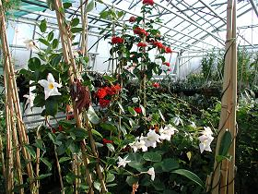

"Near as I can figure, some really smart scientists built the Nursery before they decided to let the bombs fly. Like most Pre-War things, you kind of wonder what the hell was rattling in their heads when they were whipping up all these gadgets and gizmos."

Harold, the Ghoul.

Overview

The Nursery: You find yourself standing at the edge of a canyon, looking into a valley below. The valley is green and filled with lush vegetation as far as the eye can see. At the head of the canyon is a lake of crystal blue water, not the murky brown of the wasteland. A river flows from the lake, down the center of the valley, and vanishes into the far canyon wall. Bordering the lake, you can glimpse several buildings, but the details are blurred by distance.

The Nursery is a miracle of pre-war engineering. It is a self-contained balanced ecological system set within a deep canyon. The valley floor of the canyon is rife with the flora and fauna of times past. At the head of the valley is a lake of crystal blue water that feeds a river. The river flows from one end of the valley to the other, disappearing into the canyon wall. Bordering the lake are several buildings that house the maintenance equipment that keeps the Nursery functioning.

The Nursery is located southwest of Denver Colorado near the Black Canyon National Park. The rim of the canyon is approximately a mile above sea level and the canyon itself is approximately a half mile deep. This area was chosen as the home for the Nursery because of its isolated location, its protected status as a national park, and it was deemed least likely to be effected by a war (or most capable of recovering from such effects).

The Nursery will be composed of the following maps:

MAP AREA | TRANSITION | MAP # | MAP SIZE | COMPLEXITY
Spillway 1 | Full Party |  | Small | Mist filled cave
Spillway 2 | Full Party |  | Small | Vault like
Nursery, Greenhouse Ext. | Full Party |  | Large | Vegetation filled valley, river
Nursery, Greenhouse Int | Full Party |  | Large | Vegetation filled greenhouse
Nursery, Outdoors | Full Party |  | Large | Vegetation filled valley, river
Nursery, Control | Full Party |  | Large | Vegetation filled valley, river, and buildings
Factory 1 | Full Party |  | Small | Factory interior, damaged
Factory 2 | Full Party |  | Small | Factory interior, damaged
Power Plant | Full Party |  | Small | Cavernous underground
Tower | Full Party |  | Small | Tower interior
Repository | Full Party |  | Medium | Laboratory interior, damaged

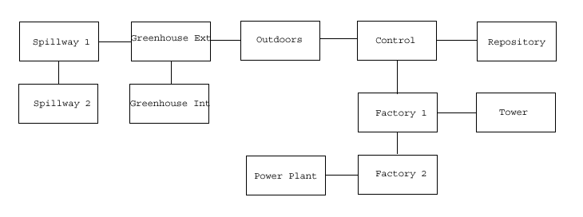

The goal of the area is the following:

- Foreshadowing: The Nursery is intended to give the player a feeling of hope for the future. It can be viewed as the last surviving remnants of Mother Nature, the last hope of the earth being returned to its former glory.

- Threat of destruction: The Nursery has suffered several technological malfunctions that could, if not tended to, ultimately lead to its destruction. The player will have the opportunity to restore functionality.

- Threat of contamination: The Nursery has suffered a biological accident that is threatening to wipe out major sections of the plant life it contains. The player will have the opportunity to re-establish the status quo or to encourage the changes.

- Possible plague vaccine: The Nursery is currently run by a sophisticated robo-brain that has extensive medical knowledge at her disposal. The player can convince the curator to download this knowledge into his pipboy.

Area History

In the early days before the bomb, scientists around the country were pondering how to save mankind from the ravages of war. Eventually their musings gave birth to a company named Vault-Tek, and the vaults. Over the next decade some of the most ambitious underground construction took place throughout the United States as hundreds of vaults were built. Into these shelters, the people and the hopes, of a nation could retreat in times of war.

The Environmental Protection Agency viewed the vaults as only half the solution. Their concern was not only the salvation of mankind, but nature as well. With this in mind, they proposed yet another type of vault, but on a much grander scale. This vault would be used by Mother Nature herself, where she would patiently await the re-emergence of man. When the survivors of the war came forth to reclaim the earth, the Garden of Eden would await them. Thus the Nursery was conceived.

The construction of the Nursery posed quite a problem, however. It was agreed that it could not be built underground like the vaults. Nature needed the sun, the wind, and the rain to flourish. And yet, if exposed and open, how could it possibly survive? The only conceivable answer was that it must be located in an isolated area, free from influence man, and the ravages of war. A search for such a location began.

Computers were fed massive amounts of data detailing the effects of war, where the bombs were likely to strike, and how the devastation would spread. Information about air currents, weather patterns, and the conditions that the Nursery would need to survive were then added to the equation. Finally, topographical maps of the nation input, and the machines were asked to choose.

It took years, but a choice was made. A single canyon was found to house the Nursery, deep in the mountains, shielded from the influence of both man and war. Soon afterward the most ambitious project conceived by the minds of men was devised: a self contained, self sustaining ecological system, with the capacity to reproduce itself. Of course, the expense of such an enterprise could not be footed by the government alone. The project was put up for bid in the private sector.

Derek Greenway was a scientist working under the employ of Poseidon Energy. When it became apparent that Poseidon was more interested in the development of weapons of destruction, and less in the saving of mankind, Derek resigned and started his own company. Greenway Hydroponics, with its turnip headed stick man logo Mr. Green, was the result.

Over the years Derek's company prospered due to their state of the art innovations in farming technology. When the Nursery project was put up for bid it was only natural that Greenway Hydroponics won and construction was began.

Area Composition

The Spillway:

It is here that the river that exits the valley of the Nursery, is strained, purified, and then recycled for irrigation.

The Nursery:

The Nursery is divided into three major sections: the Valley, the Gardens, and the Control Facility. The Control Facility is further divided into four sections: the Factory, the Repository, the Power Plant, and the Control Tower.

The Valley:

This is the actual canyon floor that houses the Nursery and its facilities. It is filled with lush vegetation and samples of wildlife. A river teeming with fish divides the valley in twain. The western end of the valley houses the Gardens, while the eastern end houses the Control Facility.

The Gardens:

This large greenhouse straddles the river of the valley for about half a mile. It is subdivided into four sections. Each section contains the flora and fauna of one of the major climate zones of the United States. The gardens are maintained by a vast network of irrigation pipes, computer equipment, and a small army of robots.

The Factory:

This is a fully automated production facility capable of creating the legendary GECK, the Garden of Eden Creation Kit. Each kit can be supplied with the appropriate flora and fauna from any area in the continental United States, and comes complete with detailed operations manuals. The kits can be distributed by various automated transportation systems such as truck, train, or verti-bird.

The Repository:

Within these walls are sperm and egg samples of a diversity of animal life in the United States. The Repository also contains a computerized gestation environment, the CGE, capable of giving birth to each of the various species.

The Power Plant:

The Geothermal Power Plant is the ultimate in power systems. Relying entirely on thermal energy converted into usable electricity, this plant stands ready to provide all the power needs of the Nursery. It is self sustaining, self repairing, and, in case of unforeseen emergencies, it boasts a crew of robotic repairmen ready to tackle any situation that may arise.

The Control Tower:

This is the heart of the Nursery. It is here that all data pertaining to maintaining the many facilities is collected, correlated, and digested. A state of the art robo-brain then decides on the appropriate course of action necessary to keep operations at an optimum level.

The Helipad:

The helipad provides access to the Nursery via helicopter. Once construction is completed and production begins, the helipad will be disabled to prevent unauthorized entry.

Locations

The Spillway:

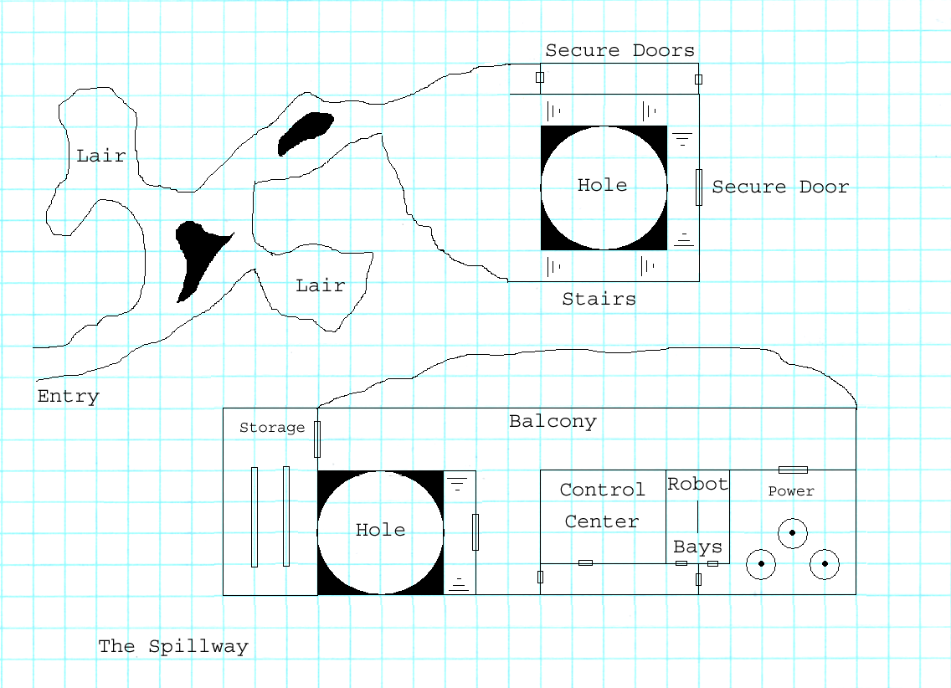

Entry to the Nursery is through a small cave in a mountainside. The cave meanders a short distance before it dead ends at a spillway for the river. Water under pressure flows from a manmade nozzle in the cave wall and arcs toward an opening in the cave floor. Water striking the wall is aerated and then falls into the hole below, much like a heavy rain. Within the hole is a fine grate that captures debris from the river. A set of stairs surrounding the hole leads down to yet another secure door.

The hole contains the filtration plant for the river. Debris captured by the grate is collected by crab-like scurry robots. The debris is then separated into organic and non-organic piles and taken to grinders where it is recycled. The water falls into a natural underground cavern where it is filtered through the water table. Finally, the water empties into yet another reservoir where it is pumped to the surface to replenish the river at its source. The filtration plant is powered by the geothermal power plant beneath the Nursery. However, in case of emergencies, the plant has a trio of hydro-electric generators for back up.

The filtration plant is overseen from a nearby control center. Here small contingents of robot wardens carefully watch the entire process. Most of these robots are simple maintenance droids capable of making the necessary decisions to keep the plant functional. However, the plant supervisor is a more sophisticated model capable of making command decisions independent of the main computer of the Nursery. He also has a small contingent of security robots armed with stun weapons at his disposal.

To gain entry to the Nursery the player must get by the locked security door in the spillway. This can be accomplished several ways (regardless of the method used, the door will be repaired within an hour of its use):

- Combat boy: Can use bash the door open with the proper weaponry. (attacking the door will activate the security robots)
- Diplomacy boy: Can convince the robot supervisor in the filtration plant to open the door.
- Science boy: Can program the computer in the filtration plant to open the door.
- Stealth boy: Can hack the electronic portion of the lock to open the door or blow it open with explosives.

Once opened, the door reveals a long hallway that slopes upwards and rises through several switchbacks. This hallway is patrolled by more security robots; however, their weaponry is of the deadly variety. At the opposite end of the corridor is another secure door. It can be opened using the same methods as the previous door (regardless of the method used, these doors will be repaired within an hour of their use).

The robot workers in the filtration plant pose a small threat to the player. Anyone attempting to tamper with any equipment will be asked to stop. Failure to do so will result in the workers trying to gently remove the player. If combat ensues, the supervisor will order the workers to retreat and initiate a lockdown of the plant. The workers will then flee to recharges stations located throughout the area and seal themselves in. At this point the supervisor will try to deal with the player diplomatically. If this fails, he will call upon security robots to deal with the player.

The robot supervisor can be spoken to and possibly reasoned with. The following can be revealed to the player:

- An earthquake recently rocked this area.
- The master computer has not issued any directives since the earthquake.
- The filtration plant lost power and had to switch to the emergency system.
- The percentage of water loss throughout the closed system appears to be on the rise.
- The master computer recently granted a human female access to the Nursery. She has not been seen leaving.
- The only other person to have been granted access to the Nursery was a ghoul. However, that was several years ago. The ghoul has not been seen leaving either.

Finally, the cave that houses the spillway can be a small combat area. Wasteland animals could use the area as a lair because of the abundant water supply and organic matter that can be used as food.

Scripting:

- Locked security door.

There are two proper ways of doing this. The first is to get the Supervisor to open the door. The second is to hack the computer and get it to open the door. If either of these methods is used the door opens without consequences.

If an improper method is used (attacking the door, hacking the door, etc) the security robots will then spawn and attack the player.

- Messing with equipment.

The player can mess with things here (certain objects will be dynamic I guess). If he does, the worker robots need to ask him to stop. If he does not stop within 30 seconds they will ask again. If he still does not stop then the Supervisor is summoned.

The Supervisor should auto initiate dialog with the player. The outcome of dialog will determine his level of hostility to the player. If hostile, he will order all robots to their recharging bays. Security robots will then spawn and attack the player.

If the security robots are destroyed, the Supervisor will offer the player whatever he wants to prevent further destruction. This could include opening the secure door, shutting down the plant until further notice, or any number of other options. We can determine which option via flags that are set in game.

The Valley:

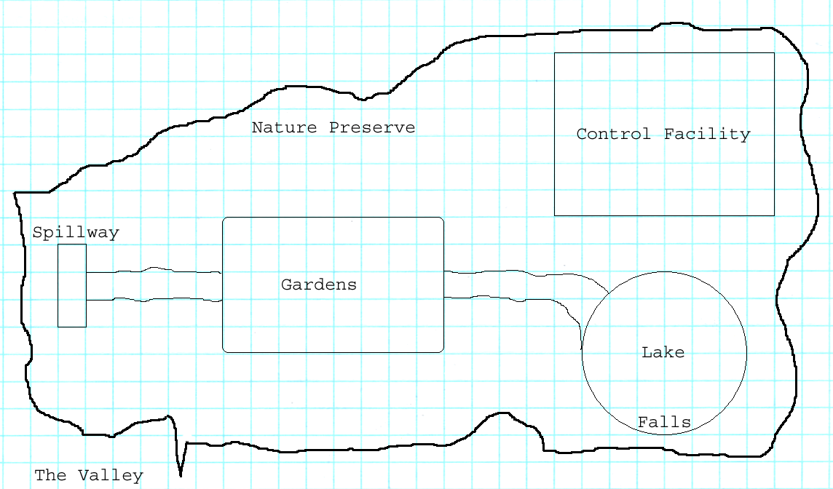

This area is to be used for exposition purposes. It is intended to show the earth as it was in the golden era of the 50's, and instill hope that at some point it could return to such a state. The valley is lush with vegetation and wildlife. Grass, flowers, and trees are abundant here. Wolves, mountain lions, badgers, and raccoons (to name a few) flourish here and show no fear of man. However, there are some telltale signs that all is not as it should be.

The water level along the river banks appears to be receding as well as that of the lake. Patches of grass are beginning to turn brown in some areas. Trees further away from the river are starting to show signs of dehydration. In most areas lamps are not lit, computer equipment does not work, and door locks have failed.

For the most part, the player can wander the valley at leisure and explore. There are no dangers here with the exception of the greenhouses. This area is terrorized by wandering bands of carnivorous plant life that will attack animal life on sight. Examination of the greenhouse will show that these creatures escaped through small cracks in the glass that seem to have been formed very recently. The greenhouse itself is in lockdown mode and cannot be entered.

The carnivorous plants will ignore the player but attack indigenous animal life. If the player intervenes he will be marked as a target for attack from that point forward. The plants can be eradicated but they will return unless they are halted at their source. This can only be accomplished by gaining access to the greenhouses.

It should begin to be obvious to the player that the Nursery has undergone some recent catastrophe that has damaged its systems. The most apparent damage is to the power systems and the greenhouse. He can continue to explore the area or begin to search for the cause of the failures and how to deal with them. Game play at this point moves to the Control Facility.

While exploring this area the player can become involved in the following:

- Animal defense. An animal lair is under siege by a group of aggressive plants. The player can choose a side to support (aiding the plants does not make them the players friend).
- Lake infestation. The lake is infested with a version of the hag-snake. The player should find their lair (a cave behind the waterfall) and destroy it.
- Marauding plants. Bands of plants wander about and try to slay any animal life that the find. The player can destroy them.

Scripting:

- Random encounters

The player can run into various animals and plants while wandering the Nursery. If he encounters an animal it will be wary but stare at him with curiosity. If it is a plant it will pause for a few seconds, giving the player the feeling he is being watched, and then continue on.

If the player attacks an animal they will flee. Any further encounters with animals will result in their fleeing. If the player attacks a plant it will attack back. Any further encounters with plants will result in their attacking.

- Animal defense

The player can encounter an animal lair that is being besieged by a group of plants. The player can either choose a side to defend or just watch. Defending the animals will set them as friendly to the player and plants as an enemy. Defending the plants will leave them as neutral to the player and set animals to enemy.

If the player has already been marked as an enemy by animals due to random encounter attacks, this can repair animal faction and make them friendly again. However, plants remain as enemies even if the player aids them in this encounter.

- Lake infestation

The creatures in the lake are enemies of all and will attack on sight. There is nothing the player can do to befriend this faction.

The Control Facility:

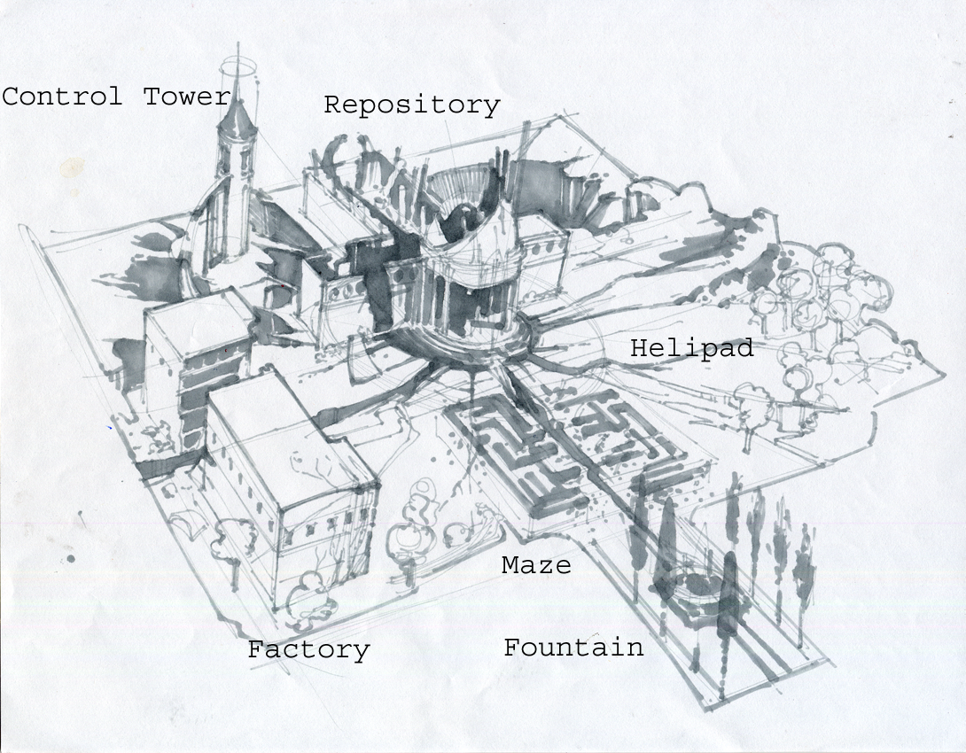

This area is to be used for exposition purposes. It is intended to show the stark reality of the damage that has occurred here in contrast to the beauty of the surrounding valley. It is here that the player will see the true nature of the catastrophe that has befallen the Nursery. The control facility has been wracked by an earthquake that has literally shattered the area. The buildings are in various stages of ruin, fissures have opened in the ground in several places, and the area appears to be powerless.

It should be obvious to the player that, unless power is restored, this area is dead. Finding the power source for the many facilities should be the player's first goal. The control facility can be explored freely; there is little danger here except for random encounters.

Two minor parts of the control facility are the helipad and the hedge maze.

The helipad was originally used to gain access to the Nursery during its construction. It now lies in ruin because of the earthquake that ravaged the area. Sitting on the pad is the remains of a helicopter that was destroyed in the quake. There is nothing else of interest here.

The hedge maze is a simple manor house garden maze. The plants are well trimmed and the path clear of debris and weeds. However, it is home to some of the carnivorous plants that are plaguing the Nursery. Creeping vines, thorn sprayers, and tangle weeds have taken root here. They have inadvertently turned the maze into a trap for unwary animals that wander in.

Note: The maze is not meant to be difficult to navigate. It was simply a fanciful addition to the Nursery during its construction.

Scripting:

- The maze

If the player enters the maze plants will spawn at all the entrances/exits to the maze after a minute. This will simulate it being a trap of sorts.

- Random encounters

The same rules apply here as in the Valley.

The Factory:

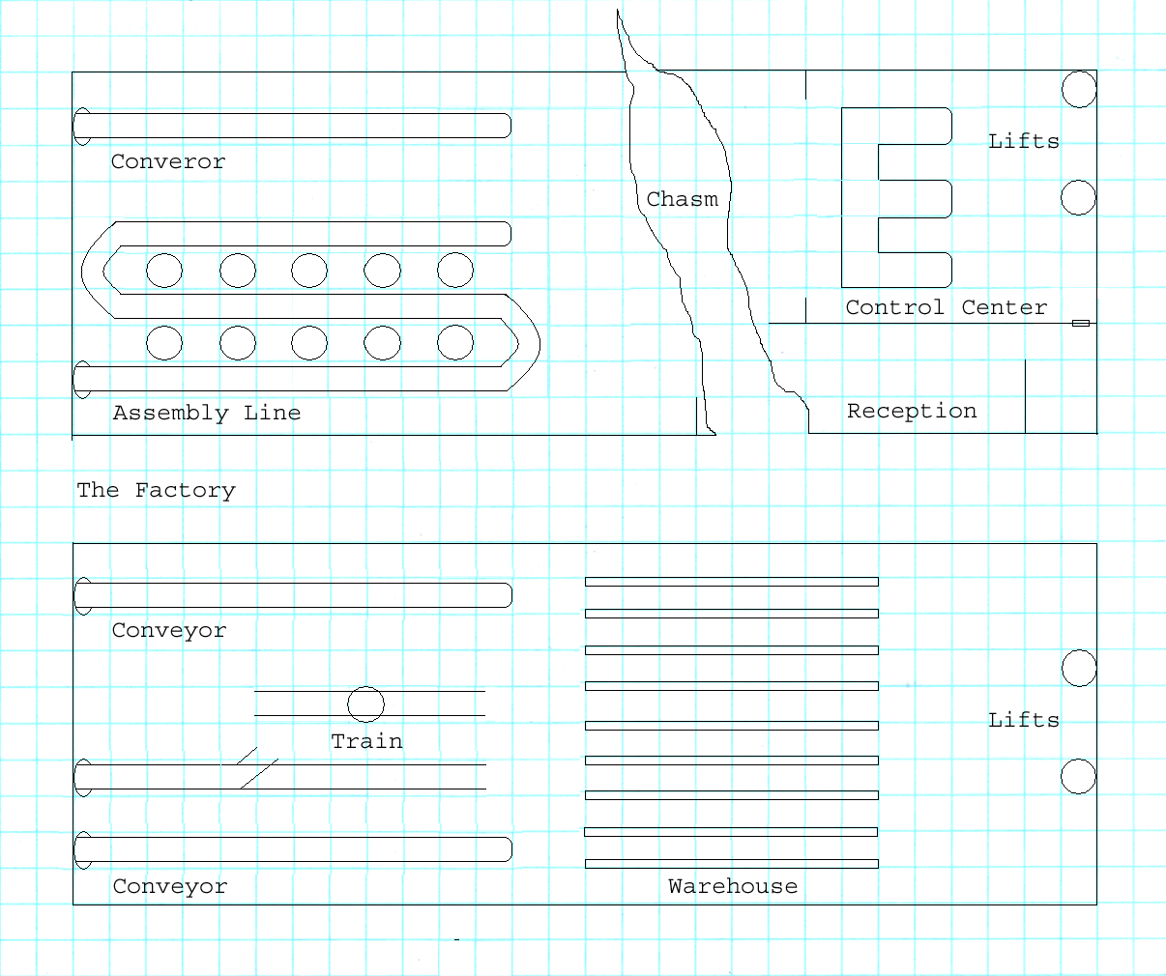

This is the production center for the GECKs. A conveyor belt winds its way around a variety of robotic arms that assemble the kits. At the end of the line is another conveyor belt that delivers the finished product to the distribution center below. Next to the assembly area is a huge chasm that has split the building in twain. The ruins of the testing center for the GECKs can be found here. On the opposite side of the chasm is the control center for the factory. A pair of lift tubes here leads to the distribution center below and the control tower access above.

Central to the distribution center is a small train station with a side rail. Currently the side rail holds a flatbed car with a semi-truck upon it. The main rail holds a locomotive with a boxcar attached. The distribution center also acts as a warehouse for finished products and the parts required for their manufacture. Next to the warehouse are a series of robot charging stations and two lift tubes. The first lift connects to the upper level of the factory and the second to the power plant.

When the player enters the factory he will find that it has been overrun by creeping vines. These plants have wound themselves throughout the machinery and are clogging up just about everything. The plants seem to be living off the seed packets intended for the GECKs. Inspection of the conveyor belts shows that the plants are currently winding their way along the belt toward the level below.

Lodged among the plants is an unusual robo-brain shell. Instead of the usual housing that contains a human brain, this shell contains a sophisticated remote control apparatus. Careful inspection reveals that the remote control is removable and that a 'brain' module can then be inserted. Unfortunately, this shell has been severely damaged.

Before the factory can be made operational the player will need to clear out the vines as well as restore power. One possible way to do this would be to use an herbicide (which can be obtained in the Garden). Another choice would be to burn them out. A controlled blaze (or maybe a flame thrower) would not damage most of the equipment here. However, just setting fire to the place would.

The robo-shell is used by the main computer for inspection of the Nursery. It can be used remotely or, by having her 'brain' transferred into it, directly. The damage to the shell is severe and will require replacement of the motivational units. Also, the radio receiver will need to be replaced. Once this is accomplished the power cell can be replaced (or recharged) and the shell will function.

As for the lower level, the main thing here will be to get the train system functional. Once power is restored to the factory the trains will start to recharge their power sources. However, the sealed doors will not open due to damage. The player will need to patch power to the door locks to get them to open.

Scripting:

- Removing vines

The vines here can be removed by using an herbicide. Another method would be to use a controlled burn such as a flame thrower. It sounds dramatic, but you can control the damn thing. The player could also just pour oil on the plants and set them on fire. However, this would be a dirty burn that would then require the machinery to be hosed down.

- The elevators

Unless power is restored, they don't work. We can do the same thing that we did in Fallout 1. If the player has rope and clicks on the descending shat then it ties the rope there and lets him go down. If the player has a grappling hook and a rope and clicks on an ascending shaft then it hooks the rope there and lets him go up.

- The robo-brain shell

This is a simple repair job. If the player has the proper parts and the appropriate skill he can repair the shell.

- Train station doors

The player will need a power cable that can be stretched from a power outlet (robot recharge bay) to the door panel. This will provide power to the doors and make them functional.

The Repository:

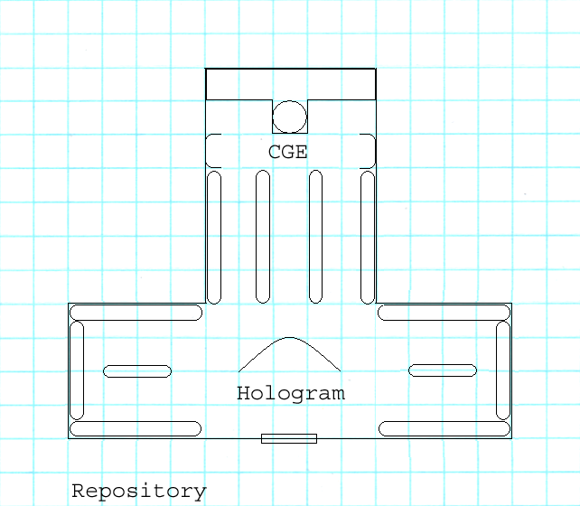

The Repository is a sight to behold. The walls are lined floor to ceiling with pairs of vials set into small niches. Each niche has a plaque beneath it with cryptic inscriptions such as Felis Libyca or Canis Lupus. At the rear of the building is a complex looking piece of machinery with a glass dome. The dome has been cracked due to debris falling from the roof. A series of flashing red lights along a side panel indicates that the machine is functional, but a fault has occurred. At the front of the building is a hologram showing the Nursery valley.

The Repository contains sperm and egg samples from a variety of wildlife throughout the United States. The samples are kept frozen until artificial insemination is ready to begin. The building also contains a computerized 'womb' in which samples can gestate to maturity, at which point they are released into the valley. The computer carefully controls which species are released and in what numbers. The ratio of predator to prey is finely balanced. Two service-bots run the entire process.

The building is also patrolled by two battle-bots. These sentries will not take kindly to anyone tampering with anything within these walls. However, if the player can convince the bots that he is there to repair malfunctioning equipment he will be allowed to do so.

This is the only building within the area that currently has power. When the power plant went off-line, the main computer diverted all available backup power to the Repository to keep it functional. However, the system is currently in standby mode and will remain so until the main power is restored. Also, the 'womb' has been damaged by falling debris. It can be repaired by replacing the glass dome.

Once the player enters this building he will have to deal with the battle bots in one form or another.

- Combat boy: Beat the living crap out of them. Violence does, after all, solve everything.
- Diplomacy boy: Talk to the bots. Convince them that he wants to repair, not destroy.
- Science boy: Shut down the bots. They must have some sort of on/off switch.
- Stealth boy: Sneak by the bots, find the damn off switch.

Once the Repository is fully functional an option opens for the player. He can program the 'womb' to produce and animal companion. There are several choices available: a grizzly bear, a large panther, a wolf, or a badger (I don't want to get into the DnD 'dire' animals here but these critters should be above average so that they can hold their own). In any case the computer will need to be programmed to allow this, part of the animals creation will involve imprinting it will the desire to follow and obey the player. If he just has the machine pop out an animal 'as is' he will find that it wants to put him on the lunch menu.

Some thoughts on the animals are listed below.

- Grizzly bear: This animal is huge, slow, and obviously a carnivore. It hits hard and for a good amount of damage. When close to death it goes berserk and does double damage. It is not accepted in towns and no amount of diplomacy will change that.
- Panther: This animal is large, fast, silent, and obviously a carnivore. It hits good and does a fair amount of damage. It can sometimes surprise its prey, but usually depends on its great speed to reach enemies before they have a chance to react. It is questionable as to whether or not it would be accepted in a town. Perhaps if leashed with a chain.
- Wolf: This animal is large, silent, and stealthy. It is often mistaken for a dog. It hits good and does fair damage. It has the advantage of stealth and can take enemies by surprise. It would most likely be accepted in town as a dog. It may not be required to be leashed so long as it displays obedience.
- Badger: This animal is average, tenacious, and viscous. Most people wouldn't know what to think of it. It hits good and does fair damage. However, it doesn't let go of anything it hits and continues to do damage each combat round. It would probably be allowed in towns. Most people would consider it a curiosity until it bit them.

Scripting:

- Battle robots

These robots will auto initiate dialog and warn the player away. Through dialog the player will have the opportunity to try and convince them that he means no harm to the facility. If successful they will allow him entry.

If dialog fails, the robots begin a thirty second countdown. During this time the player can try to access the side panel of the robot and reprogram it, find the off switch on one of the control panels inside, or prepare for a fight.

- Repair the CGE

This is a simple repair job. If the player has a robo-brain dome and the appropriate skill he can accomplish the task.

- Restoring power

This is a long and drawn out process that is covered in several areas. What needs to be done here is to press the reset button. If power has been restored and the jury-rigged cable removed then the place powers back up.

- Animal companions

This requires a punch card with the proper information imprinted on it. The player can choose and an animal and insert the card. Said animal will then be ready in X amount of time. However, when born it will not follow the player or obey his commands. In order to receive a proper companion a second punch card must be used that has the appropriate commands imbedded in it. When both cards are used the player receives a companion that will follow his instructions.

The Power Plant:

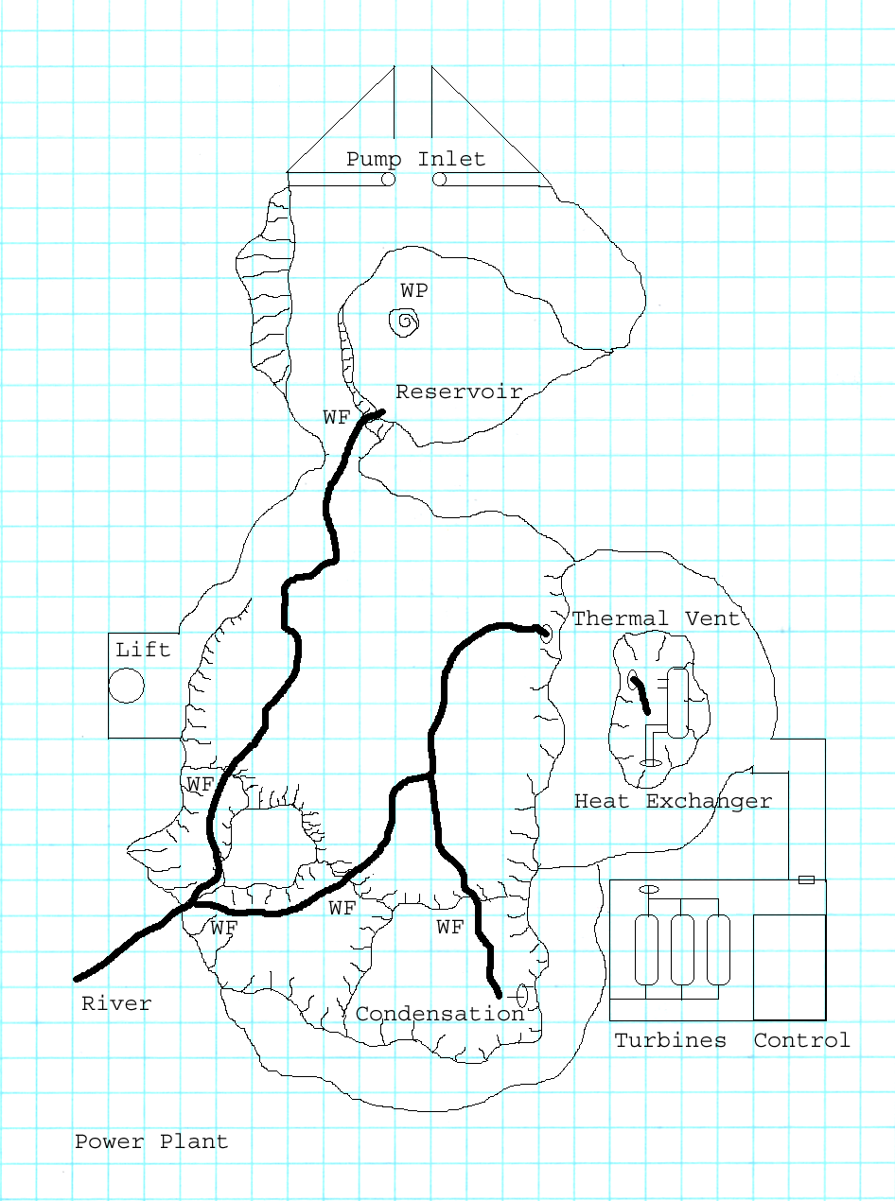

This cavern serves two purposes. First, it is the final stage of the natural purification process of river water. The water cascades down several waterfalls until it comes to rest in a reservoir. From there it is pumped up to the lake above. Second, a part of the river water is diverted to the geothermal power plant. Here the water is converted to steam to power a trio of turbines.

Upon investigating this area the player will discover three faults. First, the pipe that carries river water to the heat exchanger in the power plant has broken. The water now flows freely into the thermal vent and is converted to steam. Second, the floor of the reservoir appears to have cracked. A whirlpool has formed and is slowly draining away the water. It will be necessary to repair both faults to bring the power plant online. Finally, the reservoir has been infested with hag-snakes like the lake above. These creatures wander freely down here and attack anything on sight.

Repairing the power plant will not be an easy task for the player. First, a way must be found to repair the pipe that delivers water to the heat exchanger. There are a few ways that this could be done:

- Combat boy: Find pipe. If owner of pipe disagree with it being taken, then beat the crap out of them. There will be areas where this is possible. The Spillway for example could have a pipe but it is currently in use. Taking it would piss off the security bots.
- Diplomacy boy: Am appropriate piece of pipe could be found at the Jericho water plant. Perhaps the foreman could be talked into relinquishing it.
- Science boy: Draw up a set of plans for the new part and have it made somewhere. Of course, the power to the repository could be diverted to the factory just long enough for a replacement to be made...
- Stealth boy: Steal the plans for a similar part and have it made somewhere. Or do the power diversion routine above.

In any case, once the part is found/made then it will need to be installed. This can be done by using one of the scurry-bots from the spillway. The robots are made to crawl around on unstable sections of grating in the hole and carry away debris. This would be a simple matter for one of them to complete. Some thoughts on how to do this:

- Combat boy: Beat the crap out of everything except one of the scurry bots. Then take the damn bot where it is needed.
- Diplomacy boy: Talk nicely to the robot warden until he agrees to loan the player one of the robots.
- Science boy: Program one of the bots to follow him to the power plant and perform the task.
- Stealth boy: Sneak into the maintenance room of the spillway and abscond with one of the bots there.

The second task involved in this area is the repairing of the reservoir floor. Unless this is done quickly the water in the closed system will drain away and everything will shut down again. In order to accomplish this, the player will need to have the water pumps in the spillway shut down. Once the water in the reservoir is empty a patch can be made to seal the crack.

The first task will be to shut down the water pumps. Some ways this can be done are:

- Combat boy: Damage the pumps in some way. The repair bots will try to repair them but not if he beats the crap out of them.
- Diplomacy boy: Talk nicely to the robot warden again. He must be your buddy by now.
- Science boy: Program the computer to show a fault in the system. It will then shut down until the fault is cleared.
- Stealth boy: Sneak into the pump room and disable them.

The second task is to patch the hole. Some ways this can be done are:

- Combat boy: Blow up some of the cavern wall and have the debris plug the hole.
- Diplomacy boy: Talk one of the bots into giving up its life by having it plug the hole with its body.
- Science boy: Devise a patch. Perhaps disassembling the round plate in the distribution center (the rotating tracks use it) and having a robot put it in place.
- Stealth boy: Mine the crack in such a way that it will seal itself when the explosives go off.

The hag-snake infestation will give this area the needed combat opportunities to round it out. These creatures have formed a nest near the steam outlet in the condensation area of the cavern. They really like that humid sultry heat for their eggs (since they lack 'hosts'). The player will need to find their nest and destroy it.

Note: The replacement for the damaged pipe can be made at the Blackfoot town foundry.

Scripting:

- Repair the pipe

The act of repairing the pipe is no big deal. If they player has the item in his inventory, he can repair it. I think it would be interesting if he also had to find a way down to the pipe. For instance, he could use a rope or maybe have to reprogram one of the scurry robots to go down to the pipe and do it.

- Repair the reservoir

The act of repairing the reservoir will be a bit more involved in that it requires the river to be turned off. This can be handled by speaking with the Supervisor in the spillway, or possibly by damaging the pumps. If successful, the river and reservoir will need to disappear at this point so that repairs can be made. Once made, they can come back. As for the river in the Nursery, it won't disappear but it will appear to no longer be flowing. Also, the waterfall that feeds the lake will need to stop. Whatever is done, this will only last for 24 hours. After that amount of time things start working again and return to normal.

In any case, the repair of the reservoir may be a simple matter of having a patch item ready. If that is the case then the player need only click and have the appropriate skill. I'd also like to have it be repairable by using explosives on the reservoir wall. Maybe the player can blow a chunk of the wall away and have it seal the crack.

- Hag snakes

It's combat. Kill them.

The Control Tower:

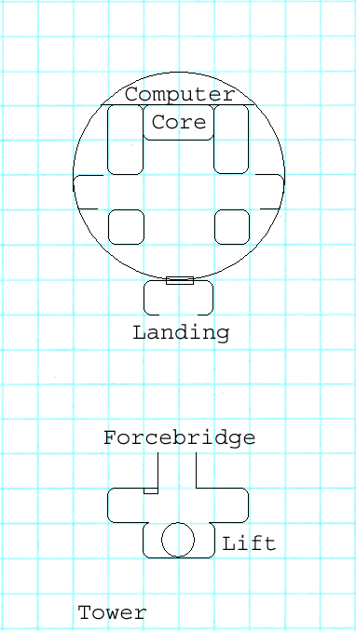

The Control Tower is accessed via a lift in the factory. The lift exits on the force-bridge landing stage. Activating the bridge will span the gap between the landings with a force field. A secure door gives access to the main computer room in the tower. Neither the lift nor the force-bridge is functional until power is restored.

The tower contains the main computer room that controls all Nursery functions. The computer is composed of two Zax units operating in tandem with a central brain (a human volunteer was chosen to donate her brain) core between them. Next to the computer are two empty recharging bays. On either side of the door are two massive memory cores. None of this equipment is currently functional, even if power has been restored to the Nursery.

Upon reaching the control tower the player will find that the secure door has been opened. A thick power cable runs from inside the tower, out the door, and over the landing to the ground below. From there the cable runs to the Repository. Once inside, the player will find that several floor panels in front of the computer core have been removed to give access to the main power line. The main line has been severed and a new cable, the one that leads out the door, has been attached.

When the power for the Nursery went offline the auxiliary system, solar charged batteries, kicked in. The central computer immediately tried to determine the damage to the facility and how best to correct it. Unfortunately the damage was much more severe than the facility was meant to sustain. Repairs were possible, but not within the time needed to save the most critical of the Nursery's systems, the Repository.

Fortunately, the Nursery had a visitor at the time of the disaster, a Follower of the Apocalypse named Akeisha Moon. Following instructions given her by the computer she was able to rig power from the auxiliary system to the Repository to keep it functional. However, this created a few problems on its own. First of all, she had to disconnect power from the central computer. Second, she had to put the Repository into standby mode indefinitely. There was simply no way for the solar backup system to support such a drain on its resources.

There are two ways for the player to get to the computer room. First, he could restore power to the Nursery and simply use the force-bridge. Second, he can climb the power cable draped over the landing. In either case, he will find Akeisha waiting for him.

Akeisha is provided for informational purposes (she is also one of the missing prisoners). She will gladly explain everything that has befallen the Nursery since the earthquake. If the player has not already done so, she will ask him to make the necessary repairs to all Nursery equipment. If the player attempts to bring the main computer online before power is restored (by disconnecting the backup power from the Repository) she will try to talk him out of it, explaining to him the importance of the Repository. If the player refuses to listen she will not interfere.

If the main computer comes online and the Repository is at risk, the computer will ask the player to undo what he has done. She will use any means at her disposal, including begging and bribes. If the player refuses she will then send out an SOS signal to Ulysses alerting him of the player's presence and the clear danger to the Nursery. This will result in a tactical death squad arriving and trying to take the player out. Regardless of what happens here, Akeisha tries to stay in the background out of harms way until she can reconnect power to the Repository.

If, however, the player has restored full power then the computer will be most grateful and all is well and good. She can then ask the player to perform certain quests for her:

- Restore production: Get the factory online and producing again. This will require clearing out unwanted plants, cleaning up the warehouse, and getting the distribution center running.
- Greenhouse repair: Find out what has happened in the greenhouse and put it to right. This will entail repairing the malfunctioning hub.
- Robo-brain shell: Find the parts needed to repair her shell and get it working. This could require the player to go to Boulder Dome for parts.
- Leave: Hey, you guys have the freakin plague! Now I'll have to purify everything and start all over. Get the fuck out!!

The main computer is named Diana. She is the same Diana who poses as the goddess of the Twin Mothers tribe. Once she is activated, she will once again assume her divine role for the tribe. This will include re-activating the robots in vault 29 and insuring the isolation/protection of the tribe (for more information, see the area overview for the Twin Mothers). Of course, this is all dependent upon actions taken by the player while he was with the Twin Mothers.

If the player has caused irreversible harm to the Twin Mothers, Diana will take great exception to the fact. After the player leaves the control tower she will seal the door, collapse the force bridge (even if the player is on it), and turn all the security robots against the player. If this is ineffective in dealing with him she will send an emergency signal to Ulysses so that a tactical hit squad can be sent after the player.

If the player has done well by the Twin Mothers, Diana will be indebted to the player. She will offer him technical/medical help or even an animal companion from the repository. Another possible boon is to restock the dying Brahmin herds of the wasteland with Brahmin that are resistant/immune to the plague. When she discovers that the player is carrying the new plague, she will begin work on finding a possible vaccine, but ask him to leave before he infects the entire Nursery.

Scripting:

- Akeisha Moon

Akeisha needs to auto initiate dialog upon the player entering this area. She will not go hostile because of dialog responses. However, she will leave the map (to return later) if the player is an ass or attacks her. Her dialog will check several flags that have to do with the state of repairs at the nursery.

- Main computer

If power to the main computer is restored then Diana needs to initiate dialog with the player. As with Akeisha above, her dialog will check several flags that have to do with the state of repairs at the nursery.

If the repairs have been completed and in a proper manner then Diana will simply be another character to interact with. However, depending on the state of repairs she may ask that the player shut her down until repairs are completed. A flag needs to be set if the player complies. If the player is a total ass or attacks Diana she will set all robots in all areas of the facility to attack him. If this fails to deal with the player then a flag needs to be set that will allow the spawning of robot death squads randomly throughout the game.

- Robo-brain shell

If the player repairs Diana's shell then she can transfer herself to it and become a mobile NPC. We need to set a flag that indicates whether or not she is in the shell.

The Gardens:

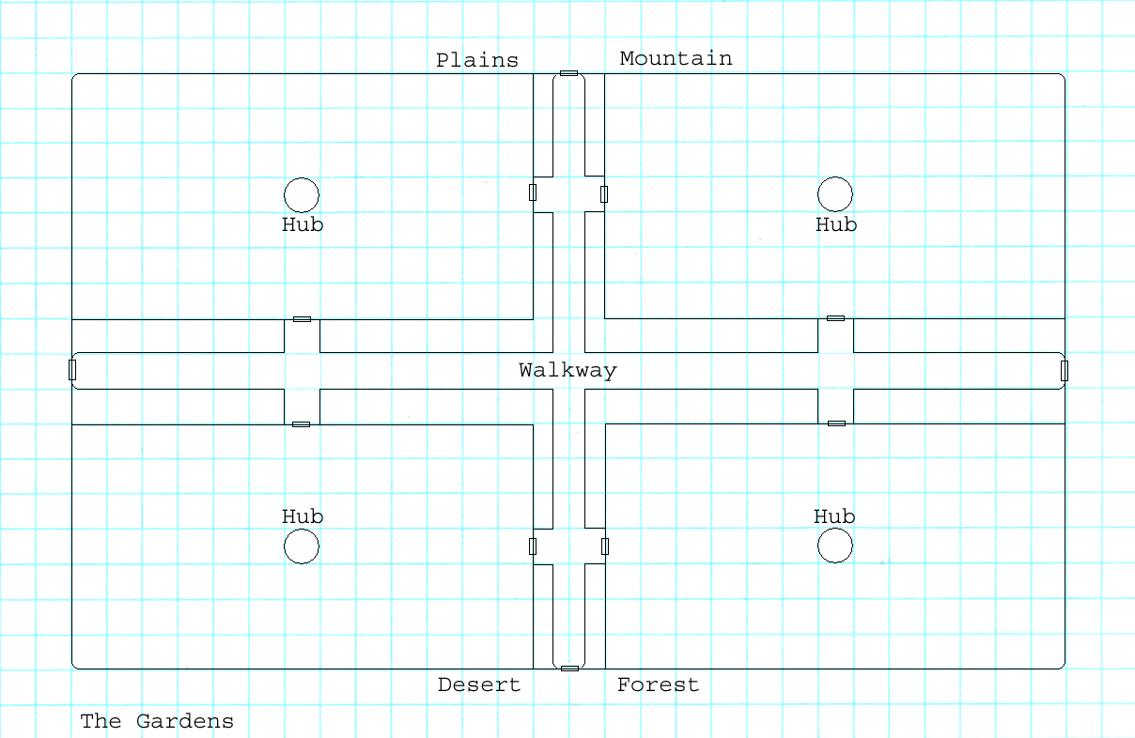

The garden is a huge greenhouse that straddles the valley river. It is divided into four sections, each detailing a different environment. The four sections are: mountains, plains, forests, and deserts. Each section is rife with plant life indigenous to that type of environment. The garden is monitored and controlled by the central computer. However, in case of emergencies, each section has a central hub that acts as a backup unit should communication be lost.

When the earthquake struck, communication was lost with the central computer. The hubs in each greenhouse section immediately activated and began to monitor activity and issue commands to stabilize the area under its care. One of the hubs, the one in the plains section, was severely damaged by falling debris. The hub sent out a burst of scrambled commands that were interpreted by the greenhouse as instructions for altering the plant life and environment in that section. As a result, a variety of carnivorous plant life that was created. The damaged hub then shut down and no longer monitors the area.

The rogue plants pose a threat to the greenhouse and the Nursery both. Although they are non-intelligent, they are inimical to plant life that they do not recognize as their own species. They are very aggressive in their growth and are insinuating themselves throughout the Nursery. If they run unchecked they will take over as the dominant form of life. These plants also have a rudimentary form of locomotion, much like creeping vines, and are capable of traveling about the Nursery. Having been mistaken for food by some of the herbivorous life in the Nursery, the plants now attack animal life.

They player can deal with this threat by simply eliminating the plants and their nests. The hub of the greenhouse will also need to be repaired so that it can issue the proper commands to restart proper plant growth.

Harold the ghoul has made himself a home in the gardens, specifically the forest area. It seems that the Nursery took a liking to his tree and wanted a sample of it for its records. Meanwhile, Harold is trying to decide if he wants to exchange 'Fred' for another type of vegetation. In any case, Harold is here just to talk to the player and offer advice/suggestions for dealing with various problems in the area.

One thing that Harold would like is a nice little hut in the forest that he can call his own. Maybe the player can program the hub to provide him with one? If not could he find the materials and build him one? In return Harold can reveal information to the player that would be of great benefit to him:

  - Plants that can cure disease and poison, or absorb radiation, or cure addictions.
  - Plants that can be used for healing like stim-paks.
  - How to grow/maintain these plants.

Notes: Each of the garden areas needs to be set up as small self contained worlds. I want them very detailed, as if they are an entire theme park in themselves.

Scripting:

- Repair the hub

Once again this is a simple matter of having the right skills. If the player does, then the hub is repaired. This will cause all carnivorous plants to stop spawning.

- Harold's hut

Diana can instruct the hub in Harold's garden to produce a hut for him. Otherwise the player can do it with the appropriate skill.

Art Requirements

The Nursery will require a wide variety of art. The areas presented here depict a wide range of styles from underground caverns, high-tech laboratories, to lush gardens.

Tile Set

The following sets will be needed: high tech, desert, forest, ruins, mountains, rivers and lakes.

Critters

The following creatures will be in the Nursery: various plants of dubious nature, dogs, cats, wolves, bobcats, bears and tigers. For the dog/cat models we can just make one model, resize it, and retexture it so that it looks like several other models.

Generic Scenery Objects

The following generic objects will be needed: high-tech equipment, trees, plants, rocks, ruined machinery.

Specific Scenery Objects

The following specific objects will be needed:

Spillway:

  - Hole with water injector (upper level)
  - Hole with water shower effect (lower level)
  - Balcony overlooking the underground river

Valley:

- Greenhouse exterior
- Lake fed by waterfall

Control Facility:

- Helipad surrounded by turrets
- Cracks and fissures throughout the area

Factory:

- Conveyor belts
- Assembly line with robotic arms
- Fissure
- Locomotive and semi-truck

Repository:

- Hologram
- Artificial womb

Power Plant:

- Multiple waterfalls
- Carlsbad like caverns with lighting
- Heat exchanger
- Thermal vent with lava glow
- Steam turbines
- Condensation area with steam outlet
- Lake with whirlpool

Control Tower:

- Special computer
- Memory core

Gardens:

- Miniature areas set up as mountainous, plains, forest, and desert terrain
- Control hubs

Maze:

- Hedge maze

Dynamic Scenery Objects

Spillway:

To be determined.

Valley:

To be determined.

Control Facility:

To be determined.

Factory:

- Conveyor belts
- Assembly line with robotic arms
- Rotating train platform
- Locomotive

Repository:

To be determined.

Power Plant:

- Broken pipe
- Replacement pipe
- Whirlpool crack in floor
- Water level needs to be changeable

Control Tower:

- Power cables
- Floor panels
- Bridge

Gardens:

- Control hub.

Maze:

- Exits/entrances that can be opened/closed.

Area Photo

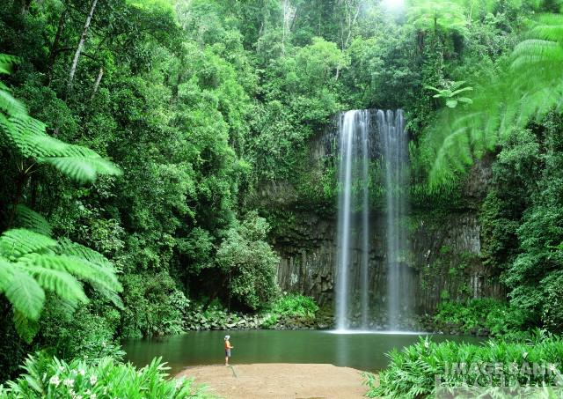

The Nursery photo should look like this.

Town Map In Pipboy

The Nursery Valley map should look like this.

Scripted Scenes Or Movies

- When the player first enters the Nursery I would like to have a short movie that pans across a lush valley filled with life.
- When the player gets the power plant working I would like to have a short movie showing the different areas of the Nursery powering up. The movie would end with a scene showing defense turrets in some areas coming online for foreshadowing.
- When the player gets the distribution center working and uses the locomotive there I would like to have a short movie showing the train powering up, the secure door to the tunnel opening, and the train pulling out of the station through it.

Cast Of Characters

Akeisha Moon (Human Female)

Akeisha is a member of the Followers of the Apocalypse. She spent the majority of her life searching for the ancient vaults and any knowledge that they may contain. She would routinely spend her time traveling the wasteland, researching stories or rumors about the vaults, and then attempt to find them. She has been moderately successful in her chosen career and has discovered two vaults.

While visiting a tribe in the south west, Akeisha noticed that an unusual number of the tribes brahmin were dying. Although not trained in medicine, she was naturally curious and decided to look into the matter. If nothing else she could report her findings to the Followers and perhaps interest them in sending someone qualified to look into the matter. Not long after beginning her research the tribe was attacked during the night by unknown assailants. Akeisha was struck unconscious during the attack.

When she next awoke, Akeisha found herself in what appeared to be a prison cell. For untold days she attempted to contact the warden of the prison, but all she ever saw were the robot helpers. She had just about given up hope when the prison was rocked by an explosion and the door to her cell was jarred open. She wasted no time in fleeing her captors.

Akeisha wandered the desert for days until she stumbled upon a cave. She was intrigued by the sound of running water and decided to investigate. What she found was the spillway to the Nursery. As she stared in wonder at her discovery she was approached by a robot that began to question her as to why she was there. Still awestruck, she stuttered out some answer that seemed to satisfy its master. She was invited to enter the Nursery and speak with the curator. This was an opportunity that could not be passed up.


Diana, Nursery Central Computer Intelligence (Robo-brain Female)

Diana Stone was a scientist working for Greenway Hydroponics. She was a brilliant woman with a career that path that would gain her a place of recognition among some of the greatest scientific minds in the United States. Unfortunately, she was diagnosed with breast cancer and given little time to live.

The news of her impending death had a profound effect on Diana's life. She turned away from science and began to look into the spiritual side of life. However, with so little time left to her, she soon became frustrated and despondent. This was to change when she was contacted by Derek Greenway.

Derek was proposing a new type of super-computer that would be years ahead of any system currently in production. Even the highly touted Zax units would pale in comparison. He proposed building a computer that could take a quantum leap forward by being able to pose the simplest of questions: What if? With this in mind he devised a system that would house a human brain with each hemisphere, logical/emotional, linked to a Zax unit. The human mind would have vast amounts of computation power and almost unlimited storage capacity at its disposal. Who could predict what such a mind would be capable of doing? All he needed to find out was a volunteer. With nothing to lose, Diana jumped at the chance.
When Diana awoke from the operation she was overjoyed at the success... at first. As the months progressed she began to doubt the wisdom of becoming part of a machine. Her hearing was acute, but too much so. She could hear into a range far above normal and it was disturbing. Her eyesight was perfect, but once again too perfect. Her vision showed a sharpness of clarity that made the world look unreal. The most disturbing aspect was her lack of skin. She no longer felt the weight of clothing, the touch of a cool breeze, or her own caress. Everything that made her human... was either changed or gone. And they had told her she could live virtually forever.

Diana knew that she had to come to grips with what she had become when they told her the purpose she would serve. After she was installed in the Nursery she buried herself in her work, knowing that she would play a significant part in the salvation of the world and mankind itself. Unfortunately, it simply wasn't enough. She hadn't counted on the years of loneliness once the Nursery was sealed and the war begun. In desperation she began to look for something to do to maintain her sanity.

Harold, Mister Tree Head (Ghoul Male)

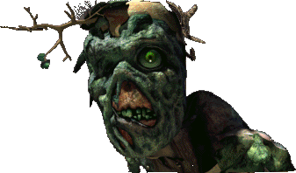
Harold the ghoul was ill. The tree in his head developed and unknown disease and was dying. Much to his surprise, Harold found himself affected as well. He didn't think he was going to die, mind you, but still... he just didn't feel right in the head.

So, he set out on a quest for a cure. Naturally, he didn't have an easy time of it either. People just didn't seem to want a ghoul around any more. But, Harold didn't let that stop him. He persisted in his quest until he came upon the Twin Mothers tribe.

Much to his surprise the tribe took him in and accepted him as he was. He explained his quest to the tribal leaders and was told that they would consult their goddess. Days later, Harold was approached by the tribal shaman and given a potion to drink. It was a foul concoction, but it worked. Fred, the tree, got better and was happy again.

Harold couldn't let such a good deed go unrewarded so he offered to help the tribe in any way that he could. They smiled at him, thanked him, but declined his help. "The goddess will provide," they always said. Harold, nice ghoul that he is, said that he would like to pay his respects to the goddess. He was taken to the tribal shrine and granted a private audience. He wasn't really surprised when the projected image of a woman appeared before him, but he was taken aback when she told him where he could find her.

Harold traveled to the Nursery and has been there ever since. He is considering settling down and spending the remainder of his day, however long that may be, in the tranquility of the gardens.

Scripting

General

To be determined.

Cut-scenes

To be determined.

Monster Roster

The players are likely to encounter the following “monsters” at the Nursery:

MONSTER | NUMBERS | DIFFICULTY
Dogs, domestic | ? | Non hostile
Dogs, wild | Chaotic pack | Easy to medium
Wolf | Organized pack | Medium to hard
Mastiff | Single or pack | Medium to hard
Raccoon | ? | Easy
Badger | ? | Easy
Cat, domestic | ? | Non hostile
Cat, wild | Loner or pride | Easy to medium
Cat, bobcat | Loner or pride | Medium to hard
Cat, panther | Single or pride | Medium to hard
Plant, carnivorous vine | Single | Medium to hard
Plant, carnivorous bush | Organized pack | Medium to hard
Plant, thorn sprayer | Single | Easy to medium
Plant, gas sprayer | Single | Easy to medium
Various robots | ? | Easy to hard
Scurry bots | ? | Easy
Worker bots | ? | Easy
Gardening bots | ? | Easy to medium
Pest control bots | ? | Medium
Security bots | ? | Medium to hard
Battle bots | ? | Hard

Random Encounters

Emotional Porn

This section sets up all the emotional role-playing opportunities present in the Nursery.

Drama

When the player arrives he finds that an ecological treasure is threatened with destruction by several things ranging from natural disasters to ecological blunders. Working to save the Nursery will require a wide variety of skills to be successful. The suspense of whether or not the player can or will succeed should be gripping.

Moral Dilimmas

The only moral dilemma that I see for this area is what it could be used for. The ability to hoard the knowledge and resources stored here for a profit is huge.

Role-playing Tests And Epithets

Try to find ways to grant karma based on a player's reasons for taking certain actions. Perhaps this can be done through dialog.

Ties To Overall Game Themes

The main theme of the Nursery, in my opinion, is the folly of the war that created the Fallout universe. When the player compares the beauty of the Nursery to the wasteland that the world has become he can ask himself "Was it worth it?" "What can I do to prevent this from happening again?"

NPC Companion Uses

There are no specific NPC uses in the Nursery. However, the area does challenge the player by requiring a large skill base in order to satisfy all of the quests. Having NPC's with various skill concentrations will prove to be quite useful.

Cool Shit

The players will find the Nursery cool for the following reasons:

- The player can explore an area unlike any other in previous Fallout titles.
- Saving the Nursery will give the player a supreme sense of accomplishment and instill hope for the future of the Fallout world.
- The player can get a special animal companion in the Nursery that is unequaled anywhere in the game.

Possibilities

- To be determined.

Quest Items

- To be determined.

Quests

Main Quests

There are several quests required in the Nursery. For the most part these quests are not assigned but rather assumed by the player. I have listed them in no particular order.

- Gain entry to the Nursery.
Find the spillway and discover the best way to bypass it and enter the Nursery proper.
- Explore the valley and discover the tragedies that have befallen it.
Find the greenhouse and the destructive plant life that is escaping from it. Discover the lack of power to all Nursery facilities.
- Restore power to the Nursery and all of its facilities but especially the Repository.
Find the geo-thermal power plant and repair it. Find the fissure in the reservoir and repair it as well.
- Restore power to the Nursery central computer.
Reconnect the computer to the normal power supply once the power plant has been brought online.
- Heal the central computer of her ails (Diana is a robo-brain).
Find a replacement robo-brain shell or repair the one found in the factory.
- Destroy the carnivorous plants that are taking over the gardens.
Infiltrate the gardens and then locate and destroy all inimical life forms there.
- Restore the functionality of the distribution system.
Bring the trains online and hack the doors that have sealed off egress to the outside world.
- Start up GECK production.
Get the factory up and running to full capacity.

Merchant Quests

There are some scenarios listed in the location descriptions that could provide a reason for the player to travel to other areas throughout the game.

- Find a replacement pipe for the power plant.
A replacement pipe could be located in another area (Jericho water plant?)
- Find a replacement robo-brain shell for the central computer.
A robo-brain shell could be located in another area (Boulder Dome?)
- Collect wasteland animal samples worth preserving and bring them to the Nursery.
Find plants and animals that are not currently infected with the plague and bring samples to the Nursery for future re-introduction to the world.

Floating Quests

There are no floating quests for this area.

Area | Quest Name | Designer | DStatus | Script | SStatus | Log Stat | Passable | QA 100%
Nursery
 | Gain Nursery Entry | Deiley | 0 | ? | No | 0 | No | No
 | Explore Valley | Deiley | 0 | ? | No | 0 | No | No
 | Restore Nursery Power | Deiley | 0 | ? | No | 0 | No | No
 | Restore Repository Power | Deiley | 0 | ? | No | 0 | No | No
 | Restore Computer Power | Deiley | 0 | ? | No | 0 | No | No
 | Find Robo-Shell | Deiley | 0 | ? | No | 0 | No | No
 | Clear Gardens | Deiley | 0 | ? | No | 0 | No | No
 | Restart Factory | Deiley | 0 | ? | No | 0 | No | No
 | Restart Distribution | Deiley | 0 | ? | No | 0 | No | No

Sound Requirements

Music

Most of the Nursery is a beautiful lush woodland valley. The music should reflect a feeling of wonder, serenity and the like. In areas where this is inappropriate I have listed changes.

Basic SFX

The basic ambient sounds for this area should be natural outdoor or woodland sounds. Distant animal life, wind rustling through the leaves of trees, running water through a brook, etc.

The basic chart for SFX would be as follows:

AREA | SOUND REQUIREMENTS
Spillway | MUSIC DESCRIPTION
Spillway | Typical Fallout background music. There is nothing that really distinguishes this area from any other underground area.
Spillway | BASIC SFX
Spillway | The distant roar of water (this will increase in volume until the player reaches the main chamber at which point it will overpower any other sfx).
Spillway | WALLA SFX
Spillway | None
Filtration plant | MUSIC DESCRIPTION
Filtration plant | Typical Fallout background music. There is nothing that really distinguishes this area from any other high-tech area.
Filtration plant | BASIC SFX
Filtration plant | The distant roar of water (this will be subdued unless the player enters the hole at which point it will overpower any other sfx). The hum of machinery, water pumps, flowing water.
Filtration plant | WALLA SFX
Filtration plant | None
Valley, general | MUSIC DESCRIPTION
Valley, general | Since this area is so different than any previous Fallout areas I'd like the music here to be something special. This is going to be a beautiful lush valley complete with natural wildlife. The music should reflect wonder, serenity, etc.
Valley, general | BASIC SFX
Valley, general | The rustling of wind through the leaves of trees. Distant animal life. Running water.
Valley, general | WALLA SFX
Valley, general | None
Valley, gardens | MUSIC DESCRIPTION
 | This area of the valley is the home to some carnivorous plants. The music here should change to give the player a more 'dangerous' feeling.
 | BASIC SFX
 | The rustling of wind through the leaves of trees. Distant animal life. Running water.
 | WALLA SFX
 | None
Control facility | MUSIC DESCRIPTION
 | For this area I think we can return to standard Fallout music themes. The area is in ruins and is open to exploration. The music should reflect the lack of imminent danger.
 | BASIC SFX
 | Distant wildlife. Crumbling stone. Somewhat silent and dead.
 | WALLA SFX
 | None
Repository | MUSIC DESCRIPTION
 | The music here should reflect a sense of wonder again so I think it should return to the music used in the valley.
 | BASIC SFX
 | The hum of machinery.
 | WALLA SFX
 | None
Power plant | MUSIC DESCRIPTION
 | Typical Fallout background music. There is nothing that really distinguishes this area from any other underground area.
 | BASIC SFX
 | Running water. Distant thunder of waterfalls.
 | WALLA SFX
 | None
Control tower | MUSIC DESCRIPTION
 | Typical Fallout background music. There is nothing that really distinguishes this area from any other high-tech area.
 | BASIC SFX
 | Running water. Distant thunder of waterfalls.
 | WALLA SFX
 | None
Gardens, good | MUSIC DESCRIPTION
 | The gardens are composed of four small areas. In three of the areas the music should reflect a sense of wonder again so I think it should return to the music used in the valley. In the fourth area (listed below) this should change.
 | BASIC SFX
 | Running water. Distant thunder of waterfalls.
 | WALLA SFX
 | None
Gardens, bad | MUSIC DESCRIPTION
 | This is a dangerous area controlled by carnivorous plants. The music should change to reflect this danger.
 | BASIC SFX
 | Running water. Distant thunder of waterfalls.
 | WALLA SFX
 | None

Map And Map Key

The maps are in the locations section above. I'll have to move them down here.

