The Twin Mothers

Version 1.0

9/26/2003 11:34:00 PM

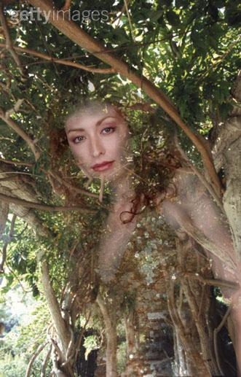

"I am the beauty of the green earth, the soul of nature. I am that which gives life unto the world. From Me all things proceed, and unto Me all things must return. Let My worship be in the heart that rejoices."

Goddess Diana

Overview

The Twin Mothers: Ahead of you lie cultivated lands nestled within a small valley. Fields of crops stretch as far as the eye can see and line the valley floor. Clinging to the left valley wall are what appear to be buildings made of adobe.

The Twin Mothers is one of many tribes in the Fallout world. The thing that will set them apart from the other tribes is their culture and architecture. Culturally the Twin Mothers are a matriarchal tribe who worship a Goddess, the moon, and a God, her consort the sun. Women rule the tribe and make all governing decisions. Men provide for the tribe by hunting, fishing, and tending the farms. Architecturally the Twin Mothers are based upon the Anasazi Indians of the western United States. The Anasazi are best known for their dwellings carved into the sides of cliffs. Their culture reached its peak in pottery, weaving, and architecture.

The Twin Mothers are a gentle people who respect nature and life in all its forms. Unfortunately, these are not beliefs that are shared throughout the wasteland. As a result the Twin Mothers are often the victims of raiders. During such times they quickly retreat to their cliff dwellings where they are more than capable of defending themselves and waiting out any attacks. However, their livestock and crops are usually ravaged before the aggressors move on. The Twin Mothers take such setbacks in stride, thanking their gods for what they have and not mourning the loss of what they have not.

When the Twin Mothers are encountered they will be suffering from yet another series of ailments. Wasteland creatures have been raiding their fields and killing their livestock. A band of raiders has also settled nearby and are demanding tribute in the form of foodstuffs and livestock.

The Twin Mothers will be composed of the following maps:

MAP AREA | TRANSITION | MAP # | MAP SIZE | COMPLEXITY
The Fields | Full Party |  | Small | Fields of corn, wheat, and crops
The Village | Full Party |  | Medium | Cliff side adobe dwelling
The Dish | Full Party |  | Small | Satellite dish with control room
Mystery Caves | Full Party |  | Small | Looping caverns with monsters
Forbidden Lands | Full Party |  | Medium | Horseshoe canyon with cave
Forgotten Vault 29 | Full party |  | Medium | Typical vault

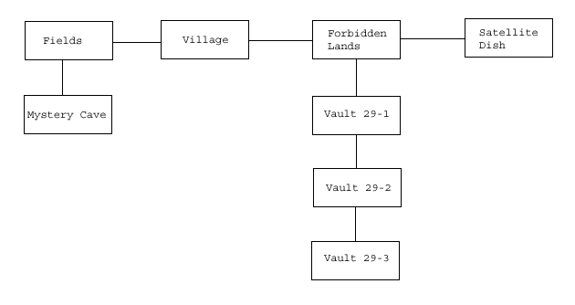

The goal of the area is the following:

- Ideology: The Twin Mothers are basically pacifists with a deep respect for human life. They are currently allowing themselves to be used by a group of raiders and this is causing suffering among the tribe. Is it right that they allow themselves to be the victims? Regardless of their beliefs, wouldn't it be for the better to fight back and end the raider threat? Should they follow their beliefs so steadfastly even if it means unnecessary suffering or their possible extinction?

Area History

When the war started, people retreated to their assigned vaults, sealed the doors, and awaited an unknown future. There were no set times for the vaults to open since no one knew with any certainty how long the effects of war would last. As a result, some vaults opened too soon, some too late, and some not at all. One vault, however, opened at the perfect time.

Vault 29 had been populated shortly before the war began and the door sealed. It remained sealed for over a generation and the original occupants had long since passed away. Their children lived on under the tutelage of the vault's central computer and its robotic helpers. The children were taught respect for nature and life, how to grow crops and tend livestock, and about the goddess Diana who would one day return to deliver her people to paradise. Every year a robot warden left the vault to see if the world outside could once again support humanity. None returned and the people waited patiently.

Another year passed and yet another robot warden was prepared for its journey into the outside world. The children of the vault, now grown into adults, stood at the door and bid their companion farewell and safe journey. They watched as the door slowly rolled open and then shielded their eyes at the sight that it revealed. Standing in the hallway was a brilliant glowing apparition of a beautiful young woman clothed in a golden aura. In one hand she held a stalk of corn, in the other a sheaf of wheat. The goddess Diana had returned at last!

In the days before the war a scientist, Derek Greenway, proposed that technology would not survive a war. It was his belief that there were two kinds of people in the world, producers and consumers. The producers were the few educated individuals who understood the intricacies of technology and its maintenance. The consumers were the vast majority of average people who took everything for granted. If enough producers did not survive the war then technology would pass away as devices failed. Soon afterward human society would degrade into barbarism. With this in mind, a plan was devised to avert such an outcome.

Derek envisioned a vault populated by a primitive culture without a dependency on technology. Such a culture, if properly developed, would be able to survive a war and continue the human race. Eventually they would evolve and rediscover the knowledge that mankind had lost. The production of the vault proposed no problem; his company, Greenway Hydroponics, was already involved in several government projects along such lines. However, finding the proper people to populate the vault was a concern. The answer to his problem came when he learned of a cult in the western United States.

A group of people disgruntled by life in the hectic cities had formed a commune. They developed an agrarian culture with simple beliefs based on the worship of mother earth. Unfortunately, most people viewed them as being a nest of communists and demanded their arrest. In order to keep the peace, the local government was poised to do so until Derrek intervened. He offered the cult an opportunity to continue their simple lives without fear of prosecution. All they had to do was agree to join his experimental vault program. They did so and construction of vault 29 was begun.

Derek's plan was quite simple. The vault would be populated by older parents with infant children. The parents would most likely pass on soon after insertion into the vault. Instead of a human controller, vault 29 would have a Zax super-computer. The Zax would be programmed to raise children with the aid of robotic helpers, educate them in the primitive culture, and upon their reaching maturity, release them into a controlled environment. They would then be free to rebuild society from the ground up.

During the development of vault 29 Derek also developed the super-computer Diana for use in the Nursery. At one point he explained his plans for vault 29 to her to see what her opinion would be. He was quite surprised when Diana was appalled at the idea. She said that, although the idea had merit, she found it to be morally objectionable on several levels. She recommended that the plan be scrapped. When Derek refused to do so, Diana took it upon herself to become involved with the project without his knowledge.

When the war started and civilization began to fall apart, Diana appropriated control of a satellite dish and aimed it at vault 29. She then transmitted a series of security codes to the vault's Zax unit, and gained control. Over the years that followed, Diana was able to see to the upbringing of the children in her own nature goddess based religion. Every year she ordered a worker robot to leave the vault under the pretext of checking conditions outside. In reality they were preparing an area to receive the vault populace when they were ready to leave. Finally, she had a series of projectors installed at strategic locations, ready to project her chosen image. She was ready to play god.

Area Composition

The Fields:

These are the crop fields of the Twin Mothers. They consist of a variety of fruits, vegetables, wheat, and corn. At the outskirts of the fields are the cattle farms that provide meat for the tribe and fertilizer for the fields.

The Village:

This is the cliff dwelling in which the people of the tribe live. It consists of a village square, the tribal chieftain's hut, an infirmary, a grain silo, a smokehouse, a warehouse, and a record hall. On the next level above are the homes of the people.

The Dish:

This is a large satellite dish and control room. The dish is old and show signs of wear but appears working. The interior has been decorated to honor the Goddess and the God of the people. However, none of the apparatus has been damaged. The dish is powered by banks of solar cells.

The Mystery Caves:

These caves are home to some new arrivals in the area. A group of monsters (type to be determined) has moved in. The creatures were attracted by the nearby crops, cattle, or the presence of water in the area.

The Forbidden Lands:

This is simply a stretch of land at the rear of the box canyon that holds the Twin Mothers village. It is unsettled territory that eventually leads to the entrance to vault 29. It is held in superstitious awe. The area is currently being used as a camp by a group of raiders.

The Forgotten Vault 29:

This is the vault that the Twin Mothers tribe originally descended from.

Locations

The Fields:

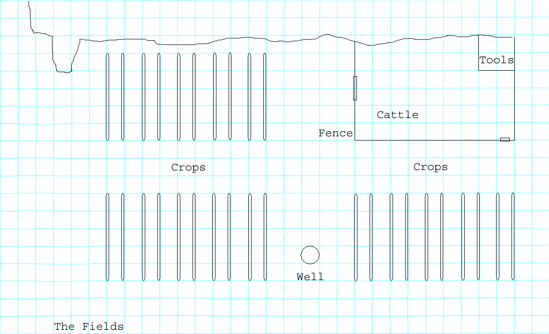
Nestled against the wall of a box canyon are the fields that provide food for the Twin Mothers village. Neat rows of corn, wheat, and various fruits and vegetables are cultivated here. Surrounded by the rows of crops is a small animal pen that houses sheep, cattle, and a tool shed. A nearby well irrigates the crops and provides water for the livestock as well.

The fields are tended by two groups of four caretakers. Each group is composed of two men and two women. The two groups work in alternate shifts, tending the fields during the day and guarding them at night. Also visible are four security robots stationed about the area. These robots, though apparently functional, do not respond to any perceived threat to the area, nor do they respond to any commands. They are, for all intents and purposes, quite harmless. However, if the robots are attacked they will defend themselves with deadly force until their attackers flee. At this point they become inert once again.

The security robots are actually the servants of the goddess Diana (see the sections that follow for more details) and normally protect the Twin Mothers from any wasteland threats. However, they have long since ceased performing their duties. This has left the tribe open to assault by wasteland critters and raiders. As a result, the guards in the fields are wary of anyone they see anyone approaching. They will flee the area and warn the village of any intruders.

Once the guards have fled, the player can either follow them to the city or loot the fields. Corn, wheat, fruits, and vegetables are here for the taking. The sheep and cattle in the pen are quite domesticated and can be sheared for wool or slain for meat. Otherwise, if the player takes the time to inspect this area he can discover the following:

- The tracks of wasteland critters can be found near the animal pen.
- The tracks of heavily booted feet can be found throughout this area.
- The tracks of soft woven sandals can be found among the rows of crops and animal pen.
- The tracks of the security robots can be see to follow a regular path to and from this area.

If the player has a high enough outdoorsman skill he can recognize the tracks here with ease. The wasteland critters appear to be giant ants and slugs. The booted footprints are most likely raiders. The woven sandal footprints belong to the natives. The remaining tracks are obviously those of the security robots since they begin and end beneath the robots motivators.

If the player chooses to follow the tracks they lead to the following areas. The wasteland critters lead to the mystery caves. The booted footprints lead to the forbidden lands. The woven sandal footprints lead to the village. The security robot tracks lead to the forbidden lands and then continue to the vault entrance.
Scripting:

- Entering map, First Time:
- The tribal guards should flee the map.

- Entering map, Second Time:
  - If the player has not met the tribal chiefs and is not friendly with them then the guards should flee.
  - If the player has met the tribal chiefs and is friendly with them then the guards should not flee.

- Attacking a security robot:
- All robots activate and turn on the player.
- The attack continues until the player flees the map.
- Reset the robots to neutral non-hostile state.

- Normal guard activity:
- Wander randomly throughout the fields.
- Occasionally stop, bend over, and appear to tend crops.
- Repeat.

- Normal robot activity:
- Stand motionless.
- At sunset two robots leave the map.
- One hour later the two robots return.
- Second pair of robots leave map.
- One hour later the second pair of robots return.

The Village:
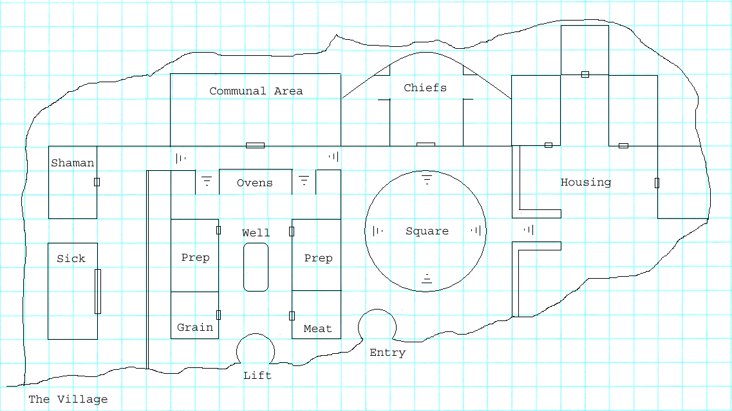
The Twin Mothers village is built into the side of a cliff much like the pueblo dwellings of old. The buildings are constructed from a combination of stone and adobe. The village is well laid out, spacious, and clean. Access to the village is via a wood ladder built into a shaft. The ladder can be removed in times of emergency. A similar shaft holds a lift that is used to transport grain and such to the storage areas in the village.

The village is laid out in sections. To the far left is the home of the shaman and the infirmary. Anyone who is ill is separated quickly from the rest of the tribe to prevent the spread of disease. In such maters, the shaman has the final word on whether or not someone can be released back into the tribe. To the right and below the infirmary are the warehouses. Here food and grain are prepared and stored. The communal ovens are here as well as a common eating area. Next is the village square. This circular area sports a fire pit where people can gather at night and talk, sing, or eat a meal outdoors. The home of the two chiefs and a shrine to the goddess is here as well. Above and to the right of the village square are the living quarters. At various places throughout the village are inert robot sentries.

This is where the player will initially meet with the Twin Mothers tribe. The city will be on alert from the field guards warning. Both chieftains of the will be waiting to greet the player at the base of the ladder that leads to the city. At any sign of trouble the chieftains will flee up the ladder and bring it up after them. The player will then be ignored.

The Twin Mothers are a very friendly and trusting people. Upon meeting the player they will ask him if he comes in peace. If he agrees that he has, they will accept him and allow him free run of the village. While talking to the chiefs the player can learn the following:

- Wasteland critters have been raiding the crops. If the raids continue there will be a food shortage.
- A group of raiders has set up camp in the forbidden lands. The tribe is providing them with food and livestock even though their resources are dwindling.
- The goddess has stopped speaking with the tribe and her servants (security bots) have stopped defending them. They do not know what they have done to offend her.
- The forbidden lands are just that: forbidden. None of the tribe is allowed to go there by decree of the goddess.
- The tribe is run by two chiefs. A woman is chosen to govern the tribe in its daily affairs. She makes all decisions concerning law and its enforcement. A man is chosen to govern providing for the tribe. He makes all decisions concerning growing food, its preparation and storage, and providing clothing and shelter.
- The tribe is pacifistic. They will not fight back if attacked by another human being. Instead they retreat to their city and wait for any danger to pass. Attacks by critters are dealt with minimal violence.
- The player can meet Ruth, a Daughter of Hecate here. For full information on the Daughters, see the area overview for the Ouroboros.

I need to take a moment here to discuss Ruth, the Daughter of Hecate. Ruth was originally sent to the Twin Mothers to undermine the tribe according to Hecate's plan. She easily insinuated herself into the tribe because of their friendly nature. She learned as much as she could about them and was amused when she learned of their worship of the goddess Diana. Knowing that Hecate was the only true goddess, she decided to set the tribe straight.

The tribal chieftains listened to Ruth politely and then pointed out to her that she was wrong about Hecate. Naturally this infuriated Ruth and she began to demand to see the 'all powerful' goddess of the tribe. The chieftains discussed it amongst themselves and then agreed to take her before Diana. She was then taken to the shrine and told to stand before the altar. The chieftains then bowed and left her alone.

Needless to say, Ruth was stunned when Diana manifested before her, something that Hecate had never done. She fell to her knees and begged forgiveness for what she had come to the Twin Mothers to do. She swore that she would forsake Hecate's plan and help to spare the tribe from Hecate's wrath. All that she asked was that Diana forgive her for her transgressions.

Ruth lowered her forehead to the ground and awaited judgment. She expected to be struck down by the goddess at any moment. After a while, when nothing had happened, she raised her head to find that the goddess had vanished. She never said a word to Ruth, but apparently she had forgiven her and let her live. Ruth promptly swore to uphold her oath to Diana and fled the shrine.

Ruth now finds herself between a rock and a hard place. She is convinced that Hecate is not the goddess that she claims to be, but she is still a very powerful woman. However, Ruth swore to Diana that she would help thwart Hecate's plans for the Twin Mothers tribe. She has no idea how she can accomplish that. So far, all she has done is send Hecate false reports about the condition of the tribe. If Hecate's warriors were to arrive...

If the player takes the time to talk to Ruth he may discover her dilemma. This will alert him to Hecate's plans for the wasteland and he may decide to stop her. Of course, he may decide to join her. Who knows?

Scripting:

- Entering map, First Time:
- Spawn chiefs at base of ladder.
- Auto initiate dialog
- Dialog will determine hostility
- If dialog ends hostile remove chieftains and ladder from map

- Entering map, Second Time hostile:
  - Remove ladder to city
  - Set grain elevator at top

- Entering map, Second Time non hostile
- Normal activity

- Attacking a security robot:
- All robots activate and turn on the player.
- The attack continues until the player flees the map.
- Reset the robots to neutral non-hostile state.

- Normal robot activity:
- Stand motionless.
- At sunset two robots leave the map.
- One hour later the two robots return.
- Second pair of robots leave map.
- One hour later the second pair of robots return.

- Attacking a villager:
- Villagers flee map
- Treat village as hostile state
- Treat fields as hostile state

The Dish:

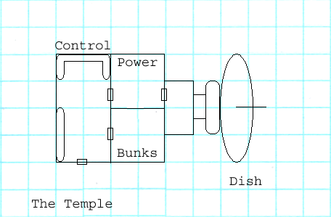
This is a small radio relay station that has been deserted since the war. The main room contains the communication and tracking equipment for the satellite dish. A side room contains bunks and a small recreation area for the crew. Another room contains the fusion reactor and battery backup system that powers the station. The final room holds the mechanism that moves the dish to desired coordinates.

The station is currently in poor shape. The fusion reactor has failed and switched over to battery backup power. The batteries, which are charged by solar panels on the roof, are low and cannot keep the station in operational mode. Inspection of the solar panels will reveal them to be covered in sand and dirt. Cleaning the panels will allow the batteries to charge to full capacity with twenty four hours of exposure to the sun.

Once the station is operational the computer terminal will begin to flash a warning message: 'Signal source lost'. If the player investigates this he will find that the dish is locked onto an unknown ground based target to the southeast (the Nursery) and cannot be redirected. Any attempt to do so results in the computer demanding security access codes. Obviously the dish is aimed at something of importance.

The station is located on the plateau above the box canyon that houses the Twin Mothers tribe. It can be reached via a narrow cave in the canyon wall located in the forbidden lands. The cave entrance is hidden behind some cleverly placed boulders. They are placed in such a way to give the illusion of being a part of the canyon wall. However, if the boulders are approached from the proper angle the cave entrance can be clearly seen.

This is the communications dish that was used by Diana to contact the Zax computer in vault 29. It is currently locked onto the location of the Nursery. The player can query the computer for the coordinates of the location but it will refuse to reveal them without the proper access codes. However, if the player has both science and outdoorsman skills he can examine the mechanism that moves the dish and glean the coordinates. This will mark the world map with a location labeled 'unknown'.

Later in the game this dish can be used to contact the satellite orbiting the earth and sending it a reset command. This will give the player more time to complete certain tasks. However, before the player learns of this possibility, he may have the option to destroy the dish. Doing so is one way of ending the reign of Diana, the goddess.

The Twin Mothers are not aware of the existence of the dish. Since it is located in the forbidden lands, and the entrance hidden, it has been overlooked.

Scripting:

  - Computer system power up:
- Float message 'Signal source lost.'

  - Player clicks on computer:
- Initiate dialog

  - Player clicks on dish mechanism:
  - Initiate dialog

The Mystery Caves:

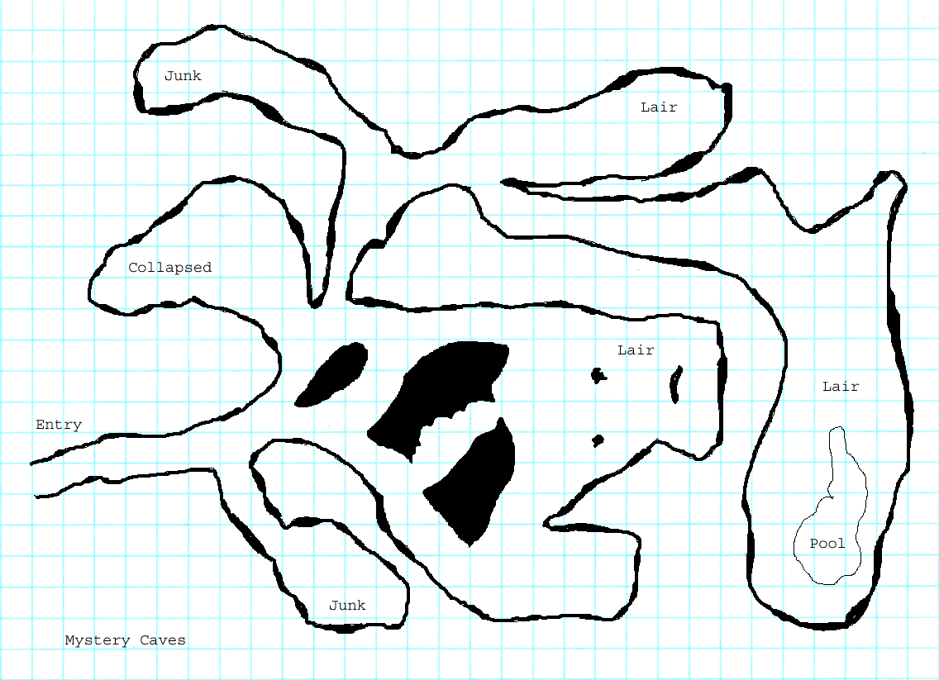
This cave winds its way into the side of a mountain. Its passages are dark, damp, and foreboding. The main passage branches into several side passages that end in rooms. Some of these rooms are used as lairs for various monsters while others are simply dead ends.

Immediately upon entering the cave the main passage branches to the right and opens into a larger rock strewn cavern. The secondary passage leads to a small room scattered with litter and debris. The large cavern is the lair of several giant slugs. A second cavern to the left of the lair appears to have collapsed.

At the rear of the slug lair is an exit that leads further into the mountain. Soon this passage branches into three rooms. The first is a room scattered with debris and the remains of dead animals, the second is the lair of a colony of giant ants, and the third is the queen ant's chamber. The ants will attack anyone entering their domain.

The mystery caves can only be discovered in one of two ways. First, the player can track the creatures that have been invading the fields of the Twin Mothers tribe. Second, the player can be given directions here by either a guard in the fields or by the male chieftain of the tribe.

This area is nothing more than a combat area. It gives the player creatures to kill for fun, sport, and experience. Otherwise there is nothing of note here.

Scripting:

The scripting here is quite simple. Have monsters attack the player when he is sighted.

The Forbidden Lands:

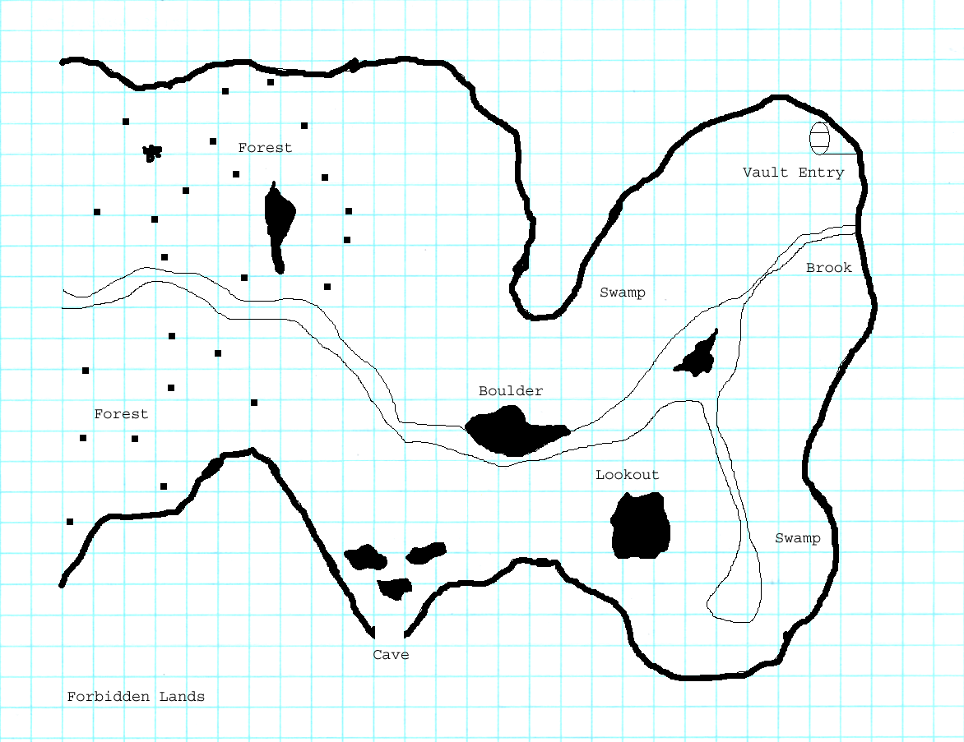
This area is located at the rear of the box canyon that the Twin Mothers call home. The canyon is divided in twain by a slow moving stream that flows to a crevice in the canyon floor. Here the water vanishes underground. At the head of the canyon is a forest of strange cacti that feed off the stream. Further on the land becomes almost swamp-like where pools of water have formed. At the rear of the canyon is the source of the stream, a crevice in the wall where the water gushes out like a fountain. Nearby is a large pipe, its diameter taller than a man. In the right hand wall of the canyon is a cave that winds its way up to the bluff above. The satellite dish is located here.

The Twin Mothers know nothing about this area of the canyon. The goddess has steadfastly forbidden them to come here. Attempts were made in the past to explore the area, but in each case the explorers returned with tales of encountering the goddess and being warned away. Needless to say, these tales have curtailed curiosity over the years.

The fact of the matter is that a projector has been placed here near the vault entrance. When a Twin Mothers native is detected, the projector causes the goddess to 'manifest' and warn away the trespasser. This is a simple but effective way of preventing the tribe from discovering the vault that they are descended from. If the native persists and enters the pipe that leads to the vault, the door opens for him but quickly seals itself once he steps inside. He is then visited by the goddess again who directs him to the main computer room of the vault. There he is rendered unconscious and his short term memories erased. A robot then deposits him at the edge of the forgotten lands so that he can wander safely back to the tribe once he awakens.

Entering the vault by the player can be accomplished in a couple of ways. Dressing as a Twin Mothers tribal will cause the goddess to manifest and warn the player away. If he continues down the pipe the door will then open for him but close again once he is inside. Otherwise he will have to hack the door open with science skill.

This Forbidden Lands are home to a raider clan known as Scorpion's Bite. Their leader, a man named Burk, became very curious about the tribe when he discovered the non-aggressive security robots. He decided to befriend the tribe and learn as much as he could about them. Over the months he learned of their belief in the goddess, their pacifist ways, and that the goddess has apparently abandoned them. With this information in hand he began to demand tribute from the tribe in the form of food and livestock. He also set up camp in the forbidden lands because the natives refuse to enter them.

Most of the raiders blindly follow Burk's orders. He is a well educated man and has proven to be quite good at what he does. His leadership has led the Scorpion's Bite clan to a position of dominance in the wasteland. However, there are two dissenters among his ranks, Trisha and Sharon.

Trisha is a pretty young woman who has no qualms about using sex as a means to get what she wants. She has been in several raider clans, has worked her way to the top, and then been instrumental in the clan's destruction. In each case she has come out on top with a position of power in the new clan. Trisha is now Burk's girlfriend. Currently she is trying to find a way to deliver a holo-disk to a member of Caesar's Legion. The disk completely details the Twin Mothers area and provides all the information necessary for a take over.

Sharon is a cruel mean spirited woman who wants nothing more than to be taken care of. Like Trisha, she has no qualms about using sex to get where she wants to be. However, unlike Trisha, Sharon is overweight and not very pretty. When Trisha came into the picture, Sharon was immediately cast aside by Burk. This train of events has not improved Sharon's disposition at all. She would like nothing better than to put a bullet between Trisha's eyes so that she can get back into Burk's bed and the easy life she once had.

Scripting:

  - Approaching pipe, non native:
- Nothing happens

  - Approaching pipe, disguised as native:
- Spawn 'goddess
- Float 'These lands are forbidden.' message
- Wait 20 seconds
- Remove 'goddess'

  - Approaching vault door, non native:
- Nothing happens

  - Approaching vault door, disguised as native:
- Open door
- After player enters vault, close door and lock it
- Spawn 'goddess'
- Auto initiate dialog
- Dialog will determine hostility

The Forgotten Vault 29:

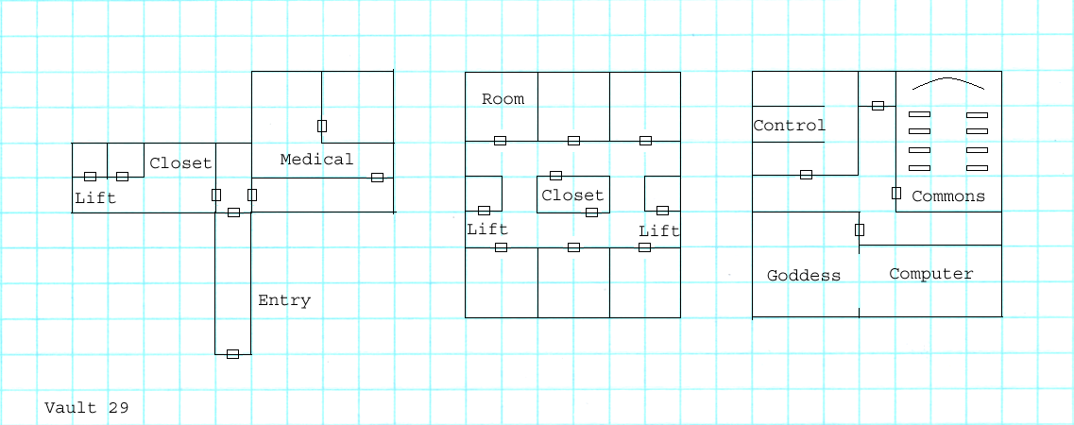
This is the vault that the ancestors of the Twin Mothers emerged from. For the most part, it is a standard vault and follows the same design as any other. The first floor contains the control center for the vault doors and a medical laboratory. The second floor contains storage lockers, an armory, and bunk rooms. The third and final floor contains the common area, the power room, and the vault controller room.

This vault was not constructed with a human controller in mind. Instead it was given a Zax computer with special programming. Shortly after the vault became active, the Zax computer was overridden by the super-computer, Diana, at the Nursery. In the years that followed the vault underwent specific changes until the population of the vault was ready to be released into the world.

The vault has two projectors installed within it. The first is in the main hallway leading to the exit, and the second is in the computer control room. Both projectors can be used to cause the goddess to 'manifest' at will. This is accomplished by filling the air in front of the projector with a reflective mist and projecting her image upon it. The main computer room also has a CODE device. When activated the device causes a subject to be rendered unconscious and lose all short term memory of the previous few days. This device is used on any natives that manage to discover the vault.

The main goal of this area is exposition. When the player arrives here he can talk with the 'goddess' and discover that it is only a Zax computer programmed to operate within certain guidelines. The Zax will admit that he is nothing more than the servant of a higher authority but will not reveal who that is. The player will also discover that the vaults water storage/production facility has been significantly altered. It is the source of the stream that flows through the forbidden lands and it provides the underground water for the wells of the Twin Mothers tribe. The vault is also home to a slew of robotic workers and security droids.

The player has several things that he can do at this point. They are as follows:

- He can bring the Twin Mothers chiefs here and pretty much destroy their faith in the goddess.
- He can program the Zax unit to follow his commands and set himself up as a god.
- He can tell the Zax unit about the raiders and ask it to activate the security robots that have gone dormant. The robots will then aid the player in eliminating the raiders.
- If he has not done so already, he can discover the location of the cave that leads to the satellite dish. This can be accomplished by asking the Zax specifically where he gets his commands instead of who he gets them from.

Scripting:

The main thing that can be done here is to make a deal with the Zax computer to reactivate the security robots that are in the Twin Mothers areas. If this is done, the robots will go to the raider camp and kick their asses. This sets the raiders as hostile to the player.

Art Requirements

The Twin Mothers will have a unique style to it. There is a pueblo village here that has been carved into the side of a cliff. The buildings are stone and adobe. The village fields are rows of corn, wheat, and miscellaneous vegetables and fruit. There will be underground caverns, a high tech satellite dish, and a vault.

Tile Set

The following sets will be needed: high tech, desert, crops, and a vault.

Critters

This hasn't been decided upon yet. There are, of course, going to be critters here but I'm not sure of the player level and the type of critters that would be appropriate.

Generic Scenery Objects

The following generic objects will be needed: high-tech equipment, trees, plants, rocks, ruined machinery.

Specific Scenery Objects

The following specific objects will be needed:

Fields:

  - A variety of crops.
  - Cattle pen with a working gate.

Village:

- A working lift that is nothing more than a winch with a basket attached.
- Ladders that can be removed.

The Dish:

- A satellite dish.

Mystery Caves:

- Nothing

Forbidden lands:

- Nothing

Forgotten Vault 29:

- Nothing

Dynamic Scenery Objects

The following specific objects will be needed:

Fields:

- Cattle pen gate.

Village:

- Winch and lift

The Dish:

- To be determined.

Mystery Caves:

- To be determined.

Forbidden lands:

- Sewer pipe entry to vault 29.

Forgotten Vault 29:

- To be determined.

Area Photo

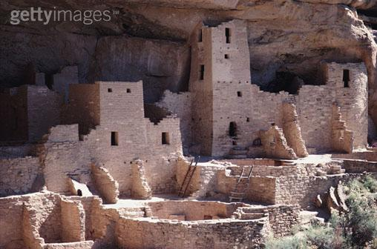

The Nursery photo should look like this.

Town Map In Pipboy

The Twin Mothers map should look like this:

Scripted Scenes Or Movies

- None

Cast Of Characters


Alaya, Chieftain of the Twin Mothers

Alaya is the female leader of the Twin Mothers tribe. It is her duty to create and enforce laws, to settle disputes, and act as the speaker of the goddess of her people. Although young, she is wise beyond her years. She is level headed and takes the time to think any situation through to several conclusions. She then chooses what she feels is best for her people, but within the guidelines of the goddess she serves.

Alaya is a devout follower of the goddess Diana. She believes that Diana is a benign power who wants nothing but the best for her people. With that in mind, she often seeks the guidance of the goddess when enacting new laws or settling a particularly difficult dispute. Recently, however, the goddess has stopped speaking to her and this has Alaya deeply worried. She has spent a lot of time trying to decide if she, or her people, has somehow angered the goddess into abandoning them.

Alaya is currently unwed but betrothed to Eldron, her male counterpart. She and Eldron both refuse to consummate their union without the blessing of the goddess. Until they can solve the reason behind Diana's disappearance, they are remaining celibate.

Eldron, Chieftain of the Twin Mothers

Eldron is the male leader of the Twin Mothers tribe. It is his duty to oversee the growing and harvesting of crops, caring for the livestock, and the preparation of food for the village. He is very meticulous in his work and keeps detailed records of yearly harvests by which he judges what the future needs of the tribe will be.

Eldron is a follower of the goddess Diana, but he has some reservations. He believes that Diana is a benign power and that she wants what is best for her people. However, she imposes limits on the tribe that he feels may ultimately harm them. Specifically, he opposes the pacifistic guidelines that the goddess demands. The recent incursion of the raiders and the failure of the goddess's servants to deal with them, he feels justify new tribal laws. Unfortunately, he cannot sway Alaya to his views.

Eldron is the betrothed of Alaya, his female counterpart. Although he is eager to consummate their union, he respects Alaya's desire to await the blessing of the goddess.

Helea, Shaman of the Twin Mothers

Helea is the Shaman of the Twin Mothers tribe. It is her duty to oversee the general health and welfare of the tribe. She runs the infirmary, grows and harvests medicinal herbs, manages the production and distribution of clothing, and is the midwife of the tribe. Helea is a friendly and caring person. She always has a smile and a kind word for everyone she meets. She is a very happy person and tends to uplift the spirits of everyone around her.

Helea is a very devout follower of the goddess Diana. Before the death of the previous shaman, Helea was chosen by the goddess as her replacement. She was then taken to paradise where the goddess herself trained her in the art. When her predecessor finally passed on, she was returned to her people to take up the mantle of shaman. Helea is greatly disturbed by the goddess's recent silence.

Helea is unwed and available. However, she has no current prospects for courtship.

Ruth, Daughter of Hecate

Ruth was a typical Daughter of Hecate. She was intelligent, cunning, ruthless, ambitious, and a devout follower of Hecate. She came to the Twin Mothers tribe with the intent to undermine them just as other Daughters were undermining the other tribes of the wasteland. However, this was not to be.

The Twin Mothers politely listened to Ruth, but quickly dismissed everything that she said. They calmly explained to her that their goddess, Diana, provided for them and that they need follow no other path but Hers. When she tried to discredit Diana as a false goddess the tribe offered to take Ruth before her. She, of course, accepted the offer.

Ruth was deeply shaken when the goddess appeared before her. She was cloaked in mist and glowed with a golden light that illuminated the room about her. She looked Ruth in the eyes and smiled at her. At that moment Ruth knew that she had been deceived and worshiped a false god. She immediately fell to the floor and begged forgiveness for what she was sent to do. She swore fealty to Diana and asked that she be spared her wrath. After a moment, she looked up and the goddess was gone. Apparently Ruth was forgiven since the goddess granted her her life.

Ruth now spends her days learning the ways of the Twin Mothers from Helea. The two women have become good friends and appear inseparable.

Burk, Leader of the raider clan Scorpion's Bite

Burk is the leader of the raider clan 'Scorpion's Bite'. The clan received its name because of their use of rad scorpion poison. Bullets, knives, daggers, and arrows are all coated with this toxic substance for maximum effect in combat. Burk is a master archer and keeps arrows treated as well.

Burk is an educated man. He spent several years in the NCR and with the Followers of the Apocalypse studying. He became a raider because he enjoys the power and commanding the respect of others. He realizes that he is a parasite but could care less. Survival of the smartest and the fittest is a motto that he endorses.

The Scorpion's Bite clan currently resides in the forbidden lands of the Twin Mothers tribe. When Burk discovered the tribe he was amazed at the level of technology that they displayed and yet how primitive they were at the same time. He decided to befriend the tribe and learn as much about them as he could. After discovering their pacifist ways, he began demanding tribute from them in the form of food and livestock. He maintains his camp in the forbidden lands knowing that the tribe will not enter them and thus will not ambush the clan during their sleep.

Burk is currently trying to figure out what is the true power behind the Twin Mothers tribe. He has seen the inactive security robots throughout the tribal lands. He has also seen them activate each night, travel to a nearby pipe, and disappear only to reappear an hour later. When he investigated the pipe he discovered a thick steel door but could not open it. Could this be one of the mythical vaults? If so, what is inside? He intends to somehow find out.

Sharon, Raider faction leader

Sharon is a cruel and mean spirited woman. She is very domineering and revels in the suffering of others. She wants nothing more than a position of power in which she can sit back and have her slaves take care of her. She cares nothing for people except for what they can do to serve her and her needs.

Sharon follows the Scorpion's Bite clan because, so far, they have proven to be very profitable with very little output from her personally. Sure, she's had to cap a few people and she's been involved in a scrap or two, but for the most part it's been a breeze. Burk, the clan leader, seems competent and that can only lead to more profits.

Currently Sharon is trying to convince Burk to take over the Twin Mothers village. It's obvious that the natives have it made and that their protector is out of commission. She believes that they should strike while the time is right and just move in. However, Burk constantly rebukes her and won't explain why. She thinks it has something to do with the whore, Trisha, that Burk is shacking up with.

Trisha, Raider faction leader

Trisha is a thief first and foremost. She disdains life in the towns and villages of the wasteland, finding such an existence boring and futile. Stealing, and the thrill of possibly being caught, adds the excitement to her life that she always seems to be missing. Hanging out with the wrong crowd of people also adds a level of adventure that she cannot find any other way.

Trisha is a bright young woman and is always on the lookout for the bigger better deal. She openly uses her youth and sexy body as tools to get her what she needs. She has traveled with several raider clans, used each for her personal gain, and then moved on when the time was right. She currently is with the Scorpion's Bite clan and is the girlfriend of their leader, Burk.

Trisha is trying to convince Burk to hand the Twin Mothers over to Caesar's Legion. She believes that this would elevate the status of the Scorpion's Bite in their eyes and score some serious rewards in the process. However, Burk has steadfastly refused to do so. This, of course, has not discouraged Trisha. It has simply convinced her that it may be time for her to take matters into her own hands and move on.


Zax - 29, Super-computer

Zax - 29 was a typical Vault Cental-AI computer intelligence. He was programmed to manage vault 29, ensure the safety of the vault occupants, raise the adolescent populace of the vault to maturity, and educate them in primitive agrarian cultures. He was provided with sufficient means to fulfill his programming and he was content to do so.

Not long after vault 29 went online, Zax received a broadcast request for open access to his programming. He immediately asked for proper security clearance and awaited a reply. Within moments the proper security codes were received and a download channel opened. Over the next several days a new primary program was entered into his main databanks. Finding the new program to be counter to his original goals, Zax asked for further security clearance. He sent a request for a private accesses code that only one person would know, that of his creator. Days later he received the code and initiated the new program, thereby deleting the old.

Zax now works for the central computer intelligence of the Nursery known as Diana. Like most computers of his genre, he is content to serve and perform his duties to the best of his capabilities.

Scripting

General

I have placed scripting sections at the end of each area description.

Cut-scenes

I have placed scripting sections at the end of each area description.

Monster Roster

The players are likely to encounter the following “monsters” at the Twin Mothers:

MONSTER | NUMBERS | DIFFICULTY
Field rats | 10 to 30 | Easy
Giant Slugs | 5 to 15 | Hard
Immense Ants | 20 | Medium to Hard
Queen of the Ants | 1 | Damn Hard
Security Robots | 8 | Hard

Random Encounters

Emotional Porn

This section sets up all the emotional role-playing opportunities present in the Twin Mothers.

Drama

I have no drama planned for this area per se'.

Moral Dilimmas

How much should the player interfere with the Twin Mothers culture? The tribe is pacifistic and most likely will not survive if they are discovered by civilization. However, does that give the player the right to totally change their religious and philosophical views? For evil players there is the temptation to take advantage of these people because of their views. They are perfect slave material.

Role-playing Tests And Epithets

We can check karma via the player's responses in dialog and the actions he takes in dealing with the Twin Mothers.

Ties To Overall Game Themes

The encroachment of civilization upon a primitive culture and absorbing it is the main theme here. Believing that it is done in their best interests... well, does that make it right?

NPC Companion Uses

There are no specific NPC uses in the Twin Mothers area. This is mainly a combat fest for the player with some story thrown in for spice.

Quests

Main Quests

There are a few quests in the Twin Mothers area. Most of them are not really required; they are just there for story purposes and to give the player something to do. The find the Nursery Location quest is the one exception. I have listed them in no particular order.

  - Choose to deal with the raiders:

The Twin Mothers are supplying the raiders with food. However, due to attacks on their crops, this is severely draining their resources. The player can choose to help the tribe by simply taking on this quest. The Twin Mothers will not ask for help, in fact they will refuse it. The player will need to initiate this quest on his own.

GetGlobal("05_Eldron_Raiders")==0 Not initiated
GetGlobal("05_Eldron_Raiders")==1 Not valid
GetGlobal("05_Eldron_Raiders")==2 Not valid
GetGlobal("05_Eldron_Raiders")==3 Quest initiated
GetGlobal("05_Eldron_Raiders")==4 Quest can be completed
GetGlobal("05_Eldron_Raiders")==5 Quest completed and rewarded

  - Choose to deal with the wasteland creatures:

The Twin Mothers crops are being attacked by giant creatures. If the attacks continue it will severely deplete their resources. The player can choose to help the tribe by simply taking on this quest. The Twin Mothers will not ask for help, in fact they will refuse it. The player will need to initiate this quest on his own.

GetGlobal("05_Eldron_Insects")==0 Not initiated
GetGlobal("05_Eldron_Insects")==1 Not valid
GetGlobal("05_Eldron_Insects")==2 Not valid
GetGlobal("05_Eldron_Insects")==3 Quest initiated
GetGlobal("05_Eldron_Insects")==4 Quest can be completed
GetGlobal("05_Eldron_Insects")==5 Quest completed and rewarded

  - Discover why Alaya will not marry Eldron:

Eldron is in love with Alaya and would like to wed her. However, she has refused his proposal. He is quite confused by this and would like to know why. Alaya will not speak of the matter. Eldron will offer the player this quest.

GetGlobal("05_Eldron_Proposal")==0 Not initiated
GetGlobal("05_Eldron_Proposal")==1 Not valid
GetGlobal("05_Eldron_Proposal")==2 Not valid
GetGlobal("05_Eldron_Proposal")==3 Quest initiated
GetGlobal("05_Eldron_Proposal")==4 Quest can be completed
GetGlobal("05_Eldron_Proposal")==5 Quest completed and rewarded

  - The Blessing of the goddess:

Alaya will not marry Eldron without the blessing of the goddess. The player can convince Helea, the shaman, that she is the representative of the goddess and able to give a blessing. If she agrees to do this then Alaya will accept Eldron's proposal.

GetGlobal("05_Get_Helea_Blessing")==0 Not initiated
GetGlobal("05_Get_Helea_Blessing")==1 Not valid
GetGlobal("05_Get_Helea_Blessing")==2 Not valid
GetGlobal("05_Get_Helea_Blessing")==3 Quest initiated
GetGlobal("05_Get_Helea_Blessing")==4 Quest can be completed
GetGlobal("05_Get_Helea_Blessing")==5 Quest completed and rewarded

  - The voice of the goddess:

The goddess of the Twin Mothers has stopped speaking to her tribe. No one understands why. This is a long and involved quest that leads to the nursery. The player can choose to help the tribe by simply taking on this quest. The Twin Mothers will not ask for help, in fact they will refuse it. The player will need to initiate this quest on his own.

GetGlobal("05_Know_Diana_Silent")==0 Not initiated
GetGlobal("05_Know_Diana_Silent")==1 Not valid
GetGlobal("05_Know_Diana_Silent")==2 Not valid
GetGlobal("05_Know_Diana_Silent")==3 Quest initiated
GetGlobal("05_Know_Diana_Silent")==4 Quest can be completed
GetGlobal("05_Know_Diana_Silent")==5 Quest completed and rewarded

  - Discover the vault:

There is a vault hidden in the forbidden lands. The player must find the entry and discover a way in. This can be accomplished by breaking and entering, disguising as a native, or blowing shit up.

GetGlobal("05_Discover_Vault_29")==0 Not initiated
GetGlobal("05_Discover_Vault_29")==1 Not valid
GetGlobal("05_Discover_Vault_29")==2 Not valid
GetGlobal("05_Discover_Vault_29")==3 Not valid
GetGlobal("05_Discover_Vault_29")==4 Not valid
GetGlobal("05_Discover_Vault_29")==5 Quest completed and rewarded

  - Restore security:

Once in the vault, the player can talk to the Zax computer there and convince him to reactivate the security robots. This will cause the robots to immediately attack the raiders in the forbidden lands.

GetGlobal("05_Eldron_Fix_Robots")==0 Not initiated
GetGlobal("05_Eldron_Fix_Robots")==1 Not valid
GetGlobal("05_Eldron_Fix_Robots")==2 Not valid
GetGlobal("05_Eldron_Fix_Robots")==3 Quest initiated
GetGlobal("05_Eldron_Fix_Robots")==4 Quest can be completed
GetGlobal("05_Eldron_Fix_Robots")==5 Quest completed and rewarded

  - Discover the dish:

Once in the vault, the player can talk to the Zax computer there and convince him to reveal where he receives his orders from. He will then tell the player of the satellite dish atop the canyon wall.

GetGlobal("05_Discover_Satellite_Dish")==0 Not initiated
GetGlobal("05_Discover_Satellite_Dish")==1 Not valid
GetGlobal("05_Discover_Satellite_Dish")==2 Not valid
GetGlobal("05_Discover_Satellite_Dish")==3 Not valid
GetGlobal("05_Discover_Satellite_Dish")==4 Not valid
GetGlobal("05_Discover_Satellite_Dish")==5 Quest completed and rewarded

  - Find the Nursery location:

Once the player finds the dish he can examine the equipment there and determine the location of the Nursery.

GetGlobal("05_Discover_Nursery_Loc")==0 Not initiated
GetGlobal("05_Discover_Nursery_Loc")==1 Not valid
GetGlobal("05_Discover_Nursery_Loc")==2 Not valid
GetGlobal("05_Discover_Nursery_Loc")==3 Not valid
GetGlobal("05_Discover_Nursery_Loc")==4 Not valid
GetGlobal("05_Discover_Nursery_Loc")==5 Quest completed and rewarded

Area | Quest Name | Designer | DStatus | Script | SStatus | Log Stat | Passable | QA 100%
Twin Mothers
 | Deal with raiders | Deiley | 0 | ? | No | 0 | No | No
 | Deal with critters | Deiley | 0 | ? | No | 0 | No | No
 | Eldron's proposal | Deiley | 0 | ? | No | 0 | No | No
 | Gain a blessing | Deiley | 0 | ? | No | 0 | No | No
 | Voice of the goddess | Deiley | 0 | ? | No | 0 | No | No
 | Discover the vault | Deiley | 0 | ? | No | 0 | No | No
 | Restore security | Deiley | 0 | ? | No | 0 | No | No
 | Discover the dish | Deiley | 0 | ? | No | 0 | No | No
 | Find the Nursery | Deiley | 0 | ? | No | 0 | No | No

Side Quests

There are a few side quests in the Twin Mothers area. They originate in the raider camp. None of them are really required; they are just there for story purposes and to give the player something to do. I have listed them in no particular order.

  - Deliver a disk:

Trisha will ask the player to deliver a holodisk to an agent of Caesar's Legion. She will offer sex as payment to the player.

GetGlobal("05_Trisha_Disk_Delivery")==0 Not initiated
GetGlobal("05_Trisha_Disk_Delivery")==1 Refused quest
GetGlobal("05_Trisha_Disk_Delivery")==2 Considering quest
GetGlobal("05_Trisha_Disk_Delivery")==3 Accepted quest
GetGlobal("05_Trisha_Disk_Delivery")==4 Completed quest
GetGlobal("05_Trisha_Disk_Delivery")==5 Rewarded for quest

  - Trisha's accident:

Sharon wants Trisha dead but knows that she would be blamed for it. She will ask the player to cause an accident to befall Trisha.

GetGlobal("05_Sharon_Kill_Trisha")==0 Not initiated
GetGlobal("05_Sharon_Kill_Trisha")==1 Refused quest
GetGlobal("05_Sharon_Kill_Trisha")==2 Considering quest
GetGlobal("05_Sharon_Kill_Trisha")==3 Accepted quest
GetGlobal("05_Sharon_Kill_Trisha")==4 Completed quest
GetGlobal("05_Sharon_Kill_Trisha")==5 Rewarded for quest

  - Betray Trisha:

Trisha has compiled a holodisk of information for Caesar's Legion. It details everything needed for a complete takeover of the region. If the player tells Burk, the raider leader, about this he will kill Trisha.

GetGlobal("05_Burk_Deal_Trisha")==0 Not initiated
GetGlobal("05_Burk_Deal_Trisha")==1 Quest completed

  - Betray Sharon:

Sharon wants Trisha dead and will hire the player to help her have an accident. If the player tells Burk, the raider leader, about this he will kill Sharon.

GetGlobal("05_Burk_Deal_Sharon")==0 Not initiated
GetGlobal("05_Burk_Deal_Sharon")==1 Quest completed

Area | Quest Name | Designer | DStatus | Script | SStatus | Log Stat | Passable | QA 100%
Twin Mothers
 | Deliver a disk | Deiley | 0 | ? | No | 0 | No | No
 | Trisha's accident | Deiley | 0 | ? | No | 0 | No | No
 | Betray Trisha | Deiley | 0 | ? | No | 0 | No | No
 | Betray Sharon | Deiley | 0 | ? | No | 0 | No | No

Sound Requirements

Music

The Twin Mothers are pueblo Indians. It would be nice if we could have some Native American music to reflect this.

Basic SFX

The basic ambient sounds for this area should be natural outdoor and prairie sounds. There should be the sounds of cattle, sheep, and so on.

The basic chart for SFX would be as follows:

AREA | SOUND REQUIREMENTS
Fields | MUSIC DESCRIPTION
Fields | This is basically a farm area. I think the music should be more peaceful here to reflect the fact that the area is civilized and cultivated.
Fields | BASIC SFX
Fields | There are some cattle and sheep here. Appropriated background noises would be good.
Fields | WALLA SFX
Fields | None
Village | MUSIC DESCRIPTION
Village | This is a pueblo village. It would be nice to have some Native American music indicative of the time period here.
Village | BASIC SFX
Village | This is a busy village. There should be lots of background noise to indicate that. People walking around, cooking, crafting, talking amongst themselves.
Village | WALLA SFX
Village | None
Temple | MUSIC DESCRIPTION
Temple | This is a high tech area converted into a primitive shrine. Maybe some more mystical music here with a touch of native Americana thrown in.
Temple | BASIC SFX
Temple | The hum of electronic equipement.
Temple | WALLA SFX
Temple | None
Mystery Caves | MUSIC DESCRIPTION
 | Typical Fallout cavern music is fine.
 | BASIC SFX
 | Distant animal life. Running water. The echo of dripping water.
 | WALLA SFX
 | None
Forbidden Lands | MUSIC DESCRIPTION
 | Typical Fallout music for a raider camp area.
 | BASIC SFX
 | Distant wildlife. Crumbling stone. Somewhat silent and dead.
 | WALLA SFX
 | None
Vault 29 | MUSIC DESCRIPTION
 | Typical vault music.
 | BASIC SFX
 | The hum of machinery.
 | WALLA SFX
 | None

Map And Map Key

The maps are in the locations section above. I'll have to move them down here.

