The Ouroboros

Version 1.0

9/12/2003 11:34:00 PM



"The Earth began to bellow, trees to dance, and howling dogs in glimmering light advance, ere Hekate came."

The Aeneid, book VL. Virgil.

Overview

The Ouroboros: Ahead of you lies a small village made from the scavenged ruins of the wasteland. Truck beds, trailers, and small metal buildings on wheels are haphazardly laid out before you. In the center of the village a pyramid of steel and tin rises out of the confusion. Surrounding the village is a wall of ruined steel and debris.

The Ouroboros is home to a raider clan known as the Hounds of Hecate (formerly the Vipers) and a religious organization known as the Daughters of Hecate. Both groups are run by a mysterious woman who claims to be the goddess Hecate herself incarnate.

The Hounds of Hecate are a fierce tribe comprised of male members only. They are well equipped and specialize in various forms of unarmed warfare. The elite of the Hounds are also well versed in the use of melee weapons. All members of the tribe have been known to consume strange poultices before battle. Afterwards, they fight like the devil and seem almost immune to pain and injury. The tribe is unwavering in its loyalty to their goddess, Hecate.

The Daughters of Hecate are a religious matriarchy who practices a primitive life/death/rebirth cult. The Daughters are well traveled and are versed in the art of midwifery, healing, and the making of potions and poultices. A Daughter of Hecate can be recognized by their dress, a floor length black robe with silver trim, the face paint that they wear, making one Daughter nearly indistinguishable from another, and their braided hair, often cropped at shoulder length.

MAP AREA | TRANSITION | MAP # | MAP SIZE | COMPLEXITY
Gate | Full Party |  | Small | Entryway, moat, wall
City | Full Party |  | Medium | City square with shops and markets
Pyramid | Full Party |  | Medium | Interior, several rooms

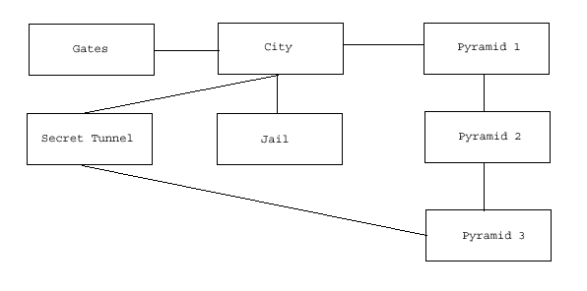

Area History

The Twisted Hair tribe was one of the most domineering tribes in the wasteland. They regularly raided their neighbors for food, supplies, and slaves. They were merciless in their efforts and the other tribes began to fear even the mention of their name.

It was during the reign of the Twisted Hairs that Caesar's Legion rose up. The Legion taught the tribes to fight back and the Twisted Hairs were soon driven from their lands. Weakened and on the retreat, the Twisted Hairs were then set upon by the Legion and destroyed. No one was spared, but one woman did manage to escape.

She wandered the desert passing from tribe to tribe trying to find someone who would take her in and give her a home. The tribes spurned her and turned her away. They told her that she was cursed, that the Legion had marked her, and that she would bring death to any who gave her succor. Consumed with anger and hatred she fled back into the desert from which she came. None of the tribes ever saw her again.

The wasteland consumed her. All that she was was lost to the unforgiving sun and the burning sands. Her mind left her and she forgot who she was. She felt parts of herself drifting away day by day until nothing remained. She fought to hold on to herself but to no avail... until she remembered the anger and the hatred. The Legion had taken all that was dear to her. The tribes had called her cursed, death maiden, dark mother... she would show them all... someday... Finally she paused in her wanderings, collapsed, and let the desert take her.

She awoke in paradise. She found herself at the edge of a lake surrounded by trees. Water fell from the sky in torrents and filled the lake as waves rolled across its surface. Everywhere she looked the world was green. Plants and trees that she had never seen before stretched as far as the eye could see. And from among the trees strange animals gazed at her, their eyes filled with curiosity, not the hunger of the wasteland.

As she stood looking across the landscape she heard a whirring sound behind her. When she turned to look, she saw a shinning metallic thing, watching her.

"I see that you are awake at last," it said with a woman's voice. "I am Diana. Can you tell me your name?"

"I... I don't..." She paused as she tried to remember who she was, struggling with the blackness that was her mind. "Dark Mother," she blurted at last. "They called me the Dark Mother."

"Did they, now? Well, I shall call you Hecate then. Do you mind?"

"Hecate..."

"Yes. Forgive me, I know you don't understand, but I find it amusing. You see, I am Diana and she was the goddess of the full, or bright moon. Hecate was her opposite, the goddess of the new, or dark moon. She was also known as the Dark Mother. So, I thought I would christen you Hecate."

"Goddesses?"

"Yes. Both were goddesses of the moon... Forgive me; I must be confusing you to no end. I've been alone for centuries and I find myself babbling now that I have someone to talk to. Come. Let me show you my world and we will talk and get to know one another. There is much that we can learn from each other."

Hecate gazed at the shinning one, nodded, and began to walk with... her. She had found paradise, a goddess, and had been elevated to the status of an equal. Now she was being offered knowledge. It was knowledge with which to gain vengeance over those who had wronged her.

When Hecate had collapsed in the desert she was near death from dehydration and heat stroke. Fortunately for her, she was near the Nursery when she collapsed. Diana had been performing a routine survey of the Nursery surroundings when she saw the tribal lying in the sand. She immediately dispatched a worker robot to collect her and bring her back. She spent the next couple weeks tending her until she regained consciousness.

Diana spent the next several months teaching Hecate about herbs, plants, and their uses in treating ailments. She also spoke of breeding among animals, what to look for to ensure strong future stock, and how to recognize congenital traits that could be eliminated by proper breeding. When Hecate asked if the same technique could be applied to humans, Diana admitted that it could, but spoke of the virtues of love and free choice. She did not realize that her words now fell upon deaf ears.

Diana did not realize that Hecate had sunk into madness. In her loneliness and innocence she continued to teach her everything that she asked for, and Hecate absorbed it all and twisted it to suit her own needs and desires. Eventually she told Diana that she needed to leave, but would someday return when the time was right for her to do so.

Hecate braided her hair in the fashion of her lost tribe, and then painted her face so that none could recognize her. She traveled to the very same tribes that had rejected her and aided them with her new found knowledge of midwifery and herbal medicine. Once she gained the trust of a tribe, she began to preach her life/death/rebirth religion. She asked that young women of the tribe join her and aid her in helping all the tribes of the wasteland. Thus the Daughters of Hecate were born.

Eventually the Daughters began to decide who could marry and who could not, who could have children and who could not. Only a Daughter was allowed to deliver a child into the world and it was done in a birthing tent set apart from the rest of the tribe. No males were allowed in or near the tent. Anyone who disobeyed their edict was either stricken with impotence or their wives bore sickly children. If a Daughter was ever harmed or killed the, men of the tribe were rendered impotent until a new Daughter was assigned to them. And so the Daughters grew in power and infamy.

Unbeknown to the tribes, the Daughters were taking the best of their children and replacing them with the weak or infirm. The best of the males were taken to the Ouroboros to become warriors in the Hounds of Hecate. The best of the females were taken to become Daughters. Over the years Hecate watched as the tribes grew subtly weaker and her followers grew stronger and stronger. Soon, vengeance would be hers.

Her plan was simple. When the tribes were weak enough, her Hounds would sweep down upon them and annihilate them from the face of the earth. The same would come to pass with Caesar and his legion. When all who had wronged her were gone, she and her people would march upon paradise and reclaim it as their just reward.

Area Composition

The Gate:

This is a fortified gatehouse that allows egress to and from the city.

The City:

This is the market place of the city. It is here that people come to buy goods such as slaves, potions, poultices, or the services of a Daughter of Hecate.

The Pyramid:

This building is the religious center of the city. It houses the ritual baths, the conjugal rooms, common rooms, and kitchen on the first floor, the elite guard barracks on the second floor, and Hecate's private chambers on the third floor.

Locations

The Gate:

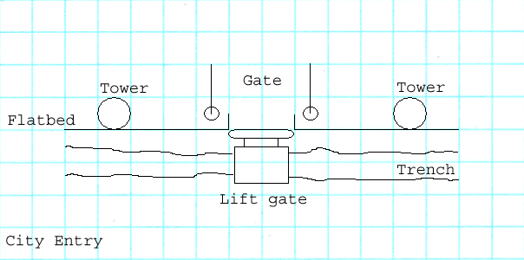
The city of Ouroboros is very well protected. The city itself is surrounded by a wall composed of flatbed trailers lying on their side. Just outside the wall is a trench filled with junk and debris of various shapes and sizes. The city gates are made from a flatbed cut in half and then mounted on the axle of yet another flatbed. A lift-gate from a truck spans the trench at the gate. Rising above the wall on either side of the gate is a small watch tower. Guards are stationed in the watch towers at all times. Another guard is stationed at the lift-gate.

The guards watch for any large forces approaching the city. If one is spotted then the lift-gate is raised and the gates sealed. The defenders then try to outlast the siege. There is ample food and water stored in the city to last for a month or more. This should be long enough to outlast any attackers who do not have well established supply lines. Small groups or individuals are allowed to approach and enter the city without any hindrance.

If they player takes the time to explore this area thoroughly he will discover an NCR ranger hiding nearby. Talking to the ranger will reveal that he has been scoping out Ouroboros for a possible raid to free the slaves trapped within the city. The ranger will ask the player to open the gates of the city at night so that his group can manage this.

The City:

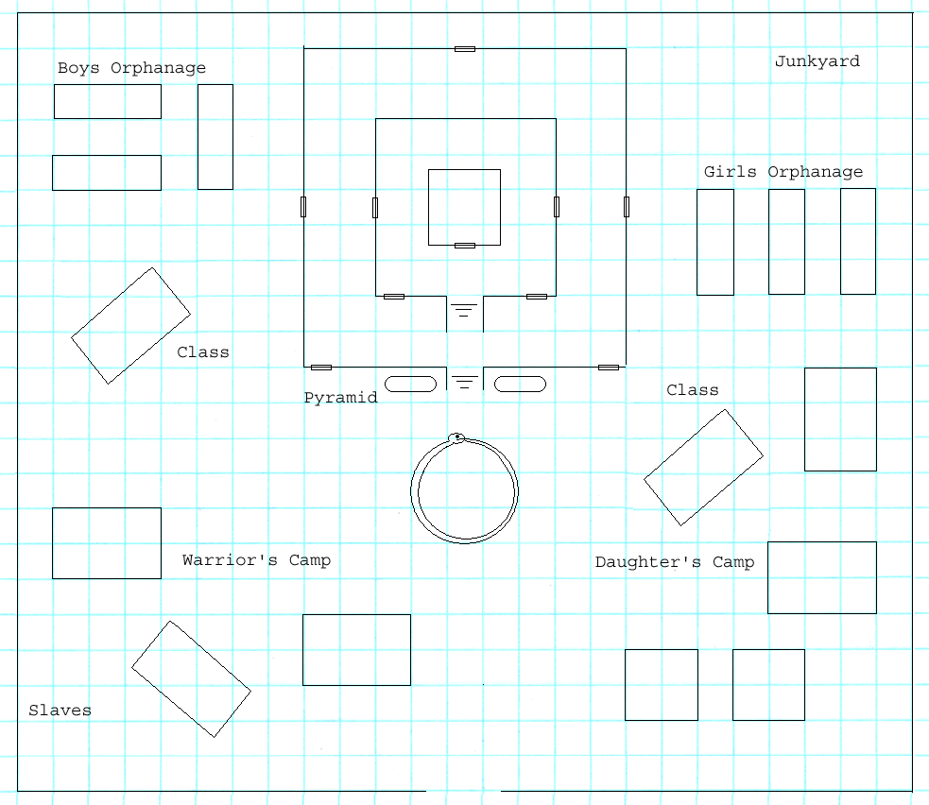

The city of Ouroboros is surrounded by a wall constructed from the undercarriages of semi-truck trailers. The buildings of the city appear to be constructed from the upper remains of the trailers, truck beds, and travel trailers of various shapes and sizes. These buildings are laid out rather haphazardly, showing no rhyme or reason. Rising up out of the city is a three story steel pyramid. Two large braziers illuminate the front of the building at all times. On the ground before the pyramid is an inlaid mosaic constructed of colored steel. It depicts a snake biting its own tail.

The left half of the city is dedicated to the Hounds of Hecate. The warriors generally camp out in the open in small groups. The officers and elite of the Hounds are allowed communal buildings which they share. Three long narrow travel trailers here house the boy's orphanage. A larger semi-truck trailer is used as a classroom where they are taught the religion of Hecate and the art of war. Huddled in one corner of the wall here is a slave camp.

The right half of the city is dedicated to the Daughters of Hecate. The sisters are allowed to sleep in the common area of the pyramid and therefore need no outdoor camps. However, the elite of the sisterhood have private quarters along the lines of those provided for the warriors. The girl's orphanage is here, as well as a classroom where they learn herbalism, midwifery, and husbandry. A building behind the classroom is used for the brewing of potions and poultices.
The pyramid is the holy of holies in the city. It is here that the religious rites of the Ouroboros are practiced. It is also home to the elite guard of Hecate and the goddess herself.

The junkyard is exactly that. Here lie the ruins of cars, trucks, boats, airplanes, and just about anything else that can be imagined. This scrap is used in the construction of the walls and other elements of the city. Hidden within this pile of junk is a jail. Imprisoned within the jail is a Follower of the Apocalypse named Adrian Beyr. He requested an audience with Hecate and she granted it out of curiosity. He made the mistake, however, of quoting the Aeneid about the true goddess Hecate. His words were considered blasphemy and the Daughters had him incarcerated.

Visitors are allowed to enter the city for the purposes of speaking with the Daughters. They can be consulted about herbal medicines, breeding of Brahmin livestock, or obtaining a Daughter for their village. They may also request an audience with Hecate, but few are ever granted. Visitors are not, however, allowed to wander around freely. Some areas, the orphanages and classrooms, are off limits. Anyone attempting to enter these areas is turned away.

There are a few things for the player to do in the city.

- Request an audience with Hecate

Hecate will grant the player an audience out of sheer curiosity. If he behaves himself he can learn all her history and her plans for conquest. The player can also receive a quest to remove Caesar's Legion agents from various areas in the game.

- Aid in the rescue of the slaves

Perhaps, through dialog, the player can expose Hecate as a fraud. I'm not sure how to work this at this time but I want to put it on this list.

- Expose Hecate as a fraud

The player can remove the night gate guards and open the gates for the NCR Rangers to free the slaves.

- Distribute plague cure

The player could have a plague vaccine from the Nursery. If that is the case then he could insinuate it into the Daughters brews and it would unknowingly be spread throughout the tribes.

- Rescue Adrian Beyr

The player can free Adrian from his prison and sneak him out of the city at night.

- Play matchmaker

Two of the city's major players, Jordan and Yvanna, are looking for a mate. The player can make a match.

The Pyramid:

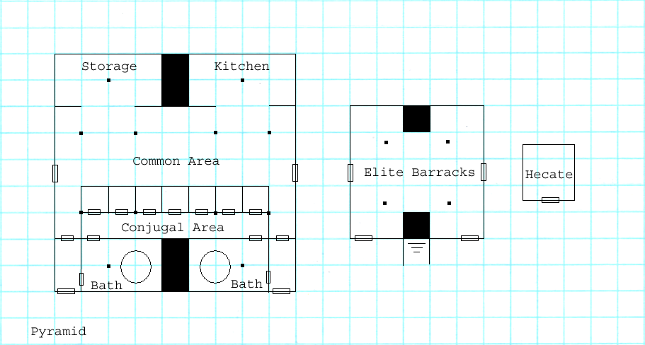

This is the religious center of the Ouroboros. The ground floor holds ritual baths for males and females, the conjugal meeting room, and private bedrooms. There is a multi-purpose common area where meals are served and at night it is used for sleeping quarters by the Daughters. A storage area contains foodstuffs, potions, poultices, and clothing. A well stocked kitchen is here. The second floor holds the barracks for Hecate's elite guard. The third and final floor is Hecate's private bedroom.

One thing not shown on the map is an escape tunnel that Hecate had installed in her bedroom. By pulling a lever on the back wall, the floor under the lever pivots and dumps whoever is standing there in a chute that leads to secret door at the rear of the pyramid on the first floor. A tunnel beyond the door leads under the city wall and out into the desert.

Art Requirements

The Ouroboros will not have a unique style to it. We can use the junktown tile set with a few modifications to it to account for the trailer trash look of the town. Also, the pyramid is a steel jungle pieced together from trash. However, the inside of it could resemble the vault tile set. Perhaps a retexture of that would be in order.

Tile Set

The following sets will be needed: junk town, desert, crops, and a vault-like set. Need 'trailer parts' added to the set.

Critters

Other than domesticated animals there are no critters here. The area is populated by Hecate, the Hounds of Hecate, and the Daughters of Hecate.

Generic Scenery Objects

The following generic objects will be needed: desert trees, plants, rocks, ruined machinery, and lots of junk.

Specific Scenery Objects

The following specific objects will be needed:

Gate:

  - Entry gate comprised of a 'hollowed out semi-truck and trailer.
  - City wall comprised of the undercarriage of semi-truck trailers.
  - A bicycle with a gear up mechanism attached to an electric generator (ridden by a slave)

City:

- There will most likely be some pens here for animals and slaves.
- A bicycle with a gear up mechanism attached to an electric generator (ridden by a slave)

Pyramid:

- Nothing

Dynamic Scenery Objects

The following specific objects will be needed:

Gate:

- Entry gate
- Sections of the city wall

City:

- The gates on the slave and animal pens.

Pyramid:

- Nothing

Area Photo

The Ouroboros photo should look like this.

Town Map In Pipboy

The Ouroboros map should look like this:

Scripted Scenes Or Movies

- None

Cast Of Characters

Hecate, the Dark Mother
Hecate is quite insane. She truly believes herself to be the goddess Hecate, the Dark Mother, the goddess of death and rebirth. She believes that she died in the desert of the wasteland, was reborn, and elevated to the status of a god. She has no memory of her past or who she was. However, she harbors a burning hatred for all wasteland tribes and Caesar's Legion.

When she was a young woman Caesar's Legion attacked and destroyed her tribe, the Twisted Hairs. Hecate, as she is now known, was the only survivor. She wandered the desert, traveling from tribe to tribe, to try and find someone who would take her in. Every tribe turned her away. No one wanted her among them in case Caesar came looking for her and found her. After days of travel in the desert with no food or water, Hecate collapsed and gave herself to death.

When she awoke she found herself in paradise, brought back from the dead by the goddess Diana. The goddess named her Hecate, blessed her with divinity, and passed her knowledge onto her. When Hecate asked to return to the world of men, her request was granted. Now, she is a goddess incarnate.


Adrian Beyr, Follower of the Apocalypse

Adrian Beyr is a very learned man. He has spent the majority of his life traveling the wasteland, digging through ruins of cities, searching for the written knowledge of the ancients. Over the years, he has found hundreds of books and holo-disks, and taken it upon himself to read every one of them. It is through his reading that he finds pleasure and purpose in life. Adrian joined the Followers so that he would have a safe depository for the works that he found, and a safe place to return to when he desired to read them again.

During his travels Adrian heard about the Ouroboros and its resident goddess, Hecate. Intrigued, he decided to visit and request an audience. Much to his surprise, his request was granted and he found himself standing before Hecate. Unfortunately, Adrian made the mistake of quoting Greek mythology about the goddess Hecate and found himself imprisoned. He has no idea what he said to cause his predicament.

Jordan Dae, Elite Hound of Hecate
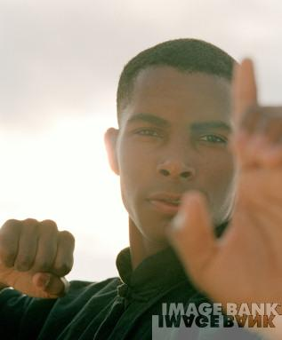
Jordon is captain of the elite city guard. He is a stern young man, devoid of any sense of humor. He takes his duty seriously and is unwavering in his loyalty to the city and the goddess that he serves. Jordan was raised in the city orphanage since the age of three years. He knows nothing of the outside world, other than what his instructors have told him, and has never traveled beyond the city walls.

It is Jordan's dream to one day serve the goddess Hecate herself as one of her elite guards. To this end he is never remiss in his duties and even reports for work when ill. Only the insistence of the Daughters has caused him to miss a day of work. Jordan is so fanatical in his devotion that nothing can sway him from his duty. He reports anyone who attempts to do so.

Jordan is currently hoping to be chosen in an upcoming mating ritual by the Daughter Yvana. He is quite taken by her and believes that they will sire a male child who will be the envy of all others. He is considering approaching Yvana, but has been unable to do so.

Yvana, Select Daughter of Hecate
Yvana is one of the Select Daughters of Hecate. As such she enjoys the privileges of being a city leader and having quarters of her own. She is also allowed personal audiences with the goddess to discuss matters of state and faith. This pleases Yvana immensely.

Yvana is ambitious but fair. She did not attain her position through unscrupulous means and it was this fact that brought her to Hecate's attention. Yvana is truly dedicated, devout and competent. But most of all, she can be trusted. She is every dictator's dream.

Currently, Yvana spends her time coordinating all the lesser Daughters in their efforts to undermine the tribes. She handles the stocking of the orphanages and writes detailed reports on the training of both new Hounds and Daughters. Her latest task is deciding who will participate in the upcoming mating ritual. She has decided to join the ritual herself, but is indecisive on whom to choose to father her child.

Scripting

General

I have placed scripting sections at the end of each area description.

Cut-scenes

I have placed scripting sections at the end of each area description.

Monster Roster

The players are likely to encounter the following “monsters” at the Twin Mothers:

MONSTER | NUMBERS | DIFFICULTY
Hounds of Hecate | 30+ | Medium to hard
Daughters of Hecate | 30+ | Medium to hard
Hecate's Select | 6 | Hard
Hecate's Chosen | 6 | Hard
Hecate's Guard Hounds | 2 | Hard

Random Encounters

Emotional Porn

This section sets up all the emotional role-playing opportunities present in the Twin Mothers.

Drama

Hecate hates the tribes of the wasteland and has passed this hatred on to her subjects. If the player enters this area with tribals in his party then the Hounds and Daughters will be rude and belligerent to him. If not handled with care, violence could break out.

Moral Dilimmas

Hecate is trying to destroy the tribes of the wasteland and produce a 'superior' race via her cross breeding experiments. The fact of the matter is that her superior race is indeed superior and does have a better chance of surviving the rigors of the world and the plague. Does the end justify the means? Should the individual tribes be replaced by a conglomerate race? Should natural evolution and survival of the fittest be restored?

Role-playing Tests And Epithets

We can check karma via the player's responses in dialog and the actions he takes in dealing with the Twin Mothers.

Ties To Overall Game Themes

Hecate's Daughters will be mentioned throughout the game.

NPC Companion Uses

There are no specific NPC uses in the Twin Mothers area. This is mainly a combat fest for the player with some story thrown in for spice.

Quests

Main Quests

There are a few quests in the Ouroboros area. Most of them are not really required; they are just there for story purposes and to give the player something to do. I have listed them in no particular order.

  - Caesar's Legion agents:

Hecate will ask the player to remove agents of the Legion from specific areas. She is worried that they are collecting information on her and her Daughters..

  - Open the gates:

An NCR Ranger will ask the player to open the city gates at night so that a slave rescue mission can proceed.

  - Expose Hecate:

The player could expose Hecate as nothing more that a madwoman with a plan to dominate the wasteland.

  - Plague cure:

The player could receive a cure for the plague from the Nursery. Adding this cure to the medicines that the Daughters distribute throughout the tribes would be a good thing.

  - Rescue Adrian:

Adrian Beyr will ask the player to free him from his prison. This could be accomplished via dialog with Hecate or by sneaking Adrian out of the city at night.

  - Play matchmaker:

The player can act as a go between for Jordan and Yvanna and arrange their 'marriage'.

Merchant Quests

There are no merchant quests in this area.

Floating Quests

There are no floating quests in this area.

Area | Quest Name | Designer | DStatus | Script | SStatus | Log Stat | Passable | QA 100%
Ouroboros
 | Remove agents | Deiley | 0 | ? | No | 0 | No | No
 | Open the gates | Deiley | 0 | ? | No | 0 | No | No
 | Expose Hecate | Deiley | 0 | ? | No | 0 | No | No
 | Plague cure | Deiley | 0 | ? | No | 0 | No | No
 | Rescue Adrian | Deiley | 0 | ? | No | 0 | No | No
 | Play Matchmaker | Deiley | 0 | ? | No | 0 | No | No

Sound Requirements

Music

The Ouroboros is home to one of the toughest tribes in the game. It is also the home to a woman who believes herself to be the incarnation of a Greek goddess. It would be nice if we could have some native Greek-like music to reflect this.

Basic SFX

The basic ambient sounds for this area should be occupied village sounds.

The basic chart for SFX would be as follows:

AREA | SOUND REQUIREMENTS
City Entry | MUSIC DESCRIPTION
City Entry | This area is a lot like the junktown entry of the original game. We could reuse the music from that area.
City Entry | BASIC SFX
City Entry | General background desert noises
City Entry | WALLA SFX
City Entry | None
City Square | MUSIC DESCRIPTION
City Square | This is a large common area. It would be nice to have some sort of busy music to reflect this.
City Square | BASIC SFX
City Square | This is a busy village. There should be lots of background noise to indicate that. People walking around, cooking, crafting, talking amongst themselves.
City Square | WALLA SFX
City Square | None
The Hounds | MUSIC DESCRIPTION
The Hounds | This area is home to the male members of the city. They are warriors so maybe some dangerous type music here.
The Hounds | BASIC SFX
The Hounds | Basic sounds of an occupied area of a village.
The Hounds | WALLA SFX
The Hounds | None
The Daughters | MUSIC DESCRIPTION
The Daughters | This area is home to the female members of the city. They are priestesses so maybe some divine type music here.
The Daughters | BASIC SFX
The Daughters | Basic sounds of an occupied area of a village.
The Daughters | WALLA SFX
The Daughters | None
Pyramid I | MUSIC DESCRIPTION
Pyramid I | This is a breeding area and a child birth area. There are also so labs here. I'd like the music to be kind of clinical and not romantic. The inhabitants here are not romantic in the least.
Pyramid I | BASIC SFX
Pyramid I | Typical indoor sounds with nothing special for the area.
Pyramid I | WALLA SFX
Pyramid I | None
Pyramid II | MUSIC DESCRIPTION
Pyramid II | This is a guard barracks and the music should be more militant and reflect this.
Pyramid II | BASIC SFX
Pyramid II | Typical indoor sounds with nothing special for the area.
Pyramid II | WALLA SFX
Pyramid II | None
Pyramid III | MUSIC DESCRIPTION
Pyramid III | This is the living chamber of a Greek Goddess. The music should be somewhat grand to reflect this. However, the woman is stark raving bonkers so the music should also have a not so right twist to it that just isn't right. Something to set the player on edge.
Pyramid III | BASIC SFX
Pyramid III | Typical indoor sounds with nothing special for the area.
Pyramid III | WALLA SFX
Pyramid III | None

Map And Map Key

The maps are in the locations section above. I'll have to move them down here.

