Jericho

Version 3

11/10/2003 10:56:00 PM

OVERVIEW

The distant community of Jericho is located near the shore of the Great Salt Lake. It was once the Jericho Water Plant and part of the larger town of New Canaan, but that town was destroyed seven years ago by rioting refugees from the war in the west. Jericho is a rough frontier town, but Sheriff O'Connor keeps a firm grasp on the town. The water desalination plant is the source of Jericho's prosperity, and brahmin-pulled water caravans from Jericho are becoming an increasingly common sight in the wasteland.

Science Boys will have a great deal to do in this area, since the water plant is ancient and only producing water at a quarter of its capabilities. Repairing and upgrading the plant will do wonders for the town. There are also some fighting jobs for Combat Boys, and Stealth and Charisma Boys can learn the terrible secret hidden in Jericho's past.

MAP AREA | TRANSITION | MAP NAME | MAP SIZE | COMPLEXITY
1. Jericho Town | Full Party |  | Medium | Junktown tileset
2. Union Station | Full Party |  | Small | Junktown tileset
3. Jericho Sewers | Full Party |  | Medium | Sewers tileset
4. Fallout Shelter | Full Party |  | Small | Vault tileset
5. Mormon Camp | Full Party |  | Small | Junktown tileset

MAP FLOW

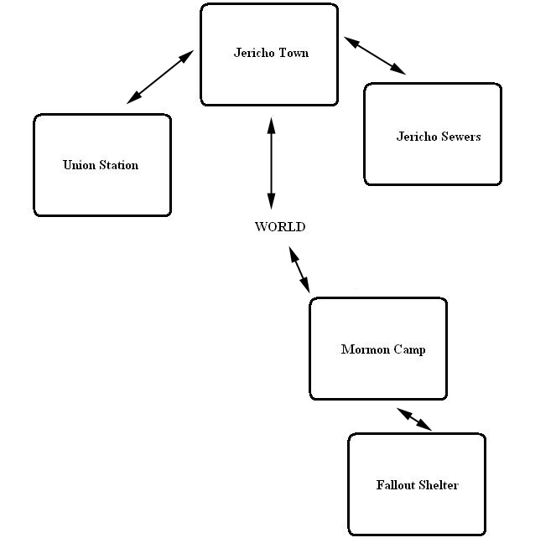

AREA BACKGROUND

The Jericho Water Plant is all that remains of the Mormon city of New Canaan. The Mormons had struggled to be a moral center for the wasteland, outlawing drugs, alcohol, and slavery, as well as offering their own limited resources to refugees from the war in the west. The Mormons' charity proved to be their downfall. Due to constant incidents of "immoral" behavior, the Mormons kept all non-Mormons outside the town walls. The refugees grew in number, and the Mormons could not give away as much food and water as they once did. Hothead refugees spread the false belief that the Mormons were living like kings inside their walls while everyone else suffered, and a large number of refugees battered down New Canaan's gates and overran the small Mormon militia one evening, and in a single night of arson, rape, and murder, New Canaan ceased to exist. The Jericho plant itself survived only because a number of refugees who wanted nothing to do with the slaughter in New Canaan barricaded themselves inside it, keeping everyone else outside, even terrified Mormons who were screaming to them for help.

Nowadays, the water plant is the centerpiece of a small community, and not surprisingly, the community's chief export is fresh water. The scarcity of water in the wasteland has proven to be quite profitable to Jericho, and the town is thriving.

YEAR | EVENT
2077 | The War happens.
2235 | The town of New Canaan is founded on the ruins of Ogden, Utah.
2244 | Refugees begin arriving in large numbers, telling stories about a war in the west.
2246 | Many disgruntled and desperate refugees storm New Canaan's gates and overwhelm the Canaanite militia, certain the Mormons are hoarding food and water while everyone outside the city walls suffers and dies. Most of the Mormons are slaughtered. The survivors scatter into the desert.
2247 | The town of Jericho arises from the ashes of New Canaan around the water plant, established by ex-New Canaan sheriff Mike O'Connor. The town reactivates the plant and begins exporting water to the rest of the wasteland.
2252 | Jeremiah Rigdon has a vision in which God commands him to wipe Jericho from the face of the earth so that the Mormons can rise again. The Mormons regroup, and the Hands of God begin raiding Jericho's water caravans, weakening the town in preparation for the day of reckoning.
2253, October 23 | "The Prisoner" escapes from Leavenworth, dooming the world and creating a holocaust of epic proportions. | F3 Begins

EMOTIONAL PORN

DRAMA

Many of Jericho's current citizens were around during the fall of New Canaan; some of them even took part in the slaughter and looting. An air of guilt hangs over the town like a miasma. In fact, the town feels a lot like Lago in High Plains Drifter (the citizens of that mining town didn't lift a finger to help their sheriff when they saw him being murdered, and now a sense of guilt pervades everything in town).

NPC ALLY DRAMA

Battery (Pending)

MORAL DILEMMAS

Justice for the Dead: Jeremiah Rigdon, a Mormon and self-proclaimed prophet, has formed a small band of Mormons calling themself the Hands of God. He's bent on vengeance and has begun raiding Jericho's caravans. Helping Jeremiah will result in the death of innocent Jericho citizens whose only fault was lacking the courage to help the Mormons when they needed it.

OTHER ROLE-PLAYING TESTS AND EPITHETS

TIES TO OVERALL GAME THEMES

- Minimizing the Damage:

NPC COMPANION USES

- Alexandra will inform the player that New Canaan once stood where Jericho now stands. She'll be reluctant to help destroy the Hands of Gods once she learns who they really are, despite the fact that she has renounced her religion.

LOCATIONS

Jericho Town
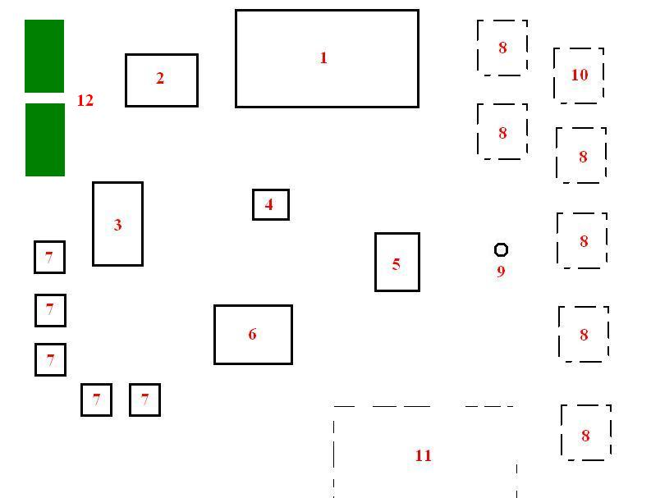

- Water Plant: The desalination plant is the largest and oldest building in town. It's loud, hot, and noisy inside when the plant is in operation during the day. Large pipes run around everywhere on the inside, and on the eastern exterior wall is a filling station where the water caravans fill up their barrels.
- Worker Dormitory: The plant workers, most of whom have been convicted of minor crimes, sleep here during the night. A deputy keeps watch to make sure none of them try to escape.
- Anson's: This Jericho's combination saloon and whorehouse. In addition to selling booze and time with his prostitutes, Anson also has a variety of drugs available.
- Gallows: Anyone convicted of a major crime (murder or rape, usually) gets sentenced to death by hanging. The gallows in the center of town is currently empty, a sign that O'Connor's no tolerance policy has been quite effective at deterring crime.
- Doc Lane's Store: Doc Lane's office and general store. Doc sells weapons, ammo, supplies, and healing items.
- Sheriff's Office/Jail: Sheriff O'Connor's office, as well as the town jail.
- Residence: A simple residence for one of the town's generic NPCs.
- Building Foundation: A building once stood here, but it's been burned down to the foundation. Nothing but blackened debris remains.
- Sewer Entrance: A manhole cover leads down into ancient Pre-War sewers.
- Cockroach Nest: A nest of giant mutant cockroaches is here. They haven't become a threat to the town... yet.
- Caravan Staging Area: Caravans arrive and depart from this point. This is also the area where the PC can park his vehicle.
- Cropfields: Generic cropfields which feed the town.

Union Station

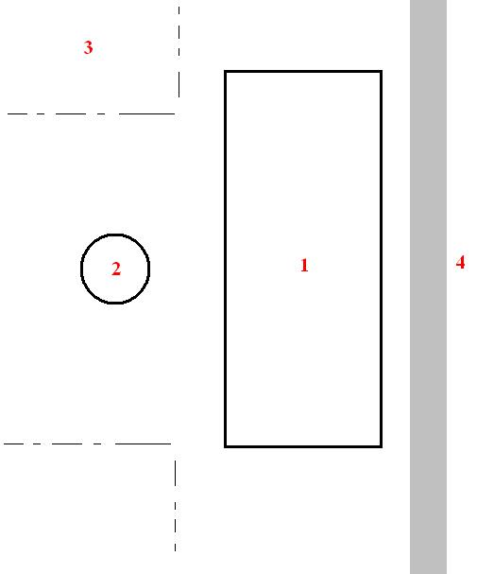

- Union Station: A large, decaying multi-room train station which has fallen into disrepair. Many of the rooms were looted long ago. It's the current home of a nest of giant wasps.
- Dry Fountain: A big, fancy fountain which is completely dried up. Although many parts of it are chipped and broken, it's still in surprisingly good shape.
- Parking Lot: An old parking lot. The PC arrives here when he enters the map, and he can park his vehicle here.
- Train Tracks: If the PC gets a train working, it'll appear here when it arrives at Jericho.

Jericho Sewers
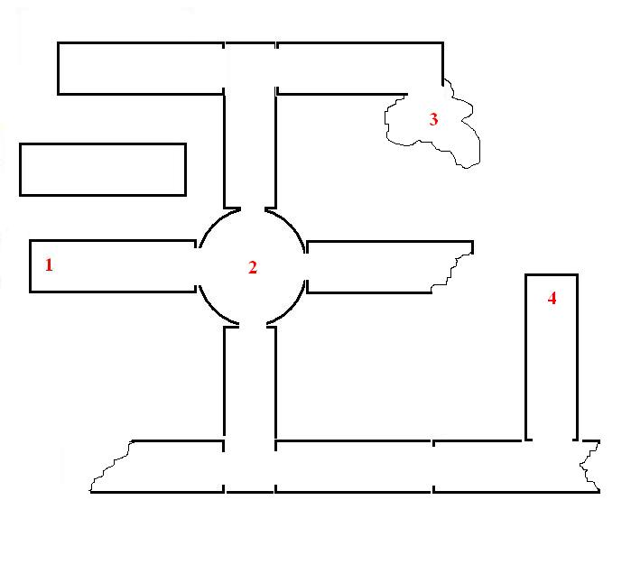
- Entrance: A ladder leading up to Jericho is here.
- Pool: A large pool of slimey, gooey water. Lots of mutant leeches swim around in here.
- Rat Nest: The main body of rats has a nest here. The body of a Jericho deputy who tried to exterminate the rats himself is also here, and his weapons and items are scattered all over the lair.
- Pre-War Debris: A whole bunk of junk from the surface washed down through drains and ended up here. Some of it is useful (mechanical parts, armor, weapons, etc.)

Fallout Shelter
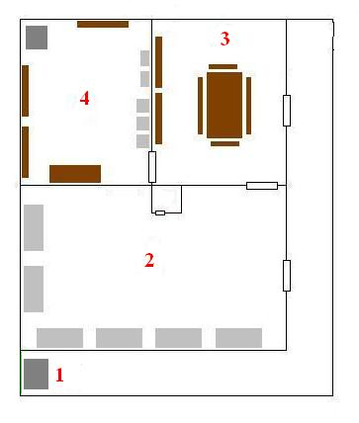
- Elevator: This elevator is the only entrance into the fallout shelter. It exits out into the ruined church above.
- Living Quarters: A small living area for the shelter, with a bathroom (complete with shower), beds, and desks.
- Dining Room: A large metal table dominates the center of this room. Shelves and boxes filled with supplies line the walls.
- Generator Room: The generator which powers the shelter is located here. Tools and other mechanic supplies can also be found in this room.

Mormon Camp
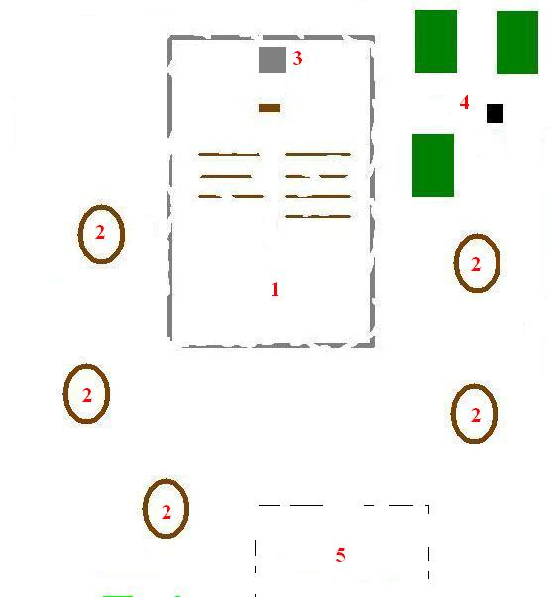
- Destroyed Church: The burnt-out remains of a church stand here. While the walls have crumbled, the pulpit and several pews still remain. The Mormons worship here, and at the back of the church is an elevator leading down into the fallout shelter where Jeremiah and the Hands of God hang out.
- Tent: There isn't enough room in the fallout shelter for everybody, so all of the generic Mormons camp out in tents around the church.
- Elevator: This elevator leads down into the fallout shelter beneath the church.
- Cropfields: These sorry-looking crops are supplied with water from the nearby well.
- Entrance: This is where the PC enters the map and parks his vehicle.

ART REQUIREMENTS

Jericho Town
Tileset: Uses the junktown tileset, augmented by the city tileset.
Meta-tiles: Require meta-tiles for Anson's place (a bartender's bar) and many of the handpumps and pipes for the interior of the water plant.
Dynamic Objects: The gallows at the center of town is a dynamic object. It's currently empty, but it has room for three corpses which will sway in the wind. In addition, Anson's place, the water plant, the sheriff's office/jail, Doc Lane's store, the workers' dormitory, and the generic NPC residences should be dynamic objects since they can be burned down by Jeremiah and his followers. Some of the pipes, the storage vat, and the filling station at the water plant also need to be dynamic objects so that the player can repair them.

Union Station
Tileset: Uses a combination of city and junktown tilesets for the exterior.
Meta-tiles: Need a meta-tile for the dried up fountain (it's got fancy carving and sculptures around it). Union Station itself needs a big meta-tile, since it's based on an actual building and isn't generic.
Dynamic objects: A big, ugly mud wasp nest which the player can attack and destroy is required. Two versions will be needed: an intact nest and a broken, shattered nest when the PC has destroyed it.

Jerico Sewers
Tileset: Uses the sewer tileset.
Meta-tiles: Need a meta-tile for the large pool of slimey water in the sewers.
Dynamic Objects: Most of the level is knee-deep in gooey, icky water (less if it's too much of a performance hit).

Fallout Shelter
Tileset: Uses the vault tileset.
Meta-tiles:
Dynamic Objects: The elevator and the doors of the fallout shelter are dynamic.

Mormon Camp
Tileset: Uses the junktown tileset.
Meta-tiles: Need meta-tiles for the pews and pulpit, and perhaps the shattered remains of a stained glass window or two to fit in along the ruined walls. Might need unique meta-tiles for the tents if we don't already have them.
Dynamic Objects: The elevator which descends into the fallout shelter is dynamic.

Movie – Destruction of Jericho
Destruction of Jericho: If Jeremiah succeeds in destroying Jericho and the PC is present, perhaps the player can be treated to a movie of the water plant and other buildings completely engulfed in flames, eventually collapsing in among themselves.

NPCs

Sheriff Mike O'Connor
Level 1, ST 5 PE 5 EN 4 CH 5 IN 6 AG 6 LU 5
Intermediate character. Male human. Sheriff and mayor of the town. He's a hard man, but not cruel. He won't let anything stand in the way of Jericho's prosperity.

O'Connor is a tall Hispanic man armed with .45 revolver and a .223 hunting rifle. He dresses a lot like an Old West sheriff – jeans, vest, Stetson hat.

Jake Caulwell
Level 1, ST 4 PE 4 EN 5 CH 3 IN 4 AG 5 LU 4
Intermediate character. Male human. He runs the water plant and keeps an eye on the convicts doing all the labor.

Jericho Deputy (5)
Minor character. Male human. These guys are generic police officer-types armed with shotguns. Three of them will be wandering around town at all times, while two will be asleep in their bunks at the sheriff's office.

Doc Lane
Level 2, ST 5 PE 6 EN 5 CH 5 IN 6 AG 6 LU 5
Intermediate character. Male human. Runs Jericho's general store and serves as the town "doctor". In reality, Lane has no medical skills, relying entirely on drugs to fix his clients. He's a new arrival, and rather cheerful in comparison to the rest of the town.

Daniel (PRISONER)
One of the prisoners from the Big Empty will asked to be returned to his wife and kids in New Canaan. Since New Canaan has been destroyed, Daniel will renege on his deal with PC and decide to hang out in Jericho for awhile (really didn't care about his family or his religion after all).

Jeremiah Rigdon
Intermediate character. Male human. Mormon Living Prophet and leader of the Hands of God. He claims that the Mormons cannot restore themselves to their former glory until Jericho cleansed of sin. It sounds dramatic, but he just wants the people of Jericho to give the Mormons' land back and move somewhere else.

Hands of God (8)
Minor characters. Generic male and female humans, all part of Jeremiah's band. They're "elite" Mormons, combat veterans and tougher than the Mormons in the camp. Armed with knives, pistols, and hunting rifles.

Worker (9)
Level 1, ST 6 PE 4 EN 6 CH 4 IN 4 AG 5 LU 4
Minor characters. This your generic plant worker (male/female humans and two or three male/female ghouls). Only has a hammer or a wrench for a weapon. These NPCs are all indentured servants or criminals convicted of minor crimes. Jericho doesn't like it when outsiders refer to the workers as slaves, even though that's what they pretty much are.

Anson
Intermediate character. Male human. Heads the brothel, and really, really despises women, but doesn't overtly show his hatred. He's usually very calm and emotionless, as is typical in this well-ordered town, runs a tight ship with his combo tavern/brothel.

Jericho Townsperson (7)
Minor characters. Male and female humans. Average, everyday townspeople.

Jericho Prostitute (2)
Minor characters. Both generic female humans.

Caravaner (5)
Minor characters. Male and female humans. These generic people work for the water caravans and aren't permanent residents of the town. They tend to be loud and drunk when they're between caravans.

Mormons (8)
Three men and five women inhabit the Mormon camp to the southeast of Jericho. They're very meek and will ask the PC to leave them alone, but they'll turn violent if the PC tries to gain access to the elevator which leads to the shelter where Jeremiah is hiding unless the PC is persuasive. They're lightly armed with knives and a zip gun or two.

Ivan
Ivan is the escaped plant worker. He is indeed guilty of the crime he was convicted of (theft), but he's not the healthiest of people. Ivan was afraid that he'd die working in the plant before his sentence was up, so he slipped out of the barracks at night and hid in the supply wagon of an caravan bound for Fort Abandon. He is still at Fort Abandon.

Marianne
Female human. Marianne is one of Anson's prostitutes, and she's been drugs from him and selling them on the side to caravans that pass through town in an effort to buy her freedom and get out of Jericho.

Simon Krieger
Male human. After the plant has been upgraded with an automated pump and biodiesel generator, Krieger, a representative from Hoover Dam, will show up in town to negotiate a discount his town's water purchases, in exchange for an equal discount on one or more goods exported to Jericho.

Krieger's Bodyguards (2)
Two male humans. who accompanied Krieger to Jericho. They direct the PC to Krieger if he tries to speak to them.

Paranoid Ghouls (10)
Male and female ghouls. Armed with pistols, hunting rifles, and various melee weapons. These ghouls have been holed up in the sewers beneath Jericho for a very long time. At the time of the War, a paramilitary citizen's group converted parts of the sewers into makeshift shelters in the event that the bombs fell while they were too far away to reach any proper shelter. Much of the group chose to remain and use the sewer system as a permanent home, fearful of the Commies they're certain are still running around all over the surface. They're not rational any more, and will attack the PC and his crew on sight.

COMPANIONS!

Battery
Battery is one of the plant workers. Unlike the other workers, he actually volunteered at the plant for the opportunity to tinker with the unique machinery. He's a little bored now, but he doesn't have any real incentive to leave. The other workers, who are not there voluntarily, think Battery is weird and stupid for sticking around. Then again, he is a tribal.

MONSTER ROSTER

Radioactive Leeches (~10)
About two feet long, these slimy monstrosities roam the flooded sections of the sewers beneath Jericho.

Cockroach Swarm (15)
A horde of icky giant cockroaches infests one of the burnt out buildings in Jericho. They're not particularly threatening to the people, but they raid the cropfields and gross out the townsfolk.

Rats (20)
Big, mean sewer rats wandering the drier parts of the sewers, mostly to avoid being attacked by the leeches. They've recent begun making bold raids on the Jericho food supply, injuring several townspeople in the process.

Wasps (11)
These giant, dangerous annoyances have built themselves a nest in the abandoned Union train station to the south of town. They will have to be dealt with if the PC plans on connecting a train to Jericho.

RANDOM ENCOUNTERS SURROUNDING THE AREA

Jericho Patrol (3 times)
A group of five men out patrolling near the city. They are lightly armed with pistols and pipe rifles. They're not looking for trouble, but they will defend themselves against the PC if the PC doesn't look too tough. The PC will run into this group a maximum of three times (unless he kills them all in a early encounter).

Destroyed Water Caravan (2 times)
The PC comes across the remains of a destroyed water caravan, but no bodies. If the PC scrounges, he can find some supplies which survived the blaze.

QUESTS

- Fix the leaks in the plant.
  - Pipes: The pipes running between all the equipment are old and corroded, and have tendency to burst.
  - Filling station shutoff valves: The valves of the water dispenser at the filling station don't shut off the water coming from the storage vat completely, causing water to constantly drip away into the dirt.
  - Storage vat: There are numerous hairline cracks in the sides of the storage vat.

Initiator: Deputy Caulwell
Importance: Minor
Scope: Small
Science Boy: Using a basic toolkit, patch all the leakrs (Mechanics/Easy).
Combat Boy:
Stealth Boy:
Charisma Boy:
Journal: I repaired most of the leaks at the water plant.
Dumb Journal: Plant not leaky no more.

10_PIPE_REPAIR

10_FILLING_STATION_REPAIR

10_VAT_REPAIR

- Build an automated water pump
Pumping the water into the plant for desalination by hand is slow and inefficient. The plant's old computer contains the schematics for an automated pump, but only a mechanically-skilled character can understand the schematics.

Initiator: Deputy Caulwell
Importance: Major
Scope: Medium-Large (depending on what parts will be required)
Science Boy: Using the schematic learned from the computer on, build an automated pump for the main floor using parts like a small electric motor and an air compressors (Mechanics/Hard).
Combat Boy:
Stealth Boy:
Charisma Boy:
Journal:
1. I downloaded the schematic for an automated water plant into my PipBoy from the Jericho water plant's pump control computer.
2. I built an automated water pump for the water plant in Jericho. The plant should be able to produce fresh water a lot more quickly and efficiently now.
Dumb Journal: I make man-less pump for plant. More faster water for everybody now.

PLANT_PUMPS = 0 // Plant pumps are manually-operated
PLANT_PUMPS = 1 // PC has learned how to build an automated pump
PLANT_PUMPS = 2 // PC has installed an automated pump in the plant

- Kill Jeremiah.
The Hands of God, led by Jeremiah Rigdon, have recently attacked and burned three of Jericho's caravans. There were no casualties on either side, but O'Connor feels the Hands of God may soon become a bigger threat, so he wants the PC to enter the Mormon camp and assassinate Jeremiah if Jeremiah cannot be convinced to lay off the caravans.

Initiator: Sheriff O'Connor
Importance: Major
Scope: Minor
Science Boy:
Combat Boy: Kill Jeremiah.
Stealth Boy: Kill Jeremiah without alerting the camp.
Charisma Boy: Convince Jeremiah to back down and make peace with Jericho (Persuasion/Hard). Or, trick O'Connor into thinking the Mormons are planning an attack, and get his militia's help in wiping out all the Mormons (Deception/Hard).
Journal:
Dumb Journal:

10_HANDS_OF_GOD

0 = Quest hasn't been mentioned
1 = O'Connor mentioned quest
2 = PC accepted quest
3 = PC has killed all the Hands of God
4 = Quest complete

- Exterminate the vermin
In and around Jericho are several locations infested with creatures. Sheriff O'Connor would like an enterprising mercenary to go to heart of these infestations and remove the creatures once and for all. The PC will need to defeat the wasps and destroy their nest at Union Station, descend into the sewers and wipe out all the rats, and

Initiator: Sheriff O'Connor
Importance: Minor
Scope: Small
Science Boy:
Combat Boy: Kill the leeches, which will be of average difficulty if the level is still flooded, or easy if the level is drained first.
Stealth Boy:
Charisma Boy:
Journal: I killed the radioactive leeches plaguing the lower level of the Jericho plant.
Dumb Journal: I kill all icky leech things in water at water plant.

10_EXTERMINATOR

0 = Quest hasn't been mentioned
1 = O'Connor mentioned the quest to the PC
2 = PC accepted the quest
3 = PC completed the quest
4 = Quest complete

- Sabotage the water plant
Certain factions in Hoover Dam would rather see Jericho fail and turn to dust rather than prosper as an independent entity in the wasteland. These elements will ask the PC to sabotage the water plant and render it incapable of producing fresh water ever again.

Initiator: (Hoover Dam caravan group?)
Importance: Major
Scope: Small
Science Boy:
Combat Boy:
Stealth Boy: Walk up to the boilers, pumps, and pipes and remove or loosen parts without being noticed and without causing the equipment to fail immediately (Steal/Hard).
Charisma Boy:
Journal: I subtlely sabotaged much of the Jericho plant's equipment. It won't fail immediately, but soon... and when I'm not around to be blamed.
Dumb Journal: I make water plant machines not work good. Soon all be broke.

10_PLANT_SABOTAGE

0 = Quest hasn't been mentioned
1 = Quest has been mentioned to the PC
2 = PC accepted the quest
3 = PC completed the quest
4 = Quest complete

- Poison the water shipments
By poisoning the water shipments, Jericho's credibility will be ruined, and other towns in the wasteland will refused to buy water from them.

Initiator: (Hoover Dam caravan group?)
Importance: Major
Scope: Small
Science Boy: Concoct the poison yourself (Science/Average) if you don't have anything better on you.
Combat Boy:
Stealth Boy: Slip the poison into the water barrels at the caravan staging area without anyone noticing (Steal/Average).
Charisma Boy:
Journal:
Dumb Journal:

10_WATER_POISON

- Negotiate a water contract with Hoover Dam
Hoover Dam has difficulty gaining easy access to fresh water, and they want to negotiate a contract with Jericho for shipments of fresh water. If the PC doesn't step in, the slick Hoover Dam guys will see to it that Hoover Dam benefit mores from the deal than Jericho does. This quest will only happen once the water plant has increased its output due to the automated water pump and biodiesel generator.

Initiator: Sheriff O'Connor (he brings the matter to the PC's attention)
Importance: Minor
Scope: Small
Science Boy:
Combat Boy:
Stealth Boy:
Charisma Boy: A PC with a good Barter skill can negotiate a contract fair for both sides or one that favors one side.
Journal:
Dumb Journal:

10_WATER_CONTRACT

0 = No contract
1 = A contract has been agreed upon

10_HD_DISCOUNT

0 = No discounts from Hoover Dam
1 = Jericho gets a discount on one HD export
2 = Jericho gets a discount on two HD exports

10_PC_BRIBE

0 = PC didn't take a bribe
1 = PC took a bribe

- Build a biodiesel generator for the Jericho water plant
The water plant can't use the automated pump unless the pump is supplied by electricity. Due to the lack of gasoline, a biodiesel engine which can run on the same salicornia oil Jericho uses for heating and lighting needs to be built.

Initiator: Deputy Caulwell
Importance: Major
Scope: Medium (PC can learn about biodiesel and salicornia from the FoA library in Hoover Dam)
Science Boy: Build a generator which runs on biodiesel so that the plant can use the automated pump (Mechanics/Hard).
Combat Boy:
Stealth Boy:
Charisma Boy:
Journal:
Dumb Journal:

- Find and return Ivan, the escaped worker
One of the workers from the water plant managed to slip out of the barracks during the night. O'Connor will ask the PC find Ivan, kill him, and bring back his corpse, where it will be hung up in the plant as an example to the other workers.

Initiator: Sheriff O'Connor
Importance: Minor
Scope: Medium (requires the PC to travel to Fort Abandon)
Science Boy:
Combat Boy:
Stealth Boy:
Charisma Boy: The PC can use Deception to lie to O'Connor about finding and killing Ivan if the PC is a good guy and decides to spare Ivan's life. He'll only get half the reward he was promised, though.
Journal:
Dumb Journal:

10_ESCAPED_WORKER

0 = Quest hasn't been mentioned
1 = O'Connor mentioned the quest
2 = PC accepted the quest
3 = PC found Ivan; Ivan is dead
4 = PC found Ivan; Ivan is alive

- Find out who's been stealing from Anson.
Anson has suffered a series of burglaries lately, and he really wants to know who's responsible. He'll hire the PC to watch over his bar at night or "investigate" other people's belongings to find the culprit.

Initiator: Anson
Importance: Minor
Scope: Small
Science Boy:
Combat Boy:
Stealth Boy: Pick the lock on the chest in Marie's room (Security/Average), swipe the loot, and show it to Anson as proof. Alternately, hide in the bar after it closes and wait for Marie to come out and start pilfering Anson's stash (Sneak/Average).
Charisma Boy: Lie to Anson about who's responsible and either blame an innocent man (Doc Lane) or a fiction thief (Goatee Man).
Journal:
Dumb Journal:

10_ANSON_THIEF

0 = Quest not mentioned
1 = Anson mentioned the job
2 = PC took the job
3 = PC knows who the thief is
4 = Quest complete

Area | Quest Name | Designer | DStatus | Script | SStatus | Log Stat | Passable | QA 100%
JERICHO PLANT
Jericho Town | Fix the leaks in the plant | Jhusges
Jericho Town | Build an automated pump for the plant | Jhusges
Jericho Town | Kill Jeremiah | Jhusges
Jericho Town | Exterminate the vermin | Jhusges
Jericho Town | Sabotage the water plant | Jhusges
Jericho Town | Poison the water shipments | Jhusges
Jericho Town | Negotiate a water contract with Hoover Dam | Jhusges
Jericho Town | Build a biodiesel generator for the plant | Jhusges
Jericho Town | Find and return Ivan | Jhusges
Jericho Town | Find out who's been stealing from Anson | Jhusges

SCRIPTING

GENERAL

Ivan's Execution: If the PC brings Ivan back to O'Connor, the sheriff will order Ivan's execution. A deputy escort Ivan to the gallows, followed by fade-out/fade-in, and Ivan's corpse will be dangling from a rope, swaying in the wind.

Marie's thefts: At 1:30 AM, Marie will sneak out of her room, go behind the bar, and pilfer Anson's bar. The PC must be sneaking to be able to catch her in the act. If Marie spots the PC, she will float something like "Eek!" and retreat to her room. She won't try stealing for another 24 hours. Otherwise, once the PC witnesses her stealing, he can either stay hidden and let Marie go back to her room, or emerge from hiding and confront her.

Generic Mormons: These generic Mormons will run away and hide in the fallout shelter if the PC approaches the camp (it's a desert, so they can spot him coming from a long way away). They'll also futz the elevator controls so the PC can't get down to them. However, when Jeremiah and the Hands of God appear, the generic Mormons should appear outside in the camp along with Jeremiah and krew, feeling safe and happy again now that the Mormon protectors have returned.

TOWN-SPECIFIC

Water plant security: After the water plant operation ceases at 8 PM, a single deputy will be patrolling the plant. If he sees the PC sabotaging anything, he'll raise the alarm. The PC will have to take him out or otherwise be out of sight if the PC is up to no good.

Jeremiah and the Hands of God: Jeremiah and his little band of caravan wreckers won't show up at the Mormon camp until the PC has accepted the quest to hunt them down and kill them. Prior to that time, Jeremiah and krew are out in the wasteland trying to tear shit up.

COOL SHIT

Cool Epithets

"Water Baron": if the PC takes over the Jericho plant.

"Hangman's Friend": If the PC's actions result in all three nooses of the gallows being occupied, he gets this epithet. The three potential hangees are Jeremiah, Doc Lane, and Ivan.

Cool Hooks

Plant Power Supply
If the plant becomes automated, it becomes reliant on Hoover Dam's electricity. Eventually, a delegation from Hoover Dam will arrive to start negotiations. Things won't go well if the PC doesn't step in and fix things.

SOUND REQUIREMENTS

AREA | SOUND REQUIREMENTS
Jericho Town | MUSIC DESCRIPTION
Jericho Town | Something like the FO track "Industrial Junk", or a mixture of that and the New Canaan theme to reflect that this is an industrial part of New Canaan
Jericho Town | BASIC SFX
Jericho Town | The water plant is only during the day, from 8 AM to 8 PM. During this time, the following sounds will be heard:  - The rumble of the fires heating the boilers (louder the closer the PC is to a boiler, but reduced to a low rumble when the PC is on the opposite side of the plant)  - Water plip-popping from the leaking pipes running between the various pieces of equipment. This effect stops when the PC has repaired the pipes.  - Water gushing and splashing into the vat (loudest when the PC is to the storage vat)  - Hissing steam as it escapes occasionally bursts from cracks in the pipes and boilers (centered around the boilers). This effect stops when the PC has repaired the seals around the boilers.  - On/off sound of water surging through the pipes as it's being manually pumped (loudest when standing next to a pump)  - Constant sound of surging water through the water pipes if the pumps are automated  - Humming automated pumps, if present (the pumps next the storage vat will be loudest, since the boiler fires tend to drown out the pumps near them)  Of course, if the people of Jericho are slaughtered or the PC sabotages the plant, the plant will become silent.  In the town exterior, the wind can be heard on occasion, shrieking between the buildings.
Jericho Town | WALLA SFX
Jericho Town | Occasional loud swears coming from the exhausted workers.  Inside Anson's, the low murmuring of conversation between people and the clink of glasses can be heard.
Union Station | MUSIC DESCRIPTION
Union Station | Desolate wilderness music, since the train station is abandoned and set away from the main town.
Union Station | BASIC SFX
Union Station | Wind, occasional creaking of old wood.
Union Station | WALLA SFX
Union Station | No walla.
Jericho Sewers | MUSIC DESCRIPTION
Jericho Sewers | "Underground Troubles" – spooky, underground music.
Jericho Sewers | BASIC SFX
Jericho Sewers | Occasional dripping of water from the ceiling into standing pools of water. This area is still somewhat damp
Jericho Sewers | WALLA SFX
Jericho Sewers | None
Fallout Shelter | MUSIC DESCRIPTION
Fallout Shelter | Religious-style music, since this is Mormon territory.
Fallout Shelter | BASIC SFX
Fallout Shelter | Typical vault sounds – computers beeping, vents humming, fans whirring. Not too much of this, since it's a small vault.
Fallout Shelter | WALLA SFX
Fallout Shelter | Mormons murmuring prayers to themselves once in awhile. Overall, they're a pretty quiet group.
Mormon Camp | MUSIC DESCRIPTION
Mormon Camp | Religious-style music, since this is Mormon territory.
Mormon Camp | BASIC SFX
Mormon Camp | Tents flapping occasionally in the wind
Mormon Camp | WALLA SFX
Mormon Camp | Mormons murmuring prayers to themselves once in awhile. Overall, they're a pretty quiet group.

LOCATION CHECKLIST

Attribute | Challenge | Reward
CHARACTER SPECIFIC
Evil Karma Character
Good Karma Character
Stupid Character
Low Reputation Character
High Reputation Character
Human Character | None | None
Male Character | None | None
Female Character | None | None
Strength | Force open the stuck doors on the flooded level | Gain access to spare parts for the plant and other goodies without using up any explosives
Perception | Notice the movement of the leeches in the flooded level | Bonus to hit them under the water?
Endurance | Resist the radioactive leech bites better | General radiation resistance
Charisma | Better results when speaking to people in the area | More effective diplomacy and barter skills
Intelligence | Realize after fixing the equipment on the lower level that they're connected to an electric power source. | Use the knowledge to help automate the top floor
Agility | Dodge some falling debris in the Sewers if you trigger a cave-in | Take less damage
Luck | Get the emergency floodpump working simply by kicking it | No need to repair the floodpump to make it work
Combat Boy
Firearms | General combat | General combat experience
Melee | General combat | General combat experience
Unarmed | General combat | General combat experience
Charisma Boy
Deception
Barter | Negotiate an electricity deal between Hoover Dam and New Canaan | Rep boost between one or both sides, XP
Persuasion
Science Boy
Medic | Discover that the ill workers are suffering from radiation poisoning  Discover that the ill workers were all bitten by something | Experience and knowledge of how to treat the workers' illness  Experience and information
Mechanics | Repair broken stuff in the plant  Build automated pumps for the plant  Convert the plant to an alternate power source  Study the water still at the cultist camp and figure out how to build more | Experience and the gratitude of the foreman and the Mormons  Lots of experience, and big rep boost among the Mormons  Lots of experience, and a big rep boost among the Mormons  Teach the Mormons how to build water stills to alleviate their water shortage
Science
Outdoorsman
Stealth Boy
Lockpick
Sneak | Walk through the unstable section in the sewers | Won't trigger a tunnel collapse and can bypass the icky rats
Steal | Sabotage pipes, pumps, and valves by removing and loosening parts | XP and the reward of whoever put you up to the job
Traps
EASTER EGGS
Easter Egg, Easy 1 | The ancient corpse of a worker buried in the silt | Corpse has some items on him
Easter Egg, Medium 1
Easter Egg, Hard 1
PERKS + TRAITS
Perks
Traits
ENVIRONMENT
Economics
Power/Infrastructure | The boilers in the water plant are fed with coal
Food | Food is provided by New Canaan.
Tie to Another Area 1 | Hoover Dam | The lower level of the plant is connected to the generators at Hoover Dam, and the engineers there may notice a drop in power if the PC gets the automated plant pumps working.
Tie to Another Area 2 | Mesa Verde | The CNPC Battery works at the plant, and can point the way to his home village.
Tie to Another Area 3 | Burham Springs
Tie to Another Area 4
MULTIPLAYER GAMING
Multiplayer Elements?
Post-Game Adventuring
Ending 1 | Player never visited the plant | No cinematic.
Ending 2 | Player automated the plant and converted it to a new power source | New Canaan survives, and prospers somewhat (supposing that the refugee situation is handled appropriately)
Ending 3 | Player took over the plant and sucks all the wealth out of the town | Most of New Canaan dies out and only the plant is left standing, which becomes the new town of Jericho
Ending 4 | Player destroyed the plant | New Canaan either withers away, refusing to join NCR 'cause they think NCR had their plant destroyed (might even be true)
Ending 5 | Player left the refugees in charge of the plant | Refugees fight among themselves and the Mormons over the plant, destroying it in the process; the battle engulfs the city, and New Canaan is destroyed in the fighting
Ending 6 | Player visited the plant but didn't convert the plant to another source of fuel | New Canaan runs out of coal and has to shut down the plant
Possible Other Endings

ROOM FOR IMPROVEMENT

Prosperity: People in Jericho will have more cash on them the more efficient the plant becomes. Lane's store will also contain more valuable items.
Store Frequency: Restocking will occur less frequently if the PC is selling the plant's water since the people can't afford to buy as much stuff.
Community: If the PC sabotages the water plant, all the named characters except Lane and most generic NPCs will be gone from the town. It'll become a ghost town.

END MOVIES

WHERE TO GO CONDITIONS
The player never entered Jericho | Skip Cinematic
PC made peace between Jericho and the Mormons | Goto 1
Jerich got nuked | Goto 2
PC optimized the water plant | Goto 3
PC didn't help Jericho OR the Mormons | Goto 4

1. Jericho and Mormons together in peace, plant optimized
The presence of the Mormons tempered Jericho with morality as the town grew large and prosperous thanks to its optimized water plant. Jericho becomes one of the most important towns in the wasteland, known for its fairness towards its trading partners and generosity towards the unfortunates of the wasteland. | Jeremiah and O'Connor shaking hands, surrounded by smiling townsfolk and a prosperous Jericho.

2. Jericho and Mormons together in peace, plant not optimized
When Jericho's aging water plant eventually breaks down, the citizens are sustained by their faith through the troubled time, thanks to the Mormons. Although Jericho's dreams of prosperity turn to dust, the town manages to survive, and becomes a place many decent, hard-working people call home. | Jericho with a nice Mormon church in the middle of town. Not prosperous, but not falling apart.

3. Jericho nuked
Atomic fire wipes Jericho from the face of the wasteland. The radiation from the blast ensures that no one will rebuild anywhere near the ruins of Jericho for a long, long time. | Jericho as a big, black, smoking radioactive crater, maybe with an scorched, upside-down sign reading "Jericho".

4. Mormons destroyed, water plant not optimized
Jericho enjoys many years of peace and prosperity until their water plant, reliant for far too long on jury-rigged parts, breaks down completely. Jericho eventully becomes a ghost town, the empty water plant the only sign of its former glory. | The water plant with its doors wide open, abandoned. Rusty piles of junk are strewn everywhere.

5. Mormons destroyed, water plant optimized
Jericho becomes one of the most important towns in the wasteland, thanks to its fully operational water plant. However, as Jericho's wealth grows, so does the corruption inside the town. Factions vie for control of the town, and bribery and assassinations become an integral part of Jericho's politics. | Jericho, looking prosperous, but with a dead guy in the street as other well-dressed townspeople look on.

6. PC didn't help Jericho OR the Mormons
The skirmishes between Jericho and the Mormons eventually turn deadly, and although the Mormons are eventually wiped out in the conflict, much of the town is destroyed in the process. Many citizens choose to start over somewhere else in the wasteland, and the dream of Jericho is abandoned. | Jericho with a lot of burned down buildings.

RANDOM NOTES

APPENDIX

6/12/03: Created this document

6/23/03: Added the Sewers, Fallout Shelter, and Cultist Camp. Modified/added quests and area details based on suggestions from the meeting.

6/30/03: Made changes based on Sawyer comments
- Expanded the story for the cultists and the reason the Mormons don't run them off
- Added a quest where the PC can expose the cultists' true nature to the Sheriff
- Added more quests for Stealth Boys
- Added a new Barter quest for Charisma Boys

9/15/03: Incorporated elements of New Canaan into the newly-christened town of Jericho. Turned Jericho into a stand-alone place.

10/28/03: Modified some of the end movies. Changed the descriptions of some of the quests to match NPC dialogues.

