

Bloomfield

Space Center

Version 1.0

10/15/2003 06:07:00 PM

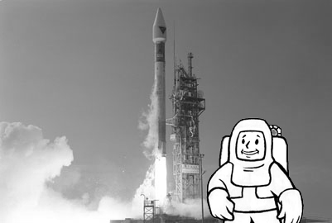

“Man’s need to explore is only rivaled by his need to expand; but all that is trivial compared to his need to kill and subjugate.”
-Bear

OVERVIEW
Bloomfield Space Center, surprisingly enough, survived the atomic war – well, for the most part. Thanks to its very remote location in southwest Arizona, the only real damage that the space center received was from time and weather – and also the current occupants.

The current occupants in question are the Rusty Hooks, as they like to be called. Comprised of two-dozen raiders, the Rusty Hooks came upon the remains of the Bloomfield Space Center about one year ago, drawn to the sight by tall, pointed structures (two space rockets) that could be seen on the horizon (however, by the time the PC arrives at Bloomfield, Dr. Presper and his NCR guys have already taken the other space rocket to B.O.M.B.-001). The leader, Kyle “the Hook,” knew they found a special location and decreed among his faithful that this facility would be their permanent residence and base of operations. The raiders then took up occupancy in the building that was once used for flight operations and communications. From there they managed to get the sub-reactor working (barely) to power the building and the rest of the grounds. However, the Rusty Hooks found out the hard way that the five high powered turrets surrounding the launch pad and the space rockets were active and had no connection to the sub-reactor they worked on (two of the Rusty Hooks found out the bloody way that the turrets were active and deadly). Suffice it to say that the members of the Rusty Hooks kept a respectful distance from the launch pad and the well preserved, twin space rockets, but that situation didn’t bother them. All they needed was located right in the building they called home; a healthy weapons and ammo cache stored in the security block of the Operations and Communications building.

The Rusty Hooks are known to make regular raids on caravans from the tribes in the area – the area being pretty much all of Arizona. Raids have been known to last upwards of a month or so. Just about anything is fair game to them, and they are willing to trade with anyone who does not have a problem with where they get their merchandise – though very few people in the wasteland know about the Bloomfield Space Center or how to get there. However, the Launch Pad and the twin space rockets are very visible from the horizon, so those who have seen it usually wander to Bloomfield in curiosity. Unfortunately, those who do happen to find the facility rarely lives long enough to go and tell anyone else, thanks to the turrets guarding the Launch Pad’s perimeter. Should someone be lucky enough to live after finding the Bloomfield Space Center, they would find that there is a touch of dissent within the ranks. Bear, Kyle’s super mutant bodyguard and right-hand man, seems obviously more intelligent than Kyle and seems to be the one who dishes out better ideas to help the Rusty Hooks. However, Bear also seems somewhat content being the voice behind the man in power, and no one else would dare to usurp Kyle’s authority with Bear backing him up.

If the player has completed his quest of returning all the prisoners to the Big MT, then by the time the player arrives at Bloomfield, Dr. Presper and some of his NCR buddies have taken the other space rocket, Hermes-14, and launched to dock with B.O.M.B.-001. Four NCR guys stayed behind to guard the remaining space rocket, in addition to coming to an agreement with the Rusty Hooks. The Rusty Hooks would stay away from the launch pad and the NCR guards wouldn’t kill them. Also, the Rusty Hooks would provide them with food and such and the NCR guys would provide additional protection should the need arise (NCR tech is much higher than the Rusty Hooks).
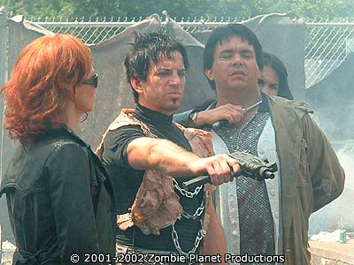

The Area is composed of three maps

MAP AREA | TRANSITION | MAP NAME | MAP SIZE | COMPLEXITY
1: Entrance | Full Party |  | Small | Desert Plain, 2 Buildings, walkway
2: Control Center | Full Party |  | Medium | Desert Plain, 4 Buildings, walkways
3: Launch Pad | Full Party |  | Medium | Desert Plain, Rocket Launch Pad Super-Structure, 5 Turrets, 1 Space Rocket

- Entrance: (Small Map) A broken asphalt road leads to an almost entirely collapsed multi-level parking structure. A beaten path leads through the debris, but this path is riddled with traps of various primitive make. Some traps are nothing more than deep holes covered with tarp and dirt, some are spears attached to bent rebar waiting to be released, while others are grenades attached to trip wires. A player with a good trap skill could find and disable the myriad traps.

Passed the parking structure and to the west is a weather beaten sidewalk that leads to an oval, one-story building with a main entrance facing the parking structure. This oval building is the Bloomfield Space Museum, housing broken objects of a space program long forgotten. Here the player will meet up with four Rusty Hooks. Dialogues would ensue and results may vary depending upon player attitude. The player may also get a bit of space history from the broken museum objects and one or two functional holo-dics (the Rusty Hooks are too ignorant to know how to use the holo-disc). There is an exit from the museum that leads to the northern exit grid.

- Control Center: (Medium Map) The entrance to this map is smack dab in the middle of the rocket transport road – a seventy-five foot wide road used to transport a completed space rocket to the launch pad – and directly east of the Rocket Assembly Building. The player will find a smattering of Rusty Hooks guards walking to and fro outside of the building. Inside the Rocket Assembly Building the player will find Sid, the Rusty Hooks’ best version of a mechanic/scientist/Mr. Fixit. I say “best” version because their original mechanic-type was abducted less than a year ago by a prison security robot. Jillian McKinley, one of the escaped prisoners from the Big MT, and one of the escaped prisoners the player must take back to the Big MT, is a member of the Rusty Hooks and was their very competent mechanic/weapons smith during her years with the raiders. However, during her absence, Sid was elected new mechanic/weapons smith expert, whether he had skill or not (more not).

The player will find Sid shuffling through the vast deposits of parts and debris littering the building’s spacious work floor – a floor that resembles the inside of a large airplane hanger. He is trying to put together parts to make weapons, vehicles, traps, and what-not to not only help his tribe of raiders, but further solidify his worth. It seems that Kyle the Hook is getting tired of Sid always barely making things work (which always, eventually, breaks down), and would like to find someone a bit more mechanically inclined. Kyle has given Sid a deadline to get the area’s sub-reactor working at a higher efficiency, as well as figure out how to turn off the turrets guarding the Space Rocket (not to mention eliminate the four patrolling security robots and NCR guards on the Launch Pad). If Sid fails, Kyle will volunteer Sid as a target practice dummy.

As the player heads north from the Rocket Assembly Building, he will pass a very large satellite dish to his left and a small, caved-in observation building to his right. Straight ahead, the player will run into the Operations and Communications Building. However, about halfway upon approach to the Operations and Communications Building, two sentry security bots will activate from their previously dormant state and attack the player (latent robot attack). These will be pretty tough, bipedal security bots equipped with twin gattling guns for arms. The Rusty Hooks will get freaked out by the bots all-of-a-sudden coming to life and help the player destroy the bots. The completion of this scene will bring Bear, Kyle’s super mutant bodyguard and second in command, up to the player to thank the player for helping destroy the bots (it’s not apparent that the player is the target since the bots will respond to other threats shooting at them). This dialogue will put the player in the position of gaining information about the Rusty Hooks, the growing dissent in the ranks, what, exactly, Sid has been able to fix/activate, and launch the player into figuring out how to get the remaining Space Rocket working. In addition, the player could figure out how to get the communications satellite dish working to further his cause. Also, the player may get the opportunity to not only participate in raids against caravans, but possibly get Bear to overtake Kyle, or have the player overtake and control the Rusty Hooks (the player would get the opportunity to rename the raiders to whatever he wants and the raiders would refer to themselves by that new name).

- Launch Pad: (Medium Map) This bad boy is the WOW! factor of the area. It is comprised of a very large launch platform superstructure with a very tall space rocket in the center. Surrounding the launch platform is a tall barbwire fence and five very large, and active, gattling gun turrets at each corner of the wall, as well as two at the main, gated entrance. Since the gattling guns are active, there is not a living thing in this area. The player must secure the security codes, or deactivate through hacking (or some other means), to disable the gun turrets. Once that is accomplished, the player may access the catwalk which leads to the platform elevator. The elevator will take the player to the top of the space rocket where the cockpit is. The door to the cockpit is locked and requires an access code, or the player may use a very high lock pick skill combined with an electronic lock pick. Inside the cockpit the player will see seats for four passengers. Playing around with the controls will do nothing since the interior needs to be activated from mission control, thus creating the need of someone competent calling the shots at the mission control terminals (BOS scientist type, NCR scientist type, Reservation scientist type, Dr. Huxley, or a scientific CNPC). Since the space rocket’s navigation is automated, all the player needs to do is sit back and enjoy the ride (BITCHIN’ LAUNCH CUT-SCENE CGI MOVIE THING – ZOOM! POW! BANG!). Next stop; B.O.M.B.-001 nuclear missile satellite (of course this comes VERY late in the game since this is pretty much part of the end-game scenario – Hey let’s rain down nuclear death on everyone! YAY!).



Map Flowchart & Layout for Bloomfield Space Center
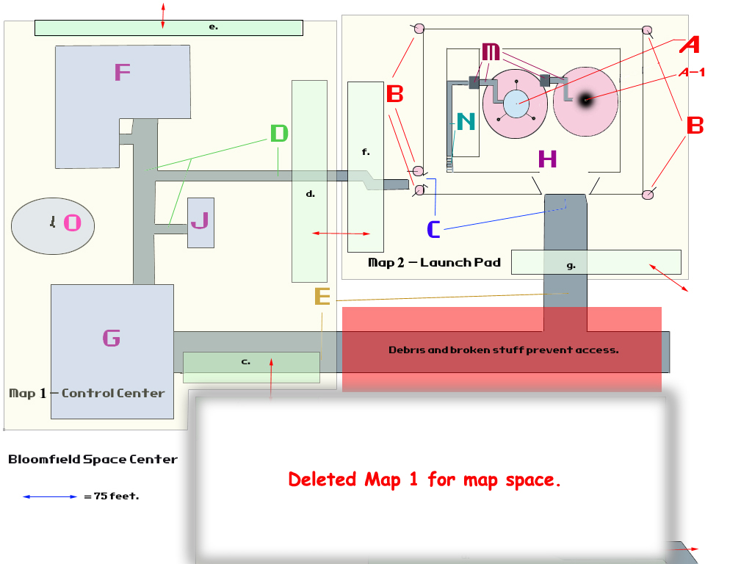

Legend

A – 1st Launch Pad w/Space Rocket  A-1 – 2nd Launch Pad w/o Space Rocket (scorch marks from previous launch) |  | O – Satellite Communications Dish
B – Gattling Gun Turrets |  | a. – Map 1 World Map Entrance/ Exit Grid
C – Rocket Transport Road | J – Observation Building | b. – Map 1 Entrance/Exit Grid to Map 2 c. Entrance/Exit Grid
D – Beat up sidewalks | K – Sidewalk | c. - Map 2 Entrance/Exit grid to World Map.
E – Rocket Transport Road | L – Entrance Grid to World Map | d. Map 2 Entrance/Exit Grid to Map 3 f. Entrance/Exit Grid
F – Operations and Communications Building | M – Launch Platform Catwalk Elevator | e.& g. – Map 2 & Map 3 (respectively) grid to World Map.
G – Rocket Assembly Building | N – Stairs leading up to 1st level catwalk | f. Map 3 Entrance/Exit Grid to Map 2 d. Entrance/Exit Grid

Area Background
2073 was a turbulent year. Nuclear proliferation reached an all time high. As a reaction to possible nuclear threats, the U.S. government completed a space station/satellite that housed two-dozen nuclear missiles each carrying four warheads. Named the Ballistic Orbital Missile Base, or the B.O.M.B.-001, it was considered the ultimate offensive weapon. The only things missing were the main power reactor and launch instructions and codes. However, since all other space and rocket facilities already used up their resources constructing the missiles for the station, and launching the cargo rockets to carry them to the base, the U.S. needed to scramble to get the much needed codes and a power reactor to the station. Their answer was to use the new Bloomfield Space Center, which was in the process of building a rocket that would go to Mars, and convert the Mars rocket into the vehicle that would carry the codes and reactor to the base. The conversion started in 2074.

So, in August, 2076, the Hermes–13 space rocket was completed and ready to launch at Bloomfield. Unfortunately, by October, 2076, funding for the rocket and Bloomfield had to be drastically cut and diverted to vault technology, thanks in large part to the rising world tensions and imminent threat of nuclear war – the launch of Hermes-13 had to be put on hold. All personnel, except for a skeleton maintenance crew, were reassigned to other locations. Bloomfield, B.O.M.B.-001, and Hermes-13 were essentially mothballed. In November, 2076, the Enclave seized control of Bloomfield Space Center. They knew nuclear war was just around the corner, so they tried to refit the Hermes-13 and convert it into a vehicle that would take selected personnel (mainly themselves) off-planet, destination yet to be determined.

Unfortunately for the Enclave, the bombs started dropping less than a year later. All were either relocated to “hot-spots,” or took cover away from Bloomfield. The last people to leave shut down the sub-reactor to Bloomfield and abandoned the facility, letting Hermes-13 and Bloomfield to brave the elements. For whatever reason, the facility never succumbed to nuclear attack. Only time and weather beat on the facility for almost two-hundred years, and neither was very kind. However, Hermes-13 managed to stand proud through the centuries, perhaps in hope that one day it would be allowed to carry out its mission.

The ruined grounds, dark, cold, and dirty buildings, and rusted launch platform super-structure might have laid dormant forever if it weren’t for the wandering and greedy spirits of the Rusty Hooks; a band of raiders who wandered the wasteland. In the scorching summer heat of 2252, the Rusty Hooks came upon the remote base of Bloomfield. Kyle the Hook, the raider leader, knew they had stumbled upon a great potential home. There were plenty of defensible areas, a potential for a rich cache of materials, and that giant pointy thing (Hermes-13) must be a source of great power. With the eloquence of a junior-high drama student pretending to know and quote the great works of Shakespeare, Kyle declared the Bloomfield Space Center the Rusty Hooks’ new base of operations.

One of the first things Kyle wanted to do was find out if the facility had a power source. He ordered Sid, the apprehensive mechanic/scientist of the group, to seek out and find a power source, and find a way to get power running. After about two weeks of swearing, threats on Sid’s life, and a few deep bruises, Sid managed to not only find the sub-reactor, but he got the thing running – albeit at only forty-five percent efficiency. However, even by bringing this sub-reactor online, the turrets surrounding Hermes-13 ended up killing two Rusty Hooks who ventured too close. It seems the turrets were running on a different power source and operations computer. It was bad enough that no one in the group could cut through the titanium fencing surrounding the Launch Pad, or climb over ten feet of titanium barb wire, but the gattling turrets mounted high on thorned posts exacerbated the giant pointy thing’s (Hermes-13) inaccessibility. Kyle ordered that the power be shut down so they could figure out a way to disable the turrets (not really being able to figure out that the turrets were on a different power source and computer – I told you he wasn’t that smart), but it seems that once power was turned back on, even if it was not at full efficiency, it could not be turned off without using the proper “security access codes” - whatever those things might be. So, in a flood of cascading wisdom, Kyle decreed the area near the giant pointy thing off limits.

Since then, Kyle and his band organized several raids on caravans throughout Arizona, as well as doing some trade with assorted scum of the wastelands. Sid was tasked with figuring out a way to make the sub-reactor more efficient, as well as scavenge the grounds and create something useful – what that something could be, no one ever explained to poor Sid.

TIMELINE
YEAR | EVENT
2073, August | The Ballistic Orbital Missile Base, or B.O.M.B.-001, is completed and partially functional (for security and maintenance bots) using a temporary onboard generator. The only thing more the base needs are the manually inputted final launch instructions and codes, and the main power reactor.
2074, July | The new Bloomfield Space Center completes construction. The facility’s first task is to complete the space rocket Hermes-13 to fly to B.O.M.B.-001 (originally slated for a Mars mission before new orders arrived). The mission: have the crew deliver and install the base’s main power reactor, manually enter final launch instructions, manual check for safety nets and protocols, and do a manual inspection of the station.
2076, August | Hermes-13 & 14 are completed and await final funding and the orders to launch.
2076 October | Due to the seriousness of world events and the threat of nuclear war, launch is postponed while funds are routed to vault technology. Launch is rescheduled for 2077.
2076 November | Enclave personnel seize control of Bloomfield Space Center and begin researching and developing a way to convert Hermes-13 into a personnel transport to transport important individuals off-planet.
2077 | Bombs drop. All Enclave personnel leave Bloomfield to either take cover or maintain “hot spots.” Sub-reactor is turned off. Bloomfield, B.O.M.B.-001, and Hermes-13 & 14 are completely forgotten.
2251, May 10 | Jillian McKinley is apprehended by Ulysses’ robots. The Rusty Hooks lose their best and only mechanic/weapons smith. Sid is “volunteered” to take her place.
2252 June 15 | Kyle the Hook and his Rusty Hooks discover Bloomfield Space Center and declare it their home.
2252 June 30 | Sid figures out how to fire up the sub-reactor. Bloomfield has power once more, but sub-reactor is only operating at 45% efficiency.
2253, October 23 | Sentry robots at Bloomfield become semi-active – not moving, but the optical lenses and sensors turn on and start surveying for escaped prisoners from the Big MT. The robots ignore the Rusty Hooks. | F3 Begins
2253, October, sometime later | Dr. Presper and his NCR buddies find security overrides for the turrets and security bots at Bloomfield, as well as the space rockets’ launch codes. They invade Kyle’s beloved Bloomfield – Kyle and his men do not resist Dr. Presper, mostly due to the recommendation from Bear, and his technically more advanced brigade – and launch themselves into space to dock with B.O.M.B.-001. Four NCR guys stay behind with the remaining rocket to prevent anyone from launching the second rocket. The Rusty Hooks keep clear of the launch pad and form an “understanding” with the NCR guards.

EMOTIONAL PORN
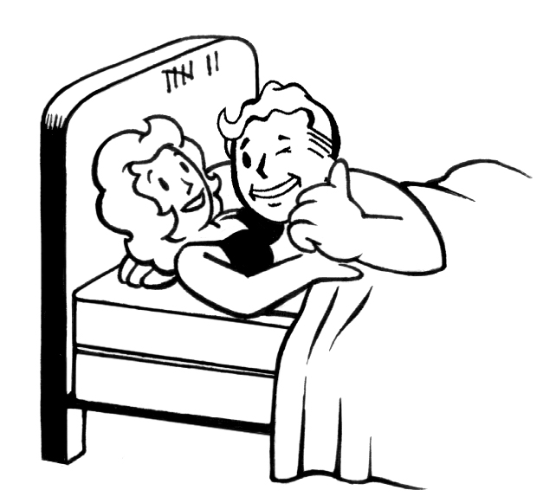

DRAMA

- Freeing Jillian from the Reservation and returning to Bloomfield:
If the player frees Jillian from her slavery at the Reservation and brings her back to Bloomfield before brining her back to the prison, it will be a devil of a time trying to convince Bear to let her leave again to go back to the prison. Aside from Jillian being an excellent mechanic and weapons smith, Bear has very much infatuated with Jillian. He does not let this be known since he knows he’s a super mutant and that someone as hot as Jillian would never go for him. However, he will exhibit a strong, protective posture to anyone he thinks might be threatening her well being. Even Jillian, who is fairly headstrong herself, will not be able to convince Bear to let her go back to the prison (she won’t show resistance if the player explains why she needs to temporarily go back). A Charisma Boy would be able to explain the circumstances of Jillian needing to go back to the prison and convince Bear to let her go, but anyone else would have to earn Bear’s trust before he will allow his secret love to brave the wasteland without him. And even after that point, Bear will insist on going along (he won’t be forced on the player to be a CNPC, but he will make it known that he would feel a lot better if he went along).

- Sid’s insecurity and the growing guilt:
Sid already is a mountain of insecurity thanks to his obvious ineptitude at mechanics. The funny thing is, Sid is better at mechanics than anyone else in the Rusty Hooks (save for Jillian, but she’s not around). But this fact completely escapes Sid since Kyle hits Sid with daily insults about his homeliness and lack of worth. Not a day goes by that Kyle does not tell Sid that he could be easily replaced, and it might be fun to use Sid as a target practice dummy. If this was not bad enough, Sid also carries a great, festering guilt. When Kyle created Bear’s heart bomb, he ordered Sid to insert it. The dirty deed was done well out of sight of any other Rusty Hooks – the less witnesses, the more plausible the ruse of Bear blindly following Kyle. Kyle told Sid that should he ever utter one word about Bear’s heart bomb and the radio trigger, he would make sure Sid gets tied up and thrown into a den of hag snakes. Naturally, Sid agreed never to say anything, but Sid’s big problem is that he actually likes Bear, and each day he sees Bear he is reminded of the terrible deed of implanting the heart bomb. One gets the impression from Sid that it would not take much to send him over the edge.

- The pieces to a second B.O.M.B. rotting away in the Rocket Assembly Building (foreshadowing):
Inside the Rocket Assembly Building, where Sid is slaving away at trying to make something useful, are major pieces to a large vehicle of some sort. There are three cylindrical pieces, each roughly twenty-five feet in length, fifteen feet high and wide, hollow, and slightly curved. It looks like if there were several of these pieces, and if one linked them all together, they would form a perfect circle. Inside each cylinder are empty compartments that look like pieces of machinery could fit (computers, actually). Two of the cylinders have what looks like windows carved out of them, but there is no glass. One of the cylinders, what looks like the most completed version, has a computer terminal installed. The computer is not working, though it is plugged into a line that, presumably, links to the sub-reactor (it turns out that the reactor is not putting out enough power to fuel non-essential equipment like this computer). Lastly, on the side of the more complete cylinder is the acronym B.O.M.B.-003.

In order to find out what the deal is with the cylinders, the player will need to restore the sub-reactor to sixty-percent efficiency. This will bring the main computer online. However, to get the information in the computer, the PC will need the proper access code (One person who has this code is Willem Clark, the leader of the Reservation), or the PC could try to hack the computer, but he will need a fairly high computer skill (over 50%). Once inside, the PC will find the story about the Hermes-13 & 14 rockets, the existence of the B.O.M.B.-001 and 002 (the remains of which can be found in the Grand Canyon), and the effort to construct a third B.O.M.B. If the PC wants to take a rocket ride, he will need to get official launch codes and authorizations. However, since Hermes-13’s launch codes were never delivered to Bloomfield, the PC will need to find the official launch codes, figure out a way to get Hermes-13 running, launch enabled, and almost most importantly, get the turrets protecting it disabled.

- Kyle, Sid, and Bear’s dirty little secret:
It’s no secret that Bear is far more competent than Kyle the Hook when it comes to leadership of the Rusty Hooks. But Kyle has an odd hold on Bear, one that prevents him from ever acting against Kyle. Bear does make it known that he considers the Rusty Hooks his family, but even though he shows loyalty to Kyle, there is an air of dissent in his eyes. The player will come to find out, after a bit of investigation, that Bear has a small heart bomb imbedded in his chest. It seems that Kyle is quite proficient with demolitions and created a small, radio controlled C4 device that he had Sid secretly implant into Bear when he was severely injured.

Several years ago, just after Kyle took over the Rusty Hooks, Kyle and some of his raider mates were out on a raid when they came across Bear. Bear was the caravan protection leader and proved to be the most fearsome fighter of the caravan’s bunch. So good, in fact, that Bear ended up killing six raiders before succumbing to his plethora of bullet wounds. Kyle instantly saw the potential of having a fierce super mutant like Bear under his command, so he created the heart bomb. Sid, the Rusty Hooks’ part time medic and full time slacker, inserted the heart bomb for Kyle, persuaded by a .44 pointed at his skull. After secretly placing the bomb and stitching Bear up away from prying eyes, Kyle told Sid that if he ever mentioned this device to anyone, he would make sure Sid was tied up and thrown into a den of hag snakes. Later, after Bear awoke and not wanting to die just yet, he figured that protecting the little human, Kyle, would not be such a bad gig and thus did not show any resistance. However, in the back of Bear’s mind brews the desire to be free of the heart bomb and lead his life as he saw fit; maybe even taking over the Rusty Hooks.

NPC ALLY DRAMA

MORAL DILEMMAS

- One way trip into space. Part of the big dilemma with the player going into space and going to B.O.M.B.-001 is that it will be well known that the flight is a one-way trip since there is only enough fuel for launching and docking. If the player wants to go to the space base to enable the station, to disable the station, to destroy it, or let the missiles fly, he will do it under the assumption that he won’t be coming back. Of course there is a way back, via the escape pods, but it will not be apparent before launch.

- Which CNPC gets to go with the PC? The player may also choose which CNPC goes with him into space – the one-way ticket into space. Since there is only room for six passengers, someone might get left behind, while others might have to be convinced to go. Basically, the player will have to ask/order which CNPC wants to die a slow, agonizing death in the cold reaches of space (not knowing that there are escape pods).

- Should the player help the Rusty Hooks or destroy them? The Rusty Hooks are not inherently evil. They perform raids and such as a basis of survival. When the do their raids, it is not dogma to kill everyone they see. In fact, they rarely fire their weapons at anyone. They just will steal supplies and rations from caravans solely for the purpose of helping their own; their family, so to speak. Some would look at this as evil just on the basis of the fact that the Rusty Hooks steal other’s livelihood. Others might just see the Rusty Hooks doing what they feel is necessary to survive. It’s up to the player to decide the “proper” morality of the Rusty Hooks and try to either fix it (sway them from stealing, or encourage them to do it more), or destroy the Rusty Hooks altogether.

- Help Sid overcome his festering guilt, or talk him into committing suicide. Sid’s secret of implanting Bear’s heart bomb eats at his soul on a daily basis. Each time Sid sees Bear, he is reminded of his crime. Sid considers Bear a genuinely good person, despite being a super mutant, and Bear is pretty much the only Rusty Hook who treats him with respect. Because of this, Sid is either always depressed, angry, or a combination of both. The PC has the opportunity to help Sid clear his conscience by helping Bear rid himself of the heart bomb through a series of actions, and the PC could try to get some help from Sid. Having Sid help begins to alleviate some of the guilt, but not all of it. A good Charisma Boy could try to council Sid and make him come to grips with what he did, thus getting over it, or Charisma Boy can be an evil bastard and talk Sid into committing suicide.

OTHER ROLE-PLAYING TESTS AND EPITHETS

- Player can play “devil in one’s ear” and try to convince Bear that Kyle needs to be replaced (Instigator).
- Player could talk Sid into committing suicide (Devil’s Proxy) May get Devil’s Tongue perk (+5% to Deception)
- Player may take of the Rusty Hooks and turn it into a prosperous community, leaving behind a life of crime (Born Leader).
- Player may take over Rusty Hooks and increase their crime abilities and make them a force to reckon with, especially considering the potential control of Hermes-13 and B.O.M.B.-001 (Kingpin or Criminal Mastermind).
- Seeing how Sid is a zero in almost anything he touches or does, the player may help him with his problems and move him up on the self esteem ladder (Therapist). May get the perk Guidance Counselor (+5% to Persuade).
- Player may discover Bear’s infatuation with Jillian and get the two “hooked up” (Cupid).
- Player can figure to a way to disable or remove Bear’s heart bomb, thus freeing Bear (Samaritan).
- Player can figure out a way to control Bear’s heart bomb and make him his very own slave (Slaver).
- Player can rewire Kyle’s radio trigger watch to explode and blow off his lone good hand (Angel of Vengeance).
- Player beats Bear in a legitimate fight (did not work out a deal to have Bear take a fall), gets Sting Like a Bee perk (+5% to critical with Unarmed only).

TIES TO OVERALL GAME THEMES

- Ignorance is bliss: The Rusty Hooks do not know what the real purpose of the Hermes-13 is (except for Bear), and they are happier for not knowing that the Hermes-13 could be the key to another nuclear Armageddon.
- Fear of the unknown: Everything about this place is pretty much unknown. What’s the big rocket do? Why is it here? What’s its purpose? What is the B.O.M.B.?
- Power corrupts: Winning control of Bloomfield by either usurping Kyle the Hook, or bringing in another faction, will grant the player with a lot of power, especially after he figures out the whole story behind Hermes-13 and B.O.M.B.-001. Controlling that much nuclear weaponry (or the potential of controlling it) could cause the player to become very heavy handed.

NPC COMPANION USES

LOCATIONS

Map 1 – Entrance delete
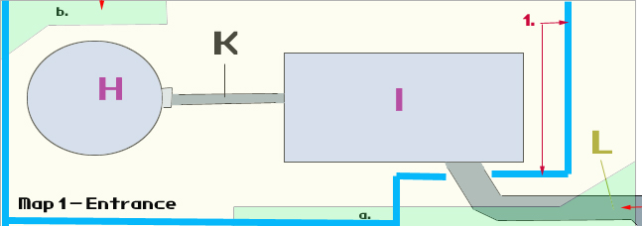

1. = Electrical fence | K = Sidewalk | L – Entrance Grid to World Map | a.& b. = exit grids

Parking Structure (I)

The parking structure did not fare well in the hardships of time. The once proud, four-story building is now a crumbled mess of debris, towering, broken concrete walls, bent, rusted girders, and empty husks that used to be automobiles – though there are few. Since an electrically charged fence surrounds all of Bloomfield Space Center, the only way to actually enter the complex is through the almost destroyed parking structure, unless the PC is an efficient Science Boy, then he has a chance of bypassing the electrical charge and cutting through the fence (the fence can be deactivated within the Operations and Communications Building so the player does not have to go through this each time he comes to Bloomfield). Within the mess of debris, concrete, and girders can be found a trail of sorts, seemingly carved out by “someone.” The trail splinters in different directions, with visible paths blocked by broken walls and debris. Some paths are harmless, while others hide deadly traps for the unsuspecting traveler (or intruder - depends on the perspective). The optimal path will eventually lead out. PC’s with a good outdoorsman skill will have a better time negotiating the proper route, and will avoid physical harm if their trap skill is above average.

Bloomfield Space Museum (H)

This small, oval building is almost completely intact. Approaching the front entrance facing the parking structure, the player will meet with two Rusty Hooks guards brandishing assault rifles. They will be very terse and ask the player what he or she is doing there. If the player is very charismatic and is a good speaker, he may convince the guards that he is there to trade special items and information. However, if the player is not very charismatic, or is just a dick, the guards will tell him to fuck off and give the player ten seconds to leave before they open fire on his mangy ass.

If Jillian is with the player, the guards will respond nicely and let the player through stating that he should meet with Bear when they get to the control center just north of the museum. Or, if the player freed Jillian, took her back to the prison, go the whole prison quest done and the prisoners went free afterwards, Jillian will leave a good word about the player with the same guards after she returns.

In any event, passing through the museum, the player will see large, broken models of ancient flying machines and space capsules. There are terminals here and there, but none are working except for a terminal that is located on a desk in a small room to the northwest. Using this computer, the player will discover that the power to Bloomfield is only running at forty-percent and that all non-essential equipment is either in stand-by or turned off. Once power is restored to sixty-percent efficiency (eighty-five percent for the really talented), the player may fire up some of the terminals next to the dilapidated exhibits and learn about the ancient flying machines, especially the Hermes series of rockets.

Map 1 – Control Center
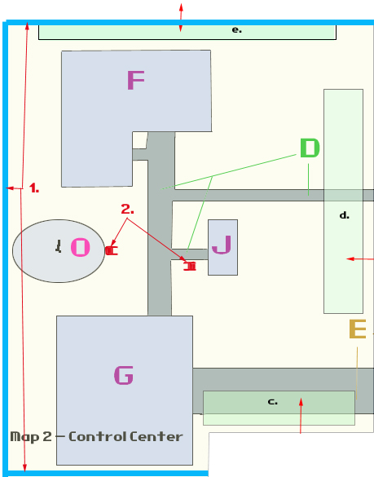

1. = Electrical fence | e. c. d. = Exit grids 2. = Security Robots

Rocket Assembly Building (G)
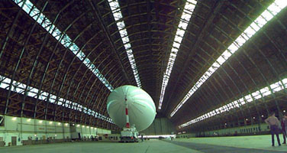

This is a very tall and wide hanger, similar to size and shape as the Tustin Air Base hangers on Barranca, just north of Interplay, but not quite as long and the west end of the hanger has collapsed. Inside the still standing section are three cylindrical pieces, each roughly twenty-five feet in length, fifteen feet high and wide, hollow, and slightly curved. It looks like if there were several of these pieces, and if someone linked them all together, they would form a perfect circle. Essentially these are three pieces of a second B.O.M.B., which never got completed.

Also inside the hanger, the player will find a toppled over rocket engine mounted sideways on what looks like a very large wagon made out of a full size truck bed. Behind and attached to the rocket engine is a large fuel tank equal to the size of the engine. Attached to the fuel tank is a set of controls and levers. The player will later find out from Sid that this is a giant flamer to be used against a large attacking force. Sid will also admit that he is not certain of its reliability since a prototype was never made or tested. Since there was only one available engine, and Kyle the Hook is not a patient man, Sid is willing to take the chance that his giant flamer will work.

There is more scattered debris and half-complete projects all over the hanger floor, as well as tool chests wheeled to each project. Basically this is homage to an ancient tech long forgotten and recently cannibalized by Sid and the Rusty Hooks to make other objects. A savvy player could create improvements to his armor and weapons with the materials present in the hanger. And, if the player is feeling a bit generous, he may help Sid complete a few of his projects, especially getting the sub-reactor to run at a higher efficiency.

Operations and Communications Building (F)
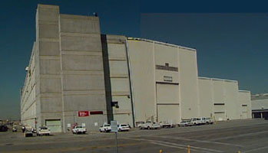

This is the heart of the Bloomfield Space Center. The Operations and Communications Building is remarkably intact, standing two stories and being half as long as the hanger. Upon entering the building from the front, main entrance, the player will come into contact with the reception area, now dirty and littered with empty and broken bottles, smashed furniture, and huge graffiti over what used to be the receptionist’s desk reading, “Rusty Hooks.” The player will find assorted offices with similar scattered debris, as well as smashed computers with evidence of pieces being literally ripped out of the CPU cases. There is also a stairway that leads down to a small basement level where the player will find the sub-reactor, which is usually locked behind two large, concrete doors. Other than that, the first floor certainly seems like a ghost town.

The second story is a different matter. Each office houses a member or two of the Rusty Hooks. These offices are relatively clean and hold the best furniture. One of the offices in the southeast end is noticeably larger than the other offices. This office is marked as the CEO’s office and is the domicile of Kyle the Hook and his bimbo of the month. At the same end of the building on the second floor, and facing the launch pad in the distance, is mission control. This very large room is filled with computers which are largely untouched, save for the randomly smashed monitors from drunken arms shooting. Power to the computers is minimal, allowing the player to get just the bare facts about Bloomfield. If the player wants more in-depth information, or is interested in launching Hermes-13, the sub-reactor needs to be at sixty-percent efficiency. Really good Science Boys could get the reactor to eighty-five percent efficiency, thus giving even more computers to get information from.

This building is where the player may do the better part of his dialogues, as well as tinker with the computers, fix the sub-reactor, and launch Hermes-13.

Satellite Communications Dish (O)


This is an inactive dish that is roughly the same diameter as the Operations and Communications Building. There is a small power room at its base which the player may access. This room houses the dish positioning controls, a computer, as well as the power breakers. Since power at Bloomfield is not running at full, the dish is out of commission. The player may restore power by having the sub-reactor’s efficiency being restored, but accessing the computer will take a bit of hacking, or the codes from someone who was familiar with the B.O.M.B. project.

Observation Building (J)

As the name states, this building was originally designed to view the launch of the Hermes-13. However, it is completed caved-in and inaccessible.

Sidewalk in Between the Rocket Assembly Building and the Operations and Communications Building (D, west side connecting F and G)
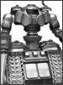

On the way from the Rocket Assembly Building and to the Operations and Communications Building, the player will be greeted by two large, well armed security robots. These robots were pretty much dormant the whole time the Rusty Hooks occupied Bloomfield, but went into passive sensor mode once the player escaped from prison. Since that time, the robots have been quietly waiting for the player to arrive. Once within fighting range, the robots will wheel themselves to face the player and open fire. Armed with two gattling guns for arms, the robots should make for a tough opponent. Luckily for the player, the Rusty Hooks will freak out at the sight of the robots firing their weapons and inadvertently help the player destroy the mechanical beasts.

Map 2 - Launch Platform
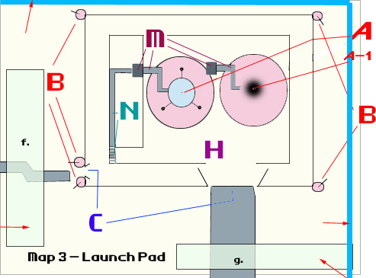

1. = Electrical fence | f. g. = Exit grids | B = Turrets | 3. = Barbed wire fence

Launch Platform (H)
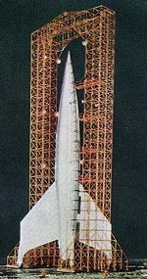

This impressive structure houses the identical Hermes-13 and Hermes-14 space rockets (pre completing the “return all the prisoners” quest for the Big MT). Even though the space rockets and structure have been exposed to the elements for nearly two-hundred years, they have held up quite well. However, if the player has returned all the prisoners to the Big MT (quest complete), then to the east of Hermes-13 is a second launch pad scorched by what looks like a recent launch (the Hermes-14 will have launched and not be there). The player will later find out that a group of NCR guys, led by Dr. Presper, commandeered Hereme-14 and launched into space. Currently, rust and creeks can be found all over the launch pad, but it seems that the foundation and structure are still intact. The only things keeping anyone from getting a closer look are the five high powered gattling turrets surrounding the structure, the four NCR guards, and the four security robots patrolling the launch pad. Everything on Bloomfield is powered by the sub-reactor in the Operations and Communications Building, except the turrets. The turrets are powered by their own sub-reactor underneath the center of the Launch Platform as well as its own computer control system. Accessibility is nearly impossible, except for a very well trained stealthy type (read: 100% + Sneak, 100% + Science). All others will need the access override codes which can be found either in the Boulder Dome or the Reservation. Doing so (or a successful hack) would allow the player to either shut down the turrets, or reprogram them to attack the four security robots and NCR guards.

After disabling the turrets, the player may follow the first level catwalk to the elevator. This elevator leads to the cockpit level and accessing catwalk.

2nd Level Catwalk and Cockpit (M)
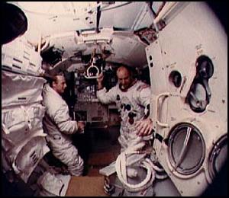

Not much happens on the catwalk to the cockpit of the space rocket. The door to enter the space rocket’s cockpit can only be opened with the same code that enables launch (acquired from either Boulder Dome or the Reservation - maybe). Once inside, there is enough room for six passengers (the player may bring CNPC’s). Everything about the launch and flight are automatically taken care of via the onboard computer and mission control. All the player needs to do is sit down and enjoy the ride.

Turret Control Computer Room

Should the player be super-stealth boy, there is door that leads to a room under the launch platform that controls the five turrets. This room houses the min-sub-reactor which powers the turrets as well as a computer that controls the turrets. Should the player have the required high skills, he may opt to power down the mini-sub-reactor to disable the turrets, reprogram the turrets to take out any perusing or potential enemies (the Rusty Hooks, Robots, NCR Guards, or any other threat that manages to follow the player into the range of the turrets), or just hack the computer to shut the turrets down.

ART REQUIREMENTS

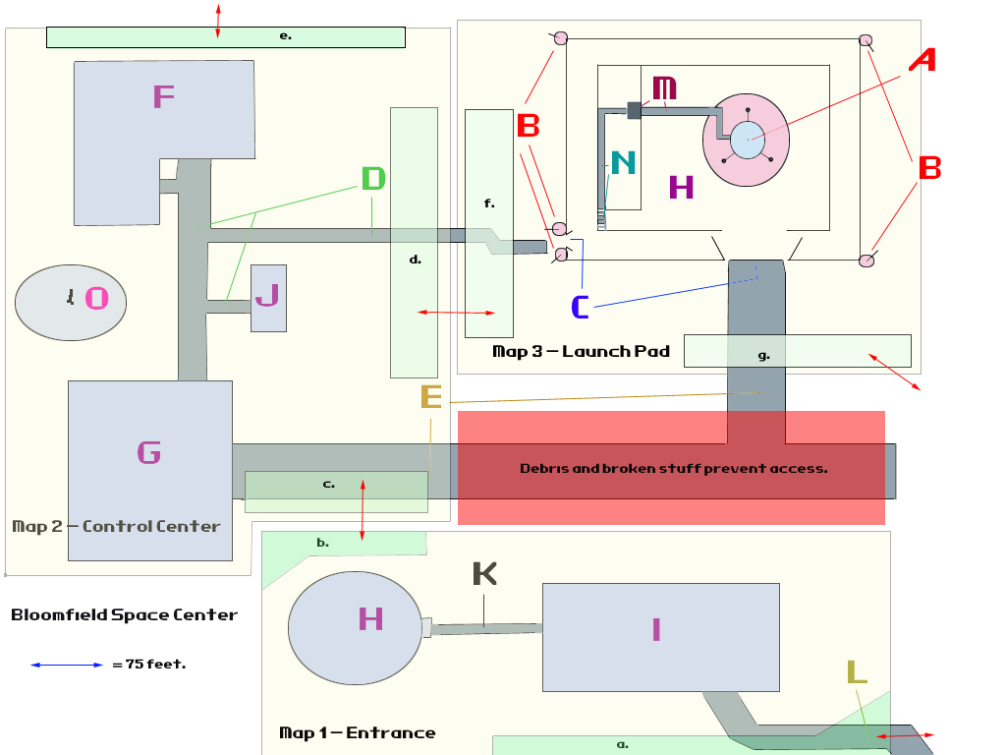

*A – Space Rocket  Meta-tile | *H – Bloomfield Space Museum  Meta-tile | *O – Satellite Communications Dish  Meta-tile
*B – Gattling Gun Turrets  Dynamic | *I – Collapsed Parking Structure  Meta-tile | a. – Map 1 World Map Entrance/ Exit Grid
*C – Rocket Transport Road  Tile | *J – Observation Building  Meta-TIle | b. – Map 1 Entrance/Exit Grid to Map 2 c. Entrance/Exit Grid
*D – Beat up sidewalks  TIle | *K – Sidewalk  Tile | c. - Map 2 Entrance/Exit grid to Map 1 Entrance/Exit Grid
*E – Rocket Transport Road  Tile | L – Entrance Grid to World Map | d. Map 2 Entrance/Exit Grid to Map 3 f. Entrance/Exit Grid
*F – Operations and Communications Building  Meta-tile | *M – Launch Platform Catwalk Elevator  Meta-tile | e.& g. – Map 2 & Map 3 (respectively) Entrance/Exit Grid to World Map
G – Rocket Assembly Building  Meta-tile | N – Stairs leading up to 1st level catwalk  Meta-tile | f. Map 3 Entrance/Exit Grid to Map 2 d. Entrance/Exit Grid

- On Map-2, the Rocket transport road (E), I would like a broken down rocket crawler-transporter machine (i.e. thrashed). It should not block the player’s access to the other building in the area, but it should block any access to taking the road directly east (red area on map should be inaccessible because of debris and broken machinery).


- Big CGI movie! Will need a CGI movie of the Heremes-13 launching, with a similar cinematic feel as the launch scene in Apollo 13. After launch, need to see the Hermes-13 leaving Earth’s atmosphere, slow, 2001 type of earth fly-over, and then see the Heremes-13 approach the B.O.M.B. (the Ballistic Orbital Missile Base). Lastly, see the Heremes-13 clamp and dock with B.O.M.B. and open the air lock.
- Big CGI Movie #2! Will need another CGI movie of an escape pod ejecting from the space station, making it’s way through the upper atmosphere, parachutes opening once passed the upper atmosphere, and “soft” landing in a desert field near Bloomfield.

CAST OF CHARACTERS

GENERIC NPCs

Kyle “The Hook” (Male – Human)
Importance - Intermediate

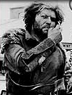

Level - 12
STATS
ST - 05
PE - 08
EN - 05
CH - 03
IN - 04
AG - 07
LK – 06
Traits – Finesse, One Hander
Perks – Demolition Expert, Tag!
Tag Skills – Deception (90%), Traps (110%), Firearms (105%), Persuasion (70%)

Some people are born leaders. These people possess the dynamic personality to guide and influence others through great words and actions. They rise above mediocrity to champion their cause and give meaning to the lives of those who follow. Great and memorable things happen when born leaders set about a task, and often become the thing of legends. Kyle “The Hook” is not that person.

Kyle was the guy with the gun. Five years ago, Kyle was just a cog in a greasy, unkempt machine. He was one of a handful of raiders who decided to go out on his own. Unfortunately, Kyle had zero influence on his colleagues around him, possessed a pointy stick, and had a rusty meat hook for a left hand to brave the hazards of the wastes. But Kyle devised a plan in that cavern he called a mind. He decided he would steal the gun of his raider leader (it was the only gun in the raider camp), kill him, and command any who opposes him to leave at once or face death (no one said it was a good plan).

Well, there’s a god with a great sense of humor floating around in the brown haze known as the sky, because Kyle was able to pull off his “genius” plan. After a late night rotgut fest, the leader of the raiders ended up passing out in-between Kyle’s tent and the tent of some other guy whose name is not important. Kyle wisely chose not to drink as much as everyone else in camp and made his move when he thought no one was awake enough to notice (or care). Kyle snagged his leader’s gun (a .44 caliber hand gun), pointed it at his leader’s head, and pulled the trigger. In the bloody, chunky mess that used to be his leader’s head, Kyle declared himself the new leader. No one was sober enough to care. However, the following morning, after Kyle retrieved the rest of his former leader’s ammunition, Kyle rousted his fellow raiders and re-declared himself the leader of the raider camp and decided to name his band of raiders the Rusty Hooks. About half of the raiders decided to stay, figuring Kyle could do no worse, and the other half gave Kyle the finger and left camp. From that point on, Kyle ruled with an “iron fist,” so to speak, but was surprisingly fair. His band of raiders were rather loyal to Kyle, especially after Bear became his second in command (Bear commanded a lot of respect among his raider-mates, especially since he was a super mutant). Over the years, Kyle’s Rusty Hooks grew to accept Kyle as their leader, mostly due to the fact he was the guy with the gun. What pretty much sealed the deal for Kyle was when he found Bloomfield Space Center. It is because of this great find that the Rusty Hooks increased their loyalty to Kyle and that they still consider him their leader, even though Kyle is no longer the only guy with a gun (thanks to the weapons cache in the security room in Bloomfield).

Kyle is an average built guy in his late thirties with shoulder length, grungy hair, and sun burned, leathery skin. Surprisingly enough, he still has most of his teeth which can be seen through all its plaque filled glory behind his half-assed beard and mustache. As alluded to earlier, Kyle is also not a very smart man, though he fancies himself a veritable genius. He will often make up long, polysyllabic words that almost sound real, just to give the impression he is quite intelligent and learned. Nothing could be further from the truth, though no one in the Rusty Hooks seems to mind, save for maybe Sid, the resident mechanic.

If the player can find a way to get passed Kyle’s ridiculous self image and peculiar vocabulary, then the player will find a fairly reasonable man, though a ruthless criminal when the need calls. If Kyle is convinced the player has no intention of disrupting his little haven in the wastes, there is plenty of opportunity to work with Kyle and the Rusty Hooks.

Kyle the Hook Personality Outline
- Leader of the raider tribe.
- Left hand is a sharp, rusted meat hook – hence the name.
- Dirty, brash, fair, dumber than he looks.
- Thinks he’s brilliant.
- Will often use big, made up words to sound smart.
- Damn proud he and his cronies found Bloomfield and claimed it as theirs.
- Rules with an iron, er, um, hook.
- Easily miffed, especially if someone calls him on his made up words.

Scripting stuff goes here

Scripting to keep in mind:
- If Kyle and troop become enemy to player, Kyle gives a +5% combat bonus to his buddies. This bonus disappears after he dies.

Sid (Male – Human)
Importance - Intermediate

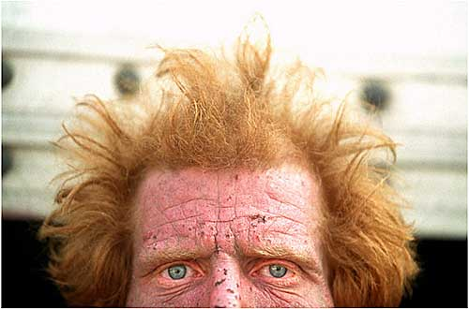
Level - 7
STATS
ST - 05
PE - 08
EN - 06
CH - 04
IN - 06
AG - 07
LK – 03
Traits – One in a Million; Increased Metabolism
Perks – TBD
Tag Skills – Firearms (90%), Mechanics (75%), Medic (75%)

Sid is not a gifted man in either looks or brains. He was always the guy who hung out in the back, never trying to stand out from the rest of the pack. The only thing that kept Sid from disappearing into obscurity completely was his mechanical and science skills. Now, no one would confuse Sid with a bona fide mechanic/science expert, but he did show an above average skill with such things. If he tinkered with something long enough, he usually figured out how to get it to work – mostly.

For the longest time, Sid was content being the forgotten Rusty Hook. He coasted from one raid to the next, hiding behind the braver (or dumber, depending on how one looked at it) warriors during a fire fight, always assuring himself the minimal respect of at least being in the fray, if not in front of the fray. Sid might have lived his entire life coasting on the coattails of his mates if it were not for the unfortunate abduction of Jillian McKinley, the Rusty Hooks’ true mechanic and science expert. When Jillian was hauled away by a security robot during a raid, and was never seen or heard again, Kyle appointed Sid the resident mechanic. That would have been just dandy for Sid if Kyle never found Bloomfield. However, now that Bloomfield was the declared hideout for the Rusty Hooks, Sid actually has to work and show results. This put a hamper on Sid’s preferred lifestyle of sloth and mooching, so Sid is none too pleased with his current predicament – a predicament exacerbated by the fact that Kyle is not pleased Sid only got the sub-reactor to work at 45% efficiency, and has yet to produce anything “useful” from all the shit that’s laying around Bloomfield. Sid knows that his time is limited if he does not produce something for all his work, and is pretty desperate for any help.

Sid will be fairly short with the player at first, but will lighten up if the player shows interest in helping Sid attain either better mechanical skill, finish his little projects, or return Jillian to the Rusty Hooks so Sid can fall back into obscurity.

Sid Personality Outline

    - Wannabe electrician and mechanic who monkeyed around with enough things to sorta get them working.
    - Has quite a few screws loose.
    - Looks like he hasn’t washed in years.
    - Has fits of rage if something he’s working on does not go as planned – which is often.
    - Player can trade items with him, though his prices seem unusually high.
    - If player becomes leader of these raiders, Sid’ prices will drop fifty-percent.
Scripting stuff goes here

Bear (Male – Super Mutant)
Importance - Major

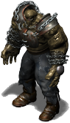

Level - 10
STATS
ST - 08
PE - 05
EN - 08
CH - 03
IN - 07
AG - 07
LK – 05
Traits – Gifted, Bruiser
Perks – Action Boy, More Criticals, Tag!
Tag Skills – Unarmed (120%), Melee Weapons (110%), Firearms (110%), Persuasion (100%)

Some within the ranks of the Rusty Hooks would say Bear is the true leader of the pack. Bear is the uncompromising tactician when it comes to violent caravan raids, the diplomatic liaison when it comes to settling disputes within the gang, and the enforcer of the law within the Rusty Hooks. This is all the more extraordinary considering Bear is a super mutant. Some would even say that the only reason Kyle gets any respect at all is because Bear seems uniquely loyal to him. In fact, Bear’s loyalty seems to boarder on the submissive, like a regularly disciplined dog.

Bear has been with the Rusty Hooks since almost its inception. About a month or so after Kyle the Hook “established” the Rusty Hooks, Bear was found leading a caravan through the wastes. When Kyle and his band attacked the caravan, Bear single-handedly killed six Rusty Hooks with his unusual iron bear claw weapon, before taking several bullets to the chest which rendered him unconscious and nearly dead. When Bear awoke and was pretty much back to normal (seems the bullet wounds were not as fatal as everyone thought thanks to that super mutant hide), he was mysteriously loyal to Kyle; so much so that Bear beat the living shit out of a few “possible” dissenters as a message to anyone who might even think of betraying Kyle. Since that time, Bear has been very close to Kyle the Hook, as well as offering advice to Kyle, which kept Kyle in power.

The big “mystery” as to why Bear is so loyal to Kyle is that Kyle, despite all his dumbness, is actually quite the expert at demolitions – almost idiot savant-like. Kyle instantly saw the potential of having a fierce super mutant like Bear under his command, so he created the heart bomb. Sid, the Rusty Hooks’ part time medic and full time slacker, inserted the heart bomb for Kyle, persuaded by a .44 pointed at his skull. After secretly placing the bomb and stitching Bear up away from prying eyes, Kyle told Sid that if he ever mentioned this device to anyone, he would make sure Sid was tied up and thrown into a den of hag snakes. Kyle then made it known to Bear that he would always be in control of him as long as that device was nestled safely next to Bear’s heart. Should Bear decide to break out on his own, he would become scorpion food. As long as Bear remained loyal, he would be treated as a second in command, especially since he showed such great physical and combat prowess. Bear, not being a stupid man, agreed to Kyle’s terms in the secret hope that one day he could regain control of his own life and squash Kyle. That thought is Bear’s driving force and which allows him to wake up each morning with hope.

Bear is a huge, standing over 7’6” and weighing in at a muscular 440 lbs. He is a master of hand-to-hand combat, melee weapons, and large guns - though he rarely uses guns. In fact, he’s so good at beating things up, that legend has it that Bear once beat the shit out of two super mutants with nothing more than his bare fists. However, despite Bear’s physical and combat prowess, he is also very smart and well spoken. He conveys his thoughts intelligently and does not seek to belittle anyone who does not have the extra brain power that he so obviously has. He is fairly easy to reason with and will happily help the player, should the player figure out Kyle’s weird control over Bear. If the player is able to free Bear from his predicament, Bear will be very grateful and perhaps become a CNPC. In addition, Bear actually knows all about Bloomfield and what the Hermes-13 was designed for and where it is programmed to go. He keeps this information secret because he does not think anyone in the Rusty Hooks is intelligent or responsible enough to know. He knows this information because he is one of the surviving super mutants from the Master’s army. He is well versed in NCR’s undertakings, as well as the BOS and Enclave, and is a good source of information, once the PC earns Bear’s trust.

Bear’s Personality Outline

- Kyle’s body guard.
- Super Mutant
- Huge – 7’ 6” 440 lbs.
- Over the top, homemade wasteland armor – droppable.
- Actually very smart and philosophical.
- Unique melee weapon – iron bear claw glove – also droppable.
- Hanging around these losers because Kyle has some mysterious hold on him.
- Very knowledgeable about NCR, BOS, and the Enclave.

Scripting stuff goes here

Scripting to keep in mind:
- If Bear and troop become enemy to player, Bear gives a +5% combat bonus to his buddies. This bonus disappears after he dies.

Jillian McKinley (Female, Human)

Importance - Intermediate


Level - 11
STATS
ST - 05
PE - 07
EN - 05
CH - 07
IN - 08
AG - 07
LK – 05
Traits – TBD
Perks – Gifted,
Tag Skills – Firearms (110%), Mechanics (120%), Science (110%)
Jillian McKinley is one of the vital escaped prisoners. Like many of her escapee comrades, she carries one of the New Plague mutations – a piece in a large and lethal puzzle that the player needs, and the same virus that inhabits player’s own body.

Jillian is a striking woman in her late thirties, despite her unkempt, “wasteland” look when the player finds her. Her looks are only exceeded by her intelligence and skill with mechanics and science (it’s rumored that her family came from an actual vault, which explains her high mechanical and science knowledge, but she never talks about her family – possible PC dialogue quest). It is because of this intelligence, and her enviable skill with all things mechanical, that her life was spared the ghoul procreation process; a process that is usually fatal to humans. The ghouls found her ability with tools and cognitive thinking both refreshing and useful, almost to the point of making her an “honorary” ghoul. So, the ghouls charged her with gun smithing under the direct supervision of Hank, the ghoul gun and ammo smith. Jillian made no protest since the alternative was probably a grotesque and horrifying death.

Jillian was abducted by a retrieval robot not long after the Rusty Hooks found Bloomfield. Like many of her fellow prisoners, she headed out in a direction she was somewhat familiar. Day and night she braved the wastelands, evading creatures of nightmarish size and grotesqueness. She thought she might actually make it to her home, Bloomfield. However, a few days before she reached her beloved home, Jillian was captured by a ghoul patrol and taken to The Reservation as a slave and potential procreation catalyst. Luckily for her, the ghouls discovered her high intelligence and skills in mechanics, and decided to make her a slave.

The player will find Jillian sweating away in a radiation suit in the little trade area on the surface of The Reservation. It will be made clear that the player may not speak to any slaves. However, the player may inquire about purchasing Jillian from Hank, though it will take a very charismatic person with a high speech skill to even get Hank interested in selling Jillian (Hank is far too fond of Jillian, and even shows a bit of affection towards her, mostly because of her skill, which he admires and respects). Other options of acquiring Jillian is proving to the ghouls that the player can be trusted by freeing Harold from his capture and returning him to The Reservation, by foiling a trade scam that a human trader is conducting on the ghouls, by talking the guards into taking the player to meet Willem by saying that the player knows about a hi-tech launch platform that is fairly functional, or by blowing the shit out of the ghouls, though the last option would be very tough due to the sheer number of ghouls and their formidable equipment.

As far as Sid is concerned with Jillian, she couldn’t return sooner. He will be ecstatic if the player brings Jillian back to Bloomfield so he can return to his life of background obscurity.

Jillian’s Personality Outline

- Headstrong, independent.
- Exceptionally smart.
- Excellent mechanic and science skills
- Will steal and kill to help herself and the ones she cares about.
- Carries New Plague and one of the prisoners who needs to be returned.

Scripting stuff goes here

COMPANIONS!

Bear

Level - 8
STATS
ST - 08
PE - 06
EN - 08
CH - 04
IN - 07
AG - 07
LK – 05
Traits – Gifted, Bruiser
Perks – Action Boy, More Criticals
Tag Skills – Unarmed, Melee, Firearms

Some within the ranks of the Rusty Hooks would say Bear is the true leader of the pack. Bear is the uncompromising tactician when it comes to violent caravan raids, the diplomatic liaison when it comes to settling disputes within the gang, and the enforcer of the law within the Rusty Hooks. This is all the more extraordinary considering Bear is a super mutant. Some would even say that the only reason Kyle gets any respect at all is because Bear seems uniquely loyal to him. In fact, Bear’s loyalty seems to boarder on the submissive, like a regularly disciplined dog.

Bear has been with the Rusty Hooks since almost its inception. About a month or so after Kyle the Hook “established” the Rusty Hooks, Bear was found leading a caravan through the wastes. When Kyle and his band attacked the caravan, Bear single-handedly killed six Rusty Hooks with his unusual iron bear claw weapon, before taking several bullets to the chest which rendered him unconscious and nearly dead. When Bear awoke and was pretty much back to normal (seems the bullet wounds were not as fatal as everyone thought thanks to that super mutant hide), he was mysteriously loyal to Kyle; so much so that Bear beat the living shit out of a few “possible” dissenters as a message to anyone who might even think of betraying Kyle. Since that time, Bear has been very close to Kyle the Hook, as well as offering advice to Kyle, which kept Kyle in power.

The big “mystery” as to why Bear is so loyal to Kyle is that Kyle, despite all his dumbness, is actually quite the expert at demolitions – almost idiot savant-like. Kyle instantly saw the potential of having a fierce super mutant like Bear under his command, so he created the heart bomb. Bud, the Rusty Hooks’ resident medic, inserted the heart bomb via one of Bear’s bullet wounds for Kyle, persuaded by a .44 pointed at his skull. After placing the bomb and stitching Bear up, Kyle killed Bud so his little secret would never get out. Kyle then made it known to Bear that he would always be in control of him as long as that device was nestled safely next to Bear’s heart. Should Bear decide to break out on his own, he would become scorpion food. As long as Bear remained loyal, he would be treated as a second in command, especially since he showed such great physical and combat prowess. Bear, not being a stupid man, agreed to Kyle’s terms in the secret hope that one day he could regain control of his own life and squash Kyle. That thought is Bear’s driving force and which allows him to wake up each morning with hope.

Bear is a huge, standing over 7’6” and weighing in at a muscular 440 lbs. He is a master of hand-to-hand combat, melee weapons, and large guns - though he rarely uses guns. In fact, he’s so good at beating things up, that legend has it that Bear once beat the shit out of two super mutants with nothing more than his bare fists. However, despite Bear’s physical and combat prowess, he is also very smart and well spoken. He conveys his thoughts intelligently and does not seek to belittle anyone who does not have the extra brain power that he so obviously has. He is fairly easy to reason with and will happily help the player, should the player figure out Kyle’s weird control over Bear. If the player is able to free Bear from his predicament, Bear will be very grateful and perhaps become a CNPC. In addition, Bear actually knows all about Bloomfield and what the Hermes-13 was designed for and where it is programmed to go. He keeps this information secret because he does not think anyone in the Rusty Hooks is intelligent or responsible enough to know. He knows this information because he is one of the surviving super mutants from the Master’s army. He is well versed in NCR’s undertakings, as well as the BOS and Enclave, and is a good source of information, once the PC earns Bear’s trust.
If the player is able to free Bear from his predicament, Bear will be very grateful and perhaps become a CNPC.

Bear will become a companion if:

- Player figures out Kyle’s mysterious hold in Bear and disables the C4 implant.
  - The device may be removed if the player has a high medic and science skill, and a good quality doctor’s bag.
    - Player is able to get the trust and support of the Rusty Hooks and becomes their leader.
- By fixing everything Kyle wants fixed, by defeating the turrets, and showing better leadership skills by exposing Kyle’s elevated stupidity.
- By openly challenging Kyle to combat for the leadership of the Rusty Hooks. Kyle will choose Bear as his champion. If player can beat Bear into submission via unarmed or melee combat (player’s choice), Kyle would be forced to let player become leader – it is their way!
- Same as above, but the player can work out a deal with Bear in which Bear takes a fall. Player will have to fight pretty effectively (Deception) in order to fool Kyle into thinking fight is real. If player succeeds, player gets the Rusty Hooks and can free Bear b demanding control of the radio detonator.
- Player figures out a way to get radio control device that detonated Bear’s heart bomb. Bear will become player’s slave.
  - Fun note: heart bomb may explode if it comes in contact with electricity, like from a pulse rifle shot and hitting Bear in the chest. Result – pretty big BOOM!

Scripting stuff goes here

MONSTER ROSTER

Rusty Hooks - #~22, Lvl: 6-8
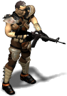
The Rusty Hooks are pretty typical when it comes to raider types. They are all human and are pretty evenly distributed between male and female. All of them are proficient in small guns, rifles, and melee weapons. They will not respawn. They will attack with their best available weapon if the PC attacks them or triggers something to piss them off.

NCR Guards - #~4, Lvl: 15-20
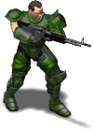
These are the NCR soldiers who accompanied Dr. Presper and helped launch the Doc and his men to B.O.M.B.-001. The hover around the launch pad making sure no one messes with the space rocket, the turrets, and the security robots. Over a small amount of time, they established an “understanding” of sorts with the Rusty Hooks. The NCR would let them live at the base in peace and the Rusty Hooks would not bother the NCR guards. In addition, the Rusty Hooks would try to prevent anyone from accessing the facilities and the NCR guards would help the Rusty Hooks if anyone tried to overtake them.
The NCR Guards are armed with high powered rifles, grenades, and combat armor.

Security Robots - #~6, Lvl: 8
These security robots are bad news. They are treaded beasts with a tall, thick torso and two gattling laser arms. Two of the robots are dormant in the Operations and Communications map. They will become active and attack once the PC gets within visual of them. The remaining four robots are patrolling the Launch Pad map and will shoot at anything that moves. These robots do not respawn.

Laser Turrets - #~5, Lvl: 8
These laser turrets are along the fenced off area around the Launch Pad. They will fire at anything that moves, besides the security robots.

Hag Snakes - #~5, Lvl: 1-3 (For Random Encounters)
Radioactively evolved from the hag fish , these nasty critters grow to seven feet, have slimy, purple & green leathery skin, small, red eyes, and a large, round mouth filled with serrated teeth ideal for burrowing into flesh. They will strike its victim much like a rattle snake strikes, but the hag snake will try to latch and hold onto its prey. If its attack is a critical success, it will lay an egg in its victim after it has feasted for a couple of rounds. The egg will gestate for two months before hatching, in which case the young hag snake will dine on its host from within until the host is dead (this could take an additional week).

A decent medic skill, along with a doctor’s bag, will get rid of the egg. The player will know something is amiss because his EN (Endurance) is lowered by one while the hag snake egg is still impregnating its host. If the hag snack egg hatches, the player’s EN will go down by three. However, a PC with an egg implanted in his body can walk freely among hag snakes without worrying about being attacked.

S.O.R. -1000 Gamma (For One-Time Random Encounter)
This little fellow recently escaped from the B.O.M.B.-001. He crash landed on the Earth via an escape pod. Thanks to the impact, he’s feeling a bit discombobulated. He looks pretty much like a typical brain bot, but instead of two arms, he’s got four; two for maintenance work and two for laser guns (not holding laser pistols, but his additional arms are actually laser guns). He gets around on two tractor treads, similar to the larger security bots.

RANDOM ENCOUNTERS SURROUNDING THE AREA

Hag Snakes Minor Encounter
A small nest (~ 4 – 6) of hag snakes are mucking around a nearly dried up stream. They will seek to attack the player at first sight, unless the player is already impregnated with a hag snake egg, in which case they will ignore the player.

Hag Snakes Major Encounter
This has a larger body of water coming from a cave. A few hag snakes are meandering around the cave opening. If the player ventures into the cave, he will find a small nest of hag snakes with incapacitated hosts lying about. Some of the host are still alive, but in some sort of coma, while others are hollowed out husks. There are about a dozen hag snakes going about in the cave, with one really big one (about 14 feet) nestled at the far end. There seems to be more bodies around this hag snake than the others. Happy hunting!

Rusty Hooks Patrol
A few of the Rusty Hooks are out on patrol in the area. When they come across the PC they will say that it is advisable that he/she clear out and find somewhere else to snoop around. The PC can try his speech skill on the speaker to try and find out about the area, tell them he has some good loot to trade (depending on the speech skill will decide if the Rusty Hooks will try and mug the PC), or shoot them in the face. Basic raider encounter, in other words. Fighting these guys will lower the PC’s karma with the Rusty Hooks by a point or two.

Rusty Hooks Showdown
Here the player will drop in on a firefight between the Rusty Hooks and a rival band of raiders. If the player helps the Rusty Hooks defeat the invading raiders, the player’s reputation with the Rusty Hooks is raised by one point. If the player fights the Rusty Hooks, the player’s reputation with the Rusty Hooks goes down by one point. If the player just sits and watches the show, his reputation is unaffected.

Rusty Hooks and Hag Snakes
Here the player will drop in on a firefight between the Rusty Hooks and some hag snakes. If the player helps the Rusty Hooks defeat the hag snakes, the player’s karma with the Rusty Hooks is raised by one point. If the player fights the Rusty Hooks, the player’s karma with the Rusty Hooks goes down by one point. If the player just sits and watches the show, his karma is unaffected.

B.O.M.B.-001 EPB (Escape Pod Beta)
This encounter will drop the player into a small desert field with an escape pod from the B.O.M.B.-001. It looks as if the escape pod had a rough landing because of the impact slide and crater. There is a lot of debris from the pod lying around, but the pod is still pretty much intact, and the markings B.O.M.B.-001-EPB is still clearly written on its side. A bit more investigation will reveal robot treads around the area, but there is no robot to be found. All onboard electronics are not functioning, but there are a few medical supplies still onboard and waiting for the player to happily take.

S.O.R. -1000 Gamma
This is the former occupant from the Escape Pod Beta encounter. This robot is a S.O.R.-1000 security and operations robot from the B.O.M.B.-001. When the player arrives in this run down rocky area, the S.O.R.-1000 Gamma (its designation) is treading along erratically, making beeps and whirr sounds. Every once in a while, it will blurt out, “No one is left, need new program parameters.” If the player approaches the little robot, it will wig out and attack, saying, “Intruder alert! Sterilize intruders!” Killing this little fellow and searching him will garner a holo-disk giving a bit of information about the B.O.M.B.-001 and its function.

QUESTS

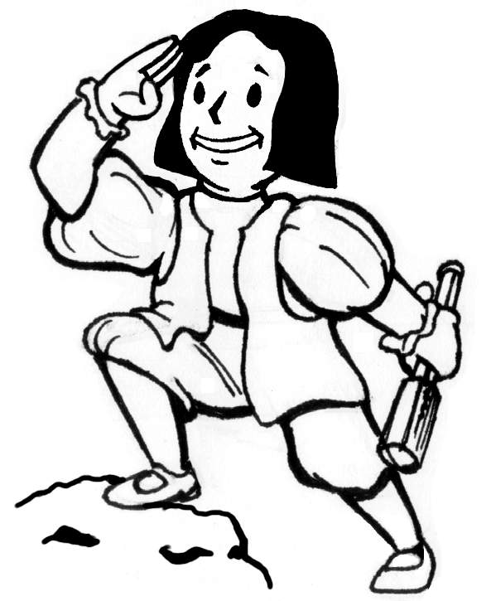

MAIN QUESTS

Restore Sub-Reactor from 45% Efficiency to 60%-85% Efficiency

  - Initiator – Sid or Kyle the Hook
  - Importance (Critical) – allows Mission Control to operate, which in turn initiates the guidance and navigations systems of the Hermes-13, and will let the player input the Hermes-13 launch codes.
  - Scope – Small
  - Description - The sub-reactor for the Control Center map is only working at 45% efficiency, thanks to Sid’s customary half-assedness. The sub-reactor, located in a small basement accessible from a stairway on the first floor of the Operations and Communications building, is what powers everything useful on this map, and has some direct input control on the Hermes-13. Running at 45%, there is not enough power to operate Mission Control computers, or any computers, except for a couple of general maintenance computers. Restoring the power output to 60% will get the necessary computers back online to control the basics of Mission Control, and is the player’s first step in getting the Hermes-13 launched. A really good science boy can get the sub-reactor to 75%, and even 85%, which will allow the PC to access more information and grounds control.
  - Character type completion breakdown –
      - Combat Boy - If this character type does not have his Mechanics skill over 50%, then his next option to complete this quest is to bring back Jillian McKinley and have her fix it (which she will more than happily do if her raider buddies are still alive). However, if Combat Boy has gone Rambo on everyone here first, Jillian will not be very cooperative. In this case, Combat Boy may choose to learn mechanics by buying books, or get taught by the ghouls at the Reservation (if he makes nice there, he can learn Mechanics from certain ghouls), or he can get a CNPC with Mechanic skill and have them take care of it.
      - Diplomacy Boy – Pretty much the same options as Combat Boy, here, though I suspect Diplomacy Boy is less likely to go Rambo on the raiders, thus allowing for more civilized conversations and acquiring help from Jillian.
      - Science Boy – No-duh, here. It’s a safe bet that Science Boy will have the right stuff to fix the sub-reactor. The bonus here is that the player can teach good ol’ Sid a trick or two and make him a better mechanic.
      - Stealth Boy – Pretty much in the same boat as Diplomacy Boy and Combat Boy.
- Quest flags – “15_Restore_OC_Power”
0 = not started
1 = player knows about it
2 = player accepted quest
3 = player restored full power
4 = player got reward
- Rewards -
- Beau Coup XP (2,000-ish)
- +2 Reputation with Rusty Hooks (provided they are not already dead).
- All computers in the Control Center map are now fully functional.
- Allows continuation of other, related quests.
- Journal Entries –
- Good
- Bad
- Normal
- Dumb

Convince Rusty Hook Guards to Allow Passage
  - Initiator – Rusty Hook Guards
  - Importance (Minor) – Lets the player go into Bloomfield without bloodshed.
  - Scope – Small
  - Description - After getting through the parking structure, these guards will approach the player and initiate dialogue. If the player has not yet freed Jillian from the Reservation and completed the prisoner retrieval quests, the guards will basically say to get the hell out of here. If the player is a good Charisma Boy, then he should be able to get some information out of the guards pertaining to what the Rusty Hooks are and that they are always interested in some trading as long as the trader does not care where the loot came from. If this is acceptable to the player, they will let him pass and tell him to meet Bear in the main walkway between the workshop (Rocket Assembly Building) and the homestead (Operations and Communications building). They will also insist that the player keeps his weapon holstered.
  - Character type completion breakdown –
      - Combat Boy - If the player has completed the prisoner retrieval quests, and the player had not killed Jillian, then the guards will let the player pass with honors. If the quest has not been completed, then the guards will tell the player to piss off. Should the player refuse, or if his speech/persuade is not adequate, the player may choose to mow the guards down. Since gunfire is loud, more Rusty Hooks will pour into the area (~10 to 15) accompanied by four NCR guys with high powered weapons and combat armor. Good luck.
      - Diplomacy Boy – Can talk his way into seeing Bear whether or not he completed the prisoner retrieval quests.
      - Science Boy – Pretty much the same as Combat Boy, except if the player is good at science and mechanics and mentions it to the guards, they will let the player pass and instruct him to meet Bear first, the Sid.
      - Stealth Boy – Straight forward, here. If the player is capable of sneaking passed the guards, he can meander pretty much anywhere. However, if the player fails his sneak and is seen by a Rusty Hook, then there will be hell to pay.
- Quest flags – “15_Entrance_Guards”
0 = not started
1 = player knows about it
2 = player accepted quest
3 = player completed quest
4 = player got reward
- Rewards -
- Medium XP for talking way passed guards.
- Medium XP for sneaking passed guards.
- Medium XP for getting in because of mechanical and science skills.
- Minor XP for getting passed guards via finishing the prisoner retrieval quests and Jillian is still alive.
- Journal Entries –
- Good
- Bad
- Normal
- Dumb

Make it Through the Parking Structure Unscathed
  - Initiator – N/A
  - Importance (Minor) – The player can get through injured, but there is bonus XP for getting through unscathed and setting one trap off.
  - Scope – Small
  - Description – If the player is a good Stealth Boy, he can try to get through the Parking Structure’s myriad of traps without setting them off. This will be a combination of outdoorsmanship and traps skills. The player can opt to disable traps and discover where traps are, thus avoiding them. Getting through the Parking Structure without setting off a trap will result in bonus XP.
  - Character type completion breakdown –
      - Combat Boy – It’s possible for combat boy to get through unscathed as long as his traps and/or outdoorsman skills are good. If not, he’s going to take a few cuts and bruises through the structure. The traps are not lethal by themselves, but they can be accumulatively.
      - Diplomacy Boy – Can’t talk your way through traps; they won’t listen. Same situation as Combat boy.
      - Science Boy – Ditto
      - Stealth Boy – This is Stealth Boy’s shining area. Make sure he ahs good trap and/or outdoors skills.
- Quest flags – “15_Parking_Traps”
0 = not started
1 = player knows about it
2 = player accepted quest
3 = player completed quest
4 = player got reward
- Rewards -
- Minor XP Bonus.
- Journal Entries –
- Good
- Bad
- Normal
- Dumb

Help Sid Complete the Mega-Flamer
  - Initiator – Sid, Bear, or Kyle.
  - Importance (Major) – Helping Sid to complete the Mega-flamer will boost Sid’s confidence and status within the Rusty Hooks. This in turn will lower Sid’s prices.
  - Scope – Small
  - Description – Sid has been struggling with completing his many projects. One of the most important project, other than restoring efficiency to the sub-reactor, is the completion of the Mega-flamer – a rocket engine mounted to a detached pickup truck bed, which is then mounted to a large fuel tank and some controls. If the PC is mechanically inclined, he can help Sid figure out how to complete the Mega-flamer. If the PC finishes it himself and gives Sid the credit, Sid’s prices will drop 30%. If the player helps Sid, by guiding him through the process, Sid’s prices will drop 15%. Lastly, if the player does most of the work, takes credit for it, but gives Sid some degree of credit, Sid will lower his prices 5%. Should the player take all the credit, no matter how much the player helped (it’s not too difficult to convince Kyle that the player did most of the work), then Sid will get a bullet through his head and the player will become the new mechanic for the Rusty Hooks.
  - Character type completion breakdown –
      - Combat Boy – Combat boy can be errand boy for Sid, if Combat Boy has minimal mechanical skill.
      - Diplomacy Boy – Can make it seem that player did a lot of work by bullshitting his way through the process.
      - Science Boy – Up to the player how much he wants to contribute to the completion of the Mega-flamer.
      - Stealth Boy – In the same boat as Combat Boy.
- Quest flags – “15_Mega_Flamer”
0 = not started
1 = player knows about it
2 = player accepted quest
3 = player completed quest
4 = player got reward
- Rewards -
- Medium XP
- Price drops for Sid’s store (30%, 15%, 5%)
- Journal Entries –
- Good
- Bad
- Normal
- Dumb

Use the Mega-Flamer to Eliminate the Rusty Hooks
  - Initiator – Completion of the Mega-flamer.
  - Importance (Minor) – If the player just does not want to deal with the Rusty Hooks, this option wipes them out.
  - Scope – Small
  - Description – After completing the Mega-flamer, and if the player is good at his persuade skill, he can gather the Rusty Hooks for a demonstration of the Mega-flamer. When everyone is gathered in front of the Mega-flamer (aided in direction by the PC), the player can fire up the Mega-flamer and turn the Rusty Hooks into smoldering piles of ash. Good fun for the whole family.
  - Character type completion breakdown –
      - Combat Boy – Will need a bit of the Persuade skill to convince the Rusty Hooks to “participate” in the demo. Otherwise, the Rusty Hooks will be on to the player’s intentions. They will like the PC a bit less.
      - Diplomacy Boy – Time to shine. Good Persuade skill gets the optimum outcome – BBQ Rusty Hooks.
      - Science Boy – Same as Combat Boy
      - Stealth Boy – Same as Combat Boy
- Quest flags – “15_MFlamer_Kill_Hooks”
0 = not started
1 = player knows about it
2 = player accepted quest
3 = player completed quest
4 = player got reward
- Rewards –
- Medium XP
- Any loot the ashes may have that wasn’t charred.
- Journal Entries –
- Good
- Bad
- Normal
- Dumb

Get Sid to tell PC about Bear’s Heart Bomb and Kyle’s Radio Trigger
  - Initiator – Sid
  - Importance (Minor) – This gives the PC vital information about how Kyle controls Bear.
  - Scope – Small
  - Description – The player can dig into Sid’s guilt and get information about Bear’s heart bomb and Kyle’s radio trigger. A really good Charisma Guy can get Sid to confess about him implanting the heart bomb into Bear’s chest.
  - Character type completion breakdown –
      - Combat Boy – Will need a bit of the Persuade skill to get Sid to give details about the heart bomb and radio trigger. Being Sid’s errand boy may eventually get Sid to give out a hint or two about the heart bomb and radio trigger.
      - Diplomacy Boy – Time to shine. Good Persuade skill gets the optimum outcome – Confess thy sins, Sid!
      - Science Boy – Through helping Sid complete his assigned tasks, Sid may lighten up and divulge a bit about the heart bomb and radio trigger. Each task quest makes Sid trust the PC a bit more.
      - Stealth Boy – Same as Combat Boy, although Deception could play a role in getting Sid to talk.
- Quest flags – “15_Sid_Confess”
0 = not started
1 = player knows about it
2 = player accepted quest
3 = player completed quest
4 = player got reward
- Rewards –
- Minor - Medium XP
- Unlocks Bear’s Heart Bomb Quests
- BONUS! If player gets Sid to confess about installing the heart bomb, PC gets bonus XP and a half-way finished radio signal jammer (PC must get the jammer to work).
- Journal Entries –
- Good
- Bad
- Normal
- Dumb

Disable Bear’s C4 Heart Bomb
  - Initiator – Bear
  - Importance (Major) – Doing so will allow Bear to be a CNPC.
  - Scope – Small
  - Description – A medic and science savvy PC can offer to disable Bear’s C4 heart bomb. If the player is successful, then Bear will not only kick the shit out of Kyle, but also volunteer to be a CNPC.
  - Character type completion breakdown –
      - Combat Boy – Unless he has good science and medic skill, he can’t do much.
      - Diplomacy Boy – Ditto
      - Science Boy – Made for the Science Boy, as long as there is some degree of Medic skill (it does not have to be very high).
      - Stealth Boy – Same as Combat Boy (other option is linked to Get Control of Bear’s C4 Heart Bomb radio trigger).
- Quest flags – “15_Disable_HBomb”
0 = not started
1 = player knows about it
2 = player accepted quest
3 = player completed quest
4 = player got reward
- Rewards –
- Medium XP
- Get Bear as CNPC
- Journal Entries –
- Good
- Bad
- Normal
- Dumb

Get Control of Bear’s C4 Heart Bomb
  - Initiator – Bear
  - Importance (Major) – Doing so will allow the player to choose whether he gives Bear his freedom, or takes control of Bear.
  - Scope – Small
  - Description – If the player is somewhat stealthy and is pretty good at stealing things, he can try to steal the radio control trigger for Bear’s C4 heart bomb. Kyle has the radio trigger on a secret item on his person. The player will have to figure out that the item in question is Kyle’s gaudy watch which has never worked in telling time (first clue). The player can then try to steal Kyle’s watch while he sleeps, which would take quite a bit of high sneaking ability. However, the player could try to get Kyle very drunk and then try to steal the watch after he passes out, thus lowering the risk of getting caught considerably. Either way, when the player has control of the trigger, it’s up to him if he wants to free Bear from the device, or take control of Bear.
  - Character type completion breakdown –
      - Combat Boy – Pretty much anyone can talk Kyle into getting drunk, especially if the PC brings quite a bit of booze. This will increase any class type’s chances of stealing Kyle’s watch trigger.
      - Diplomacy Boy – Diplomacy Boy will have an easier time figuring out what controls Bear by talking to Kyle. Getting Kyle drunk makes Kyle talk too much, which will reveal his secret.
      - Science Boy – Science Boy would have a pretty good chance of figuring out that Kyle’s watch is being used for something other than telling time. At that discovery, Science Boy can go the drunk/pass out route to get the watch.
      - Stealth Boy – Once the player figures out what’s what, he should have no trouble sneaking up on a sleeping Kyle and stealing the watch.
- Quest flags – “15_Watch_Control”
0 = not started
1 = player knows about it
2 = player accepted quest
3 = player completed quest
4 = player got reward
- Rewards -
- Medium XP
- Get Bear as CNPC
- Journal Entries –
- Good
- Bad
- Normal
- Dumb

Disable Trigger of Bear’s C4 Heart Bomb
  - Initiator – Bear
  - Importance (Minor) – Enables player to give Bear his freedom.
  - Scope – Small
  - Description – Instead of actually stealing the trigger watch from Kyle, the player could devise a way of disabling the trigger. One way is to sneak up on Kyle when he’s sleeping and use the mechanic skill on the trigger to disable it, thus not risking waking Kyle while trying to remove the watch. Another way is to use the science skill to devise a way of rendering the signal in the trigger watch useless – some kind of frequency jammer made from the parts found in the Rocket Assembly Building. Either solution would allow the player to grant Bear freedom, clear the path for either Bear or the PC to become leader, and/or make Bear a CNPC.
  - Character type completion breakdown –
      - Combat Boy – All boils down to whether or not the player has put enough points into mechanic or science. If not, then a possible alternative is to get Jillian to disable the trigger, provided the prisoner retrieval quests are done and the player didn’t piss her off.
      - Diplomacy Boy – Same as Combat Boy, but player has the option to try and talk Sid into doing the deed.
      - Science Boy – Another shining moment for Science Boy. The skills are his, make good use of them.
      - Stealth Boy – This would help when sneaking up on the sleeping Kyle, but after that, it depends on how much was put into mechanics or science.
- Quest flags – “15_Disable_HTrigger”
0 = not started
1 = player knows about it
2 = player accepted quest
3 = player completed quest
4 = player got reward
- Rewards –
- Medium XP
- Bear becomes CNPC
- Journal Entries –
- Good
- Bad
- Normal
- Dumb

Rewire Trigger of Bear’s C4 Heart Bomb to Explode
  - Initiator – Bear
  - Importance (Major) – Enables player to give Bear his freedom.
  - Scope – Small
  - Description – If the player has a high mechanic skill, he can sneak up on Kyle while he’s sleeping (preferably after he passed out from being drunk) and rewire his watch trigger to explode when used. So, the next day when the player tells Bear to be defiant to Kyle and Kyle pressed the radio trigger, it explodes and blows off his lone good hand.
  - Character type completion breakdown –
      - Combat Boy – All boils down to whether or not the player has put enough points into mechanic. If not, then a possible alternative is to get Jillian to rewire the trigger, provided the prisoner retrieval quests are done and the player didn’t piss her off.
      - Diplomacy Boy – Same as Combat Boy, but player has the option to try and talk Sid into doing the deed.
      - Science Boy – Another shining moment for Science Boy. The skills are his, make good use of them.
      - Stealth Boy – This would help when sneaking up on the sleeping Kyle, but after that, it depends on how much was put into mechanics.
- Quest flags – “15_Rewire_HTrigger”
0 = not started
1 = player knows about it
2 = player accepted quest
3 = player completed quest
4 = player got reward
- Rewards –
1. Medium XP
- Bear becomes CNPC
- Journal Entries –
- Good
- Bad
- Normal
- Dumb

Build Sid’s Self-Esteem
  - Initiator – Sid, Bear
  - Importance (Major) –
  - Scope – Medium
  - Description – Helping Sid with the Mega-flamer, the sub-reactor, and whatever else he’s working on, and actively teaching him, will make Sid feel better about himself.
  - Character type completion breakdown –
      - Combat Boy – Basically boils down to a Combat Boy being Sid’s errand boy and listening to him bitch. If the player gives all the credit to Sid and is not condescending to him, Sid will feel like he accomplished a lot and feel better about himself.
      - Diplomacy Boy – The player has a chance to be Dr. Phil. A good speech skill of any category can lead Sid into the realm of self forgiveness and esteem.
      - Science Boy – If the player ends up doing most of the work but gives Sid all the credit, then Sid will earn some of Kyle’s respect, which in turn makes Sid feel better.
      - Stealth Boy – Same as Combat Boy.
- Quest flags – “15_Sid_Feelgood”
0 = not started
1 = player knows about it
2 = player accepted quest
3 = player completed quest
4 = player got reward
- Rewards –
- Medium XP
- Lower prices on Sid’s stuff
- Advanced Tool Kit
- Journal Entries –
- Good
- Bad
- Normal
- Dumb

Convince Sid to Kill Himself
  - Initiator – Sid
  - Importance (Minor) –
  - Scope – small
  - Description – If the player discovers Sid’s festering guilt about implanting the heart bomb in Bear, the Charisma Boy may try to get Sid to kill himself. A really good Charisma Boy can talk Sid into strapping some C4 onto his chest, run up to Kyle, and take him out, too.
  - Character type completion breakdown –
      - Combat Boy – Unless the player has a really good speech skill, it ain’t gonna happen.
      - Diplomacy Boy – This was made for him. Any good speech skill (besides Barter, of course) will get the optimum outcome. A great speech skill will get the bonus “suicide bomber” attack on Kyle.
      - Science Boy – Same as Combat Boy.
      - Stealth Boy – Same as Combat Boy.
- Quest flags – “15_Sid_Suicide”
0 = not started
1 = player knows about it
2 = player accepted quest
3 = player completed quest
4 = player got reward
- Rewards -
- Medium XP
- (If suicide bomber) Makes Bear a CNPC (provided he does not find out that the PC talked Sid into killing himself)
- Player gets to loot Sid’s stuff
- Journal Entries –
- Good
- Bad
- Normal
- Dumb

Challenge Kyle to Fight for Rusty Hooks’ Leadership
  - Initiator – Kyle, Sid, Bear
  - Importance (Minor) –
  - Scope – Small
  - Description – After getting to know the Rusty Hooks for a bit, the player can find out that he can challenge the current leader (in this case, Kyle) to a fight (unarmed only) and whoever wins becomes the new leader of the Rusty Hooks. The one caveat of the current leader is that he may choose anyone to be his “champion,” and Kyle will always choose his favorite super mutant, Bear. After the challenge, the fight begins. Good luck! If the player wins the fight, he is the new leader of the Rusty Hooks. However, Kyle might be so pissed after Bear losing the fight that he triggers Bear’s heart bomb – hopefully the player is not too close.
  - Character type completion breakdown –
      - Combat Boy – Straight up and fight. One thing the player can do to improve his chances is to speak to Bear first, work up a rapport, and ask him to take a fall. He will tell the player about his heart bomb and will refuse to take a dive until he can be assured that the heart bomb won’t go off if he loses. See other quests, 7, 9, 10. If he is assured the heart bomb won’t go off, he will take the fall, no finagling required.
      - Diplomacy Boy –Ditto
      - Science Boy – Ditto
      - Stealth Boy – Werd.
- Quest flags – “15_Bear_Dives”
0 = not started
1 = player knows about it
2 = player accepted quest
3 = player completed quest
4 = player got reward
- Rewards -
- Journal Entries –
- Good
- Bad
- Normal
- Dumb

Convince Bear to Try and Take Over Rusty Hooks
  - Initiator – Bear, Sid
  - Importance (Major) – Convincing Bear to take over the Rusty Hooks gives the player the chance to redeem them – i.e. make them a legitimate, non-raiding group.
  - Scope – Medium
  - Description – If the player can do any of the non-lethal disabling the heart bomb quests, then the player can convince Bear to take over the Rusty Hooks. Bear will not attempt a takeover if he knows his heart bomb is still functional and Kyle has control of it. Having Bear as the leader of the Rusty Hooks gives the player the opportunity to convert the raiders from a criminal organization to a legitimate organization. With all the materials present at Bloomfield, the Rusty Hooks could make out pretty well as a major manufacturer of metal goods and establish important trade routes.
  - Character type completion breakdown –
      - Combat Boy – As long as Bear is safe from his heart bomb, it’s pretty easy to talk him into it.
      - Diplomacy Boy – Ditto
      - Science Boy – Ditto
      - Stealth Boy – Werd
- Quest flags – “15_Bear_Leader”
0 = not started
1 = player knows about it
2 = player accepted quest
3 = player completed quest
4 = player got reward
- Rewards –
- Medium XP
- Chance to establish trade routes
- Journal Entries –
- Good
- Bad
- Normal
- Dumb

Sneak Passed Launch Pad Turrets, Security Bots, and NCR Guards, and Gain Access to Computer Control Room
  - Initiator – PC
  - Importance (Minor) – Successfully sneaking passed these security things gives the player free reign to do with the power source and computer what he wishes.
  - Scope – Small
  - Description – The player may attempt to sneak passed the Launch Pad turrets, security bots, and NCR guards and gain access to the underground power generator and security computer. Since the turrets, security bots, and NCR guys follow a specific patrol pattern, it is possible for a savvy player to sneak through the blind spots without a very good Sneak skill.
  - Character type completion breakdown –
      - Combat Boy – Since the turrets, security bots, and NCR guys follow a specific patrol pattern, it is possible for a savvy player to sneak through the blind spots without a very good Sneak skill.
      - Diplomacy Boy – Ditto
      - Science Boy – Ditto
      - Stealth Boy – This should be the highlight of Stealth Boy’s visit to Bloomfield. If the Sneak is high, he’ll fly by.
- Quest flags – “15_Sneak_LPTurrets”
0 = not started
1 = player knows about it
2 = player accepted quest
3 = player completed quest
4 = player got reward
- Rewards –
- Medium XP
- Safe access to power generator and security computer
- Journal Entries –
- Good
- Bad
- Normal
- Dumb

Hack into Launch Pad Security Computer
  - Initiator – PC
  - Importance (Minor) – Hacking into the computer allows the player to either shut down the turrets or reprogram them to fire upon the security bots and NCR guards.
  - Scope – Small
  - Description – If the player successfully hacks into the security computer (based on Science skill), he can try to reprogram the turrets to fire on the security robots and NCR guards. This saves the player the hassle of taking on the powerful bots and NCR guards himself.
  - Character type completion breakdown –
      - Combat Boy – Unless the player invested a lot in Science, it ain’t gonna happen.
      - Diplomacy Boy – Ditto
      - Science Boy – This was made for Science Boy. Of course Science Boy would have had to sneak into this room, but it is possible.
      - Stealth Boy – See Combat Boy, above.
- Quest flags – “15_Hack_SComputer”
0 = not started
1 = player knows about it
2 = player accepted quest
3 = player completed quest
4 = player got reward
- Rewards -
- Journal Entries –
- Good
- Bad
- Normal
- Dumb

Disable Launch Pad Security Turrets Via Security Computer
  - Initiator – PC
  - Importance (Minor) – Makes it so the player has five less adversaries to worry about.
  - Scope – Small
  - Description - If the player has an adequate Science skill (equal to quest #16), he can disable the turrets, taking five gattling guns out of the picture should he choose to fight it out with the bots and NCR.
  - Character type completion breakdown –
      - Combat Boy – If the player got this far with Combat Boy, he can disable the turrets.
      - Diplomacy Boy – Nothing to talk to, here, but the same holds true as the Combat Boy.
      - Science Boy – Science Boy can opt to take this route, but if he is above the Science norm (which he should be to be a Science Boy), then he might want to opt for quest # 19.
      - Stealth Boy – Same as Combat boy.
- Quest flags – “15_Disable_Turrets”
0 = not started
1 = player knows about it
2 = player accepted quest
3 = player completed quest
4 = player got reward
- Rewards -
- Minor XP
- Don’t have to worry about turrets shooting you butt off.
- Journal Entries –
- Good
- Bad
- Normal
- Dumb

Disable Launch Pad Security Turrets Via Destroying Power Generator
  - Initiator – PC
  - Importance (Minor) – Won’t have to worry about turrets anymore.
  - Scope – Small
  - Description – If the player manages to get down to the underground power generator and security computer room, but does not have the Science skill to hack the computer, he can opt to blow up the turrets’ power source. Destroying the power generator will do the same thing as quest # 17, but with the added effect of not ever being able to reprogram the security computer. But hey, the turrets are down!
  - Character type completion breakdown –
      - Combat Boy – This is probably the best solution for the non-scientific Combat Boy – blow things up.
      - Diplomacy Boy – Ditto
      - Science Boy – Not the best choice for a Science Boy, but he can do it if he wants.
      - Stealth Boy – Same as Combat Boy.
- Quest flags – “15_Kill_PGenerator”
0 = not started
1 = player knows about it
2 = player accepted quest
3 = player completed quest
4 = player got reward
- Rewards -
- Minor XP
- 5 less turrets to worry about.
- Journal Entries –
- Good
- Bad
- Normal
- Dumb

Reprogram Security Turrets to Fire upon Security Bots & NCR Guards.
  - Initiator – PC
  - Importance (Minor) – This eliminates all the threats in the Launch Pad area without the player firing one shot or risk to his hp.
  - Scope – Small
  - Description – If the player is the total Science skill wiz, he can reprogram the security computer (provided he can successfully sneak into the underground room) to fire on the security bots and NCR guards. This saves the PC from having to face and fight the well armed and well armored security bots, turrets, and NCR guards.
  - Character type completion breakdown –
      - Combat Boy – If he has the Science skill, then this option will reap the most XP.
      - Diplomacy Boy – Ditto
      - Science Boy – This is the best path for Science Boy.
      - Stealth Boy – Same as Combat Boy.
- Quest flags – “15_Reprogram_SComp”
0 = not started
1 = player knows about it
2 = player accepted quest
3 = player completed quest
4 = player got reward
- Rewards -
- Medium XP + Bonus XP
- Any loot the security bots and NCR guards may have on them.
- Journal Entries –
- Good
- Bad
- Normal
- Dumb

Destroy Launch Pad Security Bots via More Conventional Means
  - Initiator – PC
  - Importance (Minor) – Clear out the threats that would prevent access to the Launch Pad.
  - Scope – Small
  - Description – If the PC is Butch enough, he can try to go head-on with all the firepower at the Launch Pad. If successful, the player will have free access to everything on the Launch Pad, provided he can find the proper codes and such. He’ll also get good loot from the NCR guards and the bots.
  - Character type completion breakdown –
      - Combat Boy – This is why the player created the Combat Boy.
      - Diplomacy Boy – Not advisable unless really good with weapons and have really good armor.
      - Science Boy – Ditto
      - Stealth Boy – Werd
- Quest flags – “15_LPAll_Dead”
0 = not started
1 = player knows about it
2 = player accepted quest
3 = player completed quest
4 = player got reward
- Rewards -
- Minor XP
- Get XP from killing the baddies
- Loot
- Journal Entries –
- Good
- Bad
- Normal
- Dumb

Hack Mission Control Computer Access Codes
  - Initiator – PC et al
  - Importance (Critical) – Getting control of Mission Control is critical to launching Hermes-13, but still need actual launch codes to get the bird to fly.
  - Scope – Small
  - Description – If the PC is good at Science, he can hack into the computers at Mission Control and see what he needs to launch Hermes-13.
  - Character type completion breakdown –
      - Combat Boy – Unless the PC has a good Science skill, not gonna happen.
      - Diplomacy Boy – Ditto
      - Science Boy – Made for the brainiac.
      - Stealth Boy – Like Combat Boy
- Quest flags – “15_Hack_MControl”
0 = not started
1 = player knows about it
2 = player accepted quest
3 = player completed quest
4 = player got reward
- Rewards -
- Medium XP
- Advances story
- Access to Hermes-13 launch requirements.
- Journal Entries –
- Good
- Bad
- Normal
- Dumb

Input Legit Mission Control Computer Access Codes
  - Initiator – PC et al
  - Importance (Critical) – Getting control of Mission Control is critical to launching Hermes-13, but still need actual launch codes to get the bird to fly.
  - Scope – Large
  - Description – When the PC enters the Mission Control Access codes, he will be able to see what is needed to launch Hermes-13, as well as have the ability to launch once the right launch codes are entered. (Thinking the Access codes will be at Boulder and the Launch codes will be deep inside the Reservation)
  - Character type completion breakdown –
      - Combat Boy – Anyone can enter the codes once they have them.
      - Diplomacy Boy – Ditto
      - Science Boy – Ditto
      - Stealth Boy – Uh-huh.
- Quest flags – “15_Enter_MControl”
0 = not started
1 = player knows about it
2 = player accepted quest
3 = player completed quest
4 = player got reward
- Rewards -
- Medium XP
- Advances story
- Access to Hermes-13 launch requirements.
- Journal Entries –
- Good
- Bad
- Normal
- Dumb

Enter Legitimate Mission Control Launch Codes
  - Initiator – PC et al
  - Importance (Critical) – Doing this will launch the PC into space and dock with B.O.M.B.-001. Start cut-scene.
  - Scope – Large
  - Description – Once the PC has the proper Launch codes and enters them, the game will go to cut-scene and show the PC entering into the Hermes-13 and launching into space to dock with B.O.M.B.-001.
  - Character type completion breakdown –
      - Combat Boy - Anyone can enter the codes once they have them.
      - Diplomacy Boy – Ditto
      - Science Boy – Ditto
      - Stealth Boy – Yep
- Quest flags – “15_Hermes_Launch”
0 = not started
1 = player knows about it
2 = player accepted quest
3 = player completed quest
4 = player got reward
- Rewards –
- Large XP
- Cut Scene
- Advances story
- Journal Entries –
- Good
- Bad
- Normal
- Dumb

Quest Table
Area | Quest Name | Designer | DStatus | Script | SStatus | Log Stat | Passable | QA 100%
Bloomfield Space Center
Map 1: Entrance | Convince Rusty Hook Guards to Allow Passage | Foletto
Map 1: Entrance | Made it Through the Parking Structure Unscathed | Foletto
Map 1: Entrance | Convince Rusty Hook Guards to Allow Passage | Foletto
Map 2: Control Center | Restore Sub Reactor | Foletto
Map 2: Control Center | Help Sid Complete the Mega-Flamer | Foletto
Map 2: Control Center | Use Mega-flamer to Eliminate Rusty Hooks | Foletto
Map 2: Control Center | Get Sid to Tell about Bear’s Heart Bomb and Kyle’s Radio Trigger | Foletto
Map 2: Control Center | Disable Bear’s C4 Heart Bomb | Foletto
Map 2: Control Center | Get Control of Bear’s C4 Heart Bomb | Foletto
Map 2: Control Center | Disable Radio Controlled Trigger of Bear’s C4 Heart Bomb | Foletto
Map 2: Control Center | Rewire Radio Controlled Trigger to Explode When Used | Foletto
Map 2: Control Center | Build Sid’s Self Esteem | Foletto
Map 2: Control Center | Challenge Kyle to a Fight for Rusty Hooks’ Leadership | Foletto
Map 2: Control Center | Convince Bear to Try and Take Over Rusty Hooks | Foletto
Map 2: Control Center | Hack Mission Control Computer Access Codes | Foletto
Map 2: Control Center | Enter Legit Mission Control Computer Access Codes
Map 2: Control Center | Enter Legitimate Mission Control Launch Codes | Foletto
Map 3: Launch Pad | Sneak Passed Launch Pad Turrets, Security Bots, and NCR and Gain Access to Computer Control Room | Foletto
Map 3: Launch Pad | Hack into Launch Pad Security Computer | Foletto
Map 3: Launch Pad | Disable Launch Pad Turrets via Computer Hacking | Foletto
Map 3: Launch Pad | Reprogram Launch Pad Security Computer to have Turrets Fire on Bots and NCR | Foletto
Map 3: Launch Pad | Disable Turrets via Destroying Power Generator | Foletto
Map 3: Launch Pad | Destroy Turrets, Bots, and NCR via Conventional Means | Foletto

SCRIPTING

GENERAL

TOWN-SPECIFIC
There are some important things to consider for towns...

- Traps in the Parking Structure reset after 24 game hours.

- If Bear and the Rusty Hooks become enemy to player, Bear gives a +5% combat bonus to his buddies. This bonus disappears after he dies. This bonus is cumulative with Kyle unless Bear is allied with Kyle, in which case Bear does not give a bonus to the Rusty Hooks

- If Kyle and troop become enemy to player, Kyle gives a +5% combat bonus to his buddies. This bonus disappears after he dies. This bonus is cumulative with Kyle unless Bear is allied with Kyle, in which case Bear does not give a bonus to the Rusty Hooks

- If the player has yet to complete retrieving all the prisoners and returning them to the Big MT (the New Plague quest the player gets when he escapes the Big MT), then Hermes-14 is still on the second launch platform.

- If the player has finished the prisoner retrieval quest, then Herme-14 will not be on the launch platform. Instead, there should be a large scorch mark on the ground where the space rocket used to be on the second launch pad. In addition, the catwalk that used to connect to the pilot area should be a wreck and partially littering the ground. Hermes-13 is unchanged.

- After the player takes off in Hermes-13, there should be an empty launch pad similar to the one Hermes-14 left when after it took off. So if the player wanders back after returning to Earth, he’ll find that both space rockets are gone.

- If the player has finished the prisoner retrieval quest and Jillian McKinley is still alive, she will be at Bloomfield Command Central with Bear.

- If player gets into a fight with any of the Rusty Hooks and that fight contains gun fire, then all the Rusty Hooks will come to investigate no matter what map.

- Rusty Hooks will not know what the player breaks into unless one of them actually sees the player do it. If a Rusty Hooks catches the player breaking into something (chest, desk, etc.), they will float a warning. If the player proceeds with the break-in, the Rusty Hooks will call for help and attack the player.

DUNGEON-SPECIFIC

CUT SCENE
- Hermes-13 Launch After the player enters the proper launch codes and checks “Begin Countdown,” the screen should fade to black and start the CGI movie of the Heremes-13 launching with a similar cinematic feel as the launch scene in Apollo 13. After launch, need to see the Hermes-13 leaving Earth’s atmosphere, go into a slow, 2001 type of earth fly-over, and then see the Heremes-13 approach the B.O.M.B. (the Ballistic Orbital Missile Base). Lastly, see the Heremes-13 clamp and dock with B.O.M.B. and open the air lock. *It’s important to note that the Hermes-13 is a 1950’s one piece space rocket and not a multi-stage rocket like NASA used in the Apollo lunar launches*

COOL SHIT
- Hermes-13 and becoming the Rocket Man.
The player can not only find a really neat looking 1950’s style space rocket (maybe two, depending if the player finished the prisoner retrieval quests or not), but he will end up taking a ride on the rocket. Doing so will set forth a CGI cut scene a la “Apollo-13.”
- Getting Bear as a CNPC.
Being the only Super Mutant in the game as a joinable CNPC (and being one of a very, VERY small handful of Super Mutants), this guy will give the player a solid tank to help fend off the bad guys with either his unique bear claw weapons or a really big gun.
- Mega-flamer!
The daddy of all flamers, this is a rocket engine turned on its side to offer a wide spread field of super-heated death. Why kill one piece of scum when you can kill twenty with one flip of a switch?
- Equipment upgrades potential.
Thanks to a well equipped mechanic’s lab in the Rocket Assembly Building, the player with the talent can make good use of the materials and tools there to improve his wasteland equipment. Potential upgrades could go to armor, guns, melee weapons, etc.
- Advancing the storyline.
This area is vital to advancing the Fallout 3 story line. The main focus is getting Herme-13 launched and sending the PC into space to dock with B.O.M.B.-001.
- Take over the Rusty Hooks.
Why follow when you can rule? The player has several opportunities to take over the Rusty Hooks and either turn them from their evil ways by utilizing the resources available at the resource rich Bloomfield Space center, or enhance the Rusty Hooks’ ability to raid caravans. Either way, the player will stand to ear a profit from the coinage collected. It’s similar to having a stronghold in BG2, particularly the Thieves Guild.
- Epithet possibilities. See here.
- Things to come back to.
Not everything can be done on the first visit. Several quests will unlock other quests, which in turn unlock other areas and events. For example, the player would have to build up his abilities if he wants to fix the sub-reactor and investigate further what the Hermes-13 is and find out about B.O.M.B.-001. Also, launching Hermes-13 will require the launch codes, but they can only be found at the Reservation or Boulder Dome; which both require several quests before they will be dealt out.

TASK LIST
The Tasks section is a list of all the work that needs to be done for the area. It is a good summary for the producer, other designers, artists, and programmers as to what has been done in the area, who to check with if you have questions about certain tasks, and so on.

This section is only useful if it is used. If we're several months into the project and no one has been using it, then it will no longer be used or updated. There's no sense in wasting time doing additional bookkeeping if it's serving no purpose.

SOUND REQUIREMENTS
The Sound Requirements section is intended to cover every conceivable audio question you've had to answer for an RPG in the past. You know the drill. Some aspects to consider:

MUSIC
- Music theme similar in feel to “Radiation Storm,” track #13 of the Fallout soundtrack.

BASIC SFX
An area's going to need sound to make it come alive. Some basics:

Note: If a sound needs to be scripted, include the ID of the sound here - check with Chad if you don't know what I'm babbling about.

Environmental Sounds: Mild, dry heat wind for day and night.

Item-Specific Sounds:
- Mission Control Room - Once Mission Control is up and running, it needs to sound like a radio signal is trying to get in on an old speaker – i.e. static, then silence, then static again. Maybe every once in a while there is a voice that can barely be heard saying something like “check!”
- Sub-reactor basement – At first, the sub-reactor makes a low humming noise (60% of full volume). Once 60% power is restored, the humming increases 20%. If the sub-reactor is restored to 80%, then the humming increases another 20%.
- Electrical Fence – There is an electrical fence that surrounds the parameter of the entire complex (see area maps in Locations). The static charge can be heard from about ten feet away, with the static crackling sound getting louder as the player gets closer. This fence will deactivate if the player turns it off via the security terminal under the Launch Pad.
- Launch Pad – There are a lot of tension wire and girders creaking and squeaking in this area from the old catwalks and space rocket support structures.
- Rocket Assembly Building – The interior of this building should sound like a mechanic’s shop, complete with impact wrenches whirring and metal tools falling on concrete floors. Also, there should be the occasional sound of a blow torch firing up.
- Parking Structure – The occasional falling piece of small concrete can be heard, as well as a hollow, dry breeze.

"WALLA" SFX

- Bear and PC fight for Leadership – If the PC challenges Kyle to a fight to rule the Rusty Hooks, the game will fade out and fade in for a brawl between the PC and Bear (Bear is Kyle’s champion). A crowd has gathered to form a fighting ring around the combatants. Around the ring can be heard the screams, cheers, and boos from two-dozen spectators. Every once in a while one of the spectators will blurt out a desire to see someone’s body part(s) torn off.

The basic chart for SFX would be as follows:

AREA | SOUND REQUIREMENTS
MAP 2: Control Center | MUSIC DESCRIPTION
MAP 2: Control Center | Music theme similar in feel to “Radiation Storm,” track #13 of the Fallout soundtrack.
MAP 2: Control Center | BASIC SFX
MAP 2: Control Center | The occasional falling piece of small concrete can be heard, as well as a hollow, dry breeze. Also, the faint noise of impact wrenches whirring and metal tools falling on concrete floors.
MAP 2: Control Center | WALLA SFX
MAP 2: Control Center | During the day, general smattering of conversation between Rusty Hooks. During the night, nothing.
MAP 3: Launch Platform | MUSIC DESCRIPTION
MAP 3: Launch Platform | Music theme similar in feel to “Radiation Storm,” track #13 of the Fallout soundtrack.
MAP 3: Launch Platform | BASIC SFX
MAP 3: Launch Platform | There are a lot of tension wire and girders creaking and squeaking in this area from the old catwalks and space rocket support structures. Also, a hollow, dry breeze.
MAP 3: Launch Platform | WALLA SFX
MAP 3: Launch Platform | During the day, general smattering of conversation between Rusty Hooks. During the night, nothing.

MAP AND MAP KEY
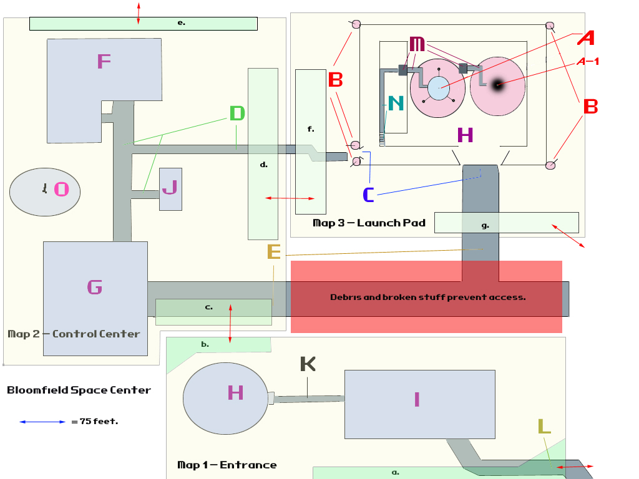

Legend

A – 1st Launch Pad w/Space Rocket  A-1 – 2nd Launch Pad w/o Space Rocket (scorch marks from previous launch) | H – Bloomfield Space Museum | O – Satellite Communications Dish
B – Gattling Gun Turrets | I – Collapsed Parking Structure | a. – Map 1 World Map Entrance/ Exit Grid
C – Rocket Transport Road | J – Observation Building | b. – Map 1 Entrance/Exit Grid to Map 2 c. Entrance/Exit Grid
D – Beat up sidewalks | K – Sidewalk | c. - Map 2 Entrance/Exit grid to Map 1 Entrance/Exit Grid
E – Rocket Transport Road | L – Entrance Grid to World Map | d. Map 2 Entrance/Exit Grid to Map 3 f. Entrance/Exit Grid
F – Operations and Communications Building | M – Launch Platform Catwalk Elevator | e.& g. – Map 2 & Map 3 (respectively) Entrance/Exit Grid to World Map
G – Rocket Assembly Building | N – Stairs leading up to 1st level catwalk | f. Map 3 Entrance/Exit Grid to Map 2 d. Entrance/Exit Grid

Economics: Bloomfield is rich with materials that can be used for trade of manufacturing. The best source of income for the Rusty Hooks, however, is from the “long-trade-n-raids.” When supplies start to get low, Kyle assembles a group of Rusty Hooks and creates a team of raiders who will venture into the wasteland to find caravans to raid. Since Bloomfield is so remote, the raids usually take a little over a month to
complete, hence the term, “long-trade-n-raids.” Sometimes trade routes are included in these ventures, since the Rusty Hooks can get good trades from the metal materials lying around Bloomfield.

Food: Good hunting around Bloomfield. Since no nukes went off near Bloomfield, the area has natural wildlife to hunt.

Tie to Another Area 1: Bloomfield is very remote. The only ties are what the player develops through adventuring. The launch codes for Hermes-13 are in the Reservation and (presumably) in Boulder Dome. Player may be able to establish trade routes with other areas, but they won’t be regular trade routes due to Bloomfield’s relative isolation.

ROOM FOR IMPROVEMENT
Also be sure to include hooks for "room for improvement." This section may change depending on how Ferret thinks it should be organized.

Room for Improvement:
- Getting the sub-reactor efficiency up:
  - The Control Center’s flood lights will all work (those that are not broken) during night time.
  - All Mission Control computers will be on.
- Get Bear to take over Rusty Hooks:
  - After one month, all traps in the Parking Structure are gone.
  - After two months, the observation building ruins in the Control Center are cleared away and the dirt is being prepared for farming.
  - After six months, all buildings are cleaned of graffiti and the interiors of the buildings (Operations and Communications Building) are clean, including all the offices, which now look like clean apartments (as clean as can be in the wasteland). Also, crops are growing on the farmland.
- If Kyle the Hook is left in control of the Rusty Hooks:
  - After three months, trash begins to litter the courtyard of the Control Center.
  - After six months, Bloomfield is abandoned, with several dead bodies strewn here and there. Kyle’s head is stuck on a post.

END MOVIES
Each area document will also have a list of possible End Movies depending on what the character did in the location. This section should contain:

- The condition for each end movie. Someone has to script this, so make sure it includes all necessary flags or other conditions that need to be checked.

- The narration text for the end movie. Write it as if Ron Perlman would read it.

- Some suggested art for the end movie slideshow. Keep it as a simple 2D image.

Note: Over the course of the project, you may wish to collect art that may be appropriate for an end movie slideshow and just keep it stored in a folder on the server or locally.

WHERE TO GO CONDITIONS
The player killed everyone in Bloomfield | Goto 1
The player had the satellite fire on Bloomfield | Goto 2
Bear becomes leader of the Rusty Hooks | Goto 3
Kyle the Hook remains leader of the Rusty Hooks | Goto 4

1. EVERYONE DEAD! (WTG)
Isolated within the wasteland, Bloomfield Space Center once again is a lifeless shell. It now stands as an empty homage to a time when technology held the future of mankind’s expansion… and demise. | Show an abandoned, ghost town looking Bloomfield. At the center of the Control Center, show Kyle’s head hanging by his own hook nailed to a post.

2. SATELLITE DESTROYS Bloomfield! (WTG)
Though the war forgot about Bloomfield Space Center, B.O.M.B.-001 did not. Those who knew of its existence became a smoldering, forgotten memory; as forgotten as the base itself. | Show a smoldering crater.

3. BEAR BECOMES LEADER OF THE RUSTY HOOKS (WTG)
No one would have thought a super mutant could bring life and prosperity to a community, but Bear did. The Rusty Hooks flourished under the leadership of Bear, harvesting fruitful farms, building and rebuilding the structures of Bloomfield Space Center, and even creating machines that helped maintain the community. | Show Bear and several earthy people tending crops in the middle of a clean, built up Bloomfield.

4. KYLE IS LEFT IN CONTROL OF RUSTY HOOKS (WTG)
Even though he found the sanctuary of Bloomfield Space Center, Kyle the Hook couldn’t maintain the confidence of his Rusty Hooks. His lack of leadership and his inability to organize left the Rusty Hooks vulnerable to attack by rival, more organized raiders. Those who survived took their chances in the wasteland. Those who didn’t, joined their former leader as a decoration on top of a post. | At the center of the Control Center, show Kyle’s head hanging by his own hook nailed to a post.

RANDOM NOTES

APPENDIX
  - Map 1 deleted for map space.

Nothing fancy, just shotguns and 9mm hand guns.
Jillian McKinley is originally found as a slave at the Reservation. The player must get Jillian to come with him since she is a vital part of the “fetch the prisoners” quest(s).
A primitive, eel like species of fish with serrated, round jaws that allow the hag fish to burrow into the flesh of its victim so it may consume the tissues from within.

