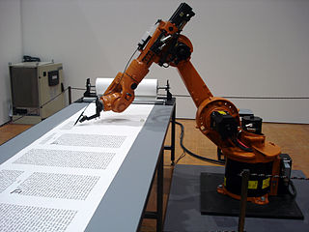
RoboRA Utilities and Macros
RoboRA is an Excel spreadsheet to populate RA templates from the eJacket and Fastlane databases, producing RA drafts in Word.

