DBLP – Query Engine Report

By: Akash Kumar Gautam, 2015011

Nishant Gahlawat, 2015151

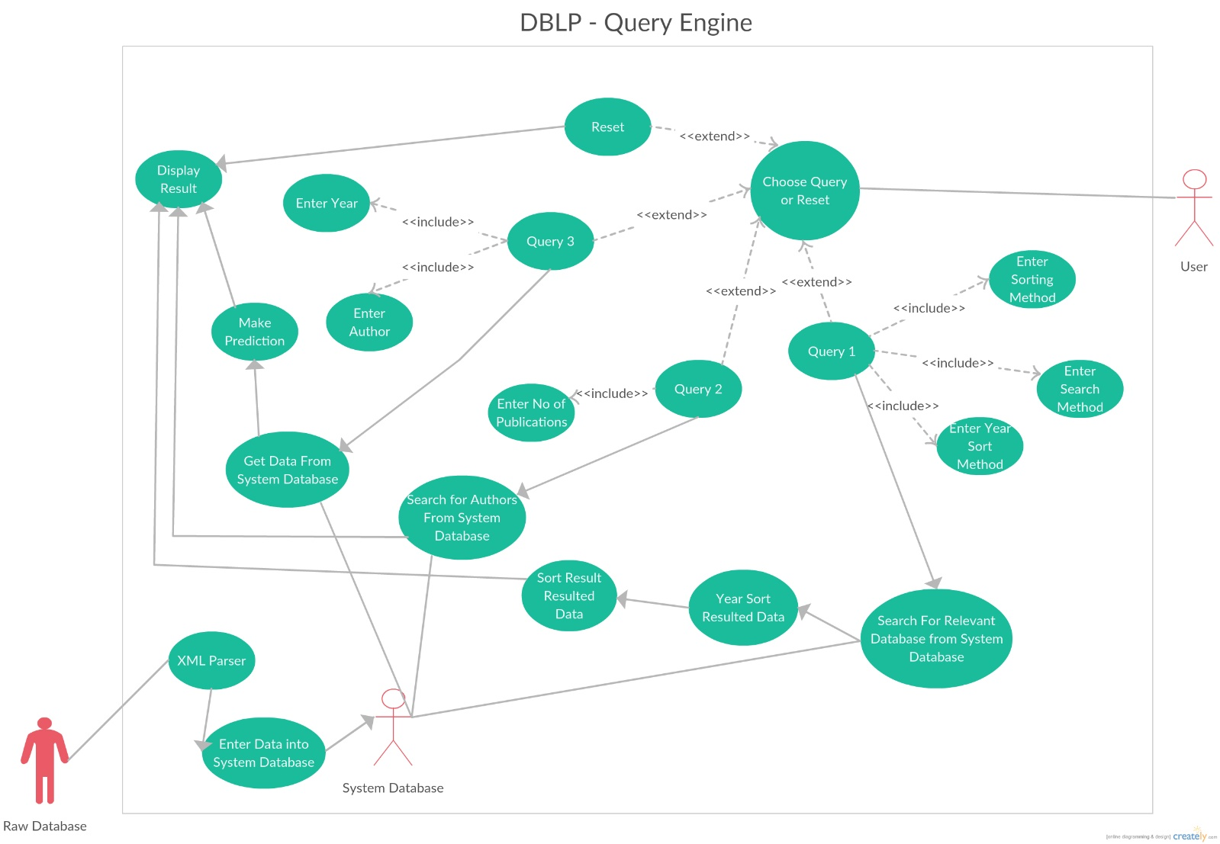

## Explanation of Important Use-Case Diagram:

**Actors in Use-Case Model:**

1)Raw Database

2)User

3)System Database

**Use-Cases:**

**1)Name:Display Result:**

Participating Actor:User

Entry Condition:

1.User has entered the query and entered relevant data he/she wants to search

Exit Condition:

1.User wants to get the view of the output on the Result panel

Event Flow:

1.User enters set of values of author/title he/she wants to search.

2.Display Result gets the set of values from “Search “ use case.

3.Display Result displays result on Result Panel.

**2)Name:Choose Query or Reset**

Participating Actor:User

Entry Condition:

1.User wishes to search based on the options of query

Exit Condition:

Choosing a query mode leads to search based on different options

Event Flow:

1.When the user chooses query mode it leads to different options query 1, query2 ,query3

Query1 leads to choosing menu:

a.Find publications by a given author name.

b.Find publications by title tags.

Both the above queries have multiple options:

a.Sorting by date (reverse)

b.Sorting by relevance (matched words)

c.Since some given year

d.In between two years

Query2 leads to choosing menu:

a.Find names of author with more than<k>publications

Query3 leads to choosing menu:

a.Predict the no. of publications of a given author in the next year

**3)Name:Search for author based from system database**

Participating Actor: system database

Entry Condition:User has chosen query2

Exit Condition:Give search based on author name or title tag

Event Flow:When the user chooses query 2 to make a search based on

k publications ,then it extracts data from system database, then displays the

names of authors with corresponding required k publications.

**4)Name:Query3**

Participating Actor:System Database

Entry Condition:User chooses query3

Exit Condition: Make prediction of publications of different authors and then

display in the result panel

Event Flow:User selects query3 ,which leads to entering different authors and

predicting the no. of respective publications in the next year.

**5)Name:XML Parser**

Participating Actor:Raw Database

Entry Condition:When Raw Database(.xml file) interacts this use case

Exit Condition:Gives combined parsed data

Event Flow:This use case gives combined parsed data by using SAX parsing

technique for parsing the raw .xml file

**6) Name:Query2**

Participating Actor:User

Entry Condition:User chooses query2

Exit Condition:Give names of author with more than k publications.

Event Flow:Database is searched for valid data which gives list of authors

**7)Name:Query1**

Participating Actor:User

Entry Condition:User chooses query1

Event Flow:

When the user chooses query1 ,then it also gets data if query search is

based on author name to title tag and thus choosing different sorting modes

like sort by date, reverse order, since some yearn between two years.

Then it searches for system database for information ,sorts the resulted data

and the displays the result in the result panel.

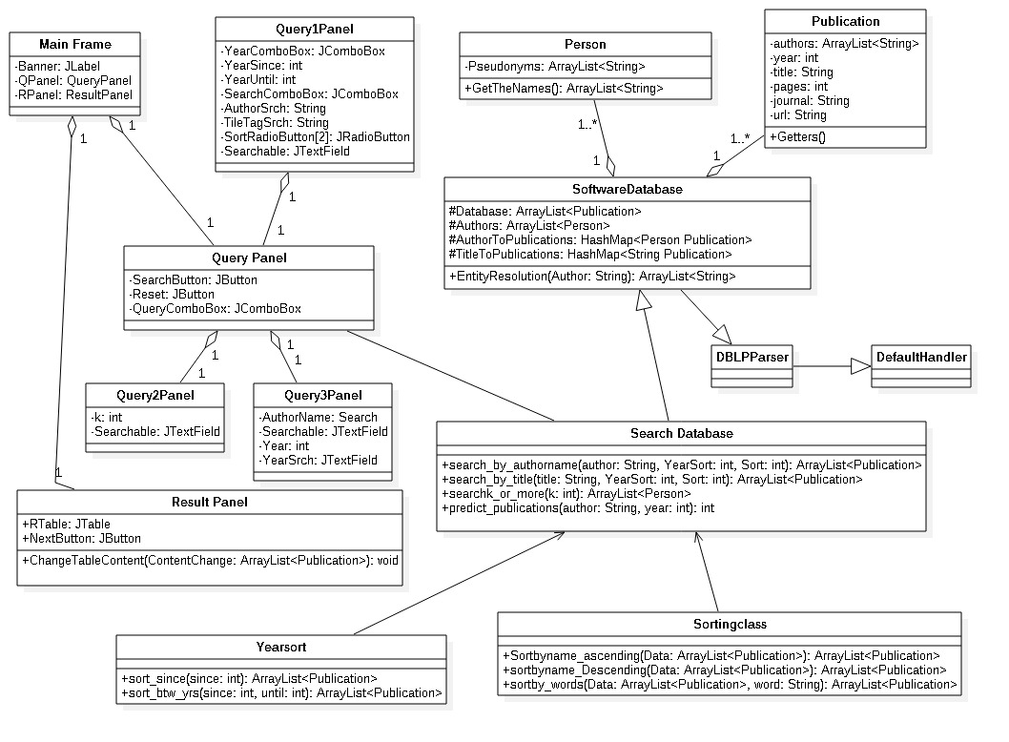

**Class: MainFrame**

Extends JFrame

The Main Screen of The GUI

**Variables:**

Banner: The Title of the program

QPanel: The Query Panel for choices for the query

RPanel: The ResultPanel which has the results from the search

**Class: QueryPanel**

Extends JPanel

The Panel includes the choices for the searc

**Variables:**

Search: Button to initiate the search

Reset: Button to Reset the ResultPanel Table Screen

QueryComboBox: Choice for Query1/2/3

**Class: Query1Panel**

Extends JPanel

Panel for Query1

**Variables:**

YearComboBox: Between 2 years or since 1

YearSince: since which year

YearUntil: until which year

SearchComboBox: Search by author or tile

AuthorSrch,TitleTagSrch: The searchable term

SortRadioButton: sort by year or relevence

Searchable: Text Field to get searchable term

**Class: Query2Panel**

Extends JPanel

Panel for Query2

**Variables:**

k: no of publications

Searchable: Text Field to get th eno of publications

**Class: Query3Panel**

Extends JPanel

Panel for Query3

**Variables:**

AuthorName: Which author to predict for

Searchable: TextField for AuthorName

Year: from which year to predict

YearSrch: TextField for year

**Class: ResultPanel**

Extends JPanel

Panel to display result

**Variables:**

RTable: Table to display data in

NextButton: Next 20 Results

**Functions:**

ChangeTableContent: Change the results that is shown on the screen

**Class: Person**

Class to store all the pseudonyms of a particular author

**Variables:**

Pseudonyms: List of all names used by the author

**Functions:**

GetTheNames: Get all the names used by the author

**Class: Publication**

The publication published

**Variables:**

All the variables that displayed on the result panel

**Functions:**

Getter Fuctions to get what to display

**Class:SoftwareDatabase**

Database of all the publications and persons involved

**Variables:**

Database:all the publications

Authors:all the authors

AuthorToPublications: To search the publications of an author (Speed over size)

TitleToPublications: Same ass above but for titles

**Functions:**

EntityResolutions: Searches for author from Authors and returns all the pseudonyms

**Class:DBLPParser**

Parser Class extending DefaultHandler to Parse the DBLP database

**Class:SearchDatabase**

The Class that gives the result to ResultPanel

**Functions:**

search_by_author: Variables tell which yearsorting to use and which sorting to use, returns the result as an ArrayList, after sending it through the required YearSort and SortingClass

search_by_title: Same as above but with titles

searchk_ot_more: Searches for wuthors with k or more publications

predict_publications: returns the probable no of publications by the author in year+1