DDS_Homework11_NShaver

Nicole Shaver

April 3, 2017

## Introduction

In this study, we will examine the volatility of the S&P500 index using a time series plot. The S&P500 data will be downloaded from the default source of the get.hist.quote function in the tseries R package. We will plot the volatility of the S&P500 using 3 different decay factors (10,30,100) and graphically compare the data for the 3 different decay factors.

## Link to GitHub

The link to the github for this project is: <https://github.com/NSHAVER1/MSDS6306-Homework11>.

The link to the markdown file specifically: <https://github.com/NSHAVER1/MSDS6306-Homework11/tree/master/paper>

## Downloading the Data

# Use the get.hist.quote function to get the closing price of S&P 500 (^gspc)  
SNPdata <- get.hist.quote('^gspc',quote="Close")

## Calculating the daily log returns and volatility measure

# Calculate the daily log returns (SNPret) by subtracting log(SNPdata) from log(lag(SNPdata))  
SNPret <- log(lag(SNPdata))- log(SNPdata)  
  
#Calculate the volatility measure, SNPvol  
SNPvol <- sd(SNPret)*sqrt(250)*100  
  
## Define getVol function for volatility  
getVol <- function(d, logrets) {  
 var = 0  
 lam = 0  
 varlist <- c()  
  
 for (r in logrets) {  
 lam = lam*(1 - 1/d) + 1  
 var = (1 - 1/lam)*var + (1/lam)*r^2  
 varlist <- c(varlist, var)  
 }  
  
 sqrt(varlist)  
}  
  
  
# Calculate volatility over entire length of series for various three different decay factors: 10 30. 100  
  
  
# Calculate volatility for SNP with decay factor of 10  
volest <- getVol(10,SNPret)  
  
# Calculate volatility for SNP with decay factor of 30  
volest2 <- getVol(30,SNPret)  
  
# Calculate volatility for SNP with decay factor of 100  
volest3 <- getVol(100,SNPret)

## Plotting the data to compare the 3 volatility measures

# Plot the results, overlaying the volatility curves on the data, just as was done in the S&P example.  
plot(volest,type="l")  
  
# Add a red line to volest2  
lines(volest2,type="l",col="red")  
  
# Add a blue line to volest2  
lines(volest3,type="l",col="blue")

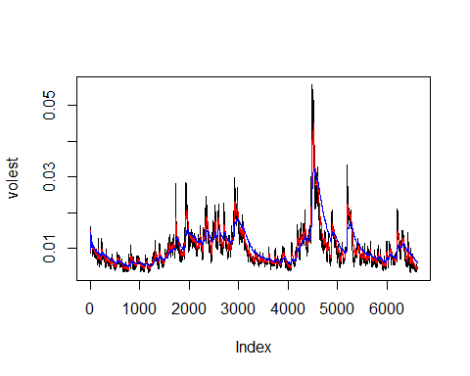

## Discussion and Conclusions

Reviewing the plot of the 3 different volatility measures, we see that as the decay factor increases (from 10=black to 30=red to 100=blue), the line becomes smoother, dampening the height of the sharp peaks and slowing the rate of decay.