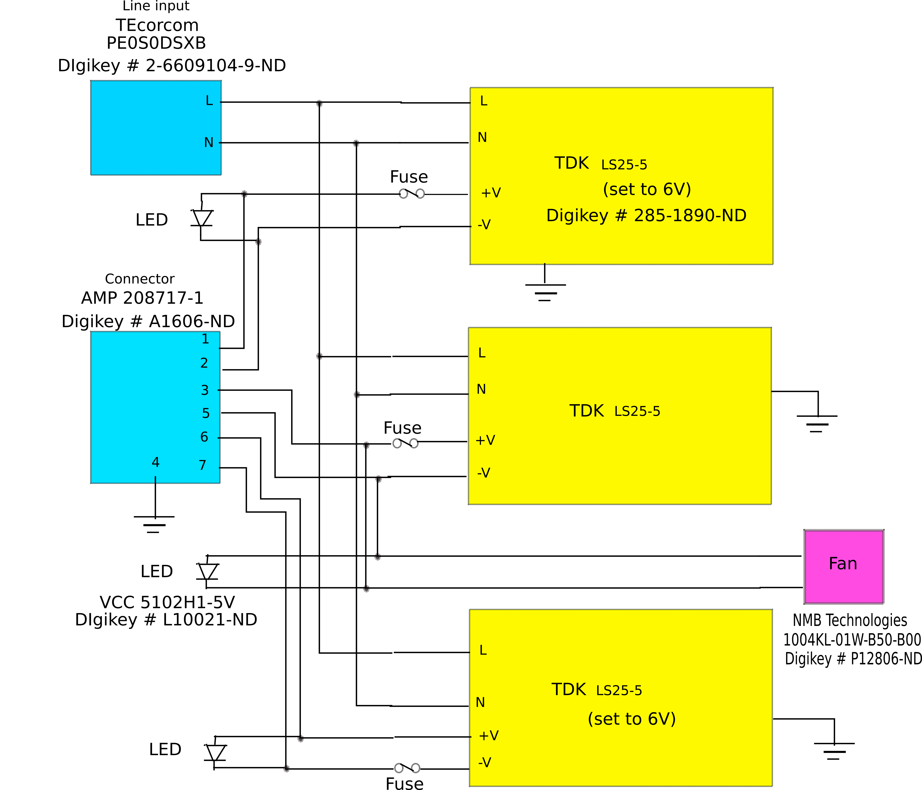
Switched-mode P.S.U. for germanium detector system.
Digikey # Desc. Qty. Price
285-1890-ND LS25-5 Lambda PSU 3 18.02 x 3
2-6609104-9-ND Power entry module 1 27.20
L10021-ND LED indicator, 5V. 3 1.92 x 3
P12806-ND Fan 1 10.91
A1606-ND Connector. 1 35.22 + 7 x 0.90 (pins)
HM1506-ND Box. 1 33.29
F1469-ND Fuseholder 3 4.36 x 3

