National Synchrotron Light Source II


Building 817
P.O. Box 5000
Upton, NY 11973-5000
Phone 631 344-2216
Fax 631 344-2646
willeke@bnl.gov

managed by Brookhaven Science Associates
for the U.S. Department of Energy
Memo

Date: Jan 10, 2010

To: F. Willeke
From: F. Willeke

Topic: Assumptions on NSLS-II Accelerator Commissioning

Table of Content

Table of Content 1
1. Introduction 3
2. Assumptions on Commissioning Authorization 4
2.1 Guiding Documents 4
2.2 Commissioning Modules 4
2.3 Elements of the Authorization Base 4
2.4 Goal of the Authorization Procedure 4
3. Assumptions on Commissioning Staging 5
3.1 LINAC Frontend 5
3.2 LINAC 6
3.3 Booster 6
3.4 Storage Ring Commissioning Phase 1 6
3.5 Storage Ring Commissioning Phase 2 6
4. Assumptions on the Tunnel Conditions, the Mechanical Stability and Alignment and on Utilities 7
5. Assumptions on Status of Accelerator Hardware at the Start of Commissioning 7
6. Assumptions on Radiation Safety during Commissioning 8
7. Assumptions on Availability of Commissioning Software tools for Commissioning 9
7.1 General Operation Software 9
7.2 Operations Software 9
7.3 Major Subsystem Control 9
7.4 Beam Diagnostics 10
7.5 Safety Systems 10
7.6 Utility Control 10
7.7 Accelerator physics applications Toolkit 10
8. Assumptions on accelerator logbook 10
9. Assumptions on Commissioning Staffing 11
10. Assumption on Involvement of Operators in Commissioning 11
11. Assumptions on Involvement of NSLS Staff in Commissioning 11
12. Assumptions on Commissioning Information and Documentation 11
13. Assumptions on Accelerator Control Room during Commissioning 12
14. Assumptions on Commissioning Schedule 13
15. Assumptions on the Commisioning Budget 13
16. Assumptions on Storage Ring Commissioning Modules 13
17. Assumptions about Roles in Accelerator Commissioning 15
18. Assumptions on Organization during Commissioning 16
19. Assumptions Concerning Funding for Commissioning 16

Introduction Sam

A Start-Up and Test Plan needs to be established as a Framework of documents which clearly identifies the requirements for

- Documentation readiness,
- Technical readiness,
- Personnel Training and Qualification,
- Hardware and Software Testing,

and which defines the acceptance criteria for CD-4 at the end of commissioning. Hardware and software testing includes the following elements:

- sub-system testing and qualification,
- integrated system tests,
- commissioning with beam.

The following assumptions are written to provide a starting point for detailed discussion and understanding of the requirements for the commissioning of the NSLS-II Accelerator complex with beam.

Definition: In the following the expression “Commissioning” refers to the particular mode of accelerator operation with beam which aims

- to test the function of accelerator hardware and software with beam,
- to verify in particular the proper functioning of the equipment protection system,
- to verify the adequacy of radiation safety shielding, the proper functioning of area radiation monitoring, and the ALARA system to minimize radiation dose experienced by humans,
- to check the integrity and the consistency of the subsystems as built
- to develop refined settings of the hardware components to allow efficient injection, and storage of accelerator beams with good stability, beam intensity, the advertised beam parameters, and good beam lifetime.
- to condition accelerator hardware system for optimum performance
- to develop and calibrate the accelerator model
- to develop and document the procedures which are necessary to operate the accelerator routinely and to perform continuous improvement and development.

Commissioning is the last step which needs to be successfully performed in order to complete the project. Most of the assumptions concerning commissioning made so far have been implicitly used in making scheduling decisions, design of hard- and software components and the definition of the technical test program. These assumptions need to be made explicit to ensure

- that all involved in preparing for commissioning have the same base of information and understanding and commissioning planning can proceed as a coordinated process,

- that a structured process can be applied to understand the implications and the interdependence of the assumptions which will lead to an optimized set of conditions and plans for commissioning,

- that logical flaws in the present planning are discovered early and corrected,

- that the resources to prepare commissioning are in place when needed.

The intention is to mature this document by detailed decisions and assessments among the NSLS-II staff. The immediate goal is to produce a detailed, well thought through Start-up and Commissioning Document within the next 3 months which will be the base for detailed commissioning plans.

Assumptions on Commissioning Authorization Steve

Commissioning can start after it has been approved by BHSO. This approval requires a detailed authorization process which addresses all the relevant issues such as completeness of relevant documentation, technical readiness, the training of the staff, the existence of detailed commission procedures, the assessment of hazards, safety and emergency procedures.

2.1 Guiding Documents

The NSLS-II Authorization Base (AB) is defined by the requirements and the guidance in:

- DOE Order 420.2B “Safety of Accelerator Facilities”
- DOE Guide 420.2-1 “Accelerator Facility Safety Implementation Guide”
- DOE Order 413.3B “Program and Project Management for the Acquisition of Capital Assets”
- BNL SBMS Subject Area “Accelerator Safety”

2.2 Commissioning Modules

The NSLS-II plan is to break the AB process into four modules (ok with 420.2B) that coincide with the accelerator equipment installation & operations. The 4 modules are:

  - LINAC (including LINAC to Booster Transfer Line)
  - Booster (including Booster to Storage Ring Transfer Line)
  - Storage Ring
  - Full Operations (roll-up of first three modules)

2.3 Elements of the Authorization Base

Each module will have the following components which are concluded by authorizations and reviews

  - SAD (Safety Assessment Document)
  - ASE (Accelerator Safety Envelope)
  - Authorization Plan (commissioning plan)
  - ORE (Occupational Readiness Evaluation)
  - ARR (Accelerator Readiness Review)

The process to enable BHSO to authorize commissioning is summarized in the block diagram below (figure 1.)

2.4 Goal of the Authorization Procedure

After these processes have been completed it can be assumed that

- all accelerator hardware systems have been properly tested,

- all procedures to secure safe operation of the accelerator have been defined. In particular, the procedures for ensuring radiation safety and electrical safety of the staff during operations have been defined,

- all procedures to turn on, turn off, repair and perform maintenance of accelerator components have been defined and technical back-up information is in place,

- all roles in the commissioning process have been defined,

- All staff participating in commissioning has been properly trained according to the requirement of the individual’s particular involvement.

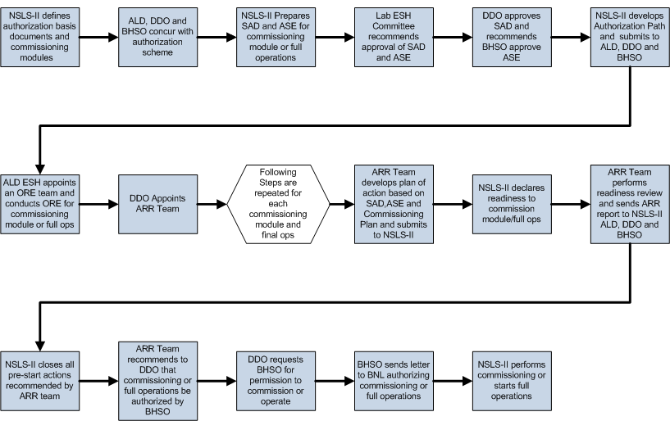

Fig 1: Block diagram summarizing the process to obtain permission to start commissioning

Assumptions on Commissioning Staging Sam

The accelerator commissioning will extend over a 2 year period. There are five well defined stages (not to be confused with the “modules” in the AB process) which are clearly distinguished in the schedule. These Stages correspond to the modules for obtaining authorization but they are not identical. The requirements will not be the same for each of these stages. The LINAC commissioning is not dependent on as many conditions as the storage ring commissioning and most of the requirements and assumptions refer to the storage ring. Particular requirements for the various stages will be marked explicitly if they are not specific for the storage ring. The successful completion of these five commissioning stage will be a necessary condition for the early finish of the NSLS-II project.

The stages are:

3.1 LINAC Frontend Jim

The LINAC frontend consists of the LINAC gun and the first stage of sub-harmonic bunching including low power RF sources and first focusing elements. This part will be delivered earlier than the linac which allows separate commissioning of this component. Linac front end commissioning and tests will be performed in the RF Laboratory in Bld. 832. The beam energy is fairly low (180keV). Because of the low beam energy, the present assumption is that frontend will be considered as a device and commissioning will be considered as a laboratory activity which will not require the full authorization process involving BSHO as required for all the other stages. The purpose of the separate commissioning of the LINAC frontend is to study operation modes for special requirements (single bunches of high intensity). It is assumed if the early study on frontend is successful; the LINAC commissioning will concentrate on the standard operation mode (multi-bunch) once the entire LINAC is available.

3.2 LINAC Jim

The LINAC commissioning will include the parts of the LINAC to Booster Transfer Line which are in the LINAC building. This includes the primary dump and the diagnostic beam dump. The LINAC commissioning will be performed by the LINAC vendor who is responsible for reaching the performance specifications. NSLS-II staff will support the commissioning activities to the extent accepted by the vendor. The transfer line part of LINAC commissioning will be performed by NSLS-II staff.

3.3 Booster Timur

The booster commissioning will include the LINAC to Booster Transfer Line, in particular the part in the booster tunnel, and the booster. This part is in the responsibility of the project and is a necessary condition for the vendor to start commissioning the booster.
Issue: There should be no gap between booster installation and testing and booster commissioning.
Thus the transfer-line has to be commissioned during the night in the integrated testing phase.

The Booster commissioning will be performed by the Booster vendor who is responsible for reaching the performance specifications. NSLS-II staff will support the commissioning activities to the extent accepted by the vendor.

The part of the booster-to-storage ring transfer line which is in the booster tunnel will be performed by NSLS-II staff under the responsibility of the project.

3.4 Storage Ring Commissioning Phase 1 Sam

- This part will include the booster-to-storage ring transfer line in particular the part which is in the storage ring tunnel. The storage ring will first be commissioned without insertion devices. This part of commissioning is aimed to demonstrate
- that storage ring beam optics model is adequate or provide calibration and beam based alignment
- the main performance parameters,
- adequacy of correction systems
- adequacy of safety and ALARA systems
- efficient injection
- adequacy of beam instrumentation
- orbital stability
- RF stability
- cryogenic stability
- beam stability
- vacuum integrity
- high intensity operations

3.5 Storage Ring Commissioning Phase 2 Sam

This part will include commissioning with insertion devices and will include commissioning of the frontends.

Assumptions on the Tunnel Conditions, the Mechanical Stability and Alignment and on Utilities Erik, Sushil, George

- The accelerator tunnel will be air conditioned. The tunnel temperature and the humidity of the tunnel air will be within specified range.

- The installation of girders and magnets will have been completed at least one year before the start of commissioning.

- The final survey and alignment will have taken place shortly before start of commissioning to allow a maximum time for ground settling

- All cable conduits and openings in the tunnel walls will be properly closed with the required shielding material.

- All heavy duty construction activities such as land fill, compaction, road construction etc will be completed so that commissioning will not be disturbed by unusual levels of cultural noise.

- All utilities which are part of conventional facilities, in particular electrical installation, de-ionized water, chilled water and liquid Nitrogen storage and supply lines will be provided as specified and designed.

Assumptions on Status of Accelerator Hardware at the Start of Commissioning Erik

It is assumed that all accelerator hard- and software systems are tested in an integrated way (meaning the tests include the control of these systems by the control system).
In particular it is assumed:

- The personnel safety system has been thoroughly tested including the interfaces to the accelerator components which prevent beam from being injected and circulated.

- The equipment protection system is fully implemented and tested via the control system.

- All magnets and girder systems have been installed well before commissioning and the final high precision alignment according to specifications has been performed shortly before commissioning starts. Insertion devices will not be installed at the time when storage ring commissioning starts.

- The power supply systems are complete. All technical interlocks have been properly tested. The power supplies are installed in sealed air-cooled racks. The assignments of controls elements to power supplies have been tested. The correct polarities and magnitude of currents of the magnets when powered by the power supplies using the control system have been verified.

- The vacuum system has a vacuum of at least 10⁻⁷ mbar. The functionally of the vacuum interlock and the function of pumps and gate valves has been confirmed. Vacuum instrumentation is installed and tested. Vacuum data can be monitored from the control room and active elements (pumps, gate valves) can be controlled from the control room.

- The two superconducting RF cavities of the storage ring are installed, connected and tested in the tunnel. The two cavities will be driven by a single 310kW transmitter station. The cryogenic system including valve boxes have been tested. The RF cavities have been commissioned and conditioned with RF power. All RF interlocks which are not depending on the presence of beams have been tested.

- A full suite of beam diagnostics is installed and tested. Application software is available to monitor these systems in the control room. All equipment is installed in sealed, air cooled racks.

- All water cooling systems have been installed and have been tested with loads from magnets and RF components.

- The timing system, in particular the synchronization of RF systems between injector and accelerator has been implemented and tested. Control of the timing and synchronization systems via the control system has been tested

- The control system is fully implemented and all hardware systems can be remotely controlled and monitored. The relational database is fully functional. Information about any component can be retrieved from the control room without extra preparation.

- All injection systems have been installed and tested. Timing has been adjusted and confirmed by measuring the waveform of the pulse. The proper control of injection elements via the control system has been confirmed.

- Fast orbit feedback has been implemented and the functionality of the hardware components has been tested

- The transverse feedback damper system has been installed and tested on the component level

- Control system fully functional including all application programs deemed necessary for commissioning

Assumptions on Radiation Safety during Commissioning Steve

- All radiation protection systems have been installed and fully tested to the extent possible without beam. No provisory solutions will be allowed and no exception will be possible.

- Initial beam intensity in the storage ring will be very small compared to nominal (0.1%). Area monitors reading for low intensity will be extrapolated to the next step in beam intensity. This extrapolation is reviewed and analyzed at each level of intensity before the next step in intensity is made.

- The initial beam losses will be large. For initial high intensity studies, it is assumed that the beam losses will be much larger than under optimized normal conditions. It is assumed that in order to arrive at an optimized stage, measures will be taken to ensure that no humans will receive a radiation dose above tolerable levels. Such measures could include the establishment of temporary controlled radiation areas, and restricting such studies to certain times in the day or the week.

- The beam containment system needs to be tested with beam. It is mandatory that the location of beam losses can be clearly identified. The assumption that the beam is lost dominantly in the extra shielded area needs to be confirmed after all system parameters have been optimized. Clear and unambiguous procedures have to be written, and operating staff needs to be trained to follow these procedures before operations with continuous injection of high charge (top-off, high intensity operation) can proceed.

Assumptions on Availability of Commissioning Software tools for Commissioning Bob, Lingyun

A fully functional list of application programs and software tools is assumed to be available at the time of commissioning. The following list captures a minimum functionality to assure efficient commissioning

7.1 General Operation Software

- Overall Status page
- Status, Alarm and Warning monitor
- Permit system monitor and control
- Data logger and data display
- Electronic logbook

7.2 Operations Software

- Accelerator parameter store/restore with file-manager, editing capability and possibility to smoothly ramp from one stage to another
- Injection Control
- Power supply control
- RF Control
- Fast orbit Feedback control
- Fast Transverse Damper Control
- Front-end monitoring and control
- Machine protection system display and control
- Magnet temperature interlock display and control
- Scraper and Moveable Mask operations

7.3 Major Subsystem Control

- Power supply page which lists for all ps: setting or waveform, read back, difference between DCCTs, status, recent history,
- RF page with all relevant settings, read back, status, parameters
- Vacuum display and control
- Cryogenics system display and control
- Pulsed magnet systems Monitor and Control

7.4 Beam Diagnostics

- Beam Orbit page with closed orbit, turn by turn, single turn, status information, difference (reference orbit display)
- Beam Current History and lifetime display
- Bunch intensity display and history
- Beam emittance display
- Injection element display and control page
- Timing system display and control
- Synchronization system display and control
- Tune display and control
- Temperature monitoring display

7.5 Safety Systems

- Personal protection system status display
- Equipment Protection Status Display and Control
- Beam containment Status display and Control
- Top-off Status Monitor

7.6 Utility Control

- Tunnel air temperature and humidity monitor
- Mechanical utilities status and control
- Electrical utilities status and controls
- Equipment enclosure monitor
- Water cooling system display
- Controls network monitor

7.7 Accelerator physics applications Toolkit

- Static orbit corrections,
- First turn steering,
- Chromatic correction,
- Response matrix measurements,
- Phase advance measurements,
- Beam base alignment of quadrupoles
- Bpm test programs,
- Beam optics measurement,
- Beam based alignment of sextupoles,
- Analysis on nonlinear dynamics,
- Dispersion measurement and correction,
- Closed Orbit bump page

Assumptions on accelerator logbook Richard

It is assumed that an operations log book will be maintained and kept. This logbook will be fully electronic. It is assumed that any application will able to print information into the control log. It is assumed that the logbook can only be accessed (for writing) from the control-room (controls-lan). It is assumed that a mirror of the log-book will be accessible from offices and by secure remote access.

Assumptions on Commissioning Organization and Staffing Ferdinand

9.1 Commissioning Organization

Accelerator commissioning is the responsibility of the accelerator systems division of NSLS-II. The AS division director is ultimately responsible for commissioning. At this point is assumed that the project organization will extend to the end of commissioning.

Accelerator Commissioning is part of the NSLS-II project and is captured in the Pre-Operation part of the work break down structure under WBS’s 1.6.02.05.1, 2, 3. In the commissioning period, the accelerator systems management will devote a large fraction of its effort to organize and supervise commissioning.

The organization of commissioning will be different for each part of the accelerator complex:

9.1.1 LINAC Commissioning

LINAC commissioning will be part of the LINAC turn-key contract with the LINAC vendor and will thus be the responsibility of the vendor. A NSLS-II lead and liaison will be defined which is the primary contact for the commissioning vendor. The NSLS-II lead will report as LINAC Commissioning taskforce leader to the ASD division director. Members of the injector group may support the taskforce leader. This group will form the LINAC commissioning team.

9.1.2 Booster Commissioning

Booster commissioning will be part of the Booster semi-turn-key contract with the Booster vendor and will thus be the responsibility of the vendor. A NSLS-II lead and liaison will be defined which is the primary contact for the commissioning vendor. The NSLS-II lead will report as Booster Commissioning taskforce leader to the ASD division director. Members of the injector group may support the taskforce leader. This group will form the Booster commissioning team.

9.1.3 Transferline Commissioning
The beam-line and storage ring commissioning work will be organized in taskforces with a taskforce leader which reports directly to the division director. Members of the injector group and the accelerator physics group will support the taskforce leader as run coordinators. Transport line commissioning will be handled in the same way as storage ring commissioning (see below). This group will form the Booster commissioning team.

9.1.4 Storage Ring Commissioning

There will be a Storage Ring Commissioning Phase I and a Storage Ring Commissioning Phase II. They will be handled the same way. Phase two is expected to have a very strong participation of the insertion device group.

The beam-line and storage ring commissioning work will be organized in taskforces with a taskforce leader which reports directly to the division director. The taskforce leader will be assisted by run coordinators which serve for a limited period and which will have a high presence in the control room on top of the accelerator physicist and operator on duty. When on shift, the commissioning crew will report to the run coordinators who in turn will report to the commissioning taskforce leader. Note that operations will only be organized during commissioning that way. The taskforce leader, the run coordinators, the involved accelerator physicists, the operators, and the technical experts will form the commissioning team. This structure is orthogonal to the group structure in ASD and will not change the supervisory responsibility of the group leaders. Group members may be considered as delegated to the commissioning team and will report in this function to the run coordinators and the commissioning task force leader. ASD management’s strong involvement in commissioning as well as in the technical tasks of completing the project will make sure that conflicting interests of groups and commissioning teams are properly mitigated.

The commissioning taskforce is charged with the following:

- Organize the commissioning task shift operation in the control room
- perform commissioning tasks
- Initiate analysis of commissioning results and the feedback of this process into the commissioning process
- communicate the commissioning results
- refine and develop the commissioning program
- schedule intervention and request engineering support if the commissioning program or an unscheduled occurrence requires it.

9.1.5 Commissioning Times
Commissioning will be organized in 3 shifts per day and seven days per week.

It is assumed that two subsequent shifts will have an overlap of at least ½ hour to assure continuity of the commissioning tasks and proper information of the incoming shift.

The physicist on duty will be responsible for carrying out commissioning tasks safely. He will make sure that safety regulations and rules are followed and that ALARA principles are obeyed carefully.

Safety during Commissioning

Handling of failures and emergencies will follow strict escalation rules to make sure that the impact of non-planned occurrences is minimized. Such escalation plan will be part of the ASE and SAD documents which will be generated in the process of receiving the approval for commissioning.

9.3 Commissioning Staffing

Commissioning of the NSLS-II accelerator complex is part of the NSLS-II project and labor to perform the commissioning has been budgeted for. To perform commissioning, part of the accelerator systems which are already commissioned need to be operated. The labor to operate completed parts of accelerator systems needed for commissioning has not been budgeted for within the NSLS-II project.

The commissioning will require the involvement of accelerator physicists, the experts on the technical components and operators. The physicist’s and engineer’s involvements have been budgeted for. The operators will need to be covered by operational funds.

Commissioning will carried out 24 h a day and 7 days a week. It is assumed that the workload of off-hour shifts will be shared between all members of the accelerator physics group and the technical experts of the subsystems.

It is assumed the engineers and technicians will be on call during commissioning to be able to resolve any technical issue during commissioning immediately.

It is assumed that the control room will be manned with at least one accelerator physicist during the entire commissioning of ~33 weeks. This requires about 16000 working hours which has been budgeted for. The involvement of engineers will be less regular and will depend on the commissioning program to be pursued.

9.4 Assumption on Involvement of Operators in Commissioning

For start up of commissioning, it is assumed that 1 machine operator will be present on every shift. This will gradually develop into a mode with 2 operators and no accelerator physicists. NSLS-II will not start its own operations group but will use members of the existing controls group of NSLS. Supervisory relationships will not have to be changed. Details of the involvement of the NSLS operations crew in NSLS-II commissioning will depend on details of the NSLS-NSLS-II integration process which is under development at this time (Jan 2010).

9.5 Assumptions on Involvement of NSLS Staff in Commissioning Ferdinand

NSLS has 85 highly trained staff which is responsible for operating NSLS. At this point no definite plans for the decommissioning of NSLS have been made and the availability of the staff for NSLS-II commissioning activities is unknown. It is assumed that part of the NSLS staff will participate in commissioning and that NSLS operators will be trained to operate NSLS-II whenever the staff will become available. There are no plans within the project for an NSLS-II operating organization at this point. Such plans need further development of plans for of NSLS and NSLS-II integration. At this point it can be assumed there will be a procedure in place for NSLS staff involvement, be it via NSLS-NSLS-II integration or NSLS-II-NSLS MOU. The development of this part of the start-up and commissioning plan will be fully aligned with the NSLS-NSLS-II integration process.

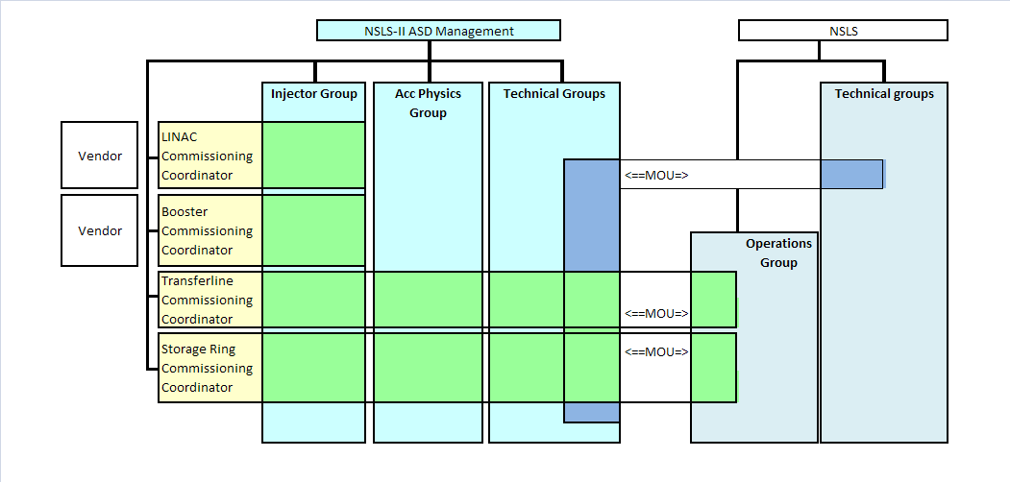

Figure 9.1 NSLS-II Commissioning Organization Chart

Assumptions on Commissioning Information and Documentation Sam

It is assumed that there will be semi-formal commissioning meetings of 15 min at the beginning of each shift which should be attended by the going and coming shift crews. The meeting will allow a seamless transition from one shift to the next and provides opportunity to communicate and discuss fine-tuning of the commissioning program. It is assumed that there will be 3 shifts per day and thus there will be three such meetings.

A weekly commissioning meeting will summarize the commissioning results. Based on the discussion of the results, it will provide opportunity to optimize the commissioning program and direction. The weekly commissioning meetings will be documented including all material presented.

The commissioning will be carried out in commissioning modules. Each module requires a written plan which indicates the purpose, the goal, supporting documents, results of calculations necessary to carry out the module, an estimate on the needed machine time and the labor resources required. The results of each module will be documented. The raw data will be stored in an organized and accessible way. The evaluation of the data, resulting set-points and procedures and parameters will be documented in an evaluation document.

At the end of commissioning, a report will be published which is based on the commissioning module evaluation documents.

Assumptions on Accelerator Control Room during Commissioning Richard

The accelerator control room is the location where

- operators operate the accelerator,
- operators coordinate with technical staff about technical difficulties and interventions,
- accelerator experiment are carried out,
- a logbook on accelerator operations is kept and maintained,
- information in case of an emergency is to be obtained
- and such information has to be delivered to,
- day-today coordination between accelerator and experimental floor are exchanged,
- shift-change briefing meetings are held,
- first hand information on the status of the accelerator is available,
- the responsibility for operating the accelerator safely within the safety regulations resides,
- routine safety measures are coordinated (LOTO),
- preparation of the accelerator for operations is coordinated after an interruption,
- special computer screens are installed to provide an optimized selection of displays for quick overview of accelerator status
- a emergency stop button is installed
- where special installations have been made (controls LAN connections, access to facility wide audio system,
- an access point is established which manned 24hr a day 7 days a week.

This functionality of the control room is not very different between commissioning and operation but at commissioning it is highly desirable that the control room is close to the accelerator hardware. It is assumed that there will be temporary control rooms in the injector and the ring-building during commissioning.

It is assumed that the control room LAN is accessible from the accelerator tunnel and from the mezzanine. Wireless LAN access is under consideration.

It is assumed that the minimum requirement for a provisory control room for commissioning is controls LAN access. No special computer hardware is required.

Assumptions on Commissioning Schedule Erik

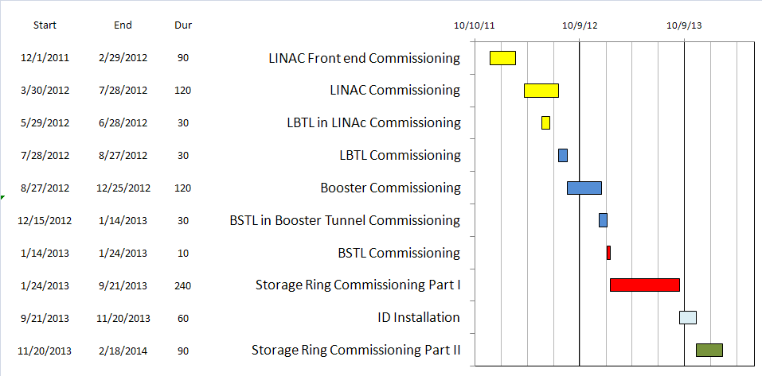

Assumptions on the Commissioning Budget Ferdinand

Table 13.1 provides an overview of the budget for accelerator pre-operations and commissioning.
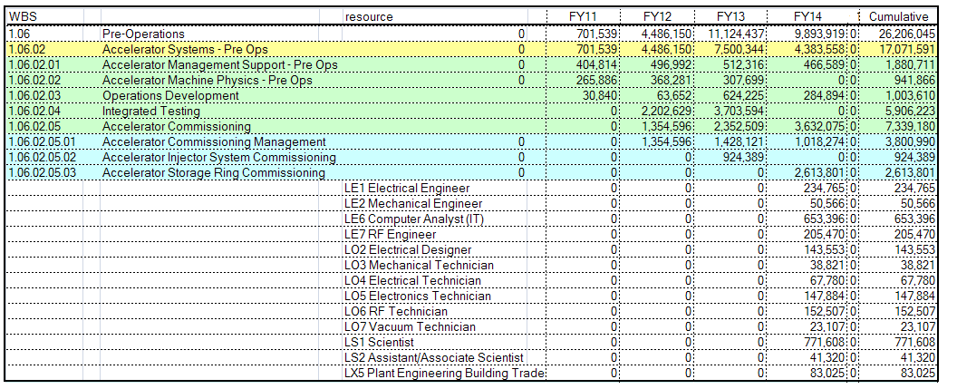

Assumptions on Storage Ring Commissioning Modules

COMMSIONING PART I

The following tasks need to be accomplished during Storage Ring Commissioning Part I in order:

Establish Initial Beam Operation Sam
Obtain stored beam (first turn steering, multi-turn tuning, RF capture…)
Adjust and verify RF parameters
set up injection for accumulation
first Orbit Correction
first iteration of correcting chromaticity and coupling
first iteration of obtaining acceptable injection efficiency

Check out Beam Instrumentation Om
establish beam monitor calibration with local bumps
check intensity monitors
check out loss monitors
check out emittance monitors

Check out Safety Functions Steve
Checkout top-off safety functions
Check-out machine protection system
Check out BCS and ALARA functionality

Fine tuning of Beam Optics Sam
Beam Optics Checks and correction (Response matrix, phase advance, coupling measurements)
Beam based alignment
measurement of chromatic distortions and correction
nonlinear dynamics related measurements and corrections (D.A., amplitude dependent tune shift, width of resonances, higher order chromaticity)
measure 1st and 2nd order momentum compaction factor
measure damping distribution

Functionality Tests Om
Fast orbit feed-back test

Fine Tuning of Orbit and Emittance Sam
Orbit correction to micron level
dispersion free steering and orbit correction
vertical emittance tuning

Synchrotron Radiation Measurements Sam
Measurement of power deposition s and power load
check of temperature monitor system
check of vacuum interlock
check of assumptions on absorber and mask temperatures, monitoring and cooling

High Intensity Studies Timur, Jim, Sam
Set up of high efficient injection
Set-up of RF feedback and fine tuning of feedback parameters and LLRF
Single Bunch Intensity Limit measurements
bunch lengthening by 3rd harmonic cavity
beam lifetime vs bunch length and bunch intensity study
BCS and ALARA studies with high intensity
Vacuum conditioning beam
RF conditioning with beam
transverse damper test
Study of high multibunch intensity limitations

COMMSIONING PART II

The following tasks need to be accomplished during Storage Ring Commissioning Part II in order:

Safety Related Measurements Steve
Check front-end PPS safety assumptions and functions
Check-out and calibrate frontend EPS
Check top-off safety function

ID Integration ( x 8) Toshi
Turn on insertion devices one-by-one
correct orbit
measure and correct beam optics
Correct chromatics
adjust and test gap-closing feed forward
measure dynamic aperture
test micron size beam stability in FE

Preparation of User Operation
Test top-off injection
reduce residual beam oscillation due to injection kickers
emittance tuning with insertion devices
beam orbit stabilization with insertion devices
test and calibrate photon beam position monitors

Assumptions Concerning Funding for Commissioning Ferdinand

An assumption is made that additional early operation funding will be available to support operation of already commissioned systems (injector, cryo-plant) and other subsystems.
It is also assumed that early operational funds will be available to cover for the expected high level of technical trouble shooting necessary for operation and commissioning.
The expected level of early operational funding which is not covered by the project budget required is ~70FTE.

