Preliminary Design of Beam Diagnostics Control System

NSLS-II Controls Group

Brookhaven National Lab (BNL)

Yong Hu

Content

Overview of Diagnostics Controls

Scope

Controls Requirements

Functionalities and Applications

Orbit Feedbacks

Filling Pattern measuring

Beam Containment System

Camera-based Diagnostics Applications

Network/Spectrum Analyzer-based Diagnostics Applications

Device Counts and Diagnostics Subsystem

Diagnostics for Linac

Diagnostics for LtB Transport Line

Diagnostics for Booster

Diagnostics for BtS Transport Line

Diagnostics for Storage Ring

Control Interfaces for Diagnostics

Classifications of Control Interfaces

Controls and Data Acquisitions for Diagnostics

DAQ for WCM & FCT

DAQ and Controls for DCCT & ICT

DAQ and Controls for BPM

DAQ and Controls for Camera-based Diagnostics

Controls for stepper-motor-based Diagnostics

Instrument Controls for Network/Spectrum Analyzer

Diagnostics Controls in Sub-accelerators

Interfaces to Other Subsystems

Interfacing to Timing System

Interfacing to Machine Protection System

Overview of Diagnostics Controls

The NSLS-II beam diagnostics and control system is designed to monitor the electron beam of NSLS-II accelerator complex. The beam quality is measured by a variety of parameters such as bunch charge, bunch structure (filling pattern), beam position/orbit, beam size/profile, energy spread, circulating beam current, tunes, beam emittance, bunch length and beam losses. Figure 1 briefly shows the beam parameters to be measured from Linac to Storage Ring.

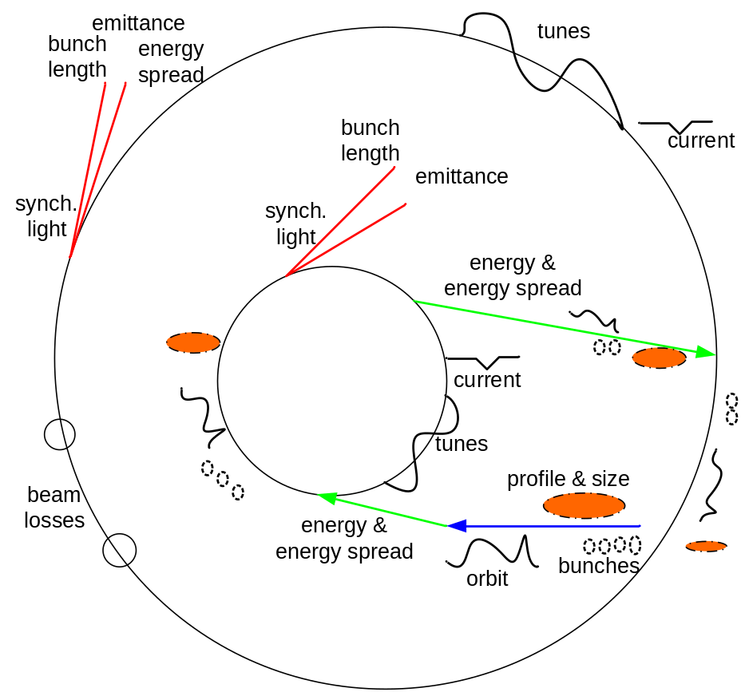

Figure 1: Beam Parameters to be measured from Linac to Storage Ring

Scope

A correct measurement of beam parameters depends on the effective combinations of a variety of beam monitors, control and data acquisition (DAQ) system and high level physics applications. Figure 2 shows the relationship between these systems. Thus, an effective collaboration between Diagnostics Group, Controls Group and Physics Group is essential. The NSLS-II Diagnostics & Instrumentation Group is in charge of the definition of beam diagnostics specifications and the design of beam monitor systems, including the layout of these monitors around the machine. The Physics Group is responsible for submitting the physics requirements for diagnostics and control, system modeling, algorithm, etc.

The scope of responsibility of Controls Group on beam diagnostics system includes the following:
- Requirement analysis and specifications for the beam diagnostics controls, working together with Diagnostics & Instrumentation Group.
- Make vs. buy analysis and decision of electronics for various beam monitors, working together with Diagnostics & Instrumentation Group.
- Development of EPICS drivers for the diagnostic monitors. System testing on the software and hardware.
- Design of interfaces between diagnostics controls and other subsystems such as timing, machine protection system (MPS), etc. System integration of diagnostics controls, timing, MPS, etc.

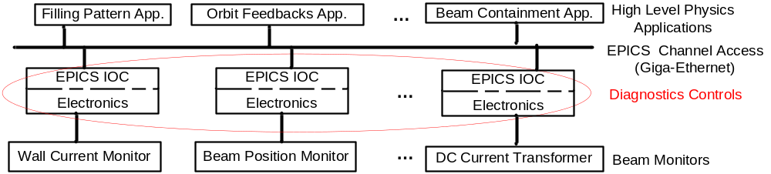

Figure 2: NSLS-II Beam Diagnostics & Control Systems

Controls Requirements

To monitor and measure various beam parameters as shown in Fig.1, a variety of diagnostic monitors will be deployed in NSLS-II. The Diagnostics Group and the Controls Group are working together on controls requirements for these beam monitors. Table 1 lists the beam monitors associated with beam parameters used in each sub-accelerator and summaries of controls requirements. Detailed descriptions about each beam monitor and its controls are presented in Sections 2 and Section 3.

Table 1: Diagnostics Controls Requirements and Specification
Accelerator  Subsystems | Beam Parameter | Beam Monitor | Controls Requirements
Linac | Fill Pattern | Wall Current Monitor (WCM) | Note 1: For fill pattern measurement:  sampling rate: 4GS/s; resolution: 8-bit  IOC update rate: 10Hz
Linac | Profile/Position | Fluorescent Screen/CCD (Flag) | Note 2: For all flags:  Binary control for pneumatic actuator  CCD: 1620*1220@15fps, IOC@10Hz
Linac | Position/Orbit | Beam Position Monitor (BPM) | Single Pass Resolution: 30um rms
LtB  (Linac to Booster Transport Line) | Fill Pattern | Fast Current Transformer (FCT) | See Note 1 described in Linac
LtB  (Linac to Booster Transport Line) | Profile/Position | Flag | See Note 2 described in Linac
LtB  (Linac to Booster Transport Line) | Position/Orbit | BPM | Single Pass Resolution: 30um rms
LtB  (Linac to Booster Transport Line) | Bunch Charge | Integrating Current Transformer (ICT) &  Beam Charge Monitor (BCM) | Note 3: for all ICTs & BCMs:  20KS/s with 16-bit  IOC@10Hz
LtB  (Linac to Booster Transport Line) | Energy Spread | Energy Slit | Note 4: for all slits in transfer lines:  stepper motor control with readback;
LtB  (Linac to Booster Transport Line) | Bunch Charge | Faraday Cup | Note 5: for all FCs:  Digitizer: 100MHz bw, 1GS/s
Booster | Fill Pattern | FCT | See Note 1 described in Linac
Booster | Profile/Position | Flag | See Note 2 described in Linac
Booster | Position/Orbit | BPM | Resolution: 30um rms
Booster | Circulating  Beam Current | DC Current Transformer (DCCT) | 20KS/s with 16-bit;10Hz for injection efficiency calculation;
Booster | Bunch Length | Streak Camera | Windows software by vendor
Booster | Tune | TBD | TBD
Booster | Emittace | TBD | TBD
BtS  (Booster to Storage Ring Transport Line) | Fill Pattern | FCT | See Note 1 described in Linac
BtS  (Booster to Storage Ring Transport Line) | Profile/Position | Flag | See Note 2 described in Linac
BtS  (Booster to Storage Ring Transport Line) | Position/Orbit | BPM | Single Pass Resolution: 2um rms@1Hz
BtS  (Booster to Storage Ring Transport Line) | Bunch Charge | ICT & BCM | See Note 3 described in LtB
BtS  (Booster to Storage Ring Transport Line) | Bunch Charge | Faraday Cup | See Note 5
BtS  (Booster to Storage Ring Transport Line) | Energy Spread | Energy Slit | See Note 4 described in LtB
Storage Ring | Fill Pattern | Stripline or synchrotron light with photo-diode (TBD) | See Note 1 described in Linac
Storage Ring | Profile/Position | Flag | See Note 2 described in Linac
Storage Ring | Position/Orbit | BPM | Resolution: 1um rms@10KHz; 0.5um rms@10Hz
Storage Ring | Circulating Beam Current | DCCT | 2KS/s with 18-bit@500Hz bw; 10Hz for injection efficiency calculation
Storage Ring | Bunch Length | Streak Camera | Windows software by vendor
Storage Ring | Tune | Pickup stripline, excitation stripline, Network Analyzer | Ethernet-based instrument control
Storage Ring | Emittance & Energy Spread | Pinhole Camera | Stepper motor control with readback;  CCD: 1620*1220@15fps, IOC@1Hz
Storage Ring | Beam Stability | Stripline, Spectrum Analyzer | Ethernet-based instrument control
Storage Ring | Beam Losses | Beam Loss Monitor (BLM), Scraper | TBD

PS: Transverse bunch-by-bunch feedback itself integrates electronics and EPICS IOC. The only control interface is timing (trigger and clock).

Functionalities and Applications

The basic functionalities of diagnostics controls can be summarized as:
- Measurement of various beam parameters (~10) via a variety of beam monitors (~16).
- Acquirement and processing of the signals from beam monitors via different electronics and EPICS IOCs.
- Provision of the processed data as EPICS PVs for high level physics applications.
- Support of Top-off operation by providing filling pattern measurement to meet the requirements of initial filling storage ring from zero to full charge at 10Hz for Linac injection and at 1(or 2)Hz for Booster injection, as well as 1-minute top-off cycle after filling up.

From the point of view of controls and applications, diagnostics and controls systems can be classified into the following groups, as shown in Figure 3:
- BPM subsystem for orbit feedbacks, lattice measuring, etc.
- Filling pattern measurements based on WCM, FCT, stripline/synchrotron light with photo-diode.
- Beam containment subsystem as well as injection efficiency involving ICT, DCCT, BLM and scraper;
- Camera-based diagnostics such as screen/flag, pinhole system, streak camera, and synchrotron light monitor (SLM);
- Network/Spectrum analyzer-based tune measurement and beam stability monitoring;

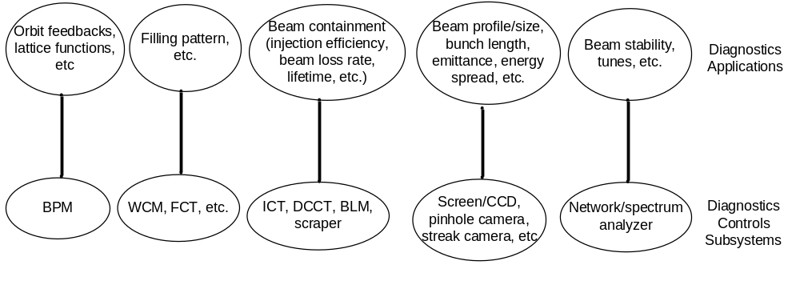

Figure 3: Diagnostics Control Subsystems and Applications

Orbit Feedbacks

BPM is the key diagnostics subsystem. BPM data is the source for NSLS-II storage ring fast orbit feedback (FOFB) and slow orbit feedback (SOFB). Orbit feedbacks are made of several parts including BPM pickup button, BPM electronics receiver, global BPMs data communication/exchange links, computing nodes for feedback algorithms, etc.

Diagnostics control system focuses on BPM receivers (Libera Brilliance or in-house electronics). It will provide 10 KHz fast acquisition (FA) data for FOFB over fast communication links (RocketIO-based Gigabit-Ethernet) and 10Hz slow acquisition (SA) data for SOFB over EPICS Channel Access (CA) network. Both FA and SA data from each BPM will be globally synchronized.

Besides orbit feedbacks application, BPM can be used for measuring turn-by-turn dynamics, chromaticity, dispersion, lattice functions, etc.

Filling Pattern measuring

Thanks to the high bandwidth of WCM (~3GHz), FCT (~1.7GHz), stripline (>1GHz), they can be used to observe individual bunch shape from the multi-bunch trains (80~150 bunches, 500MHz). So, WCM, FCT and stripline are chosen to measure filling pattern which is required for NSLS-II top-off operation.

The diagnostics controls will provide the data acquisition and process systems with over 1GS/s sampling rate and 8-bit resolution to observe the shape of each bunch whose duration is 2ns (500MHz) and calculate the charge of each bunch.

Beam Containment System

ICT (by Bergoz, coupled with BCM), DCCT (by Bergoz), BLM and scraper will be deployed in beam containment system (BCS) which is designed for monitoring and controlling radiation losses in NSLS-II. BCS should be interlocked to top-off injection. The bunch charge losses (injection efficiency) will be monitored by ICT and DCCT. BLMs will be used to confirm beam loss locations around the ring. And scrapers can be used to intercept beam and control beam losses.

The diagnostics control system will digitize the DC voltage outputs from ICT&BCM, DCCT and then calculate the injection efficiency, beam losses rate, beam lifetime, etc. Since the design and physics requirements of BLM and scraper are just starting, the controls and data acquisition for them are still not clear.

Camera-based Diagnostics Applications

Various cameras will be used in beam diagnostics for measuring beam profile, beam size, emittance, energy spread, bunch length, etc. Screens (flags) coupled with CCD cameras placed over the whole NSLS-II accelerators are very useful to trace beam position and observe beam profile during machine commissioning. Synchrotron-light-based measurements in the Storage Ring diagnostics beamlines will be conducted on streak camera to measure bunch length and on pinhole camera to measure beam size, transverse emittances, energy spread, etc.

To standardize CCD camera controls, the digital cameras used in flags and pinhole-systems will be purchased from the same manufacture and have the same control/communication interface. Gigabit-Ethernet interface is preferable to FireWire (1394b) in terms of bandwidth, cabling, anti-EMI, etc. Prosilica Gig-E CCD camera is under evaluation. The diagnostics control system will acquire the digital image from CCD camera and then send the raw data (pixels) to MatLab-based high level application for image analyzing and processing(background subtraction, Gaussian fit, calibration, etc).

The streak camera system itself contains control & data acquisition software. It only interfaces to timing system.

Network/Spectrum Analyzer-based Diagnostics Applications

Tune monitor is used to measure transverse tunes by two strip-lines (signal pickup and source excitation) and one network analyzer. Beam stability monitor will observe spectrum of beam motion using one pickup strip-line and one real time spectrum analyzer.

Modern network/spectrum analyzers are usually equipped with Ethernet/GPIB interfaces and Windows XP operating system. For diagnostics controls, they can be characterized as Ethernet-based instrument control.

Device Counts and Diagnostics Subsystem

NSLS-II accelerators consist of one injector and one storage ring. According to the functionality as well as geographical distribution, the injector can be divided into subsystems: Linac, Linac to Booster (LtB) transfer line, Booster, Booster to Storage ring (BtS) transfer line. Table 2 gives a summary of the diagnostic monitors distributed over the whole machine. Although Linac and Booster are turnkey solutions provided by vendors, BNL will specify the requirements for diagnostics and controls and vendors implement them. For better standardization and maintenance, the same type of diagnostics (e.g. CCD cameras) used in different accelerator subsystems will be provided by the same manufacture (Flea 2 by Point Grey Research, Inc, or GE1380 by Prosilica) so that they almost have the same control interfaces and requirements. Detailed descriptions of each beam monitor are presented in the following sections.

Table 2: Device Counts in Diagnostics
 | Linac | LtB | Booster | BtS | Storage Ring
Wall Current Monitor (WCM) | 5
Screen/Flag with CCD camera | 3 | 9 | 6 | 9 | 3
Beam Position Monitor (BPM) | 3 | 6 | 24 | 7 | 240
Fast Current Transformer (FCT) |  | 2 | 1 | 2
Integrating Current Transformer (ICT) & Beam Charge Monitor (BCM) |  | 2 |  | 2
Energy Slit |  | 1 |  | 1
Faraday Cup |  | 2 |  | 1
DC Current Transformer (DCCT) |  |  | 1 |  | 1
Streak Camera |  |  | 1 |  | 1
Pinhole system(optics & CCD camera) |  |  |  |  | 2
Tune Monitor |  |  | 1 |  | 1
Beam Stability Monitor |  |  |  |  | 1
Transverse Feedback System |  |  |  |  | 1
Photon/xray BPM |  |  |  |  | 2 per front-end
Beam Loss Monitor (BLM) |  |  |  |  | TBD
Beam Scrapers |  |  |  |  | 5

Diagnostics for Linac

Table 3 shows beam diagnostics for the electron gun and Linac.

Table 3: Diagnostics in Linac
Subsystem | Beam Monitor | Qty | Comments
Linac | Wall Current Monitor | 5 | resistive WCMs are used after the gun, pre-buncher  and buncher for beam longitudinal characteristics
Linac | Fluorescent Screen | 3 | installed between the linac tanks to  observe beam profile & position
Linac | Beam Position Monitor | 3 | orbit monitoring

The gun and Linac diagnostics consist of five resistive wall current monitors (WCM) to observe the longitudinal profile/bunch shape of the electron bunches after the gun, pre-buncher, and buncher. The WCM is formed by equally spaced broadband ceramic resistors mounted on a flexible circuit board, wrapped around a short ceramic break.

Three fluorescent screens installed between the linac tanks will be used to observe the transverse profile and the position of the electron beam. The screen material will be yttrium aluminum garnet (YAG:Ce) because it results in excellent resolution (about 30μm) of the beam image and exhibits high sensitivity and high radiation hardness.

The electron beam orbit and position will be monitored by three beam position monitors (BPM). More detailed descriptions of BPM are presented in Section 2.5.

Diagnostics for LtB Transport Line

The beam instrumentation/diagnotics that will be used for the commissioning and normal operation of the LtB line are fluorescent screens, current transformers including FCT and ICT&BCM, energy slit, BPMs, etc. as shown in Table 4.

Table 4: Diagnostics in LtB (Linac to Booster) Transport Line
Subsystem | Beam Monitor | Qty | Comments
LtB | Fluorescent Screen | 9 | observe beam profile; measure electron beam size to calculate Linac energy spread
LtB | Integrating Current Transformer & Beam Charge Monitor | 2 | measure the amount of the whole bunches charge through the transport line for calculation of Linac injection efficiency
LtB | Fast Current Transformer | 2 | measure individual bunch profile for filling pattern
LtB | Energy Slit | 1 | energy spread; driven by stepper motor with position readback
LtB | Beam Dumps | 2
LtB | Faraday Cup | 2
LtB | Beam Position Monitor | 6 | orbit monitoring

Two screens with one energy slit provide for coarse and fine (with switched-off achromatic quadrupole) measurements of energy spread. Another two screens will be used to measure electron beam size and position.

Two pairs of integrating current transformer (ICT) with beam charge monitor (BCM) by Bergoz will be located at the start and the end of LtB to measure the total amount of charge passing through the transport line. Bergoz ICT is a sensor only with one coaxial output. Its output voltage multiply time integral is in exact proportion to the beam pulse charge, irrespective of the bunch width, i.e. irrespective of the bunch frequency spectrum. For NSLS-II Linac injection with the maximum 150 bunches (500MHz RF), the bunch train to be integrated and measured is 298ns long. It will pass through the ICT and the ICT output will be a 368ns long signal with rise-time (10%-90%) about 20ns, fall-time (10%-90%) about 30ns and a flat top (if the 150 bunches are evenly charged). The ICT's only drawback is that the original shape of the signal is lost. Bergoz BCM is a piece of electronics for ICT in a chassis. It has a bipolar voltage output that is directly proportional to the total beam charge. BCM electronics are made in various versions. The version to measure single pulse or bunch trains up to 5us long is called BCM-IHR-E (Integrate-Hold-Reset).

Two Bergoz fast current transformers (FCT) will be used for fill pattern monitoring. The Bergoz FCT, usually directly mounted on the beam chamber with a ceramic break and RF shielding, will provide electrical signal proportional to the charge of individual bunches. It has 1.75 GHz bandwidth with a 200 psec rise time. Fast ADC sampling (>1GS/s) of the FCT output voltage will make charge distribution available to the control system. The information obtained will be used in the top-off algorithm.

The beam dumps can include Faraday cups for absolute bunch charge measurement. The beam trajectory during normal operations is monitored by six BPMs.

Diagnostics for Booster

Booster diagnostics are summarized in Table 5. The following parameters will be monitored: beam profile/position, filling pattern, circulating beam current, beam orbit, bunch length, emittance and working point (tunes in both planes).

Six fluorescent screens will be used to observe shape and position of the injected electron beam during the first turn. The filling pattern will be monitored with one Bergoz FCT. The booster orbit will be monitored with 24 BPMs (no orbit feedbacks are needed).

The Booster circulating current will be measured with a Bergoz new parametric current transformer (NPCT/DCCT). More information about NPCT is presented in Section 2.5.

The synchrotron radiation from one of the bends will be used for bunch-length measurement with the help of a streak camera. More information about streak camera is presented in Section 2.5.

The Booster emittance measurement is also based on synchrotron light from bending magnet with the help of a CCD camera. The beam image captured by the camera will be analyzed and processed for the calculation of beam emittance and also will provide information on the beam position and stability during the ramp.

The fractional tune measurement system will be based on real-time spectral analysis of the signal induced on the strip-lines by the electron beam. Electron beam motion will be excited by broadband noise generator with fixed cutoff frequencies. The real-time spectrum analyzer will be used to observe tune evolution along the ramp.

Table 5: Diagnostics in Booster
Subsystem | Beam Monitor | Qty | Comments
Booster | Fluorescent Screen | 6 | observe beam profile and position
Booster | Fast Current Transformer | 1 | measure individual bunch profile for filling pattern
Booster | DC Current Transformer | 1 | average circulating current
Booster | Beam Position Monitor | 24 | orbit monitoring
Booster | Streak Camera | 1 | bunch length
Booster | Digital CCD camera | 1 | Emittance
Booster | Tune monitor | 1 | working points in both planes

Diagnostics for BtS Transport Line

The beam instrumentation/diagnostics for BtS transport line are almost the same as that for LtB, shown in Table 6.

The fluorescent screens, accompanied by seven RF beam position monitors, will be used to measure the beam position and size. Two screens and one slit will be used for coarse and fine measurement of energy spread. Two ICTs located at the start and the end of LtB will measure the total amount of charge passing through the BtS transport line. Two FCTs will be used for fill pattern monitoring.

Table 6: Diagnostics in BtS (Booster to Storage ring) Transport Line
Subsystem | Beam Monitor | Qty | Comments
BtS | Fluorescent Screen | 9 | observe beam profile and measure electron beam size to calculate Linac energy spread
BtS | Fast Current Transformer | 2 | measure individual bunch profile for filling pattern
BtS | Integrating Current Transformer & Beam Charge Monitor | 2 | measure the amount of the whole bunches charge through the transport line for calculation of Booster injection efficiency
BtS | Energy Split | 1 | energy spread; Driven by stepper motor with position readback
BtS | Beam Dumps | 1
BtS | Faraday Cup | 1
BtS | Beam Position Monitor | 7 | orbit monitoring

Diagnostics for Storage Ring

Table 7 shows a summary of various diagnostics/instrumentation components in storage ring.

Table 7: Diagnostics in Storage Ring
Subsystem | Beam Monitor | Qty | Comments
Storage Ring | Fluorescent Screen | 3 | located at injection straight
Storage Ring | DC Current Transformer | 1 | average circulating current
Storage Ring | Beam Position Monitor | 240 | orbit feedbacks, lattice function, etc.
Storage Ring | Photon BPM | 2 per FE | X-ray position
Storage Ring | Tune monitor | 1 | vertical and horizontal betatron tunes
Storage Ring | Beam stability/oscillation monitor | 1 | Frequency components of longitudinal and transverse beam motion
Storage Ring | Stripline/synchrotron light with photo-diode | 1 | filling pattern
Storage Ring | Pinhole Camera | 2 | Beam size, transverse emittances, energy spread, etc.
Storage Ring | Streak Camera | 1 | bunch length, the system itself integrates DAQ software
Storage Ring | Transverse Feedback System | 1 | Electronics and EPICS IOC are included the system
Storage Ring | Beam Loss Monitor | TBD
Storage Ring | Scrapers | 5 | Beam loss control

A fluorescent screen in the injection straight will provide information on the shape and position of the injected beam and will assure proper matching of the beam optics. The screen will have two positions. The first position will be used to observe the incoming beam from the booster. In the second position, a special hole will allow the injected beam to enter the storage ring, and the beam shape will be observed after one turn.

A DC current transformer (Bergoz NPCT) will monitor the stored current in storage ring. NPCT has large dynamic range and high bandwidth, making it a versatile device for measuring lifetime and injection efficiency. It is insensitive to a synchrotron revolution frequency and bunch fill pattern, with residual modulator ripple being eliminated, thus enabling full bandwidth operation down to a very low current. Its resolution is better than 1 μA/Hz½. Such a small noise will allow measurement of the expected 60 hours lifetime for 20mA circulating in one minute with 1% accuracy (assuming a 1 Hz sampling rate). The high bandwidth of the DCCT will allow measurements of the steps in the current after injection, and therefore provide a means of continuously monitoring injection efficiency.

There will be six beam position monitors (BPM) equipped with receivers for each cell. Straights with insertion devices, however, will be provided with two additional instrumented BPMs. All BPMs in NSLS-II will utilize high precision 4-button pickup electrodes that are diagonally incorporated into the aluminum extrusion vacuum chamber. The scaling factors for both vertical and horizontal directions are estimated to be around 10 mm depending on the buttons geometry. The circulating current of 500 mA in the storage ring is expected to produce -1.1dBm signal into 50 Ω load at 500 MHz. Small alignment errors, as well as electrical offsets and errors in the BPM system, will be accounted for at the commissioning using beam-based alignment. The NSLS-II storage ring utilizes very strong sextupoles. This makes it very important to have the orbit of the circulating beam as close as possible to the magnetic centers of the sextupoles. We will rely on highly accurate relative alignment of the sextupoles and quadrupoles on the same girder. In addition, a beam-based alignment procedure will be used for the sextupoles.

The vertical and horizontal betatron tunes will be monitored using a network analyzer. The analyzer’s source will be connected to the excitation stripline through the buffer amplifiers. The signals from the pickup stripline electrodes will be combined with hybrids to produce vertical or horizontal signals, which will be down-converted below the revolution frequency and fed to the input of the network analyzer. Such an approach allows utilization of the maximal driving strength of the striplines and makes measurement of the tunes less sensitive to changes in the revolution frequency.

One beam stability/oscillations monitor will be used to monitor beam motions and measure the synchrotron frequency. The signal from a dedicated set of stripline electrodes will be connected to an RF spectrum analyzer. The sidebands observed can be used to analyze electron beam motion. Summing the signal from opposite electrodes helps to eliminate components with transverse oscillations, while maintaining the signal with phase motion of the electron bunches, which allows measurement of the synchrotron frequency. The difference signal will be used to observe transverse oscillations of the electron beam.

Two pinhole systems with optics and CCD cameras will utilize X-ray radiation from a three-pole wiggler and a bending magnet in order to measure beam size and calculate beam transverse emittances, energy spread, etc. The radiation will pass through a filter. The filter will remove photons with low energy creating heat load on the pinhole itself and adversely affecting resolution. Then the photons will pass through a pinhole (or set of the pinholes) and will be released into the atmosphere through a window. The intensity of the radiation will be controlled by means of an attenuator. The image of the electron beam will be created with a fluorescent screen and will be observed by a camera equipped with a magnifying optics. The digitized image will be acquired and displayed by control system and transferred to MatLab-based high level applications for processing and analyzing.

Controls Interfaces for Diagnostics

Diagnostics controls are actually more about data acquisition (DAQ) than device control. Diagnostics control subsystem will conform to NSLS-II control system standards. It will be EPICS-based and the preferable operating systems for IOCs are RTEMS (Real-Time Executive for Multiprocessor Systems) and Linux. For VME-based controls, the CPU board will be standardized as Motorola MVME3100.
Whenever possible, diagnostics controls pursue the utilization of commercial off-the-shelf hardware to reduce cost as well to achieve better reliability. Although NSLS-II Linac and Booter are turn-key solutions provided by vendors, it’s better to standardize the diagnostics controls for the whole machine. The following section describes the classified method for controls standardization.

Classifications of Control Interfaces

From point view of controls, the beam monitors output signals/interfaces can be classified into the following several groups.
- Analog output with high-bandwidth (>500MHz): WCM, FCT, etc.;
- Analog output with low-bandwidth (<10KHz): DCCT, ICT&BCM;
- Simultaneous 4-channle RF signals: BPM;
- Gigabit-Ethernet camera interface: pinhole camera, flag/CCD, streak camera etc.
- Stepper motor driven: linear stage in pinhole system, energy slit, scraper, etc.
- Ethernet-based instrument: Windows XP-based network/spectrum analyzer for tune monitor and beam stability monitor;

PS: there are other miscellaneous I/Os for diagnostics, e.g. binary input/output including TTL I/O for DCCT range settings, pneumatic actuator with limit switch in flag, limit switch in stepper-based stage; 24 V binary outputs for XIA filter inserter in pinhole system; 12-bit DAC for illuminator control in pinhole and flag system. BLM output is TBD.

Here are some considerations and principles about the selection of electronics for the above groups of beam monitors:
- WCM and FCT are used to measure individual bunch charge. The time interval between adjacent bunches is 2 ns so that the digitizer for WCM & FCT should have at least 500MHz bandwidth and 1GS/s sampling rate. Since NSLS-II physics requirement for filling pattern accuracy is 1% of maximal bunch charge, 8-bit resolution digitizer should be fine;
- The output of DCCT and BCM/ICT is nearly DC voltage so that the requirement of sampling rate for digitizer is not demanding. For Booster DCCT and transfer-lines ICT, the digitizer with 16-bit resolution and 20KS/s would be suitable. For Storage Ring DCCT digitizing, the resolution requirement is determined by beam lifetime calculation considered 20mA in 60 hours with 1% accuracy. This translates to 18-bit ADC resolution.
- For 4-button-pickup RF BPM, commercial electronics Libera Brilliance meets the requirements;
- For camera controls, NSLS-II diagnostics will/may be standardized as Gigabit-Ethernet interface for high bandwidth, easy cabling, good anti-EMI, etc;
- For stepper-motor based diagnostics, the controls will be integrated into NSLS-II motion control subsystem;
- For Windows-based network/spectrum analyzer, it’s possible to make an EPICS IOC run inside the instrument.

Controls and Data Acquisitions for Diagnostics

Each type of beam monitor requires electronics (device controller) to process its output signal. The proposed electronics for the above groups and associated EPICS IOC platform are listed in Table 8. Figure 4 shows the controls interfaces for these various beam monitors. More detailed descriptions of the controls and data acquisitions for each group are presented in the following sections.

Table 8: Diagnostics Electronics and IOC Platform
Beam Monitor Group | Diagnostics Electronics | EPICS IOC platform
WCM & FCT | Acqiris Digitizer DC252 (2GHz bw, 10-bit, 4-8GS/s ) | compactPCI/Linux
DCCT & ICT | 1) Hytec 8002 carrier board  2) Hytec IP-ADC-8401(8-channel, 16-bit, 100KHz)  3)Agilent 3458 DVM (8.5-digit, 18-bit at 2KS/s)  4) GPIB-to-Ethernet converter | VME/RTEMS
BPM | 1) I-tech Libera Brilliance  2) In-house new electronics | 1) Embedded Linux  2) VME/RTEMS
Prosilica Gig-E Camera | PC/Linux | PC/Linux
Stepper-motor-based | Delta Tau GeoBrick LV PC | PC/Linux
Instrument controls | Windows-based network/spectrum analyzer | X86/Windows
Digital I/O and DAC | 1) Hytec 8001 carrier board included digital TTL I/O  2) Allen-Bradley compactLogix for 24V digital output  3) Hytec IP-DAC-8402 (16-channel, 16-bit) | VME/RTEMS

(PS: Acqiris will be used for Faraday Cup)

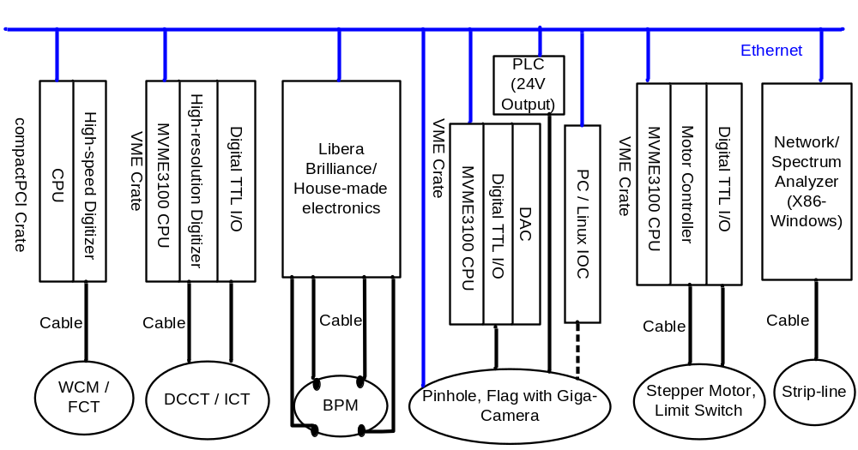

Figure 4: Diagnostics Controls Interfaces

DAQ for WCM & FCT
After several discussions on control interfaces for WCM and FCT, the Diagnostics Group and the Control Group are almost determined to adopt Agilent Acqiris Digitizer DC252. This 6U compactPCI digitizer board has excellent performance: 2-channel, 10-bit resolution, 2GHz bandwidth, software configurable sampling rate with 4GS/s at 2 channels simultaneous samplings or 8GS/s at 1 channel by interleaving, 1M sample points memory. Figure 4 shows the data acquisition systems which include one compactPCI 5-slot crate, one CPU board (PP401, intel dual core, Gigabit-Ethernet) and one or more Acqiris DC252. RTEMS EPICS driver for DC252 will be developed to run on PP401 CPU board.
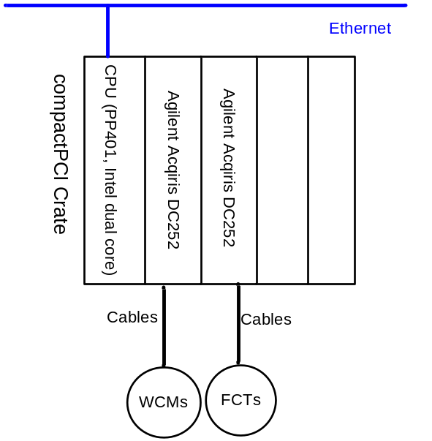

Figure 5: DAQ Systems for WCM and FCT

DAQ and Controls for DCCT & ICT
For Booster DCCT and transfer lines ICTs (coupled with BCMs), the DAQ and controls will be based on Hytec VME64x products which are widely used in EPICS community. Hytec 8002 carrier board with Industry Pack (IP) ADC module IP-ADC-8401(8-channel, 16-bit, 100 KHz, 2MBytes SRAM) will be used to digitize the DC output voltage from DCCT and ICT. Hytec 8001 carrier board integrated with digital TTL I/O (32 inputs & 32 outputs) will be used to setup DCCT’s and BCM’s range, bipolarity, etc. Figure 5 shows data acquisitions and controls for Booster DCCT and transfer lines ICTs.
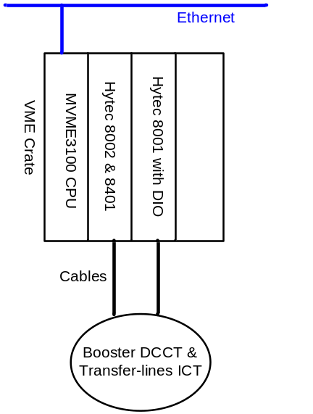

Figure 6: DAQ & Controls for Booster DCCT and Transfer lines ICTs

Storage Ring DCCT requires much higher resolution ADC than Booster DCCT. Agilent 3458 Digital Multimeter provides excellent resolution and sampling speed: 28-bit (8.5-digit)@6Hz, 21-bit@6KHz, 18-bit@50KHz. Figure 6 shows data acquisition and controls for Storage Ring DCCT.
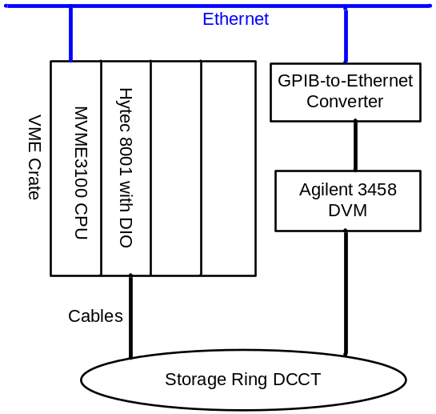

Figure 7: DAQ & Controls for Storage Ring DCCT

DAQ and Controls for BPM

Two BPM receivers are under evaluation: Libera Brilliance by I-Tech and NSLS-II in-house new BPM electronics. Both receivers have the similar control architecture shown in Figure 8. The embedded Libera IOC provides controls/configurations of the receiver as well as 3 data flows/paths over the 100 Base-T Ethernet port: continuous slow acquisition data at 10Hz, turn-by-turn data at revolution frequency (~379 KHz) on demand and ADC raw data at ~117MHz on demand. For in-house BPM receiver, the EPICS IOC will run on MVME3100 so that one VME-based IOC will control several receivers. The fast acquisition data at 10 KHz are steamed out via the FPGA Rocket-IO (Gigabit-Ethernet over UDP).

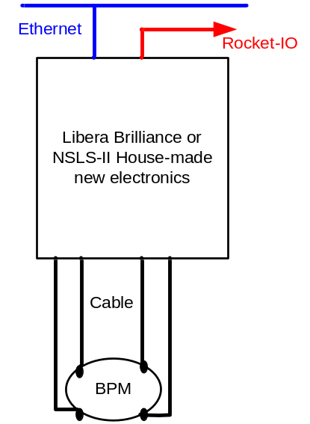

Figure 8: DAQ & Controls for BPM

DAQ and Controls for Camera-based Diagnostics

Besides the main component Prosilica Gigabit-Ethernet camera, the pinhole system and flag also include other components such as pneumatic actuator with limit switches, illuminator, XIA filter inserter, etc. Figure 9 shows the DAQ and controls for camera-based diagnostics. The camera controls and image (raw pixel) acquiring will be performed by the EPICS IOC running on a Linux-based PC. The VME system provides DAC and digital I/O. Hytec 8001will provide digital TTL inputs for limit switches. Hytec 8002 with 8402 (16-bit DAC IP module) will be used for illuminator control. Allen-Bradley compactLogix PLC with 24V digital output module will control pneumatic actuator and XIA filter inserter. The EPICS control of the PLC is by the MVME3100 over Ethernet.

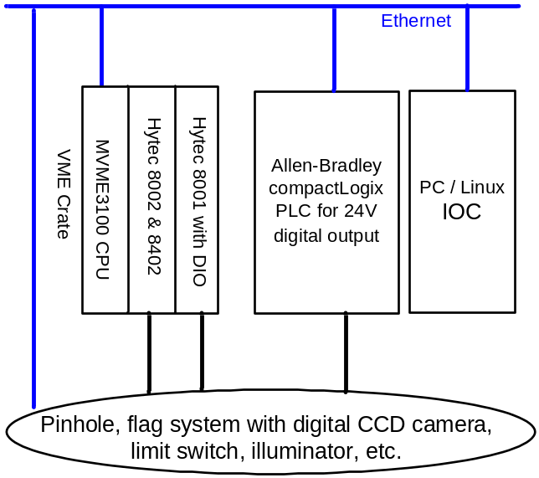

Figure 9: DAQ & Controls for Prosilica GigE Camera-based Diagnostics

Controls for stepper-motor-based Diagnostics
The controls for stepper-motor-based diagnostics will be integrated into NSLS-II motion control subsystem. Figure 10 shows the control architecture. Three types of motor controllers will be evaluated: Pro-dex OMS MAXv-8000, Hytec MDS-8 and Delta Tau GeoBrick LV PC (Linux embedded).

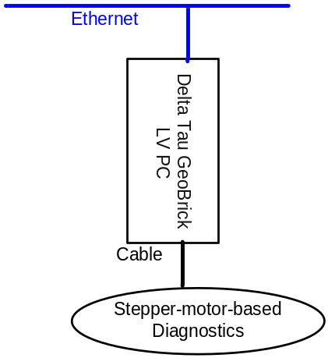

Figure 10: controls for stepper-motor-based diagnostics

Instrument Controls for Network/Spectrum Analyzer

Network/spectrum analyzers are used in tune monitor and beam stability monitor. These instruments have Windows XP OS and Ethernet interface. One control solution shown in Figure 11 is to make an embedded EPICS IOC run inside the instrument.

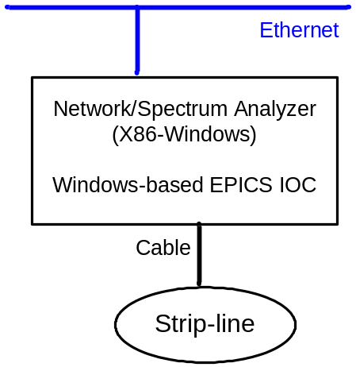

Figure 11: Controls for Network/Spectrum Analyzer

Diagnostics Controls in Sub-accelerators

The diagram of NSLS-II beam diagnostics control system in sub-accelerators, according to Table 2 and Table 8, is shown in Figure 12. The system is composed of several layers. The lowest layer is the beam diagnostics monitors which are connected to respective IOC via specific I/O. EPICS IOCs communicate with high level applications via Channel Access Protocol over Gigabit Ethernet.

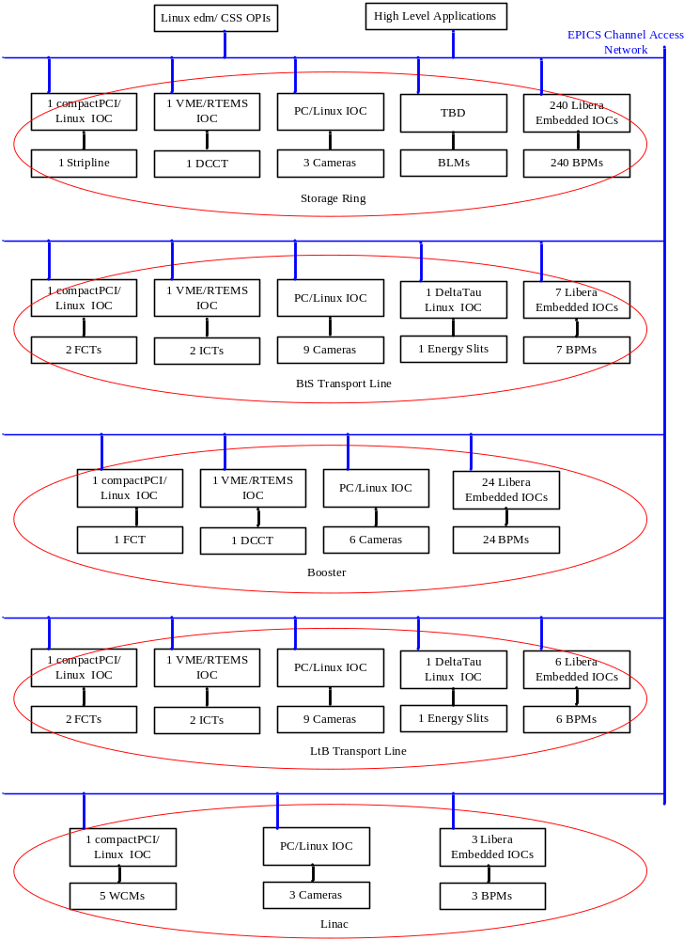

Figure 12: Diagnostics Controls in Sub-accelerators

Interfaces to Other Subsystems

Interfacing to Timing System

To capture the electron beam signal at the right time, the beam monitors should be sampled and synchronized to the passage of the beam. This function can be achieved by using Event Timing System to deliver delayed-trigger or clock signal to the diagnostics electronics.

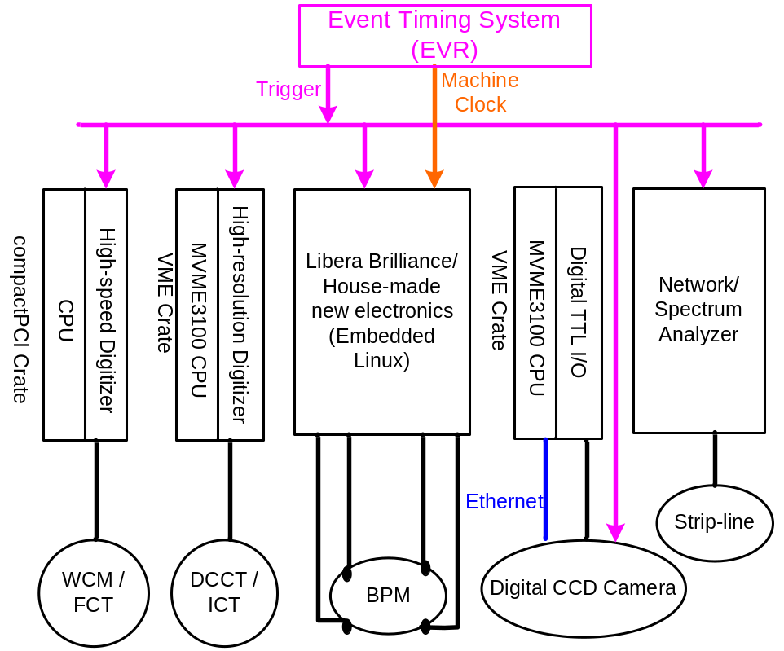

Figure 13: Interfaces between Diagnostics Controls and Timing System
The interfaces between diagnostics controls and timing system are shown in Figure 13. Some diagnostics controls, such as stepper motor, limit switch and DAC, don’t need timing while other diagnostics electronics require trigger signals from Event Timing System (EVR). Additionally, the reference for BPM Libera Brilliance Machine Clock should be provided at the Booster/Storage Ring revolution frequency. For transverse bunch-by-bunch feedback system and streak camera system, trigger/clock signals are the only control signals.
For diagnostics timing requirements, 8ns resolution and 10ps jitter should be sufficient. Diagnostics controls require precisely time delayed trigger at injection rate (10Hz for Linac, 1Hz for Booster) to capture the beam at the right time. The delayed time for each diagnostics depends on the location of beam monitor, the cable length from monitor to its electronics and the distribution of event timing.

Interfacing to Machine Protection System

The diagnostics controls should send hardwired interlock signals, to machine protection system (MPS) if any specific parameter, such as beam positions, beam loss rate, beam current, is out of range.

The design of the interfaces between diagnostics controls and MPS are still in progress. Fig.14 shows the draft diagram of the system.

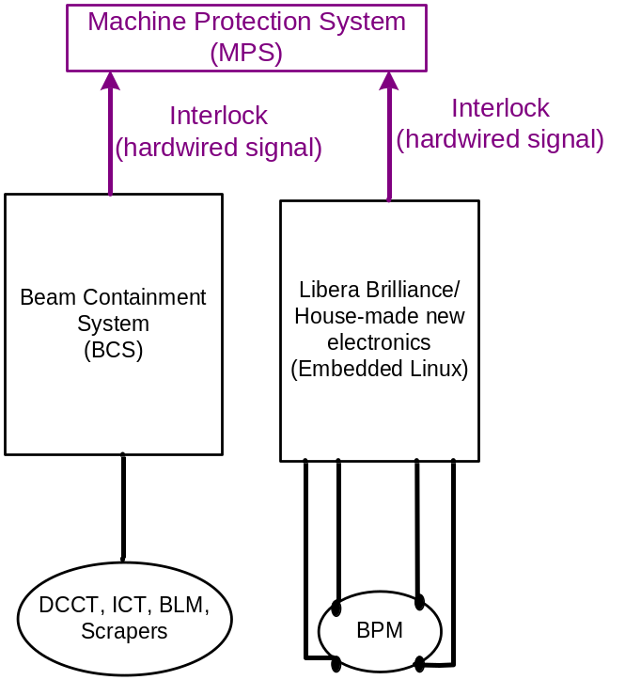

Figure 14: Interfaces between Diagnostics Controls and Machine Protection System

The followings are some cases that diagnostics interlock protection should take action:
- BPM position data are out of pre-defined position range.
- For top off operation, the stored beam current is dropped down to a limit, e.g. 100mA.
- Excessive beam loss is detected by Beam Containment system.

