NSLS-II Multi-IO Electrometer Module
Firmware Version 14
1/3/25

1.0 Introduction

The NSLS-II Multi-IO Electrometer module is primarily a 4 channel electrometer designed to interface to front end equipment such as diamond bpm's, ion-chambers, etc. The module is capable of providing feedback on X-ray beam position and provides fast feedback control on various beamline components. This small compact module (9” x 6” x 2”) provides individually programmable gains on each of the 4 channels, each channel is digitized simultaneously at rates of up to 1Msps with 20 bit resolution. The module incorporates Xilinx’s Zynq FPGA technology, hosting a dual-core ARM A9 processor which runs FreeRTOS operating system and communicates with an external IOC using the PSC protocol. Multiple programmable rate data streams are available to the user with nominal data rates of 10Hz and 10KHz. An embedded Event Receiver allows the module to run synchronized to the accelerator complex and receive global and local accelerator commands which permit easy synchronizing of data and time-stamping with other beamline components. Also included are 8 bits of digital I/O, A high current DAC output for detector bias needs, 4 DAC outputs for feedback applications and an optional daughtercard which adds 4 voltage inputs.

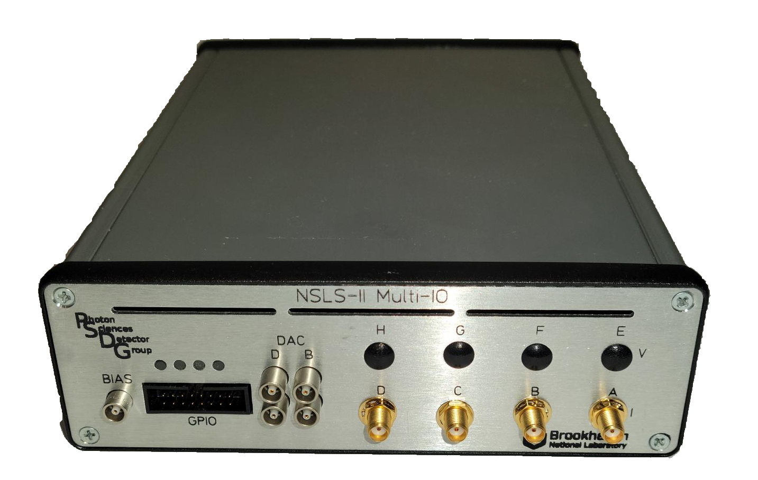

Figure 1. Electrometer

2.0 Key Performance Parameters

Readout Channels | 4 Current (independent gain control)  4 Voltage (independent gain control, via optional daughterboard)
Current Measuring Range | 6 programmable current ranges:  Range Resolution
Current Measuring Range | +/- 100 nA | 200 fA/bit
Current Measuring Range | +/- 1 uA | 2 pA/bit
Current Measuring Range | +/- 10 uA | 20 pA/bit
Current Measuring Range | +/- 100 uA | 200 pA/bit
Current Measuring Range | +/- 1 mA | 2 nA/bit
Current Measuring Range | +/- 10 mA | 20 nA/bit
ADC Sample Rate | Programmable, up to 1MHz. Can be synchronized to NSLS-II turn-by-turn event via embedded event receiver. ~378KHz
Resolution Bits | 20
Bias Voltage Output | -10v to +10v
Current Polarity | Bipolar

3.0 I/O Interfaces

Control Interface | RJ45 – 10/100/1000 Ethernet  Embedded EPICS IOC
High Speed Interface | SFP – Gigabit Ethernet
Embedded Event Receiver | SFP
Electrometer Inputs | SMA
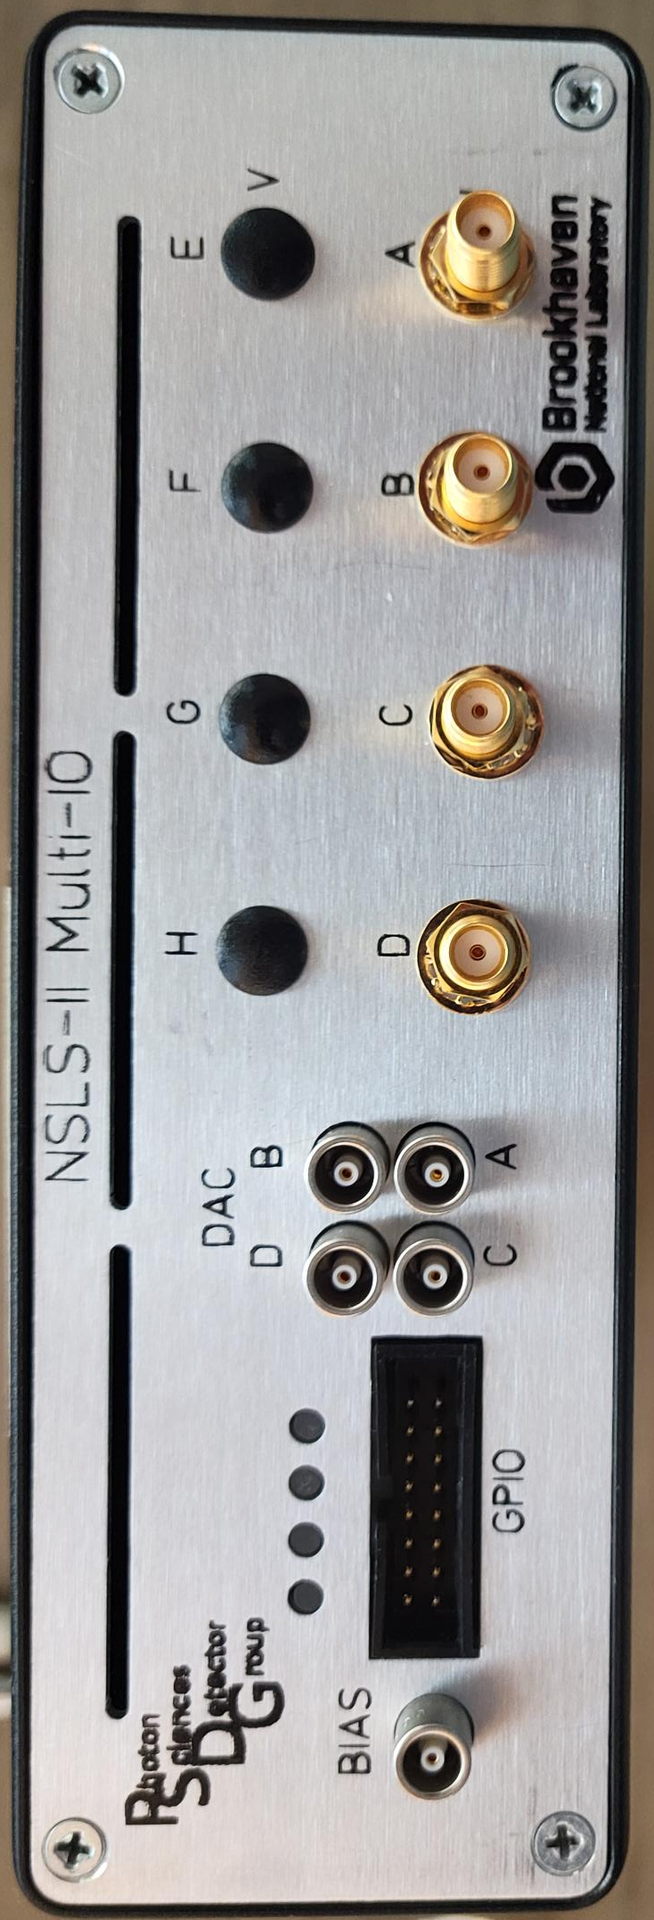  Bias Output | LEMO
Feedback Outputs | LEMO
Power | +12v @ 0.7A

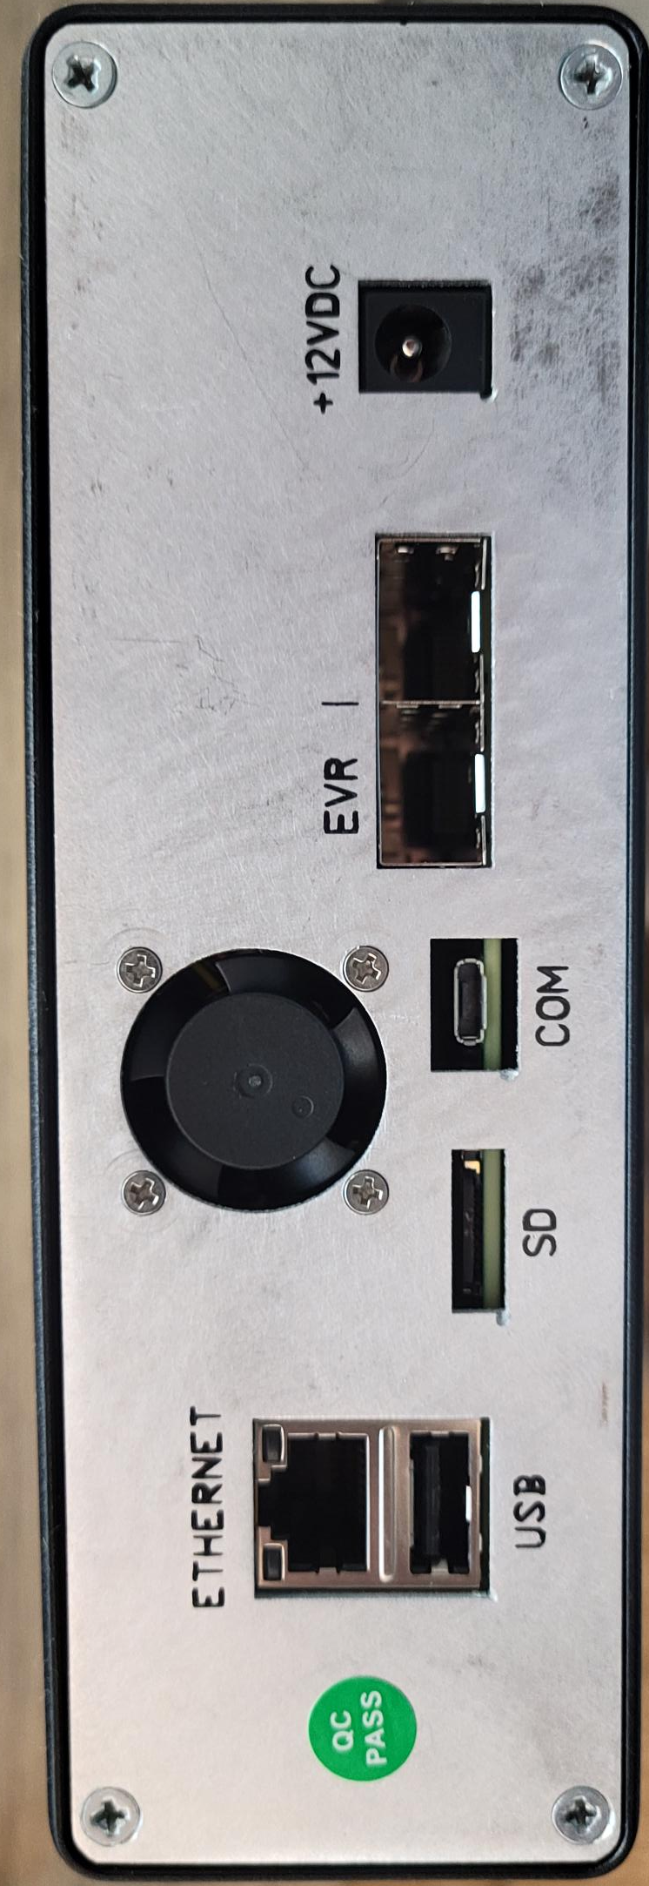

Figure 2. Front Panel

Figure 3. Rear Panel

4.0 Block Diagram

At the core of the electrometer is an Avnet PicoZed 7030 System on Module (SOM) which hosts a Xilinx Zynq FPGA, along with necessary support components including DDR memory, gigabit ethernet and power regulators. Four channels of current inputs are provided which support a very large dynamic range of currents in 6 gain settings with ranges from +/-100nA to +/-10mA with a resolution down to 200fA. A Daugher-board interface connector is provided which can provide extended channel support as well as unique functionality as needed. There currently exists a daughterboard which provides four voltage inputs. A bias DAC with a large current output supports biasing diamond and other detectors. A feedback DAC provides 4 channels of analog outputs with a maximum range of -10.8v to +10.8v is also provided which can interface to piezo nano positioners for position feedback applications. Figure 2 shows a block diagram of the hardware.

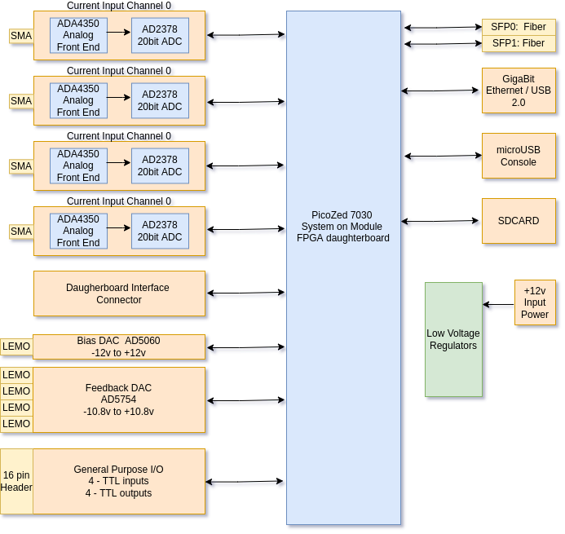
Figure 2. Electrometer Block Diagram

5.0 Printed Circuit Board.

The electrometer consists of a single printed circuit board (PCB) with a PicoZed daughterboard FPGA. Expansion I/O Daughterboard not installed.

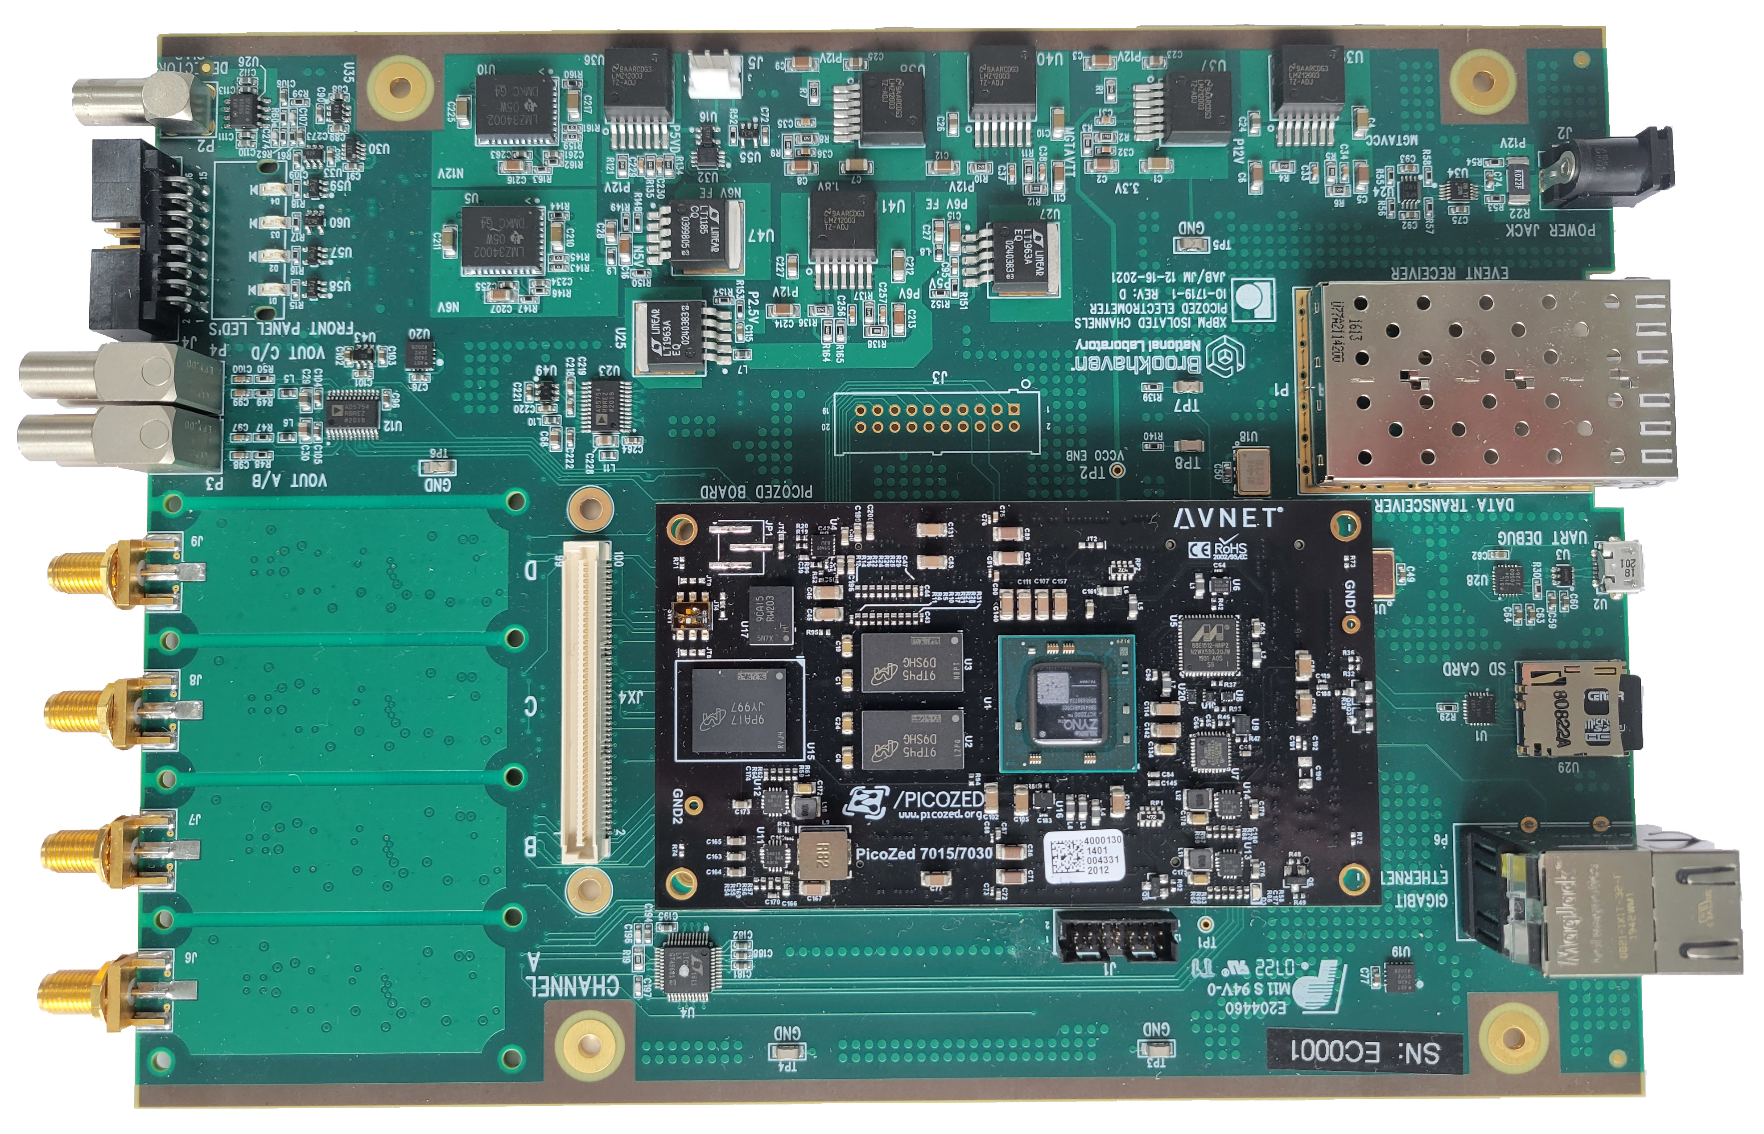
Figure 3. Electrometer PCB Top
Current Inputs
Feedback outputs
GPIO
BIAS Output
SDCARD
Ethernet
SFP’s
+12v DC input

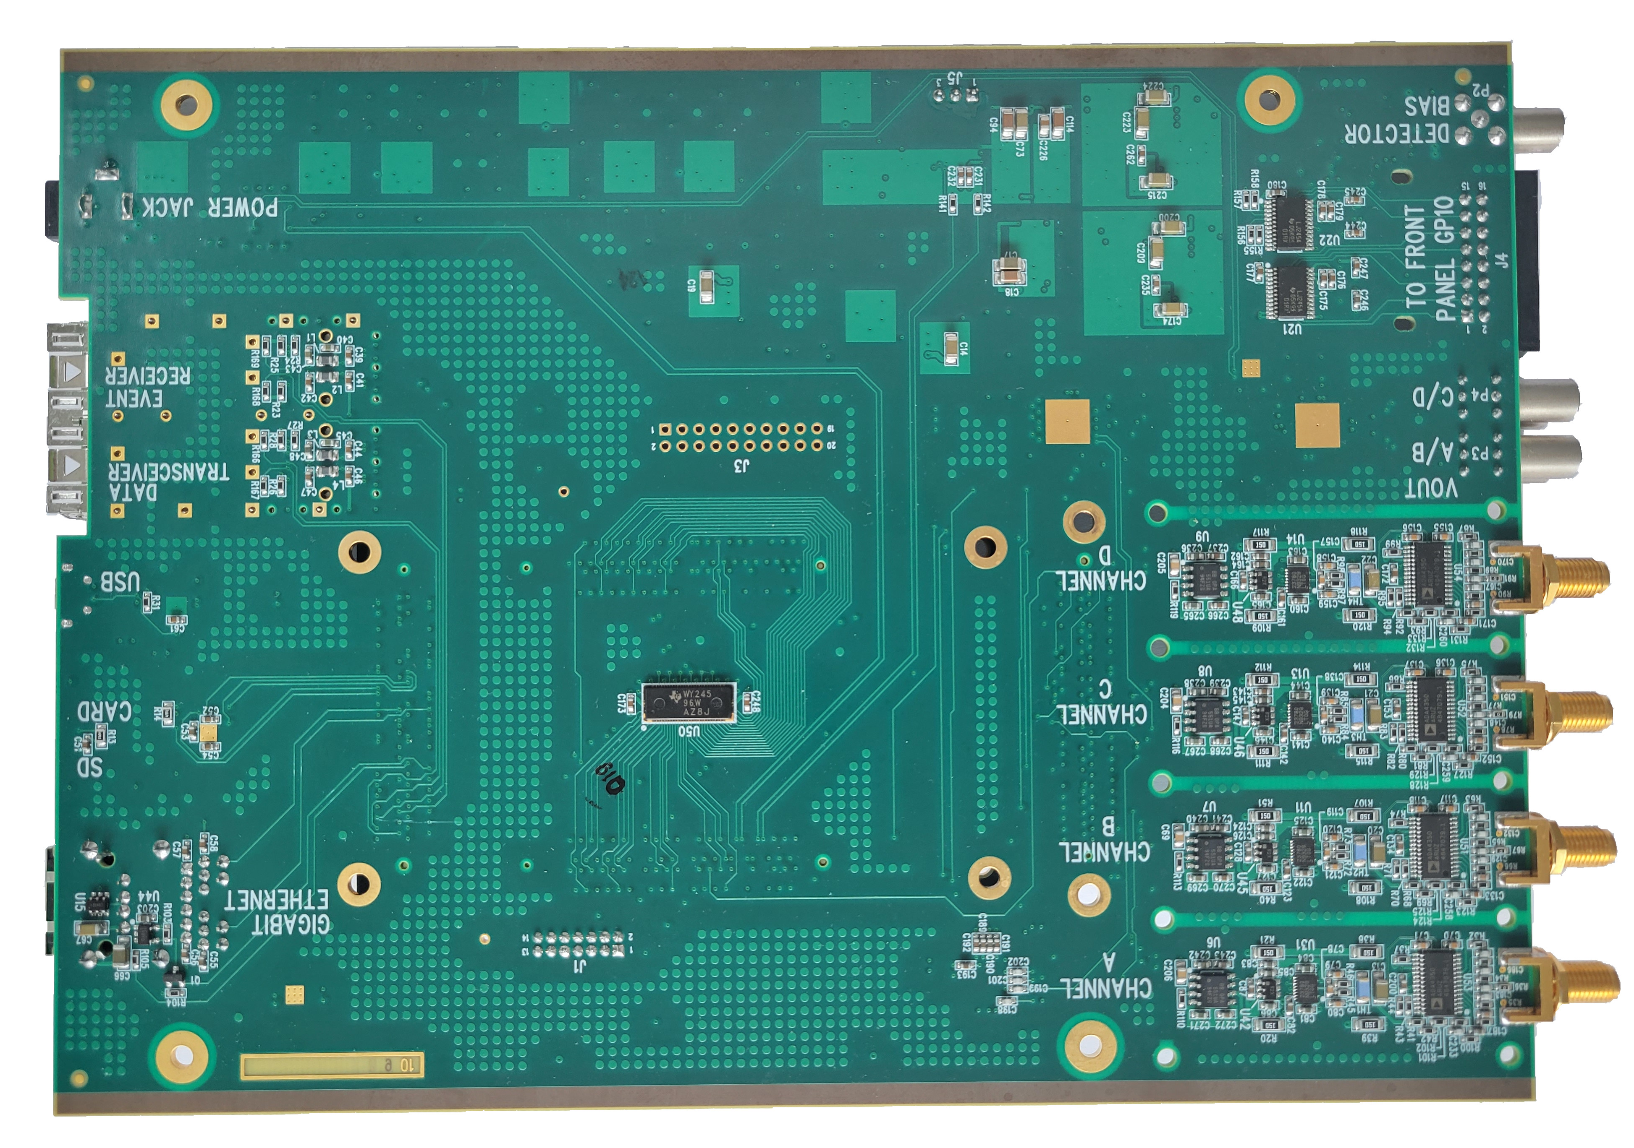

Figure 4. Electrometer PCB Bottom

4.0 Front End

The electrometer uses an Analog Devices ADA4350, which is an analog front end that includes a FET input amplifier, a switching network for gain selection and an ADC driver.
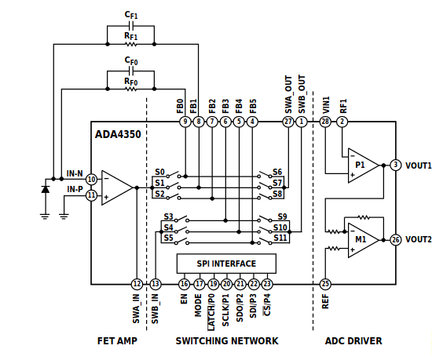

Gains can be set using the I_GAIN_SEL register.

Hex Command | Switches Closed | Gain Path Selected | Feedback Resistor | Gain | Input Current  Range | Resolution  (20 bit ADC)
0x000041 | S0 and S6 | FB0 | 25M | 40 nA/V | +/- 100 nA | 200 fA/bit
0x000082 | S1 and S7 | FB1 | 2.5M | 400 nA/V | +/- 1 uA | 2 pA/bit
0x000104 | S2 and S8 | FB2 | 250K | 4 uA/V | +/- 10 uA | 20 pA/bit
0x000208 | S3 and S9 | FB3 | 25K | 40 uA/V | +/- 100 uA | 200 pA/bit
0x000410 | S4 and S10 | FB4 | 2.5K | 400 uA/V | +/- 1 mA | 2 nA/bit
0x000820 | S5 and S11 | FB5 | 250 | 4 mA/V | +/- 10 mA | 20 nA/bit

5.0 Data Flow

The main data paths in the FPGA for the electrometer are shown below in figure 2. The module supports 4 current inputs and 4 voltage inputs (via an optional daughterboard). For the current inputs, there are 6 programmable ranges as described in section 4.0. The signal is digitized with an Analog Devices, LTC2378, 20 bit ADC. The ADC clock can be locked to the accelerator revolution frequency when connected to the accelerator event link or can free run from on on-board oscillator. There are 2 main data paths for the current and voltage inputs. The first is the Fast Acquisition Data path, which is the high speed data path used for feedback control. Data from the ADC Read block is accumulated for a programmable number of samples, which provides a simple averaging function. When the programmable number of samples is accumulated, an X, Y position is calculated and the results are pushed to FIFO, where it is then available to be read out by the processor. The processor can also connect to PID software which will calculate feedback values which are written to the DAC to close the loop. The second data path is the Slow Acquisition (SA) data path. This is typically run at 10Hz and provides the user with live position values.

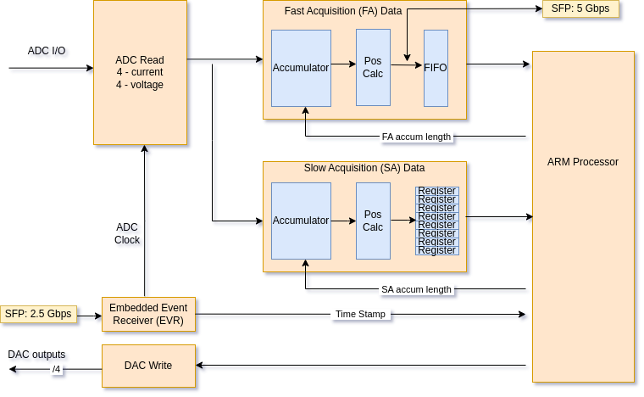

figure 2. Data Flow Block Diagram

6.0 General Purpose Inputs and Outputs.

Four inputs and four outputs are provided on a 16 pin 0.1” header to support interfacing and triggering other equipment on the beamline. Outputs are +5v TTL. The I/O is mapped to the processor which can read or write to I/O. Other functionality can be added to these I/O pins upon request.

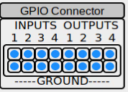
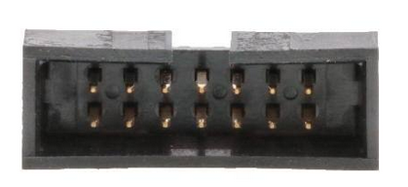  Pin # | Function
1 | Output 0
3 | Output 1
5 | Output 2
7 | Output 3
9 | Input 0
11 | Input 1
13 | Input 2
15 | Input 3
2,4,6,8,10,12,14 | Ground

7.0 BIAS DAC

A detector bias is provided from an Analog Devices AD5060 16 bit DAC which is followed by an OPA552 power amplifier which can provide up to 200mA of output current.

8.0 Feedback DAC

Four channels of DAC outputs are provided for motion feedback control and are designed to drive nano-positioner stages. The DAC is 16 bits with 6 different software programmable output ranges as shown below. The DAC has a maximum settling time of 10uS and can be updated at up to 1MHz.

Range (volts) | Resolution (uV/bit)
+ 5 | 7.6
+ 10 | 15.2
+ 10.8 | 16.4
+/- 5 | 15.2
+/- 10 | 30.4
+/- 10.8 | 33

9.0 IOC

To be updated by DSSI

10.0 CSS Panels

To be updated by DSSI

12.0 Register Map

Table containing all the memory mapped readbacks / settings between the FPGA fabric and the ARM processor.

Addr fpga (hex) | Register Name | Function
00 | GPIO_IN | General Purpose Inputs Bits 3-0 (read-only)
04 | GPIO_OUT | General Purpose Outputs Bits 3-0
08 | ADC_TESTMODE | Bit 0 : Testmode enabled (counting pattern)  Bit 1 : Reset testmode counter
14 | LEDS | Bit 0 : Bottom Left Front Panel LED  Bit 1 : Bottom Right Front Panel LED  Other two front panel LED's are predefined as:  Upper left front panel LED: 10Hz trigger  Upper right front panel LED: User trigger active (10KHz data)
1C | FPGA_VERSION | FPGA firmware version
20 | SA_DATA_RATE_SEL | Slow Acquisition (SA) data rate selection, i.e. number of samples to average. Sets the SA data rate, this value is the number of ADC samples to acquire and average before updating registers 0xB0 – 0xC8. Defaults to 32000 which sets the SA data rate to ~10Hz with a ADC sample rate of 320KHz.
24 | SA_DATA_IRQENB | Enables an interrupt when the SA data registers update.
28 | FA_DATA_RATE_SEL | Fast Acquisition (FA) data rate selection, i.e. number of samples to average. Sets the FA data rate, this value is the number of ADC samples to acquire and average before updating registers 0xB0 – 0xB4. Defaults to 38 which sets the FA data rate to ~10KHz with a ADC sample rate of 378KHz.
2C | MACHINE_CLK_SEL | Selects the source for adc sampling clk  0 = internal (~320KHz)  1 = EVR (378KHz, locked to accelerator RF, needs fiber connection from accelerator timing system)
30 | FAN_SPEED | Sets the fan speed: Range 0 to 0x3FF
34 | FAN_TACH | Read back of the fan speed
38 | FAN_STATUS | Status bits of the fan speed controller
40 | SA_DATA_TRIGNUM | Running counter of SA data updates, can be used to indicate when new SA data is available
44 | Kx | Scale Factor for X position (nm)
48 | Ky | Scale Factor for Y position (nm)
4C | ADC_SAMPLE_RATE_SEL | Not Used. Sample Rate is fixed at 378.78KHz (Locked to NSLS2 TbT clock when using Event Receiver) and MACHINE_CLK_SEL is set to EVR
50 | CHA_OFFSET | Offset (in bits) for Channel A
54 | CHB_OFFSET | Offset (in bits) for Channel B
58 | CHC_OFFSET | Offset (in bits) for Channel C
5C | CHD_OFFSET | Offset (in bits) for Channel D
50 | CHA_GAIN | Gain (16 bits) for Channel A  Fractional Setting, 2s complement, -1 (0xFFFF) to 1 (0x7FFF)
54 | CHB_GAIN | Gain (16 bits) for Channel B
58 | CHC_GAIN | Gain (16 bits) for Channel C
5C | CHD_GAIN | Gain (16 bits) for Channel D
70 | I_GAIN_SEL | Gain Selection for current inputs  Bits(7:0) = ChA  Bits(15:8) = ChB  Bits(23:16) = ChC  Bits(31:24) = ChD  0=10mA, 1=1mA, 2=100uA, 3=10uA, 4=1uA, 5=100nA
74 | V_GAIN_SEL | Gain selection for voltage inputs (daughterboard  bits(1:0) = ChA  bits(3:2) = ChB  bits(5:4) = ChC  bits(7:6) = ChD
7C | GTX_RESET | Resets the GTX communication link
80 | HV_BIAS | Sets the H.V. Bias. Bias is controlled via a 16 bit ADC (AD5060)  Bits 15-0 : DAC output  Bits 17-16: Power Down Modes (set to 00 for normal operation)
88 | XPOS_OFFSET | Horizontal position fffset (in nm)
8C | YPOS_OFFSET | Vertical position offset (in nm)
90 | ADC_CHA_I | Raw ADC Current Channel A data (not averaged)
94 | ADC_CHB_I | Raw ADC Current Channel B data (not averaged)
98 | ADC_CHC_I | Raw ADC Current Channel C data (not averaged)
9C | ADC_CHD_I | Raw ADC Current Channel D data (not averaged)
A0 | ADC_CHA_V | Raw ADC Voltage Channel A data (not averaged) (Daughterboard)
A4 | ADC_CHB_V | Raw ADC Voltage Channel B data (not averaged) (Daughterboard)
A8 | ADC_CHC_V | Raw ADC Voltage Channel C data (not averaged) (Daughterboard)
AC | ADC_CHD_V | Raw ADC Voltage Channel D data (not averaged)(Daughterboard)
B0 | SA_CHA_I | Averaged Curent ADC Channel A (SA data).
B4 | SA_CHB_I | Averaged Current ADC Channel B (SA data)
B8 | SA_CHC_I | Averaged Current ADC Channel C (SA data)
BC | SA_CHD_I | Averaged Current ADC Channel D (SA data)
C0 | SA_SUM | Averaged Sum of Channels A,B,C,D
C4 | SA_XPOS | Averaged Xpos (nm)
C8 | SA_YPOS | Averaged Ypos (nm)
CC | RESERVED | Reserved (reads back 0)
D0 | EVR_TS_S | Timestamp from EVR (seconds portion)
D4 | EVR_TS_NS | Timestamp from EVR (nano seconds portion) 8ns resolution
D8 | EVR_TS_S_LAT | Latched Timestamp (seconds portion)  (latched when usr_trig occurs on event link)
DC | EVR_TS_NS_LAT | Latched Timestamp (nano-seconds portion) 8 ns resolution (latched when usr_trig occurs on event link or soft trigger
E0 | EVR_TRIGDLY | Delay from EVR event to actual start of trigger
E4 | EVR_USRTRIG | Event Number from Event Link to start data acquisition.
F0 | DDS_FREQ | Frequency control for DDS, which can be used for a simulated x,y position. M = 2^32*freq/Frev (Frev = 378.545KHz)
F4 | DDS_ENABLE | Enables using the DDS generator as the x,y position.
120 | FEEDBACK_DAC | Controls a 4 channel 16 bit DAC (AD5754) for positional feedback correction. Register bits are directly mapped to the 24 bit SPI register as shown in the data sheet. Writing to this register will initiate an SPI transfer
124 | FDBK_DAC_LDAC | Controls the LDAC signal of the AD5754 DAC. Can be used to control when to update the DAC, Useful for synchronizing the update when using multiple channels (see data sheet for details)
128 | DAC OPMODE | 0 = DAC writes are set by ARM processor  1 = DAC values are connected directly to ADC outputs. (Useful to connect to a scope to view real time current inputs on ADC’s)
130 | THERM_DAC | Crontrols a 4 channel 16 bit DAC (AD5754) for controlling current through resistive heaters for each of the 4 current input front ends. Register bits are directly mapped to the 24 bit SPI register as shown in the data sheet. Writing to this register will initiate an SPI transfer
140 | THERM_DATA | Read/Write access for the LTC2986, multi-Sensor high accuracy digital temperature measurement system. See section 4
150 | TEMP_SENSE0 | On board temperature sensor (ADT7420)
154 | TEMP_SENSE1 | On board temperature sensor (ADT7420)
158 | INPUT_VOLTAGE | Measured input voltage
15C | INPUT_CURRENT | Measured board current
200 | SOFT_TRIG | Triggers the FA data collection
204 | FA_TRIG_STATUS | Readback if FA data is currently being streamed to FIFO  bit 0: triggered via soft trigger  bit1: triggered via EVR
208 | FA_STOP_ACQ | Setting this bit will stop the FA acquisition. FA acquisition will start with either a soft_trig write or an EVR trigger.
210 | FA_ENABLE | Enables the received data to write the FIFO
214 | FA_CONTROL | Control bits for FA data readout  bit0: FIFO reset  bit1: test mode
218 | FA_DATA | Reads latest data word from FA (Fast Acquisition) Data.
21C | FA_FIFOCNT | Number of words available to read from FIFO
220 | FA_RCVD_ENABLE | Enables the received data to write the FIFO
224 | FA_RCVD_CONTROL | Control bits for FA data readout  bit0: FIFO reset  bit1: test mode
228 | FA_RCVD_DATA | Reads latest data word from FA (Fast Acquisition) Data.
22C | FA_RCVD_FIFOCNT | Number of words available to read from FIFO
400 | MOD_ID_NUM | Module Identification Number
404 | MOD_VER_NUM | Module Version Number
408 | PROJ_ID_NUM | Project Identification Number
40C | PROJ_VER_NUM | Project Version Number
410 | PROJ_SHASUM | Project Git Repository Git check sum
414 | PROJ_TIMESTAMP | Project Compilation Time Stamp

