Final Exam (Graph Neural Networks –Fall 2025)
Full Name:
Student ID:
Note: Do not use previous solution while taking an exam.

- (GIN)(10p) Consider an undirected graph G of four nodes A, B, C, and D given in the following figure. Each node has an initial feature that is the number standing next to it. According to GIN model, the parameter is a fixed scalar , the feature of a node $i$ at layer $k$ can be updated as:
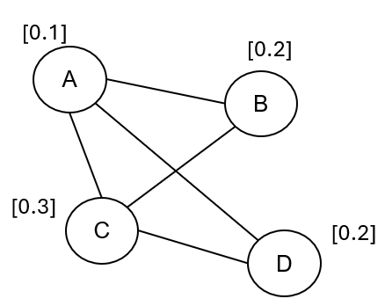 | $$h_{i}^{(k)}=\left(1+ε\right)⋅h_{i}^{(k-1)}+\sum_{j∈N(i)}{h_{j}^{(k-1)}}$$
  - Calculate the feature of each node at $k=1$.
  - What are the reasons why GIN model achieves 1-d Weisfeiler-Lehman?

- (K-GNN)(10p) Consider an undirected graph G of four nodes A, B, C, and D given in the following figure. According to GNN-AK model with a GCN model and MEAN aggregation function, the feature of a node $v$ at $k$-th layer can be updated as:

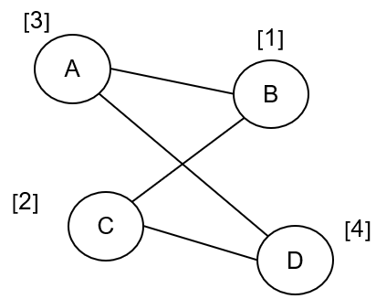 | $$h_{v}^{(l+1)}=AGG^{(l)}\left(G\left[N_{k}(v)\right]\right),l=0,1,...,L-1 \\ h_{v}=MEAN\left(h_{u}^{(L)}|u∈G\left[N_{k}(v)\right]\right)$$  where is a subgraph rooted at node v with k-hop distance, including v; and AGG(.) is a SUM function.
  - Calculate the feature of each node at $k=1$ and l $=0.$
  - Why considering a set of k-hop subgraphs will make the model more expressive than only neighbor aggregation?

- (Subgraph)(5p) What are the limitations of contrastive learning methods in molecular structure learning? And why are the subgraph-based methods better at molecular structure learning?

- (GT)(10p) Consider an undirected graph. GT use positional encoding to inject structural information before apply self-attention. Given positional encoding for a node is $z_{v}=\frac{1}{deg⁡(v)}$

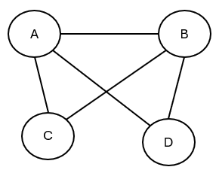
a. Calculate initial embedding of node A, B, C, D
b. Compare Laplacian eigenvector PE vs. Random walk-based PE.

- (Graphformer)(10p) Given a directed graph G of six nodes A, B, C, D, E, and F given in the following figure. Each node has an initial feature that is the number standing next to it.
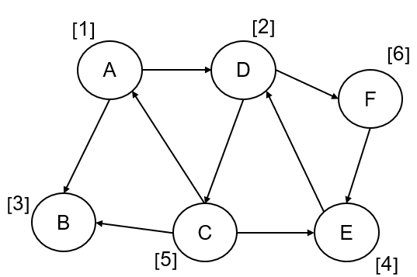
  - According to the Graphormer model, calculate the input node feature with its in-degree and out-degree. The definition of a Lookup table for node degree is as: T = {"0": 0.0, "1": 0.1, “2”: 0.2, “3”: 0.3, “4”: 0.4}.
  - Why can injecting the structural information into graphs make the model more powerful in capturing the graph structures? What kind of structural information needs to be considered?

- (NGCF)(10p) Consider a recommender system as a user(u)-item(v) bipartite graph. Given degree: deg($u_{1}$) = deg($u_{2}$) = deg($v_{2}$) = 2, deg($v_{1}$) = deg($v_{3}$) = 1. Given $h_{u_{1}}^{(0)}=1, h_{u_{2}}^{(0)}=2, h_{v_{1}}^{(0)}=0, h_{v_{2}}^{(0)}=1, h_{v_{3}}^{(0)}=3.$Given $W_{0}=1,W_{1}=2, W_{2}=1$. Given
$$h_{i}^{(1)}=ReLU(W_{0}h_{i}^{\left(0\right)}+\sum_{j∈N(i)}{\frac{1}{\sqrt{\deg\left(i\right)\deg\left(j\right)}}(W_{1}h_{j}^{\left(0\right)}+W_{2}(h_{i}^{\left(0\right)}h_{j}^{\left(0\right)}))})$$
Given final embedding is concatenation: $h_{i}=[h_{i}^{\left(0\right)},h_{i}^{\left(1\right)}]$, and recommendation score $score\left(u,v\right)=h_{u}^{T}h_{v}$
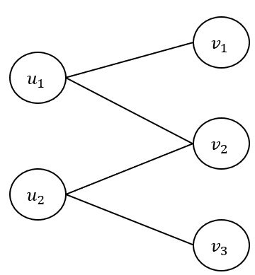
- Compute $h_{u_{1}}^{(1)},h_{v_{1}}^{(1)},h_{v_{2}}^{(1)}$
- Compute recommendation score ($u_{1},v_{1}$)
- Why NGCF is able to capture high-order collaborative signals

- (LightGCN)(10p) Consider a recommender system as undirected user-item bipartite graph. Given deg($u_{1}$) = deg($u_{2}$) = deg($v_{2}$) = 2, deg($v_{1}$) = deg($v_{3}$) = 1. Given $e_{u_{1}}^{(0)}=1,e_{u_{2}}^{(0)}=2,e_{v_{1}}^{(0)}=0, e_{v_{2}}^{(0)}=1,e_{v_{3}}^{(0)}=3$. Given LightGCN:
$$e_{i}^{(k+1)}=\sum_{j∈N(i)}{\frac{1}{\sqrt{deg⁡(i)deg⁡(j)}}}e_{j}^{k}$$
Final embedding: $e_{i}=\frac{1}{2}(e_{i}^{\left(0\right)}+e_{i}^{(1)})$
Prediction score: $score\left(u,v\right)=e_{u}e_{v}$

- Compare LightGCN with NGCF
- Compute $e_{u_{1}}^{(1)}, e_{v_{1}}^{(1)}, e_{v_{2}}^{(1)}$
- Compute $e_{u_{1}}, e_{v}$
- Compute recommendation score ($u_{1},v_{1}$)

- (Relational GCN)(10p) Consider a directed heterogeneous graph. Given $h_{A}^{(0)}=1, h_{B}^{(0)}=2,h_{C}^{(0)}=3$. Given $W_{r_{1}}=1,W_{r_{2}}=2,W_{0}=1$
Relational GCN: $h_{v}^{(1)}=σ(\sum_{rϵR}{\sum_{uϵN_{r}(v)}{\frac{1}{c_{v,r}}W_{r}h_{u}^{(0)}+W_{0}h_{v}^{(0)}}})$
where:
$N_{r}\left(v\right)$ is set of incoming neighbours of node v under relation r,
$c_{v,r}=\left|N_{r}\left(v\right)\right|$: relation,
$W_{r}$: relation-specific weight,
$W_{0}$: self-loop weight.
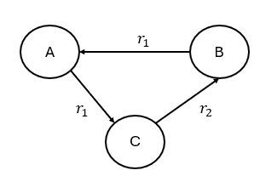
- Why Relational GCN use different neural network weights for different relation types?
- Compute $h_{A}^{(1)},h_{B}^{(1)}, h_{C}^{(1)}$

- (TransE,R)(5p) Why the TransR loss is critical in knowledge graph embedding models compared to the TransE loss?

- (ST-GCN)(10p)
- What is node and edge in human action recognition task?
- What are difference between spatial edges and temporal edges?
- Decribe three partitioning strategies

- (BPR loss)(10p) What are the main reasons why BPR loss (Bayesian Personalized Ranking loss) is commonly utilized in recommendation system models?

