Final Exam Solutions (Graph Neural Networks –Fall 2025)
Full Name:
Student ID:
Note: Do not use previous solution while taking an exam.

- (GIN)(10p) Consider an undirected graph G of four nodes A, B, C, and D given in the following figure. Each node has an initial feature that is the number standing next to it. According to GIN model, the parameter is a fixed scalar , the feature of a node $i$ at layer $k$ can be updated as:
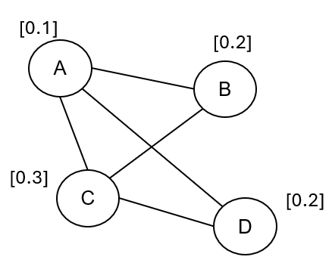 | $$h_{i}^{(k)}=\left(1+ε\right)⋅h_{i}^{(k-1)}+\sum_{j∈N(i)}{h_{j}^{(k-1)}}$$
  - Calculate the feature of each node at $k=1$.
  - What are the reasons why GIN model achieves 1-d Weisfeiler-Lehman?
SOLUTIONS:
- $h_{i}^{\left(k\right)}=\left(1+ε\right).h_{i}^{\left(k-1\right)}+\sum_{jϵN\left(i\right)}{h_{j}^{\left(k-1\right)}}$
$$h_{A}^{\left(1\right)}=\left(1+ε\right).h_{A}^{\left(0\right)}+\left(h_{B}^{\left(0\right)}+h_{C}^{\left(0\right)}+h_{D}^{\left(0\right)}\right)=\left(1+0.5\right)*0.1+\left(0.2+0.3+0.2\right)=0.85$$
$$h_{B}^{\left(1\right)}=\left(1+ε\right).h_{B}^{\left(0\right)}+\left(h_{A}^{\left(0\right)}+h_{C}^{\left(0\right)}\right)=\left(1+0.5\right)*0.2+\left(0.1+0.3\right)=0.7$$
$$h_{C}^{\left(1\right)}=\left(1+ε\right).h_{C}^{\left(0\right)}+\left(h_{A}^{\left(0\right)}+h_{D}^{\left(0\right)}\right)=\left(1+0.5\right)*0.3+\left(0.1+0.2\right)=0.75$$
$$h_{D}^{\left(1\right)}=\left(1+ε\right).h_{D}^{\left(0\right)}+\left(h_{A}^{\left(0\right)}+h_{C}^{\left(0\right)}\right)=\left(1+0.5\right)*0.2+\left(0.1+0.3\right)=0.7$$

- GIN uses a sum aggregation function to combine the features of neighboring nodes. Unlike mean or max pooling used in other GNNs, the sum operation ensures that the aggregation function is injective (i.e., distinct input features produce distinct outputs). The combination of the sum operator with an injective MLP ensures that GIN can distinguish graphs as powerful as the 1-WL testing.

- (K-GNN)(10p) Consider an undirected graph G of four nodes A, B, C, and D given in the following figure. According to GNN-AK model with a GCN model and MEAN aggregation function, the feature of a node $v$ can be updated as:

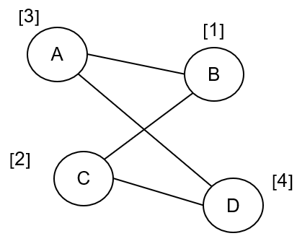 | $$h_{v}^{(l+1)}=AGG^{(l)}\left(G\left[N_{k}(v)\right]\right),l=0,1,...,L-1 \\ h_{v}=MEAN\left(h_{u}^{(L)}|u∈G\left[N_{k}(v)\right]\right)$$  where is a subgraph rooted at node v with k-hop distance, including v; and AGG(.) is a SUM function.
  - Calculate the feature of each node at $k=1$ and l $=0.$
  - Why considering a set of k-hop subgraphs will make the model more expressive than only neighbor aggregation?

SOLUTIONS:
- $h_{A}^{\left(1\right)}={AGG}^{\left(0\right)}\left(G\left[A,B,D\right]\right)=SUM\left(1,3,4\right)=8$
$$h_{B}^{\left(1\right)}=SUM\left(1,2,3\right)=6$$
$$h_{D}^{\left(1\right)}=SUM\left(2,3,4\right)=9$$
$$h_{A}=MEAN\left(h_{u}^{(L)}|u∈G\left[N_{k}(v)\right]\right)=MEAN(8,6,9)=\frac{23}{3}$$

$$h_{B}^{\left(1\right)}=SUM\left(1,2,3\right)=6$$
$$h_{A}^{\left(1\right)}=SUM\left(1,3,4\right)=8$$
$$h_{C}^{\left(1\right)}=SUM\left(1,2,4\right)=7$$
$$h_{B}=MEAN\left(6,8,7\right)=7$$

$$h_{C}^{\left(1\right)}=SUM\left(1,2,4\right)=7$$
$$h_{B}^{\left(1\right)}=SUM\left(1,2,3\right)=6$$
$$h_{D}^{\left(1\right)}=SUM\left(2,3,4\right)=9$$
$$h_{C}=MEAN(6,7,9)=7.3$$

$$h_{D}^{\left(1\right)}=SUM\left(2,3,4\right)=9$$
$$h_{A}^{\left(1\right)}=SUM\left(1,3,4\right)=8$$
$$h_{C}^{\left(1\right)}=SUM\left(1,2,4\right)=7$$
$$h_{D}=MEAN\left(9,8,7\right)=8$$

- A k-hop subgraph retains the entire subgraph's structural information (e.g., edge arrangements, motifs, and surrounding connectivity) within the k-hop distance, providing a more complete local representation. The higher-order structures, such as cycles, or cliques, are inherently captured separately within k-hop subgraphs, allowing models to leverage complex structural patterns.
Neighbor aggregation cannot distinguish nodes in different structural roles or higher-order graph features, as it focuses only on immediate neighbors. K-hop subgraphs, on the other hand, explicitly incorporate these relationships.

- (Subgraph)(5p) Recently, various studies have used contrastive learning-based methods to learn molecular structures by employing graph augmentations (e.g., edge deletion) to generate multiple molecular views. What are the limitations of contrastive learning methods in molecular structure learning? And why are the subgraph-based methods better at molecular structure learning?

SOLUTIONS: Contrastive methods rely heavily on data augmentations (e.g., node dropping, edge perturbation, subgraph sampling). However, random augmentations can destroy the molecular structures and disrupt the chemical properties. Moreover, designing augmentations that preserve chemical validity is challenging for molecular graphs.
Subgraph-based methods explicitly extract and utilize localized structural patterns, making them better suited for molecular structure learning. Subgraph-based methods capture functional groups, rings, and other motifs, which are fundamental to molecular properties. That is, Subgraph-based methods can incorporate domain-specific knowledge about functional groups or reaction mechanisms, enhancing their relevance to molecular tasks. Moreover, Subgraph-based methods are inherently more interpretable because they explicitly focus on molecular substructures.
- (GT)(10p) Consider an undirected graph. GT use positional encoding to inject structural information before apply self-attention. Given positional encoding (PE) for a node is $z_{v}=\frac{1}{deg⁡(v)}$

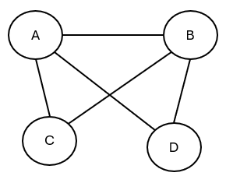
a. Calculate positional encoding of node A, B, C, D
b. Compare Laplacian eigenvector PE vs. Random walk-based PE.

SOLUTIONS:

$$z_{A}=\frac{1}{\deg\left(A\right)}=\frac{1}{3}$$
$$z_{B}=\frac{1}{\deg\left(B\right)}=\frac{1}{3}$$
$$z_{C}=\frac{1}{deg⁡(C)}=\frac{1}{2}$$
$$z_{D}=\frac{1}{\deg\left(D\right)}=\frac{1}{2}$$
- Laplacian eigenvector PE uses eigenvector of graph Laplacian $L=D-A$. The i-th row of the top-k eigenvectors is the positional encoding of node i. It captures global graph geometry and symmetries; small eigenvalues reflect local structure, large eigenvalues capture global patterns.
Random walk-based PE uses statistics from random walks. It captures multi-hop connectivity and path-based structure; emphasizes local connectivity.

- (Graphformer)(10p) Given a directed graph G of six nodes A, B, C, D, E, and F given in the following figure. Each node has an initial feature that is the number standing next to it.
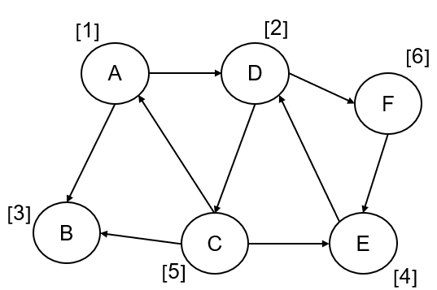
  - According to the Graphormer model, calculate the input node feature with its in-degree and out-degree. The definition of a Lookup table for node degree is as: T = {"0": 0.0, "1": 0.1, “2”: 0.2, “3”: 0.3, “4”: 0.4}.
  - Why can injecting the structural information into graphs make the model more powerful in capturing the graph structures? What kind of structural information needs to be considered?

SOLUTIONS:

- $h_{A}^{0}=h_{A}+d_{A}^{-}+d_{A}^{+}=1+T\left[2\right]+T\left[1\right]=1+0.2+0.1=1.3$
$$h_{B}^{0}=h_{B}+d_{B}^{-}+d_{B}^{+}=3+T\left[0\right]+T\left[2\right]=3+0+0.2=3.2$$
$$h_{C}^{0}=h_{C}+d_{C}^{-}+d_{C}^{+}=5+T\left[3\right]+T\left[1\right]=5+0.3+0.1=5.4$$
$$h_{D}^{0}=h_{D}+d_{D}^{-}+d_{D}^{+}=2+T\left[2\right]+T\left[2\right]=2+0.2+0.2=2.4$$
$$h_{E}^{0}=h_{E}+d_{E}^{-}+d_{E}^{+}=4+T\left[1\right]+T\left[2\right]=4+0.1+0.2=4.3$$
$$h_{F}^{0}=h_{F}+d_{F}^{-}+d_{F}^{+}=6+T\left[1\right]+T\left[1\right]=6+0.1+0.1=6.2$$
- Structural information helps the model distinguish similar graphs when considering only node-level features or simple neighbor aggregation, allowing the model to identify non-isomorphic graphs. Encoding structural properties like degree, subgraph structures, or motifs allows the model to identify such distinctions and increase the power of graph isomorphism tests as the Weisfeiler-Lehman (WL) test.

- (NGCF)(10p) Consider a recommender system as a user(u)-item(v) bipartite graph. Given degree: deg($u_{1}$) = deg($u_{2}$) = deg($v_{2}$) = 2, deg($v_{1}$) = deg($v_{3}$) = 1. Given $h_{u_{1}}^{(0)}=1, h_{u_{2}}^{(0)}=2, h_{v_{1}}^{(0)}=0, h_{v_{2}}^{(0)}=1, h_{v_{3}}^{(0)}=3.$Given $W_{0}=1,W_{1}=2, W_{2}=1.$Given
$$h_{i}^{(1)}=ReLU(W_{0}h_{i}^{\left(0\right)}+\sum_{j∈N(i)}{\frac{1}{\sqrt{\deg\left(i\right)\deg\left(j\right)}}(W_{1}h_{j}^{\left(0\right)}+W_{2}(h_{i}^{\left(0\right)}h_{j}^{\left(0\right)}))})$$
Given final embedding is concatenation: $h_{i}=[h_{i}^{\left(0\right)},h_{i}^{\left(1\right)}]$, and recommendation score $score\left(u,v\right)=h_{u}^{T}h_{v}$
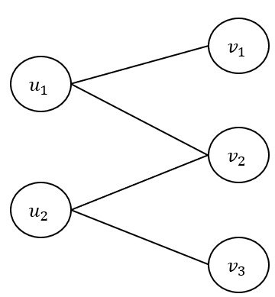
- Compute $h_{u_{1}}^{(1)},h_{v_{1}}^{(1)},h_{v_{2}}^{(1)}$
- Compute recommendation score ($u_{1},v_{1}$)
- Why NGCF is able to capture high-order collaborative signals
SOLUTIONS:
- Neighbors of $h_{u_{1}}^{(1)}$= {$v_{1},v_{2}$}
$$W_{0}h_{u_{1}}^{\left(0\right)}=1*1=1$$
$$W_{1}h_{v_{1}}^{\left(0\right)}+W_{2}\left(h_{u_{1}}^{\left(0\right)}h_{v_{1}}^{\left(0\right)}\right)=2*0+1*1*0=0$$
$$W_{1}h_{v_{2}}^{\left(0\right)}+W_{2}\left(h_{u_{1}}^{\left(0\right)}h_{v_{2}}^{\left(0\right)}\right)=2*1+1*1*1=3$$
$$h_{u_{1}}^{(1)}=ReLU\left(1+\frac{1}{\sqrt{\deg\left(u_{1}\right)\deg\left(v_{1}\right)}}*0+\frac{1}{\sqrt{\deg\left(u_{1}\right)\deg\left(v_{2}\right)}}*3\right)=1+\frac{1}{\sqrt{2}}*0+\frac{1}{\sqrt{4}}*3=2.5$$

Neighbors of $h_{v_{1}}^{(1)}$= {$u_{1}$}
$$W_{0}h_{v_{1}}^{\left(0\right)}=1*0=0$$
$$W_{1}h_{u_{1}}^{\left(0\right)}+W_{2}\left(h_{v_{1}}^{\left(0\right)}h_{u_{1}}^{\left(0\right)}\right)=2*1+1*0*1=2$$
$$h_{v_{1}}^{(1)}=ReLU\left(\frac{1}{\sqrt{\deg\left(v_{1}\right)\deg\left(u_{1}\right)}}*2\right)=\frac{2}{\sqrt{2*1}}=\sqrt{2}$$

Neighbors of $h_{v_{2}}^{(1)}$= {$u_{1}$, $u_{2}$}
$$W_{0}h_{v_{2}}^{\left(0\right)}=1*1=1$$
$$W_{1}h_{u_{1}}^{\left(0\right)}+W_{2}\left(h_{v_{2}}^{\left(0\right)}h_{u_{1}}^{\left(0\right)}\right)=2*1+1*1*1=3$$
$$W_{1}h_{u_{2}}^{\left(0\right)}+W_{2}\left(h_{v_{2}}^{\left(0\right)}h_{u_{2}}^{\left(0\right)}\right)=2*2+1*1*2=6$$
$$h_{v_{2}}^{(1)}=ReLU\left(1+\frac{1}{\sqrt{\deg\left(v_{2}\right)\deg\left(u_{1}\right)}}*3+\frac{1}{\sqrt{\deg\left(v_{2}\right)\deg\left(u_{2}\right)}}*6\right)=1+\frac{3}{2}+\frac{6}{2}=5.5$$
- $h_{i}=[h_{i}^{\left(0\right)},h_{i}^{\left(1\right)}]$
$$h_{u_{1}}=\left[h_{u_{1}}^{\left(0\right)},h_{u_{1}}^{\left(1\right)}\right]=\left[1,2.5\right]$$
$h_{v_{1}}=\left[h_{v_{1}}^{\left(0\right)},h_{v_{1}}^{\left(1\right)}\right]=[0,\sqrt{2}]$

$$score\left(u,v\right)=h_{u}^{T}h_{v}$$
$$score\left(u_{1},v_{1}\right)=h_{u_{1}}^{T}h_{v_{1}}=\left[1,2.5\right]*\left[0,\sqrt{2}\right]=\frac{5\sqrt{2}}{2}$$
- Because it propagates user and item embeddings over multiple hops in the user–item interaction graph, rather than relying only on direct interactions.

- (LightGCN)(10p) Consider a recommender system as undirected user-item bipartite graph. Given deg($u_{1}$) = deg($u_{2}$) = deg($v_{2}$) = 2, deg($v_{1}$) = deg($v_{3}$) = 1. Given $e_{u_{1}}^{(0)}=1,e_{u_{2}}^{(0)}=2,e_{v_{1}}^{(0)}=0, e_{v_{2}}^{(0)}=1,e_{v_{3}}^{(0)}=3$. Given LightGCN:
$$e_{i}^{(k+1)}=\sum_{j∈N(i)}{\frac{1}{\sqrt{deg⁡(i)deg⁡(j)}}}e_{j}^{k}$$
Final embedding: $e_{i}=\frac{1}{2}(e_{i}^{\left(0\right)}+e_{i}^{(1)})$
Prediction score: $score\left(u,v\right)=e_{u}e_{v}$

- Compare LightGCN with NGCF
- Compute $e_{u_{1}}^{(1)}, e_{v_{1}}^{(1)}, e_{v_{2}}^{(1)}$
- Compute $e_{u_{1}}, e_{v_{1}}$
- Compute recommendation score ($u_{1},v_{1}$)

SOLUTIONS:
- NGCF uses nonlinear activation functions, feature transformation matrices, and explicit feature interaction terms to model user–item relationships, making it more complex and parameter-heavy. LightGCN simplifies NGCF by removing nonlinearities, transformation matrices, and interaction terms, retaining only normalized neighborhood aggregation. While NGCF is more expressive, it is prone to overfitting and higher computational cost. LightGCN is more efficient, scalable, and often achieves better empirical performance, showing that simple neighborhood aggregation is sufficient for collaborative filtering.
- $e_{i}^{(k+1)}=\sum_{j∈N(i)}{\frac{1}{\sqrt{deg⁡(i)deg⁡(j)}}}e_{j}^{k}$
$$e_{u_{1}}^{(1)}=\frac{e_{v_{1}}^{0}}{\sqrt{deg⁡(u_{1})deg⁡(v_{1})}}+\frac{e_{v_{2}}^{0}}{\sqrt{deg⁡(u_{1})deg⁡(v_{2})}}=\frac{0}{\sqrt{2}}+\frac{1}{2}=\frac{1}{2}$$
$$e_{v_{1}}^{(1)}=\frac{e_{u_{1}}^{0}}{\sqrt{deg⁡(v_{1})deg⁡(u_{1})}}=\frac{1}{\sqrt{2}}$$
$$e_{v_{2}}^{(1)}=\frac{e_{u_{1}}^{0}}{\sqrt{deg⁡(v_{2})deg⁡(u_{1})}}+\frac{e_{u_{2}}^{0}}{\sqrt{deg⁡(v_{2})deg⁡(u_{2})}}=\frac{1}{2}+\frac{2}{2}=\frac{3}{2}$$
- $e_{i}=\frac{1}{2}(e_{i}^{\left(0\right)}+e_{i}^{(1)})$
$$e_{u_{1}}=\frac{1}{2}\left(e_{u_{1}}^{\left(0\right)}+e_{u_{1}}^{\left(1\right)}\right)=\frac{1}{2}\left(1+\frac{1}{2}\right)=\frac{3}{4}$$
$$e_{v_{1}}=\frac{1}{2}\left(e_{v_{1}}^{\left(0\right)}+e_{v_{1}}^{\left(1\right)}\right)=\frac{1}{2}\left(0+\frac{1}{\sqrt{2}}\right)=\frac{1}{2\sqrt{2}}$$
- $score\left(u_{1},v_{1}\right)=e_{u_{1}}e_{v_{1}}=\frac{3}{4}*\frac{1}{2\sqrt{2}}=\frac{3}{8\sqrt{2}}$

- (Relational GCN)(10p) Consider a directed heterogeneous graph. Given $h_{A}^{(0)}=1, h_{B}^{(0)}=2,h_{C}^{(0)}=3$. Given $W_{r_{1}}=1,W_{r_{2}}=2,W_{0}=1$
Relational GCN: $h_{v}^{(1)}=σ(\sum_{rϵR}{\sum_{uϵN_{r}(v)}{\frac{1}{c_{v,r}}W_{r}h_{u}^{(0)}+W_{0}h_{v}^{(0)}}})$
where:
$N_{r}\left(v\right)$ is set of incoming neighbours of node v under relation r,
$c_{v,r}=\left|N_{r}\left(v\right)\right|$: relation,
$W_{r}$: relation-specific weight,
$W_{0}$: self-loop weight.
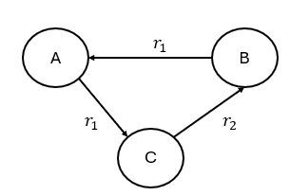
- Why Relational GCN use different edges weights for different relation types?
- Compute $h_{A}^{(1)},h_{B}^{(1)}, h_{C}^{(1)}$
SOLUTIONS:
- $h_{A}^{\left(1\right)}=\left(\frac{1}{c_{A,r_{1}}}W_{r_{1}}h_{B}^{\left(0\right)}+W_{0}h_{A}^{\left(0\right)}\right)=\left(\frac{1}{1}*1*2+1*1\right)=9$
$$h_{B}^{\left(1\right)}=\left(\frac{1}{c_{B,r_{2}}}W_{r_{2}}h_{C}^{\left(0\right)}+W_{0}h_{B}^{\left(0\right)}\right)=\left(\frac{1}{1}*2*3+1*2\right)=8$$
$$h_{C}^{\left(1\right)}=\left(\frac{1}{c_{C,r_{1}}}W_{r_{1}}h_{A}^{\left(0\right)}+W_{0}h_{C}^{\left(0\right)}\right)=\left(\frac{1}{1}*1*1+1*3\right)=4$$

- Relational GCN uses different weights per relation because in a heterogeneous graph / knowledge graph, edges have different semantics (different relation types), so messages arriving through different relations should be transformed differently. Using a single shared weight (GCN) would mix fundamentally different relations and reduce the model’s ability to represent multi-relational structure.

- (TransE,R)(5p) Why the TransR loss is critical in knowledge graph embedding models compared to the TransE loss?

SOLUTIONS: TransR projects entities into a relation vector space, allowing each relationship to have its semantic interpretation. This flexibility makes TransR better suited for multi-relational KGs compared to models like TransE, which assume a single embedding space for all relations. This allows the model to better represent: one-to-many, many-to-one, and many-to-many relationships and asymmetric relations.

- (ST-GCN)(10p)
- In human action recognition tasks, we can construct graphs representing relations in human action. What is the nodes and edges in the graphs?
- What are difference between spatial edges and temporal edges?
- Decribe three partitioning strategies
SOLUTIONS:
- Node is human joint, edge is bone and edge is time
- Spatial edge is connection between two different joints, it can be bone, temporal edge is connection between same joints at different time
- Uni-labelling: group all neighbours into a single set
Distance partitioning: partition neighbours based on their distance to the central node
Spatial configuration partitioning: partition neighbours into 3 subsets based on their distance to the skeleton’s center of gravity:
Central node itself
Neighbours closer to the centre of gravity (centripetal)
Neighbours farther from the centre of gravity (centrifugal)

- (BPR loss)(10p) What are the main reasons why BPR loss (Bayesian Personalized Ranking loss) is commonly utilized in recommendation system models?

SOLUTIONS: The BPR loss is commonly used in recommendation systems because it is designed for pairwise ranking optimization. Unlike pointwise loss functions (e.g., mean squared error), which predict absolute scores, BPR focuses on the relative order between items. For example, BPR works by comparing pairs of items: for a given user, it ensures that the predicted preference for an observed (positive) item 𝑖 is higher than for an unobserved item 𝑗.
BPR addresses implicit feedback: It assumes all unobserved interactions are less preferred than observed ones. It effectively learns to differentiate between interacted and non-interacted items without requiring explicit negative labels.
Furthermore, BPR also can handle the scalability problem: It is computationally efficient because it simplifies the optimization problem to pairwise comparisons, avoiding the need for a full ranking of all items during training.

