DOCUMENTATION:

1. Front page:

**“PLACEMENT ASSISTANT”**

**Project Report Submitted**

**To**

**Gujarat University**

**In partial fulfilment of the requirements for**

**the award to the Degree of**

**5 YEAR INTEGRATED MASTER OF SCIENCE (COMPUTER SCIENCE)**

**SEMESTER – IV**

GUIDED BY: SUBMITTED BY:

**Dr. Bhumika Shah Maitri Bhalala(40004)**

**Palak Keswani(400)**

**Nency Makwana(400)**

**Stuti Vataliya(400)**



**DEPARTMENT OF COMPUTER SCIENCE**

**GUJARAT UNIVERSITY, AHMEDABAD**

**YEAR: 2023-24**

1. Certificate:

3. Acknowledgement:

We as team members, showing a sincere gratitude towards the constant help from our Respective faculties and our project guide Dr.Bhumika Shah. Constant guidance and suggestion of project guide made the Project with better accomplishment. We acknowledge our Respected faculties under whom we got the opportunity of making these project happen. The reviews and advice solemnly exaggerated and has been implemented to the work.

4.Project profile:

|  |  |
| --- | --- |
| **TITLE** | **Description** |
| Project | Placement Assistant |
| IDE | Visual studio code |
| Team-size | 4 members |
| Team members | Maitri Bhalala  Palak Keswani  Nency Makwana  StutiVataliya |
| Project guide | Dr. Bhumika Shah |
| Project Duration | 6 months |

5. Analysis:

* 1. Requirement Analysis:
     1. software requirement specification:

We aim to develop the system for the keen requirement and the adaption of the easy work to deal with the database and the management of the placement processes. The system is been designed in such a way through which the student and the placement coordinator both gets beneficiary advantages through the software.

* + 1. Feasibility study:
       1. Economic feasibility
       2. Technical feasibility

The usage of several technologies and concepts has been conducted to perform the building of the software for the better and feasible achievement to construct a system.

* + - 1. Schedule feasibility
      2. Recourse feasibility

The constant help and guidance from our mentors and the project guide has fulfilled all our doubts and ideas.

* 1. Project timeline chart:
  2. Tools and Technologies used:

We have used HTML,CSS and PHP for the system operations. The usage of mysql database has been done to system. The deal with Microsoft excel sheets also has been shown into the software.

* 1. Software development model used:

For the developing of the software , the models like activity diagram and use-case diagram [admin and student oriented] has been developed for the better understanding of the system construction.

* 1. Wireframes/storyboards if prepared (not compulsory)
  2. Work distribution of project partners

6. Design:

a. System Architecture

b. Module Hierarchy

c. Use case Diagrams

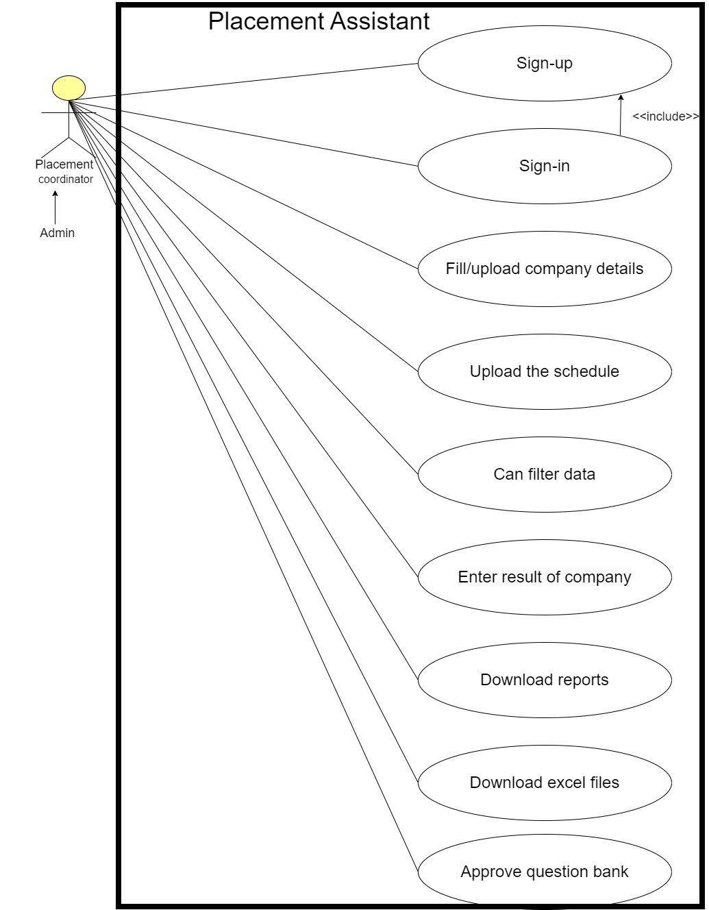

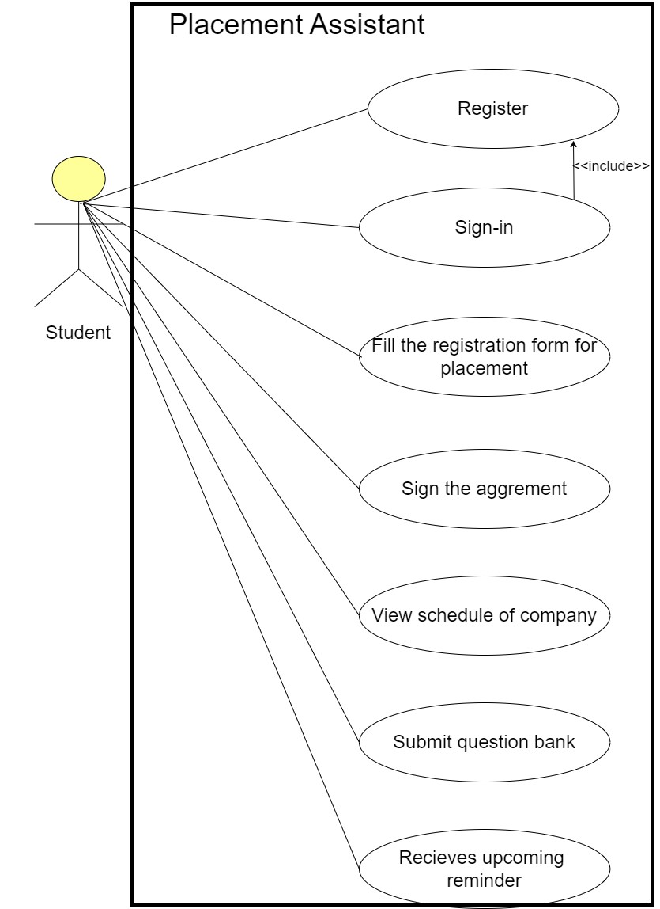

d. Activity Diagrams:

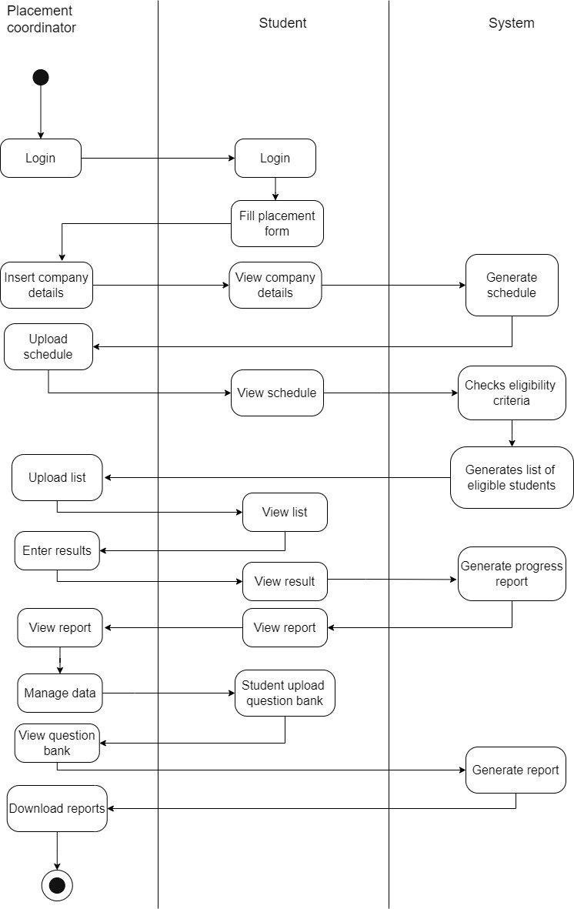

e. E-R diagram:

f. Database design:

g. Class and sequence diagrams if following OOAD approach in development/DFD otherwise

7. Implementation:

a. Tools and technologies used for implementation:

We have used HTML,CSS and PHP for the system operations. The usage of mysql database has been done to system. The deal with Microsoft excel sheets also has been shown into the software. The code has been conducted in visual studio code.

b. Screenshots of data in database:

c. Screen shots of the developed application:

i. Appropriate and sufficient data should be visible

ii. Validations should be visible

iii. As many options for filtering the data for output should be made available to the user

iv. Sufficient reports should be generated which can be useful for the management

8. Testing:

1. Testing tools used if any
2. Test cases for any 3 pages

9. Constraints and Future work:

The extensions of the future work is upto the student side to explore the more and better of the software and the convenience. For the beneficiary purpose of students we are thrilled to extend the system for multipurpose task accomplishing system.

10. Appendix (if required):

11.bibliography: