  Expansion of Startups in US from 2017-2018: Trend Analysis using small scale data  VISUALIZATION USING POWERBI | Abstract  The report encompasses the graphics created using Power Bi  Neena Shereen  Trend analysis

Contents
ABSTRACT 2
ABOUT THE DATA 3
DATA PROCESSING 3
DASHBOARD 4
REFERENCES 8

Figure 1 Overview 4
Figure 2 Average Market spending in different states 5
Figure 3Marketing Rate of Interest in each state 6
Figure 4 Concentration of startups in given area 7
Figure 5 Distribution of startups in cities 8
Figure 6 Avg annual income of startups 8
Figure 7:Regional distribution of Income and expenditure 9

ABSTRACT

This report contains the graphics created using Power Bi software and a brief explanation of the purpose of each visual. This is a relative small-scale analysis, intended to showcase the trend and regional concentration of startups in USA. The purpose of the project was to show how PowerBi can be utilized for geo-specific as well as metric illustrations.

ABOUT THE DATA

The dataset used for this analysis is “StartupExpansionData.xlsx” which contains the information of about the concentration of startups in different regions in USA, the income generated by each firm, their marketing expenditure, location. It has 150 rows and 7 columns with no missing values or predominant outliers.

DATA PROCESSING

The original data has information about the income generated by each store and the marketing expenditure they made. Now dividing “Revenue generated” by the “marketing expenditure” gives the ratio: Marketing Rate of Interest’
$$Markeing ROI=\frac{Revenue}{Market Spend}$$
Marketing ROI measures the revenue generated by per unit marketing expenditure. For ease of analysis, “Marketing ROI” is scaled using Z- score standardization. So, we have 2 additional columns, “Marketing ROI “and “Scaled Marketing ROI”. Thus, the new dimension of our data is 150 rows and 9 columns. All the metric calculations were done in PowerBi.

DASHBOARD

In this section the visualizations generated in the PowerBi is presented along with their explanations.
- Figure 1

This visual gives an overview of the data. It gives us a general idea about the average revenue generated by the stores, their market spending etc. We can see that much of the startups are concentrated on Region 2. Also, average Marketing ROI of startups in Arkansas is high and Wisconsin has highest market spending.
Figure 1 Overview

- Figure 2

The visual on the upper left corner shows the states where average market spending of startups is less than 3000 (bottom 10) and their corresponding average revenue. In the same way the combined graph at the right corner shows the states where the marketing expenditure exceed 3000 (top 10) and the respective income generated. The Map visualization enables us to navigate these graphs, as by clicking the bubbles denoting the states, we can see the corresponding data.

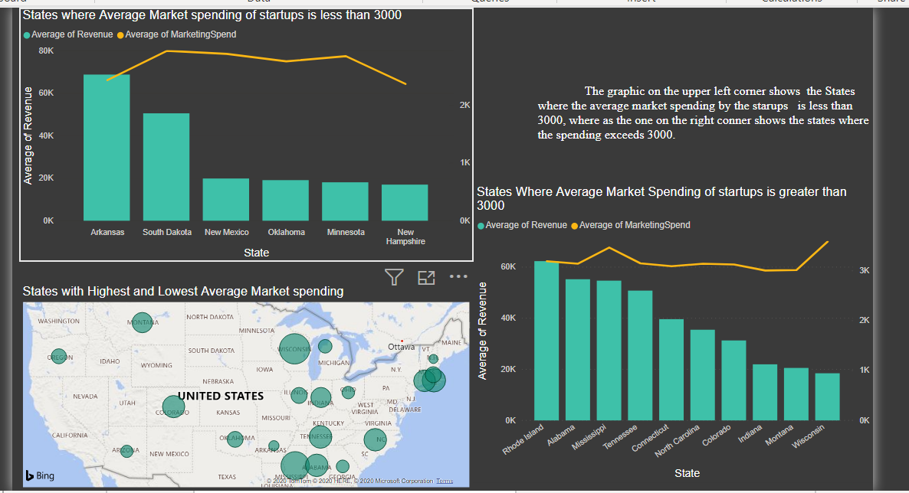
Figure 2 Average Market spending in different states

- Figure 3
This dashboard shows the marketing ROI in each state. The gauge chart in the upper right corner measures the “scaled marketing ROI”. The Maximum value for the gauge is 2.64 and the Minimum value is -1.60. The benchmark level is the median of the distribution 0.24. The gauge box is linked to the two bar and line charts in the upper left and lower right corners, that shows the average income generated and the average marketing expenditure in the states where MOI is above and below the threshold respectively. When you click the bar the represent the state, the figures show the Average income generated, expenditure incurred, and the gauge shows corresponding ROI.
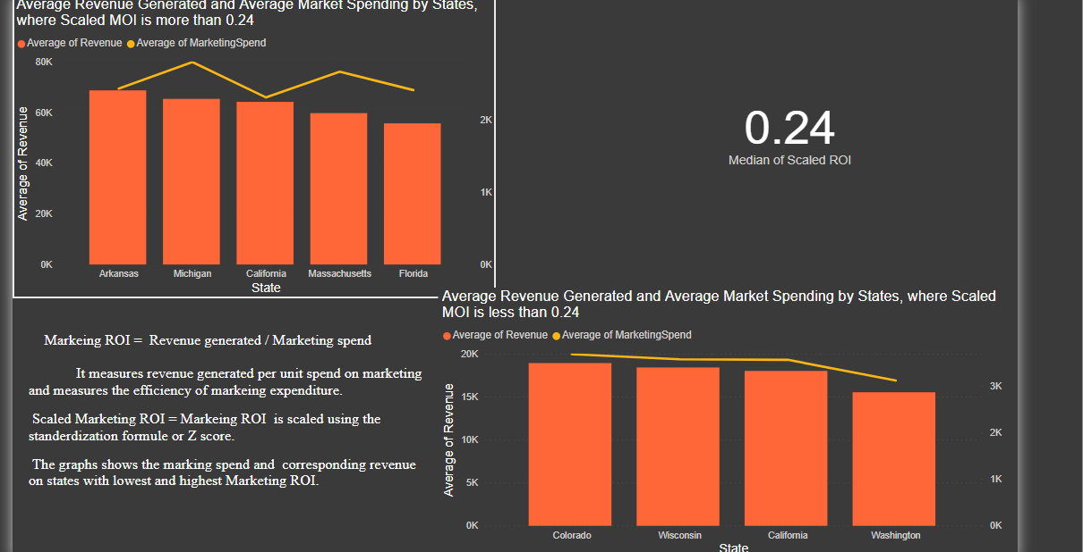
Figure 3Marketing Rate of Interest in each state

- Figure 4

This dashboard shows the concentration of startups in given area, and the Marketing ROI of old and new stores. The map visualizations show the geographical spread of the startups and the donut chart at the right corner shows that, for the given area and time, majority are old startups. At the top, the bar chart shows the average marketing ROI of old and ne establishments.
Figure 4 Concentration of startups in given area

- Figure 5
This dashboard gives an idea about city wise distribution of startups. The combined graph at the upper left corner shows major cities where the startups generate highest revenue, whereas a similar graph in the lower right corner shows the cities where the marketing expenditure made by startups were high. The funnel graphs show the cities with highest and lowest Marketing ROI
Figure 5 Distribution of startups in cities
- Figure 6
This individual illustration shows the average annual income of startups in each state in US.
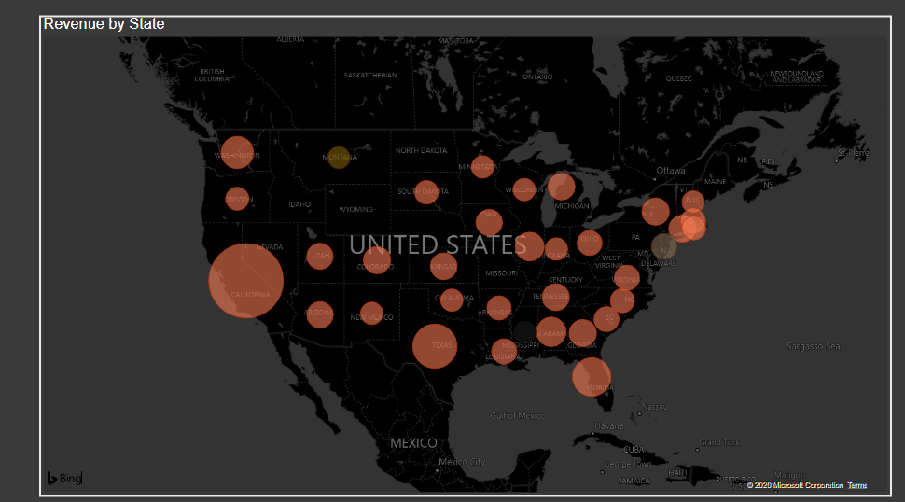
Figure 6 Avg annual income of startups

- Figure 7
The regional distribution of average revenue and marketing expenditure of the startups
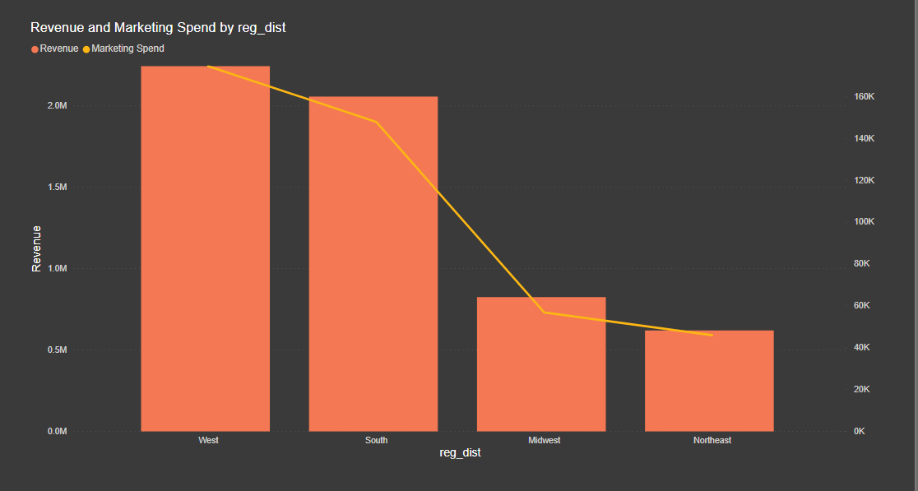
Figure 7:Regional distribution of Income and expenditure

