I

INTRODUCTION :

Fresh Bites Catering, a catering service, utilizes Zoho Books to manage their sales, track inventory, and handle invoicing. They can generate professional invoices for clients and track expenses related to ingredients and supplies. Zoho Books helps them maintain accurate financial records and streamline their catering operations.

Problem Definition & Design Thinking:

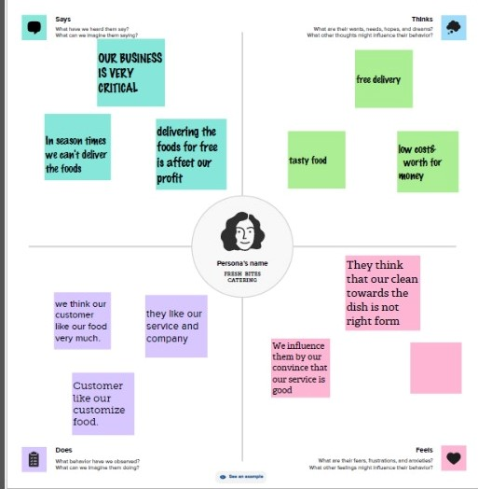

EMPATHY MAP

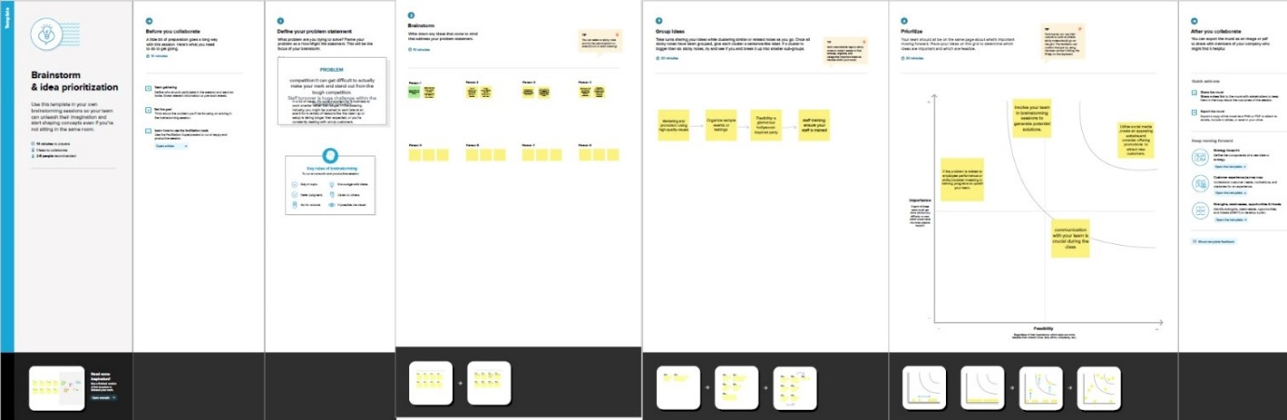

BRAINSTROMING

RESULTS:

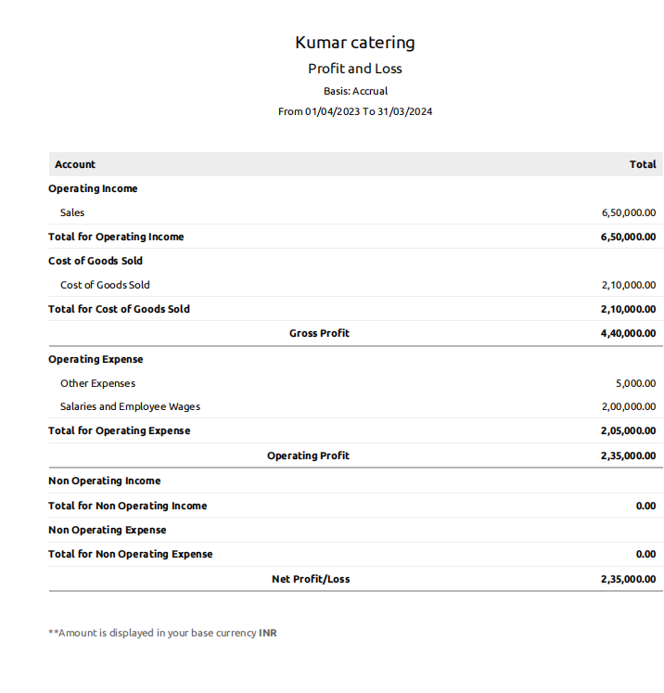

PROFIT&LOSS ACCOUNT

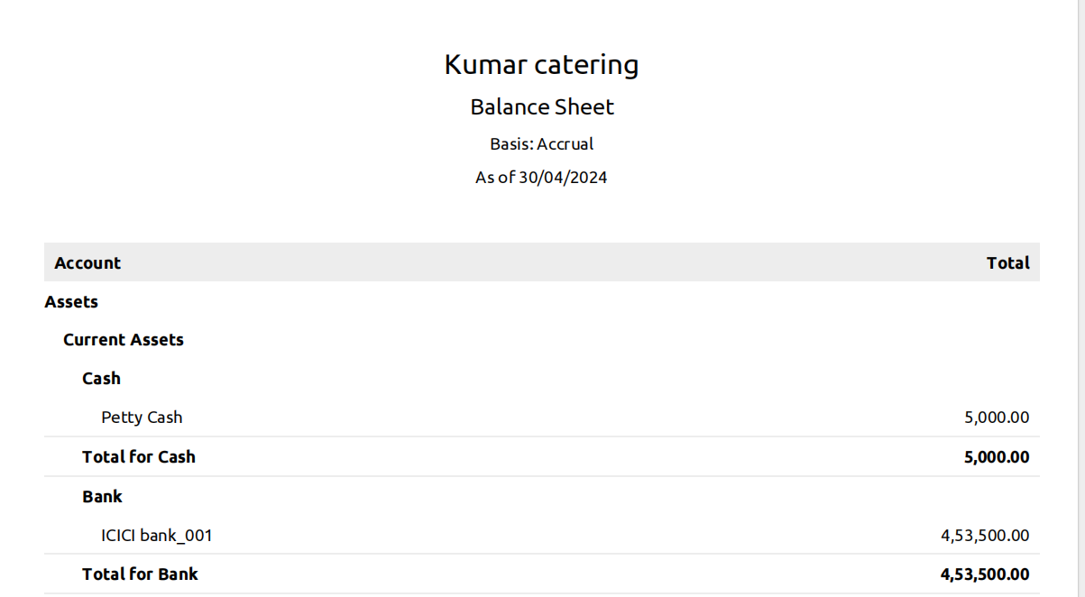

BALANCE SHEET

Advantages:

1.we gain knowledge about Zoho books.

2.It is very user friendly.

Disadvantages:

1.Difficult to work.

2.Takes more time

CONCLUSION:

Though there has been much debate on the subject, it is clear that democratic leadership is the best form of management for the modern workplace.