Working with Adobe Illustrator

Adobe Illustrator is the Departments recommended drawing and poster layout package. This document provides a basic introduction to Illustrator.

Launch Illustrator (for those unfamiliar with Apple Macs, this is done by running the cursor along the row of Application icons called the Dock at the bottom – or sometimes at the left or right hand side - of the screen and clicking on the Illustrator icon. If the Dock is not visible on your computer, click on the blue Apple icon at the extreme top left, select Dock in the drop down menu, and select Turn Hiding Off).

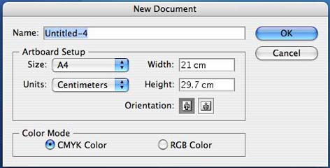
Once Illustrator is running, select File at the top of the screen, and then New… to bring up the New Document dialog box.
At the bottom of the New Document dialog box, the document colour mode can be selected. For work intended for electronic displays such as the web or PowerPoint presentations, RGB (Red, Green, Blue) can be selected. The CMYK (Cyan, Magenta, Yellow, Black) mode should be used for artwork intended for printing or publication.

Artboard Setup identifies the current paper size and orientation, as well as the current units of measurement. These settings can all be changed in this dialog box, or at a later stage by going to File and selecting Document Setup… The default A4 setting is fine for creating individual illustrations, but to create a poster-sized document, select Custom in the Size drop down menu and enter the poster dimensions in the Width and Height fields. Click OK.

The work area
When a New Document is created, Illustrator displays a work area consisting of an illustration window where you draw and lay out your artwork; a panel to the left that containss tools for drawing and editing artwork; panels to help monitor and modify artwork; and a menu bar at the top of the screen that contains commands for performing tasks. If the Tools panel is not present, select Window ⇒ Tools in the menu bar. At the top of the illustration window is the title bar. As well as the file name, this bar displays the scale at which the file is being displayed and the colour model being used. Along the top and left hand sides of the illustration window are the Rulers. These do not normally show in a new document, but can be made visible by going to View in the menu bar, and selecting Show Rulers. The units of measurement can be changed by holding down the ctrl key and clicking on the ruler.
To help align elements in the poster, ruler guides can be created by clicking in either the vertical or horizontal ruler and dragging into the work area. This can be done as many times as required. By default, each ruler guide is locked in place once created, but they can be moved by selecting View ⇒ Guides ⇒ Lock Guides. The rulers can then be dragged to new positions. Guides can be removed by selecting View ⇒ Guides ⇒ Clear Guides. A grid can also be used to help with positioning elements easier. It can be made visible by choosing View ⇒ Show Grid. It can be removed again by choosing View ⇒ Hide Grid. The guides and grid do not show when a file is printed.

Drawing in Illustrator

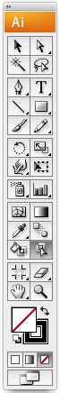
The selection tools.
At the top of the Tools panel are two arrow shaped selection tools, one black and the other white. There is also a tiny black triangle in the bottom right hand corner of the white selection tool icon. Where a tool icon shows this feature, it indicates that there are one or more additional options for that tool. Holding the mouse button down for a couple of seconds on one of these icons will reveal the options, one of which can then be selected. If this is done on the white selection tool, a version with a small + next to it appears.

These three versions of the Selection tool have slightly different functions, and to use Illustrator effectively, it is important to understand these. Illustrator files are normally made up of many separate drawn objects precisely positioned in relation to each other. To avoid inadvertantly moving objects out of position, sets can be grouped together. The group can then be moved around the page safely. The three selection tools can be used to manipulate groups, objects, and anchor points in different ways.

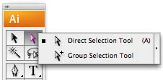
The Selection tool (black) is used to select objects or groups of objects. This tool can be used to move objects and groups around the workspace without changing their shape. It can cannot select objects within a group, nor can it select individual anchor points within an object (see section on straight paths for an explanation of anchor points).

The Direct Selection tool (white) is used to select and move individual anchor points on a path without affecting any of the others. This allows the precise editing of an existing path.

The Group Selection tool (white with +) allows for the selection of individual objects within a group. Clicking once selects an individual object, clicking again on the same object selects any group it it may be part of.

To group a set of objects together, click on one with the Selection tool, hold the Shift key down, and click once on each of the other objects to be grouped. Release the Shift key and select Object ⇒ Group in the main menu. To ungroup a set, select Object ⇒ Ungroup.

Straight Paths.
The remaining icons in the Tools panel represent tools that can be used to create and modify shapes or text on the page but only a few of them will be dealt with here. The pen tool (represented by the pen symbol) is used in different ways to draw straight or curved lines. Straight lines are drawn by selecting the pen tool and clicking once at the chosen start point, releasing the mouse, then moving the tool and clicking again at the endpoint. Every time the pen tool is clicked on the page an anchor point is created.

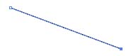
Any line or shape drawn in illustrator is referred to as a path. A path consists of one or more segments. Anchor points define where each segment of path begins and ends. A path can either be open or closed. A closed path is one that is continuous with no beginning or end such as a circle or rectangle, and the anchor points on it are closed anchor points. An open path will have two endpoints or open anchor points and may have one or more closed anchor points if it has more than one segment.

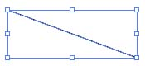
When a path is clicked on using the black Selection tool (top left in the toolbox), a bounding box appears with eight small square handles. If it does not, choose View ⇒ Show Bounding Box. Clicking on the path and dragging allows the object to be moved around the document area.

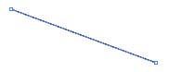
Clicking on a path with the white Direct Selection tool produces a small handle box at each end. Either of these can be dragged to change the direction and / or length of the path.

A closed object can be drawn by clicking in several different places with the pen tool, making the final one coincide with the first anchor point.

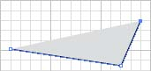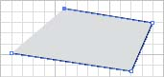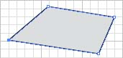

If a path is selected with the Direct Selection tool, and the pen tool is then selected, the pen tools function will vary depending on its precise location. If it is placed over a segment of path, a small + sign appears next to it and if clicked, a new anchor point is created on the path. This is the add anchor point tool.

If it is placed over a closed anchor point, a small – sign appears next to it and if clicked the anchor point is deleted. This is the delete anchor point tool.

If it is placed over an open anchor point (at the end of a path), a small / sign appears next to it and if clicked the line can then be extended by creating further anchor points.

If the pen tool icon in the toolbox is clicked and held for a couple of seconds, three variants of the tool appear. The second and third are the add anchor point and delete anchor point tools described above. The fourth is the convert anchor point tool. If this is selected and clicked on a curved anchor point, it is converted to a corner point. Clicking and dragging this tool on a corner point converts the point to a curve.

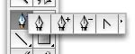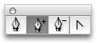

Note: The Line Segment tool (Just below the Pen tool) can also be used to draw straight lines, but is best suited to creating single lines of a precise length and angle. This is done by selecting the tool, clicking with it anywhere in the documenta area, and entering the length and orientation in the Options fields.)

Curved paths.
Curved lines can also be drawn with the pen tool. This is done by clicking on the page and dragging in any direction (Fig1). The result is an anchor Point (A), a direction line (B), and two direction points (C). Now click and drag elsewhere on the page (Fig 2). Figure 2 shows a black line with no fill colour. Figure 3 shows the same black line, but this time with a grey fill colour. (See page 5 for information on the Fill and Stroke boxes).

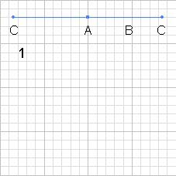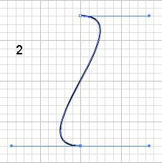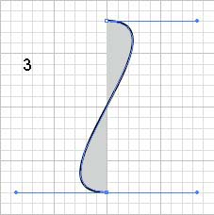

The endpoints of the path can be moved by dragging them with the direct selection tool, and the shape of the curves can be changed by dragging the direction points. Any additional anchor points placed along this path using the add anchor point tool will be curved anchor points in that they will have Direction lines an points. The line can be extended in the same way as straight lines, and additional anchor points created.

Panels (or Palettes).
Illustrator can display a number of panels to help you monitor and modify your work. They can be displayed or hidden by selecting Window ⇒ Show or ⇒ Hide for the required Panel. To save space panels can be grouped together by clicking on the title tab and dragging it over another panel. Clicking the title tab brings that panel to the front. Three of the most commonly used panels are described below.

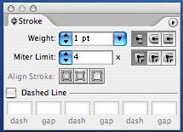
The stroke panel.
The weight or thickness of a line can be changed using the Stroke panel (right). If this is not visible on the screen, choose Window ⇒ Show Stroke or click on its title tab to bring it to the front of a group. To change the line weight, make sure that the line is selected by clicking on it with either the black or white selection tool, and click on one of the small arrows either side of the Weight box in the Stroke panel.

The Colour panel.
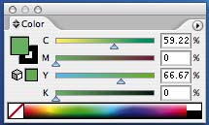
To use the Color panel, first draw a rectangle by selecting the Rectangle tool (fourth down on the right in the Tools panel), then click on the page, drag downwards and to one side, then release.

Illustrator objects consist of a stroke and a fill. The stroke is the outer line and the fill is the area within. As well as changing the weight or thickness of the line with the Stroke panel, the colour of both line and fill can be changed using the Color panel in conjunction with the Fill and Stroke boxes.

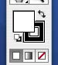
Towards the bottom of the toolbox are two large overlapping squares, one solid and one with a square hole in the middle. These are called the Fill box and the Stroke box respectively. Immediately adjacent is a small curved two way arrow called the Swap Fill and Stroke button, and a tiny version of the main boxes called the Default Fill and Stroke button, default being black stroke and white fill.

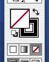
To change the Fill colour of a rectangle, first make sure that it is selected by clicking on it with either the white or black selection tool. Then click on the solid Fill box to bring it to the front if it is not already so, and select a colour by clicking on the spectrum at the bottom of the Color panel. To change the colour of the outer line, click on the Stroke box to bring it to the front and select a different colour. To create a transparent fill or stroke, bring the Fill or Stroke box to the front, then click on the small white square with a diagonal red line just below the Fill and Stroke boxes or to the left of the colour spectrum on the Colour panel. Black and white can be found to the right of the spectrum. Use the sliders on the Color panel to make subtle changes to a colour.

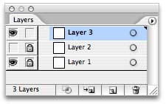
Layers.
Layers are like a stack of transparent sheets containing one or more objects. Where there are no overlapping filled objects, you can see through to the layer or layers below. Every Illustrator file contains at least one layer. Creating multiple layers lets you easily control how your artwork is displayed, edited, and printed.
Layers are created and navigated through using the Layers panel which can be displayed by choosing Window ⇒ Show Layers.

To create a new layer, click on the small triangle in the top right of the layers panel. Select New Layer… , enter a name for the new layer if required and click OK. The new layer will appear in the Layers panel. The order in which layers appear in the Layers panel is the same as their stacking order in the artwork. Objects on the lower layers will be partially or wholly obscured by any objects that overlap them on the upper layers. Layers can be made temporarily invisible by clicking on the eye symbol at the left of the layers panel. Layers rendered invisible in this way will not print. Layers can also be locked by clicking in the box to the right of the eye icon in the Layers panel.

Layers can be very useful when, for example, different versions of a map or diagram need to be produced from a basic master. Elements belonging to one version can be placed on one layer, worked on separately from elements belonging to other versions on other layers, and then made invisible when not required. Different elements such as contour lines, can be placed on a layer of their own, allowing them to be edited without inadvertently affecting other parts of the map.

Layers should always be used sparingly. It is not necessary to use them if all that is needed is to make one object overlap part of another. This can be done on a single layer by selecting the object and choosing Object ⇒ Arrange ⇒ Bring Forward or Send Backwards.

Creating posters in Illustrator

Standard poster sizes
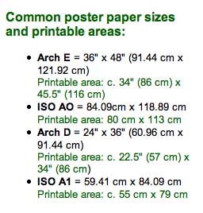
Before starting work on a poster to be printed on the Earth Sciences or other University poster printers, it is essential to read the poster printing web page at: www3.gly.bris.ac.uk/www/comp/poster/djdept.html and to go to the More Info link. This page provides a list of standard poster sizes (see left). Each of the four poster formats has two sets of dimensions. The first show the paper size the printer will work to, but as most large format printers impose a built in border, the Printable area dimensions are the ones that must be used. Note that the American Arch sizes are very similar but not identical to the European ISO versions.
To make the full use of the 36’ wide paper roll, it is best to use the Arch E or Arch D printable area figures. Creating a poster at one of these standard sizes makes the printing process more straightforward and is strongly recommended.

Text
There are two ways of entering text in an Illustrator document. The first is to select the (T) Type tool (located third from the top in the toolbox), click once anywhere in the work area, and begin typing. This method is best suited to entering short lines of text such as titles and captions.

The second method is to create a text box. Select the type tool, and this time click, hold, and drag down and to the right. Release the mouse, and a small blinking insertion point appears in the top left hand corner. At this point begin typing directly. It is not necessary to click again within the text box to create an insertion point.
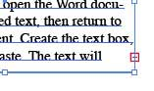
Text can be copied and pasted directly from Microsoft Word into a text box. To do this, open the Word document, copy the required text, then return to the Illustrator document. Create the text box, and select Edit ⇒ Paste. The text should automatically fit itself within the box. If the text box is too small to accommodate the pasted text, a small red cross appears near the bottom right hand corner. Resize the textbox by using the Selection tool (Top left in the Toolbox) to drag one of the small square handles around the text box until all the text appears. The text will automatically wrap itself to the new shape. Alternatively, select a smaller font size.

Font style and size can be changed by clicking on the text box with the selection tool and either going to Type in the menu bar and selecting ⇒ Font or ⇒ Size, or by selecting Window ⇒ Type ⇒ Character to bring up a floating panel and make the changes there. When pasting from Word, it is best to import small chunks at a time, rather than entire documents.

Whichever method is used, text can be edited using the Type tool, and moved around the document by dragging with the Selection tool.

Important.
The ability of text boxes to wrap text when the box is resized is a major help when preparing a document. But to make the most of this feature, they must be handled correctly. When resizing, always do so by dragging one of the eight handles around the box with the selection tool. Never use the Object ⇒ Transform ⇒ Scale menu option to change the aspect ratio of a text box. The text will distort instead of wrapping. Also, text boxes should never be grouped with non-text objects and then resized, even by dragging one of the handles. The same distortion will occur.

Placing digital images into an Illustrator file.

The best way to import images into an Illustrator file is to use the Place… command in the File menu. The image should already have been prepared in Photoshop by setting the required Document Size and Resolution. Illustrator will always display an image file at the same dimensions as the Photoshop Document Size settings regardless of the Pixel Dimensions. (See more about working with digital images on page 6.)

Using the Place… command allows a choice between linking and embedding an image. Embedded images become part of the Illustrator file and can dramatically increase the file size making the file slow to work on. To improve performance, select Link in the Place… dialog box when you place an image. Illustrator will display a low-resolution version of the image but as long as the original image file remains in the same location relative to the Illustrator file, the full resolution version will be printed. Another advantage of using linked files is that if changes are made to the image in Photoshop, Illustrator will register this the next time the Illustrator file is opened and suggest automatic updating of the image. When using linked files it is essential to keep all the images and the Illustrator file in the same folder. If an image is moved to another location the link will be broken and the image will no longer appear in the Illustrator file.

To place an image into an Illustrator file, take the following steps:
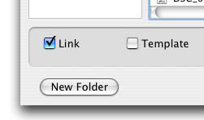
1.Open the file into which you want to place the image.
2. In the “File” menu select “Place…”
3. A “Place” dialog box will appear.
4. Locate and select the file you want to place and do one of the following:
- To create a link between the artwork file and the Illustrator file, make sure the Link option is selected in the Place dialog box.
- To embed the artwork in the Illustrator file, deselect the Link option in the Place dialog box.
5. Click Place. The artwork is placed into the Illustrator file as either a linked or an embedded image, depending on the option you selected in the Place dialog box.
6. Adjust the placed artwork as required.

Linked images can be embedded later by selecting the Links Panel in the Window menu, selecting one or all of the images listed, clicking on the small black triangle at the top right of the Panel and selecting the Embed Image option.

Working with digital images.

Applications such as Adobe Illustrator generate vector graphics objects, defined by their geometric characteristics. A line drawn in Illustrator consists of a mathematical description with specific start and end points, and a specific width and colour. This object can be selected and its attributes or position changed independently of other objects. It can also be rescaled without loss of quality

Image handling applications such as Adobe Photoshop on the other hand, work with bitmap files. These are made up of a grid of tiny squares called Pixels (short for Picture Elements), each with a specific location and colour value. The more of these pixels the image contains the higher the resolution. An image file always has one particular resolution. One part of an image cannot have different resolution from the rest of the image. A line or shape drawn in Photoshop will look grainy and uneven when magnified on the monitor. However, a pixel does not have an inherent size of its own. Modern digital cameras may fit around five million pixels onto a chip less than 2 inches across, but the pixels on a computer screen are much larger, so if each one of the camera pixels were to be displayed on a standard 72 pixels per inch screen, the screen would have to be almost three feet wide.

To make it possible to view the entire image on a more practical sized screen, Photoshop is able to display a small version of the image by taking an average of several image pixels and displaying them as one screen pixel. This is done by clicking on the View menu in Photoshop and selecting Zoom In or Zoom Out. The amount of this “virtual resampling” taking place is indicated by the percentage figure in the title bar of any image being viewed.

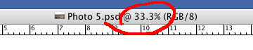
When an image is viewed at less than 100% it will not show all the detail the file actually contains. The only way to tell whether an image contains sufficient detail is to view it at 100%. It is important to remember that a low resolution image filling the whole screen at 100% will show similar levels of detail as a much higher resolution image viewed at say 25%. All this means that the image displayed on the screen is not in itself an adequate indicator of the actual image quality. The only reliable way to tell whether an image is of the right size and has adequate resolution for the intended purpose is to view the image in Adobe Photoshop and look in the Image Size dialog box by choosing Image ⇒ Image Size.

All the information needed to make an informed decision on whether an image is adequate can be found in the Image Size dialog box. It is the most important aspect of Photoshop and becoming familiar with its contents is a major step towards understanding how digital images work.

In addition to obtaining useful information about the image, the Image Size dialog box can be used to alter the image in two ways. Figure A overleaf shows a 1200 x 800 pixel image with output dimensions (or Document Size) set to 6 x 4 inches. The resolution is therefore 200 dpi. If the Resample Image box is ticked  (bottom left) and the width is changed to 8 inches (Figure B) the height of the image is increased proportionally. (Note that newer versions of Photoshop have a Scale Styles button, this should always remain ticked). Resolution remains the same but the pixel dimensions are increased. Equally, if the resolution were changed the output dimensions would remain the same but the pixel dimensions would change proportionally. This is called resampling, (not to be confused with the virtual resampling described above that takes place when an image is displayed on the computer monitor). Note that because the pixel dimensions have increased, the file size has also gone up.
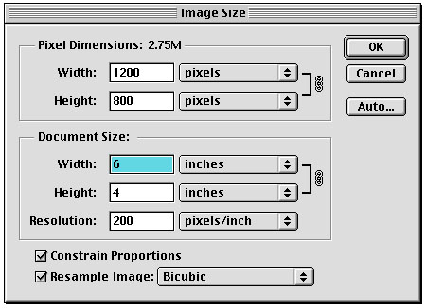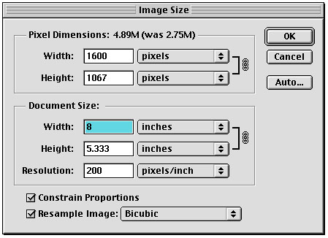
A B

Figure C shows the same 1200 x 800 pixel image but now if the Resample Image box is not ticked the pixel dimensions are locked and any changes to the dimensions will alter the resolution and vice versa (Figure D). This is Resizing. Note that at all times the Constrain Proportions box should remain checked.

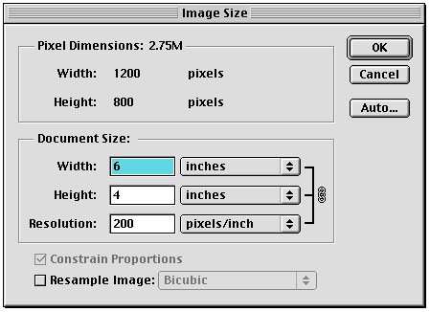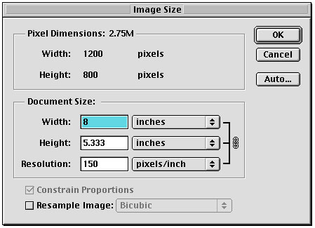
C D

Colour spaces
The human eye contains cells sensitive to three primary colours, red, green, and blue (RGB), and the perception of colour depends on the relative stimulation of each of these cell types. This colour model is referred to as additive because the more each type of cell is stimulated, the brighter the colour perceived. When all three cell types are equally stimulated, the colour perceived is white. As well as the human eye, devices that depend on transmitted light such as TV screens and computer monitors use the RGB model.

Printers on the other hand use cyan, magenta, yellow, and black inks in relative amounts of between 0 and 100% and the more colour you add the darker it gets. For this reason it is known as a subtractive model. While the RGB model depends on transmitted light to create colour, the CMYK model is based on the light absorbing qualities of printing inks. As white light strikes translucent inks, a portion of the spectrum is absorbed. Colour that is not absorbed is reflected back to the eye. In theory adding cyan (C), magenta (M), and yellow (Y) inks alone should produce black but because of inevitable impurities, a muddy brown is normally the result, so black ink is added and referred to as K to avoid confusion with blue.

Digital cameras always use the RGB model, as it is able to reproduce a wider range of colours than the CMYK model. Such an image is ideal for screen display, but may look very different when printed on an inkjet printer, so converting an image to CMYK if it is intended for printing will give a better impression of how the final image will look. This can be done in Photoshop by selecting Mode in the Image menu.

Bit Depth
Bit Depth is a measure of how much colour information is contained within individual pixels. The greater the bit depth, the wider the range of colours available. A pixel with a bit depth of one has two possible values: black or white. This type of image is referred to as Bitonal. An image with a bit depth of 8 has 2⁸ or 256 possible values. Photoshop refers to this type of image as Indexed Color because of the way it creates a limited colour panel unique to a specific image. Grayscale images, such as black and white photographs, also normally have a bit depth of 8. An image with a bit depth of 24 has 2²⁴ or about 16 million possible colour values. This type of image is referred to as RGB Colour.

