Journey Through Europe
Software Requirements Specification

Author: Paul Fodor
Debugging Enterprises
November, 2017
Version 2.0

Abstract: This document describes the program requirements for Ravensburger’s classic board game Journey Through Europe. The program interface and functionality will both be described as well as the overall goals of the project.

Based on IEEE Std 830TM-1998 (R2009) document format

Copyright © 2014 Debugging Enterprises, which is a made up company and doesn’t really own all the art work, Ravensburger does. Please note that this document is fictitious in that it simply serves as an example for CSE 219 students at Stony Brook University to use in developing their own SRS.

No part of this publication may be reproduced in any form, in an electronic retrieval system or otherwise, without the prior written permission of the publisher.
1 Introduction

Tens of millions of people played the family board game Journey Through Europe published by Ravensburger. The board is a map of Europe with various major cities marked, for example, Athens, Amsterdam and London. The players are given a home city from which they will begin and are then dealt a number of cards with various other cities on them. They must plan a route between each of the cities in their hand of cards. On each turn they throw a die and move between the cities. The winner is the first player to visit each of their cities and then return to their home base.

What could be better? Well how about if we implement it as a computer game. Yes, that’s right, forget the cumbersome board, we’re going to make the computer version.

  - Purpose

The purpose of this document is describe not only the functionality of the mailing client but also its advantages and limitations. Mailing clients exists in all forms and this document will describe the thought process behind it’s development.

1.2 Scope

Here at Debugging Enterprises, we are looking forward to a long future as a casual game development company. This starts with Journey Through Europe, but by no means ends there. We hope to release future map-related titles as well like Journey Through Long Island, Journey Through United States, Journey Through Stony Brook University, Journey Through New York State, and of course, Journey Through Manhattan. Since we’re lining up a whole series of casual games, we want to be sure to make good design decisions that result in reusable components. As such, a framework (or set of frameworks), should be designed and constructed to be used to make Journey Through Europe as well as the other similar map games. Note that the point of Journey Through Europe is simply to entertain.

  - Definitions, acronyms, and abbreviations

SMTP

Serialize

Email

Framework – In an object-oriented language, a collection of classes and interfaces that collectively provide a service for building applications or additional frameworks all with a common need.

GUI – Graphical User Interface, visual controls like buttons inside a window in a software application that collectively allow the user to operate the program.

Use Case Diagram – A UML document format that specifies how a user will interact with a system. Note that these diagrams do not include technical details. Instead, they are fed as input into the design stage (stage after this one) where the appropriate software designs are constructed based in part on the Use Cases specified in the SRS.

  - References

IEEE Std 830TM-1998 (R2009) – IEEE Recommended Practice for Software Requirements Specification

  - Overview

This SRS will clearly define how the Journey Through Europe game should look and operate as well as how to actually play the game. Note that this is not a software design document. This document does not specify how to build the appropriate technologies, it is simply an agreement concerning what to build, not how to build it. Section 2 of this document will provide the context for the project and specify all the conceptual design, including the game rules and parameters. Section 3 will present how the game interface should be laid out and all program functionality. Section 4 provides a Table of Contents, an Index, and References.

- Overall description

Journey Through Europe is a travel game of strategy and planning for all the family. It can be played by 2 to 6 players and it contains:
- 1 playing board,
- 6 playing pieces,
- 6 flags in different colors,
- 180 place cards (64 with illustrations and special instructions)
- 6 flight plans, and
- 1 dice

  - Game Description

The players go on a journey through Europe. Cards are handed out which determine an everchanging route, different for each player. The idea is to use skill and careful consideration to choose the best route in order to be first home.

Preparation:
- The user can select to play a new game or load the last saved game (a game can be saved by a user at any time in playing the game during the user’s turn).
- If the user selects to start a new game, then the user selects the number of players, the name of each player and the type: computer or user.
- Each player receives a playing piece, a flag of the same color and a flight plan.
- The place cards are sorted into three piles according to the color at the top of the card.
- The players now receive their first place card; these are dealt as follows: the first player receives a red one, the second green, the next yellow, the next red and so on.
- The city shown on a player's first card is both beginning and end of his/her journey.
- The game starts with the flags next to these cities on the board.
- Now each player receives two more cards (there are eight more cards dealt in the real game, but we have to test it with less – implement an easy programming setup to change the number of cards dealt to eight). These are dealt so that each player has a total of one card in each color. They indicate the cities to be visited on the journey through Europe. To make it easier to find these cities, each card is marked with a letter and a number which correspond to the grid marked around the edges of the board. Some place cards are illustrated, featuring tourist attractions. These cards also have special instructions on the reverse. A further educational aspect of the game is that the place cards are marked on the front with the town and city names in the native language of their country. The English name appears on the back of the cards.
- Players should look at all of their cards at the beginning of the game, take note of any instructions and thereby plan the quickest and most suitable route.

Play
- Players throw the die in turn.
- The number thrown indicates the number of cities through which the player advances.
- If he lands on or passes through a city for which he holds a place card, he gives this card to the dealer.
- If a six is thrown, the player may take another turn.
- Players can travel in any direction, but not backwards and forwards in the same go.
- They can pass any flags or playing pieces, but only one playing piece can be in one city at any given time.
- If a player reaches a city for which he holds a card with special instructions, he must stop there, even if his throw means he could normally go further. The instructions must now be carried out.
- He then gives the place card to the dealer and the next person takes his turn.

Sea Routes:
- The die is not thrown when a player crosses the sea, as he may only travel from one harbor to another.
- A player may not cross the sea as part of his go.
- He must wait at the harbor for his next turn; extra points are lost.

End of the Game
The last card to be handed in is that for the city from which the journey started. The player who is first to achieve this is the winner. If, however, there are special instructions on the player's last card, he must carry them out first. This may mean that the player will have to leave this place again and that he will only win if he returns in time.

    - System Interfaces

The Journey Through Europe game will need to provide a means to load and save progress in a game and thus must provide a means to access saved games. Note that Journey Through Europe will ultimately exist as a standalone application, though hopefully one that could be ported to and then played on a number of different platforms.

Figure 2.1: The various screen contexts for Journey Through Europe.

    - User Interfaces

Due to the fact that we’ll want to port this to a mobile interface in the future, it is important to keep the interface controls simple. So, we’ll need to make sure players will use the application in limited ways. For example, there need to be a few GUI controls inside the game itself, and we’ll limit player interactions to the mouse (no key controls). Figure 2.2 below summarizes the ways with which the user will interact with our Journey Through Europe application, which will be furthered detailed using a UML Use Case diagram for each. Note that “Clicks” always refers to a left-mouse-button click, as does “Drags”, and “Releases”. These Use-Case diagrams should be fed as input directly into Section 3.1, external interfaces, which is where the design of the user interface is specified. Here is the full list of UML Use-Case Diagrams:

Figure 2.2: Overview of Use-Case Diagrams
Figure | Screen | Use Case
2.3 | Splash Screen | Play Game
2.5 | Splash Screen | Load Last Game
2.6 | Splash, Gameplay Screens | Quit Game
2.7 | Game Setup Screen | Select Players
2.9 | Game Setup Screen | Start Game
2.10 | Gameplay Screen | Select Cities to Visit by Mouse Click
2.11 | Gameplay Screen | Close Win Dialog
2.12 | Gameplay Screen | Close Loss Dialog
2.13 | Gameplay Screen | Open Current Game History Screen
2.14 | Gameplay Screen | Save Game
2.15 | Splash, Gameplay Screens | Open About Screen
2.16 | Current Game History Screen | Close Current Game History Screen
2.17 | About Screen | Return from About Screen
2.18 | Gameplay Screen | Open Flight Plan
2.19 | Flight Plan Screen | Select Flight Destination
2.21 | Gameplay Screen | Map section selection
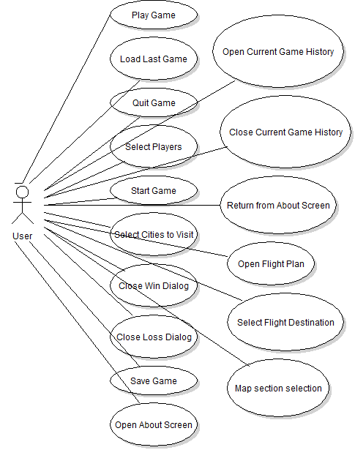

Figure 2.3: Play Game Use Case
Use-Case: | Play Game
Primary Actor: | Player
Goal in Context: | Start a brand new game
Preconditions: | The game application has been started and the initial game settings have been loaded.
Trigger: | The player clicks on the “Start” button
Scenario: | - Player starts the application, which loads game settings  - Player views the Splash Screen, which has four options, one to play a new game, one to load the last game, one to see the about screen and one to quit  - Player wants to play so presses “Start” button  - Application loads Game Setup Screen with proper progress
Exceptions: | This button should always be enabled from the Splash Screen.
Priority: | Essential, must be implemented
When available: | First Benchmark
Frequency of use: | Used every time the player starts the application
Open Issues: | Size, location, and style of button should be finalized by UI designer

Figure 2.4: Splash Screen
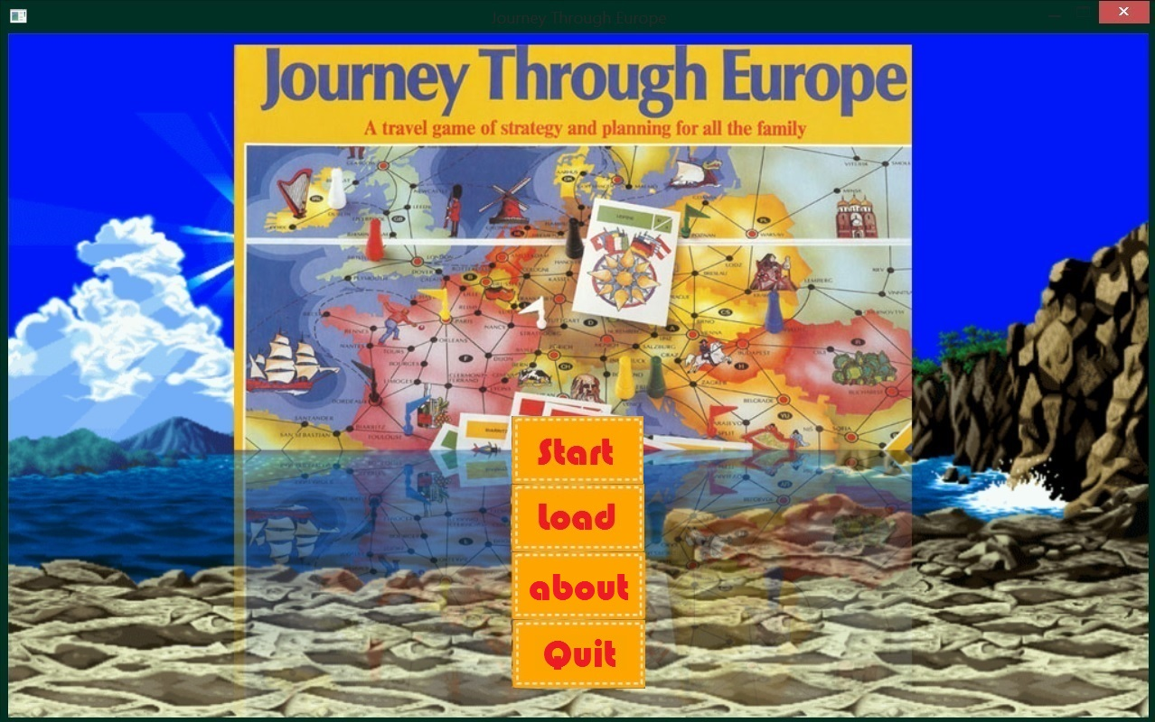

Figure 2.5: Load Last Game Use Case
Use-Case: | Load Last Game
Primary Actor: | Player
Goal in Context: | Start the last game that was saved.
Preconditions: | There exists a last game that was saved before
Trigger: | The player clicks on the “Load” button
Scenario: | - Application is started in the Splash Screen.  - Player presses the “Load” button if it is enabled.  - Application loads game settings about the game in progress and goes to the Gameplay Screen.
Exceptions: | This button should only be enabled when there exists a game that was saved before. It should not be clickable otherwise.
Priority: | Essential, must be implemented
When available: | Second Benchmark
Open Issues: | Size, location, and style of button should be finalized by UI designer

Figure 2.6: Quit Game Use Case
Use-Case: | Quit Game
Primary Actor: | Player
Goal in Context: | Quit and close the game application when the player requests it.
Preconditions: | The application has started and is in either Splash Screen or the Gameplay Screen mode.
Trigger: | The player clicks on a “Quit” button.
Scenario: | - Player is viewing either the Splash or Gameplay Screens.  - Player clicks on the “Quit” button.  - Application closes.
Exceptions: | None.
Priority: | Essential, must be implemented
When available: | First Benchmark
Frequency of use: | Once per session.
Open Issues: | Size, location, and style of button should be finalized by UI designer
Figure 2.7: Select Players Use Case
Use-Case: | Select Players
Primary Actor: | Player
Goal in Context: | Select the players number, types and names.
Preconditions: | The game has started and the user selects the number of players.
Scenario: | - Player is viewing the Game Setup Screen.  - Player clicks on the dropdown box for selecting the number of users, type of users and human players.
Exceptions: | None.
Priority: | Essential, must be implemented
When available: | First Benchmark
Frequency of use: | Many times per session for every game
Open Issues: | Size, location, and style of controls should be finalized by UI designer.
Figure 2.8: Select Players Screen

Figure 2.9: Start Game Use Case
Use-Case: | Start Game
Primary Actor: | Player
Goal in Context: | User starts game from the Game Setup Screen.
Preconditions: | The app has started and the player is currently viewing the Game Setup Screen.
Trigger: | The player clicks on the “Go!” button.
Scenario: | - Player is viewing the Game Setup Screen.  - Player clicks on “Go!” screen.  - Gameplay Screen displayed and the game Preparation is done. See Game Preparation instructions and video: each player is dealt the cards, the board is shown and the die is thrown for the first player.
Exceptions: | None.
Priority: | Essential, must be implemented
When available: | First Benchmark
Frequency of use: | Once per game session.
Open Issues: | Size, location, and style of button should be finalized by UI designer. Note that this should be carefully, artistically done, to give the player the feeling of journeying through a map Game Setup Screen.

Figure 2.10: Select Cities to Visit Use Case
Use-Case: | Select Cities to Visit
Primary Actor: | Player
Goal in Context: | After the die in thrown, the user clicks on all the cities that he wants to visit and the piece moves to the destination. Special rules apply for sea trips and flights. A counter in the right upper part of the screen should show the number of moves left. If a card destination is reached the content of the card should be shown and special instructions applied.
Preconditions: | The player is currently viewing the Gameplay Screen. The die has been thrown and it shows a number for the current player.
Trigger: | The player clicks on the Cities to Visit.
Scenario: | - Player is viewing the Gameplay Screen.  - The die was automatically thrown for the current player.  - Player clicks on the Cities to Visit.  - The piece moves using animation to these locations.  - If you pass a city with a description, you must display a message with that description (see the appendix with descriptions for 64 cities).
Exceptions: | If selected cities are not visible, then a blocked sound must be played.
Priority: | Essential, must be implemented
When available: | Second Benchmark
Frequency of use: | Many times per game session.
Open Issues: | Size, location, and style of buttons should be finalized by UI designer. Note that this should be carefully, artistically done, to give the player the feeling of journeying through a map Game Setup Screen.

Figure 2.11: Close Win Dialog Use Case
Use-Case: | Close Win Dialog
Primary Actor: | Player
Goal in Context: | One player finishes all his cards.
Preconditions: | The current user reaches the last town and satisfies the condition of having no cards left.
Trigger: | The player mouse clicks on the last town and remains without any leftover cards.
Scenario: | - Player is playing a game.  - Player clicks on the town that is his destination town.  - He satisfies the conditions on the back of the card (if any).  - A cup and a message is displayed and the player confirms by clicking on an OK button.  - The game returns to the Splash Screen.
Priority: | Essential, must be implemented
When available: | Third Benchmark
Frequency of use: | Once for every game
Open Issues: | Size, location, and style of cup should be finalized by UI designer.

Figure 2.12: Close Loss Dialog Use Case
Use-Case: | Close Win Dialog
Primary Actor: | Player
Goal in Context: | One computer player finishes all his cards.
Preconditions: | The current computer player reaches the last town and satisfies the condition of having no cards left.
Trigger: | The computer computes a path and remains without any leftover cards.
Scenario: | - A computer player is playing a game.  - After throwing the dice and finding a path to his destination town, the player satisfies the conditions on the back of the card (if any).  - A loss message is displayed and the human player confirms by clicking on an OK button.  - The game returns to the Splash Screen.
Priority: | Essential, must be implemented
When available: | Third Benchmark
Frequency of use: | Once for every game
Open Issues: | Size, location, and style of loss message should be finalized by UI designer.

Figure 2.13: Open Current Game History Screen Use Case
Use-Case: | Open Current Game History
Primary Actor: | Player
Trigger: | The user clicks on the Open Current Game History button.
Scenario: | - A player clicks on Open Current Game History.  - A history page is displayed with all the moves in the current game.
Priority: | Essential, must be implemented
When available: | Third Benchmark
Frequency of use: | Many times for every game
Open Issues: | Size, location, and style of message should be finalized by UI designer.

Figure 2.14: Save Game Use Case
Use-Case: | Save Game
Primary Actor: | Player
Trigger: | The user clicks on the Save Game button.
Scenario: | - A player clicks on Save Game button.  - The game is saved.  - A message is displayed saying that the current game was saved.
Priority: | Essential, must be implemented
When available: | Second Benchmark
Frequency of use: | Many times for every game
Open Issues: | Size, location, and style of message should be finalized by UI designer.

Figure 2.15: Open About Screen Use Case
Use-Case: | Open About Screen
Primary Actor: | Player
Trigger: | The user clicks on the “About” button either in the Splash or the Gameplay screens.
Scenario: | - A player clicks on About button.  - A page is displayed with the Wikipedia page for Journey Through Europe, our company information and a Return button.
Priority: | Essential, must be implemented
When available: | Second Benchmark
Frequency of use: | Many times for every game
Open Issues: | Size, location, and style of page should be finalized by UI designer.

Figure 2.16: Close Current Game History Screen Use Case
Use-Case: | Close Current Game History Screen
Primary Actor: | Player
Trigger: | The user clicks on the “Close” button in the Current Game History Screen.
Scenario: | - A player clicks on Close button.  - The UI is returned to the Gameplay screen.
Priority: | Essential, must be implemented
When available: | Second Benchmark
Frequency of use: | Many times for every game
Open Issues: | Size, location, and style of page should be finalized by UI designer.

Figure 2.17: Return from About Screen Use Case
Use-Case: | Return from About Screen
Primary Actor: | Player
Trigger: | The user clicks on the “Close” button in the About Screen.
Scenario: | - A player clicks on Close button.  - The UI is returned to the previous screen (Gameplay or Splash).
Priority: | Essential, must be implemented
When available: | Second Benchmark
Frequency of use: | Many times for every game
Open Issues: | Size, location, and style of page should be finalized by UI designer.

Figure 2.18: Open Flight Plan Use Case
Use-Case: | Open Flight Plan Screen
Primary Actor: | Player
Trigger: | The user clicks on the “Take Flight” button in the Gameplay screen.
Scenario: | 1. A player clicks on Take Flight button.  2. A page is displayed with the Flight map.
Priority: | Essential, must be implemented
When available: | Third Benchmark
Frequency of use: | Many times for every game
Open Issues: | Size, location, and style of page should be finalized by UI designer.
Figure 2.19: Select Flight Destination Use Case
Use-Case: | Select Flight Destination
Primary Actor: | Player
Trigger: | The user clicks on a city in the Flight Plan screen.
Scenario: | 1. The user clicks on a city in the Flight Plan screen.  2. The game returns to the Gameplay screen (points are deducted) or an error message is displayed that the flight cannot be taken.
Priority: | Essential, must be implemented
When available: | Third Benchmark
Frequency of use: | Many times for every game
Open Issues: | Size, location, and style of page should be finalized by UI designer.

The entire map is too big to be displayed on the Gameplay screen, therefore we will split it into 4 quarters and display only one part in the Gameplay (at the beginning of each player round the Gameplay should display the part that contains the player piece. The user can use a grid selector to choose quarter that he wants to see.

Figure 2.20: Grid Selector
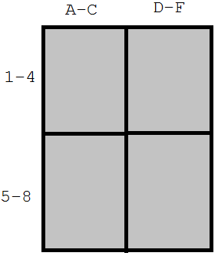

Figure 2.21: Map section selection Use Case
Use-Case: | Map section selection
Primary Actor: | Player
Trigger: | The user clicks on the “Map section selection” buttons in the Gameplay Screen.
Scenario: | 1. A player clicks on one of the four Map section buttons.  2. The Gameplay changes to one of the four quarters.
Priority: | Essential, must be implemented
When available: | First Benchmark
Frequency of use: | Many times for every game
Open Issues: | Size, location, and style of page should be finalized by UI designer.
Hardware Interfaces

The game should be designed and constructed such that it may be easily ported and published on multiple platforms. Target platforms should include PC and Android, so implementation of the game should be done in Java. Note that mobile platforms are a natural match for this game because of its point and click simplicity. No complicated keyboard commands or combinations are needed. In addition, the still viewport also makes the transition to a smaller mobile screen easier.

    - Software Interfaces

Journey Through Europe will be developed using the Java language and the JavaFX library. Note that since we plan for this to be the first map-related game among many, a Game Framework should be developed in tandem with this application, making it easier to develop future titles. That framework should provide all game timing, the update mechanism, GUI controls and Sprite management, and an overall structure to support seamless custom rendering. The game will also be developed using Java’s JavaFx framework for building user interfaces and rendering 2D graphics.

Java version 8.0 will work on all desired platforms with the notable exception of the iPhone. The game would have to be ported to Objective C to operate there. For that reason, development will proceed first as a Java game, and porting will proceed after completion of the Java game. Note again that due to the variations in screen resolutions, careful planning should be done to account for platform independence in all game data management.

    - Communications Interfaces

Note that this game will operate solely as a local game. There will be no networking requirements. At some point in the future the app may be integrated with Facebook accounts, but for now it operates as a standalone application.

    - Memory Constraints

Since this game will be ported to mobile devices, memory is an important issue. All images should be provided in the precise sizes they will be rendered. Images should never be scaled up or down. Note that the memory requirements for each platform will be different, but that memory budgets should be defined carefully before each port.

    - Operations

It is the goal of the player to complete one Journey Through Europe game.

    - Site Adaptation Requirements

N/A

  - Product functions

The game does not need to save multiple accounts data or player settings, only the progress of the current game needs to be saved and loaded. The assumption is that the game is owned by one person and only one person will play it.

  - User characteristics

These map-based games appeal to people of all ages, and Journey Through Europe should be no different. Even young children should find the point and click interface easy to pickup and use. Also note that the game is presented in a humorous context such that young players will find the maps to be harmlessly humorous and entertaining.

  - Constraints

Mobile screen resolutions, however, present a porting challenge. Different models support different resolutions and all mobile platforms fall short of PC/Mac capabilities. Note that the key hardware to plan for are the mouse (or mobile pointing device) and the screen.

  - Assumptions and dependencies

N/A.

  - Apportioning of the Requirements

It will be determined at a later date precisely how this Journey Through Europe application will be ported to additional platforms. It is the obligation of the software designers, however, to construct the program such that it may easily be modified.
3 Specific requirements

Journey Through Europe will use a simple interface with few controls. Note that the GUI controls should always be neatly drawn, carefully spaced, and properly aligned.

  - External interfaces

The player will only use mouse input to start and run the game, so the GUI will be straightforward. In additional to Figures 2.4 (Splash Screen), 2.8 (Game Setup Screen) and 2.20 (Grid Selector), we will provide the Gameplay Screen figure below.

Figure 3.1.1: Gameplay Screen - Select City to Visit by Mouse Click
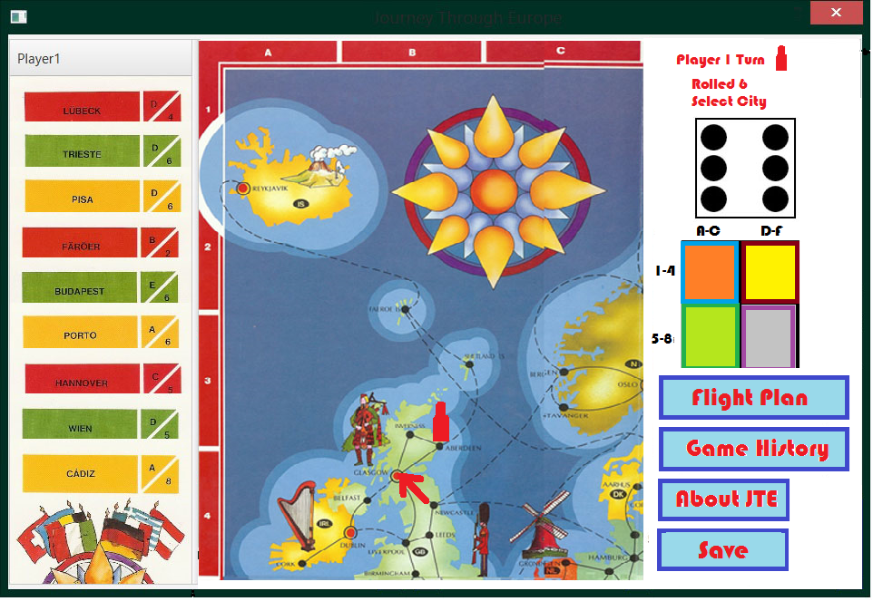

  - Functions

One of the important things to consider in our game application is providing the appropriate feedback to the user while the game is happening. Players need feedback to enjoy their game experience. This is typically done with visual cues or sound. We will not be employing sound in this project, but we will certainly need to use visual cues.

Animation Cues

The player will need animation cues for a number of scenarios. We’ll need the following animations:

- Card dealing – the cards are dealt smoothly, gradually, not suddenly.
- Travel animation – each piece is moved smoothly, gradually, not suddenly.

  - Performance requirements

The primary performance concerns will be with rendering, since it is a real-time graphical application.
Note that rendering performance testing should be an important component of the development process.

  - Logical database requirements

N/A

  - Design constraints

As mentioned, a primary concern should be efficient rendering. When available, the program should be able to take advantage of hardware (GPU) acceleration for rendering. However, in order to appeal to the maximum number of users, it should also work well when that is not available. This is a reasonable constraint, since this is a 2D game with a small world and little artwork to render.

  - Software system attributes

As professionals, all members of this project must take this project seriously. We are dedicated to producing robust software that exceeds the expectations of our customers. In order to achieve this level of quality, we should build a product with the following properties in mind:

3.6.1 Reliability – The program should be carefully planned, constructed and tested such that it behaves flawlessly for the end user. Bugs, including rendering problems, are unacceptable. In order to minimize these problems, all software will be carefully designed using UML diagrams and a Design to Test approach should be used for the Implementation Stage.

3.6.2 Availability –Customers may download and install the game application for free, but will be required to pay a fee to access the full game content, meaning anything past level 10.

3.6.3 Security – All security mechanisms will be addressed by future revisions

3.6.4 Extensibility – It is important that more levels can be added to the game, so file formats for levels should be carefully considered such that the game can be easily extended.

3.6.5 Portability – To start with, the game will target all platforms that support Java. An Objective C port should follow thereafter to make the game playable on the iPhone.

3.6.6 Maintainability – Update mechanisms will be addressed by future revisions.

  - Organizing the specific requirements

Note that the game is simple enough that we need not worry about using an alternative arrangement of the content of this document. The specific requirements for this application already fit neatly into the sections listed in the IEEE’s recommended SRS format.

  - Additional comments

It is important to keep in mind that the reason specific map UI views have not been supplied by this document is that we want the UI designers to make something that looks great and original. It will be to their discretion to design all the interface controls in an effective, entertaining style.

4 Supporting Information

Note that this document should serve as a reference for the designers and coders in the future stages of the development process, so we’ll provide a table of contents to help quickly find important sections.

  - Table of contents

- Introduction 2
  - Purpose 2
  - Scope 2
  - Definitions, acronyms, and abbreviations 2
  - References 3
  - Overview 3
- Overall description 4
  - Game description 4
  - Product functions 15
  - User characteristics 15
  - Constraints 15
  - Assumptions and dependencies 15
- Specific requirements 16
  - External interfaces 16
  - Functions 16
  - Performance requirements 16
  - Logical database requirements 16
  - Design constraints 16
  - Software system attributes 16
  - Organizing the specific requirements 17
  - Additional comments 17
- Supporting Information 17
  - Table of contents 17
  - Appendixes 18

  - Appendixes

4.2.1 Information on places of interest in 64 towns and cities

