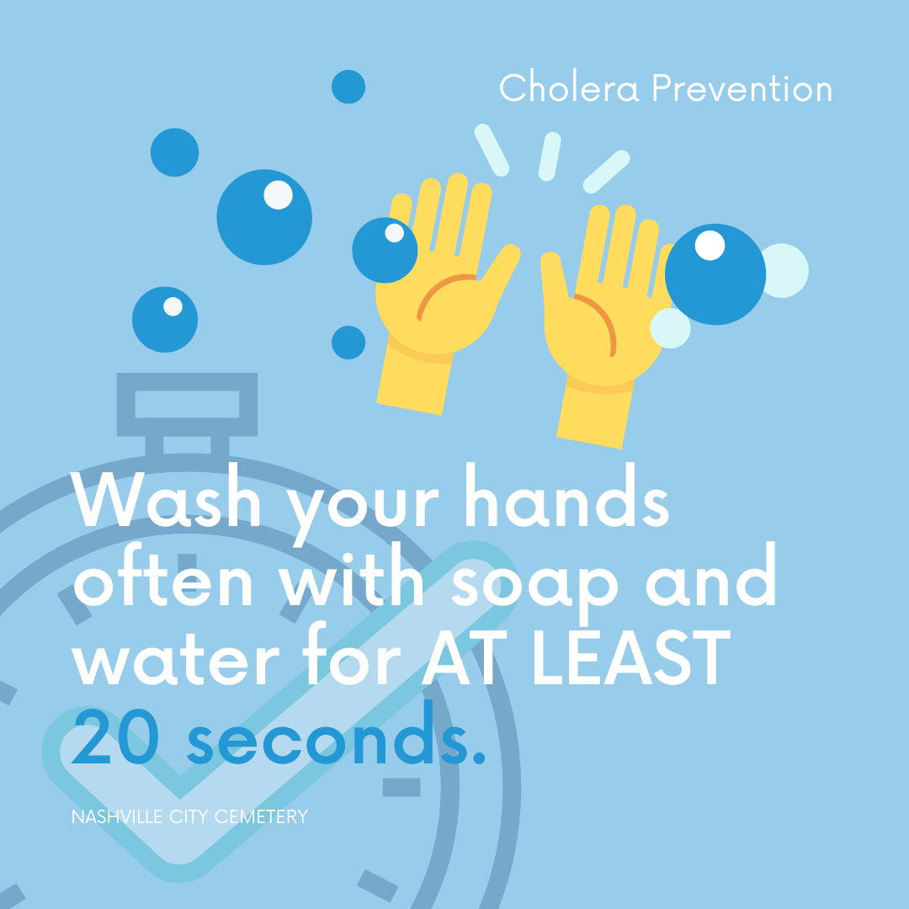

Today, I want to talk to you about an important topic: Cholera. Cholera is a serious disease that causes severe diarrhea and can be very dangerous. One of the most effective ways to prevent cholera is by practicing good hygiene, especially handwashing.

Between 1849 and 1850, Nashville faced a terrible cholera outbreak. Cholera spread quickly because people didn't know much about germs and how they spread diseases. It was a tough time and many people got sick.

Now, we're lucky to know more about how to prevent cholera and other illnesses. One simple and powerful way is by washing our hands regularly. When we wash our hands with soap and water, we wash away germs that could make us sick.

By learning from the past, like the cholera outbreak in Nashville, we can make sure we stay healthy and keep our communities safe. Remember, good hygiene, like handwashing, is a superpower that everyone can use!