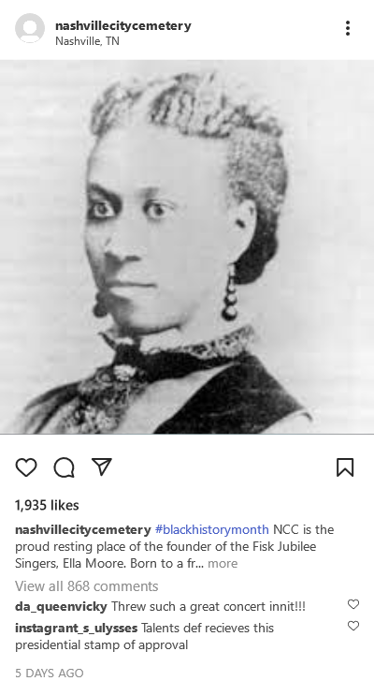

Sources:

Photo: <https://en.wikipedia.org/wiki/Ella_Sheppard>

Post Maker: <https://codebeautify.org/fake-instagram-post-generator>