Social Media Post, Cemetery Project

By Michael Shaffer



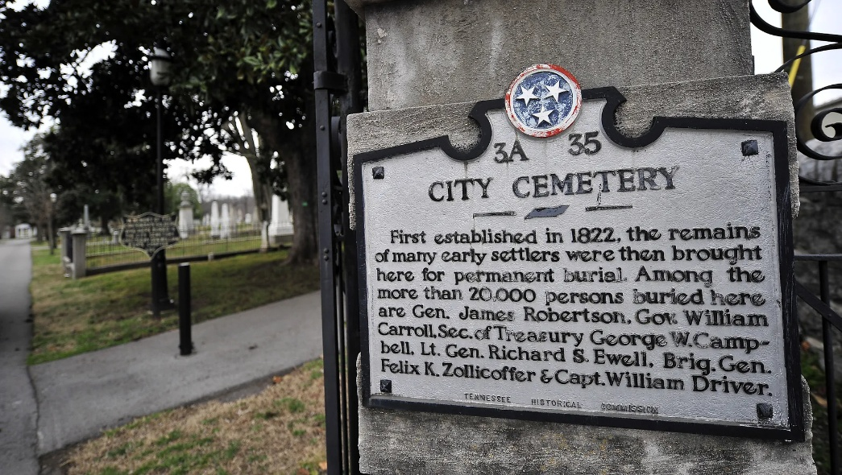

Visit Nashville City Cemetery and experience history! Visit the final resting places of generals, prominent state legislators of old, and more! Civil war buff? Pay respects to the many soldiers buried on our grounds! You can even visit the grave of ***BATMAN***!! (well, maybe not the Caped Crusader, but we have two, Catherine and Emmit…)

Download our app for a guided tour! Visit us today!

Location: 1001 4th Ave S., Nashville, TN 37215.

Follow us on Facebook and Instagram.

Want to donate to our preservation effort? Visit thenashvillecitycemetary.org