Team M&Ms - App Trader Project

Nupur Banta, Evan Dallas, Riley Higginbotham, **Carlos Rodriguez**

Deliverables

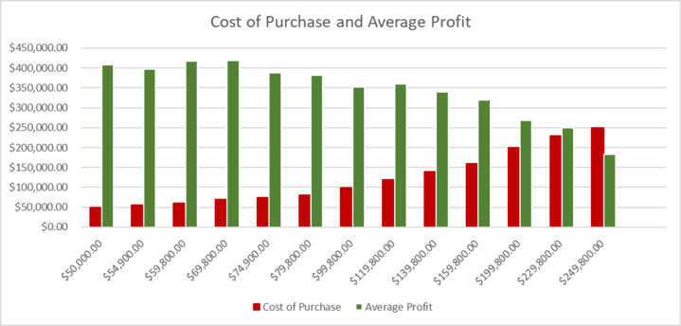

* This figure demonstrates that as the cost to purchase the app increases (x-axis & red), there is not a significant change to the average profit generated by the app (green). Because of this, the focus should be on purchasing apps at a low cost, increasing the margin for profit.

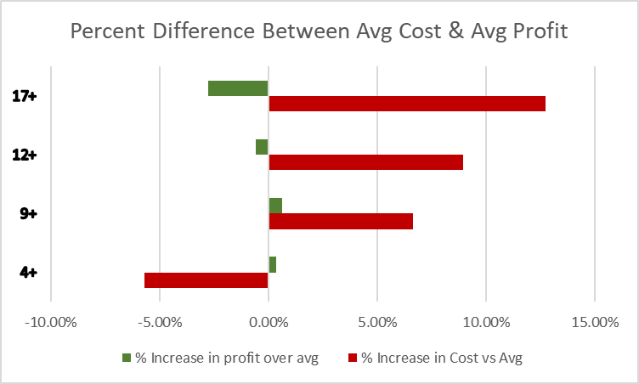

* The above figure compares the profit (green) and cost (red) of each content rating group, compared to the average of all apps (at 0.00%). The data demonstrates that compared to all apps, apps with a rating of 4+ generally cost less than other categories. The main difference in profit would be in the 17+ rating group, where there is a decrease in the amount of profit when compared to the average.

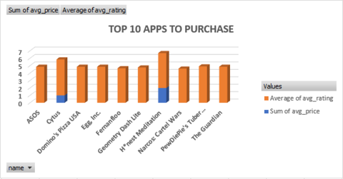

* Here are the top 10 apps we recommend purchasing, based on rating and average cost to purchase: ASOS, Cytus, Domino’s Pizza USA, Egg Inc., Fernanfloo, Geometry Dash Lite, H*nest Meditation, Narcos: Cartel Wars, PewDiePie’s Tuber Simulator, and The Guardian.
* Of note, the majority of these apps are categorized as games.
* For the upcoming Halloween campaign, we recommend purchasing Dead Trigger and Plants vs. Zombies 2 from the App Store, and Zombie Catchers and DEAD TARGET: FPS Zombie Apocalypse Survival Games from the Play Store.
  + These games have a variety of content rating recommendations, and are well-reviewed, each with at least a 4.5 average rating. These apps are free to download, minimizing the upfront purchasing costs.