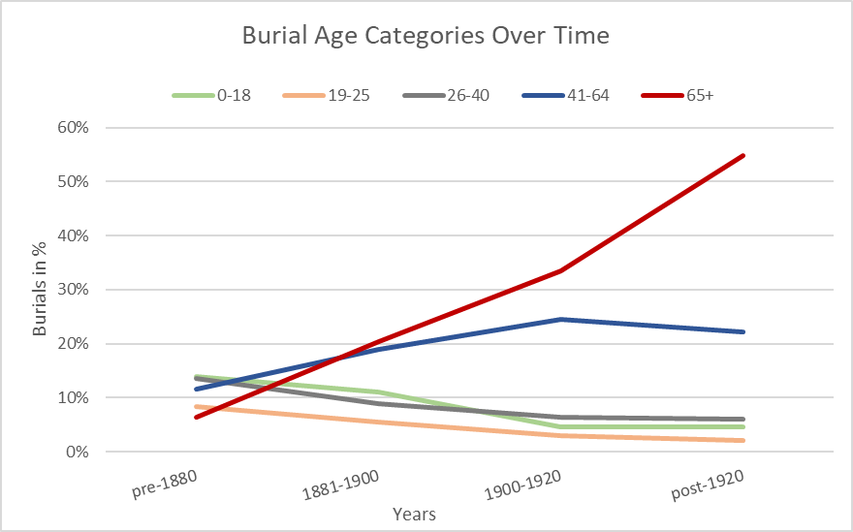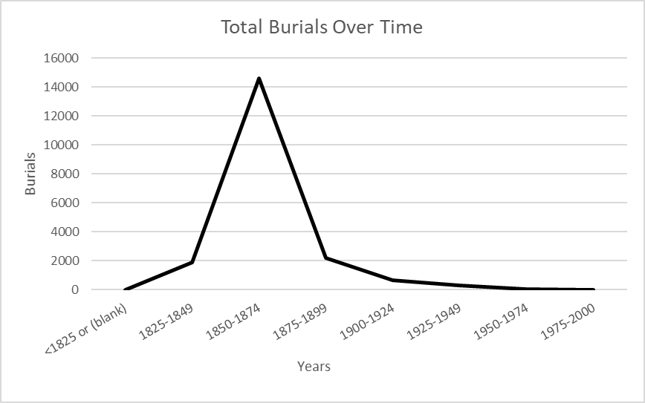

Figure 2

Figure 1

The Nashville City Cemetery had a significant increase in burials during the civil war as seen in Figure 1. In Figure 2 displays there were lower percentages of burials in the younger age categories: 0-18, 19-25, and 26-40. While it also displays higher percentages of burial in the older age categories: 41-64, and 65+. This could indicate the life expectancy in the Nashville area has increased over time.