**Nashville's Oldest Outdoor Museum**

**THE STORIES OF NASHVILLE'S PAST LIVE HERE**

**Come see the final resting place of prominent historical figures such as:**

**Lt. Lipscomb Norvell**

**Anne Robertson Johnson Cockrill**

**Ella Sheppard**

**Harlan Howard**

**James Robertson**

***…and many more!***

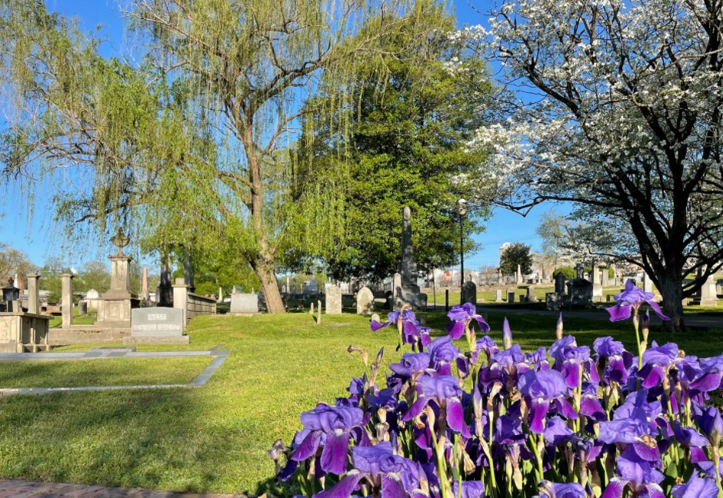

**Nashville City Cemetery hosts interments across all ages and genders, as well as resting sites for multiple ethnicities, beginning in 1822!**

**Come Celebrate with Us!**

**Commemorating 200 Years!**

**Join us for a community celebration at the cemetery!**

**Sat, October 22, 2022**

**10:00 AM – 2:00 PM**

**Free admission!**

**Popular Upcoming Events:**

**October Lantern Tours!**

**Join us for our most popular tours of the year!**

**Oct 1, 8, 15, and 29 from**

**4:30 PM - 7:00 PM**

**Tickets available now!**

**For more information, visit us online to at:**

[**www.instagram.com/nashvillecitycemetery/**](http://www.instagram.com/nashvillecitycemetery/)

[**www.facebook.com/nashcitycemetery/**](http://www.facebook.com/nashcitycemetery/)

[**www.thenashvillecitycemetery.org/**](http://www.thenashvillecitycemetery.org/)

**The Nashville City Cemetery,** located at [**1001 4th Avenue South**](https://thenashvillecitycemetery.org/contact-us), is the oldest continuously operated public cemetery in Nashville.

*[Information and images accessed from Facebook, the Nashville City Cemetery, Nashville City Cemetery Association and the Wikipedia websites.]*