# Response

* Q1 Please provide the city/state name for affiliation 1.: Verona, WI
* Q2 “The red points referred to as ‘max’ …” should be replaced by “The cross points referred to as ‘max’ …”. The plot has been modified accordingly in the main document (inserted below for reference). Corresponding plots in the supplementary material have been modified as well.



* Q3 This paper is still in press. Here is DOI: <https://doi.org/10.1016/j.cropro.2019.02.012>
* Q4 Please see below. Publisher is Routledge, but it has two locations. Please note that we are not citing the book, but only an article from the book.

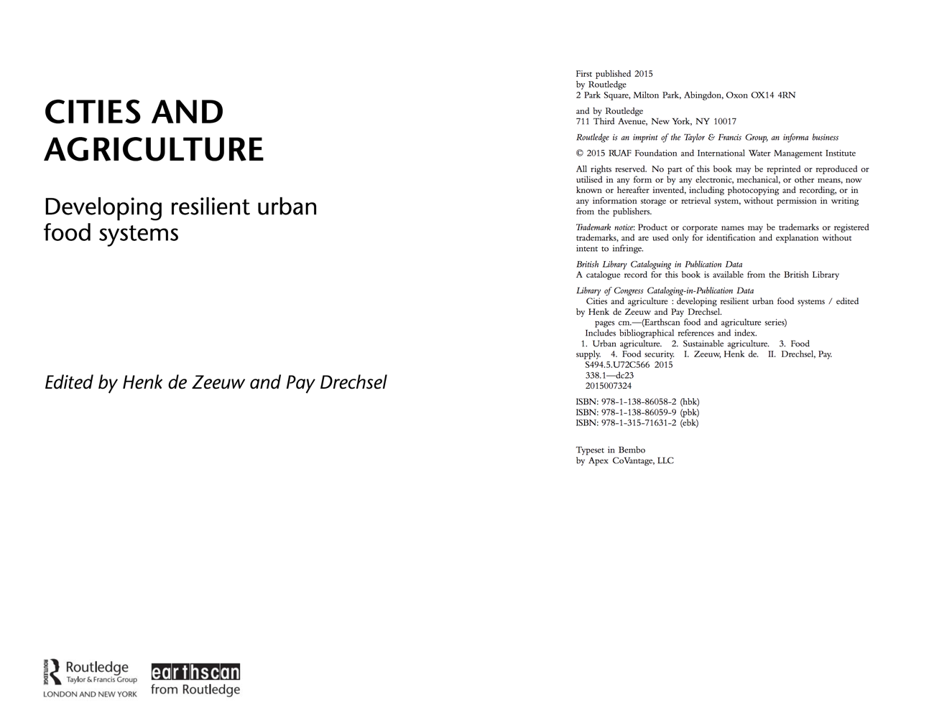

* SQ1: Electronic supplementary material mcnitt_tuta_supplementary.pdf has been modified. It is attached. There are no changes to modelA_BGD.mpeg and modelB_BGD.mpeg.
* ORCID IDs:

|  |  |
| --- | --- |
| 1. Adiga | 0000-0002-9770-034X |
| M.R. Campos | 0000-0001-9317-3215 |
| M. Marathe | 0000-0003-1653-0658 |
| R. Muniappan | 0000-0002-2992-2792 |
| H. Mortveit | 0000-0003-3363-2947 |
| T. Brevault | 0000-0003-0159-3509 |

# Request for minor modifications

* Replace Nicolas Desneux’s affiliation: Université Côte d'Azur, INRA, CNRS, UMR ISA, 06000 Nice, France
* Replace Thierry Brevault’s affiliation:
  + 5 CIRAD, UPR AIDA, Centre de recherche ISRA-IRD, Dakar, Senegal  
    6 AIDA, Univ Montpellier, CIRAD, Montpellier, France
* Line 101: “is a serious threat to China []”. Please add the following citation if possible: Han P, Zhang YN, Lu ZZ, Wang S, Ma DY, Biondi A, Desneux N. (2018). Are we ready for the invasion of Tuta absoluta? Unanswered key questions for elaborating an Integrated Pest Management package in Xinjiang, China. Entomologia Generalis 38:113-125
* Figure 1a: “moore” should be replaced by “Moore” in two places.
* Figure 1b: “monthly rade flows” should be replaced by “monthly trade flows”
* Line 83: “*Tuta absoluta”* should be replaced by “*T. absoluta*”.
* Line 339: “figure 3d” should be replaced by “figure 3c”
* Line 364: “Figure 3 shows results for two countries.” Should be replaced by “Figure 3d shows the spread after intervention.”
* Line 449: “TB, MRC and ND collected …”
* Line 451: Remove “ND, TB” in “HM, ND, TB and RM provided assistance …”.
* Line 473: Replace “15. Biondi A, Guedes R, Wan F. Ecology, worldwide …” by “15. Biondi A, Guedes R, Wan F, Desneux N, 2018. Ecology, worldwide …”.