Predicting suitable habitat of an invasive weed Parthenium hysterophorus under future climate scenarios in Chitwan Annapurna Landscape, Nepal

Seerjana Maharjan^{1,2,*}, Bharat Babu Shrestha¹, Mohan Dev Joshi³, Anjana Devkota¹, Rangaswamy Muniappan⁴, Pramod Kumar Jha^{1*}
¹Central Department of Botany, Tribhuvan University, Kirtipur, Kathmandu, Nepal
²Ministry of Forests and Environment, Singhadurbar, Kathmandu, Nepal
³Department of Plant Resources, Thapathali, Kathmandu, Nepal
⁴IPM Innovation Lab, Virginia Tech, 526 Pries Fork Road, Blacksburg, VA 24061 USA
* Corresponding author E-mail address: seerjana9@hotmail.com; pkjhaprof@gmail.com

Abstract
Chitwan-Annapurna Landscape (CHAL) in central Nepal is known for its rich biodiversity and the landscape is expected to provide corridors for species range shift in response to climate change. The environmental assessments have identified biological invasions and other anthropogenic activities as major threats to the biodiversity of the CHAL. One of the rapidly spreading IAPs in the CHAL is Parthenium hysterophorus L., a neo-tropical invasive weed of global significances. This study aimed to investigate the current and future projected suitable habitat of P. hysterophorus in the CHAL using MaxEnt modelling in three “Representative Concentration Pathways” (RCPs) corresponding to different greenhouse gases emission trajectories for the year 2050 and 2070. Potential range shift in terms of areas invaded or lost in the projected scenarios were calculated. Slope and annual precipitation were the most important variables that explained the current distribution of P. hysterophorus. Twenty percent of the total area of CHAL was predicted to be suitable habitat for the growth of P. hysterophorus in current climatic condition. Highest gain in the suitable habitat of this noxious weed was found under RCP 4.5 scenario in 2050 and 2070 whereas there will be a loss in the suitable habitat under RCP 8.5 scenario in 2050 and 2070. Out of four physiographic regions present in CHAL, three regions - Siwalik, Middle mountain and High mountain have suitable habitat for P. hysterophorus under current climatic condition. The mountainous region is likely to be affected more by further spread of P. hysterophorus in future under low (RCP 2.6) to medium (RCP 4.5) emission scenarios. Maximum gain in suitable area has been predicted in the west part of CHAL under RCP 4.5 scenario in 2050 and 2070. The suitable habitat for this weed is likely to increase in the protected areas of mountain regions (Langtang National Park, Annapurna Conservation Area and Manaslu Conservation Area) in future. The results could be helpful to assess the risk of spread of P. hysterophorus from present localities to non-invaded areas in the current and future climatic condition that would help scientific community and decision makers in planning and effective management to reduce the ecological and economic impacts of the weed in CHAL.
Keywords: Parthenium weed; species distribution model; MaxEnt; invasive species, habitat suitability
Introduction
Biological invasions are considered as a vital component of global change causing impact on native biodiversity, agriculture, ecosystem processes and ecosystem services (Vitousek et al., 1997; Ricciardi et al., 1998; Pejchar and Mooney, 2009; Paini et al., 2016). Recently climate change and biological invasions are gaining much interests because they have emerged as major threat to biodiversity, habitat loss and species extinction (Vitousek et al., 1997; Dukes and Mooney, 1999; Thomas et al., 2004). The adverse effect of invasive species is further
exacerbated by ongoing climate change (Simberloff, 2000). Some elements of global change such as the increased concentration of carbon dioxide and change in land use patterns are likely to have synergistic roles in the spread of invasive species (Dukes and Mooney, 1999; IPCC, 2014). Rapid growth rate, a typical characteristic, support invasive alien plant species to response quickly to the changing climate allowing invaders to expand into new ranges (Thuiller et al., 2007; Bradley et al., 2010). Altered introduction and dispersal mechanisms, shifting of the geographical range of invasive species, establishment of new invasive species, altered impact and distribution of existing invasive species, altered effectiveness of control strategies are the main consequences of climate change for invasive species that increase the extinction risk of many terrestrial species (Sutherst et al., 2000; Hellmann et al., 2008; IPCC, 2014).
Species distribution models are increasingly being used to develop predictive current and future suitable habitat of species based on the species’ current occurrence that can be useful for many aspects of resource management and conservation planning including invasive species risk assessment (Guisan and Thuiller, 2005; Franklin, 2009). The possibility of invasion of species before its actual introduction to the new areas can be predicted by the help of modelling procedures (Peterson and Vieglais, 2001).
A large number of general and specific software packages and systems of species distribution modelling techniques are being used in predicting suitable habitat of species (Franklin, 2009). Among them, Maximum entropy (MaxEnt) is a general-purpose machine learning technique that can be applied to presence-background data to generate habitat suitability predictions using environmental variables (Phillips et al., 2006). It is widely used in the modelling the potential distribution of invasive species as it has shown higher predictive accuracy using presence only data (Franklin, 2009). Absence data for invasive species may not be reliable because the species may be under expansion process and might not have undergone equilibrium state. So, such absent data may mislead the modelling procedure if the modelling is being considered to estimate the complete area at risk for invasion (Jimenez-Valverde et al., 2011).
Due to its unique geography and environmental condition, Nepal, is ranked as third most threatened agricultural country (Paini et al., 2016). Parthenium hysterophorus L., a native of tropical America is one of the noxious weed in 48 countries and five continents of the world over the last 60 years (Haseler, 1976; Shabbir et al., 2019). Among 25 invasive alien plant species found in Nepal, P. hysterophorus is rapidly expanding invasive species in short period of time due to human interference from northern border to southern part within elevation range from <100 m to >1900m asl (Shrestha, 2016). It is a major invasive species in shrubland, grassland, rangelands, agro-eosystem and residential areas causing serious impacts on native grassland, soil chemistry, human and livestock health (Shrestha et al., 2015).
Few studies in the impact of future climate change on the distribution and probable spread of Parthenium hysterophorus has been conducted in broader ecological range including Nepal Himalaya (Mainali et al., 2015; Lamsal et al., 2018; Thapa et al., 2018, Shrestha et al., 2018). Lamsal et al in two rcps for the year 2070The present study aims to identify and develop maps under current climate and future climate change scenarios based on the climatically suitable areas for naturalization and possible spread of P. hysterophorus in different physiographic ranges and protected areas of Chitwan-Annapurna Landscape (hereafter ‘CHAL’). Out of 20 invasive alien plant species reported in CHAL, P. hysterophorus is prioritized as second and fourth important invasive weed in agroecosystem and natural ecosystem respectively by local people in the lowland of CHAL (Shrestha et al., 2019). It is expanding rapidly in urban, periurban and now towards the natural habitats including protected areas of CHAL with negative impacts on forage supply, human and animal health (Shrestha, 2012; Shrestha et al., 2015). The probable distribution map of invasive species is an early warning tool for strategic control plans (Hussner et al. 2016). Hence, the present study on the potential distribution of P. hysterophorus in small scale including different physiographic regions and protected areas of CHAL will help to identify the geographically prone areas for its spread with the changing climate in future which will be helpful for scientific communities and policy makers to develop future monitoring and management strategies for prevention of further spread of this weed in CHAL.
Method
Study area
CHAL lies in central Nepal which covers 19 districts of Nepal. Out of five physiographic zones of Nepal, it represents four physiographic regions – Siwalik, Middle Mountain, High Mountain and High Himalaya. It has a huge elevational gradient from <200m to >8000m asl and diverse climatic condition from tropical, subtropical, temperate, subalpine to alpine climate. It also comprises three National Parks – Chitwan (also a World Natural Heritage site), Parsa and, Langtang, and two conservation areas – Annapurna and Manaslu (Figure 1). Due to its unique geographic and topographic variations it is known for its rich biodiversity. The number of naturalized plants is found higher in the central Nepal (where the CHAL is located) than in eastern and western parts of Nepal (Bhattarai et al., 2014). The number of invasive alien plant species have already been recorded in the landscape and threatening native species and habitat by competing for critical resources (WWF, 2013). The increase in temperature due to changing climate lead to encroachment of invasive species which will ultimately affect the biodiversity of CHAL (WWF, 2013).
Preparation of datasets
Species occurrence data
A total of 318 occurrence points were obtained through secondary sources that were used in previous mapping activities (Shrestha, 2014; Shrestha et al., 2016; Siwakoti et al., 2016) and 90 occurrence points were collected by one of the author SM. The method used to collect these occurrence points were roadside survey and random sampling, so these occurrence points might have biasness due to easily accessible or near roadside records which may influence the model performance by causing spatial autocorrelation (Boria et al., 2014). To remove the spatial autocorrelation and sampling bias, spatial thinning was done in ArcGIS by retaining single occurrence point within fishnet of 1×1 km² grid to link the spatial resolution of environmental variables (Elith et al., 2010). Spatial autocorrelation test performed in ArcGIS using Global Moran’s I tool expressed the pattern of the occurrence points as the random (z-score=1.03 and p-value=0.30) (Supplementary information 1). The spatial thinning process resulted 288 out of 408 collected presence records which were used to predict current and future distribution of P. hysterophorus (Figure 1b).
Variables selection
Nineteen grid based bioclimatic variables of current climatic condition (~1960-1990) with spatial resolution of 30 arc sec. (~1km²) (Supplementary information 2, SI Table 1) were downloaded from worldclim datasets (http://www.worldclim.org/version1) (Hijmans et al., 2005). Elevation plays important role in determining the species distribution at topo-scale in a country like Nepal where there is diverse topographic variation (Mackey and Lindenmayer, 2001). Similarly, invasive species and native species are generally observed within the same elevation ranges in Nepal indicating strong relationship among invasive species, native species and elevation (Bhattarai et al., 2014). So, Digital Elevation Map (DEM) was obtained from Shuttle Radar Topographic Mission (SRTM). Slope and aspect were derived from DEM using ARCGIS. To reduce multicollinearity effect among the bioclimatic variables (Merow et al., 2013) correlation matrix was built in ArcMap 10.3 using band collection statistics tool within pairs of variables and highly correlated variables having r² ≥ 0.8 value as cut-off threshold were removed (Supplementary information 2, SI Table 2). It will help for easy interpretation of results including modeled relationships and variable importance. Hence, six bioclimatic variables - (Bio2 (Mean Diurnal Range), Bio3 (Isothermality), Bio12 (Annual precipitation), Bio14 (Precipitation of Driest Month), Bio15 (Precipitation Seasonality), Bio17 (Precipitation of Driest Quarter)) and two topographic variables (aspect and slope) were selected for MaxEnt modelling after multicollinearity test (Supplementary information 2, SI Table 2). The main aim of current study was to know the effect of nonchanging variables on the future probable distribution of P. hysterophorus. Hence, other probable variables like road network, landuse, human population density that might have influences in the current distribution of this weed were excluded in this study.
A global circulation model, Community Climate System Model (CCSM4) adopted by IPCC (AR5) was selected based on an average annual change in means and ranks for Gangetic plain (Lutz et al., 2016) for the projections and to determine the future distribution of the species under different climate change scenario. We have chosen four future GHG (greenhouse gas) emission scenarios, Representative Concentration Pathway (RCP 2.6, RCP4.5 and RCP8.5) for two different time periods (2050 and 2070). RCP 2.6 represents strict mitigating GHG pathway in which there will be very low increase in radiative forcing and the projected change in global mean temperature is 1ºC; RCP 4.5 represents the intermediate Greenhouse Gas (GHG) emission pathway in which there will be steady increase in radiative force and projected change in global mean surface temperature is 1.4-1.8ºC; and RCP 8.5 represents the nonstop GHG emission pathway in which there will be highest increase in radiative forcing and projected change in global mean surface temperature is 2-3.7ºC (IPCC, 2014). Even though RCP 2.6 is now considered as unfeasible (Sanford et al., 2014), it is used in present study as a control scenario assuming that it will provide information on how more efficient measures against global warming could have influenced the future distribution of P. hysterophorus. We downloaded all above data from worldclim datasets.
Raster layers for CHAL were extracted from all the above downloaded present and future scenarios in ArcGIS. Similarly, raster layers for CHAL were prepared for slope and aspect too. All the datasets were converted into ASCII files in ArcGIS.
Modelling
We used freely available software Maximum Entropy (MaxEnt, version 3.4.1) to predict the current and future distributions of Parthenium hysterophorus. Logistic output was used to improve model calibration (Phillips and Dudik, 2008). The random test percentage was set to 25 which means 75% of the occurrence points were used for training the model and remaining 25% were used for testing the model. One of the advantages of MaxEnt modelling is that it does not require absence data instead it uses background environmental data for the entire study area by setting maximum number of background points to 10000 (Merow et al., 2013). The number of replicates was set to 15 and averaged model was built across all the replicates to generate the result. The model was run in subsample replicate type with 5000 maximum iterations and 10 percentile training presence threshold rule. Rest of the parameters were run with default settings. The resulting maps, showing the predicted probability of species presence for each raster cell of the study area for present and all future climate change scenarios, were converted into binary ‘presence–absence’ maps in ArcGIS through “Reclassify” tool, using 10 percentile training presence threshold value to define suitable and unsuitable areas for species because it was considered as a liberal prediction of species presence and tolerance to the environmental variables by incorporating a larger predicted area and it provides ecologically more significant results for invasive species (Liu et al., 2005; Pearson et al., 2007; Qin et al., 2014).
The suitable maps for current and all future climate scenarios were extracted. The range shift in terms of gain, loss and stable area for all future climate scenarios compared to current suitable area were extracted from suitable map. Shifts in uppermost elevation limit of P. hysterophorus with future climate change scenarios compared to current was obtained by extracting the altitude data from DEM raster for all map. Similarly, the change in area in different physiographic regions of CHAL - the Siwalik Hills, the Middle Mountains, the High Mountains and the High Himalayas and major protected areas (Chitwan, Parsa and Langtang National Parks, Annapurna and Manaslu Conservation Area) of CHAL with respect to current scenarios were calculated in all future climate scenarios.
Model evaluation
The performance of all models was evaluated through evaluation metrices - area under receiver operating characteristics (ROC) curve (AUC), accuracy, sensitivity, specificity, prevalence and True Skill Statistic (TSS) (Swets, 1988; Fielding and Bell, 1997; Allouche et al., 2006). To calculate all of the above evaluation metrices, MaxEnt output files (sample prediction and background prediction) were processed in ARCGIS to get error matrix value for all the model outputs (Table 1).

Results
Models performance and variables’ response
The output model performance evaluated by different performance matrices scores are given in Table 2. AUC and TSS value ranged from 0.89 to 0.9, and 0.63 to 0.69 respectively. Prevalence of all models was 2.6 and accuracy between 71 to 87%.
Out of eight predictor variable, slope, annual precipitation (Bio 12) and mean diurnal range (Bio2) represented the top three contributing variables, with 43%, 34% and 8% of the total contribution respectively to the MaxEnt model for current projected distribution (Table 3). The results of the Jackknife test of variables’ contribution (Figure 2) also showed slope had highest training gain and highest AUC value than other variables when used independently. Similarly, the gain decreased when the variable slope was omitted indicating that the variable slope contained more useful information by itself. The response curve showed that the suitability of P. hysterophorus is high in flat area and the suitability decreased with increase in slope of the area. Similarly, suitability increases with increase in annual precipitation (Bio12) and mean diurnal range (Bio2) (Figure 3). The slope of all occurrence points that were used for model building was below 21.5°, and 90.6% of sample points were lower than 10° (Supplementary information 3).
Habitat suitability in current climate and future climate change scenario
Currently 17 out of 19 districts of CHAL had suitable habitat for P. hysterophorus. The habitat suitability map showed 20% of the total area of CHAL suitable for the growth of P. hysterophorus in current climatic condition (Table 4, Figure 4A). The climatically suitable habitat for the growth of P. hysterophorus differ in different GHG emission scenarios. The highest increase in suitable habitat for P. hysterophorus is seen in RCP 4.5 scenario for both 2050 and 2070 which may lead to increase the suitable habitat upto 30% in CHAL but there will be decrease in suitable habitat in RCP 8.5 scenario for both years (Table 4). The variations of predicted suitable areas for year 2050 and 2070 of all three RCP scenarios compared to present modelled prediction are shown in Figure 4. The effect of future climate on the predicted range of P. hysterophorus in CHAL were very noticeable. Area gain increases with increase in radiative forcing from 2.6 to 4.5 whereas area loss is seen in RCP 8.5 in both 2050 and 2070. More area gain towards western region is seen in all future climate change scenarios (Figure 4). Some districts of western CHAL like Arghakhanchi, Gulmi, Parbat, Myagdi, Baglung, Syangja might gain suitable habitat for P. hysterophorus in RCP 4.5 scenario.
The present occurrence records of P. hysterophorus were found within elevational range 142 to 2032 m (Supplementary information 3) but the current maxent prediction resulted the suitable habitat of this weed within an altitudinal range 119 to 2490 m. Uppermost suitable elevation limit for P. hysterophorus will expand in RCP 2.6 and 4.5 but it will significantly decrease in RCP 8.5. With the changing climate the weed may move upslope by 30 m compared to current uppermost elevation limit by 2070 in RCP 2.6 and 4.5 scenario (Figure 5).
Out of four physiographic regions present in CHAL, three regions - Siwalik, Middle mountain and High mountain are found infested by P. hysterophorus in current predicted scenario. The highest suitable area was seen in Siwalik region followed by middle mountain of total current predicted suitable area and similar trend is seen in all future climate change scenario except in RCP 2.6 for the year 2070 and 4.5 for both years (Table 5). But with the changing climate when we compared the total suitable area in each physiographic region, suitable area will decline in Siwalik region in RCP 2.6 and 8.5 scenarios for both years, but it will increase in 2050 and 2070 under RCP 4.5 scenario. There will be an increase in suitable area for P. hysterophorus in mountainous region in two future climate change scenario RCP 2.6 and 4.5. Similar decreasing trend in suitable area is predicted for the year 2050 and 2070 in RCP 8.0 scenario. Middle mountains seem to be affected more with changing climate in future (Figure 6). Suitable habitat for P. hysterophorus is seen in all protected areas of CHAL. Almost all (97%) of the total area of Chitwan and Parsa National Park is found suitable for P. hysterophorus. In future climate change scenario, the mountainous protected areas (Langtang National Park, Annapurna Conservation Area and Manaslu Conservation Area) will be more affected by the P. hysterophorus particularly in RCP 2.6 and 4.5 (Table 6). Manaslu conservation area is the only protected area in CHAL of which very negligible area (0.07% of total area) is infested by P. hysterophorus in current climatic condition. But the change in climate in future might develop more suitable habitat for this weed (Table 6). Similarly, more areas in Langtang national park will be affected.
Discussion
The model performance evaluation matrices indicated that all the habitat suitability models developed for P. hysterophorus performed better than random. Prevalence of all models was 2.6 indicating 97.4% correct classification rate of the models (Fielding and Bell, 1997). Model showing accuracy rate closer to 100%, TSS value closer to one and AUC value within the range 0.8-0.9 is considered as the good performance of the model ( Swets, 1988; Allouche et al., 2006). Hence, our model has shown a good performance based on the various performance matrices.
The slope of topographiy had the highest contribution in the distribution of P. hysterophorus current climatic condition as well as in future climate change scenario. This indicates that P. hysterophorus prefers to grow in plain land and the suitability decreases with increased degree of slope of the land.
With the changing climate, the projected temperature as well as precipitation in western region is comparatively higher (OECD, 2003; NCVST, 2009) leading favourable climatic condition for the growth of P. hysterophorus and other invasive species. Under laboratory condition, elevated atmospheric CO₂ favours the growth of P. hysterophorus (Shabbir et al., 2014). These findings further suggest that global warming resulting from climate change is likely to facilitate invasion of P. hysterophorus into new areas. All these observation stresses the importance of implementation of an early detection and eradication plan of P. hysterophorus within the suitable areas. The suitable habitat for P. hysterophorus will decrease by 6.79% in RCP 8.5 scenario. Lamsal et al., 2018 also found decrease in suitable habitat by 7.44% in Himalayan range in RCP 8.5 scenario. Hence, extreme high temperature might be the limiting factor for the growth of P. hysterophorus by compromising physiological activities (Pandey et al., 2003) that may lead to the decrease in suitable habitat in extreme climate change scenarios. There is the mismatch of altitudinal range between occurrence records of P. hysterophorus (142-2032 m) and current MaxEnt projection (119-2490m) indicating that the full extent of the distribution has probably not yet been achieved and there is also the report of this weed upto 2600 m asl in other parts of the world (McConnachie et al., 2011). Hence, still there are the chances of movement of this weed upslope in CHAL if the conditions for the dispersal of seed is favourable like spread by anthropogenic activities, vehicular movement etc. The changing climate in future in combination of human interference may exacerbate the spread of this weed towards higher elevation.
The predicted current suitable map showed Siwalik region with elevation range from 200 to 1500 m asl (DHM, 2017) have more suitable areas in CHAL and it is also the suitable altitudinal range (100-1600m) for P. hysterophorus in its native range (Dale, 1989). The scatter plot between the elevation and mean annual precipitation of the occurrence points used for modelling also showed that most of the parthenium presence records are confined in Siwalik region (below 700 m) (Supplementary information 3). Similar altitudinal range (below 500m) for majority of P. hysterophorus has been reported from other parts of the world (McConnachie et al., 2011). P. hysterophorus is regarded as roadside weed as it spreads quickly along the roadsides due to vehicular movement (Bajwa et al., 2018). Invasive plants thrive along roadsides and spread quickly due to disturbance. So quick dispersal of seeds of these species with the help of vehicle over great distances should be some of the earliest species to shift their ranges as climate change (Dukes and Mooney, 1999). The protected areas which are directly connected to the road network of Nepal (Chitwan national park, Langtang national park and Annapurna conservation area) are in the high risk of invasion by P. hysterophorus. Almost whole area of Chitwan national park being in tropical (Siwalik) region have suitable habitat for P. hysterophorus. But in case of mountainous protected areas – Langtang national park and Annapurna conservation area increased suitable habitat for P. hysterophorus in two RCP scenario might be further exacerbate due to their connectivity to the roads.
Adverse effect due to alien invasive species has already been identified as one of the biodiversity conservation issues in CHAL (WWF, 2013). At present P. hysterophorus is one of the problematic weeds in natural and agroecosystem of middle mountain in CHAL (Shrestha et al., 2019) and it may worsen the situation in future due to climate change.
Conclusion
Our study suggests that the distribution of P. hysterophorus in CHAL will expand in future causing potential threat to the native vegetation. These findings further suggest that global warming resulting from climate change is likely to facilitate invasion of this weed into new areas. All these observation stresses the importance of implementation of an early detection and eradication plan of P. hysterophorus within the suitable areas. Therefore, our study could be helpful to assess the risk of spread of P. hysterophorus from present localities to non-invaded areas in the current and future climatic condition that would help scientific community and decision makers in planning and effective management to reduce the ecological and economic impacts of the weed in CHAL.
Acknowledgement
This study was made possible through support provided by the Feed the Future Innovation Lab for Collaborative Research on Integrated Pest Management of the US Agency for International Development, under the terms of Cooperative Agreement No. AID –OAA-L-15-00001. Some of the occurrence data used in this manuscript were collected by BBS during field works supported by International Foundation for Science (Sweden), Nepal Academy of Science and Technology (Nepal), and National Trust for Nature Conservation (Nepal). We are thankful to Dr. DN Shah for his guidance during data preparation and Dr. Uttam Babu Shrestha for his valuable suggestions to enhance the model performance.
Table 1: Error matrix for the model outputs in different scenarios
N=a+b+c+d |  |  | Predicted distribution
 |  |  | Presence | Absence
Actual  Distribution | Presence | True positive (a)  226*, 231**, 231***, 243#, 239##, 190@, 215@@ |  | False positive (b)  1996*, 2055**, 2300***, 3030#, 2882##, 1342@, 1786@@
Actual  Distribution | Absence | False negative (c)  26*, 21**, 21***, 9#, 13##, 62@, 37@@ |  | True negative (d)  8004*, 7945**, 7700***, 6970#, 7118##, 8658@, 8214@@
*- Current, **- RCP 2.6 2050, ***- RCP 2.6 2070, #-RCP 4.5 2050, ##-RCP 4.5 2070, @-RCP 8.5 2050, @@-RCP 8.5 2070
Table 2: Performance of the output model under different evaluation statistics
Evaluation statistic | Current | RCP 2.6 |  | RCP 4.5 |  | RCP 8.5
Evaluation statistic | Current | 2050 | 2070 | 2050 | 2070 | 2050 | 2070
Prevalence (%) | 2.46 | 2.46 | 2.46 | 2.46 | 2.46 | 2.46 | 2.46
Accuracy (%) | 80.28 | 79.75 | 77.36 | 70.36 | 71.76 | 86.31 | 82.22
AUC | 0.902 | 0.908 | 0.901 | 0.903 | 0.899 | 0.899 | 0.904
TSS | 0.697 | 0.711 | 0.687 | 0.661 | 0.66 | 0.62 | 0.675

Table 3: Relative contribution of variables to the Maxent model
Variable | Percent contribution
Slope | 42.8
Bio12 | 33.9
Bio2 | 7.7
Bio15 | 4.9
Bio14 | 4.1
Bio17 | 2.9
Aspect | 1.9
Bio3 | 1.8
Table 4: Percentage change in suitable area in different climatic scenario
Scenario | Suitable area (km²) | Area covered in CHAL (%) | Change in suitable area in CHAL compared to current prediction (%)
current | 6374.52 | 19.88
RCP 2.6 2050 | 6444.22 | 20.1 | +0.22
RCP 2.6 2070 | 7402.80 | 23.08 | +3.21
RCP 4.5 2050 | 9696.44 | 30.24 | +10.36
RCP 4.5 2070 | 9299.26 | 29 | +9.12
RCP 8.5 2050 | 4198.61 | 13.09 | -6.79
RCP 8.5 2070 | 5564.72 | 17.35 | -2.53
+ gain, - loss
Table 5: Total suitable area in terms of percentage in different physiographic regions of CHAL
Scenario | % Suitable area (of total suitable area in CHAL)
Scenario | Siwalik | Middle Mountain | High Mountain
Current | 50.82 | 46.29 | 2.56
RCP 2.6 2050 | 49.80 | 45.87 | 3.98
RCP 2.6 2070 | 41.13 | 55.28 | 3.34
RCP 4.5 2050 | 35.38 | 59.36 | 4.98
RCP 4.5 2070 | 38.05 | 57.79 | 3.80
RCP 8.5 2050 | 62.14 | 35.65 | 1.91
RCP 8.5 2070 | 53.88 | 43.82 | 1.93

Table 6: Change in the suitable area within protected areas of CHAL
Scenario | Suitable area for P. hysterophorus (km²)
Scenario | Langtang National Park  and bufferzone (1225.56) | Annapurna  Conservation Area (7754) | Manaslu  Conservation Area (1645.99) | Chitwan-Parsa National Park and bufferzone (1941.29)
current | 60.40 | 22.67 | 1.07 | 1878.03
RCP 2.6 2050 | 74.13 | 27.77 | 2.95 | 1874.22
RCP 2.6 2070 | 69.31 | 29.72 | 6.56 | 1707.59
RCP 4.5 2050 | 99.49 | 55.15 | 13.35 | 1905.82
RCP 4.5 2070 | 90.58 | 31.69 | 1.55 | 1926.49
RCP 8.5 2050 | 12.06 | 9.38 | 0 | 1524.78
RCP 8.5 2070 | 14.18 | 10.72 | 0 | 1755.41
Total area of protected area given in parenthesis.
Figure 1: Study area showing (a) Map of Nepal and location of CHAL (b) Physiographic regions of CHAL with occurrence points (c) Major protected areas in CHAL with buffer zone and their linkage to road network (ACA - Annapurna Conservation Area, MCA - Manaslu Conservation Area, CNP - Chitwan National Park, PWR - Parsa National Park, LNP - Langtang National Park)
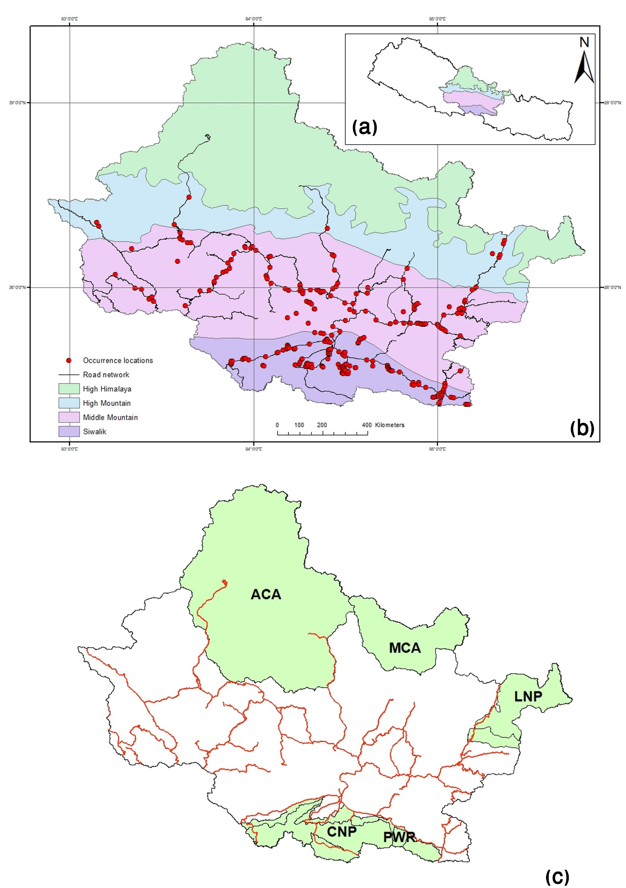

Figure 2: Jackknife test of variable’s contribution in current distribution of P. hysterophorus
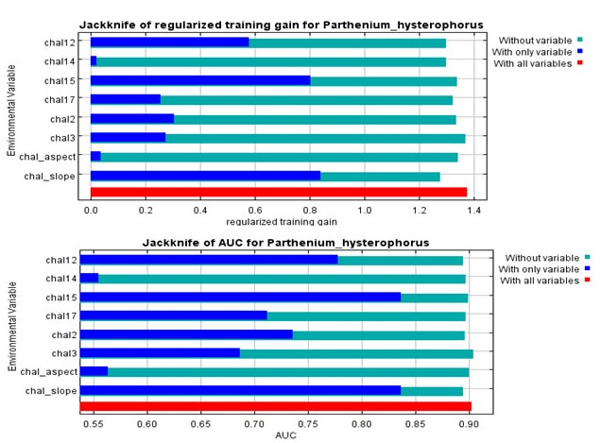
Figure 3: response curve for probability of presence obtained for top three contributing variables (A) slope, (B) Bio12, Annual precipitation and (C) Bio2, Mean Diurnal Range for P. hysterophorus for current condition
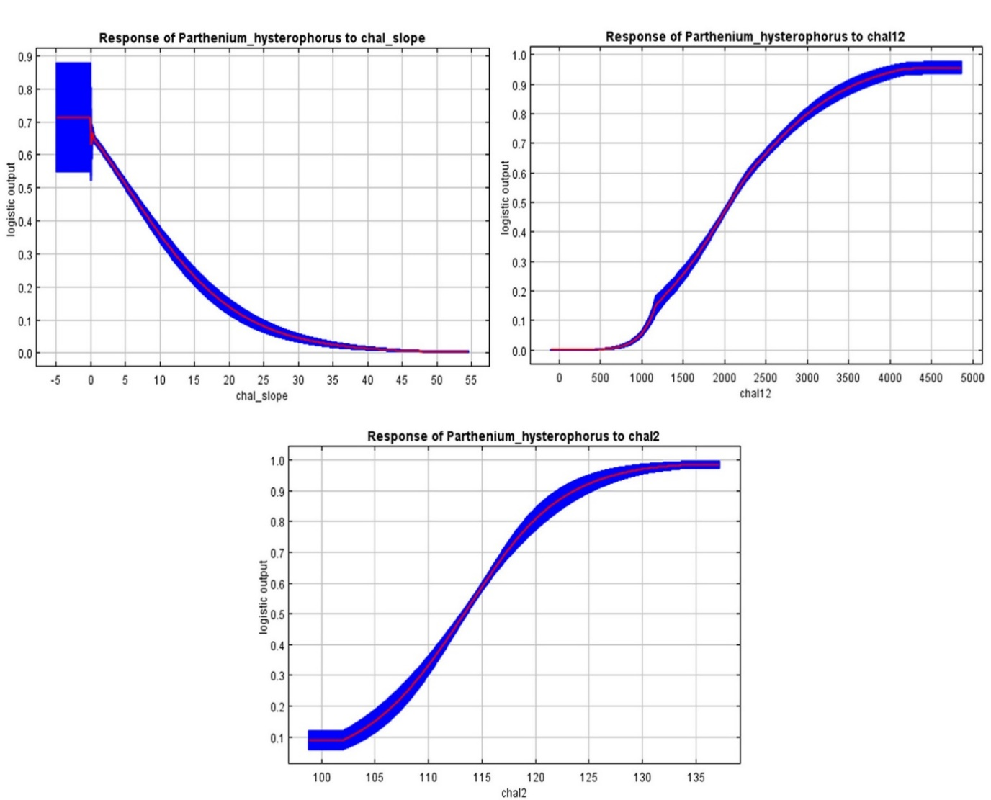
Figure 4: Current predicted distribution of P. hysterophorus in CHAL and their linkage to road network (A), Range shifts for future climate change projected scenarios (map of the range shifts resulted from future projected scenarios – RCP 2.6, 4.5 and 8.5 for 2050 and 2070 (B - F). Area gained by P. hysterophorus is shown in red, stable areas are shown in yellow and area lost are shown in green colour. 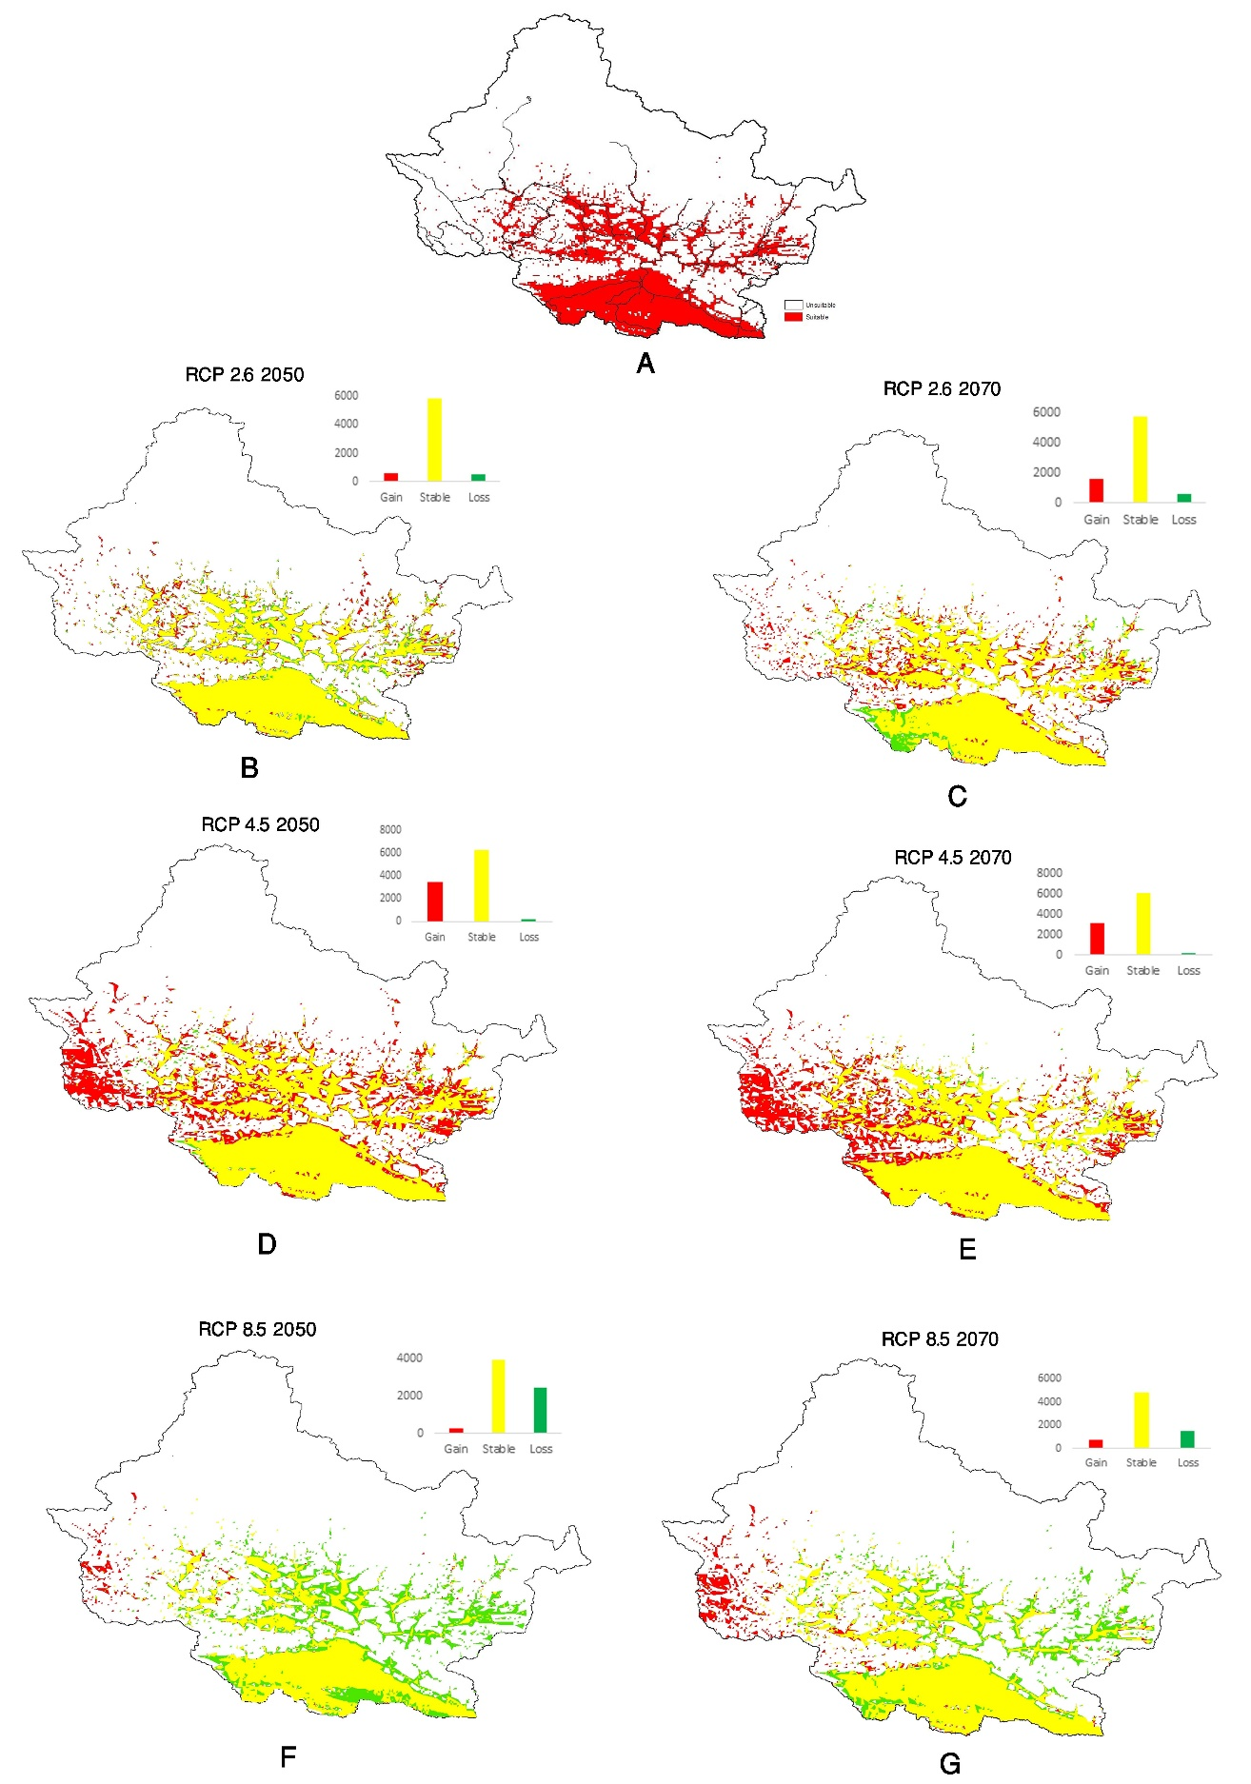
Figure 5: Shifts in uppermost elevation limit of P. hysterophorus with the future changing climate scenario
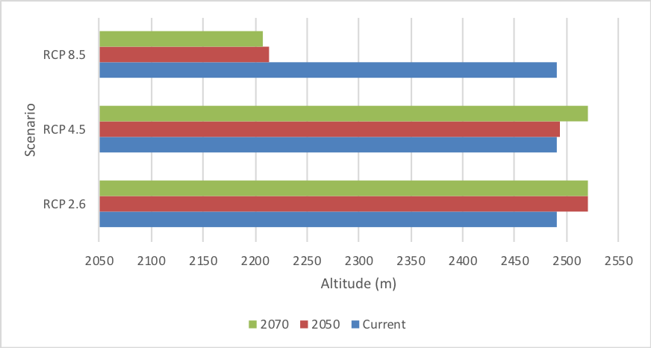

Figure 6: Change in suitable area in different physiographic regions of CHAL with changing climate in different RCP scenarios
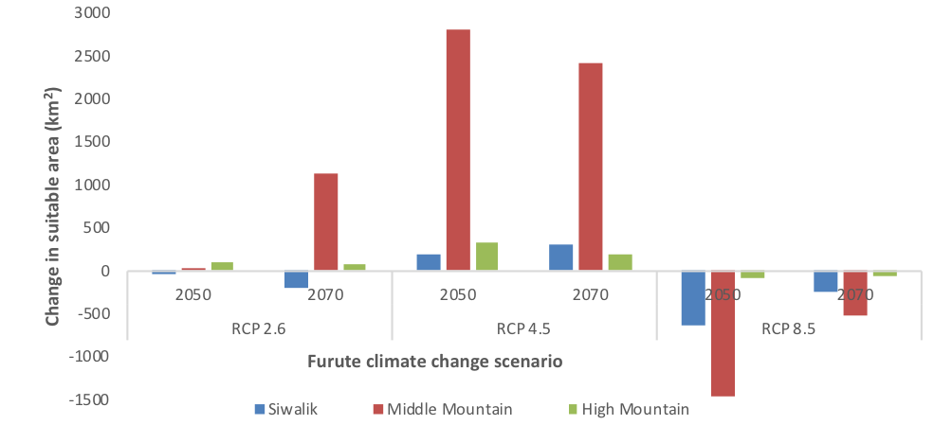

Supplementary information 1
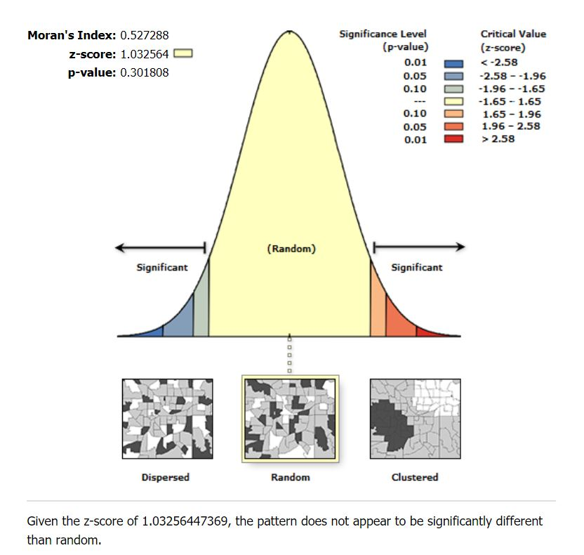

Supplementary information 2
SI Table 1: Bioclimatic variables
Code | Variable name | Unit | Code | Variable name | Unit
BIO1 | Annual Mean Temperature | ºC | BIO12 | Annual Precipitation | mm
BIO2 | Mean Diurnal Range (Mean of monthly (max temp - min temp)) | ºC | BIO13 | Precipitation of Wettest Month | mm
BIO3 | Isothermality (BIO2/BIO7) (* 100) | - | BIO14 | Precipitation of Driest Month | mm
BIO4 | Temperature Seasonality (standard deviation *100) | C of V | BIO15 | Precipitation Seasonality (Coefficient of Variation) | C of V
BIO5 | Max Temperature of Warmest Month | ºC | BIO16 | Precipitation of Wettest Quarter | mm
BIO6 | Min Temperature of Coldest Month | ºC | BIO17 | Precipitation of Driest Quarter | mm
BIO7 | Temperature Annual Range (BIO5-BIO6) | ºC | BIO18 | Precipitation of Warmest Quarter | mm
BIO8 | Mean Temperature of Wettest Quarter | ºC | BIO19 | Precipitation of Coldest Quarter | mm
BIO9 | Mean Temperature of Driest Quarter | ºC | ALT | Altitude | m
BIO10 | Mean Temperature of Warmest Quarter | ºC | slope | Slope | º
BIO11 | Mean Temperature of Coldest Quarter | ºC | aspect | Aspect | º

SI Table 2: Correlation matrix of the 19 bioclimatic and three topographic variables and descriptive statistics of the variables selected for model building
A. The correlation matrix among the 19 bioclimatic variables. Variables showing a Pearson correlation | r | > 0.8, discarded from model building, are highlighted in yellow. B. A table reporting the descriptive statistics (Mean = mean value of the variable; SD = standard deviation; Min. Value = minimum value of the variable; Max. Value = maximum value of the varaiable) for the bioclimatic variables chosen.
A
Variable  Code | Bio1 | Bio2 | Bio3 | Bio4 | Bio5 | Bio6 | Bio7 | Bio8 | Bio9 | Bio10 | Bio11 | Bio12 | Bio13 | Bio14 | Bio15 | Bio16 | Bio17 | Bio18 | Bio19 | ALT | Slope | Aspect
Bio1 | 1.00
Bio2 | -0.47 | 1.00
Bio3 | -0.16 | -0.16 | 1.00
Bio4 | -0.43 | 0.83 | -0.60 | 1.00
Bio5 | 1.00 | -0.42 | -0.21 | -0.37 | 1.00
Bio6 | 1.00 | -0.53 | -0.12 | -0.49 | 0.99 | 1.00
Bio7 | -0.30 | 0.88 | -0.59 | 0.96 | -0.23 | -0.36 | 1.00
Bio8 | 1.00 | -0.45 | -0.17 | -0.41 | 1.00 | 1.00 | -0.28 | 1.00
Bio9 | 1.00 | -0.50 | -0.17 | -0.44 | 0.99 | 1.00 | -0.31 | 1.00 | 1.00
Bio10 | 1.00 | -0.45 | -0.18 | -0.40 | 1.00 | 0.99 | -0.27 | 1.00 | 1.00 | 1.00
Bio11 | 1.00 | -0.49 | -0.13 | -0.46 | 1.00 | 1.00 | -0.32 | 1.00 | 1.00 | 1.00 | 1.00
Bio12 | 0.85 | -0.54 | -0.03 | -0.48 | 0.83 | 0.85 | -0.42 | 0.85 | 0.84 | 0.84 | 0.85 | 1.00
Bio13 | 0.85 | -0.50 | -0.04 | -0.45 | 0.83 | 0.85 | -0.38 | 0.84 | 0.84 | 0.84 | 0.85 | 1.00 | 1.00
Bio14 | 0.37 | -0.49 | -0.21 | -0.29 | 0.37 | 0.39 | -0.30 | 0.37 | 0.38 | 0.37 | 0.38 | 0.34 | 0.29 | 1.00
Bio15 | 0.74 | -0.18 | -0.02 | -0.24 | 0.73 | 0.72 | -0.13 | 0.74 | 0.70 | 0.74 | 0.73 | 0.78 | 0.82 | 0.05 | 1.00
Bio16 | 0.84 | -0.51 | -0.02 | -0.47 | 0.83 | 0.85 | -0.39 | 0.84 | 0.84 | 0.84 | 0.85 | 1.00 | 1.00 | 0.30 | 0.81 | 1.00
Bio17 | -0.11 | -0.30 | -0.45 | 0.09 | -0.10 | -0.09 | -0.03 | -0.11 | -0.08 | -0.11 | -0.11 | -0.07 | -0.12 | 0.62 | -0.46 | -0.12 | 1.00
Bio18 | 0.74 | -0.57 | 0.13 | -0.56 | 0.71 | 0.75 | -0.52 | 0.73 | 0.73 | 0.72 | 0.74 | 0.97 | 0.96 | 0.27 | 0.74 | 0.97 | -0.12 | 1.00
Bio19 | -0.40 | -0.14 | -0.33 | 0.18 | -0.39 | -0.38 | 0.03 | -0.40 | -0.36 | -0.40 | -0.40 | -0.38 | -0.42 | 0.37 | -0.74 | -0.42 | 0.91 | -0.40 | 1.00
Altitude | -1.00 | 0.47 | 0.16 | 0.42 | -1.00 | -1.00 | 0.29 | -1.00 | -1.00 | -1.00 | -1.00 | -0.85 | -0.85 | -0.36 | -0.75 | -0.85 | 0.12 | -0.74 | 0.41 | 1.00
Slope | -0.44 | -0.02 | 0.38 | -0.15 | -0.46 | -0.41 | -0.21 | -0.44 | -0.44 | -0.45 | -0.42 | -0.36 | -0.37 | -0.10 | -0.31 | -0.37 | 0.00 | -0.26 | 0.12 | 0.44 | 1.00
Aspect | 0.00 | 0.01 | 0.05 | -0.03 | 0.00 | 0.00 | -0.02 | 0.00 | 0.00 | 0.00 | 0.00 | -0.02 | -0.02 | 0.00 | 0.01 | -0.02 | -0.06 | -0.01 | -0.05 | 0.00 | 0.00 | 1

B
Variable Code | MIN | MAX | MEAN | STD
Bio2 (°C) | 10.1 | 13.4 | 11.29 | 0.49
Bio3 | 43 | 49 | 45.85 | 1.2438
Bio12 (mm) | 306 | 4446 | 1454.05 | 862.20
Bio14 | 1 | 13 | 5.1018 | 2.79
Bio15 | 57 | 126 | 98.63 | 15.73
Bio17 (mm) | 5 | 75 | 36.85 | 10.04
Slope (°) | 0 | 49.67 | 13.28 | 8.38
Aspect (°) | -1 | 359.98 | 181.36 | 98.19

Supplementary information 3: A. Scatter plot between elevation and mean annual precipitation of the occurrence points used for modelling. B. Frequency of the slope value of occurrence points
A
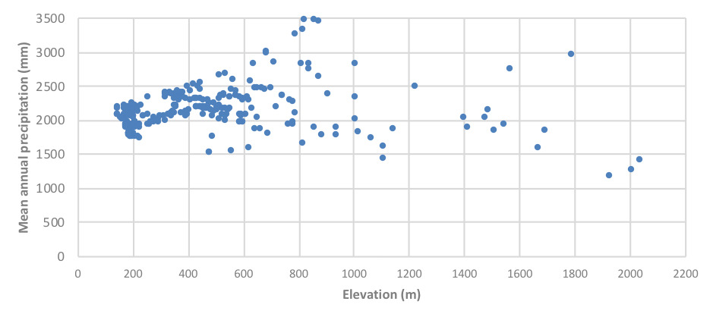
B
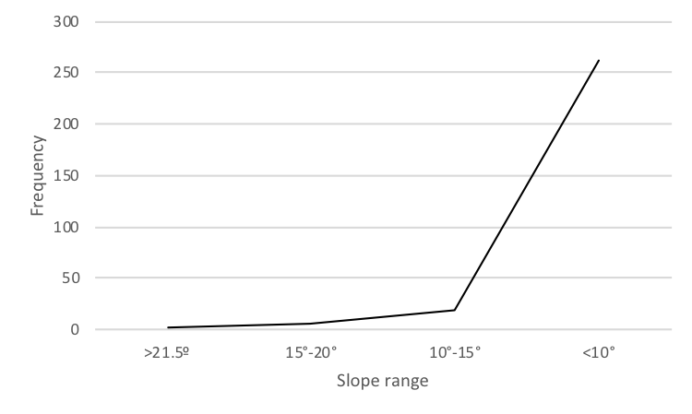

References
Allouche, O., Tsoar, A., Kadmon, R., 2006. Assessing the accuracy of species distribution models: prevalence, kappa and the true skill statistic (TSS). J. Appl. Ecol. 43, 1223–1232. https://doi.org/10.1111/j.1365-2664.2006.01214.x
Bajwa, A.A., Nguyen, T., Navie, S., O’Donnell, C., Adkins, S., 2018. Weed seed spread and its prevention: The role of roadside wash down. J. Environ. Manage. 208, 8–14. https://doi.org/10.1016/j.jenvman.2017.12.010
Bhattarai, K.R., Måren, I.E., Subedi, S.C., 2014. Biodiversity and invasibility: Distribution patterns of invasive plant species in the Himalayas, Nepal. J. Mt. Sci. 11, 688–696. https://doi.org/10.1007/s11629-013-2821-3
Boria, R.A., Olson, L.E., Goodman, S.M., Anderson, R.P., 2014. Spatial filtering to reduce sampling bias can improve the performance of ecological niche models. Ecol. Modell. 275, 73–77. https://doi.org/10.1016/j.ecolmodel.2013.12.012
Bradley, B.A., Wilcove, D.S., Oppenheimer, M., 2010. Climate change increases risk of plant invasion in the Eastern United States. Biol. Invasions 12, 1855–1872. https://doi.org/10.1007/s10530-009-9597-y
Dale, I.J., 1989. Parthenium weed in the Americas: A report on the ecology of Parthenium hysterophorus in South, Central and North America, in: Australian Weeds. pp. 8–14.
DHM, 2017. Observed climate trend analysis in the districts and physiographic zones of Nepal. Department of Hydrology and Meteorology, Government of Nepal, Kathmandu.
Dukes, J.S., Mooney, H.A., 1999. Does global change increase the success of biological invaders ? Tree 14, 135–139.
Elith, J., Kearney, M., Phillips, S., 2010. The art of modelling range-shifting species. Methods Ecol. Evol. 1, 330–342. https://doi.org/10.1111/j.2041-210X.2010.00036.x
Fielding, A.H., Bell, J.F., 1997. A review of methods for the assessment of prediction errors in conservation presence/absence models. Environ. Conserv. 24, 38–49.
Franklin, J., 2009. Mapping species distributions: spatial inference and prediction. Cambridge University Press.
Guisan, A., Thuiller, W., 2005. Predicting species distribution: offering more than simple habitat models. Ecol. Lett. 8, 993–1009. https://doi.org/10.1111/j.1461-0248.2005.00792.x
Haseler, W.H., 1976. Parthenium hysterophorus L. in Australia. PANS 22, 515–517. https://doi.org/10.1080/09670877609414342
Hellmann, J.J., Byers, J.E., Bierwagen, B.G., Dukes, J.S., 2008. Five potential consequences of climate change. Conserv. Biol. 22, 534–543. https://doi.org/10.1111/j.1523-1739.2008.00951.x
Hijmans, R.J., Cameron, S.E., Parra, J.L., Jones, P.G., Jarvis, A., 2005. Very high resolution interpolated climate surfaces for global land areas. Int. J. Climatol. 25, 1965–1978. https://doi.org/10.1002/joc.1276
IPCC, 2014. Climate Change 2014: Synthesis Report. Contribution of Working Groups I, II and III to the Fifth Assessment Report of the Intergovernmental Panel on Climate Change. IPCC, Geneva, Switzerland.
Jimenez-Valverde, A., Peterson, A.T., Soberon, J., Overton, J.. M., Aragon, P., Sobero, J., Lobo, J.M., 2011. Use of niche models in invasive species risk assessments. Biol. Invasions 13, 2785–2797. https://doi.org/10.1007/s10530-011-9963-4
Lamsal, P., Kumar, L., Aryal, A., Atreya, K., 2018. Invasive alien plant species dynamics in the Himalayan region under climate change. Ambio 47, 697–710. https://doi.org/10.1007/s13280-018-1017-z
Liu, C., Berry, P.M., Dawson, T.P., Pearson, R.G., 2005. Selecting thresholds of occurrence in the prediction of species distributions. Ecography (Cop.). 28, 385–393.
Lutz, A.F., ter Maat, H.W., Biemans, H., Shrestha, A.B., Wester, P., Immerzeel, W.W., 2016. Selecting representative climate models for climate change impact studies: an advanced envelope-based selection approach. Int. J. Climatol. 36, 3988–4005. https://doi.org/10.1002/joc.4608
Mackey, B.G., Lindenmayer, D.B., 2001. Towards a hierarchical framework for modelling the spatial distribution of animals. J. Biogeogr. 28, 1147–1166. https://doi.org/10.1046/j.1365-2699.2001.00626.x
Mainali, K.P., Warren, D.L., Dhileepan, K., Mcconnachie, A., Strathie, L., Hassan, G., Karki, D., Shrestha, B.B., Parmesan, C., 2015. Projecting future expansion of invasive species: Comparing and improving methodologies for species distribution modeling. Glob. Chang. Biol. 21, 4464–4480. https://doi.org/10.1111/gcb.13038
McConnachie, A.J., Strathie, L.W., Mersie, W., Gebrehiwot, L., Zewdie, K., Abdurehim, A., Abrha, B., Araya, T., Asaregew, F., Assefa, F., Gebre-Tsadik, R., Nigatu, L., Tadesse, B., Tana, T., 2011. Current and potential geographical distribution of the invasive plant Parthenium hysterophorus (Asteraceae) in eastern and southern Africa. Weed Res. 51, 71–84. https://doi.org/10.1111/j.1365-3180.2010.00820.x
Merow, C., Smith, M.J., Silander, J.A., 2013. A practical guide to MaxEnt for modeling species’ distributions: What it does, and why inputs and settings matter. Ecography (Cop.). 36, 1058–1069. https://doi.org/10.1111/j.1600-0587.2013.07872.x
NCVST, 2009. Vulnerability through the eyes of the vulberables: Climate change induced uncertainties and Nepal’s development predicaments. Institute for Social and Environmental Transition-Nepal (ISET-N), Nepal Climate Vulnerability Study Team (NCVST) Kathmandu National Disaster Report. UNDP-Nepal.
OECD, 2003. Development and climate change in Nepal: Focus on water resources and hydropower. Organization for Economic Cooperation and Development.
Paini, D.R., Sheppard, A.W., Cook, D.C., De Barro, P.J., Worner, S.P., Thomas, M.B., 2016. Global threat to agriculture from invasive species. PNAS 113, 7575–7579. https://doi.org/10.1073/pnas.1602205113
Pandey, D.K., Palni, L.M.S., Joshi, S.C., 2003. Growth, reproduction, and photosynthesis of ragweed parthenium (Parthenium hysterophorus). Weed Sci. 52, 191–201.
Pearson, R.G., Raxworthy, C.J., Nakamura, M., Peterson, A.T., 2007. Predicting species distributions from small numbers of occurrence records: a test case using cryptic geckos in Madagascar. J. Biogeogr. 34, 102–117. https://doi.org/10.1111/j.1365-2699.2006.01594.x
Pejchar, L., Mooney, H.A., 2009. Invasive species, ecosystem services and human well-being. Trends Ecol. Evol. 24, 497–504.
Peterson, A.T., Vieglais, D.A., 2001. Predicting species invasions using ecological niche modeling: New approaches from bioinformatics attack a pressing problem. Bioscience 51, 363–371.
Phillips, S.J., Anderson, R.P., Schapire, R.E., 2006. Maximum entropy modeling of species geographic distributions. Ecol. Modell. 190, 231–259. https://doi.org/10.1016/j.ecolmodel.2005.03.026
Phillips, S.J., Dudik, M., 2008. Modeling of species distributions with Maxent: New extensions and a comprehensive evaluation. Ecography (Cop.). 31, 161–175. https://doi.org/10.1111/j.2007.0906-7590.05203.x
Qin, Z., Ditommaso, A., Wu, R.S., Huang, H.Y., 2014. Potential distribution of two Ambrosia species in China under projected climate change. Weed Res. 54, 520–531. https://doi.org/10.1111/wre.12100
Ricciardi, A., Neves, R.J., Rasmussen, J.B., 1998. Impending extinctions of North American freshwater mussels (Unionoida) following the zebra mussel (Dreissena polymorpha) invasion. J. Anim. Ecol. 67, 613–619. https://doi.org/10.1046/j.1365-2656.1998.00220.x
Sanford, T., Frumhoff, P.C., Luers, A., Gulledge, J., 2014. The climate policy narrative for a dangerously warming world. Nat. Clim. Chang. 4, 164–166. https://doi.org/10.1038/nclimate2148
Shabbir, A., Dhileepan, K., Khan, N., Adkins, S.W., 2014. Weed-pathogen interactions and elevated CO₂: Growth changes in favour of the biological control agent. Weed Res. 54, 217–222. https://doi.org/10.1111/wre.12078
Shabbir, A., Mcconnachie, A., Adkins, S.W., 2019. Spread, in: Adkins, S., Shabbir, A., Dhileepan, K. (Eds.), Parthenium Weed: Biology, Ecology and Management. CAB International, pp. 40–56.
Shrestha, B., Shrestha, U., Sharma, K., Thapa-parajuli, R., Devkota, A., Siwakoti, M., 2019. Community perception and prioritization of invasive alien plants in Chitwan Annapurna Landscape, Nepal. J. Environ. Manage. 229, 38–47. https://doi.org/10.1016/j.jenvman.2018.06.034
Shrestha, B.B., 2016. Invasive Alien Plant Species in Nepal. Front. Bot. 269–284.
Shrestha, B.B., 2014. Distribution of alien invasive weed Parthenium hysterophorus and its biological control agent in Nepal. A research report submitted to International Foundation for Science, Sweden, Unpublished.
Shrestha, B.B., 2012. Parthenium weed in Chitwan National Park, Nepal. Int. Parthenium News 5, 6–7.
Shrestha, B.B., Kokh, M., Karki, J.B., 2016. Mapping of invasive alien plant species in Tarai Arc Landscape (TAL) and Chitwan - Annapurna Landscape (CHAL), Nepal. A report submitted to National Trust for Nature Conservation (NTNC), Kathmandu, Nepal (Unpublished).
Shrestha, B.B., Shabbir, A., Adkins, S.W., 2015. Parthenium hysterophorus in Nepal: A review of its weed status and possibilities for management. Weed Res. 55, 132–144. https://doi.org/10.1111/wre.12133
Shrestha, U.B., Sharma, K.P., Devkota, A., Siwakoti, M., Shrestha, B.B., 2018. Potential impact of climate change on the distribution of six invasive alien plants in Nepal. Ecol. Indic. 95, 99–107. https://doi.org/10.1016/j.ecolind.2018.07.009
Simberloff, D., 2000. Global climate change and introduced species in United States. Sci. Total Environ. 262, 253–261.
Siwakoti, M., Shrestha, B.B., Devkota, A., Shrestha, U.B., Thapaparajuli, R.B., Sharma, K.P., 2016. Assessment of the effects of climate change on the distribution of invasive alien plant species in Nepal. A Report submitted to Nepal Academy of Science and Technology, Kathmandu (Unpublished).
Sutherst, R.W., Maywald, G.F., Russell, B.L., 2000. Estimating vulnerability under global change: modular modelling of pests. Agric. Ecosyst. Environ. 82, 303–319.
Swets, J.A., 1988. Measuring the accuracy of diagnostic systems. Science (80-. ). 240, 1285–1293. https://doi.org/10.1126/science.3287615
Thapa, S., Chitale, V., Rijal, S.J., Bisht, N., Shrestha, B.B., 2018. Understanding the dynamics in distribution of invasive alien plant species under predicted climate change in Western Himalaya. PLoS One e0195752. https://doi.org/10.1371/journal.pone.0195752
Thomas, C.D., Cameron, A., Green, R.E., Bakkenes, M., Beaumont, L.J., Collingham, Y.C., Erasmus, B.F.N., 2004. Extinction risk from climate change. Nature 427, 145–148.
Thuiller, W., RIchardson, D.M., Midgley, G.F., 2007. Will climate change promote alien plant invasions?, in: Nentwing, W. (Ed.), Biological Invasions. pp. 197–211. https://doi.org/10.1007/978-3-540-36920-2
Vitousek, P.M., D’Antonio, C.M., Loope, L.L., Rejmanek, M., Westbrooks, R., 1997. Introduced species: a significant component of human-caused global change. N. Z. J. Ecol. 21, 1–16.
WWF, 2013. Chitwan-Annapurna Landscape biodiversity important areas and linkages. WWF Nepal, Hariyo Ban Program.

