**Application of satellite Imageries for the IAS in the Central Nepal**

**Field Visit report (March,21-23,2019)**

**Faculties: P K Jha, K P Paudel,**

**PhD Scholars: Seerjana Maharjan and Dol Raj Luintel**

**Background:**

Field visit from 21 to 23 March 2019 has been conducted in Tanahun, Kaski, Parbat, Baglung and Myagdi Districts located at the Central and Western part of Chitwan Annapunra Linkages (CHAL) in Central Nepal for the purpose of field identification, observation and verification of Invasive Alien Plant Species (IAPS) distribution, figure millet and buckwheat plantation in the field through the satellite imageries and GPS. Numbers of different sites were observed and recorded the existence of IAPS.

**Method and procedures:**

Handheld GPS sets, laptop computer with GIS and Image interpretation software were taken. The field visit sites had been selected to cover the remote areas of Central and Western part of CHAL. Therefore, in a single day travelled over 300 kilometers partially rough road, GPS location recorded and identified the species through observation.

**Field survey route and identified IAPS**

Figure 1: Field survey location and the IAPS distribution

(Table 1,Figs. 1).

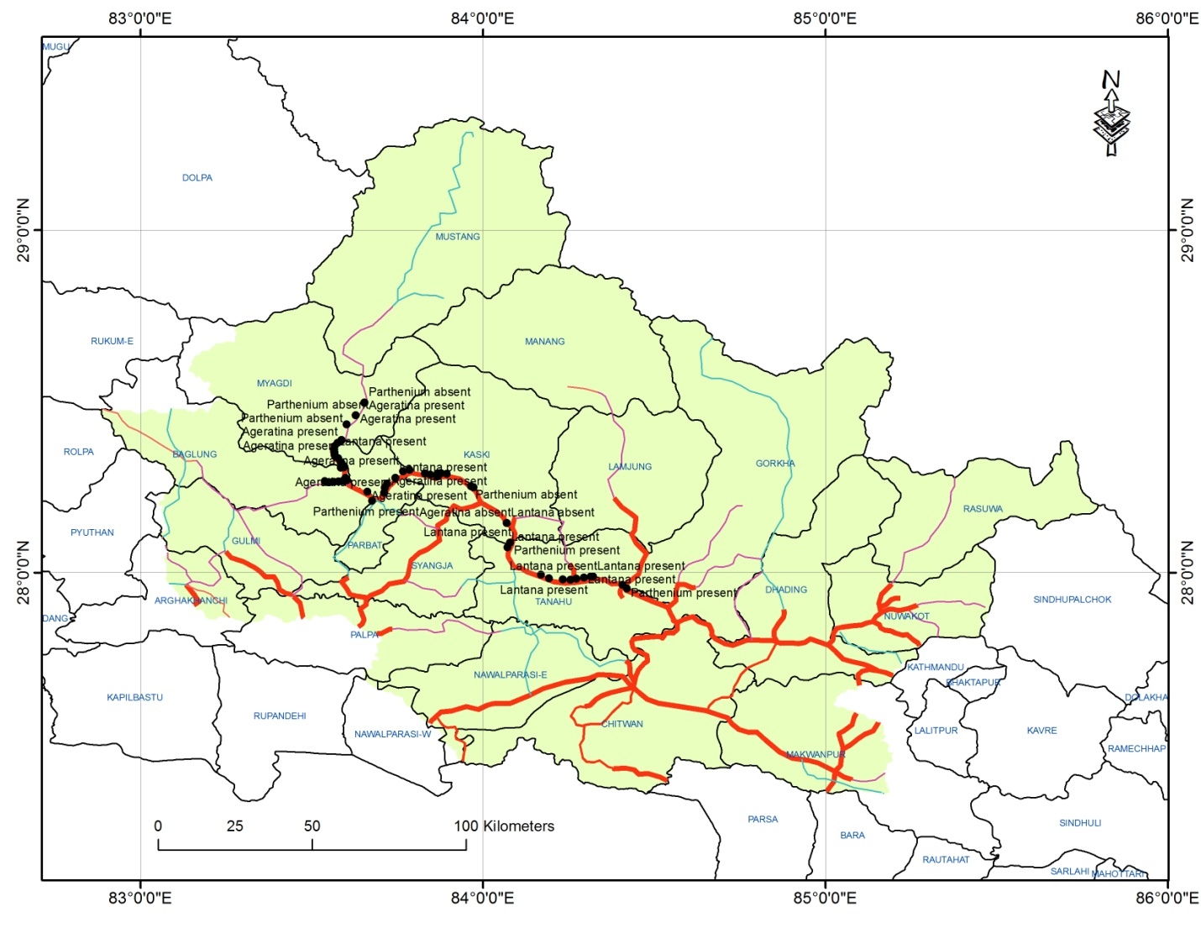

Table 1: Field survey location

|  |  |  |  |  |  |
| --- | --- | --- | --- | --- | --- |
| ID | Species | X_Coordi | Y_Coordi | Altitude | Remarks |
| 21 | Parthenium absent | 83.97384 | 28.24887598 | 930.9113 | As the survey was done during off season it is not 100% sure that the species is absent there |
| 22 | Ageratina present | 83.96619 | 28.25264901 | 937.2235 |  |
| 23 | Ageratina present | 83.89501 | 28.288701 | 1103.446 |  |
| 24 | Ageratina present | 83.8779 | 28.29040596 | 1130.755 |  |
| 25 | Ageratina present | 83.86805 | 28.28918296 | 1161.981 |  |
| 26 | Ageratina present | 83.86819 | 28.28607101 | 1254.237 |  |
| 22 | Parthenium absent | 83.96619 | 28.25264901 | 937.2235 | As the survey was done during off season it is not 100% sure that the species is absent there |
| 23 | Parthenium absent | 83.89501 | 28.288701 | 1103.446 | As the survey was done during off season it is not 100% sure that the species is absent there |
| 24 | Parthenium absent | 83.8779 | 28.29040596 | 1130.755 | As the survey was done during off season it is not 100% sure that the species is absent there |
| 25 | Parthenium absent | 83.86805 | 28.28918296 | 1161.981 | As the survey was done during off season it is not 100% sure that the species is absent there |
| 26 | Parthenium absent | 83.86819 | 28.28607101 | 1254.237 |  |
| 27 | Ageratina present | 83.8704 | 28.28337204 | 1408.286 |  |
| 28 | Ageratina present | 83.86715 | 28.281611 | 1425.922 |  |
| 29 | Ageratina present | 83.84695 | 28.28622599 | 1515.958 |  |
| 30 | Ageratina present | 83.83096 | 28.29009399 | 1687.333 |  |
| 31 | Ageratina present | 83.78642 | 28.30063004 | 1352.66 |  |
| 32 | Ageratina present | 83.66293 | 28.23620698 | 872.9537 |  |
| 33 | Ageratina present | 83.57804 | 28.33381701 | 820.3947 |  |
| 34 | Parthenium present | 83.56745 | 28.34367899 | 887.9343 |  |
| 35 | Parthenium present | 83.56743 | 28.34367799 | 887.2506 |  |
| 36 | Parthenium present | 83.56698 | 28.35093797 | 875.5178 |  |
| 37 | Parthenium present | 83.56662 | 28.35185101 | 875.6336 |  |
| 37 | Lantana present | 83.56662 | 28.35185101 | 875.6336 |  |
| 38 | Ageratina present | 83.56652 | 28.35193399 | 876.1617 |  |
| 39 | Ageratina present | 83.56542 | 28.35984902 | 879.2261 |  |
| 40 | Parthenium present | 83.56757 | 28.36969399 | 908.6736 |  |
| 41 | Parthenium absent | 83.57628 | 28.37843698 | 883.3886 | As the survey was done during off season it is not 100% sure that the species is absent there |
| 42 | Chromolaena present | 83.58775 | 28.38644899 | 912.4244 |  |
| 43 | Ageratina present | 83.58795 | 28.38701402 | 914.2874 |  |
| 44 | Ageratina present | 83.58807 | 28.38716498 | 912.8817 |  |
| 45 | Ageratina present | 83.60231 | 28.43315799 | 1028.178 |  |
| 45 | Parthenium absent | 83.60231 | 28.43315799 | 1028.178 |  |
| 46 | Ageratina present | 83.62911 | 28.46020999 | 1115.089 |  |
| 47 | Ageratina present | 83.65449 | 28.49734702 | 1239.801 |  |
| 46 | Parthenium absent | 83.62911 | 28.46020999 | 1115.089 |  |
| 47 | Parthenium absent | 83.65449 | 28.49734702 | 1239.801 |  |
| 48 | Parthenium present??? | 83.65442 | 28.49630297 | 1235.702 | Brought herbarium for confirmation |
| 49 | Ageratina present | 83.56917 | 28.33940104 | 851.0108 |  |
| 50 | Ageratina present | 83.58723 | 28.32030203 | 894.6181 |  |
| 51 | Ageratina present | 83.59289 | 28.31254902 | 948.718 |  |
| 52 | Ageratina present | 83.59426 | 28.30819697 | 1009.494 |  |
| 53 | Ageratina present | 83.58584 | 28.30626301 | 1049.789 |  |
| 54 | Parthenium present | 83.59878 | 28.27646099 | 983.496 |  |
| 56 | Parthenium present | 83.60247 | 28.268927 | 934.3969 |  |
| 59 | Chromolaena present | 83.59188 | 28.26824999 | 1028.519 |  |
| 60 | Chromolaena present | 83.57912 | 28.26616902 | 1061.367 |  |
| 61 | Chromolaena present | 83.57823 | 28.26623004 | 1053.743 |  |
| 62 | Buckwheat present | 83.56487 | 28.26472398 | 1027.547 |  |
| 63 | Chromolaena present | 83.54958 | 28.26385997 | 1055.748 |  |
| 64 | Ageratina present | 83.53854 | 28.26754399 | 1076.342 |  |
| 65 | Buckwheat present | 83.56217 | 28.26474401 | 1006.676 |  |
| 66 | Parthenium present | 83.67685 | 28.21007104 | 841.7465 | not observed in the field but according to the locals it is seen during rainy season, Football ground (Kusma, Parbat) |
| 66 | Ageratina present | 83.71162 | 28.233089 | 790.1707 |  |
| 67 | Chromolaena present | 83.71373 | 28.24803997 | 799.1519 |  |
| 68 | Chromolaena present | 83.71374 | 28.24806402 | 798.5732 |  |
| 69 | Ageratina present | 83.72055 | 28.25989299 | 821.2441 |  |
| 70 | Lantana present | 83.74452 | 28.27649896 | 884.6959 |  |
| 70 | Chromolaena present | 83.74452 | 28.27649896 | 884.6959 |  |
| 71 | Ageratina present | 83.76749 | 28.29594799 | 1017.841 |  |
| 72 | Lantana absent | 84.07001 | 28.14496603 | 659.5998 |  |
| 72 | Ageratina absent | 84.07001 | 28.14496603 | 659.5998 |  |
| 72 | Parthenium present | 84.07001 | 28.14496603 | 659.5998 |  |
| 73 | Lantana present | 84.07961 | 28.08727599 | 504.6875 |  |
| 73 | Parthenium present | 84.07961 | 28.08727599 | 504.6875 |  |
| 74 | Lantana present | 84.07198 | 28.07418102 | 492.5179 |  |
| 75 | Parthenium present | 84.16953 | 27.99459804 | 500.4727 |  |
| 76 | Ageratina present | 84.19392 | 27.98395202 | 527.7747 |  |
| 77 | Parthenium present | 84.23407 | 27.98005904 | 448.993 |  |
| 77 | Ageratina present | 84.23407 | 27.98005904 | 448.993 |  |
| 79 | Parthenium present | 84.2566 | 27.97972402 | 339.2655 |  |
| 80 | Parthenium present | 84.27269 | 27.98205896 | 327.8118 |  |
| 80 | Lantana present | 84.27269 | 27.98205896 | 327.8118 |  |
| 81 | Lantana present | 84.2951 | 27.98597499 | 352.9273 |  |
| 82 | Lantana present | 84.31603 | 27.98914301 | 440.8907 |  |
| 83 | Lantana present | 84.32208 | 27.98903799 | 467.56 |  |
| 83 | Parthenium present | 84.32208 | 27.98903799 | 467.56 |  |
| 83 | Ageratina present | 84.32208 | 27.98903799 | 467.56 |  |
| 84 | Parthenium present | 84.40813 | 27.96491504 | 404.3317 |  |
| 85 | Parthenium present | 84.4204 | 27.95347902 | 377.4048 |  |

**Output of the exercise completed at the field**

**Within a very short time duration covered a large section of the study area which has been approximately extended from 600 meters to 1200 meters. The IAPS i.e. Chromolena, Partheneam, Lantana, were observed in various location. Similarly, millet and buckwheat farming were also noticed an observed. The distributions of those species have been presented in the table along with the geographical coordinates and species types in the Table 1.**

**Few photographs of the field work**

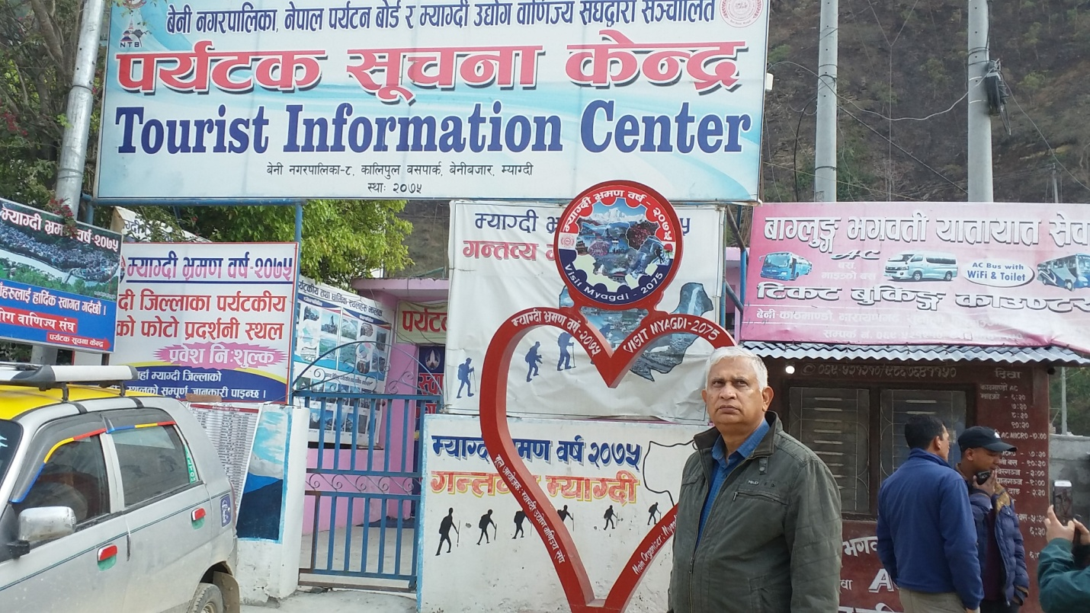

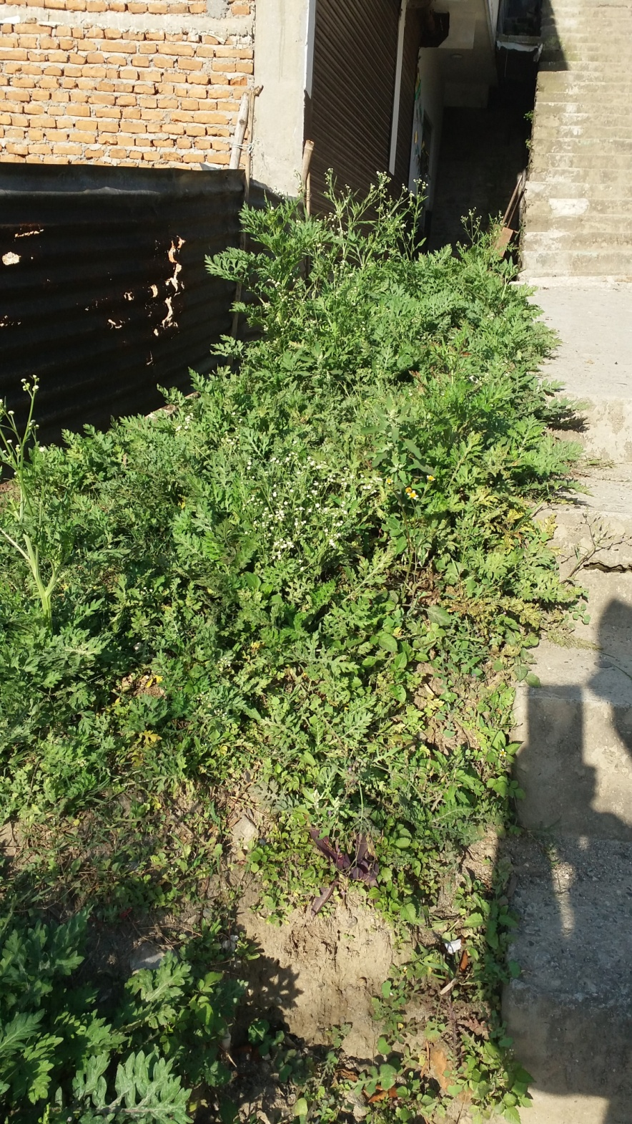

**Partheniam in Beni Bazar of Mygdi district near the Kali Gandaki bank.**

**Taking GPS Coordinate at the field**

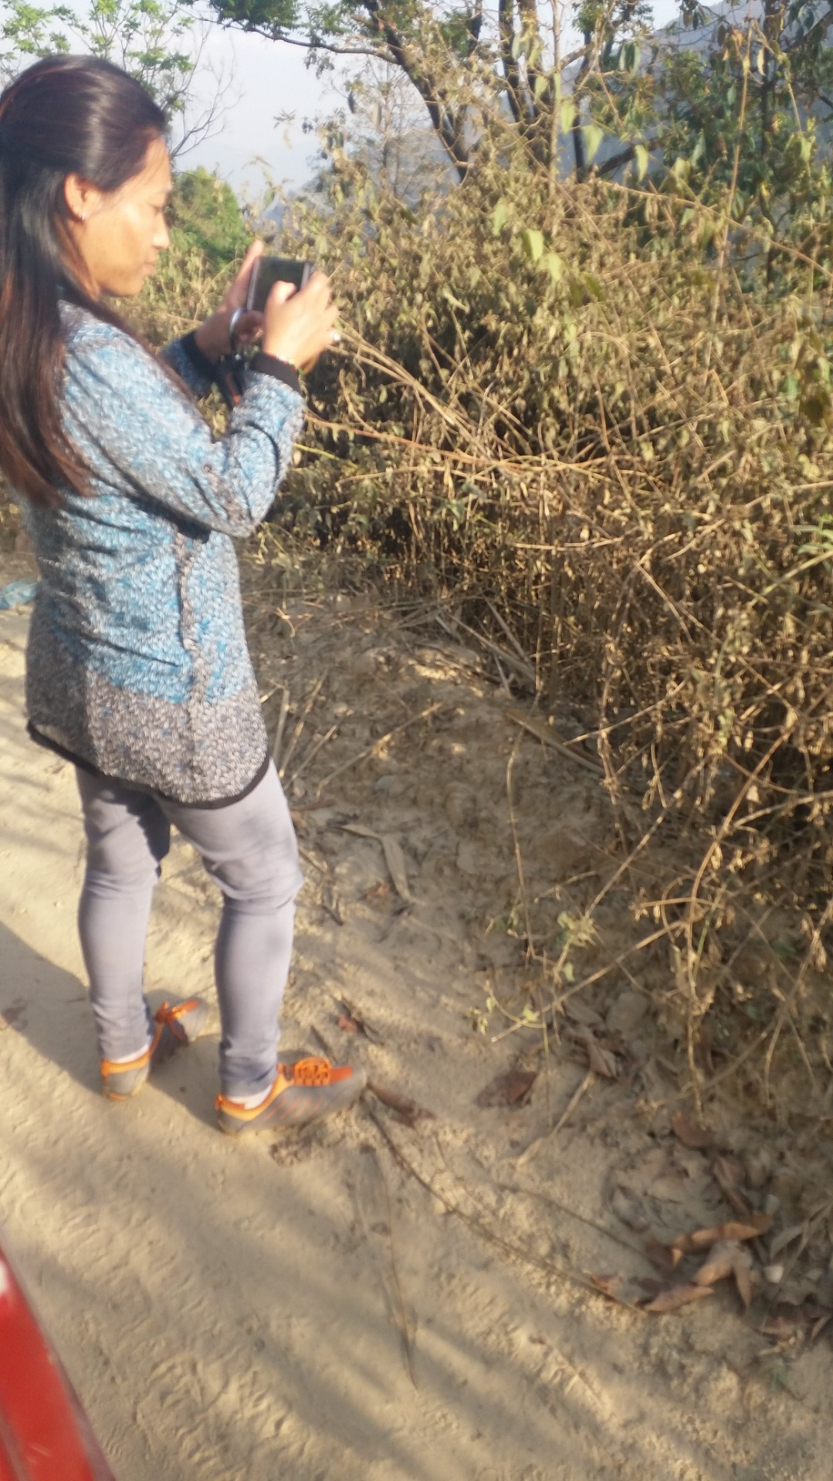

**Cromolena at the field in Baglung at an elevation of 1000m**

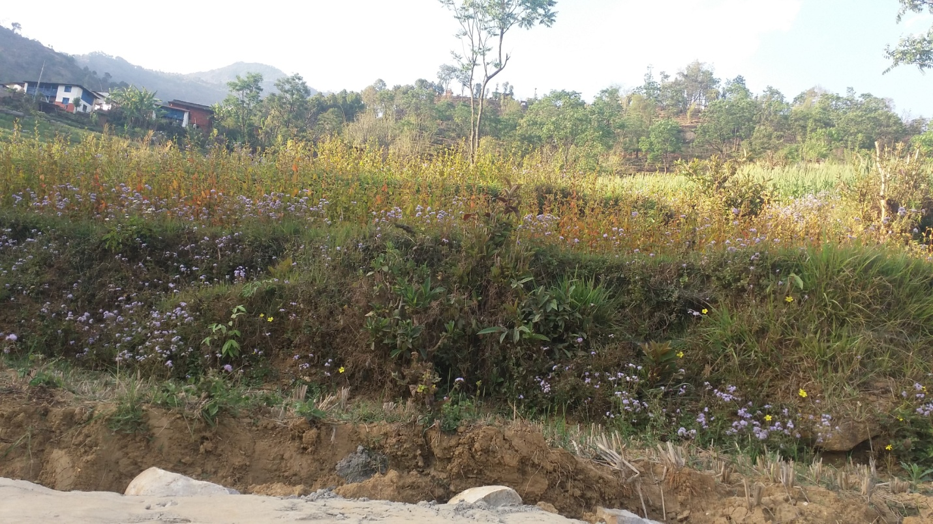

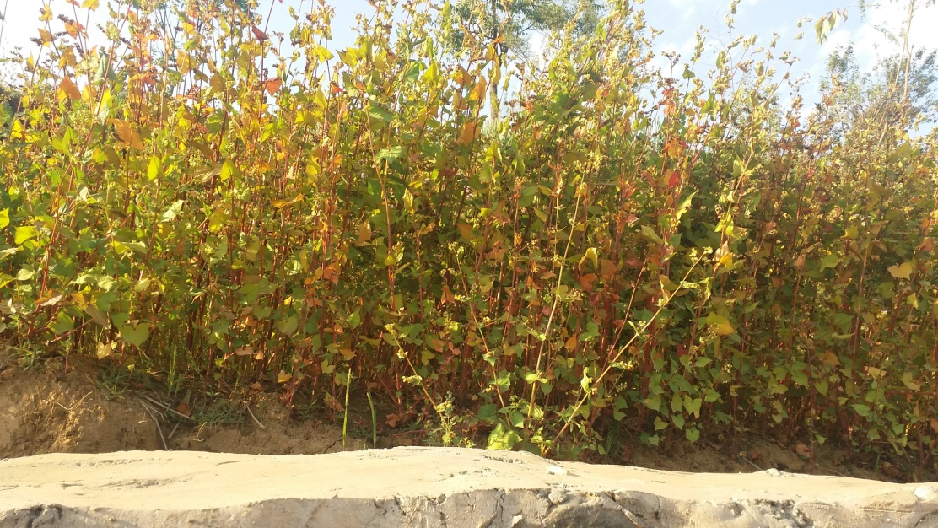

**Buckwheat farming in Khahare village, Baglung,**