# Instructions to download the code and run the tool for calculating a household’s current probability of adoption of rooftop solar panels

This tool calculates a household’s probability of adoption of solar panels, and the predicted label i.e. adopter or non-adopter. In order to use this R code-based tool, the user needs to have R on their computer and an input file in the format described below. The statistical software package R can be downloaded freely from <https://www.r-project.org/>.

## How to prepare the input.csv file

One can either manually fill in the “input-v1.csv” file or create his own file in the same format as input.csv file. A sample input file (sampe_input-v1.csv) is provided, which is shown in the below. Each row in the input file is a set of features for one household.

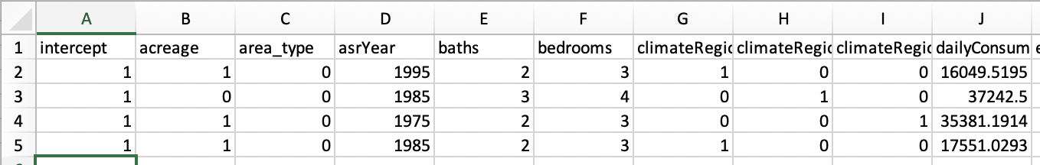

The explanations of columns are given below.

|  |  |
| --- | --- |
| **Variable** | **Description and Explanation** |
| intercept | Enter 1 for all households. |
| acreage | Acreage of the house (e.g. 0.5 if the house is built on half an acre plot). |
| Area_type | If the area type is **rural**, enter **0**, if the area type is **urban**, enter **1**. |
| asrYear | Enter the year when the house was built (e.g. 1940). |
| baths | Enter the number of bathrooms (Integer). |
| bedrooms | Enter the number of bedrooms (Integer). |
| climateRegionPub | There are three levels: Cold/Very Cold, Hot-Humid, and Mixed-Humid.  If the house is in **Cold/Very Cold region**, enter **1** for climateRegionPubCold/Very Cold, and 0 for other regions.  If the house is in **Hot/Humid region**, enter 1 for climateRegionPubhot/humid and 0 for other regions.  If the house is in **Mixed-Humid region**, enter **1** for climateRegionPubMixed-Humid, and 0 for other regions. |
| dailyConsumption | Amount of electricity consumed daily on average by the household in WattHours (e.g. 16234.56). |
| education | There are 5 levels of education.  education1: Less than high school diploma or GED (General Education Diploma)  education2: High school diploma or GED  education3: Some college or Associate’s degree  education4: Bachelor’s degree (for example: BA, BS)  education5: Masters, Professional, or Doctorate degree (for example: MA, MS, MBA, MD, JD, PhD)  E.g. if the responder education level is 1, enter 1 for education1 and 0 for other levels. If the responder education level is 2, enter 1 for education 2 and 0 for others, and so on. In other words, enter (1,0,0,0,0) for five columns respectively, if the level is education1. Enter (0,0,1,0,0) if the level is education3 and so on.) |
| fuelheat | There are 5 levels of fuelheat.    fuelheat1: Natural gas from underground pipes  fuelheat2: Propane (bottled gas)  fuelheat3: Fuel oil/kerosene  fuelheat5: Electricity  fuelheat7: Wood  If the house uses natural gas as the fuel type, enter 1 for fuelheat1 and 0 for the other levels. If it uses propane, then enter 1 for fuelheat2 and 0 for others. Similarly for other fuelheat types. |
| income | Enter the yearly income (in dollars) for the household (e.g. 35,000) |
| numCarStorage | Enter the number of car storages in the house. (e.g. 2) |
| sqFootage | Enter square footage of the house. (e.g. 1455) |
| swimpool | Enter 1 if the house has a swimming pool and 0 if it does not. |
| totalVal | Enter the total estimated value (in dollars) of the house. (e.g. 350,000) |
| typehuq | Type of housing unit. There are 3 levels of typehuq.  typehuq1: Mobile home  typehuq2: Single-family detached house  typehuq3: Single-family attached house  If the house type is mobile home, enter 1 for typehuq1 and 0 for others. Similarly for typehuq2 and typehuq3. |
| householdSize | Enter the family size. (e.g. 3) |
| X1Mile | Enter the number of solar adopters within 1 mile of the household. |
| X2Mile | Enter the number of solar adopters within 2 mile of the household. |
| X3Mile | Enter the number of solar adopters within 3 mile of the household. |
| X4Mile | Enter the number of solar adopters within 4 mile of the household. |

## Description of beta_coef-v1.csv

The “beta_coef-v1.csv” saves the coefficients for the logistic regression model. There are two columns, the first column provides the names of variables, and the second column provides the coefficient values of the variables. The “beta_coef-v1.csv” is already provided to the user

## Run of the R code: tool static-probability-v1.R

1. Choose a desired directory where the user would like to download the code.
2. Store the beta_coef-v1.csv, input-v1.csv, and “static-probablity-v1.R” in the desired directory, created in step 1. Make sure the names of files stay the same after copying.
3. Open “static-probablity-v1.R” in R or Rstudio. Before running the code, the user should specify the directory that stores beta_coef-v1.csv, input-v1.csv, and “static-probablity-v1.R”. Make sure the names of files read in the R file are the same as the names of files in the directory.



1. A sample input file, sample_input-v1.csv is provided for test. The user should change the file name to his own input file (e.g. input-v1.csv).



1. To run the code, select all lines first, the selected lines will become blue, which are shown in the below. Then click the “Run” in the user’s interface, or press command+enter (for Mac), control+enter (for Windows).

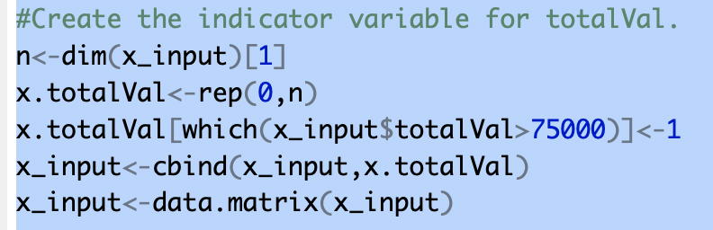

If the user presses command+enter without selecting all lines, then only the line at where the cursor blink will be run. The user also can run the code line by line from the beginning of the code.

After running this tool “static-probability-v1.R”, two csv files will be generated in the directory. One is called “static-probability-of-adoption-v1.csv”, which contains the probability that a household will adopt solar panels and the other is called “predicted-label-v1.csv”, which contains the predicted labels for the households i.e whether a household is predicted to be an adopter (the value is 1) or not (the value is 0). Notice that, the label is obtained by comparing the probability with a tuned threshold value (0.0022) instead of 0.5.