Why does SegResNet outperform U-Net for thoracic organ-at-risk segmentation on MRI? A capacity-matched comparison, component ablation and extension to six organs
Draft v1 — 06/11/2026. Generated by `paper/build_article_ablation.py`: every table is read from the verified result files (phase 2 re-evaluation, phase 3 ablation, phase 4). Hand-written numbers in the text are taken from the same files and from `results/analyse_complete/RAPPORT_ANALYSE_COMPLETE.md`, `phase3_ablation/RAPPORT_ABLATION_18M.md` and `phase4_6oar/RAPPORT_PHASE4_6OAR.md`. References marked [to verify] were not re-read for this draft.

Abstract
Purpose. Convolutional networks for organ-at-risk (OAR) segmentation are often compared at unequal capacity, and the architectural reason for a performance gap is rarely isolated. We compared 3D U-Net and SegResNet at matched capacity for thoracic OAR segmentation on MRI, identified which components explain the gap, and tested whether the result extends to the spinal cord and aorta.
Methods. We used 187 diagnostic MRI examinations from TotalSegmentator MRI v2.0 with complete annotations of the left and right lungs, heart and oesophagus. All models were trained and evaluated with the same 5-fold patient-level cross-validation, identical preprocessing, augmentation, loss and schedule. We compared a 7.9 M-parameter U-Net (E1), a U-Net widened to 18.8 M parameters (E3) and SegResNet (E2, 18.8 M). Robustness to the training seed was assessed by retraining E2 and E3 with a second seed. Three capacity-matched variants isolated single components: a U-Net with residual units (A1), a U-Net with GroupNorm (A2) and a SegResNet with InstanceNorm (A3). A six-OAR model (adding spinal cord and aorta) was trained on the 115 patients whose two additional structures were completely annotated. Evaluation used the native label grid (DSC, HD95, HDmax, surface DSC at 2 mm), paired Wilcoxon tests with Holm correction and bootstrap confidence intervals.
Results. At matched capacity, SegResNet outperformed U-Net for all four OAR (median paired DSC difference +0.025 to +0.152, largest for the oesophagus; p_Holm < 0.001). The gap was reproduced with a second training seed, and the seed effect itself stayed below 0.01 DSC. Residual units closed about half of the DSC gap (50–62 %), reduced the median number of lung components from 9 to 2 and the number of patients with left/right lung confusion from 22 to 4. GroupNorm degraded the U-Net, whereas SegResNet with InstanceNorm matched or slightly exceeded the original SegResNet. With six OAR, SegResNet remained superior for every organ (spinal cord DSC 0.881, HD95 2.6 mm; aorta DSC 0.897, HD95 4.4 mm).
Conclusions. The advantage of SegResNet over a capacity-matched plain U-Net is reproducible and is partly explained by residual units, which mainly suppress spatially distant false positives. Normalisation does not explain it. These results come from diagnostic MRI without external testing and still need confirmation on MR-guided radiotherapy planning scans.
Keywords: MR-guided radiotherapy; organ-at-risk segmentation; U-Net; SegResNet; ablation study; residual connections; normalisation.

1. Introduction
MR-guided radiotherapy (MRgRT) relies on daily re-contouring of the target and the organs at risk (OAR). Automatic OAR segmentation is therefore a prerequisite for online adaptation [Ribeiro 2023; Delopoulos 2025 — to verify]. Most thoracic auto-segmentation studies use variants of the U-Net [Çiçek 2016 — to verify] or self-configuring frameworks such as nnU-Net [Isensee 2021]. Comparisons between architectures are often confounded by differences in capacity, training recipe and evaluation, so the reason for a performance gap is rarely identified.
In a previous comparison on a public, sequence-heterogeneous MR dataset, SegResNet [Myronenko 2018 — to verify] outperformed a plain 3D U-Net. That comparison had three limits: the U-Net had fewer than half as many parameters, a single training seed was used, and the two networks differed in several components at once (residual blocks, normalisation, dropout, upsampling, depth).
This study addresses those limits with four questions:
- Does the gap persist when the U-Net is widened to the same number of parameters?
- Is the gap robust to the training seed?
- Which components explain it? We test residual units and normalisation with capacity-matched ablations.
- Does the conclusion hold when two further radiotherapy OAR, the spinal cord and the aorta, are added?

2. Materials and methods

2.1 Data
- Source. TotalSegmentator MRI v2.0 (616 diagnostic MRI examinations from 4 centres; 1.5 and 3 T; GR and SE sequences; Zenodo 10.5281/zenodo.14710732) [D'Antonoli 2025].
- Inclusion for the four-OAR cohort (D187). All four OAR present (≥ 10 voxels) and both lungs labelled.
  - 342 examinations had no non-empty OAR of interest.
  - Of the 274 converted examinations, 87 were excluded: 41 with only three classes, 21 with two, and 25 without both lungs.
  - This left 187 patients (30.4 %).
  - No additional image-quality filter was applied.
- Labels. 0 background, 1 left lung, 2 right lung, 3 heart, 4 oesophagus, taken from the dataset's semi-automatic annotations.
- Six-OAR cohort (D115). Spinal cord (5) and aorta (6) were added from the same dataset, only on background voxels; labels 1–4 were left unchanged. Patients were kept when:
  - the spinal cord was annotated on ≥ 95 % of the axial slices spanning the lungs, and
  - the aorta on ≥ 95 % of the caudal 75 % of those slices (the lung apices extend above the aortic arch).
This left 115 patients. A visual review of excluded cases showed interrupted or missing annotations and atypical acquisitions.

2.2 Cross-validation
- Folds. Patient-level 5-fold cross-validation (KFold, shuffle, seed 42) on the sorted patient list: 38/38/37/37/37 patients for D187 and 23 per fold for D115.
- Same folds for every model. The fold seed was decoupled from the training seed, so all models of a cohort share exactly the same folds. This was checked for every run.

2.3 Preprocessing, training and inference (identical for all models)
- Preprocessing. RAS orientation; resampling to 1.5 × 1.5 × 3 mm; intensities clipped to the 0.5–99.5 percentiles and rescaled to [0, 1].
- Patch sampling. Random 128 × 128 × 64 patches (positive:negative ratio 2:1, 2 patches per volume), batch size 2.
- Augmentation. Affine, rot90, gamma, bias field and noise. No flipping, to preserve left/right labels.
- Optimisation. Dice + cross-entropy loss (1:1); AdamW (learning rate 1e-4, weight decay 1e-5); cosine schedule down to 1e-6; mixed precision; gradient clipping at 1.0; 150 epochs.
- Checkpoint. Best mean validation DSC.
- Inference. Sliding window with 0.5 overlap and Gaussian weighting.
- Environment. MONAI 1.5.2 and PyTorch 2.10 (CUDA 12.8) for all phase-3 and phase-4 runs, on Tesla T4 GPUs.

2.4 Models
ID | Model | Change | Parameters
E1 | MONAI U-Net, 5 levels, channels 32–512, plain, InstanceNorm, PReLU | baseline | 7,918,061
E3 | Same U-Net, channels 48–832 | width only (capacity matched to E2) | 18,802,973
E2 | MONAI SegResNet, 32 initial filters, blocks [1, 2, 2, 4]/[1, 1, 1], GroupNorm(8), dropout 0.2 | — | 18,796,101
A1 | U-Net with num_res_units=2, channels 32–504 | residual units | 18,918,214
A2 | E3 with GroupNorm(8) | normalisation | 18,806,749
A3 | E2 with InstanceNorm | normalisation | 18,789,381
— | E3 and E2 with 7 outputs (six OAR) | — | 18,808,159 / 18,796,167

- Seeds. E2 and E3 were trained with training seeds 42 and 123; A1–A3 with seed 42 only.
- External reference. nnU-Net v2 3d_fullres (E4) is reported on 76 patients (folds 0–1) as an exploratory reference, with its own protocol.

2.5 Evaluation
Metrics were computed per patient and OAR on the native label grid:
- overlap: DSC;
- distances: HD95 (maximum of the two directed 95th percentiles, mm), HDmax and ASSD;
- surface DSC at 2 mm;
- relative volume error.
Empty predictions were excluded from distance metrics.
Robustness was assessed with two indicators:
- the number of 26-connected components and the fraction of predicted volume outside the largest component;
- left/right lung confusion, defined as > 5 % of a reference lung predicted as the contralateral lung.
An evaluation-reproducibility check, re-evaluating an existing E3 checkpoint, reproduced the earlier per-patient metrics exactly on the native grid.

2.6 Statistics
- Unit of analysis. The patient, with paired comparisons on the same patients.
- Tests.
  - Paired two-sided Wilcoxon signed-rank tests, with Holm correction within each metric family.
  - Effect size: matched-pairs rank-biserial r.
  - 95 % confidence intervals of the median paired difference by patient bootstrap (10,000 resamples).
- Gap closed. The share of the E3 → E2 gap closed by a variant was defined as median(variant − E3) / median(E2 − E3), with a paired bootstrap CI.
- Pre-specified interpretation rule. An ablation effect was considered interpretable only if it exceeded the training-seed variability, defined as the largest absolute bound of the 95 % CIs of the seed effect of E2 and E3.

3. Results

3.1 Capacity-matched comparison (D187)
Table 1. Median [Q1–Q3], 187 patients, native grid.
OAR | E1 U-Net 7.9 M | E3 U-Net 18.8 M | E2 SegResNet 18.8 M
DSC — Left lung | 0.882 [0.798–0.927] | 0.893 [0.818–0.934] | 0.935 [0.892–0.959]
DSC — Right lung | 0.907 [0.818–0.941] | 0.915 [0.828–0.945] | 0.946 [0.905–0.967]
DSC — Heart | 0.800 [0.659–0.865] | 0.825 [0.695–0.882] | 0.886 [0.823–0.925]
DSC — Oesophagus | 0.414 [0.252–0.534] | 0.502 [0.302–0.629] | 0.679 [0.554–0.753]
HD95 (mm) — Left lung | 15.6 [7.0–104.1] | 12.2 [6.0–81.5] | 6.0 [3.5–15.0]
HD95 (mm) — Right lung | 12.1 [6.0–67.5] | 11.0 [4.8–56.8] | 5.0 [2.9–12.0]
HD95 (mm) — Heart | 20.5 [10.3–44.6] | 18.3 [9.4–31.7] | 11.9 [6.2–19.4]
HD95 (mm) — Oesophagus | 19.8 [10.5–42.1] | 13.3 [8.1–31.0] | 7.8 [4.7–18.2]
Surface DSC 2 mm — Left lung | 0.636 [0.461–0.749] | 0.672 [0.492–0.790] | 0.803 [0.648–0.878]
Surface DSC 2 mm — Right lung | 0.685 [0.529–0.822] | 0.711 [0.547–0.842] | 0.836 [0.700–0.920]
Surface DSC 2 mm — Heart | 0.421 [0.299–0.580] | 0.488 [0.337–0.615] | 0.637 [0.500–0.728]
Surface DSC 2 mm — Oesophagus | 0.423 [0.267–0.529] | 0.500 [0.328–0.600] | 0.701 [0.568–0.791]

Table 2. Median paired differences [95 % bootstrap CI]. All p_Holm < 0.01. Positive DSC and negative HD95 values favour the first model.
OAR | E2 − E3 (DSC) | E3 − E1 (DSC) | E2 − E3 (HD95, mm) | E3 − E1 (HD95, mm)
Left lung | +0.027 [0.023, 0.035] | +0.011 [0.008, 0.013] | -2.8 [-4.3, -1.9] | -0.8 [-1.4, -0.2]
Right lung | +0.025 [0.020, 0.028] | +0.006 [0.005, 0.009] | -2.9 [-4.6, -1.8] | -0.4 [-1.0, -0.2]
Heart | +0.052 [0.039, 0.062] | +0.019 [0.015, 0.022] | -2.7 [-4.1, -1.9] | -0.9 [-1.4, -0.1]
Oesophagus | +0.152 [0.136, 0.168] | +0.080 [0.065, 0.091] | -4.4 [-5.2, -3.0] | -3.2 [-5.1, -2.6]

- Capacity alone helps the U-Net only a little. E3 − E1 ranges from +0.006 to +0.080 DSC.
- At equal size, SegResNet remains clearly better. E2 − E3 ranges from +0.025 to +0.152 DSC, and E2 is better than E3 for 90–97 % of patients.
- Computational cost. Median inference time on a T4 was 0.53 s per patient for E3 and 4.99 s for E2. Training took 73 s and 157 s per epoch respectively (about 3.1 h and 6.6 h for 150 epochs).
- Exploratory nnU-Net reference (E4, 76 patients). E4 exceeded E2 in DSC by +0.005 to +0.008 for the lungs and heart and by +0.070 for the oesophagus, with no significant HD95 difference.

3.2 Robustness to the training seed
Table 3. DSC, median paired difference [95 % CI].
OAR | E2 − E3, seed 42 | E2 − E3, seed 123 | Seed effect E3 (123 − 42) | Seed effect E2 (123 − 42)
Left lung | +0.027 [0.023, 0.035] | +0.031 [0.025, 0.041] | -0.001 [-0.004, -0.000] | -0.001 [-0.002, 0.001]
Right lung | +0.025 [0.019, 0.030] | +0.024 [0.019, 0.032] | +0.000 [-0.001, 0.001] | +0.000 [-0.001, 0.001]
Heart | +0.052 [0.040, 0.062] | +0.047 [0.042, 0.052] | -0.000 [-0.002, 0.003] | -0.001 [-0.003, 0.002]
Oesophagus | +0.152 [0.136, 0.168] | +0.146 [0.124, 0.163] | -0.008 [-0.016, 0.000] | +0.004 [-0.002, 0.015]

- The E2 − E3 gap was reproduced with the second seed, with overlapping CIs.
- Seed effects were small (|median| < 0.01 DSC, at most 0.008) and non-significant (p ≥ 0.10).
- The between-seed SD of fold means (0.003–0.010) was 1.8–9 times smaller than the between-fold SD (smallest ratio for the E3 oesophagus) and 4–18 times smaller than the E2 − E3 gap.

3.3 Component ablation
Table 4. Paired differences [95 % CI] and share of the E3 → E2 DSC gap closed [95 % CI], 187 patients.
Variant | OAR | Δ vs E3 (DSC) | Δ vs E2 (DSC) | Gap closed (DSC) | Δ vs E3 (HD95, mm)
A1 U-Net + residual units | Left lung | +0.017 [0.012, 0.021] | -0.010 [-0.012, -0.008] | 0.62 [0.47, 0.74] | -2.2 [-3.4, -1.5]
 | Right lung | +0.014 [0.010, 0.019] | -0.008 [-0.011, -0.006] | 0.58 [0.44, 0.76] | -1.9 [-2.6, -1.0]
 | Heart | +0.026 [0.019, 0.035] | -0.019 [-0.023, -0.016] | 0.50 [0.40, 0.64] | -1.7 [-2.8, -1.1]
 | Oesophagus | +0.080 [0.067, 0.089] | -0.068 [-0.084, -0.050] | 0.53 [0.43, 0.60] | -2.2 [-3.1, -1.4]
A2 U-Net + GroupNorm | Left lung | -0.021 [-0.027, -0.017] | -0.055 [-0.066, -0.044] | -0.78 [-1.05, -0.58] | +1.9 [0.9, 3.6]
 | Right lung | -0.018 [-0.025, -0.010] | -0.046 [-0.056, -0.036] | -0.72 [-1.04, -0.41] | +1.5 [0.5, 2.8]
 | Heart | -0.030 [-0.038, -0.023] | -0.085 [-0.103, -0.070] | -0.58 [-0.81, -0.43] | +2.3 [1.4, 3.2]
 | Oesophagus | -0.136 [-0.148, -0.119] | -0.273 [-0.295, -0.259] | -0.90 [-1.07, -0.74] | +6.3 [3.5, 7.8]
A3 SegResNet + InstanceNorm | Left lung | +0.041 [0.032, 0.050] | +0.006 [0.004, 0.008] | 1.51 [1.26, 1.78] | -4.8 [-6.9, -3.5]
 | Right lung | +0.034 [0.028, 0.042] | +0.005 [0.003, 0.005] | 1.37 [1.19, 1.62] | -4.8 [-6.1, -3.0]
 | Heart | +0.062 [0.052, 0.073] | +0.013 [0.009, 0.017] | 1.20 [1.06, 1.43] | -4.3 [-6.1, -3.3]
 | Oesophagus | +0.199 [0.171, 0.219] | +0.046 [0.036, 0.061] | 1.31 [1.15, 1.47] | -5.2 [-6.5, -4.1]

- Significance. All DSC comparisons had p_Holm < 1e-10. All effects exceeded the seed-variability threshold, except two HD95 differences for the left lung (A1 − E2 and A3 − E2).
- A1, residual units. About half of the DSC gap was closed; A1 stayed below E2 on every metric.
- A2, GroupNorm in the U-Net. Lower performance than E3 for 79–85 % of patients.
- A3, InstanceNorm in SegResNet. Equal to or slightly better than E2, by +0.005 to +0.046 DSC. These conclusions did not change when E2 and E3 were replaced by their two-seed average.

3.4 Spatial robustness
Table 5. Fragmentation and laterality, 187 patients (seed 42).
Model | Lungs: median no. of components (L / R) | Lungs: HDmax, mm (L / R) | Patients with > 1 % of the oesophagus outside its largest component | Left/right lung confusion > 5 %
E3 | 9 / 9 | 151.8 / 139.4 | 39.6 % | 22/187 (11.8 %)
A2 | 14 / 13 | 152.5 / 139.9 | 49.2 % | 19/187 (10.2 %)
A1 | 2 / 2 | 24.1 / 24.2 | 29.4 % | 4/187 (2.1 %)
E2 | 1 / 1 | 21.1 / 20.9 | 29.9 % | 8/187 (4.3 %)
A3 | 1 / 1 | 18.1 / 18.8 | 27.8 % | 3/187 (1.6 %)

- Residual units remove most of the U-Net's distant false positives.
  - The median lung HDmax fell from about 150 mm to 24 mm.
  - Left/right confusion went from 22 to 4 patients (exact McNemar p = 1e-5).
- GroupNorm increased fragmentation, without significantly changing laterality errors.

3.5 Six-OAR model (D115)
Table 6. SegResNet vs U-Net (both 18.8 M, seed 42), 115 patients, median [Q1–Q3] and median paired difference [95 % CI].
OAR | DSC U-Net | DSC SegResNet | Δ DSC (SegResNet − U-Net) | HD95 U-Net (mm) | HD95 SegResNet (mm) | Δ HD95 (mm)
Left lung | 0.908 [0.796-0.939] | 0.944 [0.895-0.961] | +0.030 [0.026, 0.040] | 15.5 | 4.9 | -3.3 [-6.3, -2.6]
Right lung | 0.919 [0.839-0.952] | 0.951 [0.915-0.970] | +0.029 [0.020, 0.033] | 9.8 | 4.3 | -3.6 [-5.6, -2.3]
Heart | 0.841 [0.720-0.888] | 0.896 [0.821-0.931] | +0.051 [0.043, 0.057] | 13.2 | 10.0 | -3.1 [-4.2, -1.7]
Oesophagus | 0.404 [0.285-0.501] | 0.678 [0.572-0.764] | +0.260 [0.234, 0.284] | 15.4 | 7.9 | -5.8 [-8.6, -4.3]
Spinal cord | 0.794 [0.729-0.846] | 0.881 [0.836-0.905] | +0.077 [0.061, 0.090] | 7.7 | 2.6 | -2.3 [-4.3, -1.6]
Aorta | 0.790 [0.702-0.859] | 0.897 [0.847-0.926] | +0.082 [0.070, 0.106] | 14.2 | 4.4 | -4.6 [-7.9, -3.4]

- SegResNet was better for every OAR, metric and fold. It won 30 of 30 fold × OAR pairs, with p_Holm ≤ 6e-8.
- Both new organs were segmented accurately. Surface DSC at 2 mm was 0.92 for the spinal cord and 0.89 for the aorta.
- The U-Net again produced distant fragments. Median lung HDmax was 140–166 mm, against about 20 mm for SegResNet.

4. Discussion
Main findings.
- The superiority of SegResNet over a plain U-Net is not a capacity effect: it persists at equal parameter count.
- It is not an artefact of a single training run: it is reproduced with a second seed, and the seed effect is an order of magnitude smaller.
- About half of it is explained by residual units, whose main effect is spatial coherence. They nearly abolish the far fragments and left/right lung confusions that dominate the U-Net's distance errors.
- This agrees with the motivation of residual learning [He 2016 — to verify] and with reported gains of residual encoders in medical segmentation frameworks [Isensee 2024 — to verify].
Normalisation.
- GroupNorm was introduced for small batches [Wu and He 2018 — to verify] and is the default in SegResNet. In our setting (batch size 2), it gave no benefit.
- InstanceNorm, the nnU-Net default [Isensee 2021], worked at least as well in SegResNet.
- GroupNorm(8) degraded the plain U-Net, whose first layer has only 6 channels per group. This suggests an interaction with the plain architecture rather than a general weakness of GroupNorm (hypothesis).
Remaining gap.
- The other half of the gap is not attributable with our design. Candidate explanations include the number of convolutions per level, trilinear vs transposed-convolution upsampling, additive vs concatenative skip connections, ReLU vs PReLU and dropout.
- MONAI's num_res_units=2 adds both identity skips and extra convolutions per level. A1 therefore tests the residual block as a whole, not the identity connection alone.
Six organs.
- SegResNet kept its four-OAR level on fewer training patients (oesophagus 0.678 vs 0.679), while the U-Net lost about 0.10. This suggests better data efficiency (hypothesis; cohort and number of classes changed simultaneously).
- Spinal cord HD95 of 2.6 mm is promising for a serial OAR, but clinical acceptability requires dosimetric evaluation.
Comparison with the literature.
- Our four-OAR results remain below those of Ribeiro et al. on 0.35 T MRgRT planning scans [Ribeiro 2023]. Conditions differ (diagnostic vs planning MRI, multi-centre data, semi-automatic labels), so the two are not directly comparable.
- We did not find, in the references reviewed, a capacity-matched component ablation for thoracic OAR on MRI. This was not established by a systematic search.

Limitations
- Seeds. A single seed for the ablation variants. Seed variability was measured on E2 and E3 and assumed similar for A1–A3.
- Selection and testing. No held-out test set (checkpoint selection on the validation fold, common to all models) and no external test.
- Data. Diagnostic MRI rather than MRgRT planning MRI; semi-automatic reference labels that are not clinical radiotherapy contours.
- Training environment. E2 and E3 seed 42 were trained with an unpinned MONAI version (≥ 1.3). All other runs used MONAI 1.5.2. The seed effect, which includes this difference, remained minimal.
- Cohort selection. The D115 cohort was selected on annotation completeness, which may overestimate real-world performance for the spinal cord and aorta.
- Untested factors. Dropout, upsampling, skip type and depth were not ablated.
- Explainability. XAI analyses from earlier drafts were computed on E1 with a bottleneck-layer Grad-CAM and are not reported here. They must be repeated on E3 and E2 with matched layers.

5. Conclusion
At matched capacity, SegResNet segments thoracic OAR on MRI better than a plain 3D U-Net. The advantage is reproducible across training seeds and extends to the spinal cord and aorta. Residual units explain about half of it, mainly by suppressing spatially distant false positives; normalisation does not explain it. The remaining gap and the clinical relevance of these differences on MRgRT planning scans remain to be established.

References (to complete; entries marked [to verify] were not re-read for this draft)
- Ribeiro MF, Marschner S, Kawula M, et al. Deep learning based automatic segmentation of organs-at-risk for 0.35 T MRgRT of lung tumors. Radiat Oncol. 2023;18:135. doi:10.1186/s13014-023-02330-4
- D'Antonoli TA, Berger LK, Indrakanti AK, et al. TotalSegmentator MRI: Robust Sequence-independent Segmentation of Multiple Anatomic Structures in MRI. Radiology. 2025;314(2):e241613. doi:10.1148/radiol.241613
- Isensee F, Jaeger PF, Kohl SAA, et al. nnU-Net: a self-configuring method for deep learning-based biomedical image segmentation. Nat Methods. 2021;18:203–211.
- Delopoulos N, Marschner S, Lombardo E, et al. Implementation and clinical evaluation of an in-house thoracic auto-segmentation model for 0.35 T MRgRT. Phys Imaging Radiat Oncol. 2025. doi:10.1016/j.phro.2025.100819
- Myronenko A. 3D MRI brain tumor segmentation using autoencoder regularization. BrainLes (MICCAI) 2018. [to verify]
- Çiçek Ö, et al. 3D U-Net: learning dense volumetric segmentation from sparse annotation. MICCAI 2016. [to verify]
- He K, Zhang X, Ren S, Sun J. Deep residual learning for image recognition. CVPR 2016. [to verify]
- Wu Y, He K. Group normalization. ECCV 2018. [to verify]
- Isensee F, et al. nnU-Net revisited: a call for rigorous validation in 3D medical image segmentation. MICCAI 2024. [to verify]
- Maier-Hein L, et al. Metrics reloaded: recommendations for image analysis validation. Nat Methods. 2024. [to verify]

Figures (existing files)
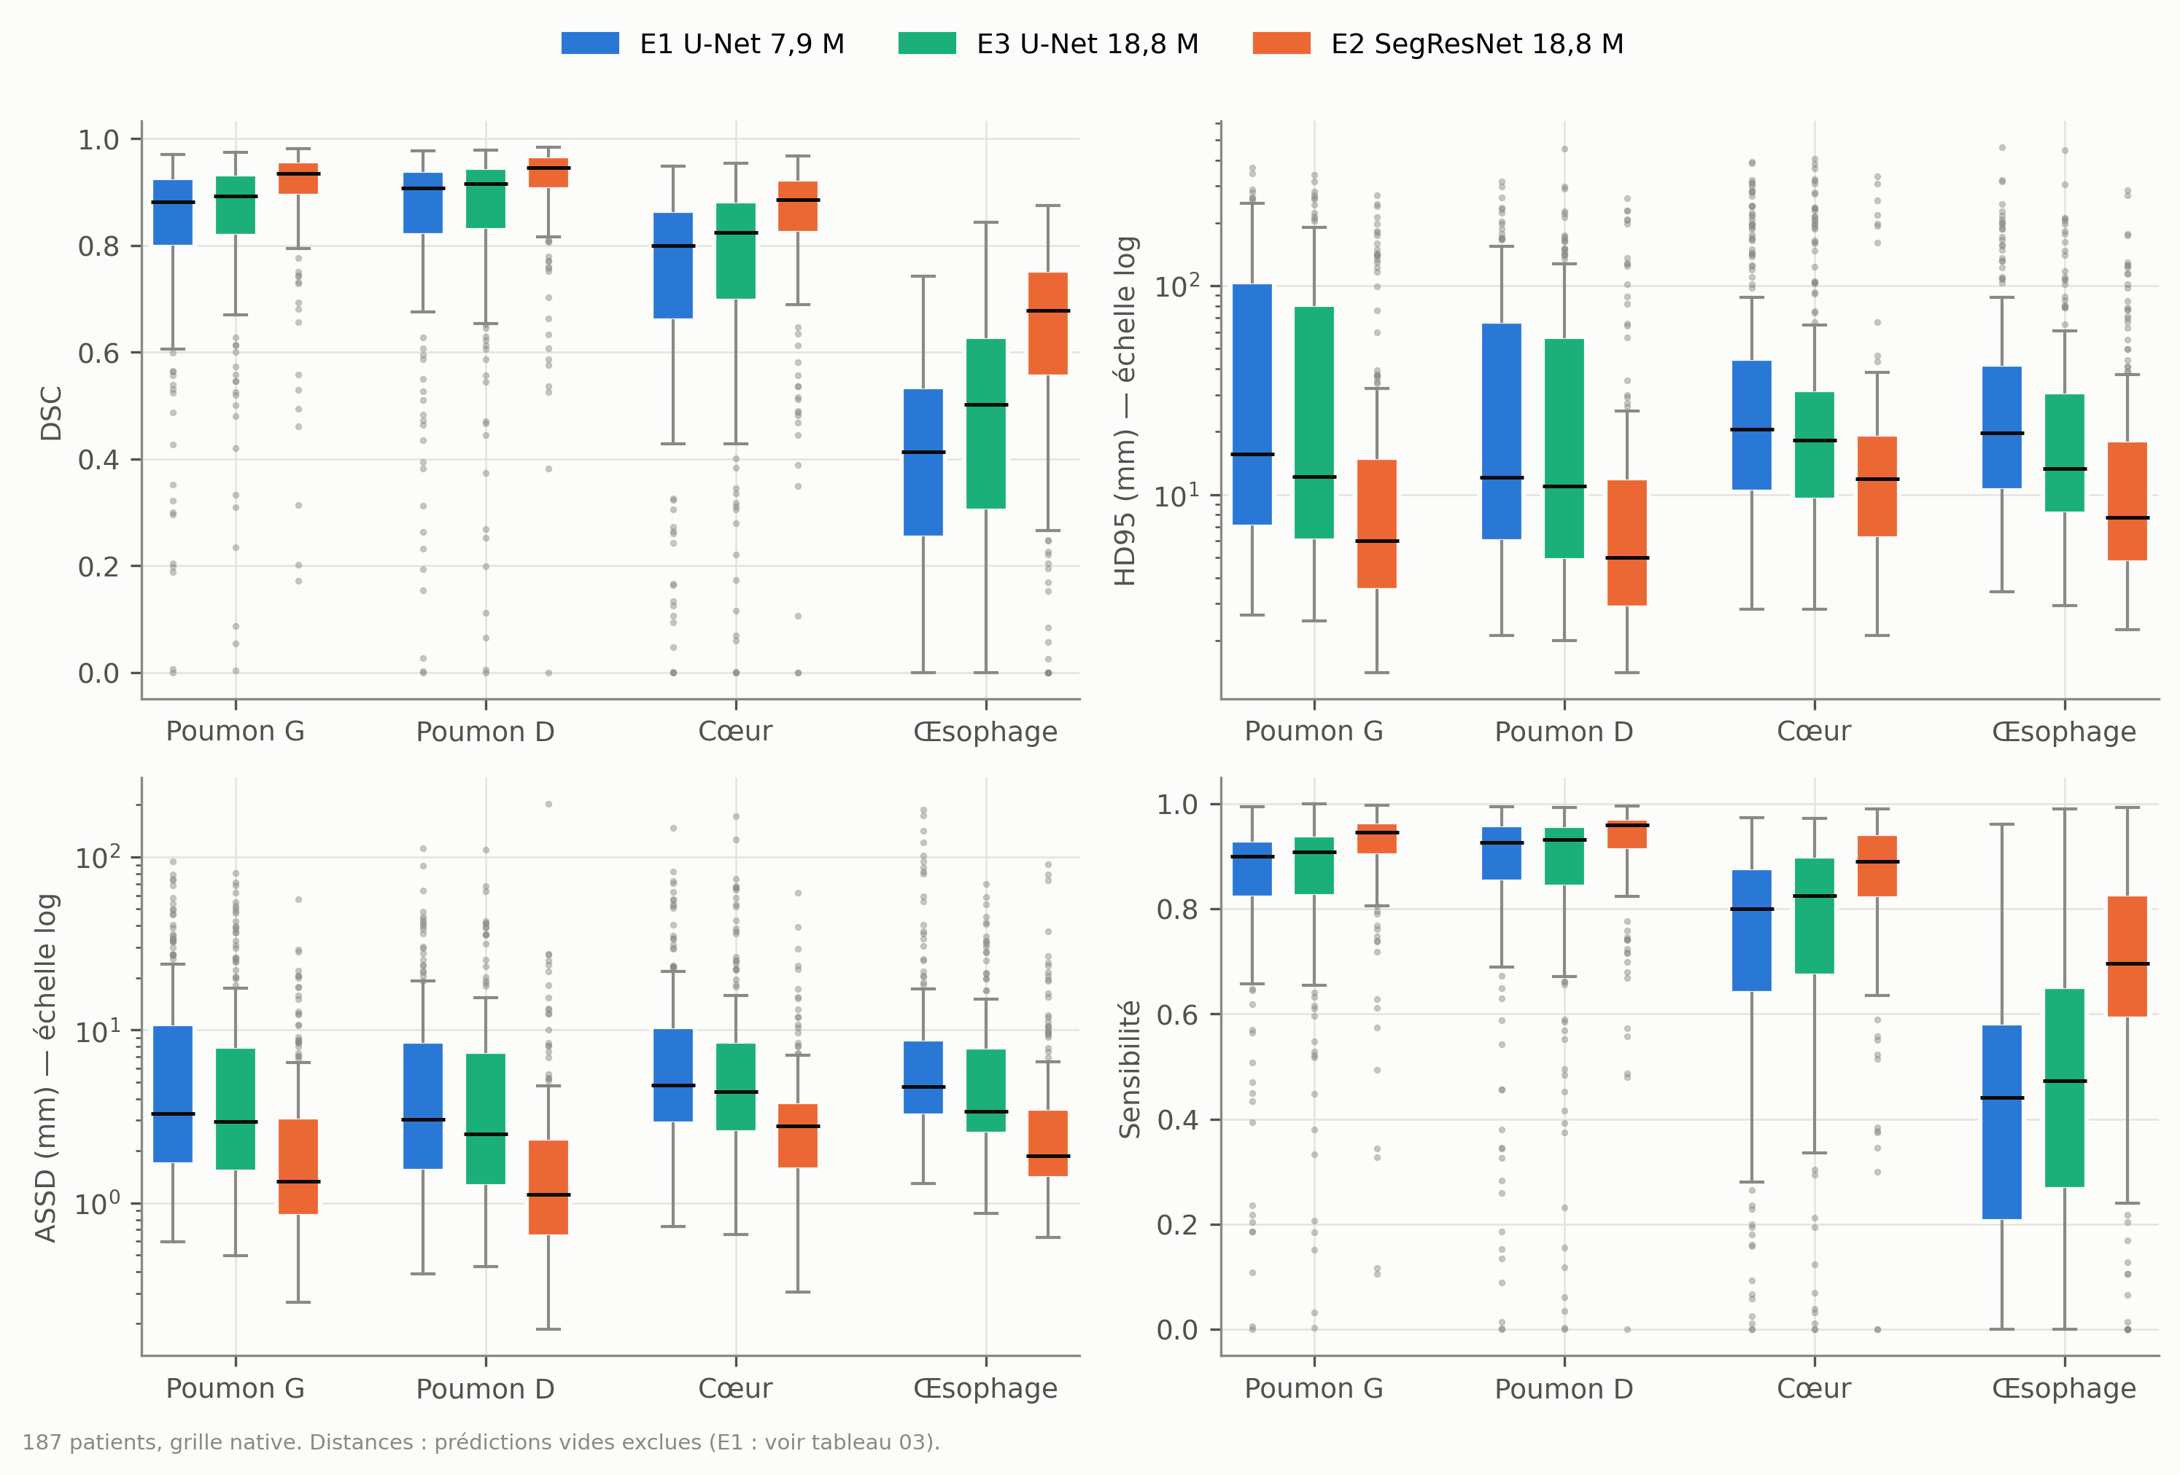
Fig. 1. Box plots of DSC/HD95, E1–E3.
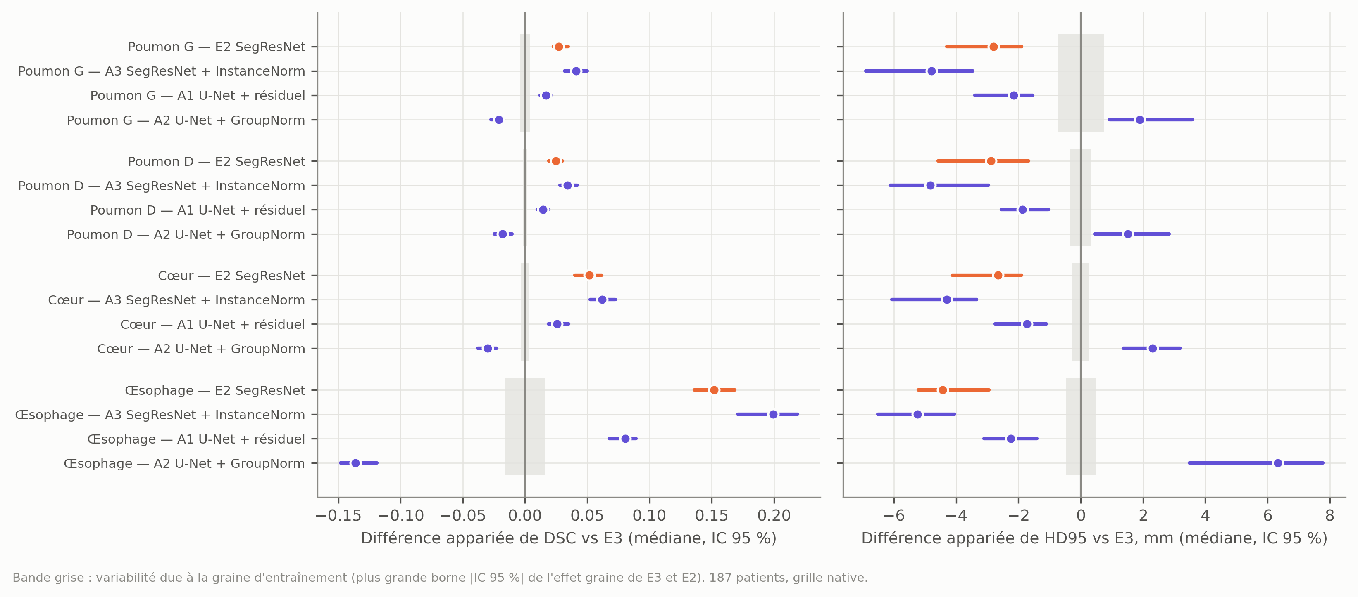
Fig. 2. Paired differences vs E3 with seed-variability band.
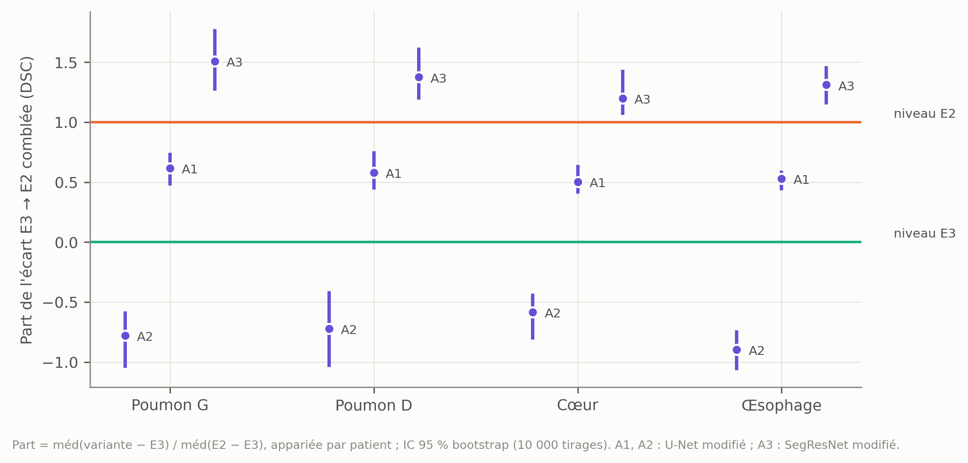
Fig. 3. Share of the gap closed.
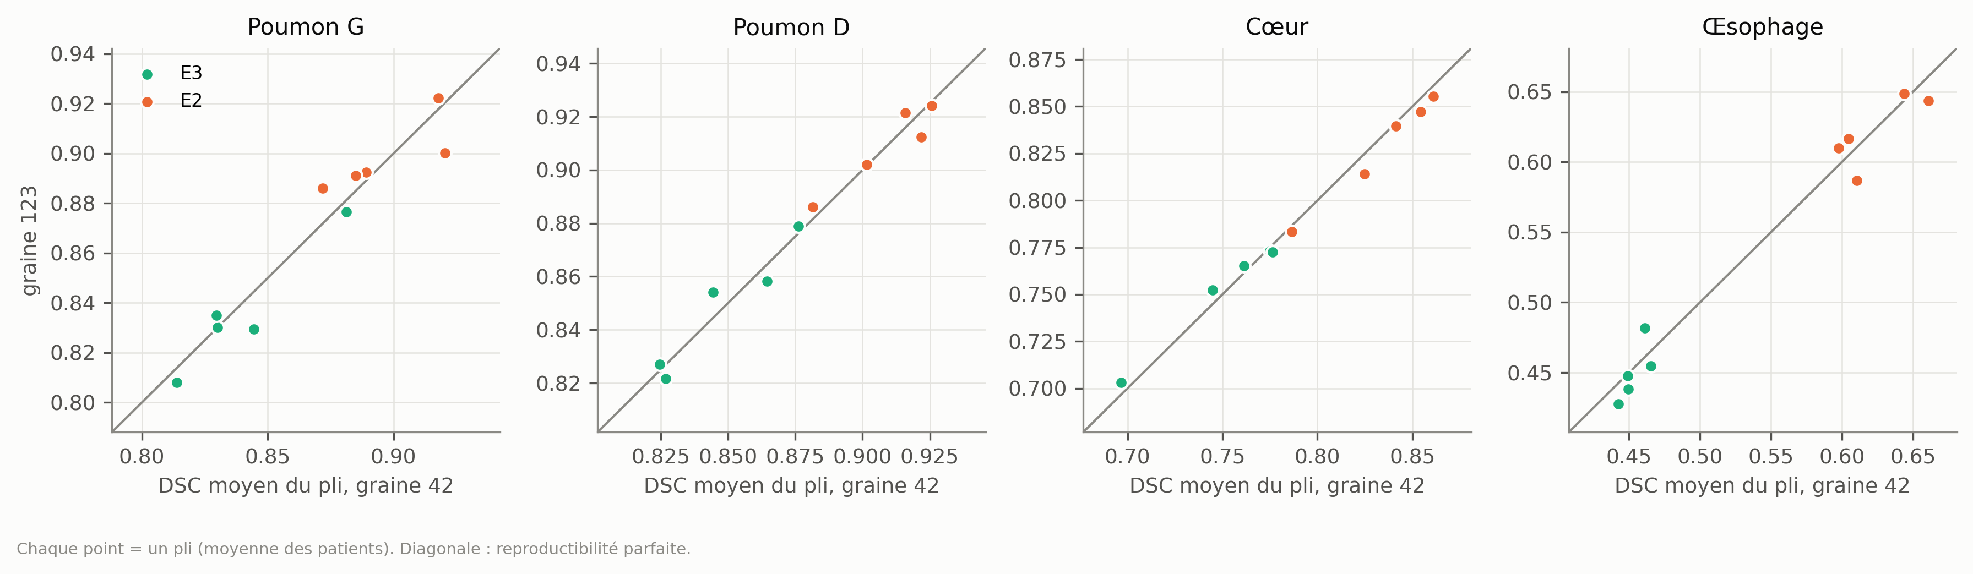
Fig. 4. Seed reproducibility.
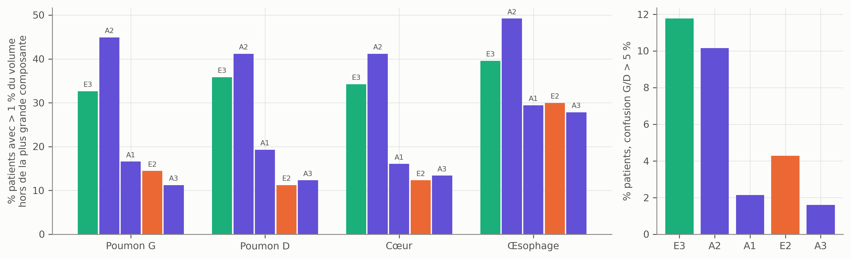
Fig. 5. Fragmentation and laterality.
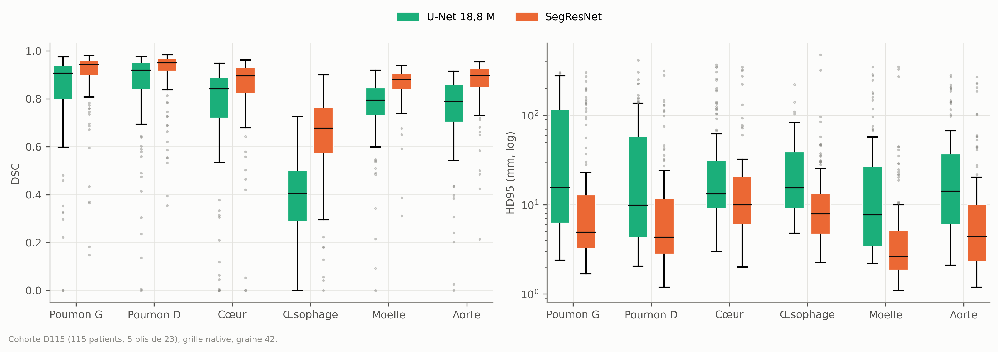
Fig. 6. Six-OAR box plots.
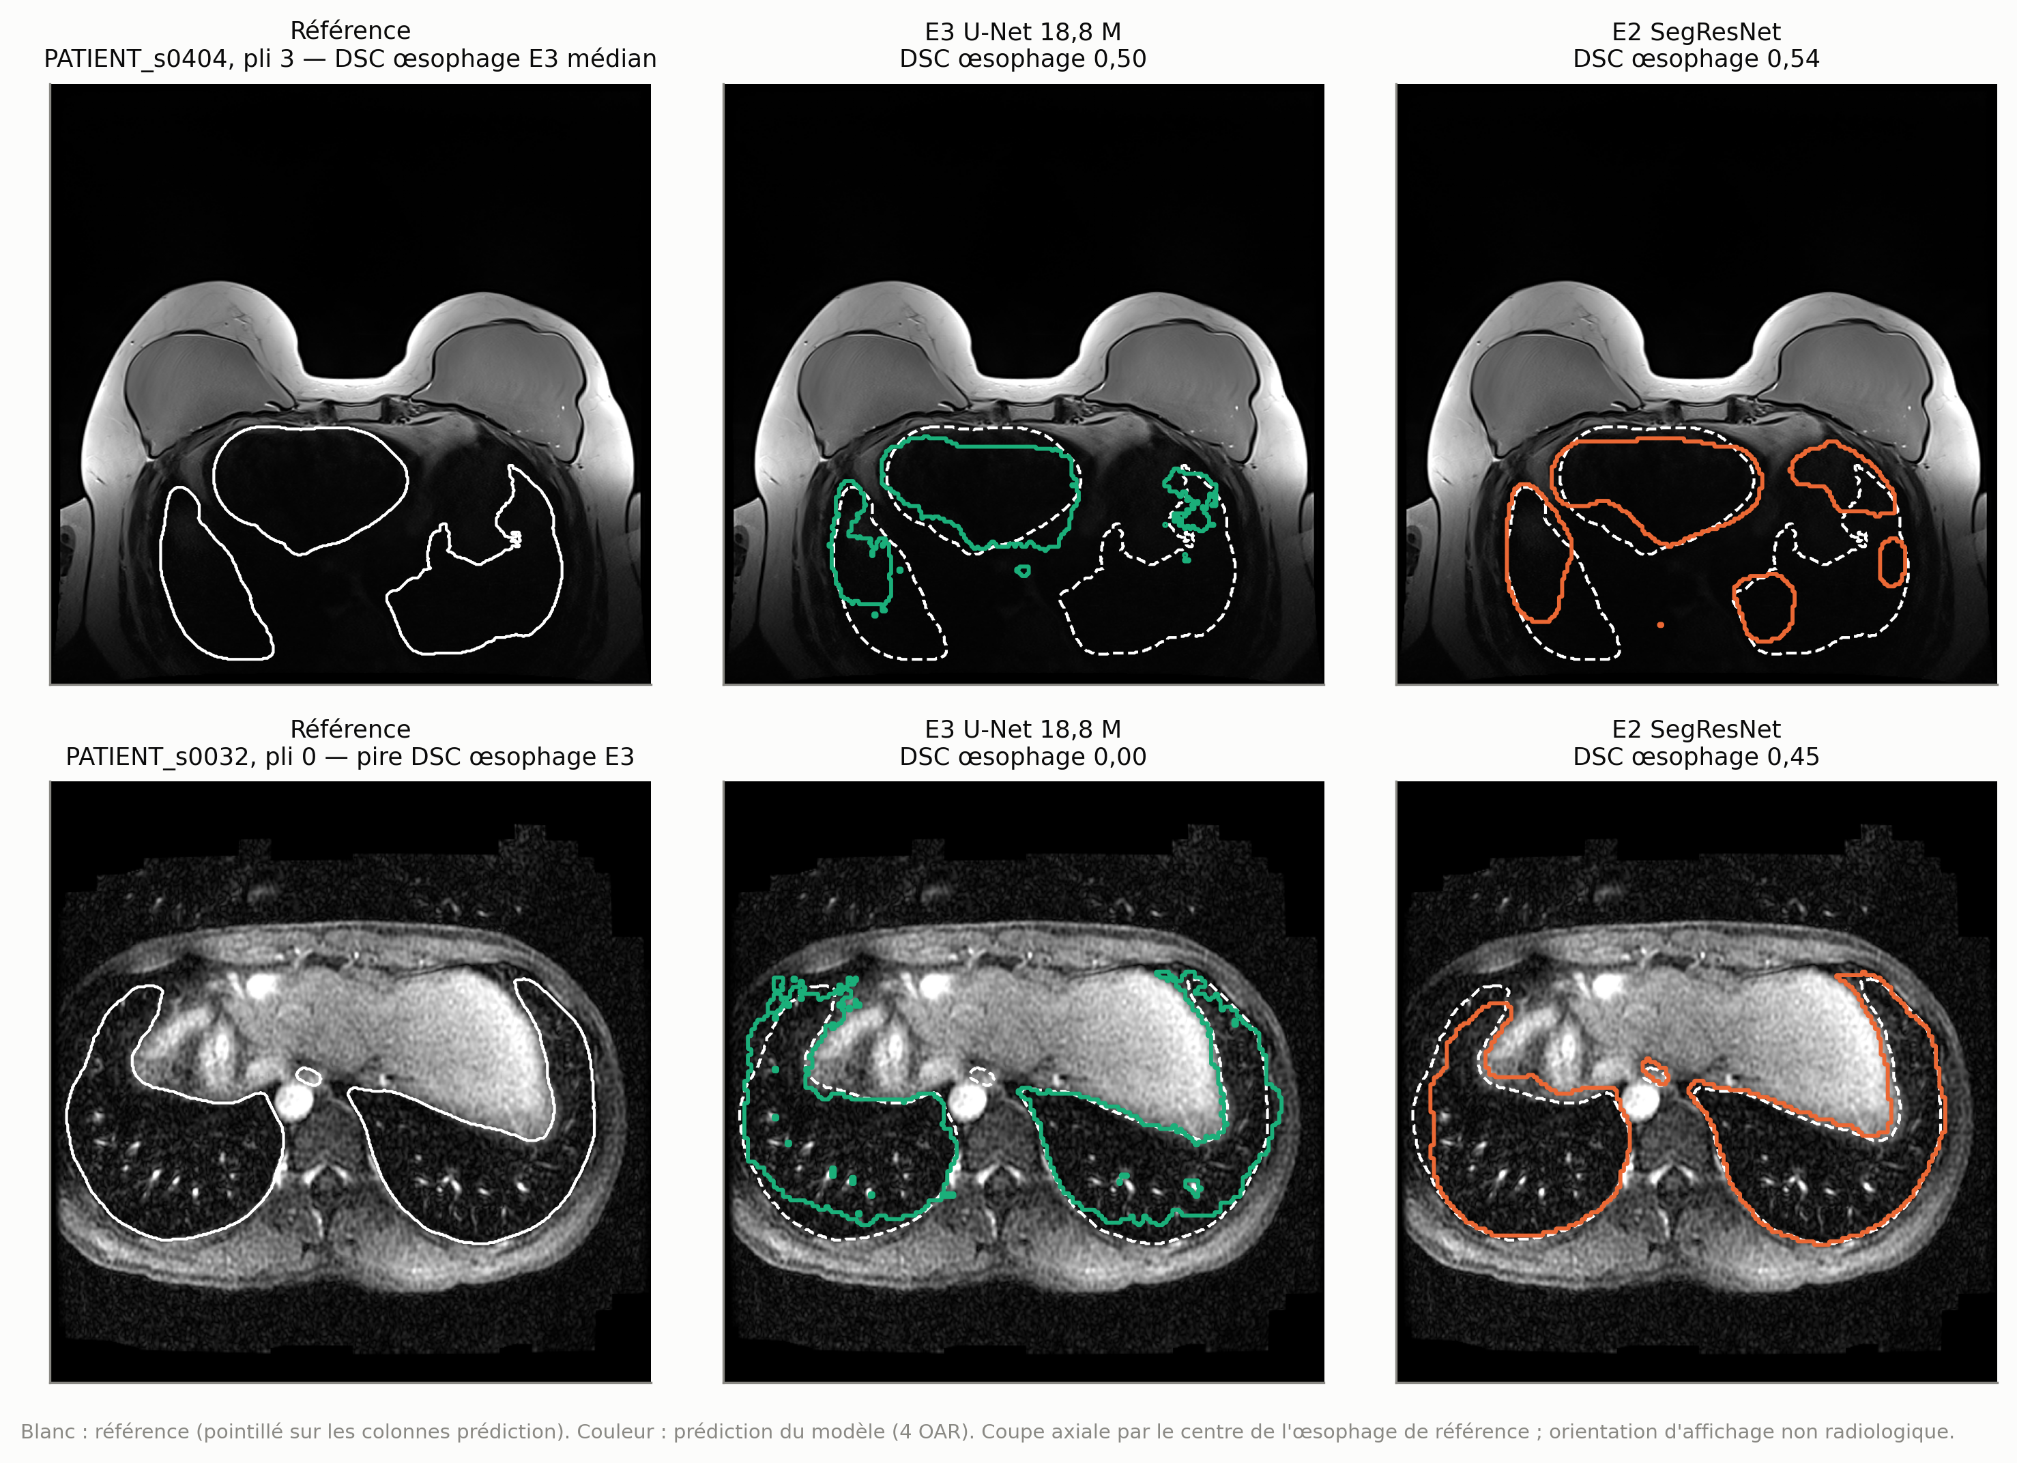
Fig. 7. Qualitative overlays.

