**The current state of KaiOS in emerging market and roadblocks**

Mohammad Rayed

Undergraduate student, North South University, [mohammad.rayed@northsouth.edu](mailto:mohammad.rayed@northsouth.edu)

With about 36% of the world’s population being poor, access to the internet and phone is a dream come true for billions of people. As these people struggle for their next meal, KaiOS, through its user-centred operating system, strives to empower them by providing smart solutions balancing affordability and sophistication. KaiOS is a specially designed Operating system that is developed for smart feature phones that can have features like WiFi, GPS, Browser, Facebook as well as WhatsApp depending on device specifications. It has enabled low literate people of Asia-pacific as well as Sub-Saharan Africa to access banking services through affordable phones while ensuring financial inclusion. Although it has a different user base, there are several obstacles KaiOS might face in the near future. In this paper, we highlight the existing and potential market opportunities of KaiOS as well as roadblocks of this emerging mobile operating system.

**CCS CONCEPTS •** Mobile Computing • Mobile phones • Mobile devices

**Additional Keywords and Phrases:** KaiOS, Smart Feature Phone, Low-literate users

1. **Introduction**

Feature phones have been the most popular and affordable choice when it comes to text messaging and voice calling. These button-based phones with a tiny display are often referred to as “Dumbphones” when compared to touch-based smartphones.[[1]](https://abrahamswallet.com/2018/10/29/the-financial-benefits-of-dumb-phones/) Emerged in the 80’s these phones have played a tremendous role in defining the future of mobile technology. Now in the 20th century when the technology of smartphones has reached the pinnacle of success, only 5 billion of the world have access to mobile phones [[2]](https://www.pewresearch.org/global/2019/02/05/smartphone-ownership-is-growing-rapidly-around-the-world-but-not-always-equally/) This depicts the economic and social challenges the smartphone industry faces in connecting with people at different levels.

In recent years, KaiOS has been popularly adopted in the smart feature phone ecosystem as a means to enable internet access for people with low literacy. KaiOS from its inception, has been a bifurcate ecosystem of affordable digital products and services. Existing in more than 100 countries throughout the world, KaiOS is currently the mainstream provider of affordable smart feature phones with services to leverage technology for the poor. “Feature phones” refer to the button mobile phones with text and call features only.[[1]](https://abrahamswallet.com/2018/10/29/the-financial-benefits-of-dumb-phones/) The smart feature phones of KaiOS refers to the feature phones equipped with smart technologies like GPS, WiFi as well as smart apps, for instance, Youtube, Facebook, WhatsApp etc.[[3]](https://www.kaiostech.com/ultimate-guide-smart-feature-phones/) These technologies have the potential to improve the lives of the people through connecting them via the internet. Billions of people around the world still do not have access to the internet. The price upsurge and the urban-centred design of smartphones have made it difficult for them to explore the opportunities that the internet brings in.[[4]](https://www.gadget-cover.com/blog/how-much-have-mobile-phone-prices-increased-over-the-last-decade)

The KaiOS offers smart feature phones in four groups: Candy bar phones- the most affordable phone of all time; characterised by its chocolate bar-like shape and size. Rugged phones- Tough phones prepared for people who work in hostile environments.[[3]](https://www.kaiostech.com/ultimate-guide-smart-feature-phones/)

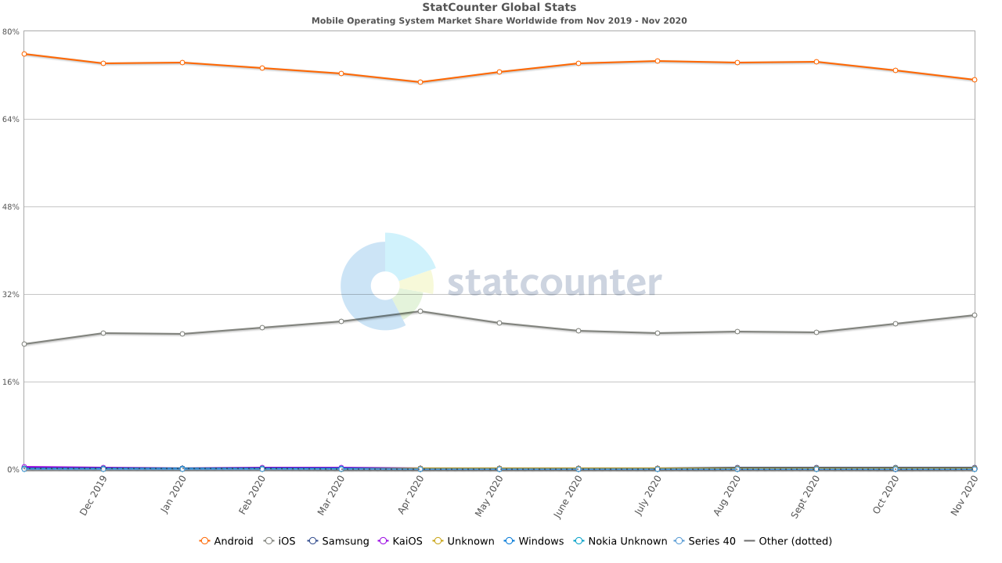

Figure 1: Mobile Operating System Market Share Worldwide, via Statcounter

[(https://gs.statcounter.com/os-market-share/mobile/worldwide)](https://gs.statcounter.com/os-market-share/mobile/worldwide))

1. **Literature Review**

The PEST Analysis invented by the ingenious Havard Professor Francis Aguilar has been a success in analysing any scenario in terms of Political, Economic, Social and Technological aspects.[[5]](https://www.mindtools.com/pages/article/newTMC_09.htm) In this paper, we analysed the status of KaiOS in emerging markets as well as the roadblocks following the principles of PEST analysis framework.

In our review, we evaluate the market trends of KaiOS and its prospects in low and middle-income countries. We do this by comparing the data charts provided in the KaiOS blogs. The KaiOS blogs serve as the primary literature for this review, but we have taken consideration of the articles published by other online tech blogs that seem useful in the context of analysingKaiOS in the market.

As we analyze the KaiOS ecosystem, we come across broad concepts of Mobile operating systems and design paradigms. A few research papers relevant to this have a guiding role in our research. As KaiOS is forked from the Firefox OS, we often reference the design paradigms of Firefox OS to provide a transparent view to the KaiOS ecosystem.[[6]](https://www.i-programmer.info/news/83-mobliephone/11940-google-invests-22-million-in-a-fork-of-firefox-os.html)

We construe KaiOS briefly in the context of User Experience, User Interface, Application Development Constraints and Accessibility. As these concepts are broadly incorporated into HCI, perhaps it is the most essential research to study the background of KaiOS.

1. **Current State**

The KaiOS originates from the discontinued open-source Firefox OS which was developed by Firefox independently in 2011.[[7]](https://www.kaiostech.com/faq/what-is-kaios/) Though it started from a fork from Firefox OS, the KaiOS is substantially different from the Firefox OS. [[8]](https://www.ghacks.net/2020/03/14/firefox-os-successor-mozilla-and-kaios-announce-partnership/) It is not just about mobile platforms; instead it is about partnerships and collaborations with carriers, phone manufacturers that enable the KaiOS to bring people under the hood of the internet. [[9]](https://www.kaiostech.com/partner-with-us/our-partners/)

We scrutinise the current state of KaiOS in Political, Economic, Social and Technological aspects, i.e. in alignment with the market framework analysis tool PEST guidelines.

3.1 Political

KaiOS started in the US and rapidly expanded their business in Europe, the Asia Pacific and Africa. The mobile operating system is now powering smart feature phones in many states including the United States, Canada, and India. KaiOS has made many partnerships with carriers across the globe that provided a breakthrough in ensuring internet accessibility in places where expensive data packs and smartphone prices act as barriers. Steadily building partnerships, KaiOS has reached billions of users through its affordable and ergonomic system software. In recent years, KaiOS has received $22 Million Series A funding from the tech giant Google. It has also signed contracts to bring Google services- Assistant, Youtube, Google Maps and other necessary services to KaiOS powered devices.[[10]](https://www.kaiostech.com/google-leads-seriesa-investment-round-kaios-connect-next-billion-users/)

KaiOS also played a pivotal role in bringing the people of Gambia, Uganda, Sierra Leone and Congo under mobile internet. It provided the users with a convenient way to switch between carriers by incorporating the OS in the dual sim phones to enable the users with the option to utilise inexpensive data packages offered by different carrier companies. Afriphone is now a success story in Sub-Saharan Africa that is made by the partnership of Africell and KaiOS. This collaboration has given the people of Sub-Saharan territory a new dimension through connecting them to mobile banking, smart healthcare as well as online education. It was also the first 3G mobile KaiOS powered phones that were brought by the popular telecom company Africell.[[11]](https://www.kaiostech.com/africell-launches-first-3g-smart-feature-phone-to-run-on-kaios/)

The mobile devices that are required for giving internet access to people with low income and low literacy rates are usually cheaper to buy but harder to produce especially in current conditions where Android and IOS dominate the market. In order to bring a flavoured device that ensures affordability and usability at the same time, KaiOS partnered with Energizer, a leading smart feature phone manufacturing company. These phones equipped with Kai Store come with preinstalled Google Assistant, Youtube, Facebook, WhatsApp and many other lifestyle and utility apps that can digitise millions of people through ensuring internet connectivity.[[12]](https://www.kaiostech.com/press/eight-new-energizer-feature-phones-to-run-on-kaios/)

The KaiOS, in its expansion in India, provided the people with 4G LTE technology by which they can enjoy Facebook and other online messaging services in their phones. This collaboration made internet communication for poor people easy by supporting them through Google Assistant and location wise device languages.[[13]](https://www.kaiostech.com/reliance-jio-became-worlds-fastest-growing-mobile-network/) This partnership of Reliance and KaiOS boarded millions of users through their innovative marketing strategy. Users had an opportunity to get Jio Phone by depositing 1500 Rupees at once or 153 Rupees for a month in instalments, the most exciting offer is that deposit or instalments would be returned to the users after three years.[[14]](https://gadgets.ndtv.com/mobiles/news/jio-phone-india-ka-smartphone-launched-by-mukesh-ambani-1727533)[[13]](https://www.kaiostech.com/reliance-jio-became-worlds-fastest-growing-mobile-network/)

The dominance of 4G feature phones also stretched through Latin America, starting from Colombia it reached to Mexico. The first 3G phone powered by KaiOS was launched in Mexico by a partnership with Alcatel. As a result of this partnership, Alcatel 3078 was born, which was a fully-fledged 3G smart feature phone having smart apps like Google Assistant, Google Maps, YouTube, WhatsApp, Facebook and many more! All of these apps were made available through KaiStore while enabling millions of users to migrate to 3G from 2G with a nominal price tag of $32.

3.2 Economic

KaiOS Technologies has raised an astounding $79 Million since its inception.[[15]](https://www.crunchbase.com/organization/kai-technologies) This company is growing faster than its competitors and creating milestones.

The company initially focused on people who cannot afford expensive phones and mobile data plans. However, the company now aids people who possess an inherent discomfort in handling technological devices. Currently, It is serving millions of older people who are able to afford smartphones but are not comfortable to use it.[[16]](https://www.mobileworldlive.com/featured-content/devices-home-banner/kaios-chief-outlines-global-growth-plans) With simple non-touch screens and buttons, KaiOS is showing light in these communities through giving access to the internet.

Focusing on two customer bases, elderly people who are unwilling to use smartphones and people who do not have the ability to afford smartphones; KaiOS is generating $28.9 billion a year.[[17] Backed by giant investors, Google, Cathay Innovation, TCL and Reliance, the company isn’t showing any signs of slowing since its establishment.[17]](https://growjo.com/company/KaiOS_Technologies)

KaiOS Technologies employs around 200 people and the team is made up of people from diverse backgrounds and cultures. This small team works efficiently and hence paid generously with an average of $145000 in revenue per employee. They have grown their team by 11% than the previous year and still hiring in different positions.[[17]](https://growjo.com/company/KaiOS_Technologies)

As they expanded their business in India through JioPhone by Reliance; KaiOS phenomenally became successful by beating iOS in India. Ruling over 15% market share in India the company is rapidly growing.[[18]](https://trak.in/tags/business/2018/05/09/jio-phone-kaios-beats-ios-in-india/?__cf_chl_captcha_tk__=b04e24aaa94ce861010a2eb15d02c6ece22a994e-1609226061-0-Ace-__4Kke5Btis0BCw8Y6kTrRjeIOrBcqlcrsF09GJVPh9WaaP0Dhe6zq7dvOPBMVX_vK6sUNYbU5iywgCAr26FJ8nmVgVDNQ8TGkPSvTzt1gqMAY0Txsvy3XF9OGR9TYVnd0jdVFbB3lz1gCa8i0GY8Q586OC6UUma4wdDkfy9_ZE_o0Thrk0SGH9vFMvUKKbI7M04lWJm0XvRZDbc50O0t_ybSypWMCuiV3dyzxb1V4qkbMEJ5mSzfJuNyuqGr59dbNd2cgkRHpt0zp1y-BrLDL33okRjN-9Dey6FSgg2mJWo1Y43eTZW9wB6KnKmS98EgZPtAbfXrg6PdYsWlCZt7yquH1TaFRfykL5TVKyG3KMVIUMKc_4nIJGK7RpL2s86Gy0_rKQI9pGVOMi5S0vsbNVkMwEzUapRYwO2mf7oLQi-8dAc4Iosop9mYcfJliGgBlxWQFUKbMRfLtBXv-y0DFUPRyxq96fSA4qeX0Ld7rVRxwpipGldufbx1Typhs6PDltvMwfIjrrOqMjglCuIrkty0JS_Q_IBo7NhXiuhn6I2-12BZs51JSv_YRtBZbgmXATJyaOavqHliGdPgvI0u9_1x33Uk7yqmMyddcTd) A majority of 100 million users acquired by KaiOS comes from India, interestingly more than 70% of Indian users belong from urban India to be specific.[[18]](https://trak.in/tags/business/2018/05/09/jio-phone-kaios-beats-ios-in-india/?__cf_chl_captcha_tk__=b04e24aaa94ce861010a2eb15d02c6ece22a994e-1609226061-0-Ace-__4Kke5Btis0BCw8Y6kTrRjeIOrBcqlcrsF09GJVPh9WaaP0Dhe6zq7dvOPBMVX_vK6sUNYbU5iywgCAr26FJ8nmVgVDNQ8TGkPSvTzt1gqMAY0Txsvy3XF9OGR9TYVnd0jdVFbB3lz1gCa8i0GY8Q586OC6UUma4wdDkfy9_ZE_o0Thrk0SGH9vFMvUKKbI7M04lWJm0XvRZDbc50O0t_ybSypWMCuiV3dyzxb1V4qkbMEJ5mSzfJuNyuqGr59dbNd2cgkRHpt0zp1y-BrLDL33okRjN-9Dey6FSgg2mJWo1Y43eTZW9wB6KnKmS98EgZPtAbfXrg6PdYsWlCZt7yquH1TaFRfykL5TVKyG3KMVIUMKc_4nIJGK7RpL2s86Gy0_rKQI9pGVOMi5S0vsbNVkMwEzUapRYwO2mf7oLQi-8dAc4Iosop9mYcfJliGgBlxWQFUKbMRfLtBXv-y0DFUPRyxq96fSA4qeX0Ld7rVRxwpipGldufbx1Typhs6PDltvMwfIjrrOqMjglCuIrkty0JS_Q_IBo7NhXiuhn6I2-12BZs51JSv_YRtBZbgmXATJyaOavqHliGdPgvI0u9_1x33Uk7yqmMyddcTd)[[19]](https://www.counterpointresearch.com/kaios-eyes-global-expansion-replicating-indias-success-challenge/)

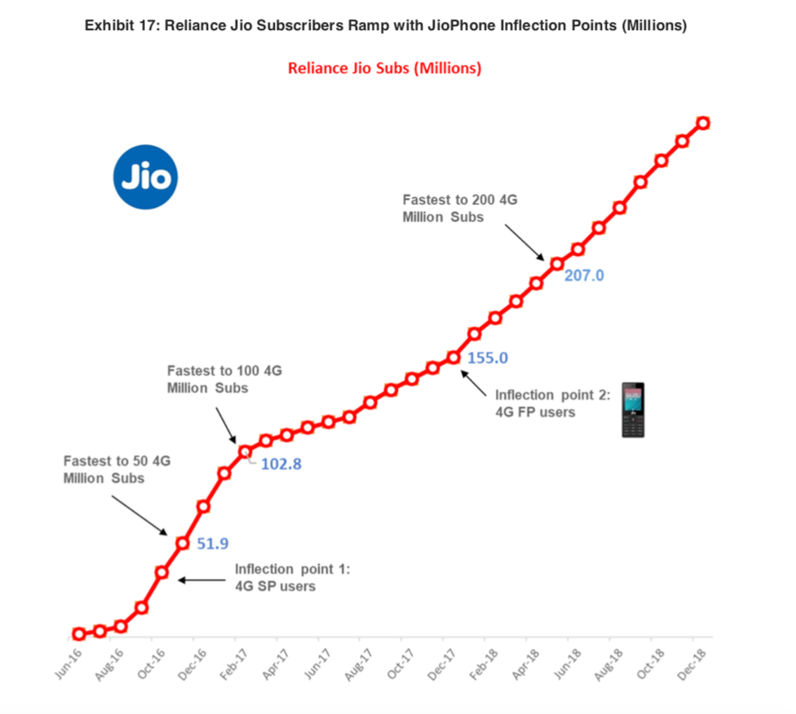

Figure 2: Rise of KaiOS powered Jio Phone in India, via KaiOS

[(https://gs.statcounter.com/os-market-share/mobile/worldwide)](https://gs.statcounter.com/os-market-share/mobile/worldwide))

3.3 Social

KaiOS connected the communities which were impoverished by the strength of 3G and 4G network as well as the internet. It was recognised as one of the top 100 best inventions under Social Good category by TIME as it brought millions of people under the shade of the internet by making mobile internet more accessible and affordable.[[20]](https://time.com/collection/best-inventions-2019/)

While bringing goods to the society, the KaiOS has brought opportunities for developers to tap into markets which were impossible before. It has opened up opportunities to build apps for people using feature phones. Due to KaiOS, 55% of Latin America users accessed the internet in 2017. KaiOS connected the mobile app developers with people who got to use the internet for the first time. Less than 40% of the people of Africa were connected to the internet and KaiOS was a hope for them to bring the light of the internet.[[21]](https://www.kaiostech.com/4-ways-kaios-is-spurring-new-interest-in-mobile-development/)

The KaiStore has made it possible to make online education accessible for all. The Life app available in KaiOS powered phones in Africa and it has been a success in teaching people about data privacy, health education as well as how to operate smart feature phones. This brought more impact in the lives of people with low literacy rates when KaiOS partnered with Worldreader. As a result of this partnership, many books were made available to users. The Life app flourished even more when useful information regarding reproductive health, farming as well as daily nutritional requirements were added into it. [[22]](https://www.kaiostech.com/life-the-kaios-in-house-app-that-bridges-the-gap-to-educational-resources-is-now-live-in-africa/)[[23]](https://www.kaiostech.com/life-app-changing-lives-around-world/)

3.3 Technological

The KaiOS is an operating system that works on basic web technologies like HTML, CSS and JavaScript. [[24]](https://developer.kaiostech.com/introduction/technologies) The KaiOS ecosystem is about both hardware and software. It is about equipping a smart feature phone with efficient system software.

The KaiOS with motto “Internet for everyone” has brought smart features like GPS, WiFi, Virtual Assistants accessible for all. It has brought the internet into the hands of billions. KaiOS devices are target specific, i.e. each of its device and software specifications is uniquely designed for the target community for which it is developed. The KaiOS achieve this through partnerships with mobile operators and phone manufacturers. For example, the KaiOS inherits the rights of app availability in Africa and Latin America, but the authority lies in India in case of Jio Phone.[[25]](https://www.kaiostech.com/frequently-asked-questions-jiophone-kaios/)

The KaiOS has provided complete documentation about how to develop applications for KaiOS along with environment setup instructions. It has also opened an online help channel to help developers in case of any troubles. Anyone who has a basic understanding of web technologies can start to develop applications for KaiOS. Furthermore, UI relevant documentation is also available in KaiOS development help guide.[[26]](https://developer.kaiostech.com/) The KaiOS team has also set up a strong team to oversee the development and monetisation of applications to ensure that the applications developed are promoted to the target audience effectively.

Currency app monetisation is conducted through full-screen ads and banner ads only. In other words, the former one is known as Interstitial ads and the latter as responsive ads.[[27]](https://www.kaiostech.com/app-monetization-kaios/) Through KaiAds, the developers can reach out to 85 million users in over 100 countries. KaiAds is also the first provider of Advertisement Development Kit for smart feature phones.[[28]](https://www.kaiads.com/publishers/index.html)

1. **Roadblocks**

Despite being the third-largest mobile operating system in the world, it has faced many challenges. Many operating systems, Firefox OS, Windows phone as well as the popular Blackberry OS failed to keep pace with Android and iOS. KaiOS forked from Firefox OS to a completely new version which targeted a separate customer base which was untapped by these dominant operating systems.[[29]](https://www.fastcompany.com/90457544/kaios-most-innovative-companies-2020)

Although it is getting popular day by day, Android and iOS will continue to challenge it even more. As people have an inherent tendency to switch into improved and better lifestyle commodities, KaiOS might be replaced along with their feature phones.[[r]](https://www.quora.com/Why-do-people-tend-to-buy-expensive-smartphones-when-they-can-get-the-same-features-at-a-cheaper-rate)

1. **Conclusion**

The KaiOS has shown great potential by making the internet accessible for everyone in recent years. It has been successful in creating a blue ocean economy while tapping into a market which was unforgotten under the touch-based smartphone revolution.

This new KaiOS is not only successful for its operating system but also the partnerships and collaborations that impacted millions of lives. Such strategic business partnerships to bring the vulnerable and elderly community into the light of the internet is one of the biggest of its kind.

Indeed it has been successful in creating a new market in spite of the dominance of Android and iOS; but to maintain its growth progression, the KaiOS must evolve in the next few decades to mitigate the increasing demand of people to switch into better devices.

**REFERENCES**

1. The Financial benefits of dumb phone. <https://abrahamswallet.com/2018/10/29/the-financial-benefits-of-dumb-phones/>
2. Smartphone Ownership Is Growing Rapidly Around the World, but Not Always Equally. <https://www.pewresearch.org/global/2019/02/05/smartphone-ownership-is-growing-rapidly-around-the-world-but-not-always-equally/>
3. The ultimate guide to smart feature phones. <https://www.kaiostech.com/ultimate-guide-smart-feature-phones/>
4. How much have mobile phone prices increased over the last decade? <https://www.gadget-cover.com/blog/how-much-have-mobile-phone-prices-increased-over-the-last-decade>
5. PEST Analysis Identifying "Big Picture" Opportunities and Threats. <https://www.mindtools.com/pages/article/newTMC_09.htm>
6. Google Invests $22 Million In A Fork Of Firefox OS <https://www.i-programmer.info/news/83-mobliephone/11940-google-invests-22-million-in-a-fork-of-firefox-os.html>
7. What is KaiOS? <https://www.kaiostech.com/faq/what-is-kaios/>
8. Firefox OS Successor: Mozilla and KaiOS announce partnership

<https://www.ghacks.net/2020/03/14/firefox-os-successor-mozilla-and-kaios-announce-partnership/>

1. Partnerships Let's succeed together. <https://www.kaiostech.com/partner-with-us/our-partners/>
2. Google leads a series of investment rounds in KaiOS to connect the next billion users.

<https://www.kaiostech.com/google-leads-seriesa-investment-round-kaios-connect-next-billion-users/>

1. Africell launches first 3G smart feature phone to run on KaiOS

<https://www.kaiostech.com/africell-launches-first-3g-smart-feature-phone-to-run-on-kaios/>

1. Eight new Energizer® feature phones to run on KaiOS

<https://www.kaiostech.com/press/eight-new-energizer-feature-phones-to-run-on-kaios/>

1. How Reliance Jio became the world’s fastest-growing mobile network

<https://www.kaiostech.com/reliance-jio-became-worlds-fastest-growing-mobile-network/>

1. Jio Phone, Free With Rs. 1,500 Deposit, Unlimited 4G Data, Launched by Mukesh Ambani at Reliance AGM <https://gadgets.ndtv.com/mobiles/news/jio-phone-india-ka-smartphone-launched-by-mukesh-ambani-1727533>
2. Crunchbase- KaiOS Technologies. <https://www.crunchbase.com/organization/kai-technologies>
3. KaiOS chief outlines global growth plans. <https://www.mobileworldlive.com/featured-content/devices-home-banner/kaios-chief-outlines-global-growth-plans>
4. KaiOS Technologies Competitors, Revenue, Alternatives and Pricing. <https://growjo.com/company/KaiOS_Technologies>
5. Jio Phone’s KaiOS Has Beaten Apple’s iOS in India; Android Still #1 But Losing Ground Rapidly! <https://trak.in/tags/business/2018/05/09/jio-phone-kaios-beats-ios-in-india/>
6. KaiOS Eyes Global Expansion but Replicating India’s Success Would Be a Challenge <https://www.counterpointresearch.com/kaios-eyes-global-expansion-replicating-indias-success-challenge/>
7. Best Inventions 2019 <https://time.com/collection/best-inventions-2019/>
8. 4 ways KaiOS is spurring new interest in mobile development <https://www.kaiostech.com/4-ways-kaios-is-spurring-new-interest-in-mobile-development/>
9. Life, the KaiOS in-house app that bridges the gap to educational resources, is now live in Africa. <https://www.kaiostech.com/life-the-kaios-in-house-app-that-bridges-the-gap-to-educational-resources-is-now-live-in-africa/>
10. How the Life app is changing lives around the world. <https://www.kaiostech.com/life-app-changing-lives-around-world/>
11. KaiOS Technologies. <https://developer.kaiostech.com/introduction/technologies>
12. Frequently asked questions about the JioPhone and KaiOS. <https://www.kaiostech.com/frequently-asked-questions-jiophone-kaios/>
13. KaiOS Developer. <https://developer.kaiostech.com/>
14. App monetization on KaiOS. <https://www.kaiostech.com/app-monetization-kaios/>
15. The KaiAds SDK , SSP. <https://www.kaiads.com/publishers/index.html>
16. How KaiOS is beating Apple and Android to the next billion cellphone users. <https://www.fastcompany.com/90457544/kaios-most-innovative-companies-2020>
17. Why do people tend to buy expensive smartphones when they can get the same features at a cheaper rate? <https://www.quora.com/Why-do-people-tend-to-buy-expensive-smartphones-when-they-can-get-the-same-features-at-a-cheaper-rate>