* For 3 letter alphanumeric key I manually set the value and also max length set is 3 for encryption key and for txt is set 150

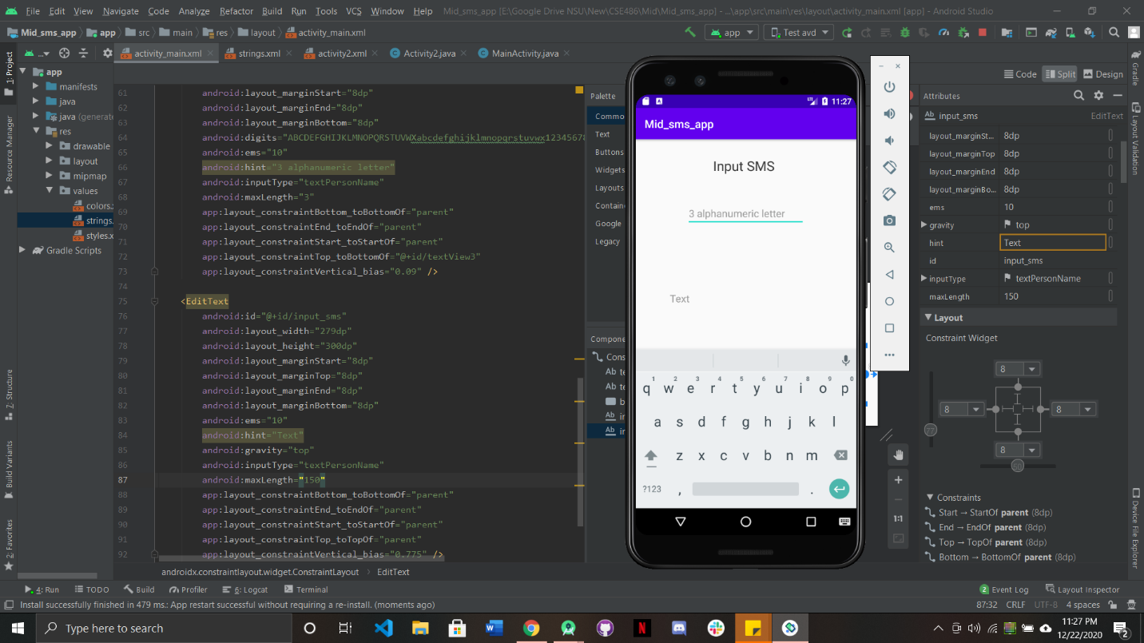

* Input 3 letter alphanumeric encryption key and sms and with the button message will sent

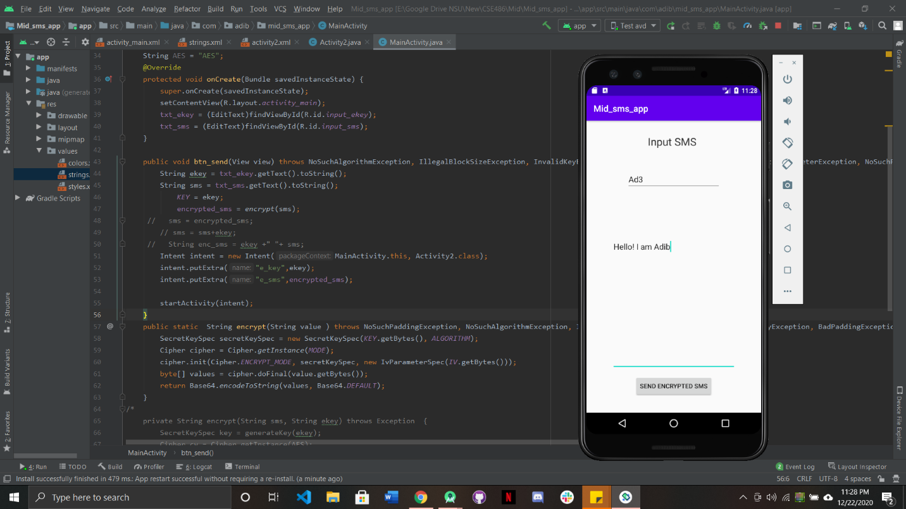

* Provided 3 letter alphanumeric encryption key + txt message

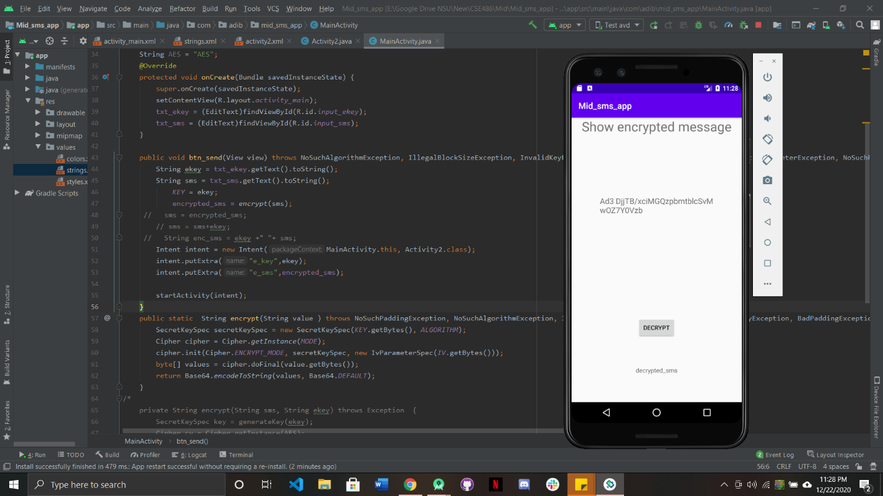

* I have added this decryption code for confirming my encryption is working

