**Abstract**

Over the last few years **Augmented Reality** has gained unprecedented popularity in both academia and industry. Mostly because of **Mobile Augmented Reality** applications, facilitated by massive improvements in smartphone hardware. A rigid, external, physical device such as- head mount or wearable is no longer needed for an immersive AR experience. Smartphones with multi-core processors, long battery life, powerful camera and IMU sensors; are more than capable for providing AR extensive apps to users. The AR domain is now endless. Gaming in real-life environment, visual & interactive educational materials, photo filters/effects in social media apps, remote manufacturing, remote workspace collaborations, navigation guide are just a few to mention. In this study we will present an overview of the current state of MAR by analyzing some of it’s application mechanisms, existing popular applications and development tools- Google ARCore, Apple ARKit and Facebook Spark AR Studio that simplify the creation of MAR applications.

**1. Introduction**

Augmented Reality (AR) is the modification of real-life environment around us by influencing visual, audio and other sensory stimuli. When such augmentation is made possible by handheld devices such as- smartphones, it is called Mobile Augmented Reality (MAR). The popularity of Pokémon GO, with almost 1 billion downloads till March 2019(https://www.businessofapps.com/data/pokemon-go-statistics/), is truly a testament to the impact MAR apps can have. However MAR is not confined to gaming only. Easy to use development tools like Google ARCore, Apple ARKit, Facebook Spark AR Studio have propelled the application domain of MAR. Global mobile augmented reality app users is estimated to reach 2.4 billion by 2023(https://www.statista.com/statistics/1098630/global-mobile-augmented-reality-ar-users/). However, augmented reality apps face very real challenges. The price of full fledged AR features supported devices are slightly on the higher range, approximately 200 USD and above. Such financial barriers makes it tough to intercept the customer base of developing countries like Bangladesh. Nevertheless the number of AR supported devices are growing day by day and with the advent of 5G, offloading hardware intensive tasks to remote servers is also becoming a viable option. But then again in developing countries there are many isolated areas where even 3G hasn’t reached. Software upgrades seem to be the only sustainable option to make up for such hardware and network speed requirement of MAR.

**2. Literature Review**

To analyze the current state of mobile supported AR research, the literature taken into account focus on three aspects- typical implementation mechanisms, development tools and popular applications of MAR. In [WebAR] before discussing the possibilities of Web AR, the authors presented the steps of typical AR application and its implementation mechanisms- sensor based, vision based and hybrid tracking. The paper also goes on explaining the computational, storage and networking complexity of each mechanism. In [Heart] a AR enhanced heart monitoring app is designed. The app lets users monitor their heart rate as well as share the monitored data history with doctors as well. [Manufacture] is a remote maintenance platform using off the shelf MAR technology as a feature of “Industry 4.0”. The app acts as a bridge between expert technicians and local unskilled operators to find errors in faulty factory equipments. [Litter] and [SW] are studies of acceptance level of AR based application among users. In [Litter] an experiment is performed among two groups of university students in promoting anti-litter activities- one group through AR app and the other with non-AR app. Similarly, in [SW] the effect of AR and non-AR guided video editing course is observed among two groups of college going students, and shows that AR supported increases student engagement in learning. Finally the paper will review the popular AR development tools- Google ARCore (https://developers.google.com/ar/discover), Apple ARKit (https://developer.apple.com/augmented-reality/arkit/) and Facebook Spark AR Studio (https://sparkar.facebook.com/ar-studio).

**3. Current State**

*3.1 MAR application design principals*

As discussed in [WebAR] the fundamental principal of MAR is to perceive the user’s ambient environment using sensor readings to bring in virtual reality as an enhancement and allow the user to seamlessly interact with it. The typical workflow of an AR application is shown in Fig. 1. The camera, IMU and GPS sensors continuously collect user ambient information. User interactions are also tracked via these sensors. Finally they are rendered altogether to provide a seamless integration of virtual contents into real space to provide an immersive AR experience.

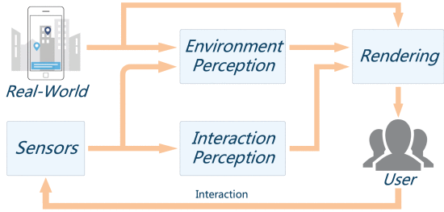Fig. 1: Typical AR process.[WebAR]

The paper [WebAR] goes on to divide the implementation mechanisms of AR applications in terms of three aspects- sensor based, vision based and hybrid tracking. The sensor based mechanism puts less strain on computation as it utilizes sensors single or multiple embedded in the phone like- accelerometer, gyroscope, GPS etc. The vision based mechanism focuses more on camera captured data, and requires high computing capability for extensive image processing. Both the methods have their shortcomings- sensor based approach cannot provide completely blended virtual content into the real environment whereas visual based mechanism requires heavy computation and/or high speed network. The hybrid implementation mechanism, a combination of both, overcome the disadvantages of previous individual methods. The computational, storage and networking complexity of the three mechanism are shown in Fig. 2.

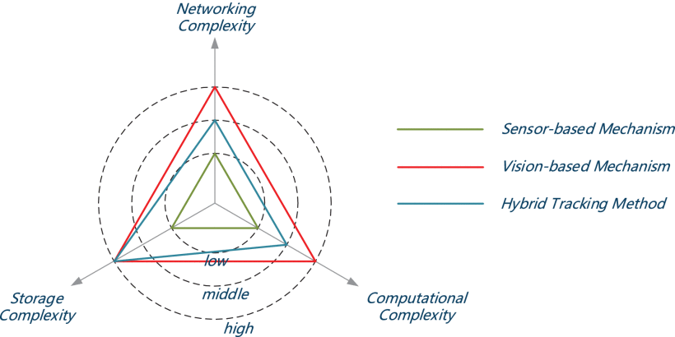Fig.2: Computational/storage/networking complexities for the

three typical implementation mechanisms. [WebAR]

*3.2 MAR in Healthcare: Heart Diagnoses System*

In [Heart] a mobile application is built to monitor heart beats and generate an online graph. The author presents an argument that for heart diagnoses visualization of heart rhythms is more important for doctors than to listen to them with a stethoscope. The application is paired with a sensitive microphone which listens to heart beats. Any unusual data is reported to the user, the doctor is also able to view the data from the app by scanning qr code shared from patient’s end.

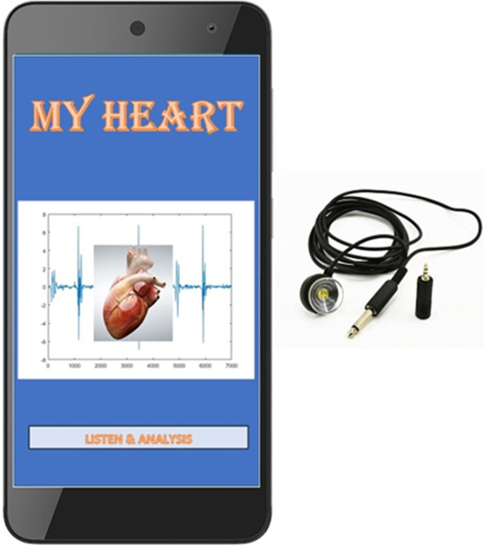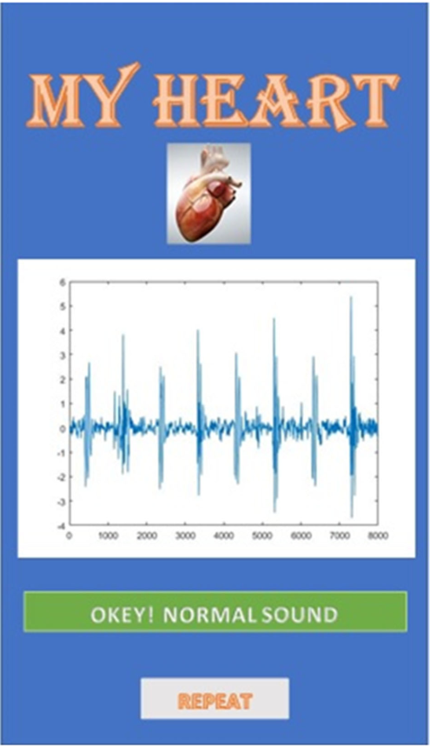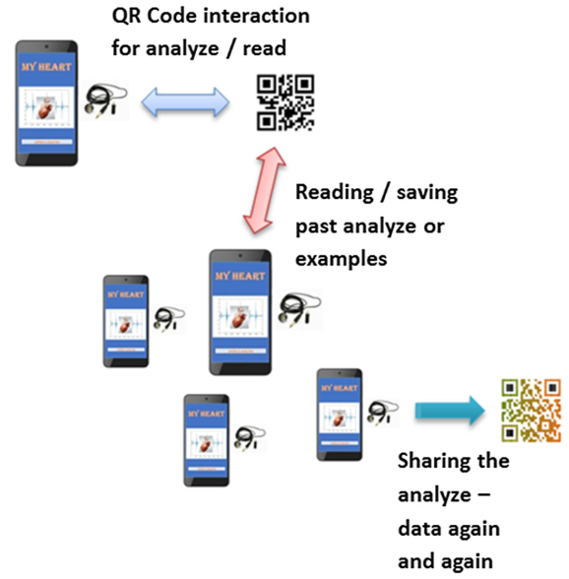

Fig. 3: MY HEART- AR based heart diagnose system.

*3.3 MAR in remote maintenance- Industry 4.0*

Remote capability of augmented reality can play a vital role in ushering Industy 4.0, especially in maintenance of complex factory equipment. In [Manufacture] a remote maintenance system has been proposed using off the self mobile phone AR technology. The system is a collaboration platform between skilled and unskilled maintenance workers. Unskilled workers can take pictures that act as markers and share with the skilled ones, who in turns can sketch symbols and/or add texts to help the unskilled worker. The interaction can also take place with live streaming audio and video, however network unavailability inside factories make the stream ineffective. The usage of symbols make the communication process universal and not language dependent.

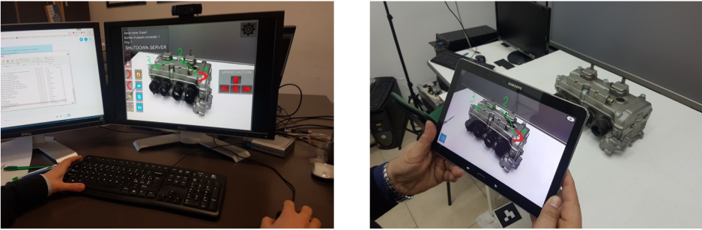

Fig. 4: Example usage of the application. On the left side the maintenance expert, on the right side the local operator.

*3.4 MAR for Environmental Awareness: Anti-littering*

In [Litter] an acceptance study was performed of an MAR app built to raise anti-littering awareness. The experiment was performed among three groups of university students- (i) with a standard mobile app without any AR features, (ii) app with marker-based AR features, (iii) app with marker-based AR & AR-Game features. Markers were placed at various locations in the campus that showed anti-litter materials to users with the AR feature apps. The study found that the second app yielded the most perceived value among users, even the necessity of downloading the non AR app rather than by scanning qr code acted as a big barrier for users.

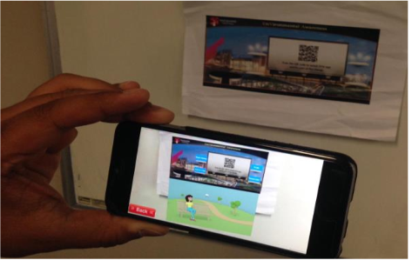Fig. 5: AR Anti-littering App Interface

*3.5 AR App in Education: Video Editing Course*

In [SW] a study was performed among two group of college going students on the use of AR-app and Online-app for a video editing course. The first week of the experiment students were taught in traditional way through in class demonstration by the instructor. On week 2, a group of student were given AR-app to aid the study material and the other group were provided with pre-recorded videos viewable over the internet. At the end of the experiment it was found that assignment submission rate and overall productivity of both group of students rose in week 2. However, there were significant difference in the two groups on an interesting aspects. The group with AR-app were more engaging and cooperative among themselves, whereas the online-app group kept to themselves while watching the online videos. In week 3 both the aiding apps were removed, this resulted in significant drop in assignment submission among the previously online-app provided group but the submission rate of the AR-app group remained steady.