**CSE 486 Project02 Report (Md. Omio Ibtehaz Somoy,1610715042)**

**Given Task:**

1. First Tab contains basic information about the members.
2. Name
3. Date of Birth
4. NID
5. Blood Group
6. Second Tab contains University Affiliation about the members. Students can add multiple university affiliation using a floating action button.
   1. University Affiliation should contain the following information:
      1. University name (Use drop down, pre-populated list)
      2. Department (Use drop down, pre-populated list, one for each university)
      3. Student ID
      4. Study Level (undergraduate / MS / PhD / Post-Doc)
      5. Email
   2. Each university affiliation should be created inside a fragment.
   3. When a fab button is clicked, another university affiliation fragment is added.
   4. Second tab should contain a listview of university affiliation fragments.
7. Third tab contains phone numbers for the members. Students can add multiple phone numbers using a floating action button.
   1. Phone number should contain the following information:
      1. Tag (Home/office/Other/Custom)
      2. Phone number
   2. Each phone number entry should be inside a fragment.
   3. When a fab button is clicked, another phone number fragment is added to the third tab.
   4. Third tab should contain a listview of phone numbers.

**Solution Steps(a-c):**

1. This tab contains basic information about the user. This information later will be used as log in authentication data. Mainly the data will be provided as Name and NID.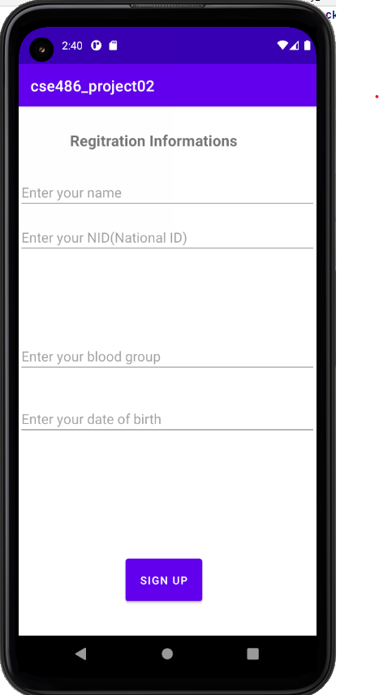Registration activity. 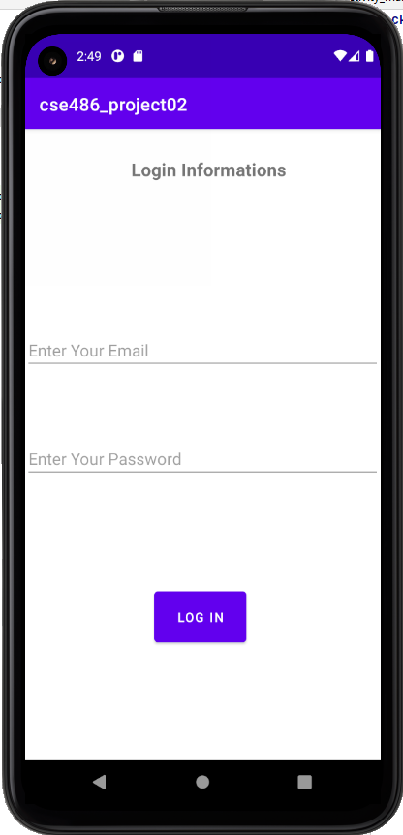” Enter your name” field and “Enter your NID“ field data will be sent to **Firebase auth** for authenticating.

Next Login activity will get the data and match user inputted data to give access to the user for login. User needs to be logged in to get the other features.

1. University name, Department and Study level will be shown as dropdown. Spinner view will store data of University name, Department and Study level. Student ID and Email will store and show the stored data in next activity.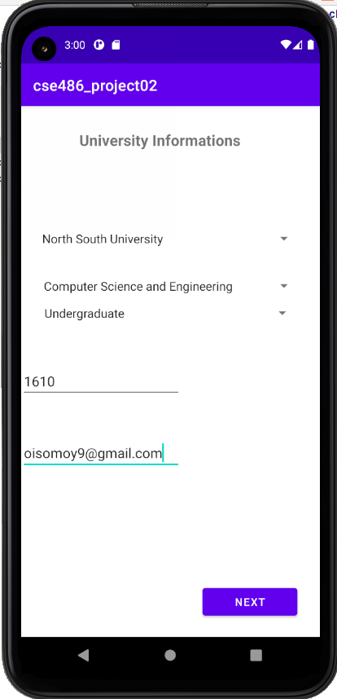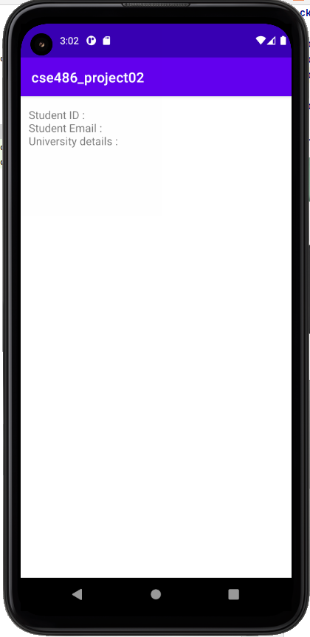
2. I have not yet completed this step.