AQA Sample Paper: GCSE English Language

Paper 1: Explorations in creative reading and writing

Time allowed: 1 hour 45 minutes

- The marks for questions are shown in brackets.
- The maximum mark for this paper is 80.
- There are 40 marks for Section A and 40 marks for Section B.
- You are reminded of the need for good English and clear presentation in your answers.
- You will be assessed on the quality of your reading in Section A.
- You will be assessed on the quality of your writing in Section B.
You are advised to spend about 15 minutes reading through the Source and all five questions you have to answer. You should make sure you leave sufficient time to check your answers.

Source A
This extract is from the opening of a novel by Jean M Auel. It is set in prehistoric times.
The Clan of the Cave Bear
The naked child ran out of the hide-covered lean-to* towards the rocky beach at the bend in the small river. It didn’t occur to her to look back. Nothing in her experience ever gave her reason to doubt the shelter and those within it would be there when she returned.
She splashed into the river and felt rocks and sand shift under her feet as the shore fell off sharply. She dived into the cold water and came up spluttering, then reached out with sure strokes for the steep opposite bank. She had learned to swim before she learned to walk and, at five, was at ease in the water. Swimming was often the only way a river could be crossed.
The girl played for a while, swimming back and forth, then let the current float her downstream. Where the river widened and bubbled over rocks, she stood up and waded to shore, then walked back to the beach and began sorting pebbles. She had just put a stone on top of a pile of especially pretty ones when the earth began to tremble.
The child looked with surprise as the stone rolled down of its own accord, and stared in wonder at the small pyramid of pebbles shaking and levelling themselves. Only then did she become aware she was shaking, too, but she was still more confused than apprehensive. She glanced around, trying to understand why her universe had altered in some inexplicable* way. The earth was not supposed to move.
The small river, which moments before had flowed smoothly, was rolling with choppy waves that splashed over its banks as the rocking streambed moved at cross purposes to the current, dredging mud up from the bottom. Brush* close by the upstream banks quivered, animated by unseen movements at the roots, and downstream, boulders bobbed in unaccustomed agitation. Beyond them, stately conifers of the forest into which the stream flowed lurched grotesquely. A giant pine near the bank, its roots exposed and their hold weakened by the spring run-off, leaned towards the opposite shore. With a crack, it gave way and crashed to the ground, bridging the turbid* watercourse, and lay shaking on the unsteady earth.
The girl started at the sound of the falling tree. Her stomach churned and tightened into a knot as fear brushed the edge of her mind. She tried to stand but fell back, unbalanced by the sickening swaying. She tried again, managed to pull herself up, and stood unsteadily, afraid to take a step.
As she started towards the hide-covered shelter set back from the stream, she felt a low rumble rise to a terrifying roar. A sour stench of wetness and rot issued from a crack opening in the ground, like the reek of morning breath from a yawning earth. She stared uncomprehendingly at dirt and rocks and small trees falling into the widening gap as the cooled shell of the molten planet cracked in the convulsion.
The lean-to, perched on the far edge of the abyss, tilted, as half the solid ground beneath it pulled away. The slender ridge-pole teetered undecidedly, then collapsed and disappeared into the deep hole, taking its hide cover and all it contained with it. The girl trembled in wide-eyed horror as the foul-breathed gaping maw* swallowed everything that had given meaning and security to the five short years of her life.
*Glossary
hide-covered lean-to = a shelter covered in animal skins
inexplicable = mysterious, strange
brush = small bushes and shrubs
turbid = confused, muddled
maw = the jaws or throat of a threatening animal

Section A: Reading
Answer all questions in this section.
You are advised to spend about 45 minutes on this section.

Q1. Read again the first part of the Source from lines 1 to 7.

List four things from this part of the text about the girl.
[4 marks]

Q2. Look in detail at this extract from lines 23 to 33 of the Source:

The girl started at the sound of the falling tree. Her stomach churned and tightened into a knot as fear brushed the edge of her mind. She tried to stand but fell back, unbalanced by the sickening swaying. She tried again, managed to pull herself up, and stood unsteadily, afraid to take a step.
As she started towards the hide-covered shelter set back from the stream, she felt a low rumble rise to a terrifying roar. A sour stench of wetness and rot issued from a crack opening in the ground, like the reek of morning breath from a yawning earth. She stared uncomprehendingly at dirt and rocks and small trees falling into the widening gap as the cooled shell of the molten planet cracked in the convulsion.
The lean-to, perched on the far edge of the abyss, tilted, as half the solid ground beneath it pulled away. The slender ridge-pole teetered undecidedly, then collapsed and disappeared into the deep hole, taking its hide cover and all it contained with it. The girl trembled in wide-eyed horror as the foul-breathed gaping maw* swallowed everything that had given meaning and security to the five short years of her life.

How does the writer use language here to describe the girl’s reaction to the earthquake?

You could include the writer’s choice of:
- words and phrases
- language features and techniques
- sentence forms
[8 marks]

Q3. You now need to think about the whole of the Source.

This extract is from the opening of the novel.

How has the writer structured the text to interest you as a reader?

You could write about:
- what the writer focuses your attention on at the beginning
- how and why the writer changes this focus as the Source develops
- any other structural features that interest you
[8 marks]

Q4. Focus this part of your answer on the first part of the Source from line 1 to line 22.

A student, having read this section of the text, said: ‘The writer makes the earthquake seem truly terrifying.’

To what extent do you agree?

In your response, you could:
- write about your own impressions of the earthquake
- evaluate how the writer has created these impressions
- support your opinions with references to the text
[20 marks]

Section B: Writing
You are advised to spend about 45 minutes on this section.
Write in full sentences.
You are reminded of the need to plan your answer.
You should leave enough time to check your work at the end.

Q5. You are going to enter a creative writing competition.

Your entry will be judged by a panel of people of your own age.

Either: Write a description suggested by this picture:

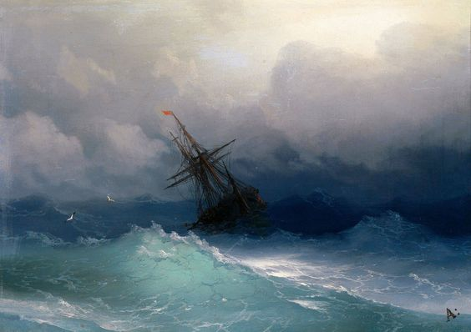

Or: Write the opening of a story set in either the distant past or the distant future.

(24 marks for content and organisation
16 marks for technical accuracy)
[40 marks]

