We read and learn Android document first, and then build a simple program, Adder. Components that Android provide, EditView, TextView, Button, and xml layout format, help us build a screen that we want. An adder needs two edit areas and one confirm button for adding. We set those in xml layout file, like this:

<?xml version="1.0" encoding="utf-8" ?>
- <LinearLayout xmlns:android="http://schemas.android.com/apk/res/android" android:orientation="vertical" android:layout_width="wrap_content" android:layout_height="wrap_content">
- <LinearLayout android:orientation="horizontal" android:layout_width="fill_parent" android:layout_height="wrap_content">
<EditText android:id="@+id/input1" android:layout_width="wrap_content" android:layout_height="wrap_content" android:layout_weight="1" />
<TextView android:layout_width="wrap_content" android:layout_height="wrap_content" android:text="@string/addmark" />
<EditText android:id="@+id/input2" android:layout_width="wrap_content" android:layout_height="wrap_content" android:layout_weight="1" />
<TextView android:layout_width="wrap_content" android:layout_height="wrap_content" android:text="@string/equal" />
<TextView android:id="@+id/numresult" android:layout_width="wrap_content" android:layout_height="wrap_content" android:text="" />
</LinearLayout>
<Button android:id="@+id/addbutton" android:text="@string/addbutton" android:layout_width="wrap_content" android:layout_height="wrap_content" />
</LinearLayout>

“LinearLayout” makes componts ordered by line. “@string” is a string stored in xml file as

<?xml version="1.0" encoding="utf-8"?>
<resources>
<string name="app_name">Adder1</string>
<string name="input1">Input number1</string>
<string name="input2">Input number2</string>
<string name="addbutton">Add</string>
<string name="equal">=</string>
<string name="addmark">+</string>
</resources>

We can reuse strings just by giving correct name in the xml file, strings.xml. Each item has an id generated by Android, so we retrieve item value relied on unique id.

EditText num1 = (EditText) findViewById(R.id.input1);
EditText num2 = (EditText) findViewById(R.id.input2);
Button addButton = (Button) findViewById(R.id.addbutton);

A Java file, R, stores every unique id and will be coded automatically. For example,

public static final int addbutton=0x7f050003;

Then, if users click the Add button, the program will add two numbers and show result on screen. The code for listening event is

addButton.setOnClickListener(new View.OnClickListener() {
public void onClick(View view) {
number1=num1.getText().toString();
number2=num2.getText().toString();
x=Integer.parseInt(number1)+ Integer.parseInt(number2);
numr=(TextView) findViewById(R.id.numresult);
numr.setText(String.valueOf(x));
}
});

The following is images during executing:
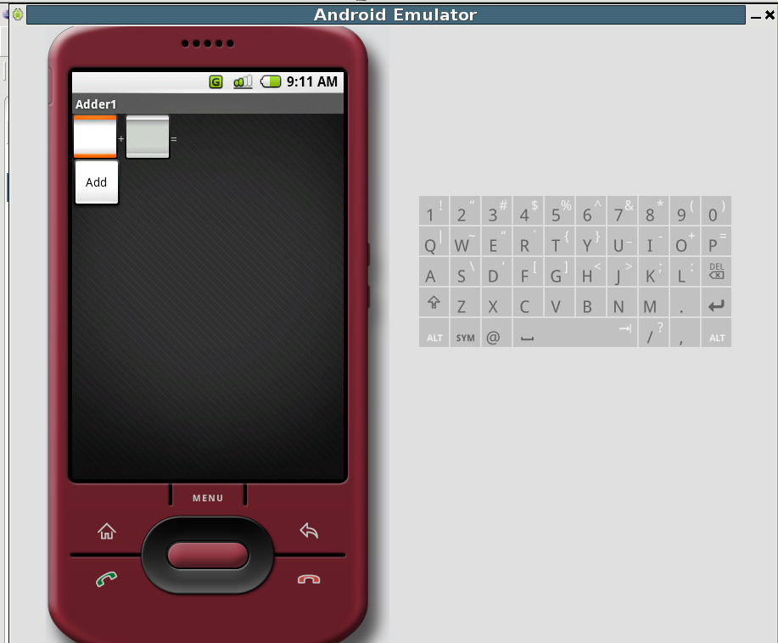

Input numbers:
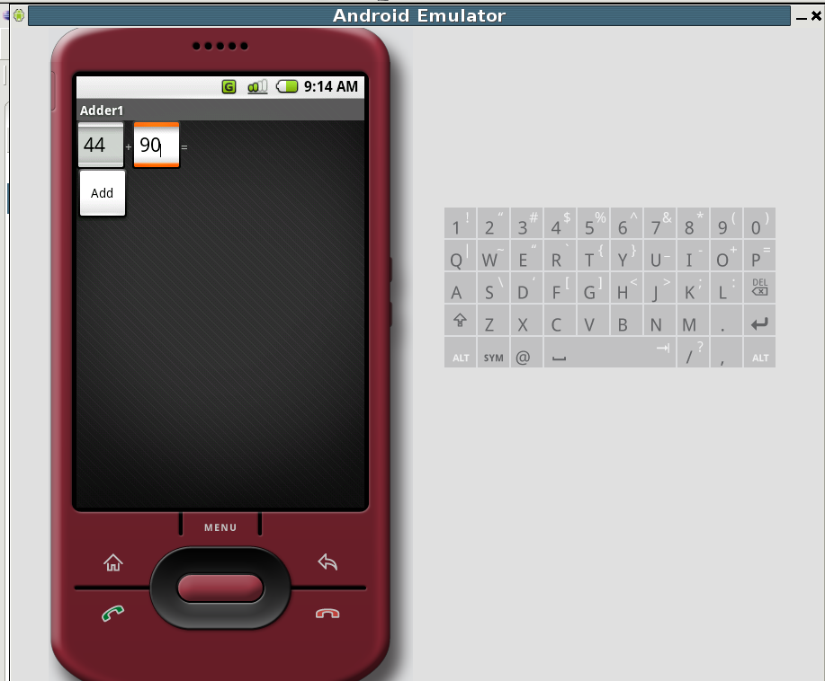

Get result:
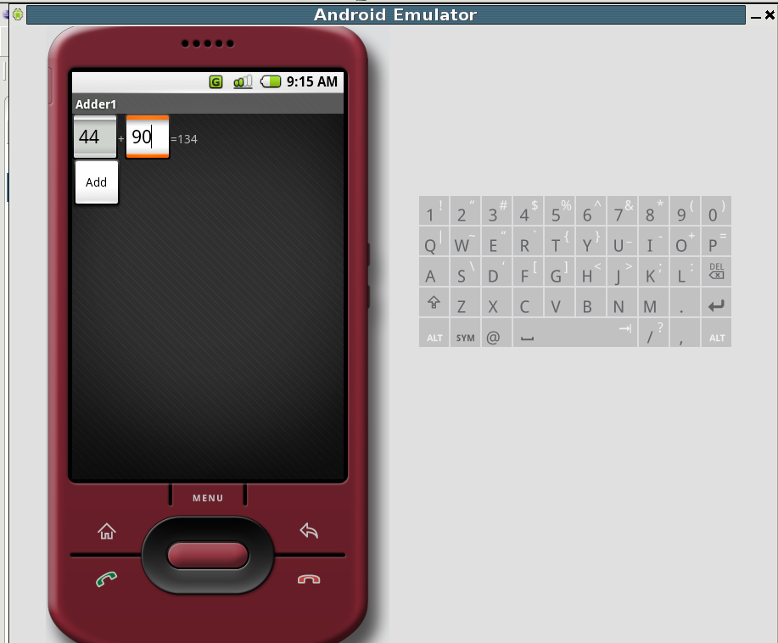

A user interface of translation machine is similar adder, one EditText for inputting source language sentence and one button for confirming input finish. Before writing an smaller machine translation on cell phones, we use a free MT tools, Moses, to translate sentences. Although Android can simulate that mobile device read sd card, Moses is written by C and perl, and Android OS does not support those language. Therefore, we adopt local network transfer for translating test. Translation machine will be written by Java and install on Android platform in the future.
In this MT example, we transfer a sentence from Android MT application to local Moses MT on Linux and focus on English-to-Chinese language pairs. Then, return translation to Android MT application. The following is execution images.
We first input a sentence.
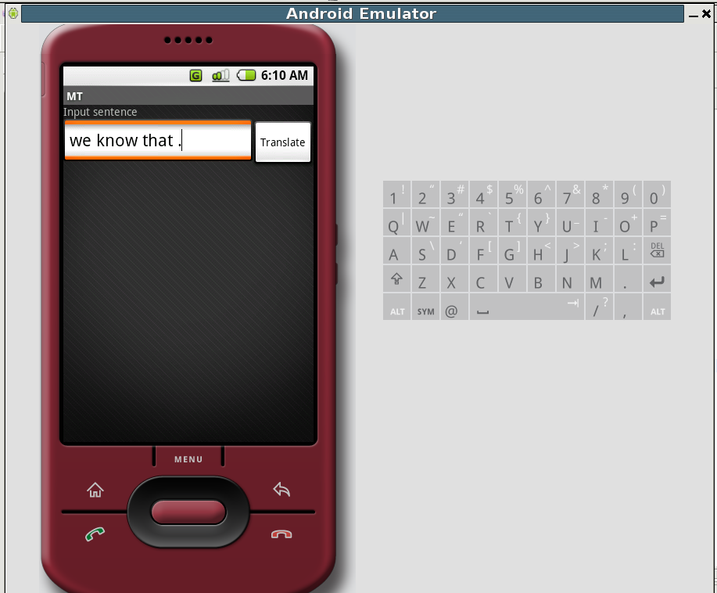

Then, push “Translate” button. This action will trigger a client connection event and transfer input string to local server. Local server will return translation result to the client. So the translation of input string “we know that .” is “我們知道的。”.

