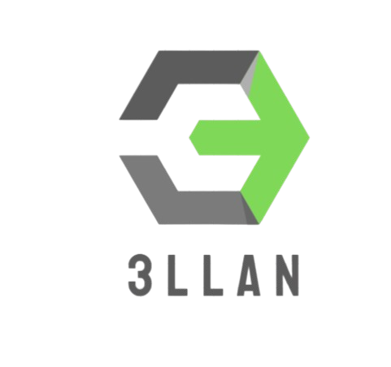

DOCUMENTATION

1. Team

|  |  |
| --- | --- |
| **#** | **Roles in the team** |
| **1** | Nikolay Zhelyazkov – Scrum Trainer |
| **2** | Stefan Radev – Back-End developer |

1. Introduction

|  |  |
| --- | --- |
| **#** | **Introduction** |
| **1** | *What is the program about?*  Multiple Enemies (Agents with AI) which focus on defeating the player. The player is able to defend himself through techniques. |
| **2** | *Main stages in the realization?*  First Week – Implementing the physics and the world around the player  Second Week – Labeling AI in the enemies – setting up the github |
| **3** | *Communication?* Communincation was frequently attained throughout the weeks. With approvals or disagreements, our ideas are formed. |
| **4** | *What libraries are used?* *Direct2D for the environment and libfann for AI management.* |

# Method and manner of implementation

|  |  |
| --- | --- |
| **#** | **Method and manner of implementation** |
| **1** | *Productive work.* The tasks are defined in a way that everyone is aware of the tasks performed so far to present and answer quickly, clear, and accurately, and teamwork is more efficient and productive. |
| **2** | *Distribution of tasks* For each task, a person is selected who is more familiar with the field and will be able to perform the task in the most competent way possible. |
| **3** | *Terms* Observance of dates was reminded by the Scrum Trainer. A meeting of the team is held every day of the second week to discuss the amount of time needed to complete the assigned task. |