Machine Learning Training Script (2–4 Hours)Guide

1. Introduction to Machine Learning (20 mins)
Definition: Machine Learning is a subset of Artificial Intelligence that enables systems to learn patterns from data and make decisions without being explicitly programmed.
Example: Email spam detection, recommendation systems (Netflix/Amazon).

Figure: ML Workflow
Data → Preprocessing → Model Training → Evaluation → Prediction
[Data] --> [Preprocessing] --> [Model] --> [Prediction]

Train-Test Split (IMPORTANT) (10 mins)
Core concept beginners must understand:
Train Set+Test Set=Total Data
- Train → model learns
- Test → model is evaluated

💻 Code:
from sklearn.model_selection import train_test_split
X_train, X_test, y_train, y_test = train_test_split(X, y, test_size=0.2)

2. Types of Machine Learning

Supervised Learning
Definition: Trains models on labeled data to predict or classify new, unseen data.
Example: Predicting house prices.

Unsupervised Learning
Definition: Finds patterns or groups in unlabeled data, like clustering or dimensionality reduction.
Example: Customer segmentation.

Reinforcement Learning
Definition: Learns through trial and error to maximize rewards, ideal for decision-making tasks. Example: Game AI.

3. Supervised Learning (40 mins)

Regression vs Classification
Regression: Predicts continuous values (price, salary).
Classification: Predicts categories (spam/not spam).

Linear Regression
Linear Regression is a supervised machine learning algorithm used to model the relationship between one or more independent variables (inputs) and a continuous dependent variable (output) by fitting a straight line to the data.

Best Fit Line in Linear Regression
The best-fit line is the straight line that best represents the relationship between input and output.
It is the line that:
- Minimizes the difference between actual values and predicted values

🎯 Goal of Linear Regression
To find a line that minimizes prediction error and can be used to predict new values.

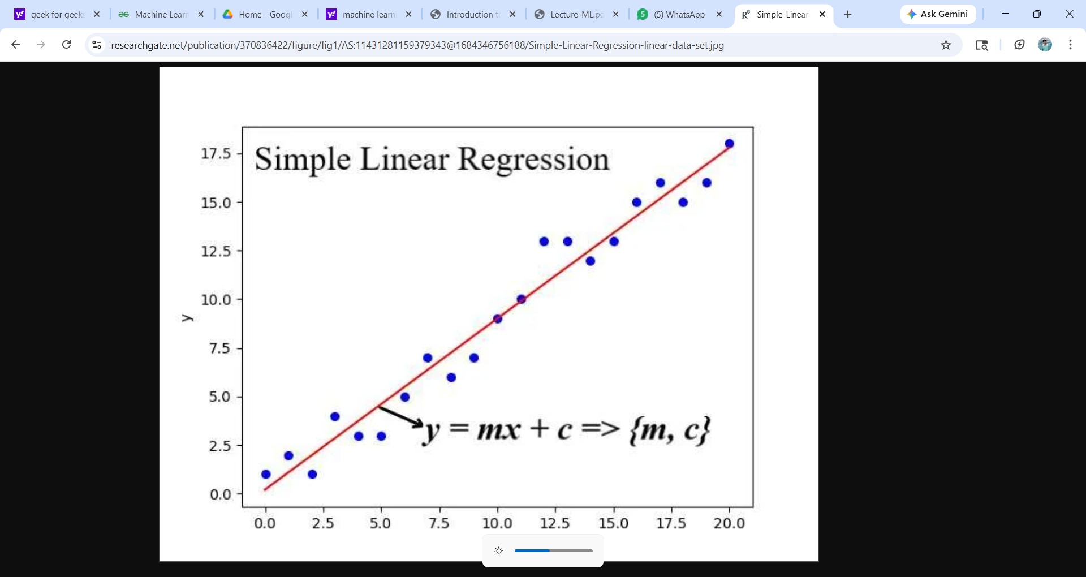

Equation: y = mx + c

Where:
- y → predicted output
- x → input feature
- m → slope (relationship strength)
- c → intercept (starting point)

Intuition
“As input increases, output changes in a predictable way.”
Example:
- Input → Hours studied
- Output → Marks
As hours increase → marks increase
So there is a relationship between them

Python Example: Linear Regression
import pandas as pd
from sklearn.linear_model import LinearRegression
data = pd.DataFrame({
'Experience': [1,2,3,4,5],
'Salary': [30000,40000,50000,60000,70000]
})
X = data[['Experience']]
y = data['Salary']
model = LinearRegression()
model.fit(X, y)
print(model.predict([[6]]))

Multiple Linear Regression

Definition
Multiple Linear Regression is a supervised learning algorithm used to model the relationship between two or more independent variables (inputs) and a continuous dependent variable (output).

Mathematical Model
y=b0+b1x1+b2x2+⋯+bnxn

Where:
- y → predicted output (Marks)
- x₁, x₂, … → input features (Hours, Attendance)
- b₀ → intercept
- b₁, b₂, … → coefficients (feature importance)

Intuition
- 1 variable → Line
- 2 variables → Plane
- 3+ variables → Hyperplane
“We are finding the best surface that fits the data using multiple inputs.”

Example: Student Marks Prediction

Dataset:
Hours (x₁) | Attendance (x₂) | Marks (y)
2 | 60 | 40
4 | 70 | 55
6 | 80 | 70

Model (Assumed)
Marks = 5 × Hours + 0.5 × Attendance

Prediction
For:
- Hours = 5
- Attendance = 75
Marks = (5 × 5) + (0.5 × 75) = 62.5

Key Insight
“We combine multiple factors to improve prediction accuracy.”

Important Concepts:

1. Error (Residual)
Difference between actual and predicted value:
Error = Actual − Predicted

2. Loss Function (MSE)
MSE=1/n∑(yactual−ypredicted)2
Goal: Minimize error to find best coefficients

3. Interpretation of Coefficients
- b₁ (Hours) → change in marks when hours increase by 1
- b₂ (Attendance) → change in marks when attendance increases by 1
Simple line:
“Coefficients tell how much each feature affects output.”

4. Assumptions
- Linear relationship
- No multicollinearity
- Errors are normally distributed
- Constant variance

5. Multicollinearity
When input features are highly correlated
Problem:
- Model becomes unstable
- Wrong importance to features
Program:
from sklearn.linear_model import LinearRegression
import pandas as pd

# Dataset
df = pd.DataFrame({
"Hours": [2, 4, 6],
"Attendance": [60, 70, 80],
"Marks": [40, 55, 70]
})

# Inputs & Output
X = df[["Hours", "Attendance"]]
y = df["Marks"]

# Model
model = LinearRegression()
model.fit(X, y)

# Prediction
print(model.predict([[5, 75]]))

Logistic Regression

Definition
Logistic Regression is a supervised machine learning algorithm used for classification problems, where the goal is to predict the probability that an input belongs to a particular class.
- Unlike Linear Regression (which predicts continuous values), Logistic Regression predicts probabilities between 0 and 1
- Mainly used for binary classification (0/1, Yes/No, Pass/Fail)

Why Do We Need Logistic Regression?
Start in class like this:
“Can we use Linear Regression to predict Pass/Fail?”

Problem with Linear Regression:
- Outputs values like 65, 72, etc.
- But classification needs:
  - 0 or 1
  - Yes or No
Conclusion:
“We need a model that gives output between 0 and 1 → probability”

Core Idea
Instead of predicting exact values, Logistic Regression predicts:
Probability of belonging to a class

Example
Hours Studied | Pass
2 | 0
6 | 1
For a new student (Hours = 5):
- Model may predict: 0.7
Interpretation:
- 0.7 → 70% chance of passing

Sigmoid Function (Heart of Logistic Regression)
σ(x)=1/1+e−x

Explanation
- Converts any real value → range between 0 and 1
- Used to convert linear output into probability

Key Understanding
- Linear model → gives any value
- Sigmoid → converts it into probability

Mathematical Model

Step 1: Linear Combination
z = b₀ + b₁x₁ + b₂x₂ + ...

Step 2: Apply Sigmoid
Final Output = σ(z)

Decision Boundary
After computing probability:
- If probability ≥ 0.5 → Class = 1 (Pass)
- If probability < 0.5 → Class = 0 (Fail)
This threshold (0.5) is called Decision Boundary

Visual Explanation (Use in Class)
Probability
1 | Pass
| /
0.5|------ Decision Boundary
| /
0 | Fail
Hours →

Loss Function
Logistic Regression uses Log Loss (Binary Cross-Entropy) instead of MSE.

Why not MSE?
- MSE is not suitable for probabilities
- Log Loss gives better optimization

Intuition
- Wrong confident predictions → heavily penalized
- Correct predictions → low loss

Interpretation of Coefficients
- Positive coefficient → increases probability of class 1
- Negative coefficient → decreases probability
👉 Example:
- More study hours → higher chance of passing
4. Decision Trees & Random Forest (30 mins)

Decision Tree

Definition
A Decision Tree is a supervised machine learning algorithm used for classification and regression, which splits the dataset into smaller subsets based on feature values, forming a tree-like structure of decisions.

Basic Idea
A Decision Tree works by:
- Repeatedly splitting the dataset
- Based on the best feature
- To make groups as pure as possible
“Decision Tree asks questions step-by-step to reach a final decision.”

🔷 3. Structure of Decision Tree

🌳 Components
- Root Node → Entire dataset
- Decision Node → Condition (e.g., Hours > 4?)
- Leaf Node → Final prediction
- Branches → Outcomes

📊 Tree Structure
(Hours > 4?)
/ \
No Yes
Fail (Attendance > 75?)
/ \
No Yes
Fail Pass

4. Working of Decision Tree (Steps)
- Start with full dataset
- Choose best feature
- Split data
- Repeat splitting
- Stop when pure → assign output

5. Core Concept: Purity
- Pure Node → all values same
- Impure Node → mixed values
Goal:
“Reduce impurity after every split”

6. Entropy (Impurity Measure)

Formula (Show, don’t over-explain)
Entropy = −∑pilog2(pi)

Explanation
- Measures randomness in data
- Higher value → more mixed data
- Lower value → more pure data

Interpretation
Case | Entropy
All same (Pure) | 0
50-50 mix | 1

7. Information Gain

Formula
IG=Entropy(parent)−∑(Weighted Entropy(children))

Explanation
“Information Gain tells how much impurity is reduced after a split.”
Goal:
- Choose split with maximum Information Gain

8. Gini Index

Formula
Gini=1−∑pi2

Explanation
- Measures impurity like entropy
- Lower Gini → better split

Interpretation
Case | Gini
Pure | 0
Mixed | 0.5

9. Gini vs Entropy
Aspect | Gini | Entropy
Speed | Faster | Slower
Complexity | Simple | Slightly complex
Use | CART | ID3, C4.5
“In real-world, both perform almost same.”

10. Splitting Criterion
Decision Tree selects:
- Lowest Gini OR
- Highest Information Gain

11. Overfitting in Decision Tree

Problem
- Tree becomes too deep
- Memorizes data

Solutions
- Pruning
- Limit:
  - max_depth
  - min_samples_split

Python Example: Decision Tree
from sklearn.tree import DecisionTreeClassifier
import pandas as pd

# Dataset
df = pd.DataFrame({
"Hours": [2, 4, 6, 8],
"Attendance": [60, 70, 80, 90],
"Result": [0, 0, 1, 1]
})

# Inputs & Output
X = df[["Hours", "Attendance"]]
y = df["Result"]

# Model
model = DecisionTreeClassifier()
model.fit(X, y)

# Prediction
print(model.predict([[5, 75]]))

Random Forest

Definition
Random Forest is an ensemble learning algorithm that builds multiple decision trees and combines their outputs to improve accuracy, stability, and reduce overfitting.

2. Why Random Forest? (Problem with Decision Tree)
“Decision Trees are easy to understand, but they have a major problem…”
They overfit (memorize training data)

Solution
- Instead of one tree → use many trees
- Combine predictions → better performance

Core Idea
Random Forest = Many Decision Trees + Combination

Intuition
“Instead of asking one person, we ask multiple people and take majority opinion.”

4. Forest Structure (Visualization)
Input Data
|
--------------------------------
| | | | |
Tree1 Tree2 Tree3 Tree4 Tree5
| | | | |
Pass Fail Pass Pass Fail
--------------------------------
|
Final Output
(Majority Vote)
Pass

Explanation
- Each tree gives its prediction
- Final output:
  - Classification → Majority vote
  - Regression → Average

Key Concepts Behind Random Forest

Bagging (Bootstrap Aggregation)

Definition
Training each tree on a random subset of data (with replacement)

Explanation
- Tree 1 → random sample
- Tree 2 → different sample
- Tree 3 → another sample
Creates diversity among trees

Random Feature Selection

Definition
At each split, only a random subset of features is considered

Why?
- Prevents trees from becoming identical
- Increases randomness
- Improves generalization

6. Working of Random Forest (Step-by-Step)

Step 1: Create multiple datasets
- Using bagging (sampling with replacement)

Step 2: Train multiple trees
Each tree:
- Uses different data
- Uses random features

Step 3: Make predictions
- Each tree gives output

Step 4: Combine outputs
- Classification → Majority vote
- Regression → Average

7. Final Prediction (Simple Formula)

For Classification
Final Output=Mode(y1,y2,...,yn)

📌 For Regression
Final Output=1n∑i=1nyi

8. Simple Example
Problem: Pass/Fail
5 trees give predictions:
- Tree1 → Pass
- Tree2 → Fail
- Tree3 → Pass
- Tree4 → Pass
- Tree5 → Fail

Final Decision
Pass (3 out of 5 votes)

Why Random Forest Works Better

Key Reasons
✔ Reduces overfitting
✔ Reduces variance
✔ Handles noisy data
✔ More stable than single tree

Important Idea
“Errors from different trees cancel each other”

10. Important Hyperparameters (Add This – Missing in Yours)
Very important for interviews & teaching:
- n_estimators → Number of trees
- max_depth → Depth of each tree
- min_samples_split → Minimum samples to split
- max_features → Number of features per split
Program:
from sklearn.ensemble import RandomForestClassifier
import pandas as pd

# Dataset
df = pd.DataFrame({
"Hours": [2, 4, 6, 8],
"Attendance": [60, 70, 80, 90],
"Result": [0, 0, 1, 1]
})

X = df[["Hours", "Attendance"]]
y = df["Result"]

# Model
model = RandomForestClassifier(n_estimators=5)

# Train
model.fit(X, y)

# Predict
print(model.predict([[5, 75]]))

5. KNN & SVM (40 mins)

KNN

1. Definition
K-Nearest Neighbors (KNN) is a supervised learning algorithm used for classification and regression, where the prediction for a new data point is based on the nearest K data points in the training dataset.

2. Core Idea
“Similar data points are close to each other”

Intuition
“If a new student behaves like students who passed, then he will also pass.”
KNN works based on similarity (distance)

3. Concept Visualization
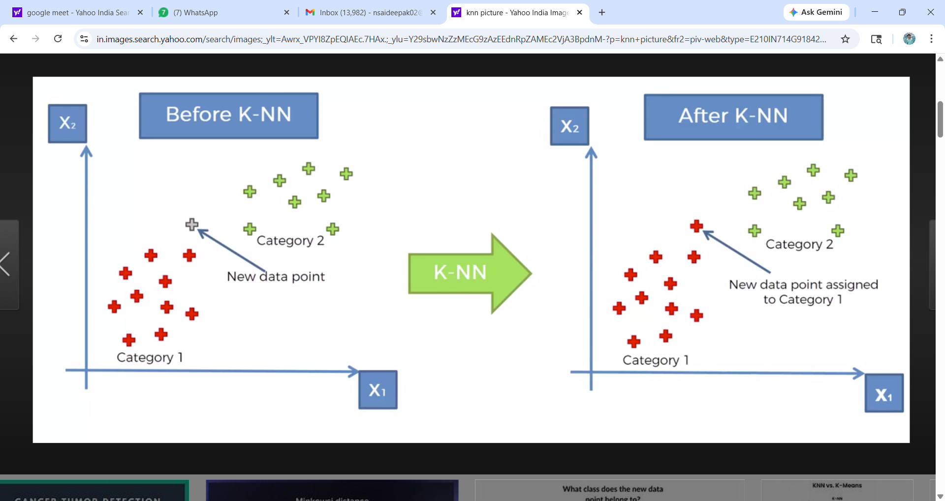

Explanation
- X → New data point
- Find nearest points
- Count neighbors
- Assign majority class

How KNN Works (Step-by-Step)

Step 1: Choose K
- Number of neighbors (e.g., 3, 5)

Step 2: Calculate Distance
- Compute distance between new point and all training points

Step 3: Find Nearest K Points
- Select closest K neighbors

Step 4: Make Prediction
- Classification → Majority vote
- Regression → Average

5. Distance Metrics (Important)

Euclidean Distance (Most Common)

d = \sqrt{(x_1 - x_2)^2 + (y_1 - y_2)^2}

Explanation
- Measures straight-line distance
- Smaller distance → more similar points

Other Distance Metrics (Add This – Important)
- Manhattan Distance → grid-based distance
- Minkowski Distance → general form
- Cosine Distance → used in text data
“Different distance metrics work better for different data types.”

6. Choosing K Value

Small K (e.g., K = 1)
✔ Captures fine details
❌ Sensitive to noise (overfitting)

Large K
✔ More stable
❌ May ignore patterns (underfitting)

Rule
Choose odd K (to avoid tie)
Use validation to select best K

7. Simple Example
Problem: Pass/Fail
K = 3
Nearest neighbors:
- Pass
- Pass
- Fail

Prediction
Pass (majority vote)

8. Why KNN Works
✔ Based on similarity
✔ No assumptions about data
✔ Works well for simple patterns

Important Concept: Feature Scaling

Problem
Different feature ranges:
- Hours → 1–10
- Salary → 10,000–1,00,000
Larger values dominate distance

Solution
- Standardization
- Normalization
Very important for:
- KNN
- SVM

10. Important Hyperparameters (Missing – Added)
- n_neighbors (K) → number of neighbors
- metric → distance type (euclidean, manhattan)
- weights:
  - uniform → equal weight
  - distance → closer points have more weight
Program:
from sklearn.neighbors import KNeighborsClassifier
import pandas as pd

# Dataset
df = pd.DataFrame({
"Hours": [2, 4, 6, 8],
"Attendance": [60, 70, 80, 90],
"Result": [0, 0, 1, 1]
})

X = df[["Hours", "Attendance"]]
y = df["Result"]

# Model
model = KNeighborsClassifier(n_neighbors=3)

# Train
model.fit(X, y)

# Predict
print(model.predict([[5, 75]]))
SVM
1. Definition
Support Vector Machine (SVM) is a supervised learning algorithm used for classification and regression, which finds the optimal boundary (hyperplane) that best separates data points of different classes with the maximum margin.

2. Core Idea
“Find the best boundary that separates classes as clearly as possible”

Intuition (How to start in class)
“Imagine two groups of students: Pass and Fail.
How do we draw a line to separate them?”
👉 Many lines are possible
👉 But we choose the best line

3. Concept Visualization
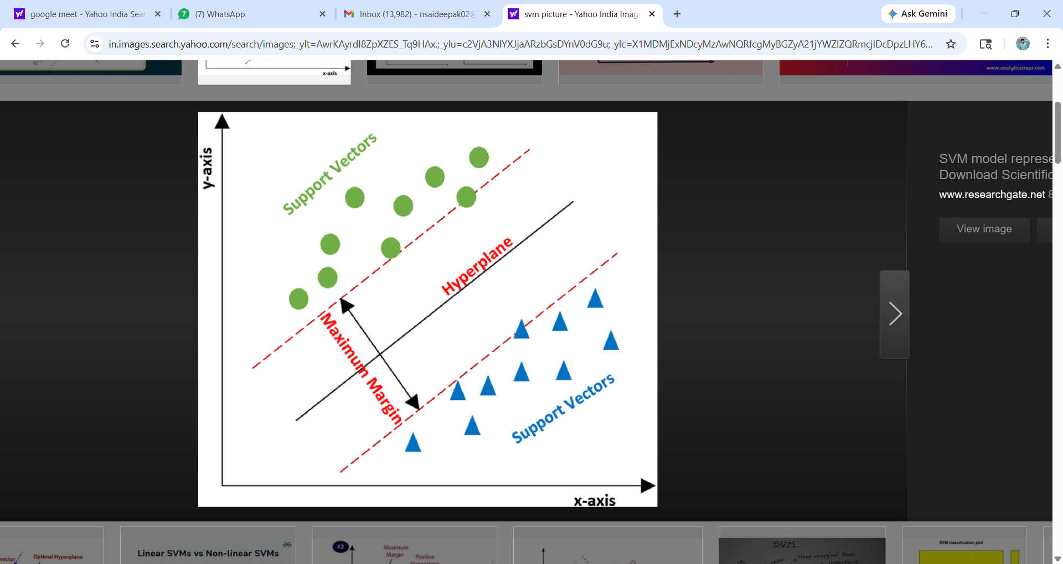

Explanation
- Line → Hyperplane
- Goal → Separate classes
- Best line → Maximum distance from both classes

Important Concepts

Hyperplane

Definition
A boundary that separates data into different classes

Explanation
- 2D → line
- 3D → plane
- Higher dimensions → hyperplane

Margin

Definition
Distance between hyperplane and nearest data points

Goal
Maximize margin

Support Vectors

Definition: Points closest to the boundary

Explanation
- They decide the position of the hyperplane
- Removing them → boundary changes

Working of SVM (Step-by-Step)
- Identify possible boundaries
- Measure margin for each
- Choose boundary with maximum margin
- Use support vectors to define it

Simple Example
Problem: Pass/Fail
- Low hours → Fail
- High hours → Pass

Prediction
- New point on Pass side → Pass
- On Fail side → Fail

What if Data is NOT Linearly Separable?

Problem
Straight line cannot separate data

Solution: Kernel Trick
“Convert data into higher dimension so it becomes separable”

Common Kernels
- Linear → straight line
- Polynomial → curved boundary
- RBF (Gaussian) → most used

Soft Margin

Real-world Problem
Data is noisy → perfect separation not possible

Solution
Allow some misclassification

Idea
“Better to allow small mistakes than overfit completely”

9. Important Hyperparameters (Very Important)
- C (Regularization parameter)
  - High C → strict separation (overfitting risk)
  - Low C → allows errors (better generalization)
- Kernel → type of boundary
- Gamma (for RBF kernel)
  - Controls influence of points

Minimal Mathematical Idea
Decision boundary is represented as:
W.x+b=0

Explain Simply
- This represents the separating line/plane
- Model adjusts it to maximize margin

11. Importance of Feature Scaling (Very Important)

❗ Problem
Different feature ranges affect boundary

Solution
Always apply:
- Standardization
- Normalization
Important for:
- SVM
- KNN
10. Code Example
from sklearn.svm import SVC
import pandas as pd
# Dataset
df = pd.DataFrame({
"Hours": [2, 4, 6, 8],
"Result": [0, 0, 1, 1]
})
X = df[["Hours"]]
y = df["Result"]
# Model
model = SVC(kernel='linear')
# Train
model.fit(X, y)
# Predict
print(model.predict([[5]]))
Unsupervised Learning:

1. K-Means Clustering – Step-by-Step Explanation

Definition
K-Means is an algorithm that divides data into K clusters such that points in the same cluster are similar.

Goal
Minimize distance between:
- Data points
- Their cluster center (centroid)

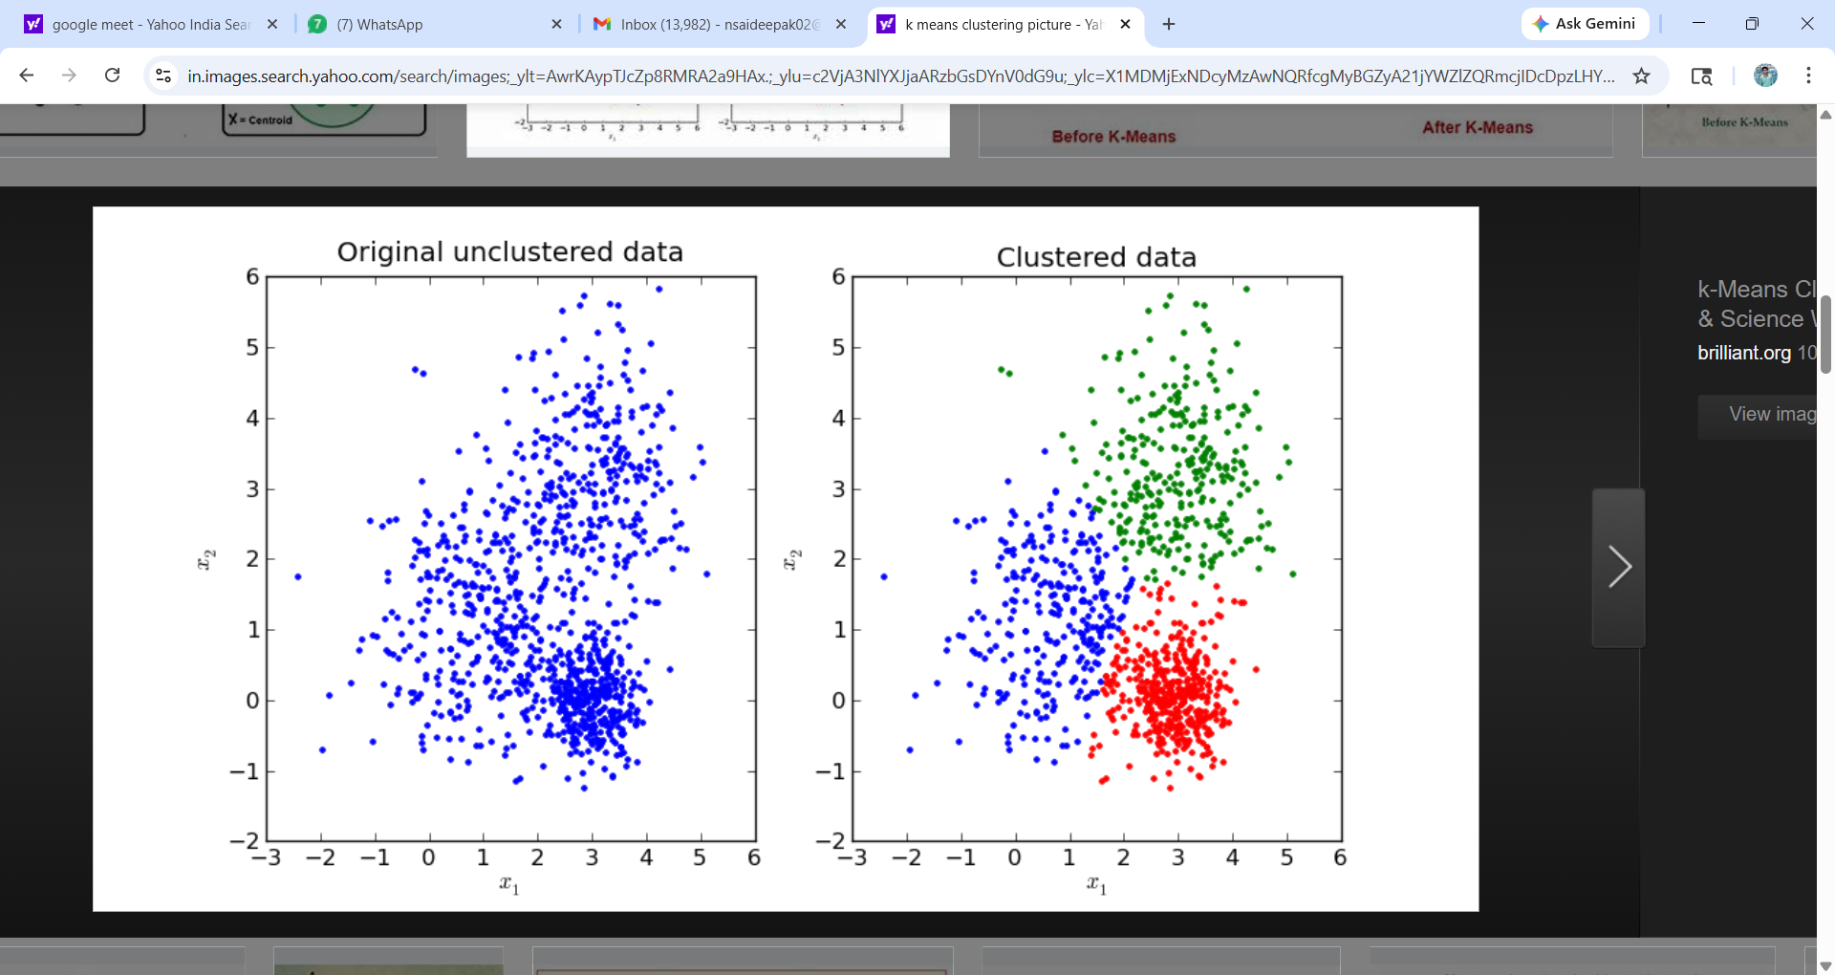

Detailed Steps

Step 1: Choose K (Number of Clusters)
Say this:
“First, we decide how many groups we want.”
- Example: K = 3
- Means → we want 3 clusters
This is user-defined

Step 2: Initialize Centroids
Say:
“We randomly place K points in the dataset. These are temporary centers.”
- These are called centroids
- Initially random → not accurate

Step 3: Assign Points to Nearest Centroid
Say:
“Each data point joins the closest centroid.”
- Distance usually = Euclidean distance
- Result → clusters are formed
Example:
- Points near centroid 1 → Cluster 1
- Points near centroid 2 → Cluster 2

Step 4: Update Centroids
Say:
“Now we recalculate the center of each cluster.”
- Take mean of all points in cluster
- Move centroid to that position
This improves cluster quality

Step 5: Repeat (Iteration)
Say:
“We repeat assigning and updating until nothing changes.”
- Points stop switching clusters
- Centroids stabilize

Stopping Condition
- Centroids do not move anymore
- OR max iterations reached

Full Flow
- Pick K
- Place centroids randomly
- Assign points
- Update centroids
- Repeat until stable

Important Intuition
- “Clusters are formed based on closeness”
- “Centroid keeps adjusting until best grouping is found”

Code with Steps Mapping
from sklearn.cluster import KMeans
# Step 1: Choose K
kmeans = KMeans(n_clusters=2)
# Step 2–5: Fit model (all steps happen internally)
kmeans.fit(X)
# Final Output
labels = kmeans.labels_
centroids = kmeans.cluster_centers_
Explain:
- .fit() → does all steps automatically

PCA – Step-by-Step Explanation

Definition
PCA reduces features by creating new variables (principal components) that capture maximum information.

Goal
- Reduce dimensions
- Keep most important information

Detailed Steps (Simple Explanation)

Step 1: Standardize the Data
Say:
“First, we bring all features to the same scale.”
- Example:
  - Age → 20–60
  - Salary → 20,000–1,00,000
Without scaling → large values dominate

Step 2: Understand Data Spread
“Now we check how data varies in different directions.”
- PCA looks for:
Direction with maximum variation

Step 3: Find Principal Components
Say:
“We create new axes where data is spread the most.”
- These new axes are:
  - PC1 → most important
  - PC2 → second important
These are combinations of original features

Step 4: Select Top Components
Say:
“We keep only the most important components.”
- Example:
  - From 10 features → reduce to 2
Based on explained variance

Step 5: Transform Data
“Finally, we convert original data into new reduced data.”
- Old features → replaced by principal components

Full Flow (Simple)
- Scale data
- Find direction of maximum variance
- Create new axes
- Select top components
- Transform data

Key Intuition
- “PCA rotates the data to find best view”
- “Keeps important information, removes redundancy”

Code with Steps Mapping
from sklearn.decomposition import PCA
from sklearn.preprocessing import StandardScaler
# Step 1: Standardize
scaler = StandardScaler()
X_scaled = scaler.fit_transform(X)
# Step 2–5: Apply PCA
pca = PCA(n_components=2)
X_reduced = pca.fit_transform(X_scaled)
# Output
print(pca.explained_variance_ratio_)

Explain This Output
- explained_variance_ratio_ → importance of each component

🔥 Final Comparison (Steps Level)
Step | K-Means | PCA
1 | Choose K | Scale data
2 | Initialize centroids | Find variance directions
3 | Assign clusters | Create components
4 | Update centroids | Select top components
5 | Repeat until stable | Transform data

Data Preprocessing (30 mins)

Definition: Data Preprocessing is the process of cleaning, transforming, and organizing raw data into a suitable format so that machine learning models can understand and learn from it effectively.

Why Data Preprocessing is Important
Start in class like this:
“Real-world data is not clean like textbook data.”
Problems in raw data:
- Missing values
- Noise (errors)
- Different scales
- Categorical values

Conclusion
“Better data → Better model performance”

Steps in Data Preprocessing

Pipeline
Raw Data → Cleaning → Transformation → Feature Scaling → Final Dataset

4. Handling Missing Values

Problem
Some data is missing:
Hours | Marks
2 | 40
4 | ?
6 | 70

Solutions

Remove rows
When missing data is small

Fill with Mean / Median
Replace missing value with average

Code
df["Marks"].fillna(df["Marks"].mean(), inplace=True)

Explanation
- Mean → good for normal data
- Median → good when outliers exist

Handling Categorical Data

Problem
Machine learning models cannot understand text
Gender
Male
Female

Solution: Encoding

Label Encoding
Male → 0
Female → 1

One-Hot Encoding
Male | Female
1 | 0
0 | 1

Code
pd.get_dummies(df["Gender"])

When to use
- Label Encoding → ordered data
- One-Hot → unordered categories

Feature Scaling

Problem
Different features have different ranges:
Feature | Range
Hours | 1–10
Salary | 10,000–1,00,000
Model gets biased toward large values

Solution: Scaling

Standardization
z=x−μ/σ

Normalization
x′=x−xmin/xmax−xminx​

Code
from sklearn.preprocessing import StandardScaler
scaler = StandardScaler()
X_scaled = scaler.fit_tr

When needed?
Important for:
- KNN
- SVM
- Gradient-based models

7. Handling Outliers

Problem
Extreme values affect model
Marks
40
50
1000

Solutions
- Remove outliers
- Replace with median
- Use robust models

8. Feature Selection

Idea
“Not all features are useful”

Goal
👉 Keep important features
👉 Remove irrelevant ones

Benefits
✔ Faster model
✔ Better accuracy
✔ Less overfitting

9. Splitting Data

Definition
Divide dataset into:
- Training data
- Testing data

Code
from sklearn.model_selection import train_test_split
X_train, X_test, y_train, y_test = train_test_split(X, y, test_size=0.2)

Explanation
- Train → model learns
- Test → evaluate model

10. Encoding Target Variable
Example:
Result
Pass
Fail
Convert:
- Pass → 1
- Fail → 0

11. Data Preprocessing Workflow (VERY IMPORTANT)
1. Load data
2. Handle missing values
3. Encode categorical data
4. Feature scaling
5. Feature selection
6. Split data
7. Train model

12. Complete Example Code
import pandas as pd
from sklearn.preprocessing import StandardScaler
from sklearn.model_selection import train_test_split
# Dataset
df = pd.DataFrame({
"Hours": [2, 4, 6, 8],
"Attendance": [60, 70, 80, 90],
"Result": [0, 0, 1, 1]
})
# Features & Target
X = df[["Hours", "Attendance"]]
y = df["Result"]
# Scaling
scaler = StandardScaler()
X_scaled = scaler.fit_transform(X)
# Splitting
X_train, X_test, y_train, y_test = train_test_split(X_scaled, y, test_size=0.2)

FINAL SUMMARY
Data Preprocessing = “Preparing raw data into clean, structured format for machine learning”

Model Evaluation (20 mins)

MODEL EVALUATION – DETAILED NOTES

Definition
Model Evaluation is the process of measuring how well a machine learning model performs on unseen data using appropriate metrics.

2. Why Model Evaluation is Important
Start like this in class:
“Just building a model is not enough —
we must know whether it is good or bad.”

Key Questions
- Is the model accurate?
- Does it work on new data?
- Is it overfitting or underfitting?

Key Idea
“Good performance on training data does NOT guarantee good performance on real-world data”

3. Train-Test Split

Definition
Split data into:
- Training Set → model learns
- Testing Set → model is evaluated

Code
from sklearn.model_selection import train_test_split
X_train, X_test, y_train, y_test = train_test_split(X, y, test_size=0.2)

Explanation
- Train → learning
- Test → checking performance

4. Types of Evaluation Metrics

Based on problem type:
Problem | Metrics
Regression | MSE, RMSE, R²
Classification | Accuracy, Precision, Recall, F1-score

Regression Metrics

1. Mean Squared Error (MSE)

Definition
Measures the average of squared differences between actual and predicted values.

Formula
MSE=1/n∑(yactual−ypredicted)2

Explanation
- Penalizes large errors more
- Lower MSE → better model

Root Mean Squared Error (RMSE)

Definition
Square root of MSE

Formula
MSE = \sqrt{MSE}​

Why RMSE?
Same unit as output → easy to interpret

R² Score (Coefficient of Determination)

Definition
Measures how well the model explains the variance in the data.

Formula
R2=1−SSres/SStot​

Interpretation
R² Value | Meaning
1 | Perfect model
0 | Poor model

Classification Metrics

Confusion Matrix

Structure
Predicted
0 1
Actual 0 TN FP
1 FN TP

Meaning
- TP → Correct Positive
- TN → Correct Negative
- FP → Wrong Positive
- FN → Wrong Negative

Accuracy

Definition
Percentage of correct predictions

Formula
Accuracy=TP+TN/TP+TN+FP+FN

Limitation
Not reliable for imbalanced data

2. Precision

Definition
Out of predicted positives, how many are correct

Formula
Precision=TP/TP+FP

Recall

Definition
Out of actual positives, how many are correctly predicted

Formula
Recall=TP/TP+FN​

F1 Score

Definition
Harmonic mean of Precision and Recall
Formula
F1=2⋅Precision⋅Recall/Precision+Recall​

When to Use Which Metric
Situation | Metric
Balanced data | Accuracy
False positives important | Precision
False negatives important | Recall
Need balance | F1-score

Overfitting vs Underfitting

Overfitting
- Good on training
- Poor on testing

Underfitting
- Poor on both

Goal
Generalization (good on new data)

Cross Validation

Definition
Technique to evaluate model using multiple splits of data

Idea
- Split data multiple times
- Average performance

Code
from sklearn.model_selection import cross_val_score
scores = cross_val_score(model, X, y, cv=5)
print(scores.mean())

Hyperparameter Tuning

Definition
Hyperparameter tuning is the process of selecting the best parameters (set before training) to improve model performance.

Key Idea
There are two types of parameters:

Model Parameters (learned from data)
- Example:
  - Weights in Linear Regression
- Learned automatically during training

Hyperparameters (set manually)
- Example:
  - Number of neighbors in KNN
  - Depth of tree in Decision Tree
These control how the model learns

Simple Intuition
“Hyperparameters are like settings of a machine — changing them changes performance.”
Example:
- KNN:
  - K = 1 → overfitting
  - K = 10 → smoother model

Why Hyperparameter Tuning is Important
- Improves accuracy
- Reduces overfitting/underfitting
- Finds optimal model configuration

Common Hyperparameters

Decision Tree
- max_depth
- min_samples_split

KNN
- n_neighbors

Random Forest
- n_estimators
- max_depth

SVM
- C
- kernel

Hyperparameter Tuning Methods

Manual Search
Try different values manually
K = 1, 3, 5, 7
Not efficient for large problems

Grid Search (Most Important)

Idea:
Try all possible combinations
Figure:
max_depth → 2 4 6
n_estimators ↓
50 ● ● ●
100 ● ● ●
200 ● ● ●
Each ● = model trained

Steps:
- Define parameter grid
- Train model for each combination
- Evaluate performance
- Select best combination

Code:
from sklearn.model_selection import GridSearchCV
from sklearn.ensemble import RandomForestClassifier
model = RandomForestClassifier()
param_grid = {
'n_estimators': [50, 100],
'max_depth': [2, 4, 6]
}
grid = GridSearchCV(model, param_grid, cv=5)
grid.fit(X_train, y_train)
print("Best Parameters:", grid.best_params_)

Random Search

Idea:
Instead of trying all combinations → try random ones
Figure:
Grid Search: Random Search:
● ● ● ● ●
● ● ● ●
● ● ● ● ●

Advantages:
- Faster
- Works well for large search space

Code:
from sklearn.model_selection import RandomizedSearchCV
random = RandomizedSearchCV(model, param_grid, n_iter=4, cv=5)
random.fit(X_train, y_train)
print(random.best_params_)

10. Complete Example Code
from sklearn.metrics import accuracy_score
from sklearn.linear_model import LogisticRegression
model = LogisticRegression()
model.fit(X_train, y_train)
pred = model.predict(X_test)
print(accuracy_score(y_test, pred))

FINAL SUMMARY
Model Evaluation =
“Measuring how well a model performs on unseen data using appropriate metrics”

8. Overfitting vs Underfitting (15 mins)
Overfitting: Model memorizes data.
Underfitting: Model fails to learn patterns.

9. Mini Project (30 mins)
Dataset: Simple salary prediction.

Python Mini Project
import pandas as pd
from sklearn.linear_model import LinearRegression
data = pd.DataFrame({
'Experience': [1,2,3,4,5],
'Salary': [30000,40000,50000,60000,70000]
})
X = data[['Experience']]
y = data['Salary']
model = LinearRegression()
model.fit(X, y)
print("Prediction for 6 years:", model.predict([[6]]))

