What is docker?
Docker containers wrap up a piece of software in a single file system. This file system includes everything that the software need to run, code, run time, system libraries- anything you can install on a server.
This guarantees that it will always run the same, regardless of the environment it is running in.

In a way, Docker is a bit like a virtual machine. But unlike a virtual machine, rather than creating a whole virtual operating system, Docker allows applications to use the same Linux kernel as the system that they're running on and only requires applications be shipped with things not already running on the host computer.
Virtual machine Docker
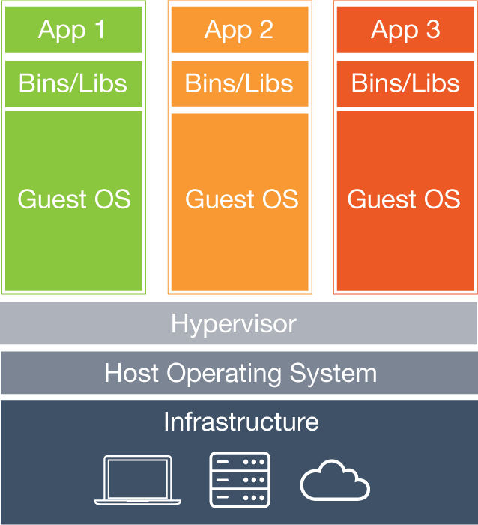
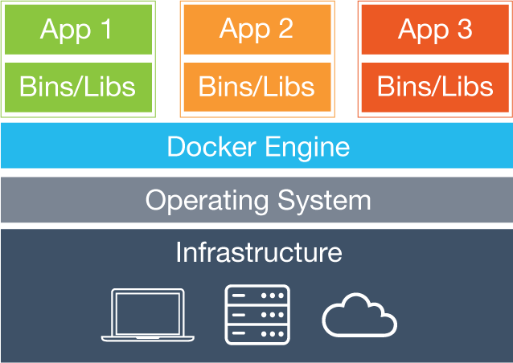

Virtual Machines

Each virtual machine includes the application, the necessary binaries and libraries and an entire guest operating system - all of which may be tens of GBs in size.

Containers
Containers include the application and all of its dependencies, but share the kernel with other containers. They run as an isolated process in userspace on the host operating system. They’re also not tied to any specific infrastructure – Docker containers run on any computer, on any infrastructure and in any cloud.

Getting started with Docker
This getting started is for non-technical users who are interested in learning about Docker. By following this getting started, you’ll learn fundamental Docker features by performing some simple tasks. You’ll learn how to:
- install Docker
- run a software image in a container
- browse for an image on Docker Hub
- create your own image and run it in a container
- create a Docker Hub account and an image repository
- create an image of your own
- push your image to Docker Hub for others to use

Install Docker
This installation procedure is written for users who are unfamiliar with package managers. If you comfortable with package managers, prefer not to use wget, or have problems installing and want to troubleshoot, please use our apt and yum repositories instead for your installation.
- Log into your Ubuntu installation as a user with sudo privileges.
- Verify that you have wget installed.
$ which wget
If wget isn’t installed, install it after updating your manager:
$ sudo apt-get update
$ sudo apt-get install wget

what is wget?
GNU Wget (or just Wget, formerly Geturl) is a computer program that retrieves content from web servers, and is part of the GNU Project. Its name is derived from World Wide Web and get. It supports downloading via HTTP, HTTPS, and FTP protocols.
- Get the latest Docker package.
$ wget -qO- https://get.docker.com/ | sh
The system prompts you for your sudo password. Then, it downloads and installs Docker and its dependencies.
Note: If your company is behind a filtering proxy, you may find that the apt-key command fails for the Docker repo during installation. To work around this, add the key directly using the following:
$ wget -qO- https://get.docker.com/gpg | sudo apt-key add -

Verify docker is installed correctly.
$ docker run hello-world

Run the whalesay image
- Put your cursor in your terminal window at the $ prompt.
- Type the docker run docker/whalesay cowsay boo command and press RETURN.
This command runs the whalesay image in a container. Your terminal should look like the following:
$ docker run docker/whalesay cowsay boo
cowsay is a program which generates ASCII pictures of a cow with a message.[2] It can also generate pictures using pre-made images of other animals, such as Tux the Penguin, the Linux mascot. It is written in Perl. There is also a related program called cowthink, with cows with thought bubbles rather than speech bubbles. .cow files for cowsay exist which are able to produce different variants of "cows", with different kinds of "eyes", and so forth.[3] It is sometimes used on IRC, desktop screenshots, and in software documentation. It is more or less a joke within hacker culture, but has been around long enough that its use is rather widespread. In 2007 it was highlighted as a Debian package of the day.[4]
Cowsay and Cowthink are written in the Perl programming language, and as such is easily adaptable to system tasks in Unix, such as telling users their home directories are full, they have new mail, etc. Additionally, it is quite adaptable to the Common Gateway Interface.[5]

command line :
https://docs.docker.com/engine/reference/commandline/daemon/

cgroups (abbreviated from control groups) is a Linux kernel feature that limits, accounts for, and isolates the resource usage (CPU, memory, disk I/O, network, etc.) of a collection of processes.

