- AF Set Up Engineer should be able to define Tiers (free/paid v1/ paid v2).
- AF Set Up Engineer should be able to define Container Specs. (t2.small/ t2.medium/ m2.small ).
- System should display each Subscription Plans ( Free / Paid v1 / paid v2) to the Organization Admin(Tenant) to choose a suitable plan for the organization.
- Organization Admin(Tenant) should be able to upgrade the subscription plan for the organization.
- System should display the each Container Specs Type( Small/medium/large) with its features such as CPU, memory, storage to all tenants.
- Organization Admin(Tenant) should be able to choose new Container Specs ( small , large , medium ) to the existing subscription plan. Organization members should use those Container Spec.
- Organization Admin(Tenant) should be able to remove Container Specs ( small , large , medium ) from the existing subscription plan.
- System should be able to view the details such as Plan Type, list of Container Specs which is running and information of each Container Spec, of a given Organization.

1.) User in the oraganization can create a applications. Then he automatically subscribe to the FREE. He can choose t2. Types.
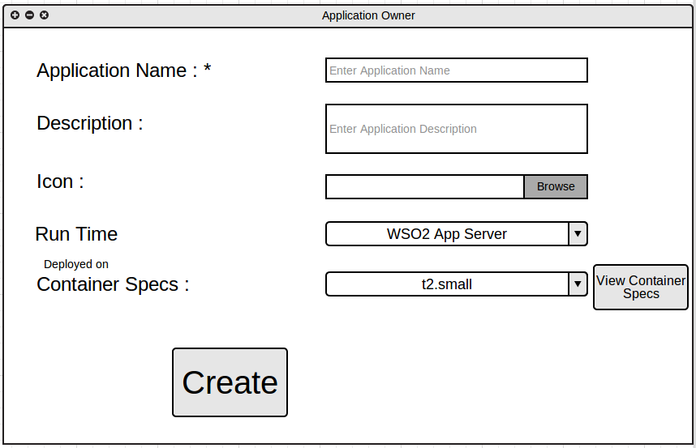
2.) When an organization register with the AF, Application Owners within that organization can upgrade to another subscription plans in the application level.
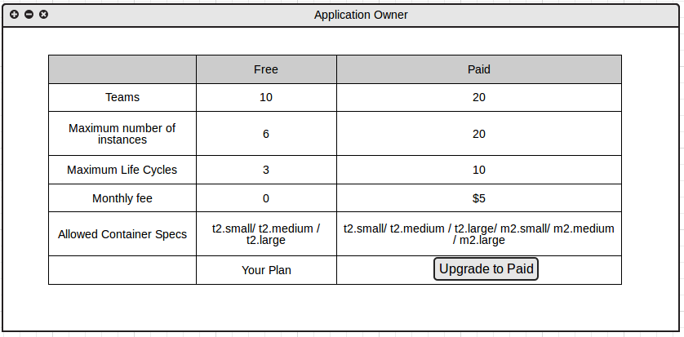
2.) Then he can select the container Specs for the Application. As an example if he is in PAID tier, but he can only select some container specs considering the pricing plan.
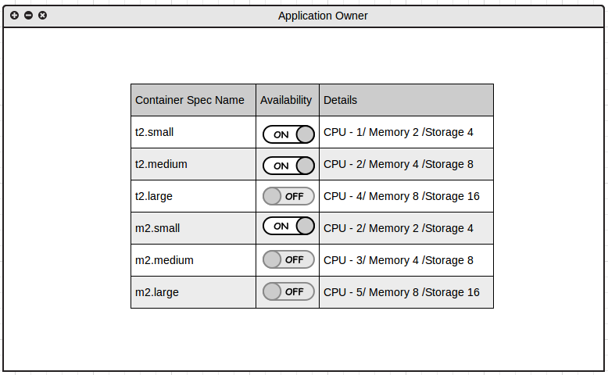
3.) Then the Users of that Application can choose container specs from the allowed types. As an example , if the application allowed only t2.small.t2.medium and t2.large, then the user can choose the suitable spec for the stage.

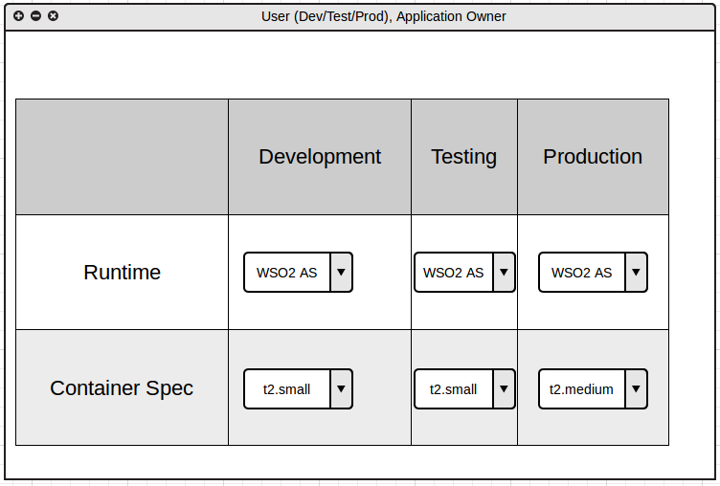
5.) Then the Organization admin can view the details of the every application.
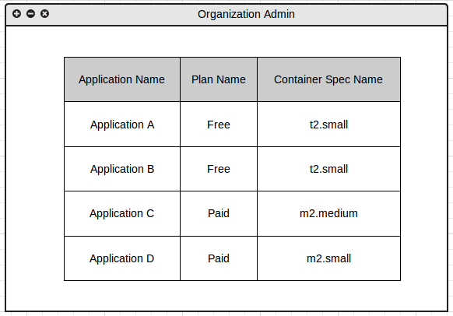
4.) Then in the Life Cycle tab we can see the Runtime Details for each stage.
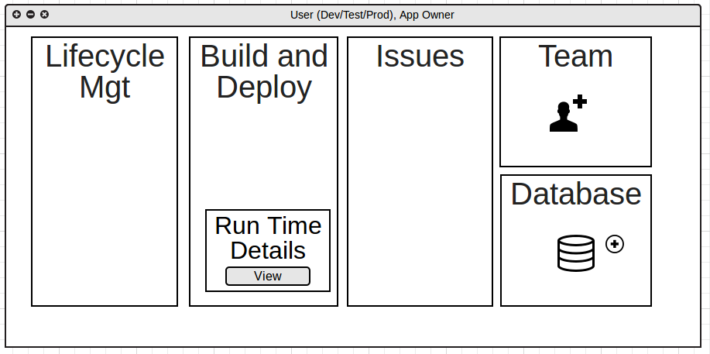

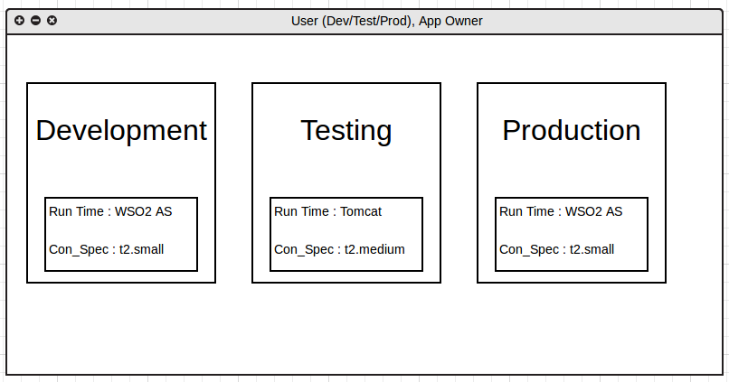
6.) On the other hand App Factory Cofiguration Engineer can define Subscription Plans and Container Specs.
7.) Can view container spec details.

Questions...
1.) Should need a monthly fee?
2.) Free trial period?
3.) Maximum number of applications?

