IT7629 Routing and Switching – Q3 2025

Practical Task Assessment

Name- Naman Sharma
Student ID- 20241215
Submission Date – 05/09/2025
Cisco Packet Tracer Device Configuration

Device | Names
Router 1 | NSTECH-R1
Switch 1 | NSW1
Switch 2 | NSW2
Switch 3 | NSW3
PC1A | PC1A
PC2A | PC2A
PC3A | PC3A
PC1B | PC1B
PC2B | PC2B
PC3B | PC3B

Subnet Design

PC Name | IP Address | Default Gateway
PC1A | 172.30.0.2 | 172.30.0.1
PC2A | 172.30.0.3 | 172.30.0.1
PC3A | 172.30.0.4 | 172.30.0.1
PC1B | 172.30.2.2 | 172.30.2.1
PC2B | 172.30.2.3 | 172.30.2.1
PC3B | 172.30.2.4 | 172.30.2.1

Subnet Mask
I’ll create my subnet mask according to my birth month October (7 October 2005). Network ID given for my birth month October is 172.30.0.0/16.
- 400 host in vlan 2

IP Address | 172.30.0.0/16
Network Address | 172.30.0.0/23
First usable Address | 172.30.0.1/23
Last usable Address | 172.30.1.254
Broadcast Address | 172.30.1.255
Subnet Mask | 255.255.254.0

- 180 host in vlan 3

IP Address | 255.2555.255.0/24
Network Address | 172.30.0.0
First usable Address | 172.30.0.1
Last usable Address | 172.30.1.254
Broadcast Address | 172.30.1.255
Subnet Mask | 255.255.254.0

- 12 host in vlan 99

IP Address | 255.255.255.240
Network Address | 172.30.3.0
First usable Address | 172.30.0.1-172.30.3.14
Total number od hosts | 16
Broadcast Address | 172.30.3.15
Number of usable hosts | 14
IP address | 172.30.3.0/28
Documentation for Hamilton site and configuration requirements
- Configure the router and switch hostnames according to your chosen naming scheme but DO
NOT change the topology names. (4 marks)

For Switch 1 – NSW1
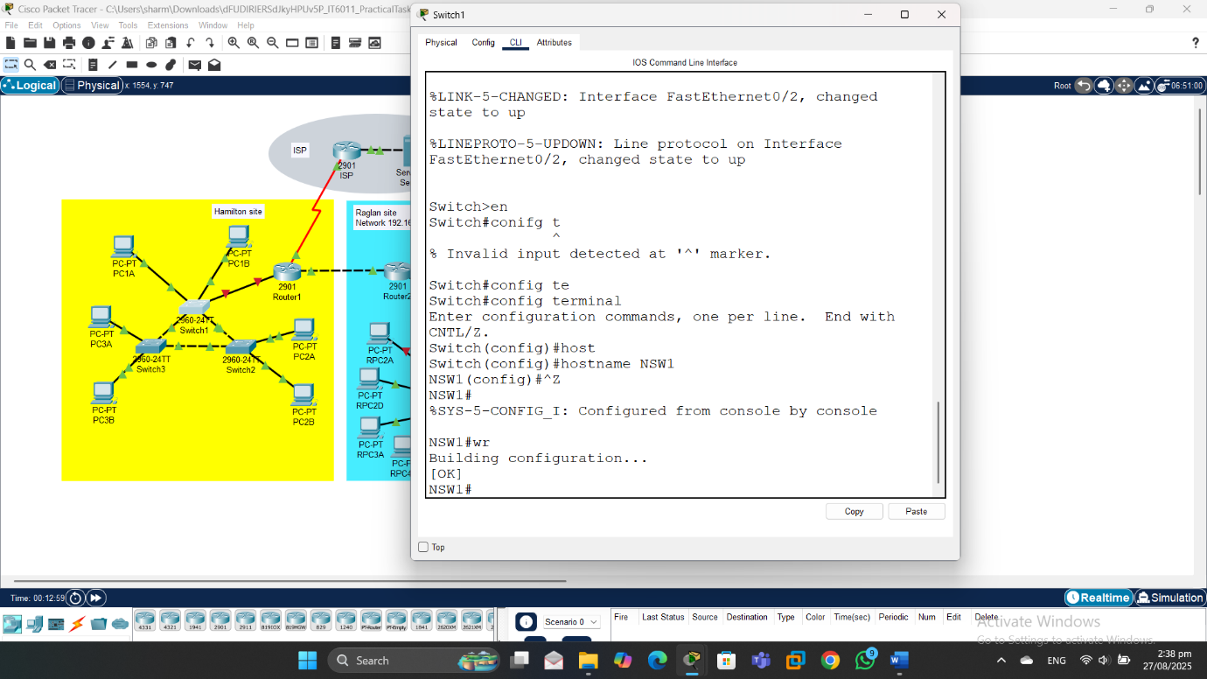

For Switch 2 – NSW2
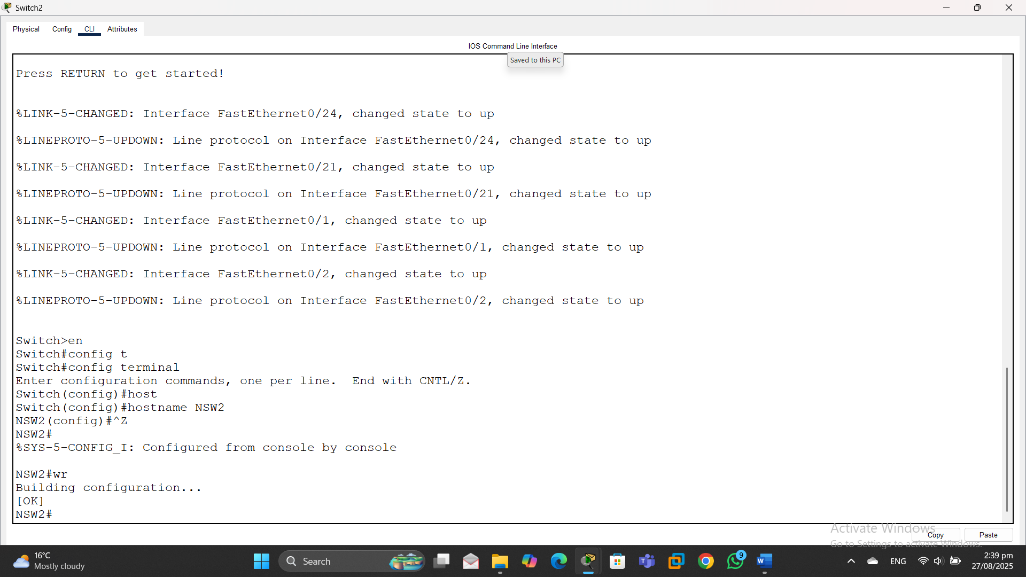

For Switch 3 – NSW3
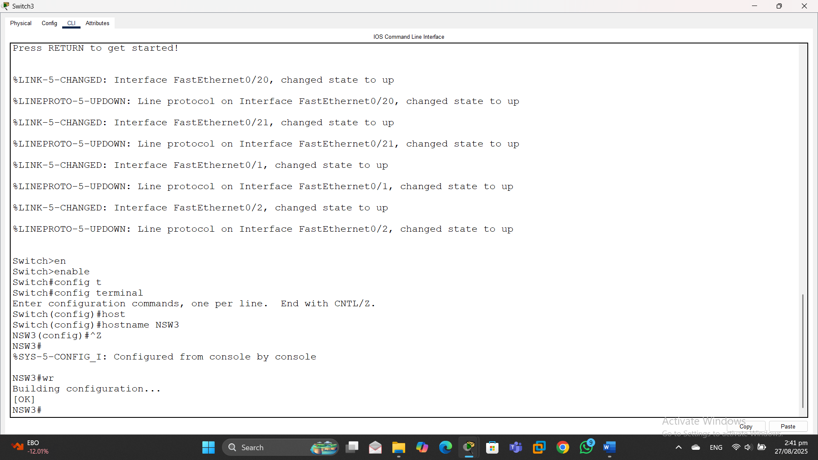

For Router – NSTECH-R1
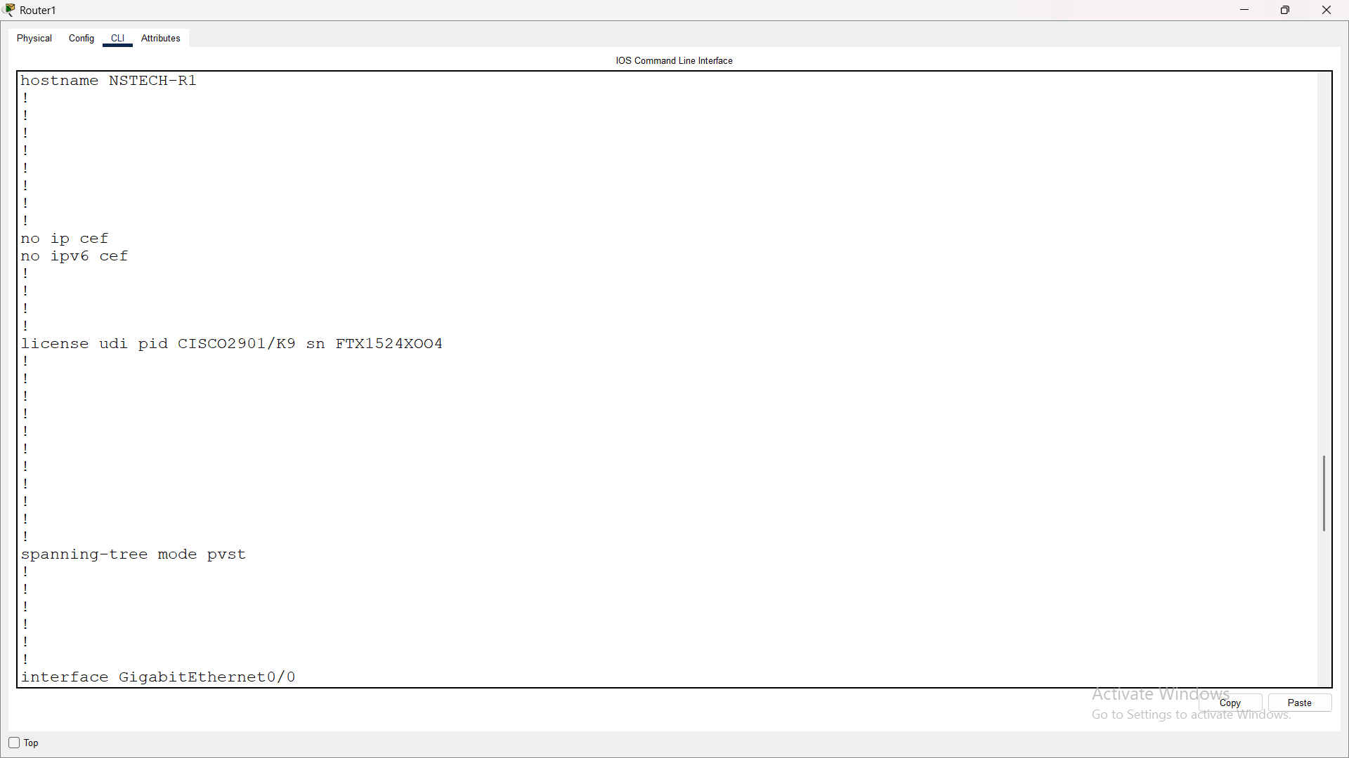

- Only Switch 1 should be a VTP server, record your configuration choices. (6 marks)
- Create and name VLAN 2 and VLAN 3 using food items that you love, and record these in your word document
-Create VLAN 4 named Star
-Create VLAN 99 named Mgmt to use as the management and native VLAN. (3 marks)

Switch 1
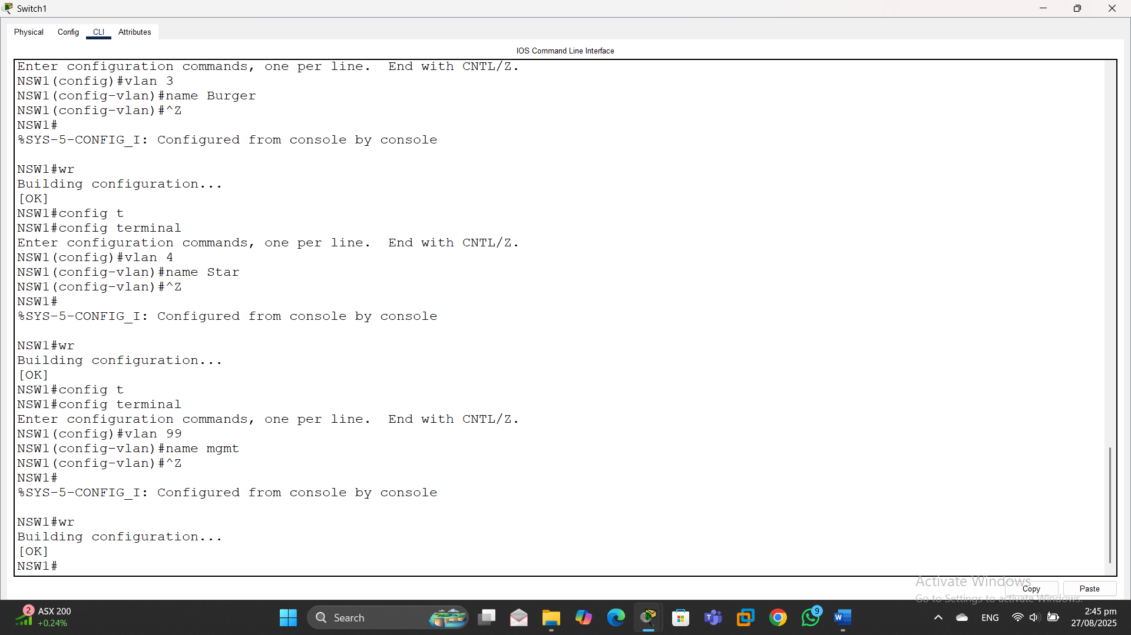

Switch 2
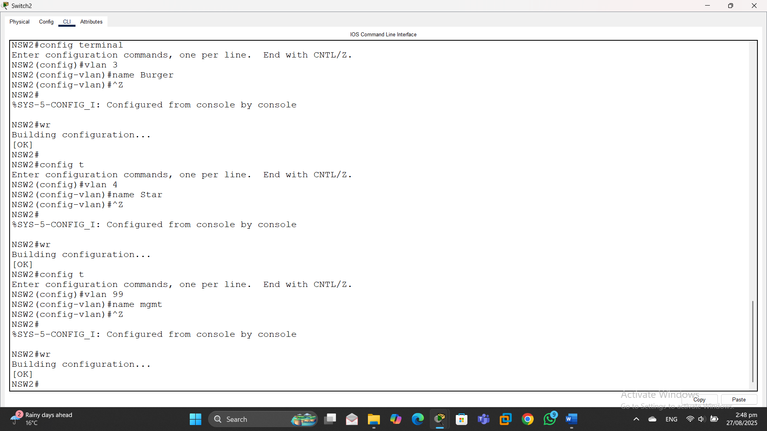

Switch 3
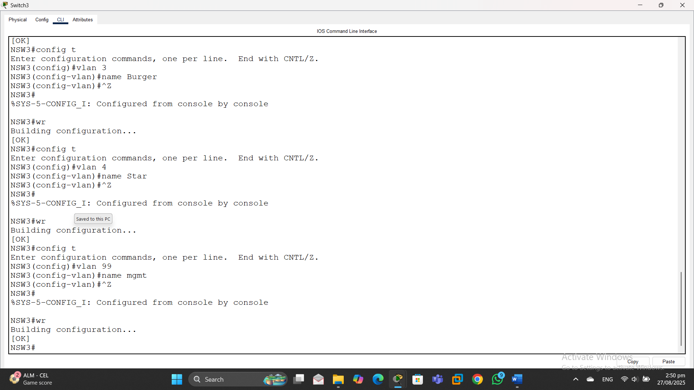
- All trunk connections should be set to always trunk
-VLAN 4 traffic should not be allowed on any trunks. (8 marks)

Switch 1
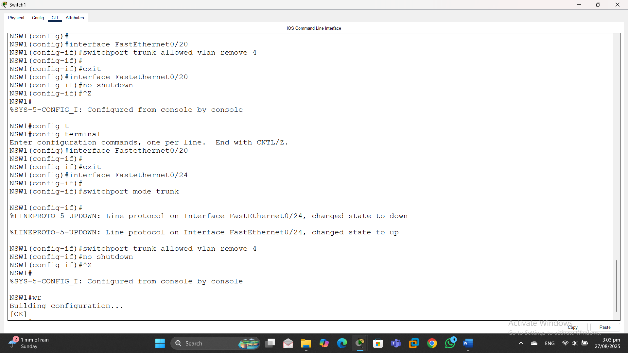

Switch 2
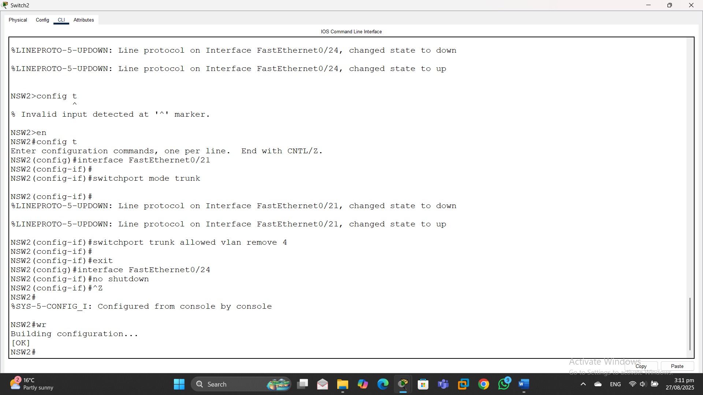

Switch 3
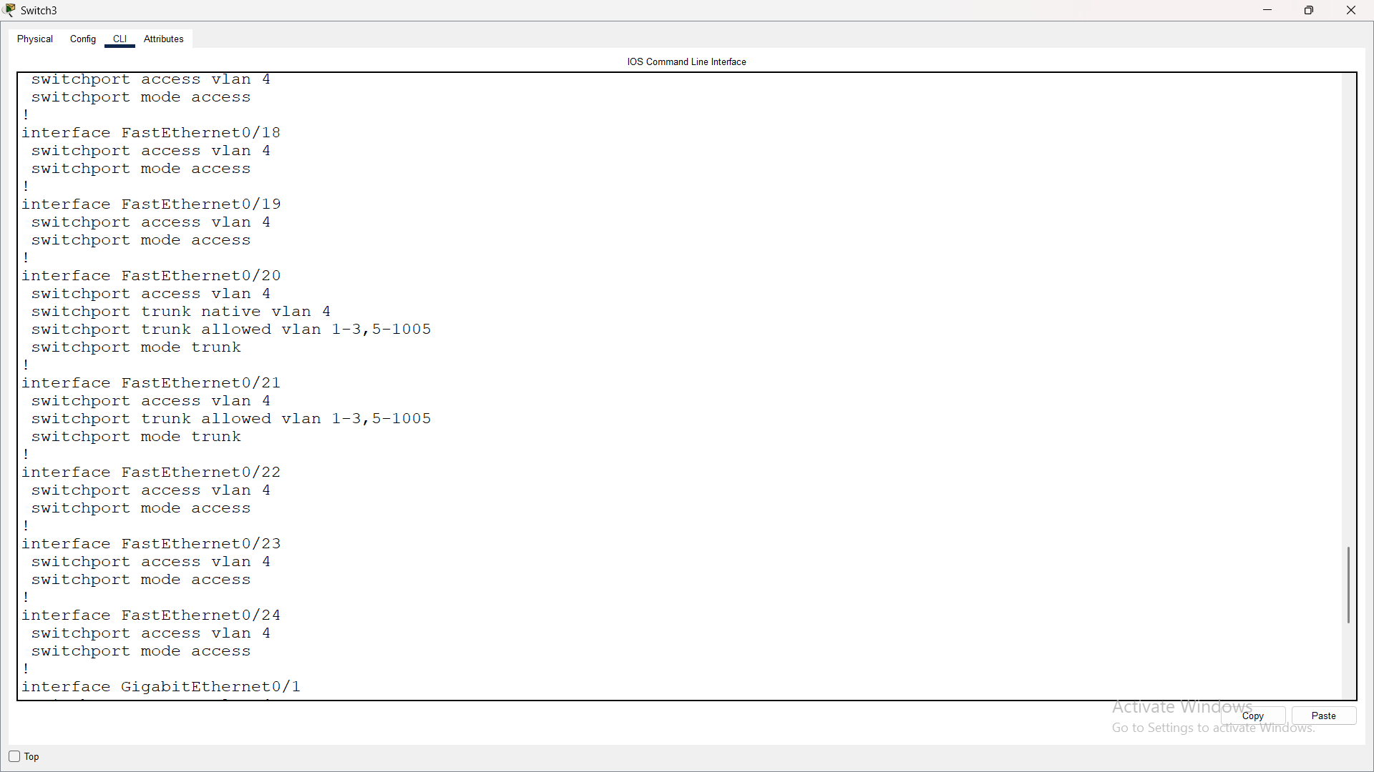

- All non-trunk ports must always be access ports
-For security purposes, all unused access ports must be administratively shut down and assigned to the Star VLAN. (6 marks)

Switch 1
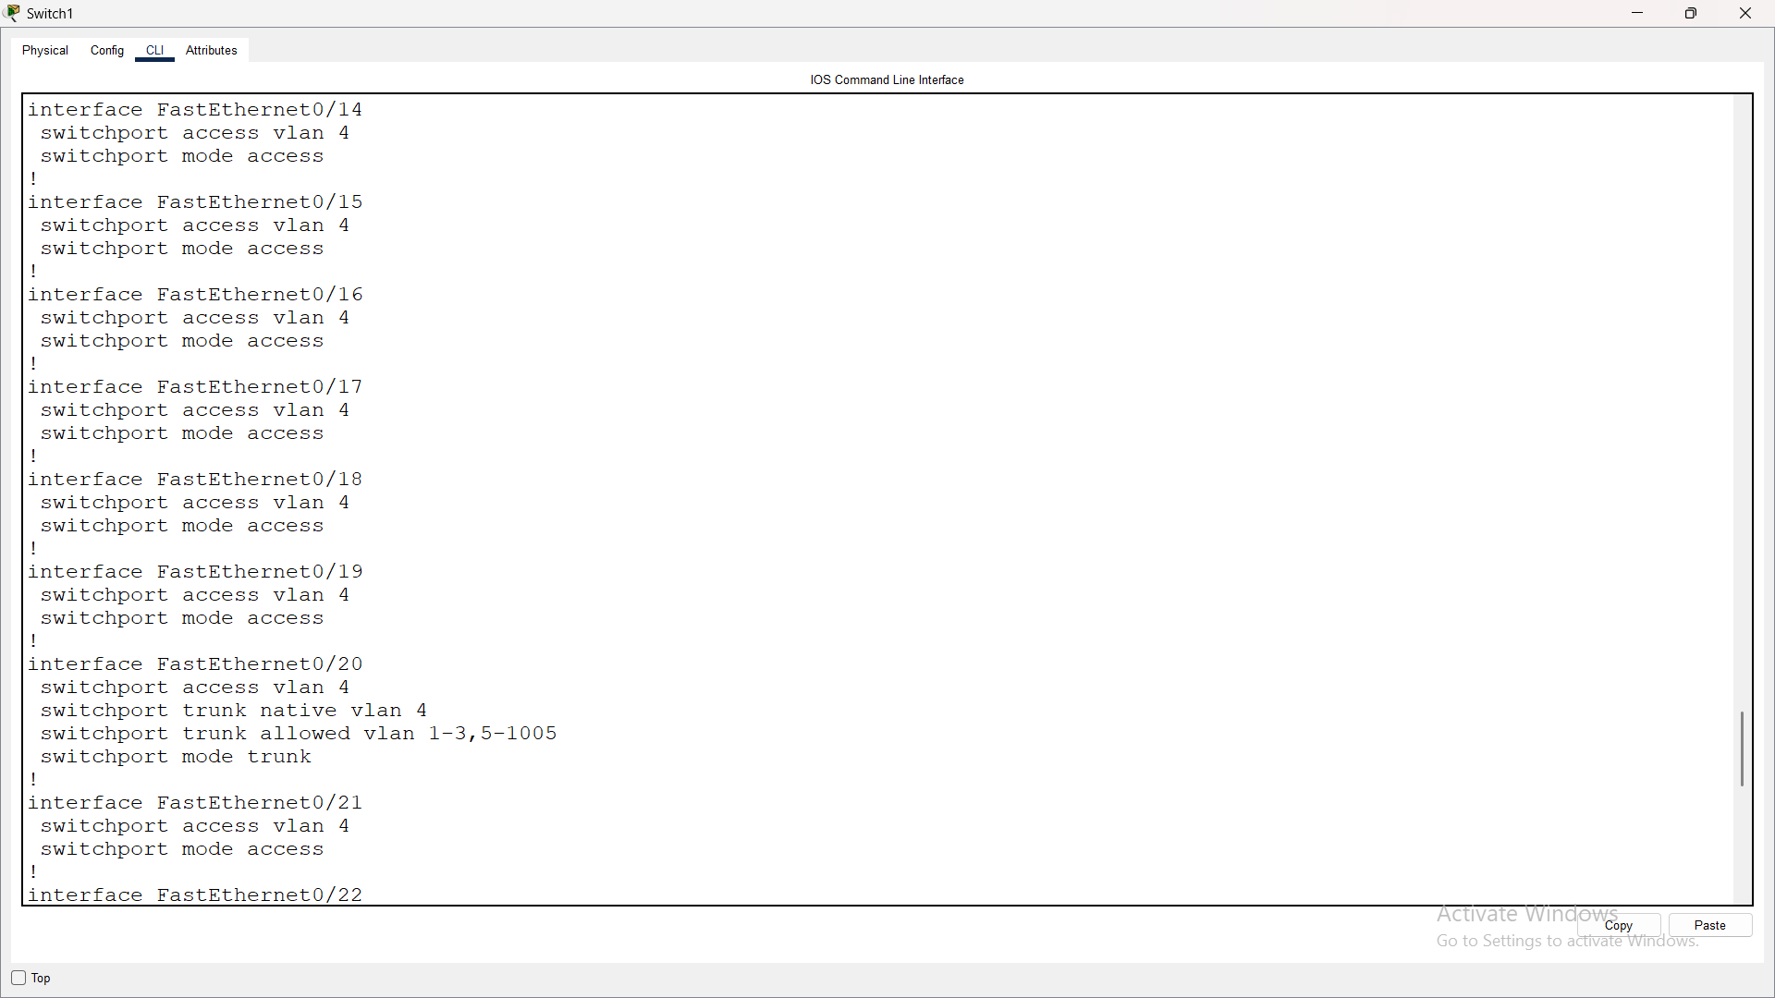

Switch 2
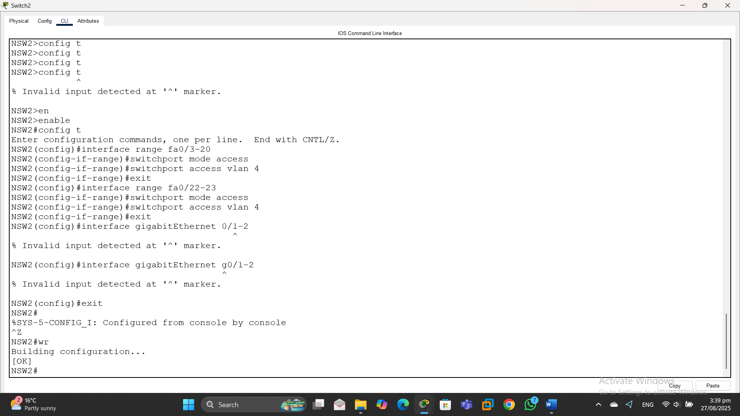

Switch 3
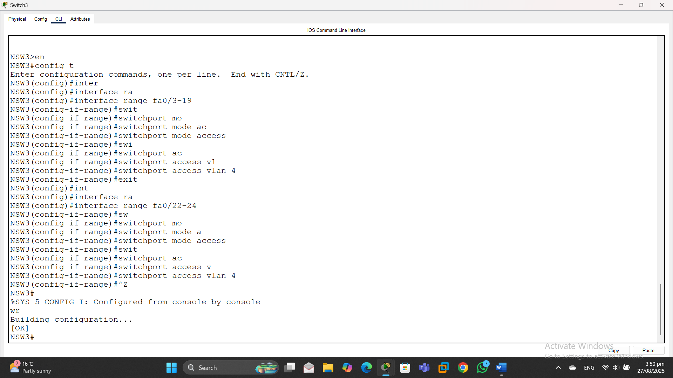

- Switch Fa0/1 ports must be assigned to VLAN 2 and Fa0/2 ports to VLAN 3. (6 marks)

Switch 1
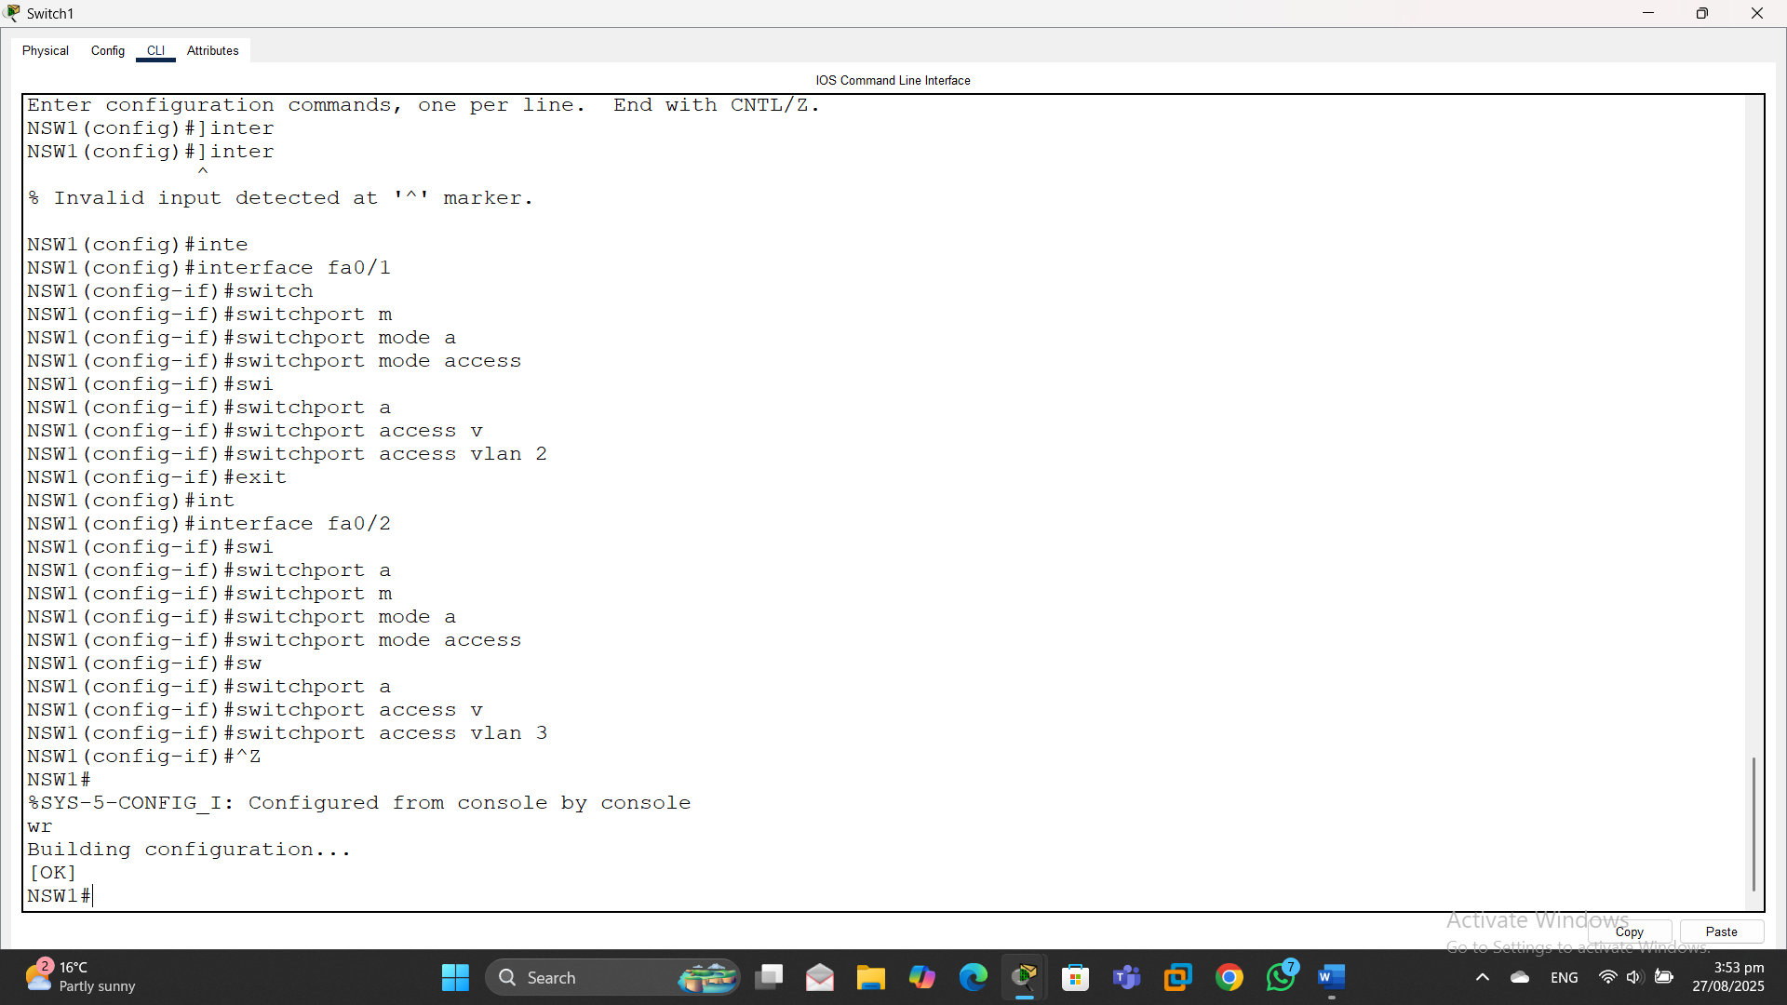

Switch 2
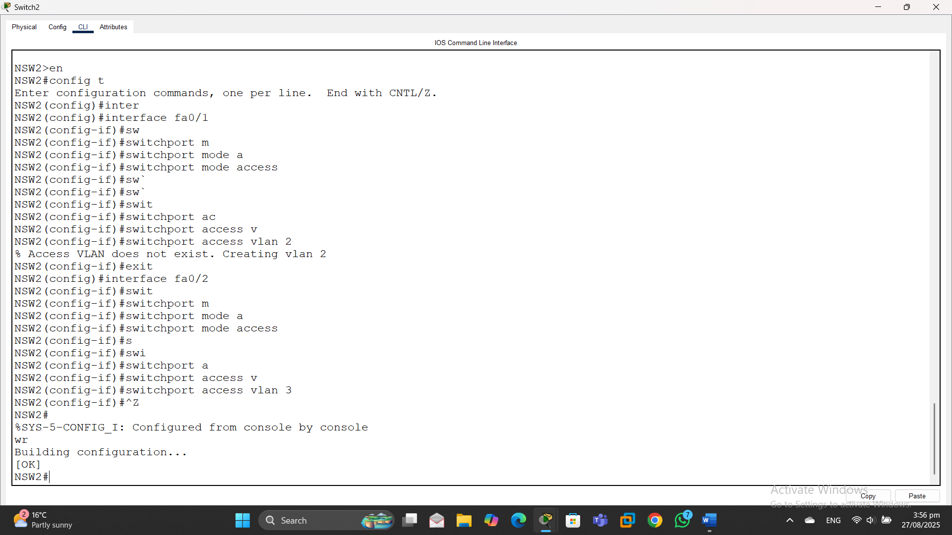

Switch 3
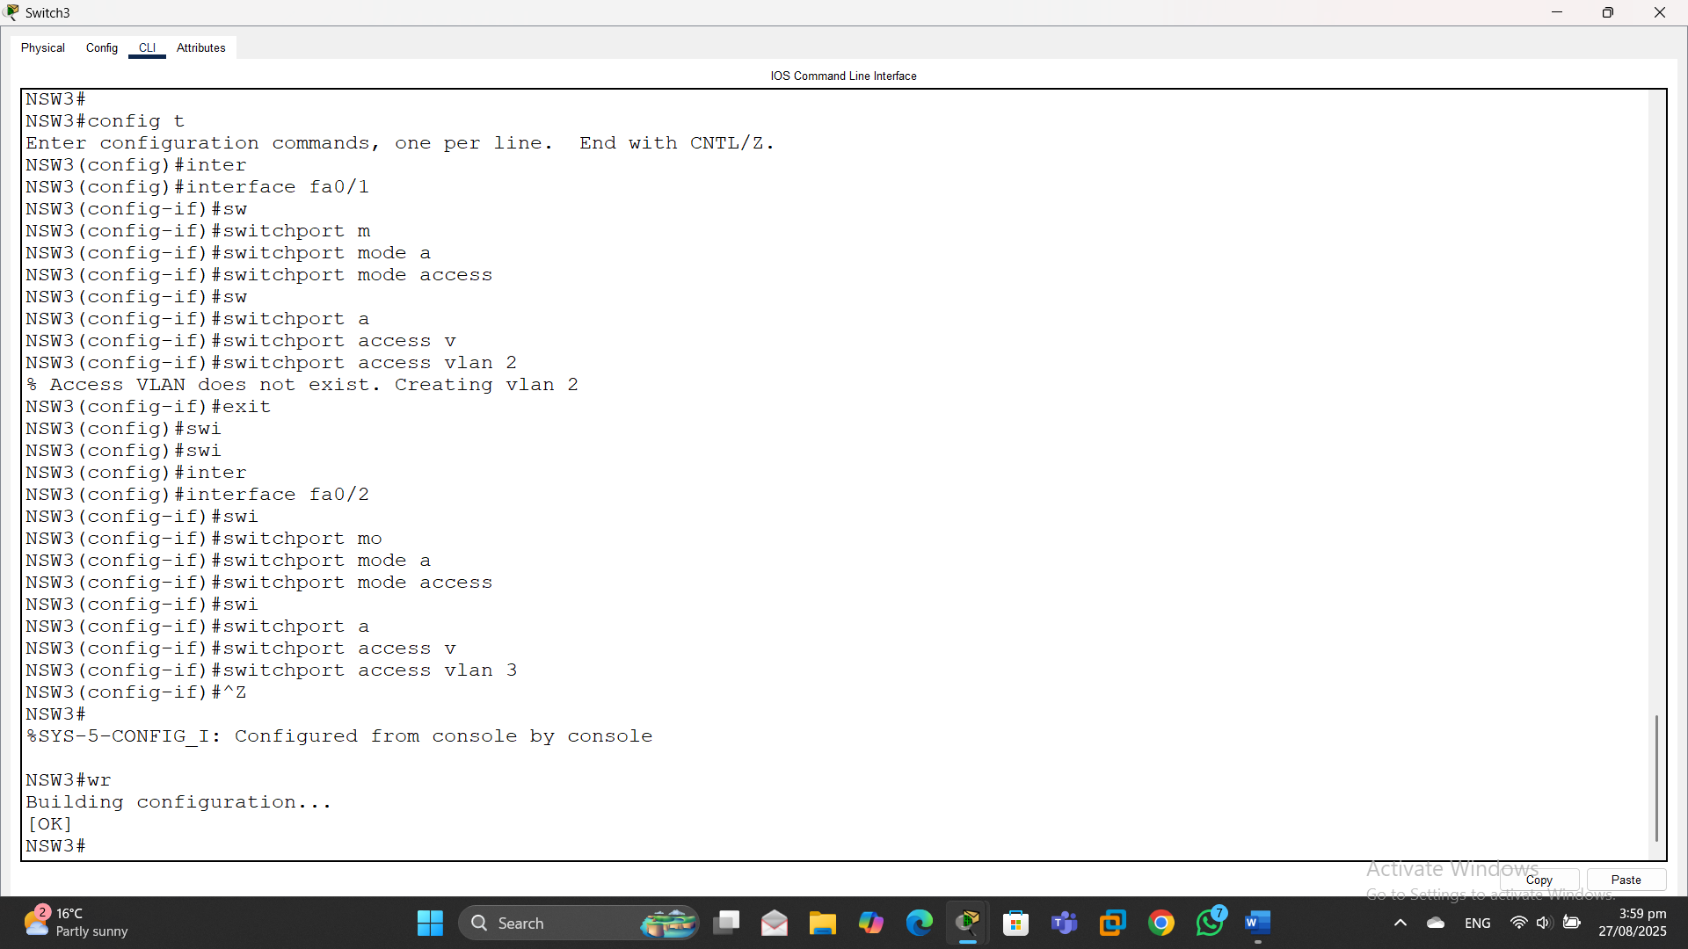

- Active access ports should dynamically learn MAC addresses and store them in the running configuration for a maximum of only one MAC address; any violations should increment the violation counter in addition to filtering the offending traffic. (6 marks)

Switch 1
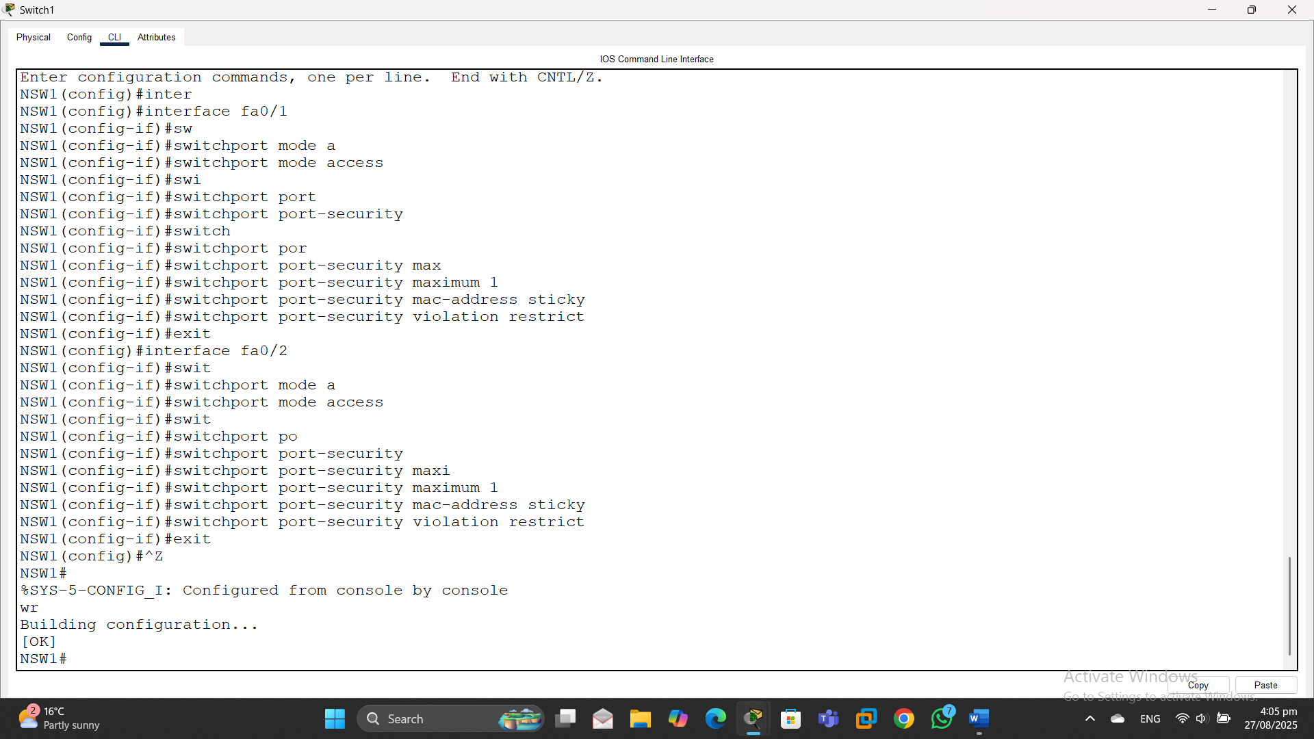

Switch 2
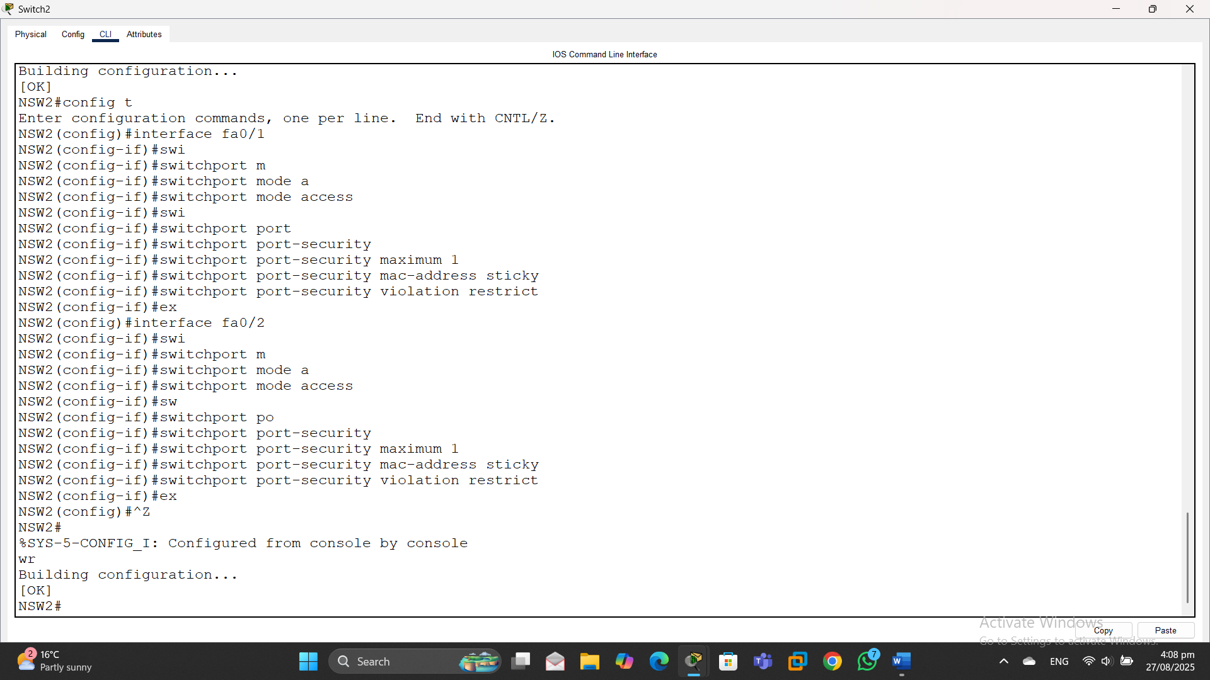

Switch 3
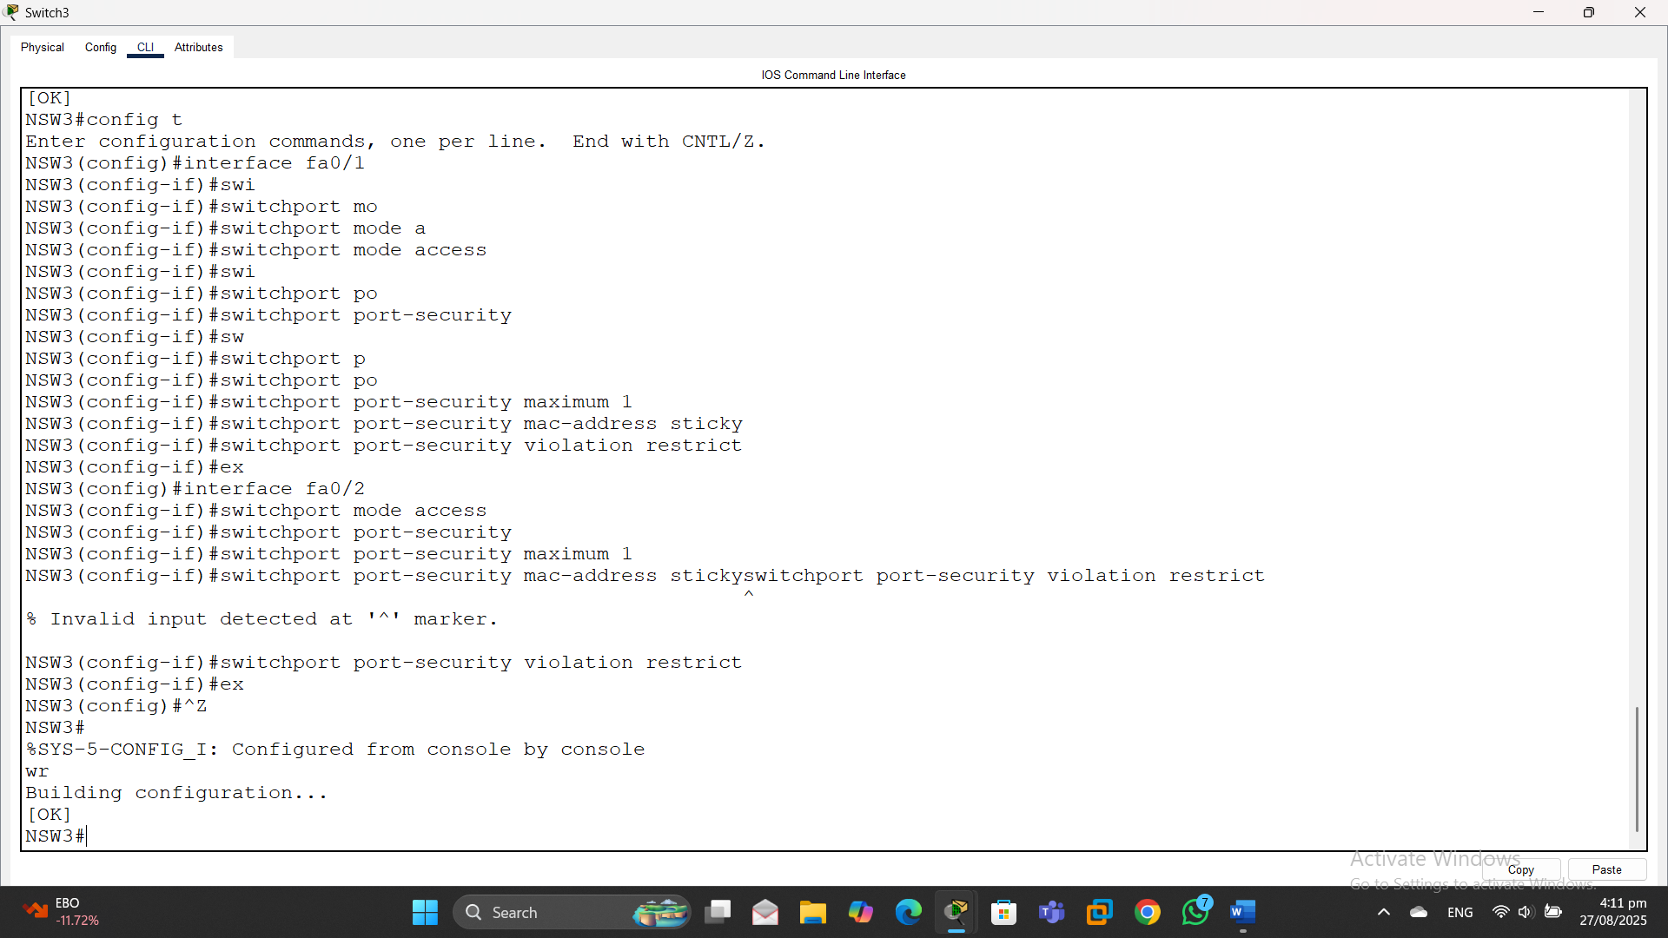

- All VLANs currently have the same root switch. For load balancing, identify the current root switch and change the root switch for VLAN 2, but allow the original switch to become root if the new root switch fails. Document which switch was the original root switch and which is the new root switch. (3 marks)
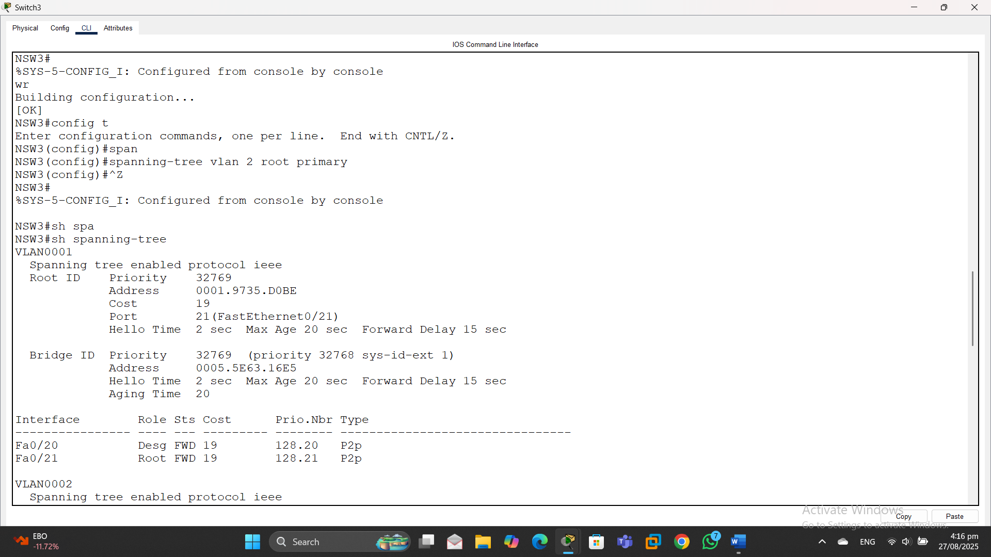

- Ensure all devices in the Hamilton LAN can communicate with each other and IP address assignment is fully documented. (15 marks)
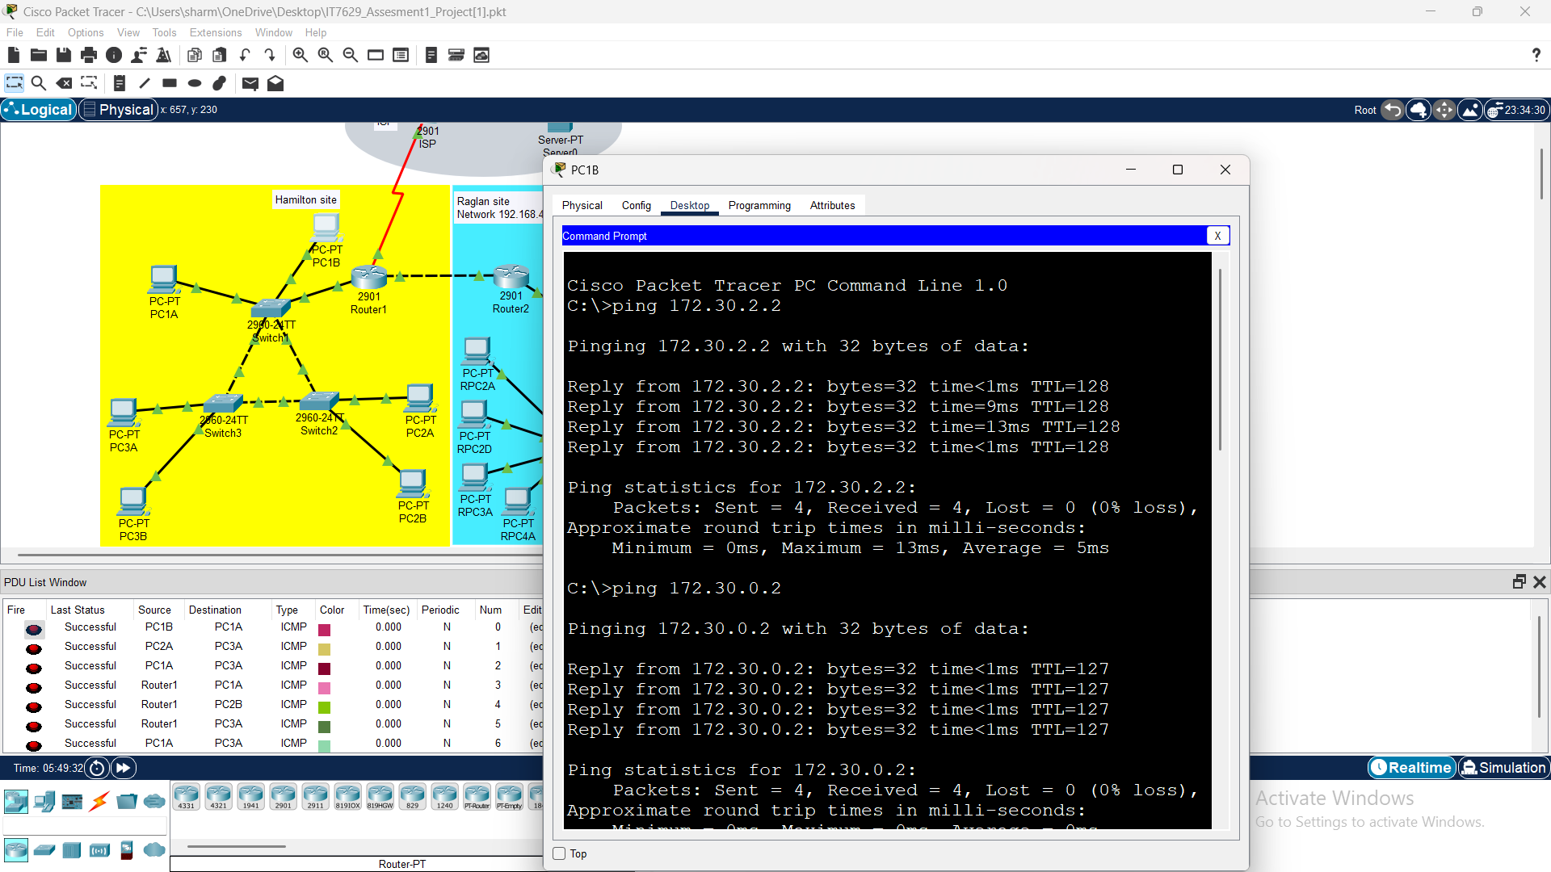
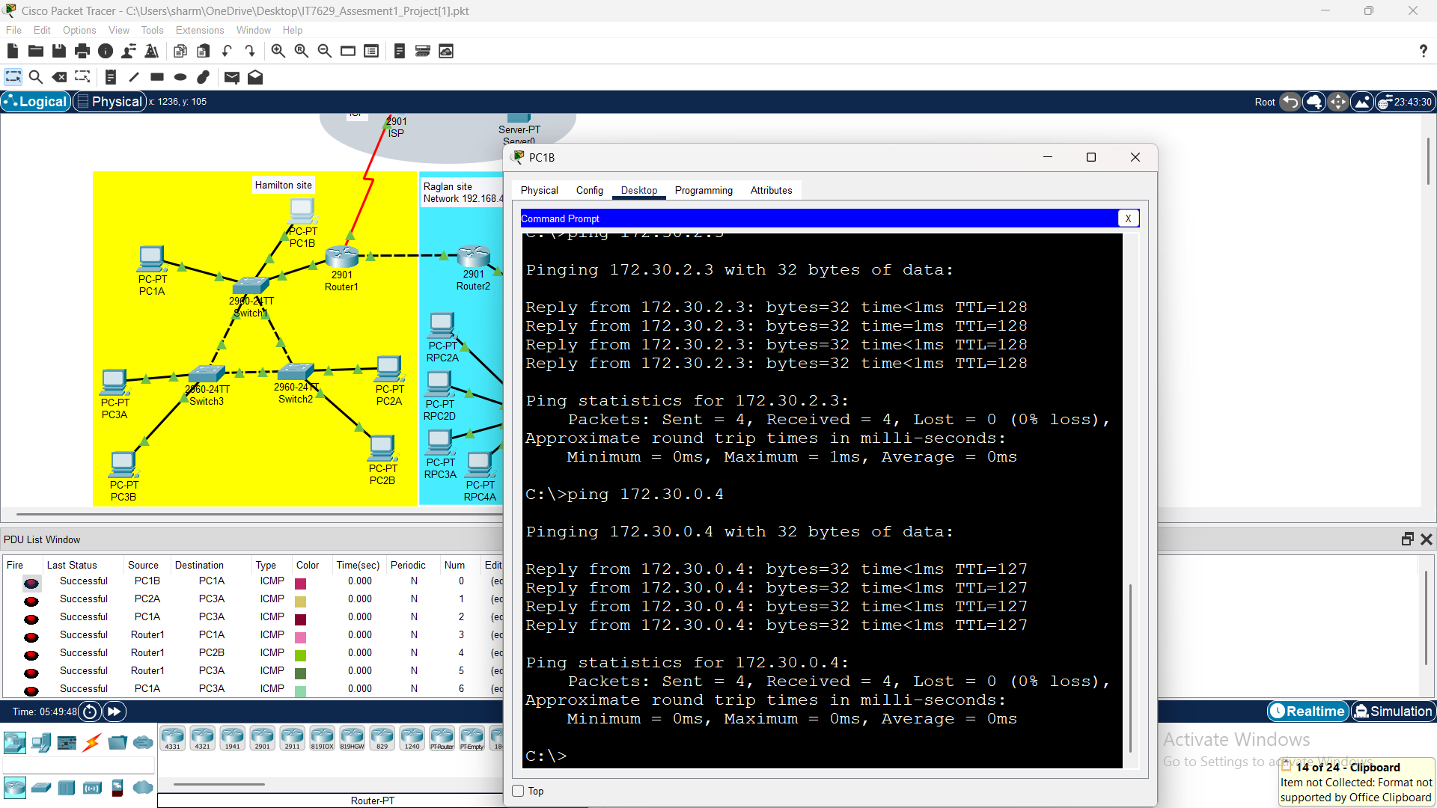

- EIGRP is the routing protocol to be used at both sites. A static route to the Raglan 192.168.4.0/24 network is required as a backup route in case EIGRP fails. (1 mark)
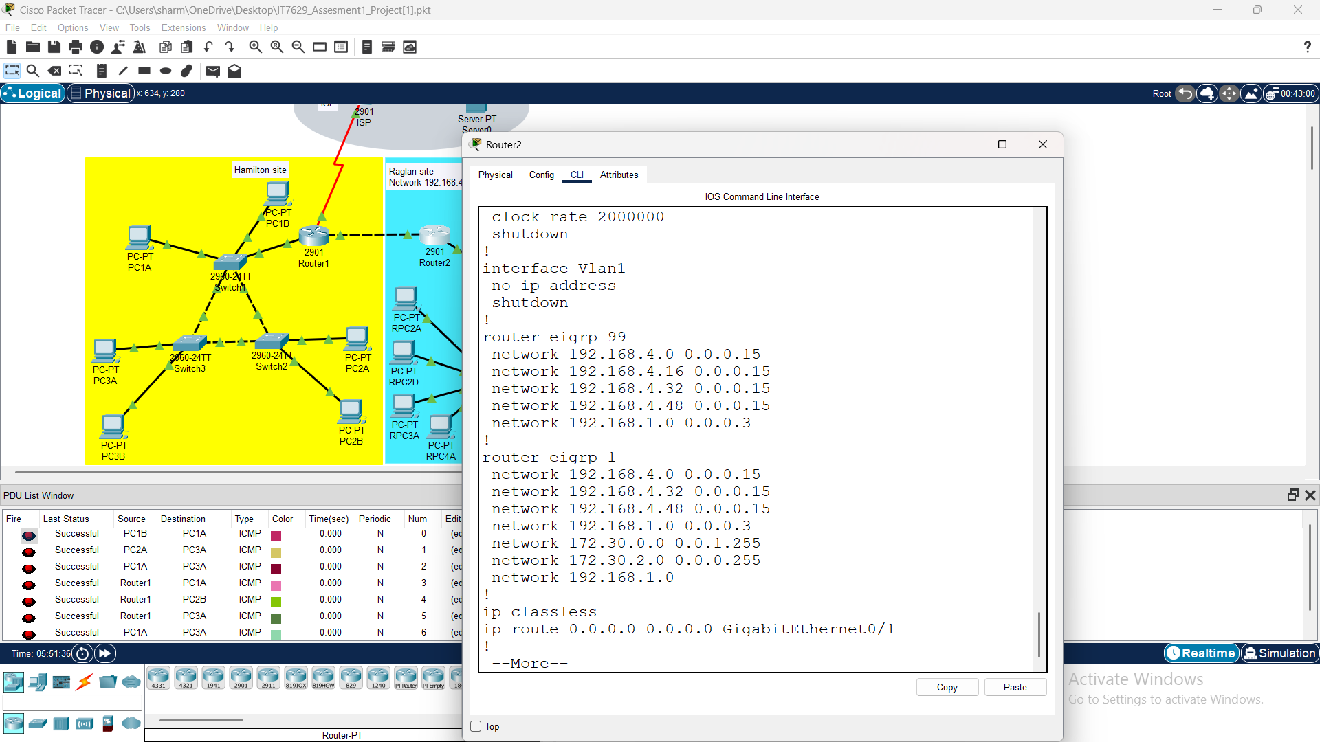

- A static default route for traffic to the ISP is required. (1 mark)
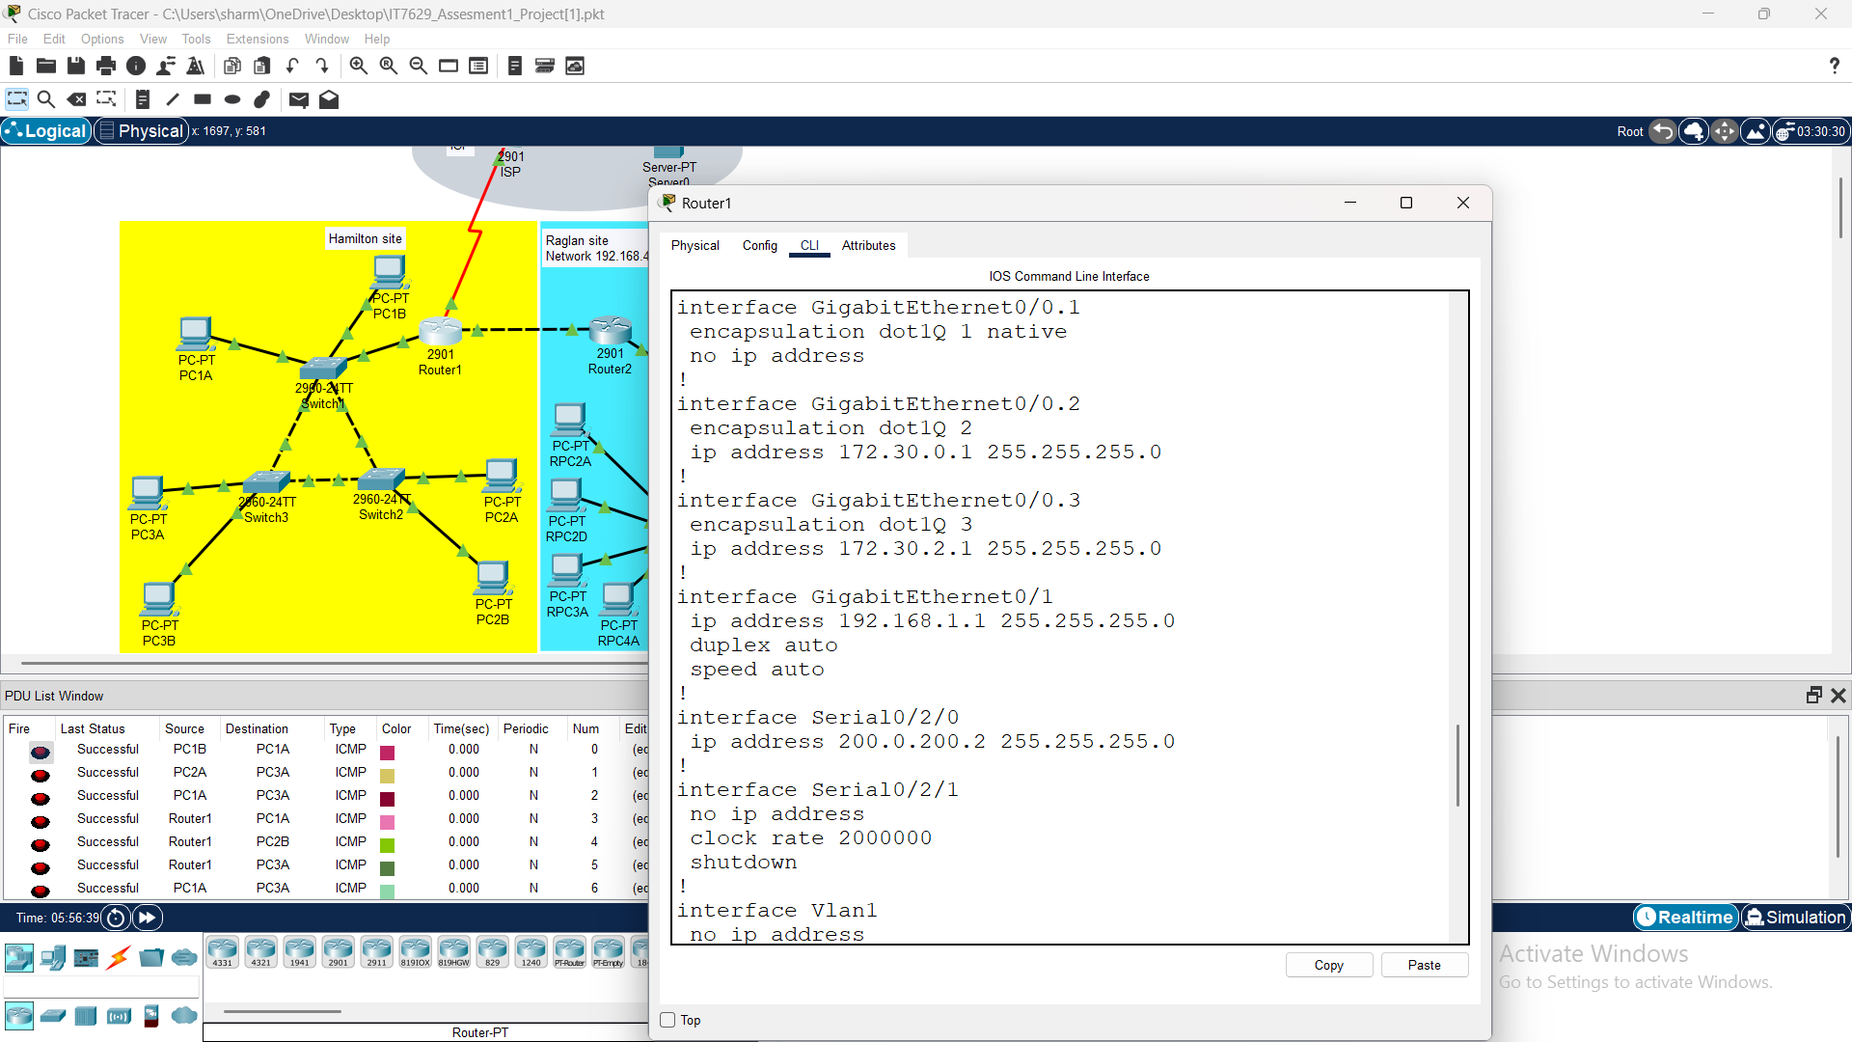

- EIGRP should be configured using your day of birth as the AS number. Record the AS number in your word document. Auto-summarization should not be used. Do not use the classful address. Ensure that Router1 can swap routes with the Raglan router (Router2). If configuration changes are required at the Raglan site, make the changes and record them in your document. (5 marks)
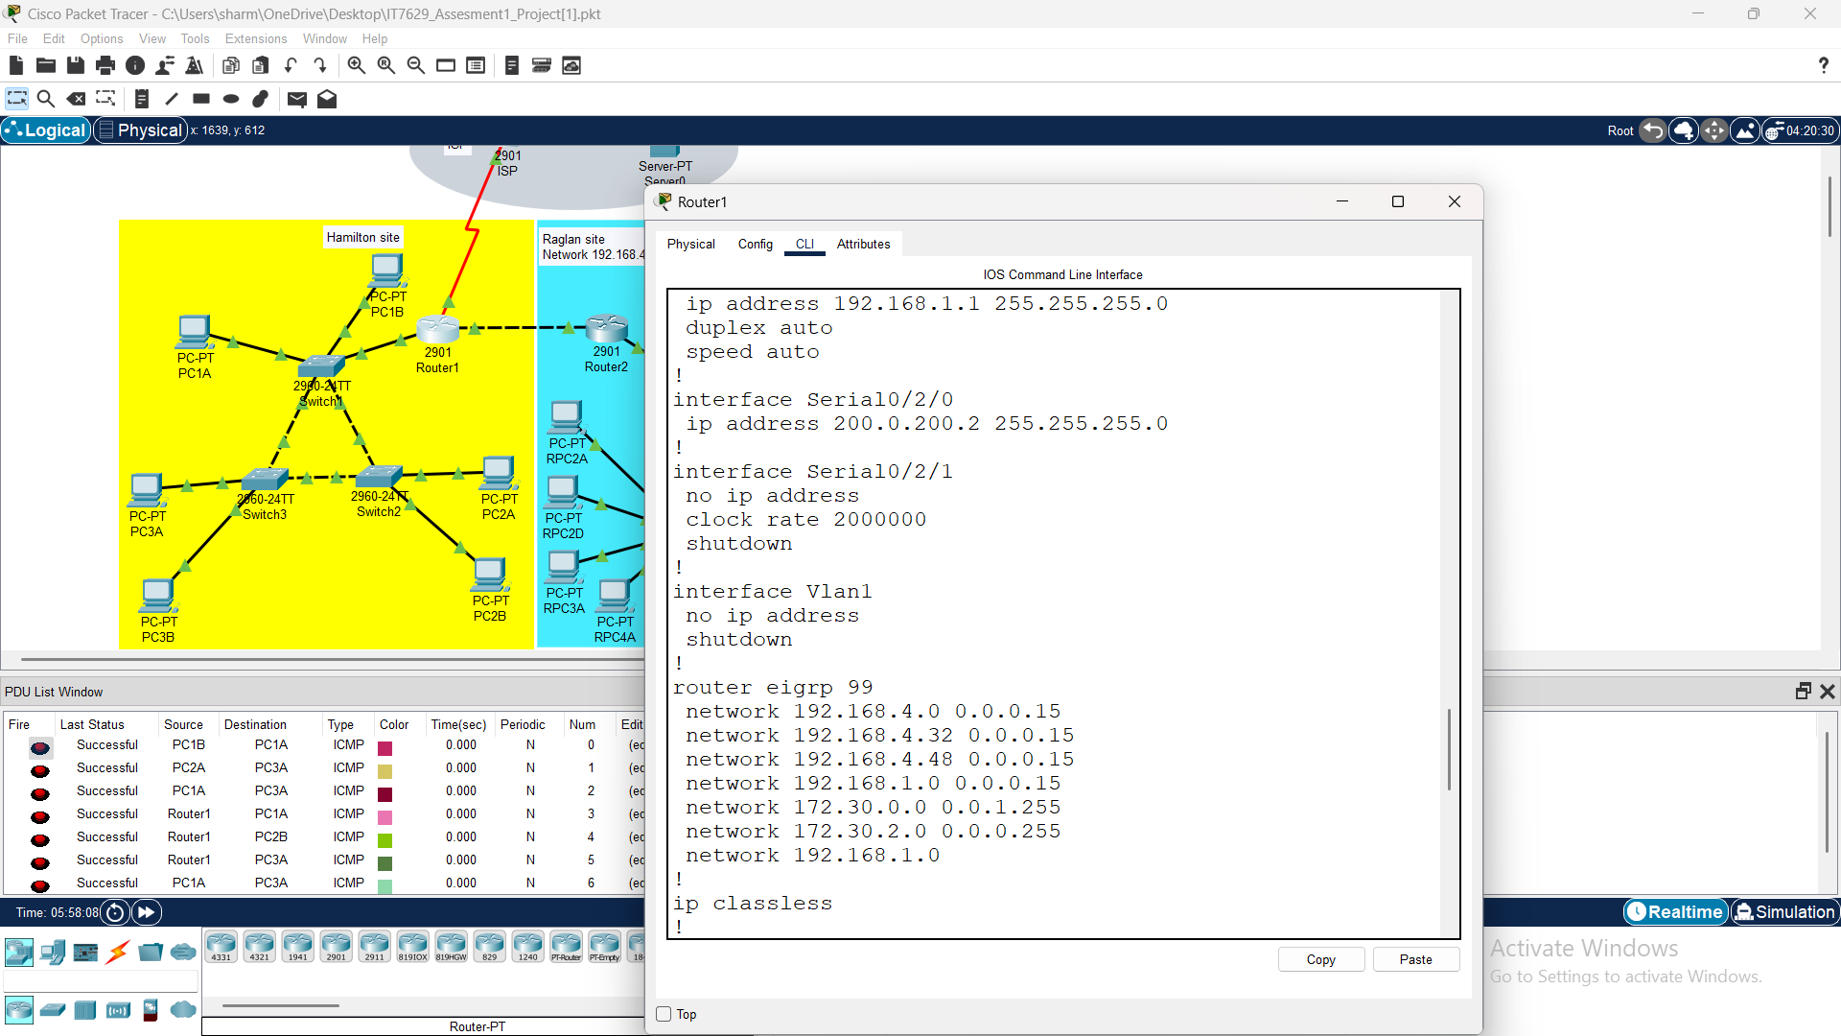

Raglan Site Troubleshooting
- Users in VLAN3 on switch 4 can communicate with each other but report they cannot
communicate with VLAN3 users on switch 5. (1 mark)
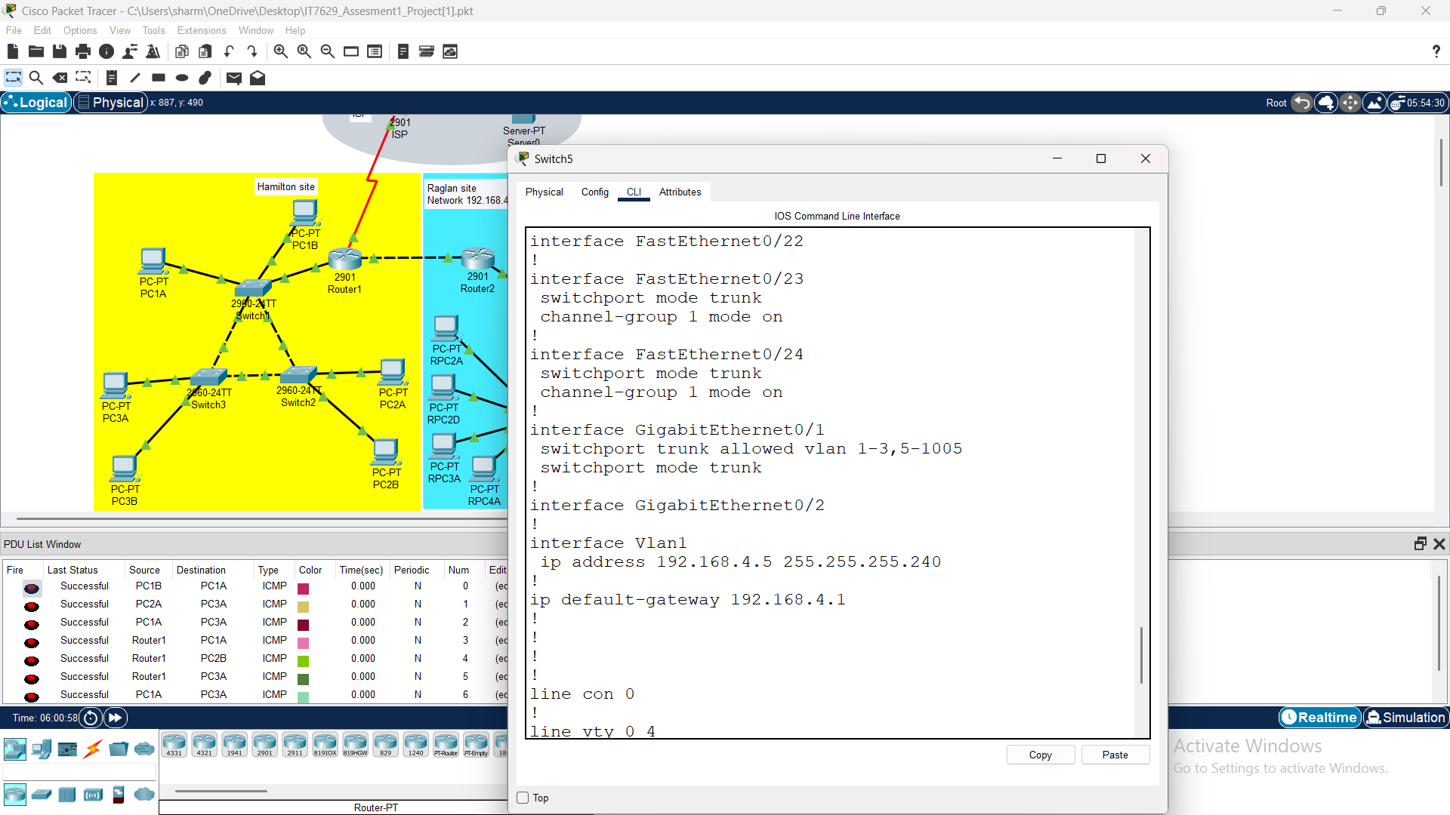

- RPC2D is the only user on Switch 6 that can communicate with other users. (3 marks)
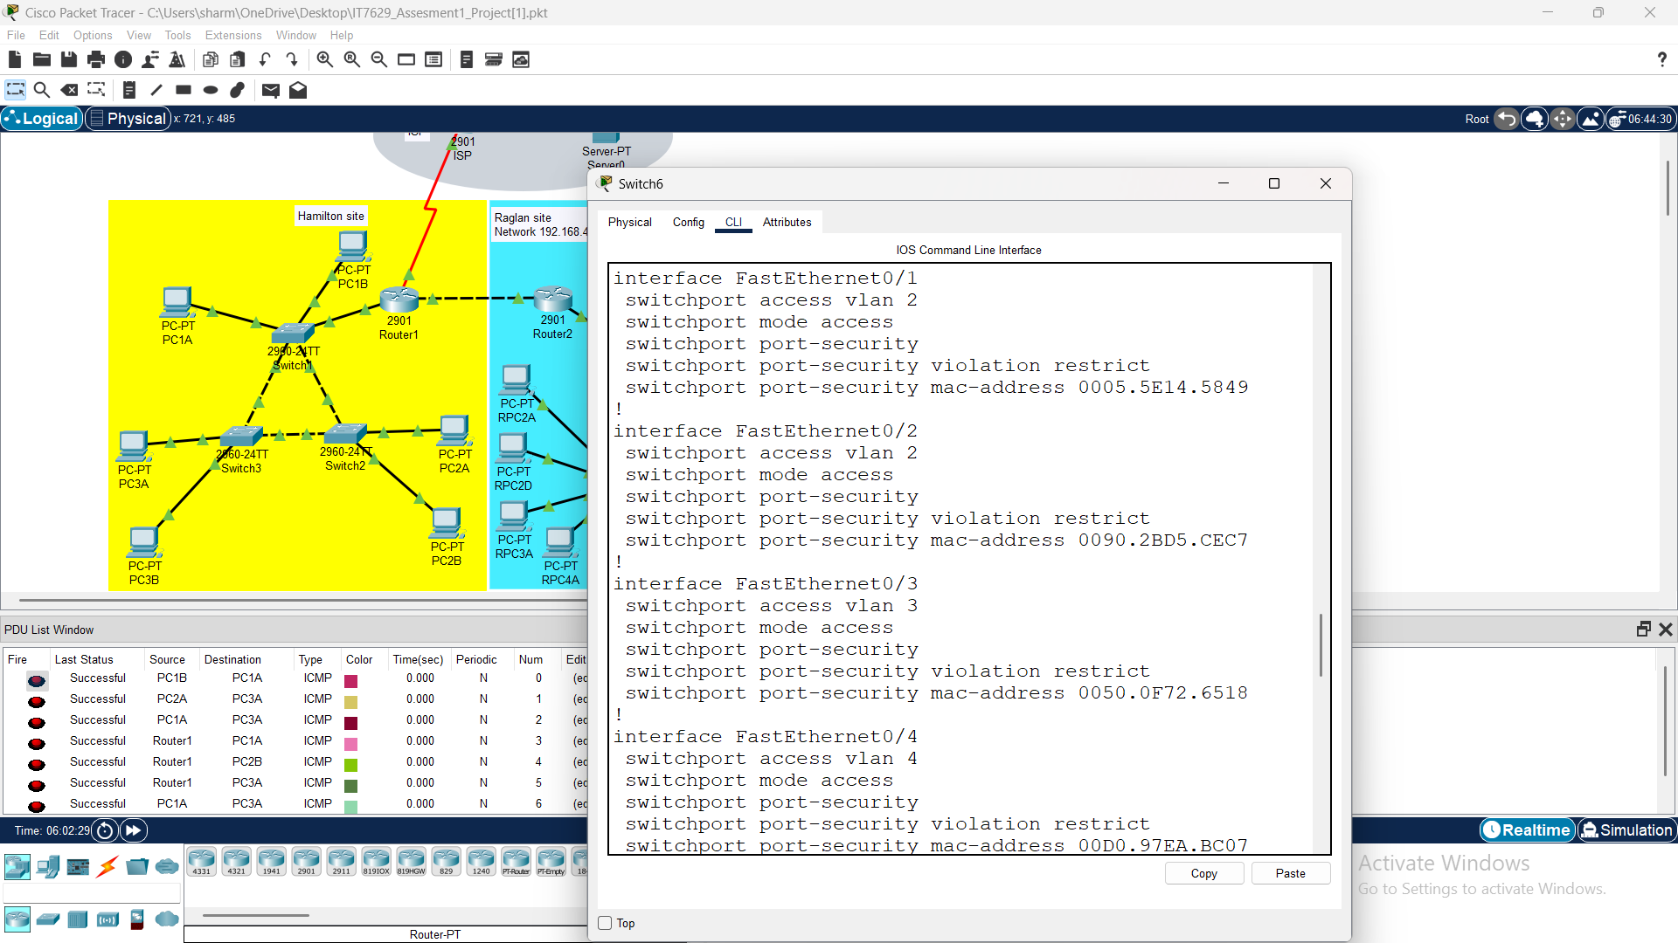

- RPC4B on Switch 5 can’t communicate with any other device on the network. (1 mark)
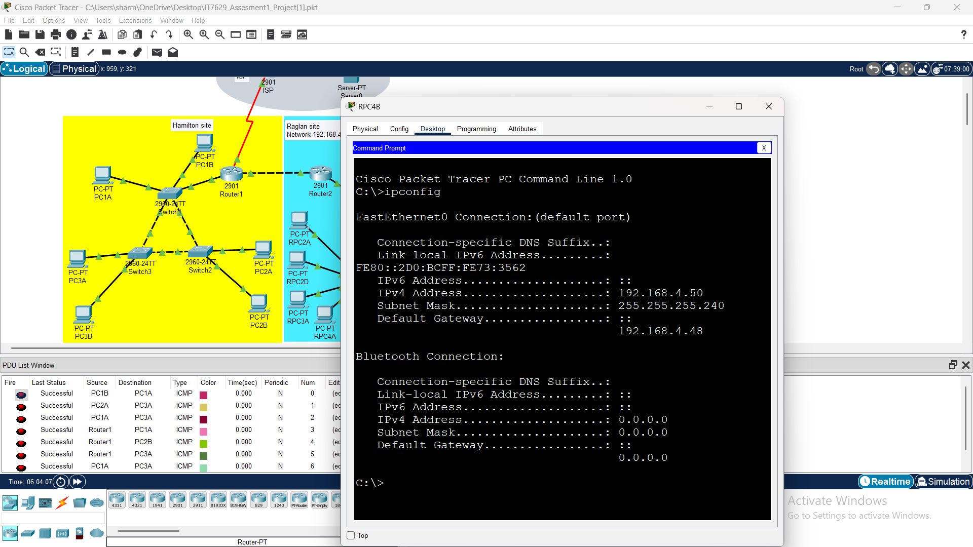

Troubleshooting on raglan site
- Users in VLAN3 on switch 4 can communicate with each other but report they cannot communicate with VLAN3 users on switch 5.?
Answers: We will make the interface 23,24 to up and had created one port channel in switch 5.
- RPC2D is the only user on Switch 6 that can communicate with other users.
Answers: RPC2D will only communicate with switch 6
- RPC4B on Switch 5 can’t communicate with any other device on the network.
Answers: Wrong IP address was assigned to the PC i.e. 192.168.4.48 and I had given the correct IP address to the PC i.e. 192.168.4.49.

