SECURE QR CODE AUTHENTICATION
A PROJECT REPORT SUBMITTED IN FULFILMENT OF THE REQUIREMENTS FOR THE AWARD OF THE DEGREE OF
BACHELOR OF TECHNOLOGY IN
COMPUTER SCIENCE AND ENGINEERING


By Batch –11

K. Sowjanya (323103210103) K. Meghana (323103210096)
K.Chinmayi (323103210097) K.Vatsalya (323103210118)

Under the esteemed guidance of
Dr. N. Sharmili
Professor
CSE Department

Department of Computer Science and Engineering

GAYATRI VIDYA PARISHAD COLLEGE OF ENGINEERING FOR WOMEN
[Approved by AICTE NEW DELHI, Affiliated to Andhra University, Visakhapatnam]
[Accredited by National Board of Accreditation (NBA) for B. Tech. CSE, ECE & IT – valid from 2019-22 and 2022-25] [Accredited by National Assessment and Accreditation Council (NAAC) with A Grade-Valid from 2022-2027]
Kommadi, Madhurawada, Visakhapatnam – 530048

2023 – 2027

GAYATRI VIDYA PARISHAD COLLEGE OF ENGINEERING FOR WOMEN

DEPARTMENT OF COMPUTER SCIENCE AND ENGINEERING



CERTIFICATE

This is to certify that the project report titled “Secure QR Code Authentication” is the Bonafide work of following III B.Tech. students from the Department of Computer Science and Engineering, Gayatri Vidya Parishad College of Engineering for Women, affiliated with Andhra University, Visakhapatnam. This project was done as part of Cryptography and Network Security lab during the academic year 2025–2026 (III Year Semester-2).

K. Sowjanya (323103210103) K. Meghana (323103210096)
K.Chinmayi (323103210097) K.Vatsalya (323103210118)

Signature of the Guide Signature of the HOD
Dr. N. Sharmili _{MTech.,} _{Ph.D.} Dr. P. V. S. L. Jagadamba _{MTech, Ph.D}
Professor, Professor,
Dept. of CSE Dept. of CSE

External Examiner

ABSTRACT

QR Code Authentication is a secure access control system designed to authenticate registered users using unique QR codes and face verification. In this project, the admin registers each user and generates a distinct QR code for that specific person. During authentication, the system verifies the QR code and then performs face matching to ensure that the person using the QR code is the legitimate owner.

The system improves security by combining cryptographic QR validation with biometric verification. Even if a QR code is copied or shared, unauthorized access is prevented because the user’s live face must also match the registered face image. The project is implemented using Python, Flask, SQLite, OpenCV, JavaScript, HTML, and CSS. It supports admin login, user registration, QR generation, face capture, live gate verification, and log storage. This project can be used in colleges, offices, hostels, secure labs, and other places where controlled entry is required.

SYSTEM REQUIREMENTS

1.1. Software Requirements

Software | Version / Specification
Python | 3.x
Flask | Web framework
OpenCV | Face and QR processing
SQLite | Database
HTML | Frontend structure
CSS | Frontend styling
Javascript | Live camera and QR scanning
Jinja2 | Template rending
VS Code | Code editor
Operating system | Windows/mac os/linux
Table 1. Software Requirements

1.2 Python packages
You can place these in the package table:

S.No. | Package Used | Description
1. | Flask | Backend web framework
2. | Werkzeug | Request handling and utilities
3. | OpenCV (opencv-python) | Camera, face, and QR decoding
4. | NumPy | Image and array processing
5. | qrcode | QR code generation
6. | Pillow | Image handling
7. | SQLite3 | Database management
8. | Jinja2 | HTML template rendering
9. | Base64/ binascii | Camera image decoding
10. | hashlib / hmac | QR token signing

Table 2. Python packages

1.3 Front End Packages used

S.NO | Libraries Used | Description
1. | HTML | Builds the web pages
2. | CSS | Styles the interface
3. | Javascript | Handles live camera capture
4. | Jinja2 | Connects frontend with Flask
5. | Browser mediadevices API | Accesses webcam
6. | BarcodeDetector / backend fallback | QR scanning in browser/backend
Table 3. Front end Packages

1.4 Hardware Requirements

The below Table 4 shows the minimum hardware requirements of our project.

Minimum Hardware Requirements:

S.No | Hardware Component | Specification
1. | processor | Intel i3 or above
2. | RAM | 4 GB minimum
3. | storage | 500 MB free space
4. | camera | Webcam / laptop camera
5. | display | Monitor / laptop screen
6. | internet | Optional for development only
Table 4. Minimum Hardware Requirements

2. METHODOLOGY

2.1 System Architecture / Work Flow Diagram
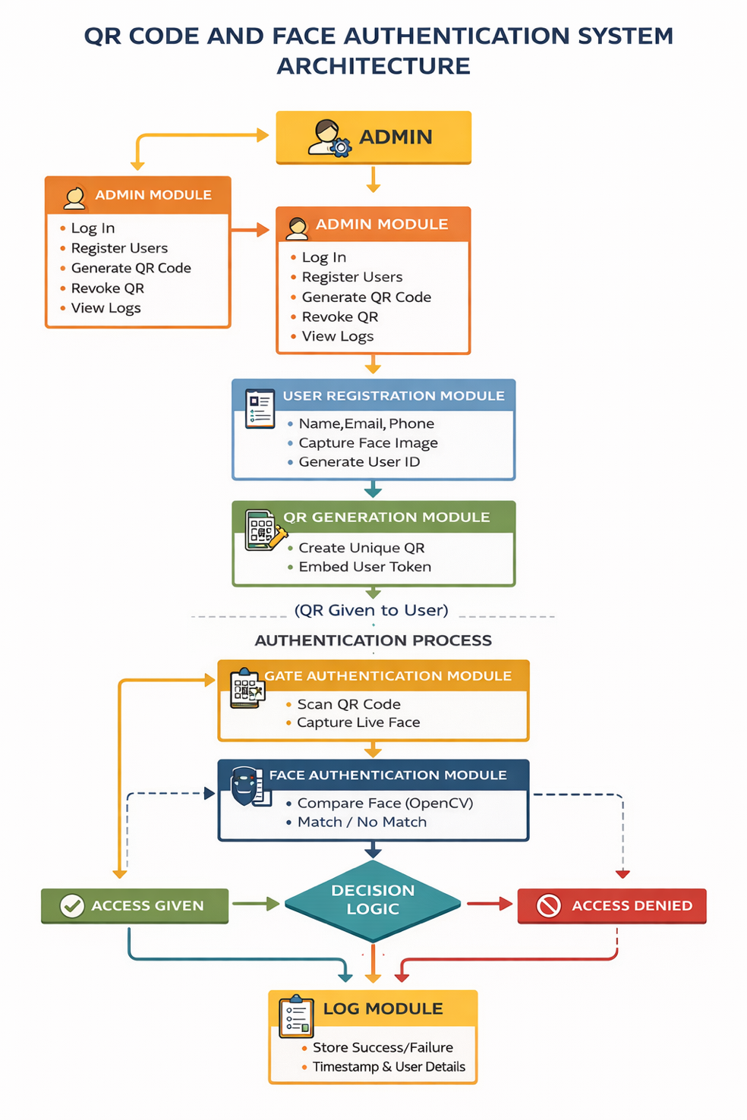
Fig 2.1: QR Code and Face Authentication System Architecture
The system architecture consists of multiple modules working together to provide secure authentication using both QR code and facial recognition. The workflow begins with the administrator registering users and generating QR codes, followed by real-time authentication using QR scanning and face verification at the entry point.

2.2 Key Components and Workflow

Phase 1: Admin Control & User Registration
- The Admin Module allows the administrator to:
  - Log in securely
  - Register new users
  - Generate QR codes
  - Revoke QR codes if needed
  - View system logs
- During User Registration, the system collects:
  - Name
  - Email
  - Phone number
  - Face image (captured via camera)
- Each user is assigned a unique User ID.

Phase 2: QR Code Generation & Security
- The QR Generation Module creates a unique QR code for every user.
- The QR code contains:
  - User ID
  - Secure authentication token
- The Cryptography Module ensures security by:
  - Signing the token using HMAC-SHA256
  - Preventing tampering or duplication
- The generated QR code is then provided to the user.

Phase 3: QR Scanning at Entry Point
- At the time of authentication:
  - The user scans the QR code at the gate
- The Gate Authentication Module:
  - Reads the QR code
  - Extracts encoded data
  - Captures live face image of the user

Phase 4: Face Authentication
- The Face Authentication Module:
  - Uses camera to capture real-time face
  - Extracts facial features
  - Compares with stored registered face data
- Matching results:
  - Match → Proceed to next step
  - No match → Access Denied

Phase 5: QR Validation & Decision Logic
- The system verifies:
  - Whether QR code is valid
  - Whether it is tampered or expired
- Decision Logic combines:
  - QR validation result
  - Face authentication result

Final Outcomes:
- Valid QR + Face Match → Access Given
- Invalid QR → Access Denied
- Face Mismatch → Access Denied

Phase 6: Logging and Monitoring
- The Log Module records:
  - Username
  - Timestamp
  - Access status (Success/Failure)
- Logs are stored for:
  - Security auditing
  - Admin monitoring

Additional Features:
- Dual authentication (QR + Face) increases security
- Prevents unauthorized access
- Detects fraud attempts
- Can be extended with:
  - Database integration
  - Cloud storage
  - Real-time alerts

2.3 Algorithm

QR Code + Face Authentication Algorithm

Registration Phase
- Start
- Admin logs into system
- Enter user details (name, email, phone)
- Capture user face image
- Generate unique User ID
- Generate QR code with secure token
- Encrypt token using HMAC-SHA256
- Store user data, face image, and QR details
- Provide QR code to user

Authentication Phase
- User scans QR code at entry
- Extract QR data
- Capture live face image
- Extract facial features
- Compare with stored face data

Decision Phase
- Check if QR is valid
- If No → Access Denied
- Check face match
- If No → Access Denied
- If both are valid:
- Grant access
- Else:
- Deny access
- Store result in log file
- Display result:
- “Access Given”
- “Access Denied”
- End

2.4 Modules and Descriptions

2.4.1 Admin Module
This module allows the administrator to manage the entire system.
Functions:
- Admin login
- Register users
- Generate QR codes
- Revoke QR codes
- View logs

2.4.2 User Registration Module
Stores user details and captures face data.
Functions:
- Store name, email, phone number
- Capture face image
- Generate unique User ID

2.4.3 QR Generation Module
Generates unique QR codes for authentication.
Functions:
- Create QR code
- Embed secure token
- Assign QR to user

2.4.4 Cryptography Module
Ensures security of QR codes.
Functions:
- Generate secure token
- Apply HMAC-SHA256 encryption
- Prevent QR tampering

2.4.5 Face Authentication Module
Handles face recognition process.
Functions:
- Capture live face image
- Extract facial features
- Compare with stored face data

2.4.6 Gate Authentication Module
Performs real-time authentication at entry.
Functions:
- Scan QR code
- Capture live face
- Send data for verification

2.4.7 Log Module
Stores authentication records.
Functions:
- Record access attempts
- Store success/failure logs
- Maintain timestamp and user details

3. IMPLEMENTATION
The project is implemented using Flask as the backend framework and SQLite as the database. The frontend uses HTML, CSS, JavaScript, and Jinja2 templates. Live camera capture is handled through browser APIs and OpenCV-based fallback processing. QR codes are generated using the qrcode library and verified using OpenCV and backend token validation.
The system includes:
- admin login page
- user registration page
- QR code generation
- gate verification page
- logs page
- GUI and console support for local testing
13. Security Features
- One QR code per user
- Unique token with nonce
- HMAC-SHA256 signed QR token
- Face verification at entry
- QR revocation support
- Entry log maintenance
- Prevention of simple QR sharing misuse
14. Testing
The system was tested using multiple scenarios:
- valid QR and correct face
- valid QR and wrong face
- invalid QR token
- revoked QR token
- missing camera input
- large image upload handling
browser QR fallback to backend scanning

FILE STRUCTURE:

QR_AUTHENTICATION/
│
├── README.md
│
├── docs/
│ └── workflow.md
│
├── backend/
│ ├── app.py
│ ├── config.py
│ ├── database.py
│ ├── gui_app.py
│ ├── live_console.py
│ ├── requirements.txt
│ ├── secure_auth.db
│ │
│ ├── routes/
│ │ └── web.py
│ │
│ └── services/
│ ├── camera_service.py
│ ├── crypto_service.py
│ ├── face_service.py
│ └── qr_service.py
│
├── static/
│ ├── css/
│ │ └── style.css
│ │
│ └── js/
│ ├── gate.js
│ └── register.js
│
├── templates/
│ ├── base.html
│ ├── dashboard.html
│ ├── gate.html
│ ├── index.html
│ ├── login.html
│ ├── logs.html
│ └── register.html
│
├── storage/
│ ├── faces/
│ │ └── (captured user face images)
│ │
│ └── qrcodes/
│ └── (generated QR code images)
│
└── .venv/
└── (virtual environment files)

Source codes:
Code of Home Page (index.html):
{% extends "base.html" %}
{% block content %}
<section class="hero">
<div class="card">
<h2>Smart Secure Access</h2>
<p>This website manages unique QR codes for registered users and verifies each entry securely.</p>
<p>It combines live QR scanning and face authentication to allow fast and protected access control.</p>
<div class="hero-actions">
<a class="button" href="{{ url_for('web.login') }}">Open Admin</a>
<a class="button secondary" href="{{ url_for('web.gate') }}">Open Gate Scanner</a>
</div>
</div>
</section>
{% endblock %}

Code of Base Template (base.html):
<!DOCTYPE html>
<html lang="en">
<head>
<meta charset="UTF-8">
<meta name="viewport" content="width=device-width, initial-scale=1.0">
<title>QR Code Authentication</title>
<link rel="stylesheet" href="{{ url_for('static', filename='css/style.css') }}">
</head>
<body>
<header class="topbar">
<div>
<h1>QR Code Authentication</h1>
<p>Live QR verification with secure user validation</p>
</div>
<nav>
<a href="{{ url_for('web.index') }}">Home</a>
<a href="{{ url_for('web.gate') }}">Gate Scanner</a>
{% if session.get('admin_id') %}
<a href="{{ url_for('web.dashboard') }}">Dashboard</a>
<a href="{{ url_for('web.logs') }}">Logs</a>
<a href="{{ url_for('web.logout') }}">Logout</a>
{% else %}
<a href="{{ url_for('web.login') }}">Admin Login</a>
{% endif %}
</nav>
</header>
<main class="container">
{% with messages = get_flashed_messages(with_categories=true) %}
{% if messages %}
{% for category, message in messages %}
<div class="flash {{ category }}">{{ message }}</div>
{% endfor %}
{% endif %}
{% endwith %}
{% block content %}{% endblock %}
</main>
</body>
</html>
Code of Admin Login Page(login.html):
{% extends "base.html" %}
{% block content %}
<section class="card narrow">
<h2>Admin Login</h2>
<p>Default credentials for demo: <strong>admin / admin123</strong></p>
<form method="post" class="form-grid">
<label>Username</label>
<input type="text" name="username" required>
<label>Password</label>
<input type="password" name="password" required>
<button class="button" type="submit">Login</button>
</form>
</section>
{% endblock %}
Code of Backend Controller (web.py):
import base64
import binascii
from datetime import datetime
from pathlib import Path
from flask import Blueprint, flash, jsonify, redirect, render_template, request, send_file, session, url_for
from werkzeug.security import check_password_hash
from werkzeug.utils import secure_filename
from config import FACE_DIR
from database import get_connection
from services.face_service import compare_faces
from services.qr_service import build_qr_token, decode_qr_image, verify_qr_toke
web = Blueprint("web", __name__)
def admin_required():
return session.get("admin_id") is not None
def save_log(user_id, token, qr_valid, face_matched, access_granted, reason):
with get_connection() as conn:
conn.execute(
"""
INSERT INTO access_logs (
user_id, scan_time, qr_valid, face_matched, access_granted, failure_reason, qr_token
) VALUES (?, ?, ?, ?, ?, ?, ?)
""",
(
user_id,
datetime.utcnow().isoformat(),
qr_valid,
face_matched,
access_granted,
reason,
token,
),
)
conn.commit()
def save_data_url_image(data_url: str, target_dir: Path, prefix: str) -> Path:
if "," not in data_url:
raise ValueError("Invalid camera image data.")
header, encoded = data_url.split(",", 1)
if "base64" not in header:
raise ValueError("Unsupported camera image format.")
try:
raw = base64.b64decode(encoded)
except (ValueError, binascii.Error) as exc:
raise ValueError("Could not decode camera image.") from exc
target_dir.mkdir(parents=True, exist_ok=True)
filename = secure_filename(f"{prefix}_{datetime.utcnow().timestamp()}.png")
output_path = target_dir / filename
output_path.write_bytes(raw)
return output_path
@web.route("/api/scan-qr-frame", methods=["POST"])
def scan_qr_frame():
payload = request.get_json(silent=True) or {}
image_data = (payload.get("image_data") or "").strip()
if not image_data:
return jsonify({"ok": False, "message": "No image frame received."}), 400
temp_path = None
try:
temp_path = save_data_url_image(image_data, FACE_DIR.parent, "qr_frame")
token = decode_qr_image(str(temp_path))
if token:
return jsonify({"ok": True, "token": token})
return jsonify({"ok": False, "message": "No QR detected in frame."})
except ValueError as exc:
return jsonify({"ok": False, "message": str(exc)}), 400
finally:
if temp_path and Path(temp_path).exists():
Path(temp_path).unlink(missing_ok=True)
@web.route("/")
def index():
return render_template("index.html")
@web.route("/login", methods=["GET", "POST"])
def login():
if request.method == "POST":
username = request.form["username"].strip()
password = request.form["password"].strip()
with get_connection() as conn:
admin = conn.execute(
"SELECT * FROM admins WHERE username = ?",
(username,),
).fetchone()
if admin and check_password_hash(admin["password_hash"], password):
session["admin_id"] = admin["admin_id"]
session["username"] = admin["username"]
return redirect(url_for("web.dashboard"))
flash("Invalid admin credentials.", "error")
return render_template("login.html")
@web.route("/logout")
def logout():
session.clear()
return redirect(url_for("web.index"))
@web.route("/dashboard")
def dashboard():
if not admin_required():
return redirect(url_for("web.login"))
with get_connection() as conn:
users = conn.execute(
"""
SELECT u.*, q.token, q.qr_image_path, q.expires_at, q.is_active
FROM users u
LEFT JOIN qr_tokens q ON q.user_id = u.user_id
ORDER BY u.user_id DESC
"""
).fetchall()
return render_template("dashboard.html", users=users)
@web.route("/register", methods=["GET", "POST"])
def register():
if not admin_required():
return redirect(url_for("web.login"))
if request.method == "POST":
full_name = request.form["full_name"].strip()
email = request.form["email"].strip().lower()
phone = request.form["phone"].strip()
face_image = request.files.get("face_image")
face_capture = request.form.get("face_capture", "").strip()
if not full_name or not email or not phone:
flash("Full name, email, and phone are required.", "error")
return redirect(url_for("web.register"))
if face_image and face_image.filename:
filename = secure_filename(f"{datetime.utcnow().timestamp()}_{face_image.filename}")
face_path = FACE_DIR / filename
face_image.save(face_path)
elif face_capture:
face_path = save_data_url_image(face_capture, FACE_DIR, "web_face")
else:
flash("A face image is required. Use live capture or choose a file.", "error")
return redirect(url_for("web.register"))
with get_connection() as conn:
try:
cursor = conn.execute(
"""
INSERT INTO users (full_name, email, phone, face_image_path, created_at)
VALUES (?, ?, ?, ?, ?)
""",
(
full_name,
email,
phone,
str(face_path),
datetime.utcnow().isoformat(),
),
)
user_id = cursor.lastrowid
token, qr_path, expires_at = build_qr_token(user_id, email)
conn.execute(
"""
INSERT INTO qr_tokens (user_id, token, qr_image_path, issued_at, expires_at, is_active)
VALUES (?, ?, ?, ?, ?, 1)
""",
(
user_id,
token,
qr_path,
datetime.utcnow().isoformat(),
expires_at,
),
)
conn.commit()
except Exception as exc:
conn.rollback()
if face_path.exists():
face_path.unlink(missing_ok=True)
flash(f"Registration failed: {exc}", "error")
return redirect(url_for("web.register"))
flash("User registered and QR generated successfully.", "success")
return redirect(url_for("web.dashboard"))
return render_template("register.html")
@web.route("/revoke/<int:user_id>", methods=["POST"])
def revoke_qr(user_id: int):
if not admin_required():
return redirect(url_for("web.login"))
with get_connection() as conn:
conn.execute("UPDATE qr_tokens SET is_active = 0 WHERE user_id = ?", (user_id,))
conn.commit()
flash("QR revoked for the selected user.", "success")
return redirect(url_for("web.dashboard"))
@web.route("/gate", methods=["GET", "POST"])
def gate():
result = None
if request.method == "POST":
typed_token = request.form.get("token_text", "").strip()
live_token = request.form.get("qr_live_token", "").strip()
qr_image = request.files.get("qr_image")
probe_image = request.files.get("probe_image")
probe_capture = request.form.get("probe_capture", "").strip()
token = typed_token or live_token
temp_qr_path = None
temp_probe_path = None
try:
if not token and qr_image and qr_image.filename:
qr_name = secure_filename(f"gate_qr_{datetime.utcnow().timestamp()}_{qr_image.filename}")
temp_qr_path = FACE_DIR.parent / qr_name
qr_image.save(temp_qr_path)
token = decode_qr_image(str(temp_qr_path))
if not token:
raise ValueError("Provide a QR image or paste a valid QR token.")
if probe_image and probe_image.filename:
probe_name = secure_filename(f"gate_face_{datetime.utcnow().timestamp()}_{probe_image.filename}")
temp_probe_path = FACE_DIR / probe_name
probe_image.save(temp_probe_path)
elif probe_capture:
temp_probe_path = save_data_url_image(probe_capture, FACE_DIR, "gate_face")
else:
raise ValueError("Provide a live face image for verification.")
is_valid, payload, error = verify_qr_token(token)
if not is_valid or not payload:
save_log(None, token, 0, 0, 0, error or "QR verification failed")
raise ValueError(error or "QR verification failed")
with get_connection() as conn:
qr_row = conn.execute(
"""
SELECT q.*, u.full_name, u.face_image_path, u.status
FROM qr_tokens q
JOIN users u ON u.user_id = q.user_id
WHERE q.token = ?
""",
(token,),
).fetchone()
if not qr_row:
save_log(None, token, 0, 0, 0, "QR not found in database")
raise ValueError("QR not found in database.")
if qr_row["is_active"] != 1 or qr_row["status"] != "ACTIVE":
save_log(qr_row["user_id"], token, 0, 0, 0, "QR inactive or user blocked")
raise ValueError("QR is inactive or the user is blocked.")
matched, score = compare_faces(qr_row["face_image_path"], str(temp_probe_path))
if not matched:
save_log(qr_row["user_id"], token, 1, 0, 0, f"Face mismatch. score={score:.4f}")
raise ValueError(f"Face mismatch. Similarity score: {score:.4f}")
save_log(qr_row["user_id"], token, 1, 1, 1, f"Access granted. score={score:.4f}")
result = {
"granted": True,
"name": qr_row["full_name"],
"score": score,
"message": "Access granted. QR and face both matched.",
}
except ValueError as exc:
result = {
"granted": False,
"name": None,
"score": 0.0,
"message": str(exc),
}
finally:
for temp_path in (temp_qr_path, temp_probe_path):
if temp_path and Path(temp_path).exists():
Path(temp_path).unlink(missing_ok=True)
return render_template("gate.html", result=result)
@web.route("/logs")
def logs():
if not admin_required():
return redirect(url_for("web.login"))
with get_connection() as conn:
rows = conn.execute(
"""
SELECT l.*, u.full_name
FROM access_logs l
LEFT JOIN users u ON u.user_id = l.user_id
ORDER BY l.log_id DESC
LIMIT 100
"""
).fetchall()
return render_template("logs.html", logs=rows)
@web.route("/qr/<int:user_id>")
def view_qr(user_id: int):
if not admin_required():
return redirect(url_for("web.login"))
with get_connection() as conn:
row = conn.execute(
"SELECT qr_image_path FROM qr_tokens WHERE user_id = ?",
(user_id,),
).fetchone()
if not row:
flash("QR not found for this user.", "error")
return redirect(url_for("web.dashboard"))
return send_file(row["qr_image_path"], mimetype="image/png")
Code of User Registration Page (register.html) :
{% extends "base.html" %}
{% block content %}
<section class="card">
<h2>Register New User</h2>
<form method="post" enctype="multipart/form-data" class="form-grid">
<label>Full Name</label>
<input type="text" name="full_name" required>
<label>Email</label>
<input type="email" name="email" required>
<label>Phone</label>
<input type="text" name="phone" required>

<label>Live Camera Capture</label>
<div class="camera-panel">
<video id="register-video" autoplay playsinline></video>
<canvas id="register-canvas" hidden></canvas>
<img id="face-preview" alt="Captured face preview" hidden>
<div class="button-row">
<button class="button secondary" type="button" id="start-camera">Start Camera</button>
<button class="button" type="button" id="capture-face">Capture Face</button>
<button class="button danger" type="button" id="retake-face">Retake</button>
</div>
<p id="register-camera-status" class="helper-text">Use the live camera or choose a file below.</p>
<input type="hidden" name="face_capture" id="face_capture">
</div>
<label>Face Image File Fallback</label>
<input type="file" name="face_image" accept="image/*">
<button class="button" type="submit">Register and Generate QR</button>
</form>
</section>
<script src="{{ url_for('static', filename='js/register.js') }}"></script>
{% endblock %}
Code of Registration Script (register.js):
(function () {
const startButton = document.getElementById("start-camera");
const captureButton = document.getElementById("capture-face");
const retakeButton = document.getElementById("retake-face");
const video = document.getElementById("register-video");
const canvas = document.getElementById("register-canvas");
const preview = document.getElementById("face-preview");
const hiddenInput = document.getElementById("face_capture");
const status = document.getElementById("register-camera-status");
let stream = null;
function buildCompressedCapture() {
const maxWidth = 640;
const sourceWidth = video.videoWidth;
const sourceHeight = video.videoHeight;
const scale = Math.min(1, maxWidth / sourceWidth);
const width = Math.max(320, Math.round(sourceWidth * scale));
const height = Math.max(240, Math.round(sourceHeight * scale));
canvas.width = width;
canvas.height = height;
const context = canvas.getContext("2d");
context.drawImage(video, 0, 0, width, height);
return canvas.toDataURL("image/jpeg", 0.72);
}

async function startCamera() {
try {
stream = await navigator.mediaDevices.getUserMedia({ video: true, audio: false });
video.srcObject = stream;
status.textContent = "Camera ready. Stand in front of the camera and capture.";
} catch (error) {
status.textContent = "Could not access camera. You can still choose a file.";
}
}
function stopTracks() {
if (!stream) return;
stream.getTracks().forEach((track) => track.stop());
stream = null;
}
function captureFrame() {
if (!video.videoWidth) {
status.textContent = "Camera is not ready yet.";
return;
}
const dataUrl = buildCompressedCapture();
hiddenInput.value = dataUrl;
preview.src = dataUrl;
preview.hidden = false;
status.textContent = "Face captured and compressed. You can submit or retake.";
}
startButton?.addEventListener("click", startCamera);
captureButton?.addEventListener("click", captureFrame);
retakeButton?.addEventListener("click", () => {
hiddenInput.value = "";
preview.hidden = true;
status.textContent = "Capture cleared. Take a new photo.";
});
window.addEventListener("beforeunload", stopTracks);
})();
Code of Admin Dashboard (dashboard.html):
{% extends "base.html" %}
{% block content %}
<section class="card">
<div class="row-between">
<h2>Admin Dashboard</h2>
<a class="button" href="{{ url_for('web.register') }}">Register User</a>
</div>
<table>
<thead>
<tr>
<th>ID</th>
<th>Name</th>
<th>Email</th>
<th>Phone</th>
<th>QR Path</th>
<th>Expiry</th>
<th>Status</th>
<th>Action</th>
</tr>
</thead>
<tbody>
{% for user in users %}
<tr>
<td>{{ user.user_id }}</td>
<td>{{ user.full_name }}</td>
<td>{{ user.email }}</td>
<td>{{ user.phone }}</td>
<td class="small">
{% if user.qr_image_path %}
<a href="{{ url_for('web.view_qr', user_id=user.user_id) }}" target="_blank">View QR</a>
{% else %}
Not generated
{% endif %}
</td>
<td>{{ user.expires_at or '-' }}</td>
<td>{{ 'ACTIVE' if user.is_active else 'REVOKED' }}</td>
<td>
<form method="post" action="{{ url_for('web.revoke_qr', user_id=user.user_id) }}">
<button class="button danger" type="submit">Revoke QR</button>
</form>
</td>
</tr>
{% else %}
<tr>
<td colspan="8">No registered users yet.</td>
</tr>
{% endfor %}
</tbody>
</table>
</section>
{% endblock %}
Code of Gate Authentication Page (gate.html):
{% extends "base.html" %}
{% block content %}
<section class="card">
<h2>Gate Authentication Panel</h2>
<p>Scan a QR live from the browser camera, or use the manual fallback. Then capture the live face and verify.</p>
<form method="post" enctype="multipart/form-data" class="form-grid">
<label>QR Token Text</label>
<textarea id="token_text" name="token_text" rows="5" placeholder="Optional if live QR scan fills this automatically"></textarea>
<input type="hidden" name="qr_live_token" id="qr_live_token">
<div class="camera-panel">
<video id="gate-video" autoplay playsinline></video>
<canvas id="gate-canvas" hidden></canvas>
<img id="gate-face-preview" alt="Gate face preview" hidden>
<div class="button-row">
<button class="button secondary" type="button" id="start-gate-camera">Start Camera</button>
<button class="button" type="button" id="scan-qr-live">Scan QR Live</button>
<button class="button" type="button" id="capture-gate-face">Capture Face</button>
</div>
<p id="gate-camera-status" class="helper-text">Start the camera, then scan QR and capture face.</p>
<p id="qr-status" class="helper-text">Live QR scan works best in Chromium-based browsers.</p>
<input type="hidden" name="probe_capture" id="probe_capture">
</div>
<label>QR Image</label>
<input type="file" name="qr_image" accept="image/*">
<label>Face Image File Fallback</label>
<input type="file" name="probe_image" accept="image/*">
<button class="button" type="submit">Verify Entry</button>
</form>
{% if result %}
<div class="result {{ 'success' if result.granted else 'error' }}">
<h3>{{ 'Access Granted' if result.granted else 'Access Denied' }}</h3>
<p>{{ result.message }}</p>
{% if result.name %}
<p>User: {{ result.name }}</p>
<p>Similarity Score: {{ '%.4f'|format(result.score) }}</p>
{% endif %}
</div>
{% endif %}
</section>
<script src="{{ url_for('static', filename='js/gate.js') }}"></script>
{% endblock %}
Code of Gate Scanner Script (gate.js):
(function () {
const startCameraButton = document.getElementById("start-gate-camera");
const captureFaceButton = document.getElementById("capture-gate-face");
const scanQrButton = document.getElementById("scan-qr-live");
const video = document.getElementById("gate-video");
const canvas = document.getElementById("gate-canvas");
const facePreview = document.getElementById("gate-face-preview");
const faceInput = document.getElementById("probe_capture");
const tokenInput = document.getElementById("qr_live_token");
const tokenText = document.getElementById("token_text");
const qrStatus = document.getElementById("qr-status");
const cameraStatus = document.getElementById("gate-camera-status");
let stream = null;
let scanning = false;
function buildCompressedCapture() {
const maxWidth = 640;
const sourceWidth = video.videoWidth;
const sourceHeight = video.videoHeight;
const scale = Math.min(1, maxWidth / sourceWidth);
const width = Math.max(320, Math.round(sourceWidth * scale));
const height = Math.max(240, Math.round(sourceHeight * scale));
canvas.width = width;
canvas.height = height;
const context = canvas.getContext("2d");
context.drawImage(video, 0, 0, width, height);
return canvas.toDataURL("image/jpeg", 0.72);
}
async function startCamera() {
try {
stream = await navigator.mediaDevices.getUserMedia({ video: { facingMode: "environment" }, audio: false });
video.srcObject = stream;
cameraStatus.textContent = "Camera ready.";
} catch (error) {
try {
stream = await navigator.mediaDevices.getUserMedia({ video: true, audio: false });
video.srcObject = stream;
cameraStatus.textContent = "Front camera ready.";
} catch (innerError) {
cameraStatus.textContent = "Could not access camera. You can still use manual input.";
}
}
}
function captureFace() {
if (!video.videoWidth) {
cameraStatus.textContent = "Camera is not ready yet.";
return;
}
const dataUrl = buildCompressedCapture();
faceInput.value = dataUrl;
facePreview.src = dataUrl;
facePreview.hidden = false;
cameraStatus.textContent = "Live face captured and compressed.";
}
async function scanQrLive() {
if (!stream) {
await startCamera();
}
if (!stream || !video.videoWidth) {
qrStatus.textContent = "Camera is not ready yet.";
return;
}
if ("BarcodeDetector" in window) {
const detector = new BarcodeDetector({ formats: ["qr_code"] });
qrStatus.textContent = "Scanning QR from live camera...";
const tick = async () => {
if (!stream || !video.videoWidth || scanning) {
requestAnimationFrame(tick);
return;
}
try {
const codes = await detector.detect(video);
if (codes.length > 0 && codes[0].rawValue) {
tokenInput.value = codes[0].rawValue;
tokenText.value = codes[0].rawValue;
qrStatus.textContent = "QR detected and filled automatically.";
return;
}
} catch (error) {
qrStatus.textContent = "Browser QR scan failed. Switching to backend scan...";
scanQrWithBackend();
return;
}
requestAnimationFrame(tick);
};
requestAnimationFrame(tick);
return;
}
scanQrWithBackend();
}
async function scanQrWithBackend() {
if (scanning) {
return;
}
scanning = true;
qrStatus.textContent = "Browser QR scan not available. Using backend OpenCV scan...";
const loop = async () => {
if (!stream || !video.videoWidth) {
scanning = false;
qrStatus.textContent = "Camera stopped before QR could be scanned.";
return;
}
const frameData = buildCompressedCapture();
try {
const response = await fetch("/api/scan-qr-frame", {
method: "POST",
headers: {
"Content-Type": "application/json",
},
body: JSON.stringify({ image_data: frameData }),
});
const data = await response.json();
if (data.ok && data.token) {
tokenInput.value = data.token;
tokenText.value = data.token;
qrStatus.textContent = "QR detected by backend and filled automatically.";
scanning = false;
return;
}
} catch (error) {
qrStatus.textContent = "Backend QR scan failed. Try again.";
scanning = false;
return;
}
setTimeout(loop, 450);
};
loop();
}

function stopTracks() {
if (!stream) return;
stream.getTracks().forEach((track) => track.stop());
stream = null;
}
startCameraButton?.addEventListener("click", startCamera);
captureFaceButton?.addEventListener("click", captureFace);
scanQrButton?.addEventListener("click", scanQrLive);
window.addEventListener("beforeunload", stopTracks);
})();
Code of Access Logs Page (logs.html) :
{% extends "base.html" %}
{% block content %}
<section class="card">
<h2>Access Logs</h2>
<table>
<thead>
<tr>
<th>Time</th>
<th>User</th>
<th>QR Valid</th>
<th>Face Matched</th>
<th>Granted</th>
<th>Reason</th>
</tr>
</thead>
<tbody>
{% for row in logs %}
<tr>
<td>{{ row.scan_time }}</td>
<td>{{ row.full_name or 'Unknown' }}</td>
<td>{{ 'Yes' if row.qr_valid else 'No' }}</td>
<td>{{ 'Yes' if row.face_matched else 'No' }}</td>
<td>{{ 'Yes' if row.access_granted else 'No' }}</td>
<td>{{ row.failure_reason }}</td>
</tr>
{% else %}
<tr>
<td colspan="6">No log entries yet.</td>
</tr>
{% endfor %}
</tbody>
</table>
</section>
{% endblock %}
Code of QR Code Service (qr_service.py):
from datetime import datetime, timedelta, timezone
from uuid import uuid4
import cv2
import qrcode
from config import QR_DIR, QR_EXPIRY_HOURS
from services.crypto_service import create_signed_token, verify_signed_token
def build_qr_token(user_id: int, email: str) -> tuple[str, str, str]:
issued_at = datetime.utcnow()
expires_at = issued_at + timedelta(hours=QR_EXPIRY_HOURS)
payload = {
"user_id": user_id,
"nonce": uuid4().hex[:16],
"expires_at": int(expires_at.replace(tzinfo=timezone.utc).timestamp()),
}
token = create_signed_token(payload)
qr_file = QR_DIR / f"user_{user_id}.png"
qr = qrcode.QRCode(
version=None,
error_correction=qrcode.constants.ERROR_CORRECT_M,
box_size=14,
border=4,
)
qr.add_data(token)
qr.make(fit=True)
image = qr.make_image(fill_color="black", back_color="white")
image.save(qr_file)
return token, str(qr_file), expires_at.isoformat()
def decode_qr_image(image_path: str) -> str | None:
detector = cv2.QRCodeDetector()
image = cv2.imread(image_path)
if image is None:
return None
data, _, _ = detector.detectAndDecode(image)
return data or None
def verify_qr_token(token: str) -> tuple[bool, dict | None, str | None]:
return verify_signed_token(token)

Code of Cryptographic Service (crypto_service.py):
import base64
import hashlib
import hmac
from datetime import datetime, timezone
from config import QR_HMAC_SECRET
def _sign(message: str) -> str:
digest = hmac.new(
QR_HMAC_SECRET.encode("utf-8"),
message.encode("utf-8"),
hashlib.sha256,
).digest()
return base64.urlsafe_b64encode(digest).decode("utf-8").rstrip("=")
def create_signed_token(payload: dict) -> str:
user_id = str(payload["user_id"])
expires_at = str(payload["expires_at"])
nonce = str(payload["nonce"])
body = f"{user_id}|{expires_at}|{nonce}"
signature = _sign(body)
return f"{user_id}.{expires_at}.{nonce}.{signature}"
def verify_signed_token(token: str) -> tuple[bool, dict | None, str | None]:
try:
user_id, expires_at_raw, nonce, signature = token.strip().split(".", 3)
body = f"{user_id}|{expires_at_raw}|{nonce}"
expected = _sign(body)
if not hmac.compare_digest(signature, expected):
return False, None, "QR signature mismatch"
expires_at = datetime.fromtimestamp(int(expires_at_raw), tz=timezone.utc)
payload = {
"user_id": int(user_id),
"expires_at": expires_at.isoformat(),
"nonce": nonce,
}
if datetime.now(timezone.utc) > expires_at:
return False, payload, "QR expired"
return True, payload, None
except Exception:
return False, None, "Invalid QR format"
Code of Face Recognition Service (face_service.py):
from pathlib import Path
import cv2
import numpy as np
CASCADE = cv2.CascadeClassifier(
str(Path(cv2.data.haarcascades) / "haarcascade_frontalface_default.xml")
)
def _load_image(path: str):
image = cv2.imread(path)
if image is None:
return None
return image

def _extract_face(image: np.ndarray) -> np.ndarray:
gray = cv2.cvtColor(image, cv2.COLOR_BGR2GRAY)
faces = CASCADE.detectMultiScale(gray, scaleFactor=1.1, minNeighbors=5)
if len(faces) == 0:
return cv2.resize(gray, (160, 160))
x, y, w, h = max(faces, key=lambda item: item[2] * item[3])
face = gray[y : y + h, x : x + w]
return cv2.resize(face, (160, 160))
def compare_faces(stored_path: str, probe_path: str) -> tuple[bool, float]:
stored = _load_image(stored_path)
probe = _load_image(probe_path)
if stored is None or probe is None:
return False, 0.0
stored_face = _extract_face(stored).astype("float32").flatten()
probe_face = _extract_face(probe).astype("float32").flatten()

stored_norm = np.linalg.norm(stored_face)
probe_norm = np.linalg.norm(probe_face)
if stored_norm == 0 or probe_norm == 0:
return False, 0.0
similarity = float(np.dot(stored_face, probe_face) / (stored_norm * probe_norm))
return similarity >= 0.92, similarity
Code of Camera Service (camera_service.py):
from datetime import datetime
from pathlib import Path
import time
import cv2
def _open_camera():
candidates = [
(0, cv2.CAP_DSHOW),
(0, cv2.CAP_MSMF),
(0, cv2.CAP_ANY),
(1, cv2.CAP_DSHOW),
(1, cv2.CAP_MSMF),
(1, cv2.CAP_ANY),
(2, cv2.CAP_ANY),
]
for index, backend in candidates:
camera = cv2.VideoCapture(index, backend)
if camera.isOpened():
camera.set(cv2.CAP_PROP_FRAME_WIDTH, 1280)
camera.set(cv2.CAP_PROP_FRAME_HEIGHT, 720)
camera.set(cv2.CAP_PROP_BUFFERSIZE, 1)
for _ in range(10):
camera.read()
time.sleep(0.03)
return camera
camera.release()
raise RuntimeError(
"Could not open webcam. Close other camera apps and allow camera access in Windows settings."
)
def capture_face_image(output_path: str, window_title: str) -> str | None:
output = Path(output_path)
output.parent.mkdir(parents=True, exist_ok=True)
camera = _open_camera()
cascade = cv2.CascadeClassifier(
str(Path(cv2.data.haarcascades) / "haarcascade_frontalface_default.xml")
)
saved_path = None
try:
while True:
ok, frame = camera.read()
if not ok:
continue
gray = cv2.cvtColor(frame, cv2.COLOR_BGR2GRAY)
faces = cascade.detectMultiScale(gray, scaleFactor=1.1, minNeighbors=5)
for x, y, w, h in faces:
cv2.rectangle(frame, (x, y), (x + w, y + h), (30, 180, 90), 2)
cv2.putText(
frame,
"Press SPACE to capture, Q to quit",
(10, 30),
cv2.FONT_HERSHEY_SIMPLEX,
0.7,
(20, 20, 220),
2,
)
cv2.imshow(window_title, frame)
key = cv2.waitKey(1) & 0xFF
if key == ord(" "):
cv2.imwrite(str(output), frame)
saved_path = str(output)
break
if key == ord("q"):
break
finally:
camera.release()
cv2.destroyAllWindows()
return saved_path
def scan_qr_live(window_title: str = "Live QR Scanner") -> str | None:
camera = _open_camera()
detector = cv2.QRCodeDetector()
token = None
stable_data = None
stable_count = 0
try:
while True:
ok, frame = camera.read()
if not ok:
continue
data, points = _decode_best_qr(detector, frame)
if points is not None:
points = points.astype(int)
for i in range(len(points[0])):
start = tuple(points[0][i])
end = tuple(points[0][(i + 1) % len(points[0])])
cv2.line(frame, start, end, (0, 255, 0), 2)
message = "Show QR to camera. Press Q to cancel."
if data:
if data == stable_data:
stable_count += 1
else:
stable_data = data
stable_count = 1
if stable_count >= 5:
token = data
message = "QR locked. Releasing scanner..."
else:
message = f"QR detected. Hold steady... {stable_count}/5"
else:
stable_data = None
stable_count = 0
cv2.putText(
frame,
message,
(10, 30),
cv2.FONT_HERSHEY_SIMPLEX,
0.7,
(240, 70, 70),
2,
)
cv2.imshow(window_title, frame)
key = cv2.waitKey(1) & 0xFF
if token:
break
if key == ord("q"):
break
finally:
camera.release()
cv2.destroyAllWindows()
return token
def _decode_best_qr(detector, frame):
candidates = [
frame,
cv2.cvtColor(frame, cv2.COLOR_BGR2GRAY),
cv2.GaussianBlur(frame, (5, 5), 0),
]

gray = cv2.cvtColor(frame, cv2.COLOR_BGR2GRAY)
candidates.append(cv2.equalizeHist(gray))
_, thresh = cv2.threshold(gray, 0, 255, cv2.THRESH_BINARY + cv2.THRESH_OTSU)
candidates.append(thresh)
for candidate in candidates:
data, points, _ = detector.detectAndDecode(candidate)
if data:
return data, points
return None, None
def show_image(image_path: str, window_title: str = "Image Preview"):
image = cv2.imread(image_path)
if image is None:
return
cv2.imshow(window_title, image)
cv2.waitKey(0)
cv2.destroyAllWindows()
def preview_camera(window_title: str = "Camera Preview"):
camera = _open_camera()
try:
while True:
ok, frame = camera.read()
if not ok:
continue
cv2.putText(
frame,
"Camera preview. Press Q to exit.",
(10, 30),
cv2.FONT_HERSHEY_SIMPLEX,
0.7,
(0, 200, 255),
2,
)
cv2.imshow(window_title, frame)
key = cv2.waitKey(1) & 0xFF
if key == ord("q"):
break
finally:
camera.release()
cv2.destroyAllWindows()

def temp_capture_name(prefix: str, extension: str = "jpg") -> str:
return f"{prefix}_{datetime.utcnow().strftime('%Y%m%d_%H%M%S_%f')}.{extension}"
Code of Stylesheet (style.css) :
* { box-sizing: border-box; }
body {
margin: 0;
font-family: "Segoe UI", sans-serif;
background: linear-gradient(135deg, #eff7f6, #f9f4e8);
color: #17324d;
}
.topbar {
display: flex;
justify-content: space-between;
align-items: center;
padding: 1rem 2rem;
background: #17324d;
color: #fff;
}
.topbar h1, .topbar p { margin: 0; }
.topbar nav { display: flex; gap: 1rem; }
.topbar a { color: #fff; text-decoration: none; font-weight: 600; }
.container {
max-width: 1100px;
margin: 2rem auto;
padding: 0 1rem;
}
.hero, .card {
background: #fff;
border-radius: 18px;
box-shadow: 0 14px 40px rgba(23, 50, 77, 0.1);
padding: 1.5rem;
}
.narrow { max-width: 420px; margin: 0 auto; }
.form-grid { display: grid; gap: 0.75rem; }
input, textarea, button {
padding: 0.8rem 1rem;
border-radius: 10px;
border: 1px solid #bfd1de;
font-size: 1rem;
}
table {
width: 100%;
border-collapse: collapse;
margin-top: 1rem;
}
th, td {
border-bottom: 1px solid #dce6ee;
padding: 0.85rem;
text-align: left;
vertical-align: top;
}
.button {
display: inline-block;
background: #c96d35;
color: #fff;
border: none;
cursor: pointer;
text-decoration: none;
font-weight: 700;
}
.secondary { background: #2f7c73; }
.danger { background: #9b2c2c; }
.row-between {
display: flex;
justify-content: space-between;
align-items: center;
gap: 1rem;
}
.flash, .result {
padding: 0.9rem 1rem;
border-radius: 10px;
margin-bottom: 1rem;
font-weight: 600;
}
.flash.success, .result.success { background: #ddf6e8; color: #0b6b39; }
.flash.error, .result.error { background: #fde7e7; color: #9b1d1d; }
.hero-actions { display: flex; gap: 1rem; margin-top: 1rem; }
.small { font-size: 0.85rem; word-break: break-all; }
ol { padding-left: 1.3rem; }
.camera-panel {
border: 1px solid #d8e1e8;
border-radius: 14px;
padding: 1rem;
background: #f8fafb;
}
.camera-panel video,
.camera-panel img {
width: 100%;
max-width: 480px;
border-radius: 12px;
background: #0c1014;
display: block;
}
.camera-panel img[hidden] {
display: none;
}
.button-row {
display: flex;
flex-wrap: wrap;
gap: 0.75rem;
margin: 1rem 0 0.5rem;
}
.helper-text {
margin: 0.35rem 0;
color: #4b647a;
font-size: 0.95rem;
}
@media (max-width: 768px) {
.topbar, .row-between, .hero-actions {
flex-direction: column;
align-items: flex-start;
}
table {
display: block;
overflow-x: auto;
}
}
Code of Main Application(app.py):
from flask import Flask, flash, redirect, request, url_for
from config import MAX_CONTENT_LENGTH, SECRET_KEY
from database import init_db
from routes.web import web
def create_app():
app = Flask(__name__)
app.config["SECRET_KEY"] = SECRET_KEY
app.config["MAX_CONTENT_LENGTH"] = MAX_CONTENT_LENGTH
init_db()
app.register_blueprint(web)
@app.errorhandler(413)
def request_entity_too_large(_error):
flash("Captured image is too large. Please retake the photo and stand a little farther from the camera.", "error")
if request.referrer:
return redirect(request.referrer)
return redirect(url_for("web.index"))
return app
if __name__ == "__main__":
app = create_app()
app.run(debug=True)
Code of Configuration Fil(config.py)e:
from pathlib import Path
BASE_DIR = Path(__file__).resolve().parent
STORAGE_DIR = BASE_DIR / "storage"
FACE_DIR = STORAGE_DIR / "faces"
QR_DIR = STORAGE_DIR / "qrcodes"
DATABASE_PATH = BASE_DIR / "secure_auth.db"
SECRET_KEY = "change-this-in-production"
QR_HMAC_SECRET = "super-secret-qr-hmac-key"
QR_EXPIRY_HOURS = 24 * 365
MAX_CONTENT_LENGTH = 8 * 1024 * 1024
ADMIN_USERNAME = "admin"
ADMIN_PASSWORD = "admin123"
Code of Database Module(database.py):
import sqlite3
from datetime import datetime
from werkzeug.security import generate_password_hash
from config import ADMIN_PASSWORD, ADMIN_USERNAME, DATABASE_PATH, FACE_DIR, QR_DIR
def get_connection():
conn = sqlite3.connect(DATABASE_PATH)
conn.row_factory = sqlite3.Row
return conn
def init_storage():
FACE_DIR.mkdir(parents=True, exist_ok=True)
QR_DIR.mkdir(parents=True, exist_ok=True)
def init_db():
init_storage()
with get_connection() as conn:
conn.executescript(
"""
CREATE TABLE IF NOT EXISTS admins (
admin_id INTEGER PRIMARY KEY AUTOINCREMENT,
username TEXT UNIQUE NOT NULL,
password_hash TEXT NOT NULL,
created_at TEXT NOT NULL
);
CREATE TABLE IF NOT EXISTS users (
user_id INTEGER PRIMARY KEY AUTOINCREMENT,
full_name TEXT NOT NULL,
email TEXT UNIQUE NOT NULL,
phone TEXT NOT NULL,
face_image_path TEXT NOT NULL,
status TEXT NOT NULL DEFAULT 'ACTIVE',
created_at TEXT NOT NULL
);
CREATE TABLE IF NOT EXISTS qr_tokens (
qr_id INTEGER PRIMARY KEY AUTOINCREMENT,
user_id INTEGER NOT NULL,
token TEXT NOT NULL UNIQUE,
qr_image_path TEXT NOT NULL,
issued_at TEXT NOT NULL,
expires_at TEXT NOT NULL,
is_active INTEGER NOT NULL DEFAULT 1,
FOREIGN KEY (user_id) REFERENCES users(user_id)
);
CREATE TABLE IF NOT EXISTS access_logs (
log_id INTEGER PRIMARY KEY AUTOINCREMENT,
user_id INTEGER,
scan_time TEXT NOT NULL,
qr_valid INTEGER NOT NULL,
face_matched INTEGER NOT NULL,
access_granted INTEGER NOT NULL,
failure_reason TEXT,
qr_token TEXT,
FOREIGN KEY (user_id) REFERENCES users(user_id)
);
"""
)
admin = conn.execute(
"SELECT admin_id FROM admins WHERE username = ?",
(ADMIN_USERNAME,),
).fetchone()
if not admin:
conn.execute(
"""
INSERT INTO admins (username, password_hash, created_at)
VALUES (?, ?, ?)
""",
(
ADMIN_USERNAME,
generate_password_hash(ADMIN_PASSWORD),
datetime.utcnow().isoformat(),
),
)
conn.commit()
Code of GUI Application(gui_app.py):
import threading
import tkinter as tk
from tkinter import messagebox, scrolledtext
from database import init_db
from live_console import authenticate_live_gate, register_user_live, show_recent_logs
from services.camera_service import preview_camera, show_image
class SecureAuthGUI:
def __init__(self, root: tk.Tk):
self.root = root
self.root.title("QR Code Authentication")
self.root.geometry("900x650")
self.root.configure(bg="#f4efe7")
init_db()
self.status_var = tk.StringVar(value="Ready. Start with camera preview or register a user.")
self.last_qr_path = None
self.busy = False
self._build_layout()
self.refresh_logs()
def _build_layout(self):
header = tk.Frame(self.root, bg="#17324d", padx=20, pady=18)
header.pack(fill="x")
tk.Label(
header,
text="QR Code Authentication",
font=("Segoe UI", 20, "bold"),
bg="#17324d",
fg="white",
).pack(anchor="w")
tk.Label(
header,
text="Live OpenCV registration, QR scan, and face verification",
font=("Segoe UI", 11),
bg="#17324d",
fg="#d9e8f5",
).pack(anchor="w", pady=(4, 0))
body = tk.Frame(self.root, bg="#f4efe7", padx=18, pady=18)
body.pack(fill="both", expand=True)
body.grid_columnconfigure(0, weight=1)
body.grid_columnconfigure(1, weight=1)
body.grid_rowconfigure(1, weight=1)
form = tk.LabelFrame(
body,
text="Live Registration",
font=("Segoe UI", 12, "bold"),
bg="white",
padx=14,
pady=14,
)
form.grid(row=0, column=0, sticky="nsew", padx=(0, 10), pady=(0, 12))
tk.Label(form, text="Full Name", bg="white", anchor="w").grid(row=0, column=0, sticky="w")
self.name_entry = tk.Entry(form, width=32, font=("Segoe UI", 11))
self.name_entry.grid(row=1, column=0, sticky="ew", pady=(4, 10))
tk.Label(form, text="Email", bg="white", anchor="w").grid(row=2, column=0, sticky="w")
self.email_entry = tk.Entry(form, width=32, font=("Segoe UI", 11))
self.email_entry.grid(row=3, column=0, sticky="ew", pady=(4, 10))
tk.Label(form, text="Phone", bg="white", anchor="w").grid(row=4, column=0, sticky="w")
self.phone_entry = tk.Entry(form, width=32, font=("Segoe UI", 11))
self.phone_entry.grid(row=5, column=0, sticky="ew", pady=(4, 10))
tk.Button(
form,
text="Register User Live",
command=self.start_registration,
bg="#c96d35",
fg="white",
font=("Segoe UI", 11, "bold"),
relief="flat",
padx=12,
pady=10,
).grid(row=6, column=0, sticky="ew", pady=(6, 0))
actions = tk.LabelFrame(
body,
text="Gate Actions",
font=("Segoe UI", 12, "bold"),
bg="white",
padx=14,
pady=14,
)
actions.grid(row=0, column=1, sticky="nsew", pady=(0, 12))
buttons = [
("Test Camera Preview", self.start_camera_preview, "#2f7c73"),
("Live Gate Authentication", self.start_authentication, "#17324d"),
("Show Last QR", self.show_last_qr, "#8f5b34"),
("Refresh Logs", self.refresh_logs, "#516b8b"),
]
for index, (label, command, color) in enumerate(buttons):
tk.Button(
actions,
text=label,
command=command,
bg=color,
fg="white",
font=("Segoe UI", 11, "bold"),
relief="flat",
padx=12,
pady=10,
).grid(row=index, column=0, sticky="ew", pady=6)
log_frame = tk.LabelFrame(
body,
text="Recent Logs",
font=("Segoe UI", 12, "bold"),
bg="white",
padx=10,
pady=10,
)
log_frame.grid(row=1, column=0, columnspan=2, sticky="nsew")
log_frame.grid_rowconfigure(0, weight=1)
log_frame.grid_columnconfigure(0, weight=1)
self.log_text = scrolledtext.ScrolledText(
log_frame,
wrap="word",
font=("Consolas", 10),
height=18,
bg="#fbfaf7",
)
self.log_text.grid(row=0, column=0, sticky="nsew")
self.log_text.configure(state="disabled")
status_bar = tk.Label(
self.root,
textvariable=self.status_var,
anchor="w",
bg="#17324d",
fg="white",
padx=14,
pady=10,
font=("Segoe UI", 10),
)
status_bar.pack(fill="x", side="bottom")
def set_status(self, message: str):
self.status_var.set(message)
def set_busy(self, value: bool):
self.busy = value
self.root.config(cursor="watch" if value else "")
self.root.update_idletasks()
def run_background(self, label: str, target):
if self.busy:
messagebox.showinfo("Please wait", "Another camera action is already running.")
return
self.set_busy(True)
self.set_status(label)
def worker():
try:
result = target()
self.root.after(0, lambda: self._finish_action(result))
except Exception as exc:
self.root.after(0, lambda: self._handle_error(exc))
threading.Thread(target=worker, daemon=True).start()
def _finish_action(self, result=None):
self.set_busy(False)
if isinstance(result, dict):
self.set_status(result.get("message", "Action completed."))
if result.get("ok") and result.get("qr_path"):
self.last_qr_path = result["qr_path"]
messagebox.showinfo(
"Registration Complete",
f"{result['message']}\n\nUser ID: {result['user_id']}\nQR saved at:\n{result['qr_path']}",
)
show_image(result["qr_path"], "Generated QR Code")
elif "message" in result:
if result.get("ok"):
messagebox.showinfo("Success", result["message"])
else:
messagebox.showwarning("Result", result["message"])
else:
self.set_status("Action completed.")
self.refresh_logs()
def _handle_error(self, exc: Exception):
self.set_busy(False)
self.set_status("Action failed.")
messagebox.showerror("Error", str(exc))
def start_registration(self):
full_name = self.name_entry.get().strip()
email = self.email_entry.get().strip()
phone = self.phone_entry.get().strip()
if not full_name or not email or not phone:
messagebox.showwarning("Missing Data", "Enter full name, email, and phone first.")
return
self.run_background(
"Opening OpenCV camera for live registration...",
lambda: register_user_live(full_name, email, phone),
def start_authentication(self):
self.run_background(
"Opening OpenCV camera for live QR scan...",
authenticate_live_gate,
)
def start_camera_preview(self):
self.run_background(
"Opening camera preview...",
lambda: preview_camera() or {"ok": True, "message": "Camera preview closed."},
)
def show_last_qr(self):
if not self.last_qr_path:
messagebox.showinfo("No QR Yet", "Register a user first to generate a QR code.")
return
show_image(self.last_qr_path, "Last Generated QR Code")
def refresh_logs(self):
rows = show_recent_logs()
self.log_text.configure(state="normal")
self.log_text.delete("1.0", tk.END)
if not rows:
self.log_text.insert(tk.END, "No logs found.\n")
else:
for row in rows:
line = (
f"{row['scan_time']} | {row['full_name'] or 'Unknown'} | "
f"QR={row['qr_valid']} FACE={row['face_matched']} "
f"GRANTED={row['access_granted']} | {row['failure_reason']}\n"
)
self.log_text.insert(tk.END, line)
self.log_text.configure(state="disabled")
if not self.busy:
self.set_status("Ready.")
def main():
root = tk.Tk()
app = SecureAuthGUI(root)
root.mainloop()
if __name__ == "__main__":
main()
Code of Live Authentication(line_console.py):
from datetime import datetime
from pathlib import Path
from config import FACE_DIR
from database import get_connection, init_db
from services.camera_service import (
capture_face_image,
preview_camera,
scan_qr_live,
show_image,
temp_capture_name,
)
from services.face_service import compare_faces
from services.qr_service import build_qr_token, verify_qr_token
def save_log(user_id, token, qr_valid, face_matched, access_granted, reason):
with get_connection() as conn:
conn.execute(
"""
INSERT INTO access_logs (
user_id, scan_time, qr_valid, face_matched, access_granted, failure_reason, qr_token
) VALUES (?, ?, ?, ?, ?, ?, ?)
""",
(
user_id,
datetime.utcnow().isoformat(),
qr_valid,
face_matched,
access_granted,
reason,
token,
),
)
conn.commit()
def register_user_live(full_name: str, email: str, phone: str):
full_name = full_name.strip()
email = email.strip().lower()
phone = phone.strip()
if not full_name or not email or not phone:
return {
"ok": False,
"message": "All fields are required.",
}
face_path = FACE_DIR / temp_capture_name("registered_face")
saved_face = capture_face_image(str(face_path), "Register User Face")
if not saved_face:
return {
"ok": False,
"message": "Registration cancelled.",
}
with get_connection() as conn:
try:
cursor = conn.execute(
"""
INSERT INTO users (full_name, email, phone, face_image_path, created_at)
VALUES (?, ?, ?, ?, ?)
""",
(
full_name,
email,
phone,
saved_face,
datetime.utcnow().isoformat(),
),
)
user_id = cursor.lastrowid
token, qr_path, expires_at = build_qr_token(user_id, email)
conn.execute(
"""
INSERT INTO qr_tokens (user_id, token, qr_image_path, issued_at, expires_at, is_active)
VALUES (?, ?, ?, ?, ?, 1)
""",
(
user_id,
token,
qr_path,
datetime.utcnow().isoformat(),
expires_at,
),
)
conn.commit()
except Exception as exc:
conn.rollback()
Path(saved_face).unlink(missing_ok=True)
return {
"ok": False,
"message": f"Registration failed: {exc}",
}
return {
"ok": True,
"message": "User registered successfully.",
"user_id": user_id,
"qr_path": qr_path,
"token": token,
"expires_at": expires_at,
}
def authenticate_live_gate():
token = scan_qr_live()
if not token:
return {
"ok": False,
"message": "QR scan cancelled.",
is_valid, payload, error = verify_qr_token(token)
if not is_valid or not payload:
save_log(None, token, 0, 0, 0, error or "QR verification failed")
return {
"ok": False,
"message": f"Access denied: {error or 'QR verification failed'}",
}
with get_connection() as conn:
qr_row = conn.execute(
"""
SELECT q.*, u.full_name, u.face_image_path, u.status
FROM qr_tokens q
JOIN users u ON u.user_id = q.user_id
WHERE q.token = ?
""",
(token,),
).fetchone()
if not qr_row:
save_log(None, token, 0, 0, 0, "QR not found in database")
return {
"ok": False,
"message": "Access denied: QR not found in database.",

if qr_row["is_active"] != 1 or qr_row["status"] != "ACTIVE":
save_log(qr_row["user_id"], token, 0, 0, 0, "QR inactive or user blocked")
return {
"ok": False,
"message": "Access denied: QR inactive or user blocked.",
}
probe_path = FACE_DIR / temp_capture_name("live_probe")
saved_probe = capture_face_image(str(probe_path), "Live Face Verification")
if not saved_probe:
return {
"ok": False,
"message": "Face capture cancelled.",
}
matched, score = compare_faces(qr_row["face_image_path"], saved_probe)
Path(saved_probe).unlink(missing_ok=True)
if matched:
save_log(qr_row["user_id"], token, 1, 1, 1, f"Access granted. score={score:.4f}")
return {
"ok": True,
"message": f"Access granted for {qr_row['full_name']}. Similarity score: {score:.4f}",
"user_name": qr_row["full_name"],
"score": score,
"token": token,
}
else:
save_log(qr_row["user_id"], token, 1, 0, 0, f"Face mismatch. score={score:.4f}")
return {
"ok": False,
"message": f"Access denied. Face mismatch. Similarity score: {score:.4f}",
"user_name": qr_row["full_name"],
"score": score,
"token": token,
def show_recent_logs():
with get_connection() as conn:
rows = conn.execute(
"""
SELECT l.scan_time, u.full_name, l.qr_valid, l.face_matched, l.access_granted, l.failure_reason
FROM access_logs l
LEFT JOIN users u ON u.user_id = l.user_id
ORDER BY l.log_id DESC
LIMIT 10
"""
).fetchall()
return row
def print_recent_logs():
rows = show_recent_logs()
print("\nRECENT ACCESS LOGS")
if not rows:
print("No logs found.")
return
for row in rows:
print(
f"{row['scan_time']} | {row['full_name'] or 'Unknown'} | "
f"QR={row['qr_valid']} FACE={row['face_matched']} "
f"GRANTED={row['access_granted']} | {row['failure_reason']}"
def main():
init_db(
while True:
print("\nSECURE QR + FACE AUTH MENU")
print("1. Register user with live OpenCV face capture")
print("2. Authenticate entry with live QR scan and live face capture")
print("3. Show recent logs")
print("4. Test camera preview")
print("5. Exit")
choice = input("Choose an option: ").strip()
if choice == "1":
print("\nLIVE USER REGISTRATION")
full_name = input("Enter full name: ").strip()
email = input("Enter email: ").strip().lower()
phone = input("Enter phone: ").strip()
print("\nOpening OpenCV camera for live face capture...")
result = register_user_live(full_name, email, phone)
print(result["message"])
if result["ok"]:
print(f"User ID: {result['user_id']}")
print(f"QR saved at: {result['qr_path']}")
print("Showing generated QR. Close the image window when done.")
show_image(result["qr_path"], "Generated QR Code")
elif choice == "2":
print("\nLIVE GATE AUTHENTICATION")
print("Opening camera for real-time QR scan...")
result = authenticate_live_gate()
print(result["message"])
elif choice == "3":
print_recent_logs()
elif choice == "4":
preview_camera()
elif choice == "5":
print("Exiting.")
break
else:
print("Invalid choice. Please try again.")
if __name__ == "__main__":
main()

4. RESULTS
The Secure QR Code and Face-Based Authentication System was successfully designed and implemented to provide a reliable and secure access control mechanism. The system integrates QR code technology with real-time face verification to enhance authentication accuracy.
The application was developed using a combination of Flask for web functionality, Tkinter for GUI, SQLite for database management, and OpenCV for live camera operations. The system performed all major functionalities effectively without errors.
- User Registration Successful
Users were able to register by entering basic details and capturing their face image through the live camera. The system stored the data securely in the database and generated a unique QR code for each user.
- QR Code Generation and Storage
A unique QR token was generated for every registered user and saved in the system. This QR code is later used for authentication purposes.
- Live Gate Authentication Working
The system successfully scanned QR codes using the camera and verified them in real-time. After scanning, face verification was performed to ensure the identity of the user.
- Face Matching Accuracy
The face recognition module correctly matched the live captured image with the stored image, allowing access only when both QR and face matched.
- Access Control Mechanism
Access was granted only when:
  - QR code is valid
  - User status is active
  - Face verification is successful
Otherwise, access was denied with appropriate error messages.
- Logging and Monitoring
All authentication attempts (successful and failed) were recorded in the system logs with details such as time, user name, and failure reason.
- User-Friendly Interface
The GUI provided smooth interaction for registration, authentication, camera preview, and log viewing.

5. Output Screens:
Home page:
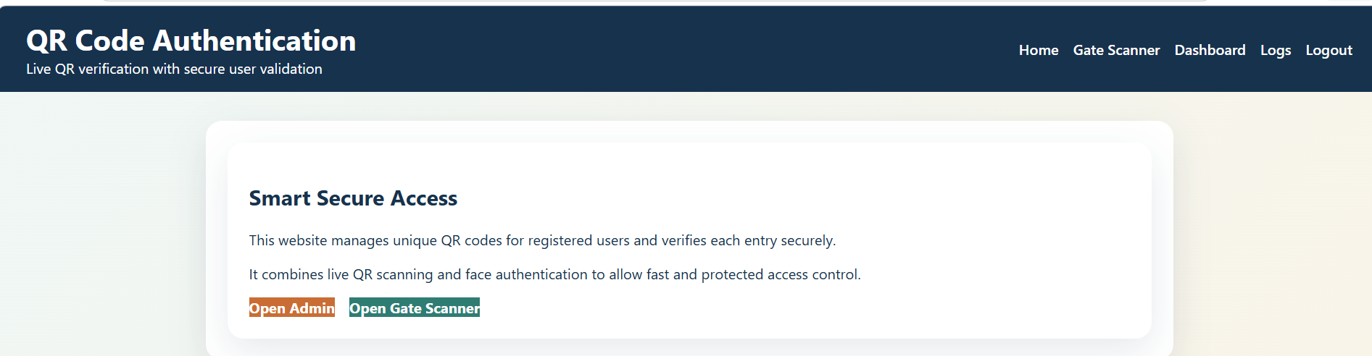

Login page:
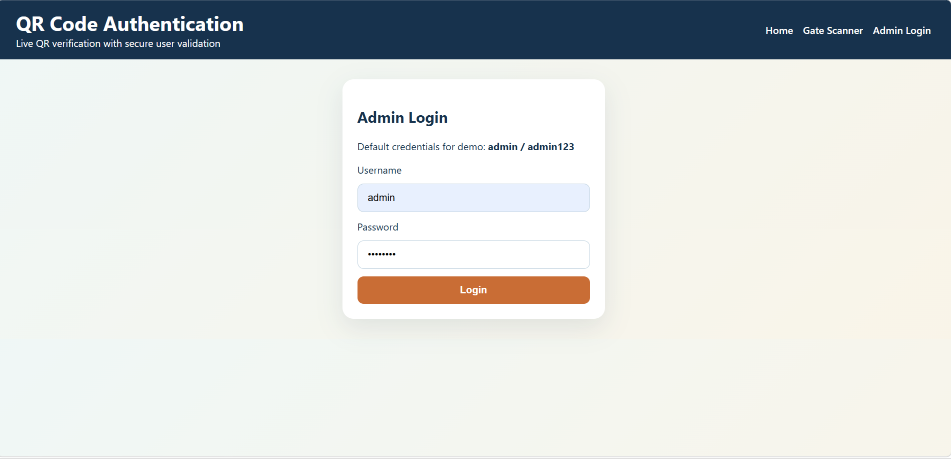

User Registration Page:
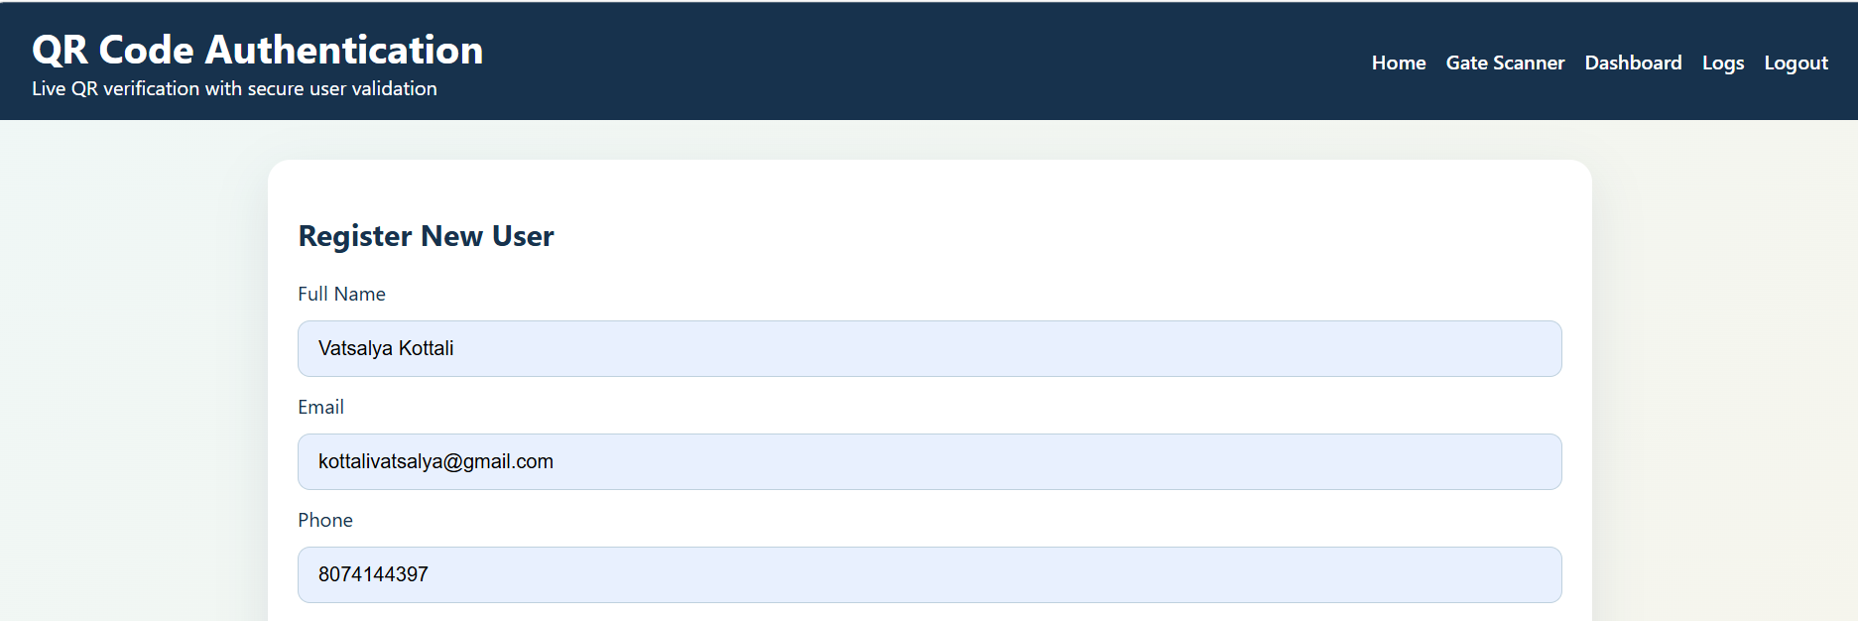

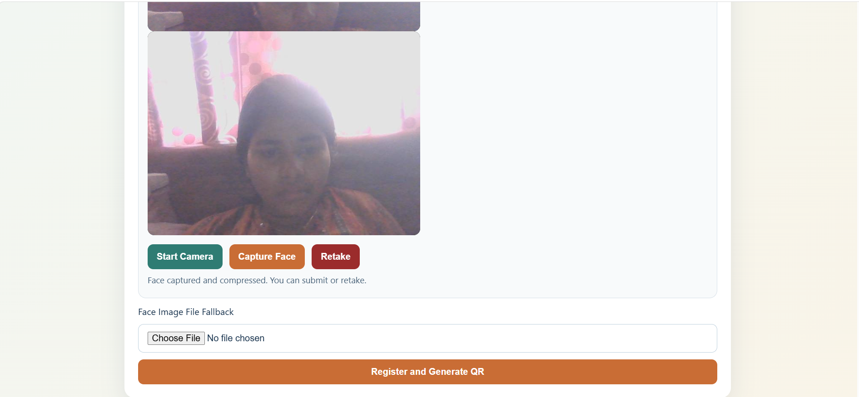
Admin dashboard:
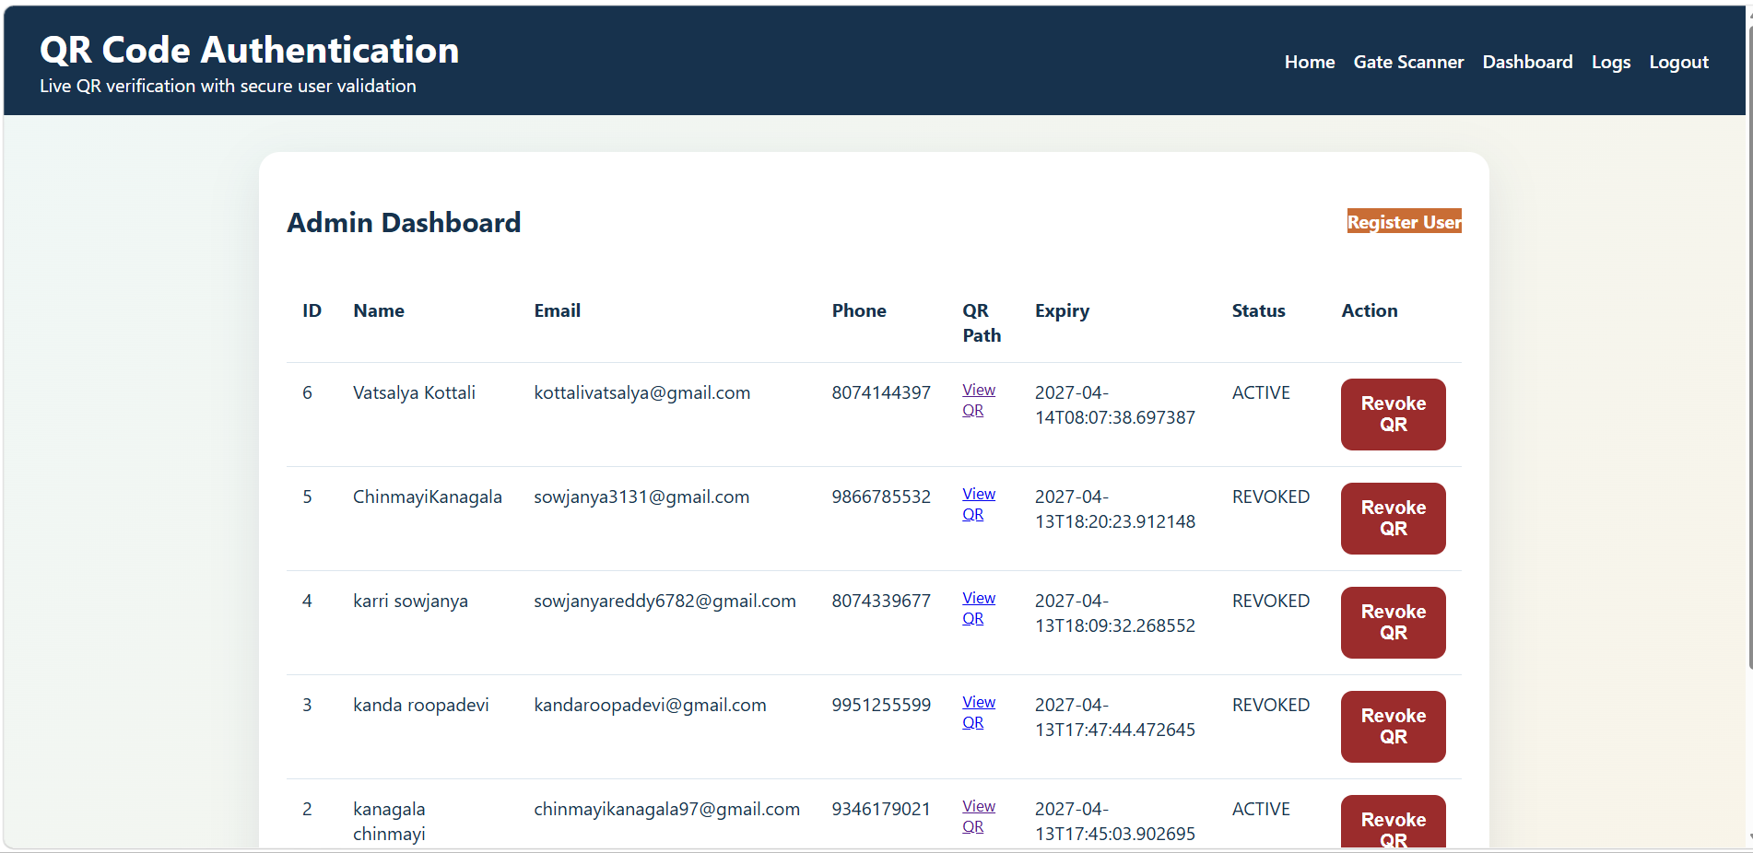
QR Code Generated Screen:
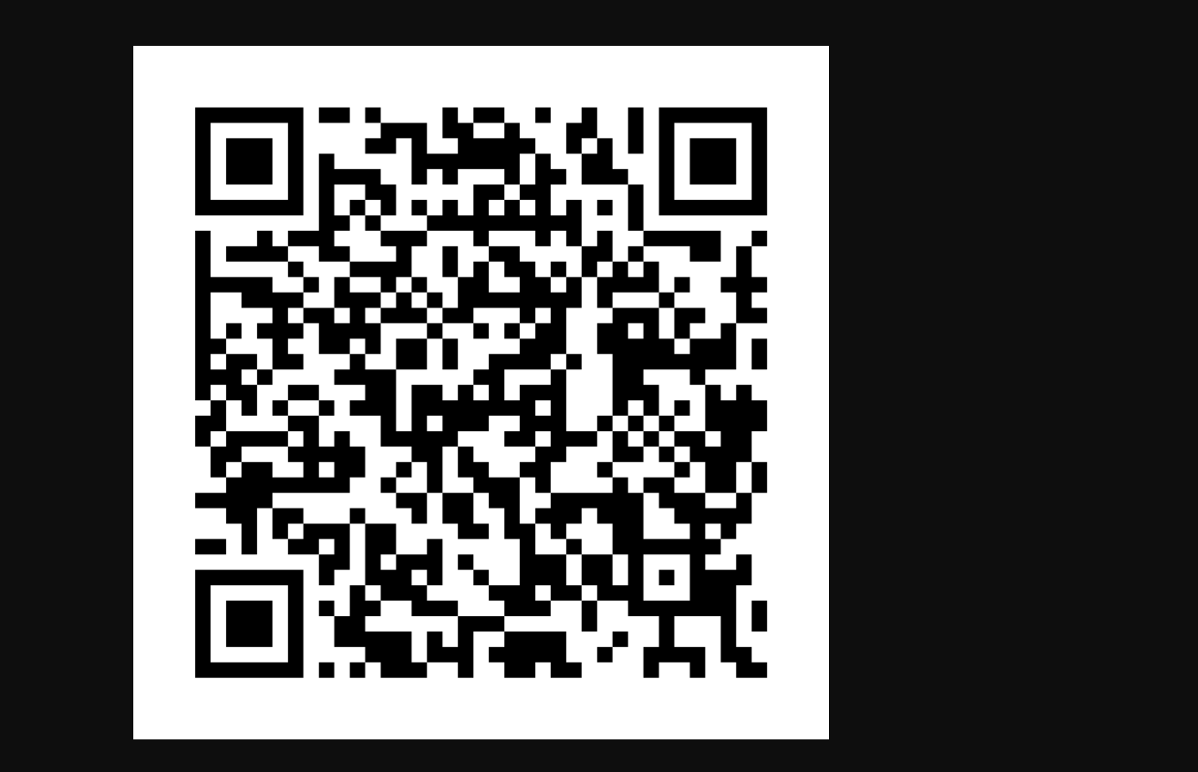

Gate Scanner:
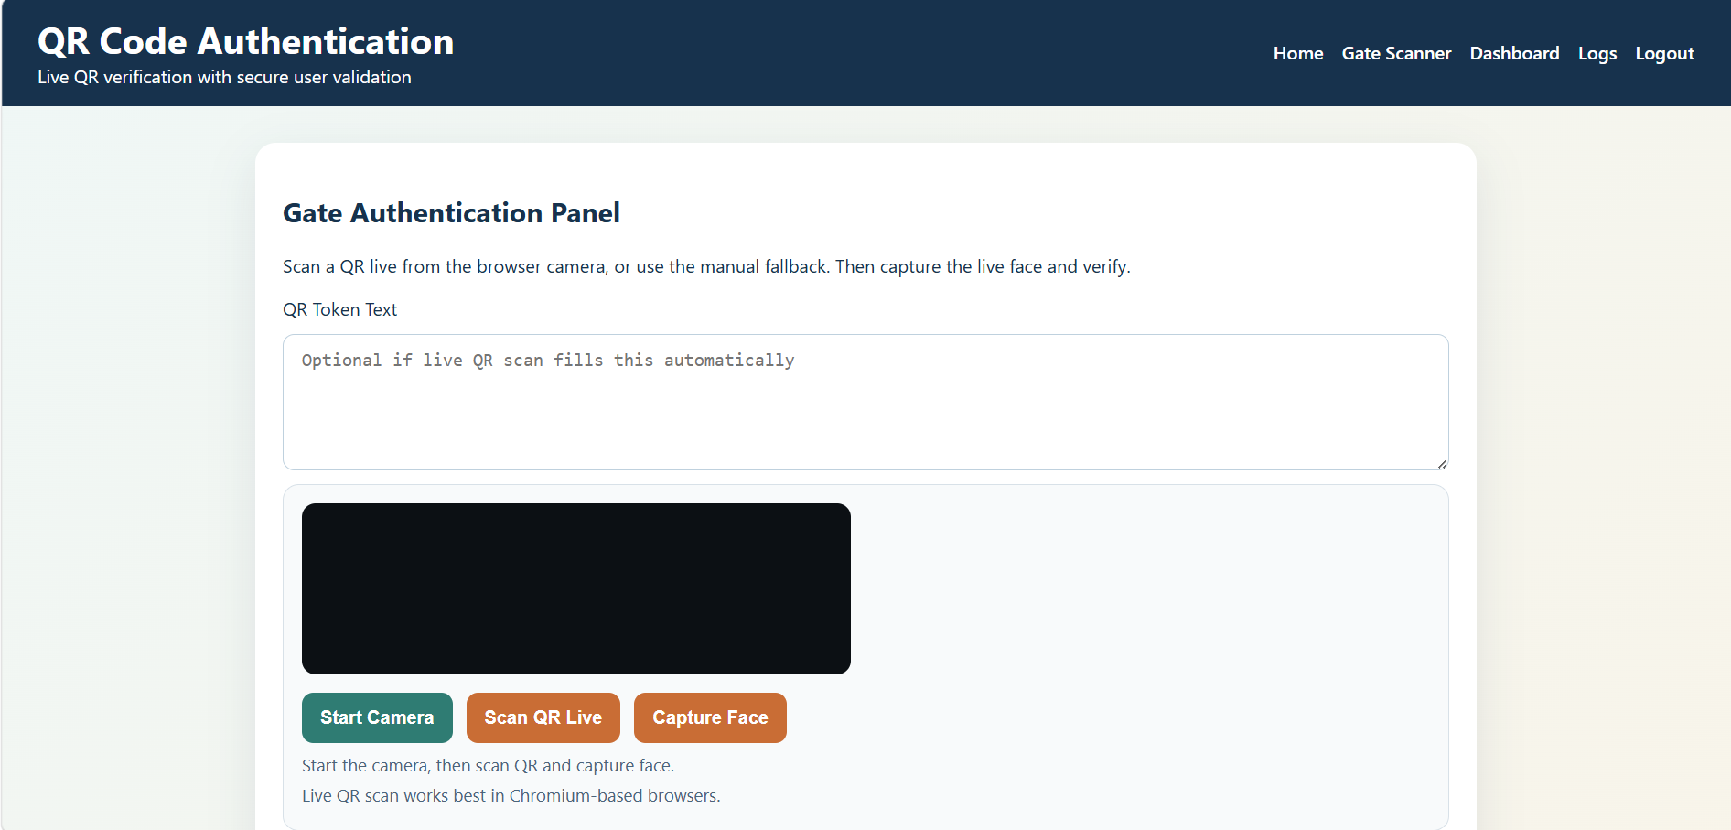
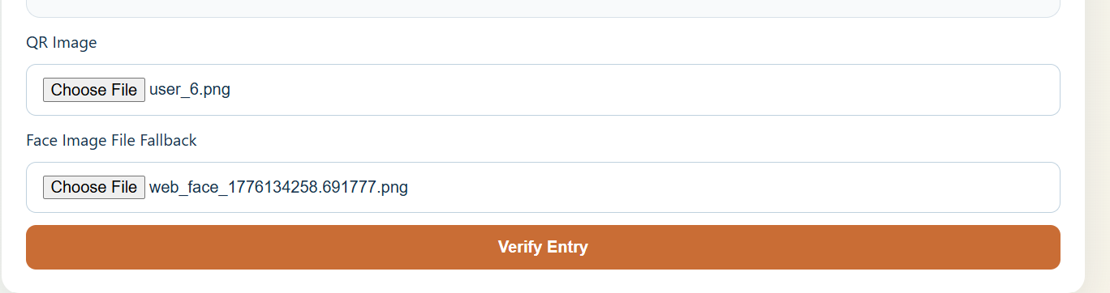

Access Granted / Denied Screen:
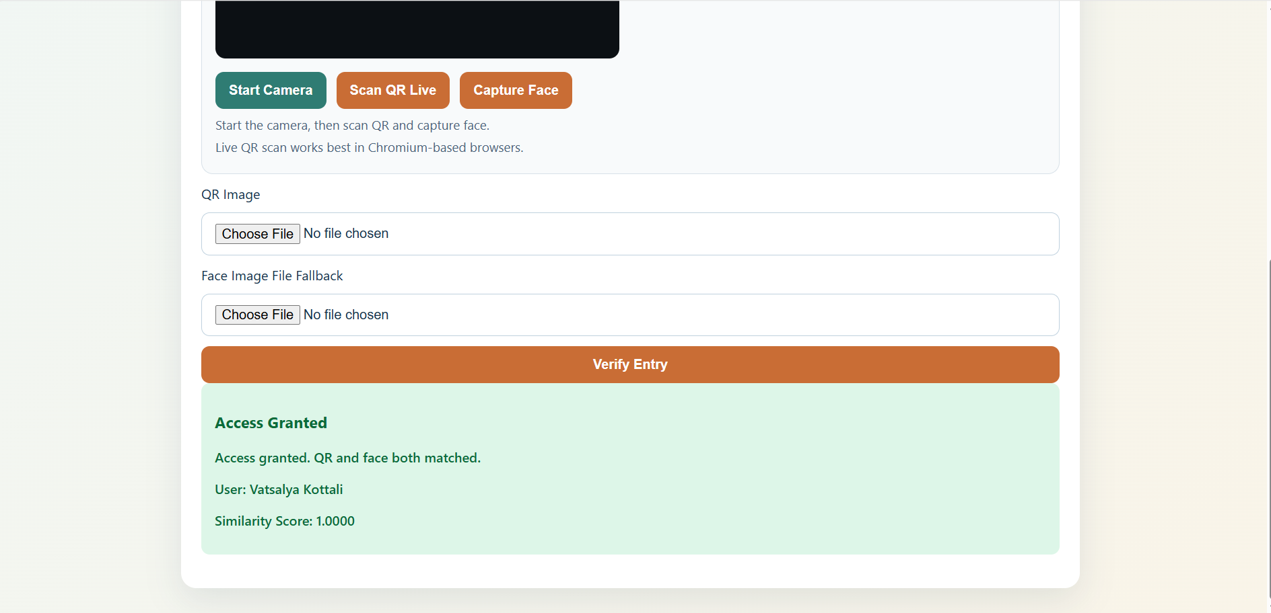

Logs Page:
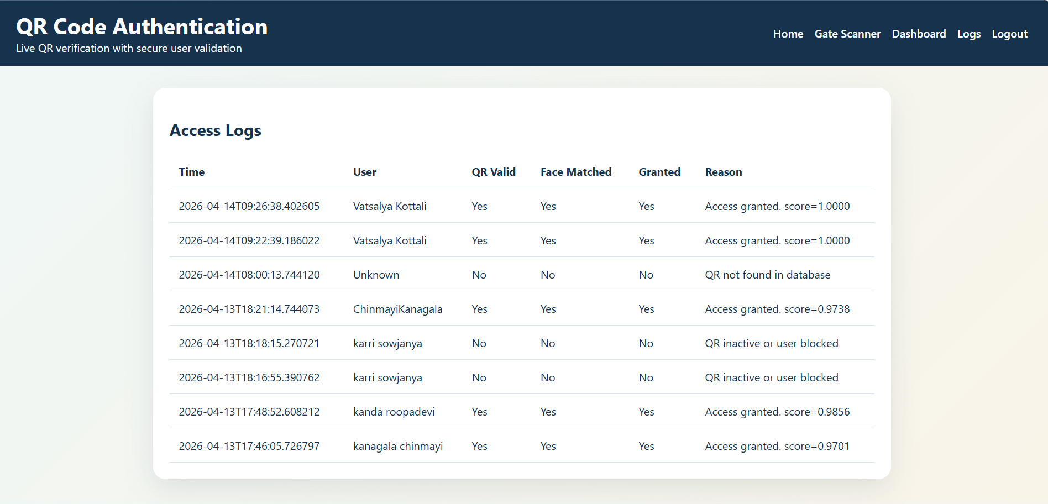

6.CONCLUSION:
The Secure QR Code and Face-Based Authentication System was successfully designed and implemented to provide a reliable and secure access control solution. The system integrates QR code technology with real-time face recognition to ensure accurate user verification. It allows users to register, generate unique QR codes, and authenticate their identity through a combination of QR scanning and facial matching.
The application efficiently performs all core functionalities, including user registration, QR code generation, live camera-based authentication, and access logging. By combining two levels of authentication, the system enhances security and minimizes unauthorized access. Technologies such as Flask, OpenCV, and SQLite contributed to smooth operation, real-time processing, and effective data management.
Overall, the project achieves its goal of delivering a secure, efficient, and user-friendly authentication system. It can be applied in real-world scenarios like offices, institutions, and restricted areas. The system can also be further improved by integrating cloud storage, mobile support, and advanced AI-based face recognition techniques for better scalability and performance.

7.FUTURE SCOPE:

The Secure QR Code and Face-Based Authentication System can be further enhanced by integrating cloud-based storage solutions to improve scalability and remote accessibility. Storing user data and logs on the cloud will allow centralized monitoring and management from multiple locations. The system can also be upgraded to support mobile applications for both Android and iOS platforms, enabling users and administrators to perform authentication and monitoring through smartphones. Integration with IoT-based devices such as smart doors and automated gates can provide fully automated access control. Real-time notifications can also be implemented to alert administrators about unauthorized access attempts. The system can be expanded to handle large-scale user data efficiently in enterprise environments. Thus, cloud and mobile integration will make the system more flexible, scalable, and user-friendly.
Further improvements can include the use of advanced AI and deep learning techniques for more accurate face recognition. This will help in reducing errors and improving authentication reliability. Multi-factor authentication can be added by including OTP verification or biometric fingerprint scanning for enhanced security. The system can also support role-based access control to manage different levels of user permissions effectively. Enhancing the user interface with improved design and usability features can provide a better user experience. Security can be strengthened by implementing encryption techniques for QR codes and stored data. Regular system updates and monitoring tools can be introduced to detect vulnerabilities and prevent threats. These advancements will make the system more secure, intelligent, and suitable for real-world applications.

8.REFERENCES:

• Flask Documentation – Official Documentation
https://flask.palletsprojects.com/
Alternative documentation mirror: https://flask-docs.readthedocs.io/
• OpenCV Documentation – Official Documentation
https://docs.opencv.org/
• SQLite Documentation – Official Documentation
https://www.sqlite.org/docs.html
• NumPy Documentation – Official Documentation
https://numpy.org/doc/stable/
• QR Code Technology Overview – QR Code Essentials
https://www.qrcode.com/en/about/
• Face Recognition – Research Papers and Online Resources
IEEE Xplore Digital Library
https://ieeexplore.ieee.org/
• GeeksforGeeks – “Face Recognition using Python”
https://www.geeksforgeeks.org/face-recognition-with-python/
• W3Schools – “Python and Flask Tutorial”
https://www.w3schools.com/python/python_flask.asp

