Secure Certificate Verification System using
QR CODES AND DIGITAL SIGNATURES

A PROJECT REPORT

BACHELOR OF TECHNOLOGY IN COMPUTER SCIENCE AND ENGINEERING

By

Batch – B15

K.Swathi(323103210112) K.Sri Durga(323103210113)
K.Hima Sri(323103210117) K.Karuna pallavi (323103210243)

Under the esteemed guidance of
Dr. N. Sharmili
Professor CSE Department

Department of Computer Science and Engineering

GAYATRI VIDYA PARISHAD COLLEGE OF ENGINEERING FOR WOMEN
[Approved by AICTE NEW DELHI, Affiliated to Andhra University, Visakhapatnam]
[Accredited by National Board of Accreditation (NBA) for B. Tech. CSE, ECE & IT – valid from 2019-22 and 2022-25] [Accredited by National Assessment and Accreditation Council (NAAC) with A Grade-Valid from 2022-2027]
Kommadi, Madhurawada, Visakhapatnam – 530048
2023 – 2027

GAYATRI VIDYA PARISHAD COLLEGE OF ENGINEERING FOR WOMEN

DEPARTMENT OF COMPUTER SCIENCE AND ENGINEERING



CERTIFICATE
This is to certify that the project report titled “Secure certificate verification system using qr codes and digital signatures” is the bonafide work of following III B.Tech. students from the Department of Computer Science and Engineering, Gayatri Vidya Parishad College of Engineering for Women, affiliated with AndhraUniversity, Visakhapatnam. This project was done as part of Cryptography and Network Security lab during the academic year 2025–2026 (III Year Semester-2).

K.Swathi(323103210112) K.Sri Durga(323103210113)
K.Hima Sri(323103210117) K.Karuna pallavi(323103210243)

Signature of the Guide Signature of the HOD
Dr. N. Sharmili MTech., Ph.D. Dr. P. V. S. L. Jagadamba MTech, Ph.D
Professor, Professor,
Dept. of CSE Dept. of CSE

External Examiner

ABSTRACT

This project presents a Secure Certificate Verification System using QR Codes and Digital Signatures. The main objective is to prevent certificate forgery and ensure authenticity through cryptographic techniques. In this system, an administrator uploads a certificate file, which is then processed to generate a unique hash using the SHA-256 algorithm. This hash is digitally signed using an RSA private key to ensure data integrity and authenticity.
A QR code is generated containing the certificate’s hash and a reference to its digital signature. This QR code is embedded or shared with the certificate. During verification, the user uploads both the certificate and its corresponding QR code. The system decodes the QR code, retrieves the stored hash and signature, and verifies the signature using the RSA public key. It then compares the newly generated hash of the uploaded certificate with the original hash.
If both the signature verification and hash comparison are successful, the certificate is declared valid; otherwise, it is marked as tampered or invalid. The system is implemented using Flask for the backend, along with cryptographic libraries and OpenCV for QR code detection.
This solution enhances security, reduces manual verification efforts, and provides a reliable method to detect forged or altered certificates in digital environments

- SYSTEM REQUIREMENTS
  - Software Requirements
Table 1. Software Requirements

Software | Version / Specification
Python | 3.10.12(64-bit)
Visual Studio Code Editor | 1.85+
Streamlit | 1.30.0
Operating System | Windows 11
Scikit-learn | 1.3.2
NumPy | 1.24.4
Pandas | 1.5.3
FTK Imager | 4.7.1
Volatility Framework | Volatility 3

Python packages
Python packages we used in our project includes the following table 2.
We used the command pip install “package_name==version” to download the packages.

Table 2. Python packages

S.No. | Package Used | Description
1. | NumPy | Used for numerical computations and handling multi-dimensional arrays efficiently.
2. | Pandas | Used for data manipulation and analysis using DataFrames and Series.  series
3. | Scikit-learn | Provides tools for machine learning tasks like classification and regression.
4. | XGBoost | High-performance gradient boosting algorithm used for predictive modeling.
5. | Matplotlib | Used for creating basic data visualizations like graphs and charts.
6. | Seaborn | Used for advanced and attractive statistical data visualizations.
7. | Flask | Lightweight web framework used for building backend applications.
8. | Cryptography/ PyCrypto | Provides cryptographic functions like hashing, encryption, and digital signatures.

9. | Volatility | Used for analyzing memory dumps in digital forensics.
10. | Regex (re) | Used for pattern matching and text processing using regular expressions.

Front End Packages used
Table 3. Front end Packages

S.NO | Libraries Used | Description
1. | Stream lit | Used to build interactive web applications for data visualization and machine learning with minimal code.
2. | Jinja2 | Used for rendering dynamic HTML templates in web applications like Flask.
3. | Virtual env | Used to create isolated Python environments for managing dependencies separately.
4. | OS | Provides the environment to run applications and manage hardware and system resources.

3.3.2 Hardware Requirements

The below Table 4 shows the minimum hardware requirements of our project.

Minimum Hardware Requirements:

Table 4. Minimum Hardware Requirements

S.No | Hardware Component | Specification
1. | Storage Device | Minimum 100 GB HDD/SSD for storing files, QR codes, and keys
2. | Processor | 64-bit processor (Intel/AMD) for efficient execution of Python and cryptographic operations
3. | RAM | Minimum 4 GB
4. | Internet Connection | Required for downloading libraries, updates, and deployment
5. | Display Unit | Monitor with at least 1366×768 resolution
6. | Input Devices | Keyboard and Mouse for user interaction

- METHODOLOGY

  - SYSTEM ARCHITECTURE
The proposed Secure Certificate Verification System follows a client-server architecture implemented using the Flask framework. The system is divided into two main modules: the Admin Module and the User Verification Module, with supporting components such as cryptographic processing, QR code generation, and storage management.
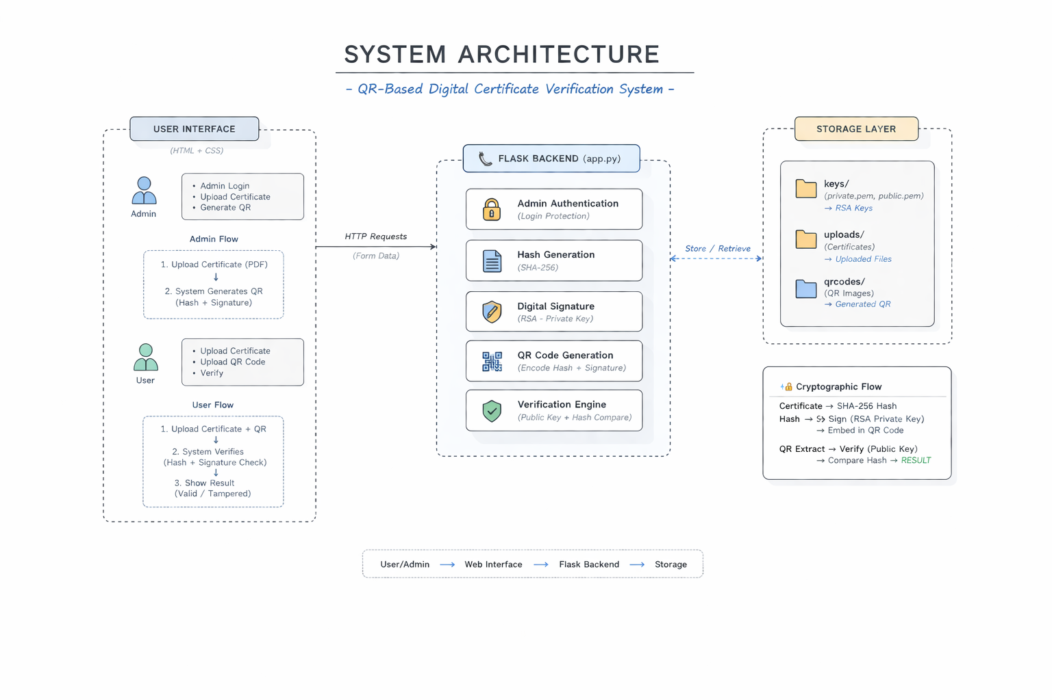

  - DESCRPTION, ALGORITHM
System Description
The Secure Certificate Verification System is designed to ensure the authenticity and integrity of digital certificates using cryptographic techniques and QR codes. The system uses the Flask framework for backend processing, along with hashing, digital signatures, and QR code technology.
The system operates in two main phases:

🔹 1. Certificate Generation Phase (Admin Side)
In this phase, an authorized administrator uploads a certificate file. The system processes the file as follows:
- The uploaded certificate is stored in the server.
- A secure hash of the certificate is generated using the SHA-256 algorithm.
- The generated hash is digitally signed using the RSA private key through the RSA Algorithm.
- The digital signature is stored separately in the system.
- A QR code is generated using the qrcode Python library, containing:
  - Certificate hash
  - Reference to the signature file
  - Issuer details
- The QR code is then made available for download and can be attached to the certificate.

🔹 2. Certificate Verification Phase (User Side)
In this phase, the user verifies the authenticity of a certificate:
- The user uploads the certificate file along with its QR code.
- The QR code is decoded using OpenCV to extract stored data.
- A new hash of the uploaded certificate is generated using SHA-256.
- The stored signature is retrieved from the system.
- The signature is verified using the RSA public key.
- The system compares:
  - Newly generated hash
  - Original hash from QR
Algorithm:
Step 1: Key Generation
- Generate RSA private key (2048-bit).
- Generate corresponding public key from private key.
- Store private key in keys/private.pem.
- Store public key in keys/public.pem.
- If keys already exist, reuse them without regenerating.
Step 2: Signing Process (QR Generation)
- Admin uploads a certificate file.
- Save the file in uploads/ folder.
- Read file content in binary mode.
- Generate file hash using SHA-256.
- Load RSA private key from keys/private.pem.
- Create digital signature of the hash using private key.
- Convert signature into hexadecimal format.
- Create data containing:
  - File hash
  - Digital signature
  - Issuer information
- Generate QR code using this data.
- Save QR code in qrcodes/ folder.
- Display/download QR code to admin.

Step 3: Verification Process
- User uploads certificate file and QR code.
- Save files in uploads/ and qrcodes/ folders.
- Read uploaded certificate file.
- Generate new hash using SHA-256.
- Read QR image using OpenCV.
- Decode QR code to extract stored data.
- If QR is not detected → display “QR Not Detected”.
- Extract:
  - Original hash
  - Digital signature
- Convert signature from hex to bytes.
- Load RSA public key from keys/public.pem.
- Verify digital signature using public key.
Step 4: Result Decision
- If signature verification fails →
Display “Invalid Signature”
- Else if signature is valid and:
  - New hash == Original hash →
Display “Valid Certificate”
- Else →
Display “Tampered Certificate”

3.IMPLEMENTATION
Source code:
Adimin_dashboard.html
<!DOCTYPE html>
<html>
<head>
<title>Admin Dashboard</title>
<link rel="stylesheet" href="/static/style.css">
</head>
<body>
<div class="container">
<h2> Generate Certificate QR</h2>

<form action="/generate" method="POST" enctype="multipart/form-data">
<input type="file" name="file" required>
<button type="submit">Generate QR Code</button>
</form>
</div>

</body>
</html>

Admin_dashboard.html:
<style>
.toggle-password {
cursor: pointer;
margin-top: 5px;
font-size: 14px;
color: #007bff;
}
.back-btn {
background: #ccc;
color: black;
}
.back-btn:hover {
background: #999;
}
</style>

<script>
function togglePassword() {
var pwd = document.getElementById("password");
if (pwd.type === "password") {
pwd.type = "text";
} else {
pwd.type = "password";
}
}
</script>

</head>
<body>

<div class="container">
<h2> Admin Login</h2>
<p style="color: gray;">Only authorized users can generate certificates</p>

<form method="POST">
<input type="text" name="username" placeholder="Enter Username" required>

<input type="password" id="password" name="password" placeholder="Enter Password" required>

<div class="toggle-password" onclick="togglePassword()">
👁 Show/Hide Password
</div>

<button type="submit">Login</button>
</form>

<br>
<a href="/">
<button class="back-btn">⬅ Back to Home</button>
</a>

{% if error %}
<p style="color:red; margin-top:10px;">{{ error }}</p>
{% endif %}
</div>

</body>
</html>

index.html:
<!DOCTYPE html>
<html>
<head>
<title>Certificate System</title>
<link rel="stylesheet" href="/static/style.css">
</head>
<body>

<div class="container">
<h1>Certificate Verification</h1>

<h3> Admin Panel</h3>
<a href="/admin"><button>Login & Generate QR</button></a>

<h3> User Panel</h3>
<a href="/verify"><button>Verify Certificate</button></a>
</div>

</body>
</html>

Qr_result.html:
<!DOCTYPE html>
<html>
<head>
<title>QR Generated</title>
<link rel="stylesheet" href="/static/style.css">
</head>
<body>
<div class="container">
<h2> QR Code Generated Successfully</h2>
<img src="{{ url_for('get_qr', filename=qr_file) }}" width="200"><br><br>
<a href="{{ url_for('get_qr', filename=qr_file) }}" download>
<button>⬇ Download QR</button>
</a>
<br><br>
<a href="/dashboard">
<button> Back to Dashboard</button>
</a>
<a href="/">
<button>🏠 Home</button>
</a>
</div>
</body>
</html>
Verify.html:

<!DOCTYPE html>
<html>
<head>
<title>Verify Certificate</title>
<link rel="stylesheet" href="/static/style.css">
</head>
<body>

<div class="container">
<h2> Verify Certificate</h2>

<form method="POST" enctype="multipart/form-data">
<input type="file" name="file" required>
<input type="file" name="qr" required>
<button type="submit">Verify</button>
</form>

{% if result %}
<div class="result">
{{ result }}
</div>
{% endif %}
</div>

</body>
</html>

App.py

from flask import Flask, render_template, request, redirect, url_for, send_from_directory
import os, json, hashlib, qrcode, cv2
from cryptography.hazmat.primitives import serialization, hashes
from cryptography.hazmat.primitives.asymmetric import padding, rsa

app = Flask(__name__)

UPLOAD_FOLDER = "uploads"
QR_FOLDER = "qrcodes"
KEYS_FOLDER = "keys"

os.makedirs(UPLOAD_FOLDER, exist_ok=True)
os.makedirs(QR_FOLDER, exist_ok=True)
os.makedirs(KEYS_FOLDER, exist_ok=True)

# 🔐 Admin credentials
ADMIN_USER = "admin"
ADMIN_PASS = "1234"

# 🔑 Generate Keys
def generate_keys():
private_path = os.path.join(KEYS_FOLDER, "private.pem")
public_path = os.path.join(KEYS_FOLDER, "public.pem")

if not os.path.exists(private_path):
private_key = rsa.generate_private_key(public_exponent=65537, key_size=2048)
public_key = private_key.public_key()

with open(private_path, "wb") as f:
f.write(private_key.private_bytes(
encoding=serialization.Encoding.PEM,
format=serialization.PrivateFormat.PKCS8,
encryption_algorithm=serialization.NoEncryption()
))

with open(public_path, "wb") as f:
f.write(public_key.public_bytes(
encoding=serialization.Encoding.PEM,
format=serialization.PublicFormat.SubjectPublicKeyInfo
))

generate_keys()

def load_keys():
with open("keys/private.pem", "rb") as f:
private_key = serialization.load_pem_private_key(f.read(), password=None)

with open("keys/public.pem", "rb") as f:
public_key = serialization.load_pem_public_key(f.read())

return private_key, public_key

# 🏠 Home
@app.route('/')
def home():
return render_template('index.html')

# 🔐 Admin Login
@app.route('/admin', methods=['GET', 'POST'])
def admin():
if request.method == 'POST':
user = request.form['username']
pwd = request.form['password']

if user == ADMIN_USER and pwd == ADMIN_PASS:
return redirect('/dashboard')

return render_template('admin_login.html')

# 📊 Dashboard
@app.route('/dashboard')
def dashboard():
return render_template('admin_dashboard.html')

# ✍️ Generate QR
@app.route('/generate', methods=['POST'])
def generate():
file = request.files['file']
path = os.path.join(UPLOAD_FOLDER, file.filename)
file.save(path)

with open(path, "rb") as f:
file_hash = hashlib.sha256(f.read()).hexdigest()

private_key, _ = load_keys()

signature = private_key.sign(
file_hash.encode(),
padding.PKCS1v15(),
hashes.SHA256()
)

data = {
"hash": file_hash,
"signature": signature.hex(),
"issuer": "Admin"
}

qr = qrcode.make(json.dumps(data))
qr_filename = file.filename + ".png"
qr_path = os.path.join(QR_FOLDER, qr_filename)
qr.save(qr_path)

return render_template('qr_result.html', qr_file=qr_filename)

# 📥 Serve QR Image
@app.route('/qrcodes/<filename>')
def get_qr(filename):
return send_from_directory(QR_FOLDER, filename)

# ✅ Verify
@app.route('/verify', methods=['GET', 'POST'])
def verify():
result = ""

if request.method == 'POST':
file = request.files['file']
qr_file = request.files['qr']

file_path = os.path.join(UPLOAD_FOLDER, file.filename)
qr_path = os.path.join(QR_FOLDER, qr_file.filename)

file.save(file_path)
qr_file.save(qr_path)

with open(file_path, "rb") as f:
new_hash = hashlib.sha256(f.read()).hexdigest()

img = cv2.imread(qr_path)
detector = cv2.QRCodeDetector()
decoded, _, _ = detector.detectAndDecode(img)

if not decoded:
result = "❌ QR not detected"
return render_template('verify.html', result=result)

qr_data = json.loads(decoded)

old_hash = qr_data['hash']
signature = bytes.fromhex(qr_data['signature'])

_, public_key = load_keys()

try:
public_key.verify(
signature,
old_hash.encode(),
padding.PKCS1v15(),
hashes.SHA256()
)

if new_hash == old_hash:
result = "✅ VALID CERTIFICATE"
else:
result = "❌ TAMPERED CERTIFICATE"

except:
result = "❌ INVALID SIGNATURE"

return render_template('verify.html', result=result)

# 🚀 Run App
if __name__ == "__main__":
app.run(debug=True)
- RESULTS
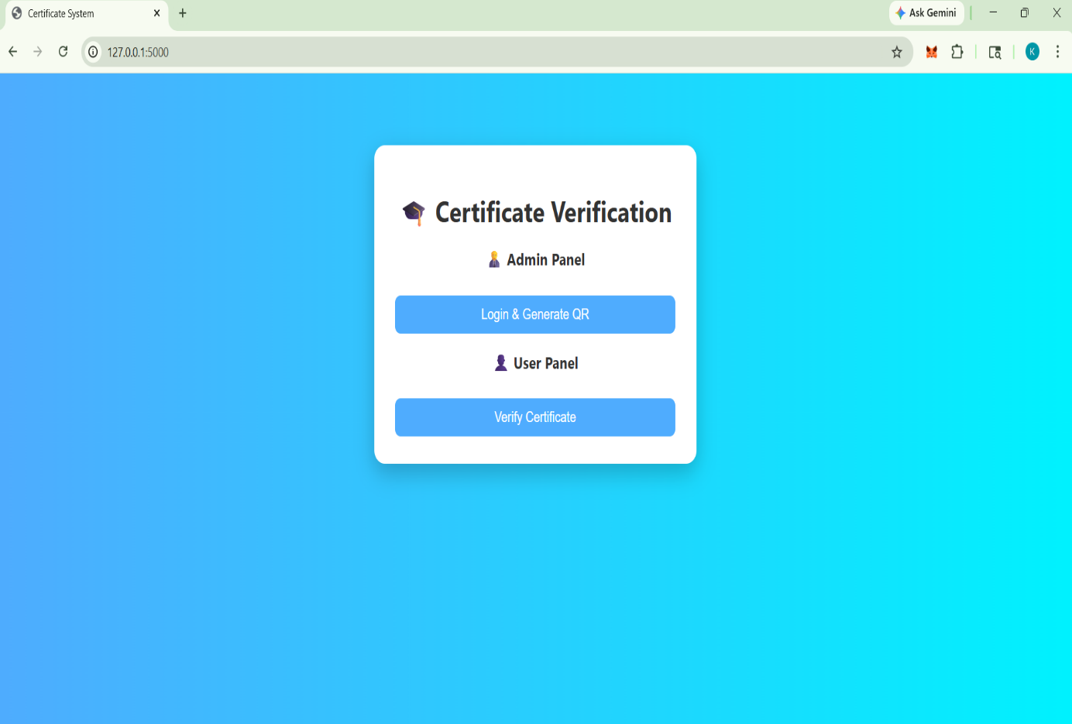
7.1 Output Screens
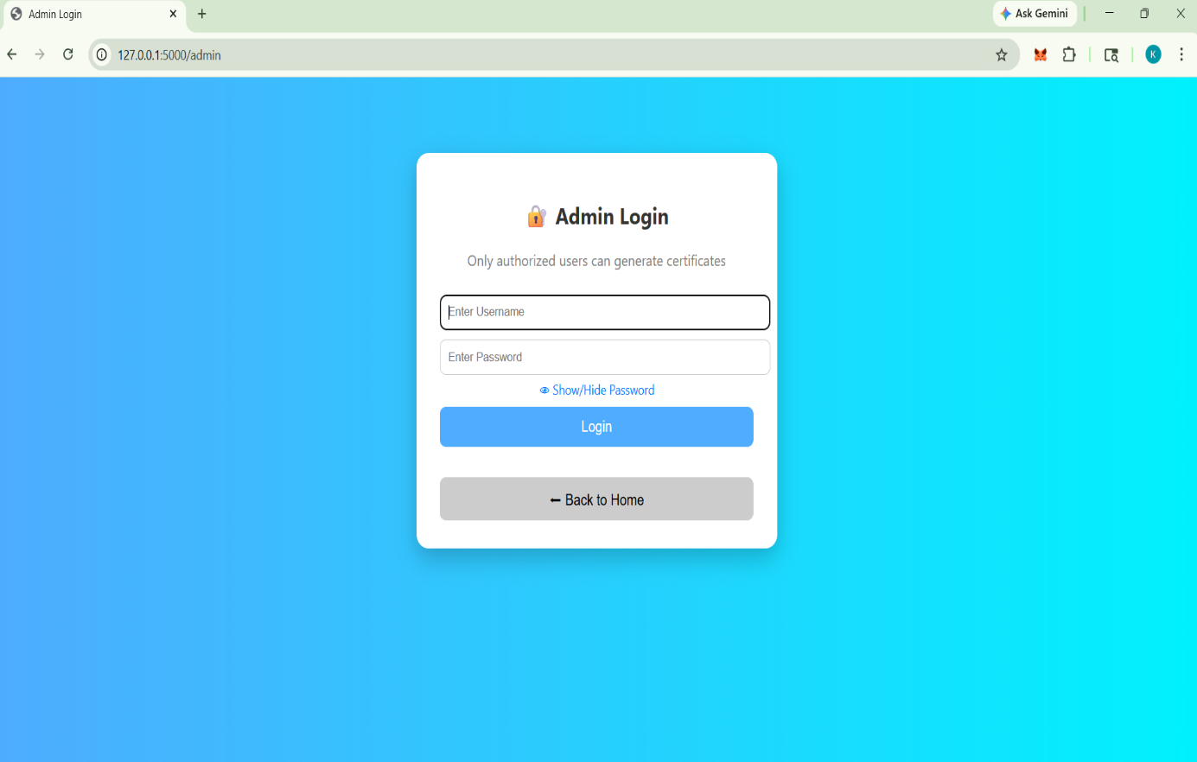

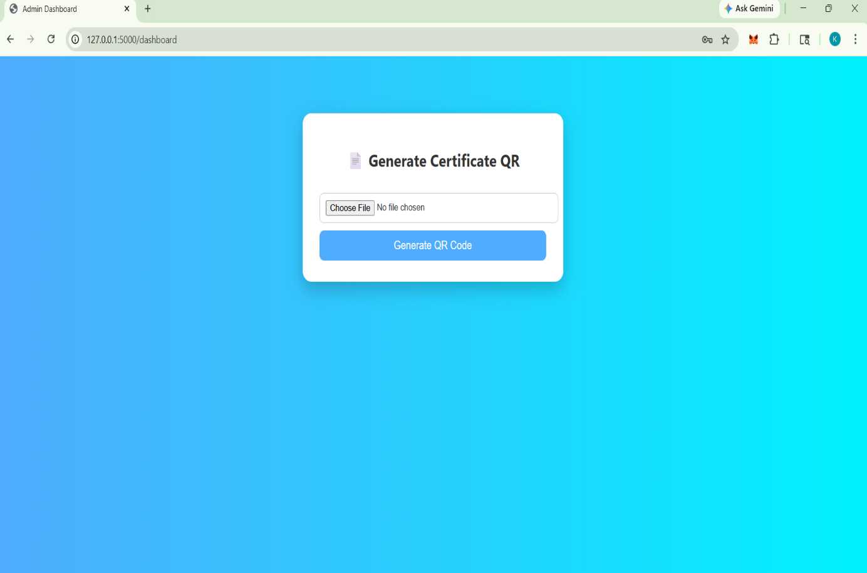
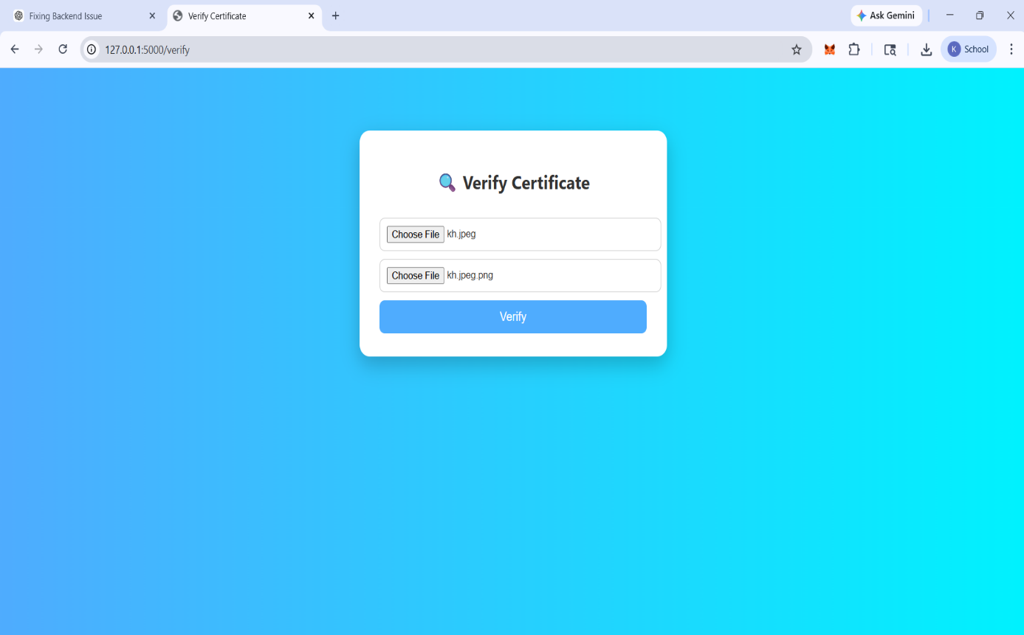

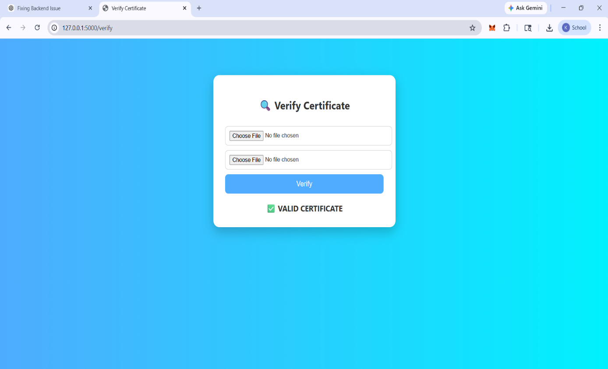
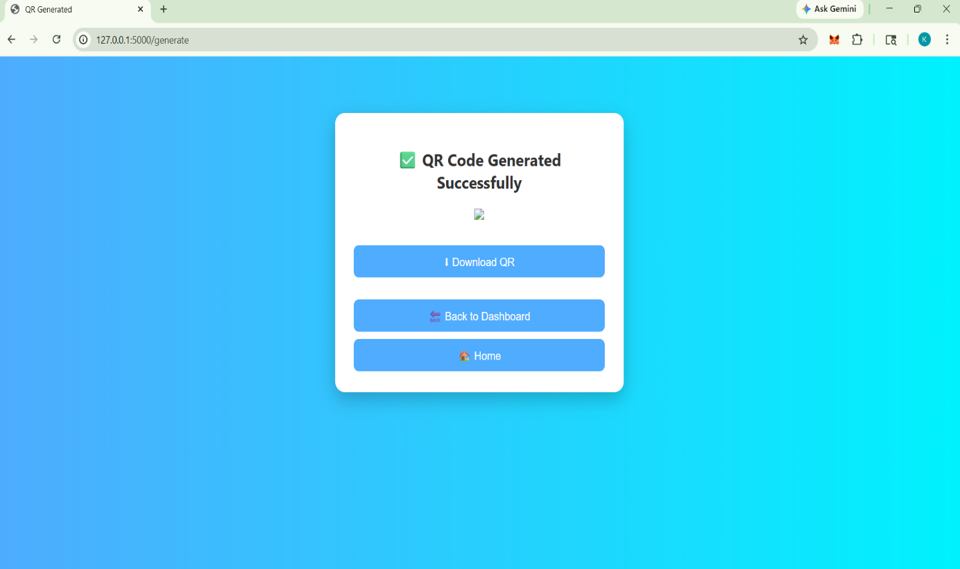

- CONCLUSION
The Secure Certificate Verification System using QR Codes and Digital Signatures successfully provides a reliable solution to detect forged or tampered certificates. The system integrates cryptographic techniques such as SHA-256 for data integrity and RSA Algorithm for authentication, ensuring that certificates cannot be altered without detection.
By generating a unique hash for each certificate and embedding its signed data into a QR code, the system enables quick and secure verification. The use of Flask provides a simple and efficient backend, while OpenCV allows accurate QR code decoding. The implementation reduces manual verification efforts, minimizes fraud, and increases trust in digital certificate systems.
Overall, the project demonstrates how modern cryptography combined with QR technology can be effectively used to enhance security in real-world applications such as education, employment, and digital documentation.

- FUTURE SCOPE
Although the current system is functional and secure, it can be further enhanced with the following improvements:
1. Database Integration
- Store certificate details, hashes, and user records in a database (MySQL/SQLite) instead of files.
- Enables better management and scalability.

2. User Authentication System
- Implement secure login sessions for admins using encryption.
- Add multi-user roles (admin, verifier, user).

3. Blockchain Integration
- Store certificate hashes on blockchain for tamper-proof verification.
- Eliminates dependency on a central server.

4. Mobile Application
- Develop an Android/iOS app for real-time QR scanning and verification.
- Improves accessibility and usability.

5. Enhanced Security
- Encrypt private keys with passwords.
- Use stronger padding methods (like OAEP or PSS).
- Add certificate expiry and timestamp validation.

6. Cloud Deployment
- Deploy the system on cloud platforms (AWS, Azure, Render).
- Makes the system globally accessible.

7. Bulk Certificate Generation
- Allow uploading multiple certificates and generating QR codes in batch.
- Useful for universities and organizations.

REFERENCES

• William Stallings, Cryptography and Network Security: Principles and Practice, Pearson Education.
• Flask Official Documentation :https://flask.palletsprojects.com/
• OpenCV Documentation :https://opencv.org/
• Python Cryptography Library Documentation: https://cryptography.io/
• QR Code Standard Information: https://www.qrcode.com/
• National Institute of Standards and Technology (NIST), Secure Hash Standard (SHA-256).
• Rivest, Shamir, and Adleman, “A Method for Obtaining Digital Signatures and Public-Key Cryptosystems,” Communications of the ACM.
• qrcode Python library Documentation: https://pypi.org/project/qrcode/

