WIFI STALKER DETECTION SYSTEM

A PROJECT REPORT SUBMITTED IN FULFILMENT OF THE REQUIREMENTS FOR THE AWARD OF THE DEGREE OF
BACHELOR OF TECHNOLOGY IN
COMPUTER SCIENCE AND ENGINEERING


By
Batch – 16

K.Pranathi(323103210114) K.Kaveri(323103210108)
K.Komali(323103210115) K.Divya(323103210116)

Under the esteemed guidance of
Dr. N. Sharmili
Professor
CSE Department

Department of Computer Science and Engineering

GAYATRI VIDYA PARISHAD COLLEGE OF ENGINEERING FOR WOMEN
[Approved by AICTE NEW DELHI, Affiliated to Andhra University, Visakhapatnam]
[Accredited by National Board of Accreditation (NBA) for B. Tech. CSE, ECE & IT – valid from 2019-22 and 2022-25] [Accredited by National Assessment and Accreditation Council (NAAC) with A Grade-Valid from 2022-2027]
Kommadi, Madhurawada, Visakhapatnam – 530048

2022 – 2026

GAYATRI VIDYA PARISHAD COLLEGE OF ENGINEERING FOR WOMEN

DEPARTMENT OF COMPUTER SCIENCE AND ENGINEERING



CERTIFICATE

This is to certify that the project report titled “WIFI Stalker Detection System” is the bonafide work of following III B.Tech. students from the Department of Computer Science and Engineering, Gayatri Vidya Parishad College of Engineering for Women, affiliated with AndhraUniversity, Visakhapatnam. This project was done as part of Cryptography and Network Security lab during the academic year 2025–2026 (III Year Semester-2).

K.Pranathi(323103210114) K.Kaveri(323103210108)
K.Komali(323103210115) K.Divya(323103210116)

Signature of the Guide Signature of the HOD
Dr. N. Sharmili _{MTech.,} _{Ph.D.} Dr. P. V. S. L. Jagadamba _{MTech, Ph.D}
Professor, Professor,
Dept. of CSE Dept. of CSE

External Examiner

ABSTRACT

The WiFi Stalker Detection System is a network security application designed to identify suspicious and potentially harmful wireless networks in a given area. With the rapid growth of wireless communication, users are increasingly vulnerable to threats such as rogue access points, evil twin attacks, and unauthorized tracking through WiFi signals. This project aims to enhance user awareness and safety by continuously monitoring nearby WiFi networks and classifying them based on risk levels.
The system is developed using Python and Streamlit for an interactive user interface, along with the pywifi library to scan available wireless networks. It collects key parameters such as SSID, BSSID, signal strength (RSSI), and security type. These parameters are analyzed using predefined rules to categorize networks as safe, high risk, suspicious, evil twin or stalker.

A local database (SQLite) is used to store scan history, enabling the system to track repeated appearances of networks over time. Networks that frequently appear are flagged as suspicious or stalker networks based on occurrence thresholds. Trusted networks are also defined to detect impersonation attacks, such as evil twin networks. The system provides multiple functionalities including real-time scanning, history tracking, final classification of networks, and identification of potential stalker networks. By combining real-time detection with historical analysis, this project offers a simple yet effective approach to improving WiFi security awareness for users.

1.SYSTEM REQUIREMENTS

  - Software Requirements

Table 1:Software Requirements

Software | Version / Specification
Operating System | Windows / Linux / macOS
Programming Language │ | Python (3.x)
Framework | Streamlit
Library | pywifi
Database | SQLite
IDE/Editor | VS Code / PyCharm / Jupyter
Browser | Chrome / Edge / Firefox
Python Packages | streamlit, pywifi, sqlite3
Package Manager | pip

1.2 Python packages
You can place these in the package table:
Table 2. Python packages

S.No. | Package Used | Description
1 | Streamlit | Used to build the web-based user interface, including buttons, tables, and layout for the WiFi detection system
2 | Pywifi | Enables scanning and interaction with nearby WiFi networks (SSID, BSSID, signal strength, security)
3 | Comtypes | Dependency required by pywifi on Windows to access WiFi hardware interfaces
4 | Sqlite3 | Built-in Python module used to store and manage WiFi scan logs in a local database
5 | Datetime | Built-in module used to record date and time of each WiFi scan entry
6 | Time | Built-in module used to introduce delay during WiFi scanning process

1.3 Front End Packages used

Table 3. Front end Packages
S.No. | Libraries Used | Description
1 | streamlit (st) | Main library used to build the web interface of the WiFi Stalker Detection System
2 | st.set_page_config | Configures page title and layout (wide screen view)
3 | st.markdown | Used to design headings and align text using HTML (center alignment, styling)
4 | st.button | Creates interactive buttons such as Scan WiFi, View History, Finalize Networks, and Show Stalker
5 | st.spinner | Displays loading animation while scanning WiFi networks
6 | st.success | Shows success message after WiFi scan completion
7 | st.subheader | Displays section headings like Detected Networks, History, and Final Classification
8 | st.table | Displays WiFi scan results and database records in tabular format
9 | st.write | Used to display dynamic classification results
10 | st.markdown (HTML styling) | Used to highlight stalker network in red color and center-align output

1.4 Hardware Requirements

The below Table 4 shows the minimum hardware requirements of our project.

Minimum Hardware Requirements:

Table 4. Minimum Hardware Requirements

Hardware Components | Specification
Processor | Intel i3 or higher
RAM | Minimum 4 GB
Storage | Minimum 500 MB free space
Network Adapter | WiFi Adapter (built-in or external)
Display | Monitor with minimum 1024×768 resolution
Input Devices | Keyboard and Mouse
Internet Connection | Required for testing network detection

2.METHODOLOGY

The WiFi Stalker Detection System follows a structured process to detect, analyze, and classify wireless networks based on their behavior and characteristics.

1. Initialization
The system starts by initializing the SQLite database to store WiFi scan records. Trusted networks with known SSID and BSSID values are predefined for comparison.

2. WiFi Scanning
Using the pywifi library, the system scans all nearby WiFi networks. It collects important parameters such as:
- SSID (Network Name)
- BSSID (MAC Address)
- RSSI (Signal Strength)
- Security Type

3. Data Collection & Storage
Each scanned network is stored in the database along with the current date and its detection status. This helps in maintaining a history of network appearances.

4.Classification
Networks are classified into different categories:
- SAFE – Normal and secure networks
- HIGH RISK – Strong signal but unsecured network
- EVIL TWIN – Same SSID as trusted network but different BSSID
- SUSPICIOUS – Repeatedly appearing networks (moderate frequency)
- STALKER – Frequently appearing networks (high frequency)

5.User Interaction
The user can:
- Scan nearby WiFi networks
- View stored history
- Finalize network classification
- Identify potential stalker networks

2.1 System Architecture

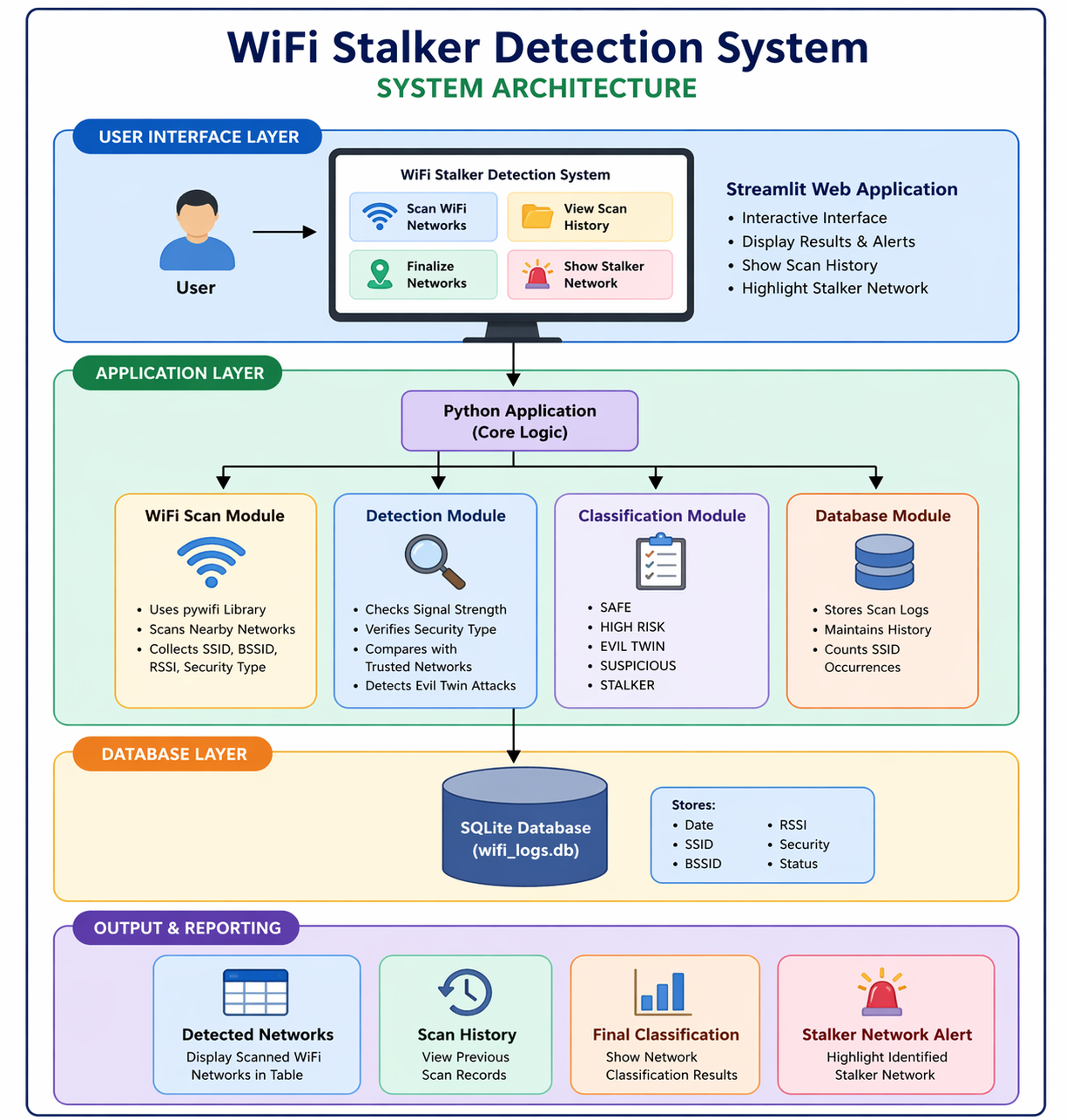

2.2 Description

The WiFi Stalker Detection System is a security-based application that monitors nearby wireless networks and identifies suspicious or potentially harmful networks. The system scans available WiFi networks using the pywifi library and collects important parameters such as SSID, BSSID, signal strength (RSSI), and security type.
The collected data is analyzed using predefined rules. Trusted networks are compared using their SSID and BSSID to detect impersonation (Evil Twin attacks). Networks with strong signal strength but weak or no security are marked as high risk.
All scanned data is stored in a SQLite database, which helps track the frequency of network appearances. Based on this historical data, networks are classified as safe, suspicious, or stalker.The system provides a user-friendly interface using Streamlit to display detected networks, scan history, final classification, and alerts for stalker networks.
The RSA algorithm plays an important role in securing communication within a WiFi stalker detection system. Although the given implementation mainly focuses on rule-based detection of suspicious networks, RSA can be integrated to enhance data security and prevent tampering.
In such a system, RSA is used to encrypt sensitive information such as detected network logs, device identities, and communication between modules. When the system scans WiFi networks and stores logs in the database, RSA ensures that this data cannot be accessed or modified by unauthorized users. A public key is used to encrypt the data before storage or transmission, while a private key is used to decrypt it when required.
Additionally, RSA helps in authentication by verifying whether the detected WiFi access point is legitimate. For example, trusted networks can be assigned digital signatures, and any mismatch during verification can indicate a potential “evil twin” attack. This prevents attackers from impersonating genuine networks.
Thus, RSA strengthens the WiFi stalker detection system by ensuring confidentiality, integrity, and authentication of network data.
The RSA algorithm is a widely used public-key cryptographic technique that ensures secure data transmission. It uses two keys: a public key for encryption and a private key for decryption.
The algorithm is based on the mathematical difficulty of factoring large prime numbers, making it highly secure. RSA is commonly used for encryption, digital signatures, and authentication.
In networking systems, it helps protect sensitive data from unauthorized access. By encrypting information before transmission or storage, RSA ensures confidentiality and data integrity, making it a crucial component in modern cybersecurity applications.

Database view:
RSA algorithm is used to encrypt and decrypt the SSID,BSSID and stores the them in encrypted format in the wifi_logs.db.
Snippet of wifi_logs.db:

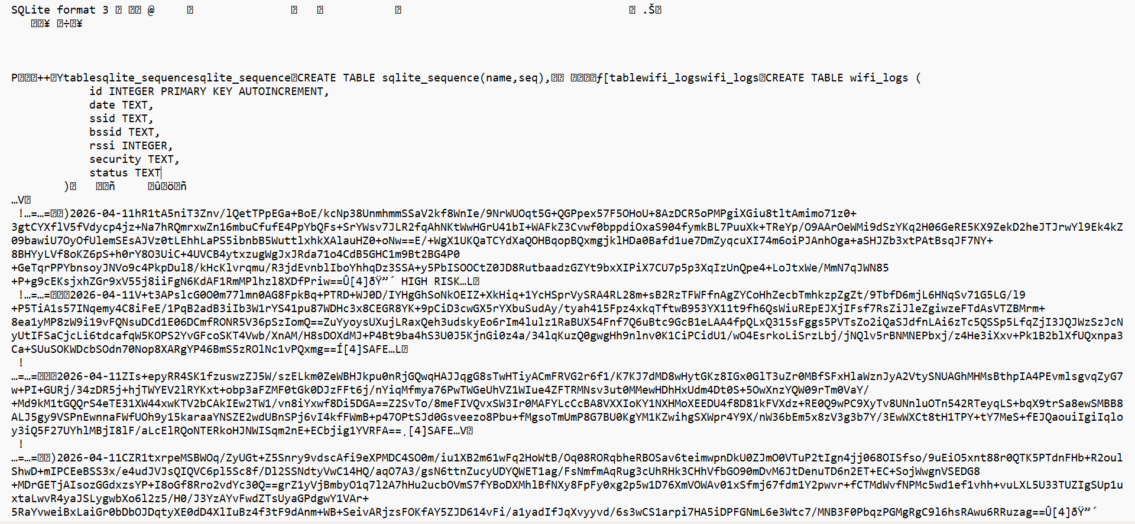

Rule Based detection System:
Rule-based detection system is a method where predefined rules are used to identify suspicious or malicious activities. In the WiFi stalker detection system, rules are applied based on factors such as signal strength (RSSI), security type, SSID, and BSSID. For example, a strong signal with no encryption is marked as high risk, and mismatched BSSID for trusted networks indicates an evil twin attack. Additionally, repeated detection of the same SSID increases its suspicion level. This approach is simple, efficient, and easy to implement, but it depends heavily on predefined conditions and may not detect unknown or evolving
threats.

2.3 ALGORITHM:

Step 1: Start
Step 2: Initialize database (wifi_logs.db)
Step 3: Define trusted networks (SSID + BSSID)
Step 4: Scan nearby WiFi networks using pywifi
Step 5: For each detected network:
a. Get SSID, BSSID, RSSI, Security type
b. If SSID is empty → Skip
Step 6: Detect network status:
a. If SSID in trusted list:
If BSSID matches → SAFE (TRUSTED)
Else → EVIL TWIN
b. Else if (RSSI >= threshold AND not secure):
→ HIGH RISK
c. Else:
→ SAFE
Step 7: Store network details in database
Step 8: Repeat scan for multiple entries
Step 9: Perform final classification:
a. Count occurrences of each SSID
b. If count ≥ 5 → STALKER
c. Else if count ≥ 3 → SUSPICIOUS
d. Else → SAFE
Step 10: Display results to user:
- Detected networks
- Scan history
- Final classification
- Stalker network (if any)
Step 11: Stop

Working Process of RSA:
- Key Generation
  - The system generates two keys: a public key and a private key.
  - Public key is shared,private key is kept secret.
- Encryption of Data
  - When WiFi networks are scanned, details (SSID, BSSID, RSSI, status) are encrypted using the public key.
  - This protects logs stored in the SQLite database.
- Secure Storage
  - Encrypted data is stored in the database (wifi_logs.db).
  - Even if the database is accessed, the data remains unreadable.
- Decryption for Analysis
  - When retrieving records, the private key is used to decrypt data.
  - The system can then analyze and display results.
- Authentication of Networks
  - Trusted networks can have digitally signed identifiers.
  - RSA verifies these signatures to detect fake access points (evil twin attacks).
- Integration with Detection Logic
  - After decryption, your rule-based logic (signal strength, security, frequency count) classifies networks as safe, suspicious, or stalker.

3. IMPLEMENTION

- UI Creation
- Built using Streamlit for interactive interface.
- Database Setup
- SQLite used to store WiFi scan data.
- WiFi Scanning
- Networks scanned using pywifi (SSID, BSSID, signal, security).
- Detection Logic
- Classifies networks as safe, high risk, or evil twin.
- Data Storage
- Scan results saved in database with timestamp.
- Display Results
- Networks shown in table format.
- Final Classification
- Based on repeated detection:
  - Safe
  - Suspicious
  - Stalker
- Stalker Detection
- Displays networks marked as stalker.

Source code:
import streamlit as st
import pywifi
import sqlite3
import time
from datetime import datetime
# ================= CONFIG =================
TRUSTED_NETWORKS = {
"Home_WiFi": "00:11:22:33:44:55",
"College_WiFi": "AA:BB:CC:DD:EE:FF"
}
STRONG_SIGNAL_THRESHOLD = -50
DB_NAME = "wifi_logs.db"
# ================= DATABASE =================
def init_db():
conn = sqlite3.connect(DB_NAME)
cursor = conn.cursor()
cursor.execute("""
CREATE TABLE IF NOT EXISTS wifi_logs (
id INTEGER PRIMARY KEY AUTOINCREMENT,
date TEXT,
ssid TEXT,
bssid TEXT,
rssi INTEGER,
security TEXT,
status TEXT
)
""")
conn.commit()
conn.close()
def insert_log(ssid, bssid, rssi, security, status):
conn = sqlite3.connect(DB_NAME)
cursor = conn.cursor()
cursor.execute("""
INSERT INTO wifi_logs (date, ssid, bssid, rssi, security, status)
VALUES (?, ?, ?, ?, ?, ?)
""", (
datetime.now().date(),
ssid,
bssid,
rssi,
security,
status
))
conn.commit()
conn.close()
def get_all_records():
conn = sqlite3.connect(DB_NAME)
cursor = conn.cursor()
cursor.execute("SELECT * FROM wifi_logs")
rows = cursor.fetchall()
conn.close()
return rows
# ================= DETECTION =================
def detect_network(ssid, rssi, security, bssid):
strong = rssi >= STRONG_SIGNAL_THRESHOLD
is_secure = "WPA" in security.upper()
if ssid in TRUSTED_NETWORKS:
if bssid == TRUSTED_NETWORKS[ssid]:
return "SAFE (TRUSTED)"
else:
return "EVIL TWIN"
if strong and not is_secure:
return "HIGH RISK"
return "SAFE"
# ================= FINALIZATION =================
def finalize_networks():
rows = get_all_records()
ssid_count = {}
for row in rows:
ssid = row[2]
ssid_count[ssid] = ssid_count.get(ssid, 0) + 1
results = {}
for ssid, count in ssid_count.items():
if count >= 5:
results[ssid] = "STALKER"
elif count >= 3:
results[ssid] = "SUSPICIOUS"
else:
results[ssid] = "SAFE"
return results
def get_stalker_network():
results = finalize_networks()
stalkers = [ssid for ssid, status in results.items() if "STALKER" in status]

if not stalkers:
return None
return stalkers[0]
# ================= WIFI SCAN =================
def scan_wifi():
wifi = pywifi.PyWiFi()
iface = wifi.interfaces()[0]
iface.scan()
time.sleep(3)
results = iface.scan_results()
data = []
for net in results:
ssid = net.ssid
bssid = net.bssid
rssi = net.signal
security = str(net.akm)
if ssid == "":
continue
status = detect_network(ssid, rssi, security, bssid)
insert_log(ssid, bssid, rssi, security, status)
data.append((ssid, bssid, rssi, status))
return data
# ================= STREAMLIT UI =================
st.set_page_config(page_title="WiFi Stalker Detector", layout="wide")
st.markdown(
"<h1 style='text-align: center;'>📡 WiFi Stalker Detection System</h1>",
unsafe_allow_html=True
)
init_db()
# Scan Button
if st.button("🔍 Scan WiFi Networks"):
with st.spinner("Scanning..."):
data = scan_wifi()
st.success("Scan Complete!")
st.subheader("📶 Detected Networks")
st.table(data)
# Show History
if st.button("📂 View Scan History"):
rows = get_all_records()
st.subheader("📊 History")
st.table(rows)

# Finalize Networks
if st.button("📌 Finalize Networks"):
results = finalize_networks()
st.subheader("📊 Final Classification")
for ssid, status in results.items():
st.write(f"{ssid} → {status}")
# Show Stalker
if st.button("🚨 Show Stalker Network"):
stalker = get_stalker_network()
if not stalker:
st.markdown(
"<h3 style='text-align: center;'>No STALKER network detected</h3>",
unsafe_allow_html=True
)
else:
st.markdown(
f"<h2 style='text-align: center; color: red;'>🚨 STALKER NETWORK: {stalker}</h2>",
unsafe_allow_html=True
)

The GUI version of code:

import tkinter as tk
from tkinter import ttk, messagebox
import pywifi
import sqlite3
import time
from datetime import datetime

# ================= RSA =================
from Crypto.PublicKey import RSA
from Crypto.Cipher import PKCS1_OAEP
import base64

key = RSA.generate(2048)
public_key = key.publickey()
private_key = key

cipher_encrypt = PKCS1_OAEP.new(public_key)
cipher_decrypt = PKCS1_OAEP.new(private_key)

def encrypt_data(data):
return base64.b64encode(cipher_encrypt.encrypt(data.encode())).decode()

def decrypt_data(data):
try:
return cipher_decrypt.decrypt(base64.b64decode(data)).decode()
except:
return data

# ================= CONFIG =================

TRUSTED_NETWORKS = {
"Home_WiFi": "00:11:22:33:44:55",
"College_WiFi": "AA:BB:CC:DD:EE:FF"
}

STRONG_SIGNAL_THRESHOLD = -50
DB_NAME = "wifi_logs.db"

# ================= DATABASE =================

def init_db():
conn = sqlite3.connect(DB_NAME)
cursor = conn.cursor()

cursor.execute("""
CREATE TABLE IF NOT EXISTS wifi_logs (
id INTEGER PRIMARY KEY AUTOINCREMENT,
date TEXT,
ssid TEXT,
bssid TEXT,
rssi INTEGER,
security TEXT,
status TEXT
)
""")

conn.commit()
conn.close()

def insert_log(ssid, bssid, rssi, security, status):
conn = sqlite3.connect(DB_NAME)
cursor = conn.cursor()

cursor.execute("""
INSERT INTO wifi_logs (date, ssid, bssid, rssi, security, status)
VALUES (?, ?, ?, ?, ?, ?)
""", (
datetime.now().date(),
encrypt_data(ssid),
encrypt_data(bssid),
rssi,
security,
status
))

conn.commit()
conn.close()

def get_all_records():
conn = sqlite3.connect(DB_NAME)
cursor = conn.cursor()
cursor.execute("SELECT * FROM wifi_logs")
rows = cursor.fetchall()
conn.close()
return rows

# ================= DETECTION =================

def detect_network(ssid, rssi, security, bssid):

strong = rssi >= STRONG_SIGNAL_THRESHOLD
is_secure = "WPA" in security.upper()

if ssid in TRUSTED_NETWORKS:
if bssid == TRUSTED_NETWORKS[ssid]:
return "SAFE (TRUSTED)"
else:
return "⚠️ EVIL TWIN"

if strong and not is_secure:
return "🔴 HIGH RISK"

return "SAFE"

# ================= FINALIZATION =================

def finalize_networks():
rows = get_all_records()
ssid_count = {}

for row in rows:
ssid = decrypt_data(row[2])
ssid_count[ssid] = ssid_count.get(ssid, 0) + 1

results = {}

for ssid, count in ssid_count.items():
if count >= 5:
results[ssid] = "🚨 STALKER"
elif count >= 3:
results[ssid] = "⚠️ SUSPICIOUS"
else:
results[ssid] = "✅ SAFE"

return results

# ================= GET STALKER =================

def get_stalker_network():
results = finalize_networks()
stalkers = [ssid for ssid, status in results.items() if "STALKER" in status]

if not stalkers:
return None

return stalkers[0]

# ================= WIFI SCAN =================

def scan_wifi():
try:
wifi = pywifi.PyWiFi()
iface = wifi.interfaces()[0]

iface.scan()
time.sleep(3)
results = iface.scan_results()

tree.delete(*tree.get_children())

for net in results:
ssid = net.ssid
bssid = net.bssid
rssi = net.signal
security = str(net.akm)

if ssid == "":
continue

status = detect_network(ssid, rssi, security, bssid)
insert_log(ssid, bssid, rssi, security, status)

tag = "red" if "HIGH" in status or "EVIL" in status else "green"
tree.insert("", "end", values=(ssid, bssid, rssi, status), tags=(tag,))

messagebox.showinfo("Scan Complete", "WiFi scan finished!")

except Exception as e:
messagebox.showerror("Error", str(e))

# ================= HISTORY =================

def show_history():
history_window = tk.Toplevel(root)
history_window.title("Scan History")
history_window.geometry("900x400")

columns = ("id", "date", "ssid", "bssid", "rssi", "status")
history_tree = ttk.Treeview(history_window, columns=columns, show="headings")
history_tree.pack(fill="both", expand=True)

for col in columns:
history_tree.heading(col, text=col.upper())

def load_data():
history_tree.delete(*history_tree.get_children())
rows = get_all_records()

for row in rows:
history_tree.insert("", "end", values=(
row[0],
row[1],
decrypt_data(row[2]),
decrypt_data(row[3]),
row[4],
row[6]
))

def delete_selected():
selected = history_tree.selection()
if not selected:
messagebox.showwarning("Warning", "Select a record")
return

record_id = history_tree.item(selected)["values"][0]

conn = sqlite3.connect(DB_NAME)
cursor = conn.cursor()
cursor.execute("DELETE FROM wifi_logs WHERE id=?", (record_id,))
conn.commit()
conn.close()

load_data()

def show_finalized():
results = finalize_networks()

result_window = tk.Toplevel(root)
result_window.title("Final Classification")

for ssid, status in results.items():
tk.Label(result_window, text=f"{ssid} → {status}",
font=("Arial", 12)).pack()

def show_stalker():
stalker = get_stalker_network()

if not stalker:
messagebox.showinfo("Result", "No STALKER network found")
return

messagebox.showwarning(
"🚨 STALKER NETWORK DETECTED",
f"Network: {stalker}\n\nThis network is finalized as STALKER."
)

tk.Button(history_window, text="Delete Selected", bg="red", fg="white",
command=delete_selected).pack(pady=5)

tk.Button(history_window, text="Finalize Networks", bg="purple", fg="white",
command=show_finalized).pack(pady=5)

tk.Button(history_window, text="Show Stalker Network", bg="black", fg="white",
command=show_stalker).pack(pady=5)

load_data()

# ================= GUI =================

root = tk.Tk()
root.title("WiFi Stalker Detector (CNS Project)")
root.geometry("900x500")

tk.Label(root, text="WiFi Stalker Detection System", font=("Arial", 16)).pack(pady=10)

tk.Button(root, text="Scan WiFi", command=scan_wifi, bg="green", fg="white").pack(pady=5)
tk.Button(root, text="View History", command=show_history, bg="blue", fg="white").pack(pady=5)

columns = ("ssid", "bssid", "rssi", "status")
tree = ttk.Treeview(root, columns=columns, show="headings")
tree.pack(fill="both", expand=True)

for col in columns:
tree.heading(col, text=col.upper())

tree.tag_configure("red", background="red")
tree.tag_configure("green", background="lightgreen")

init_db()
root.mainloop()

4.RESULTS

4.1 Output Screens:
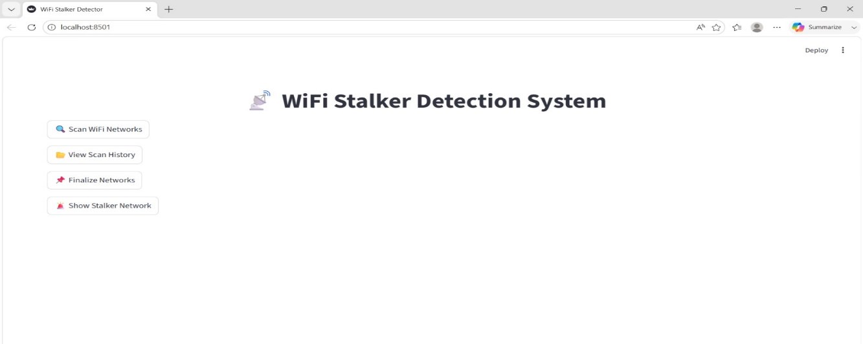

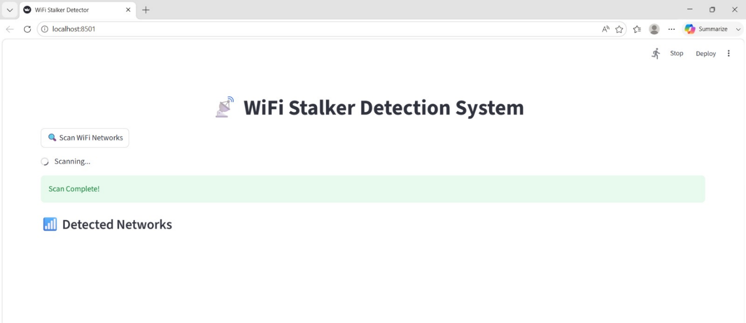
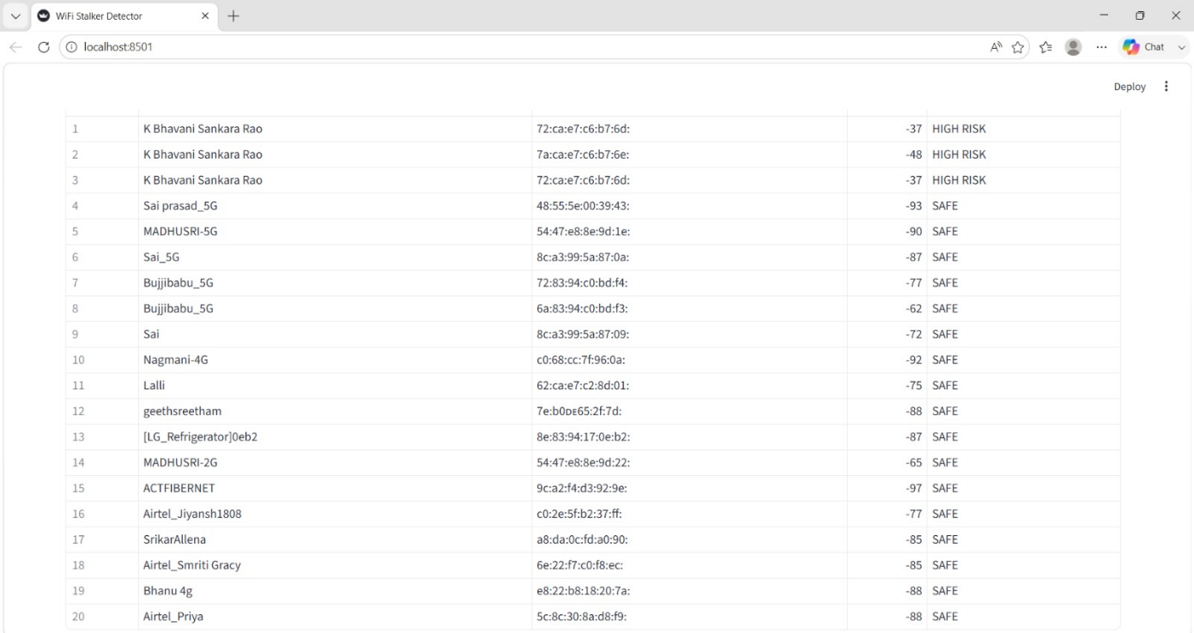

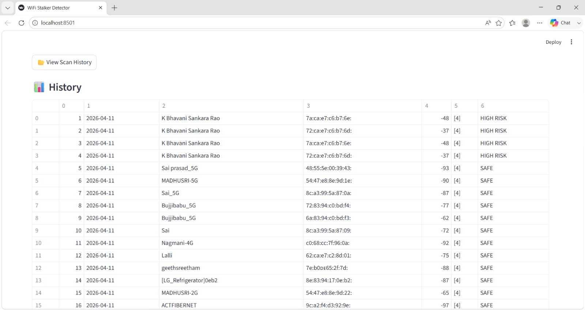

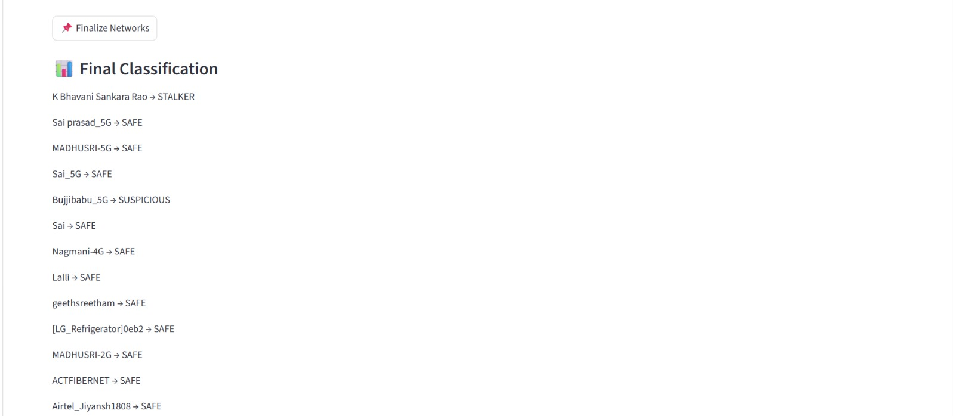

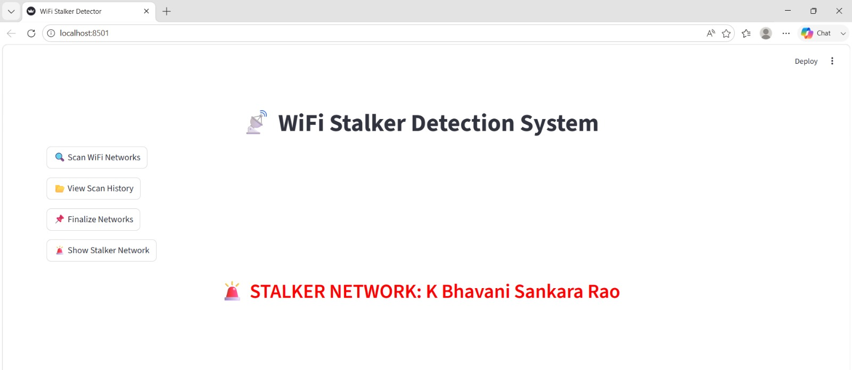

GUI Version Output Screens:

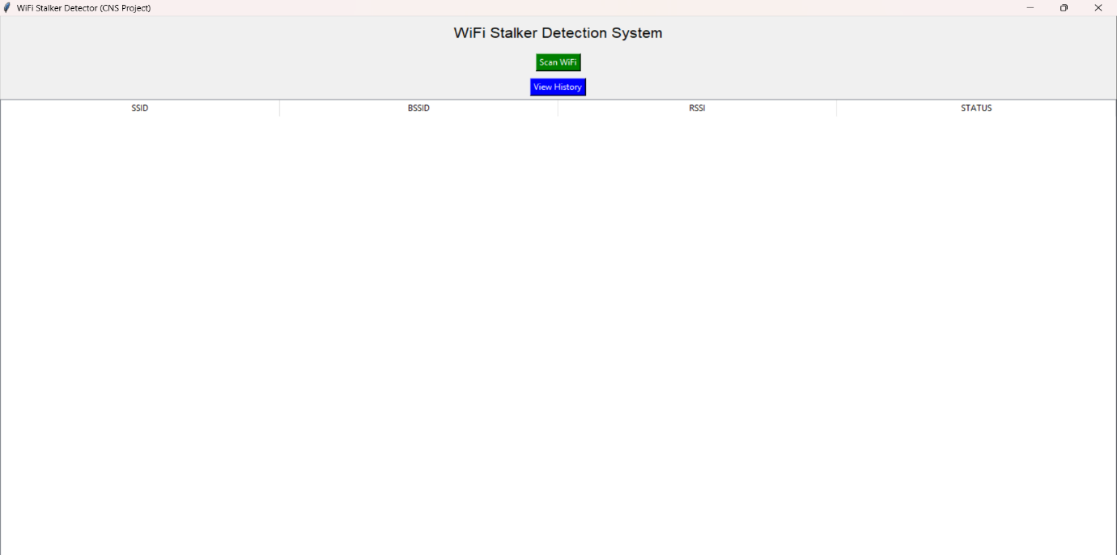

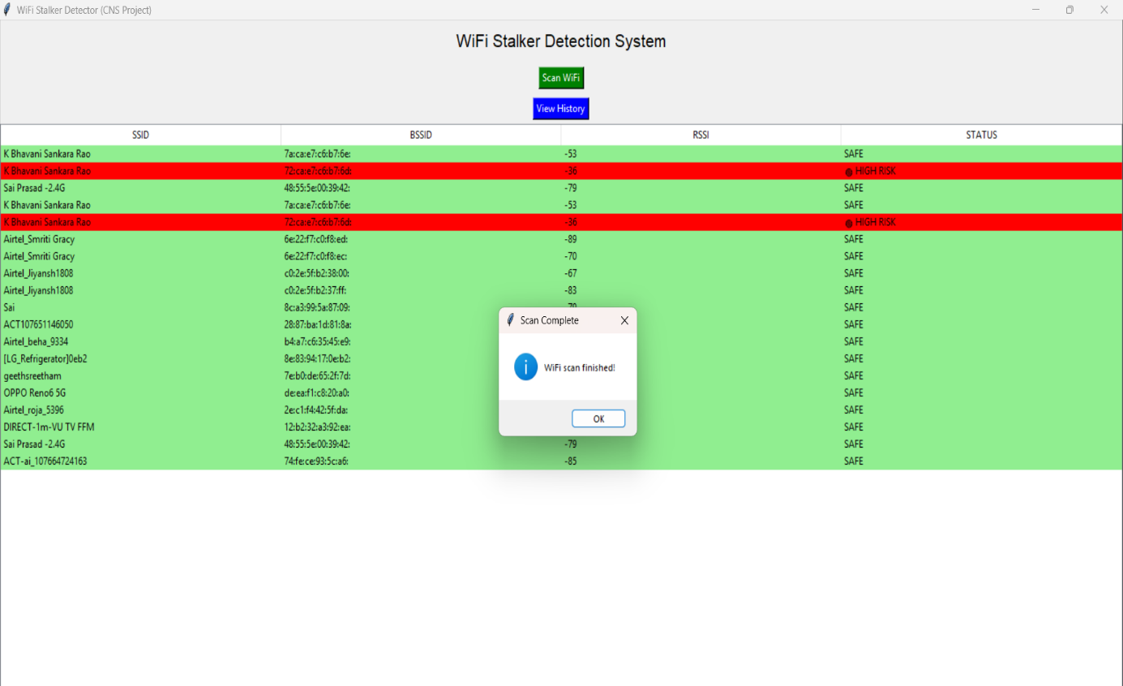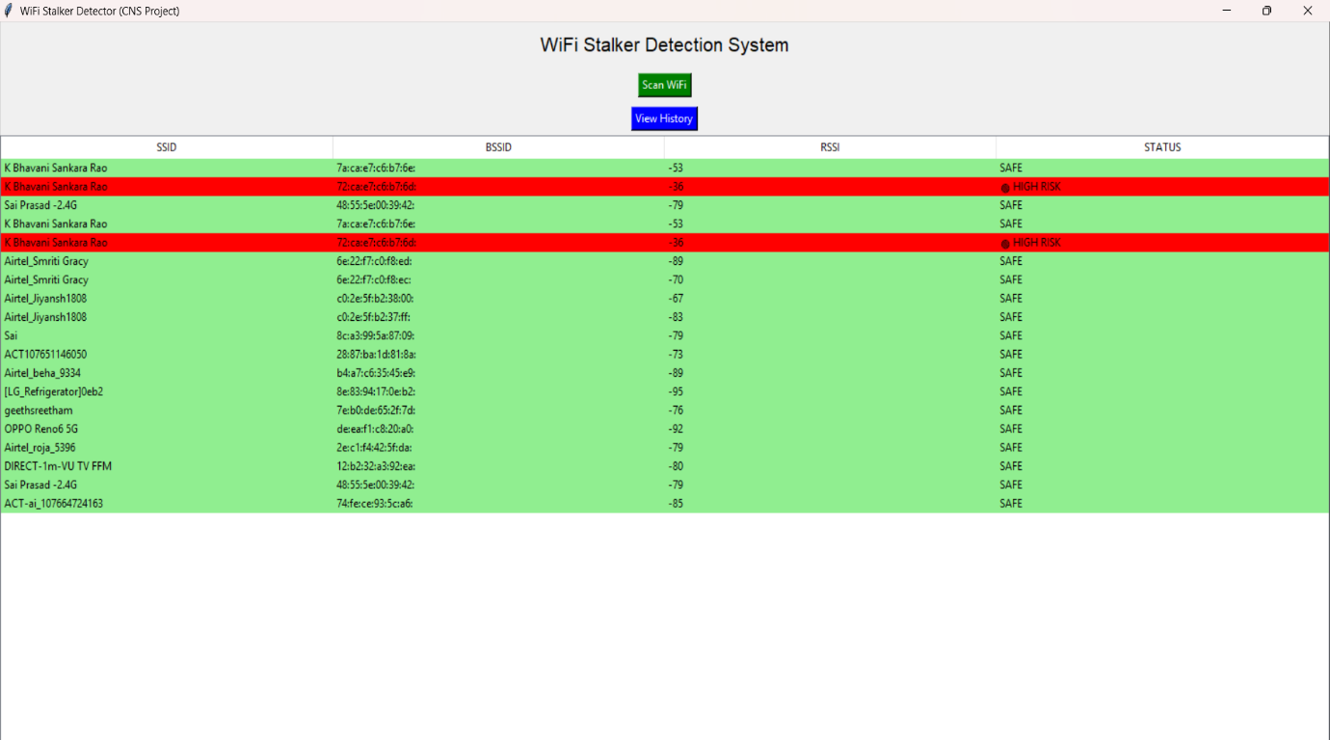

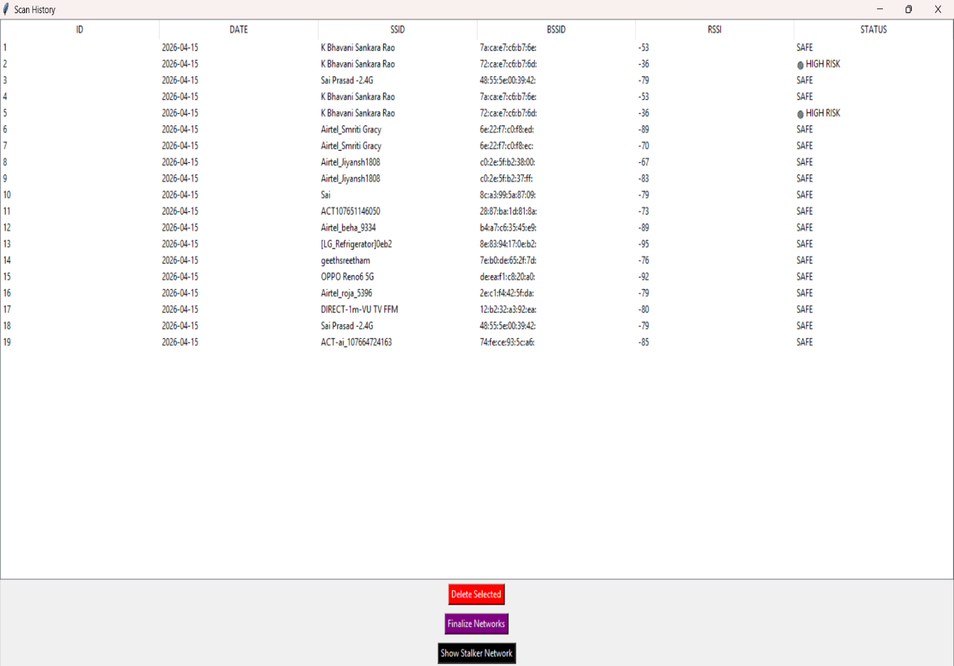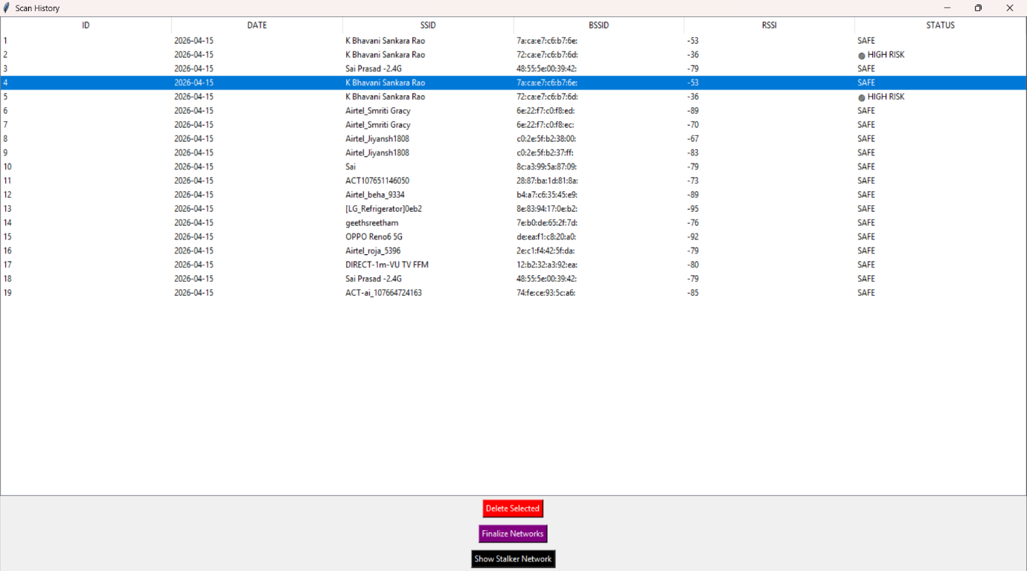

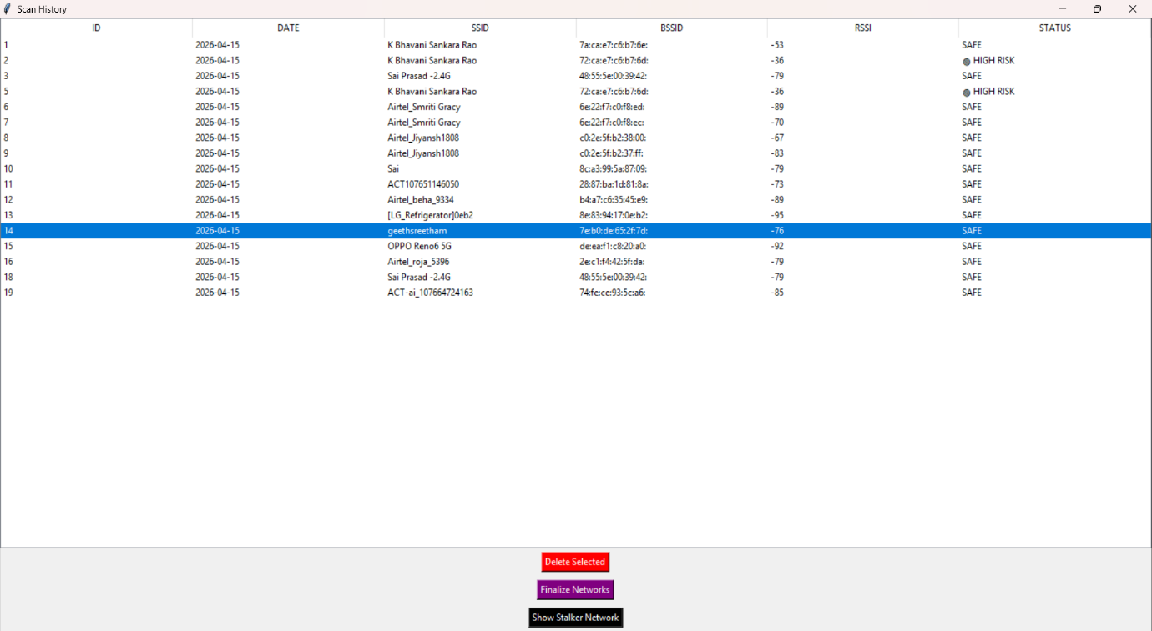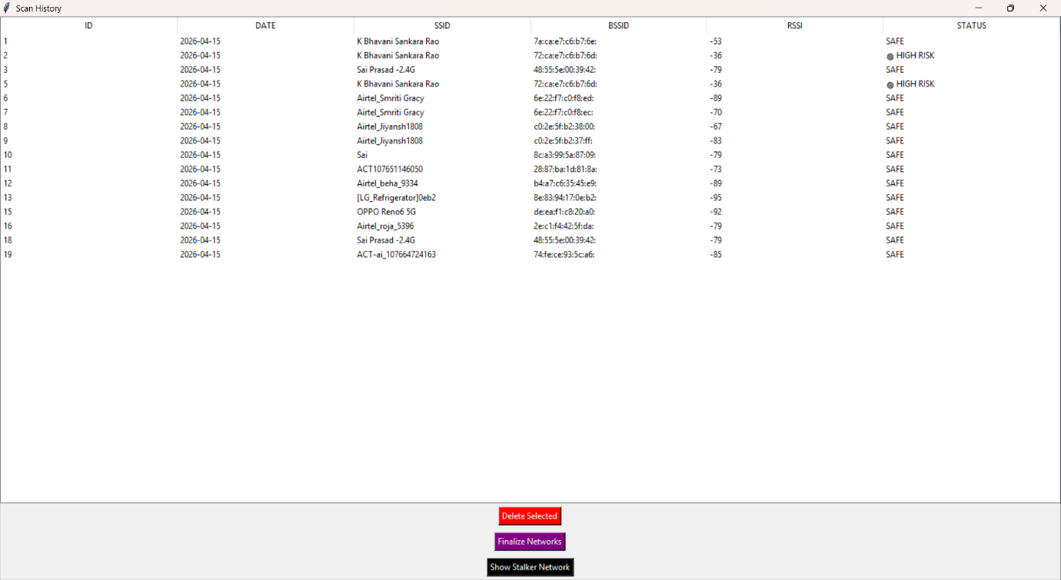

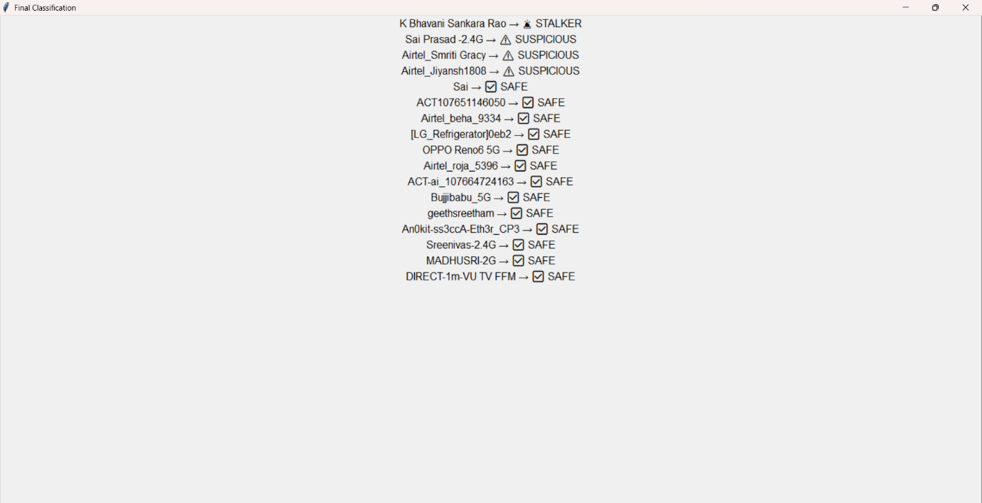
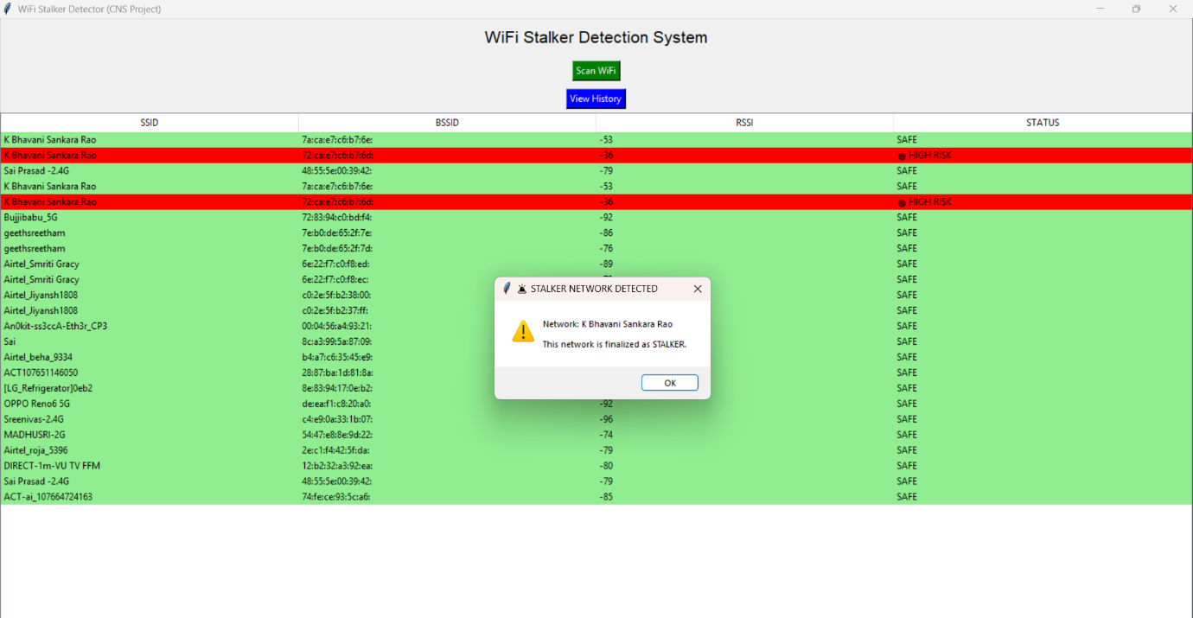

5.CONCLUSION

The WiFi Stalker Detection System successfully provides a simple and effective solution for identifying suspicious wireless networks. By combining real-time WiFi scanning with historical data analysis, the system is able to detect potential threats such as high-risk networks, evil twin attacks, and frequently appearing stalker networks.

The use of Python, along with libraries like pywifi and Streamlit, makes the system user-friendly and efficient. The integration of an SQLite database helps in maintaining scan history and improves the accuracy of classification over time. The system’s ability to categorize networks into safe, suspicious, and stalker enhances user awareness and supports better decision-making while connecting to WiFi networks.

Overall, this project demonstrates how basic network parameters can be effectively used to improve wireless security. It serves as a useful tool for monitoring WiFi environments and can be further enhanced with advanced techniques such as machine learning and real-time alert systems.

6.FUTURE SCOPE

The WiFi Stalker Detection System can be further enhanced by incorporating advanced technologies to improve its efficiency and accuracy. In the future, machine learning algorithms can be integrated to automatically learn network behavior patterns and provide more intelligent and dynamic detection of suspicious networks instead of relying on fixed rules. The system can also be extended to provide real-time alerts through mobile notifications, emails, or sound alerts to immediately inform users about potential threats. Developing a mobile application version of the system would increase accessibility and allow users to monitor WiFi networks on the go.

Additionally, GPS integration can be used to track the location and movement of suspicious networks, helping to identify stalker patterns more effectively. The system can also be improved by including advanced security features such as packet analysis to detect complex attacks like man-in-the-middle attacks. Cloud integration would enable centralized data storage, remote access, and large-scale analysis across multiple devices. Furthermore, adding user authentication and graphical data visualization features would enhance security and provide better insights into network activity. Overall, these enhancements can make the system more robust, intelligent, and suitable for real-world applications.
7.REFERENCES

- Python Software Foundation, Python Documentation. Available: https://docs.python.org/3/
- Streamlit Inc., Streamlit Documentation. Available: https://docs.streamlit.io/
- PyWiFi Library Documentation, PyWiFi – Wireless Interface Library for Python. Available: https://pypi.org/project/pywifi/
- SQLite Documentation, SQLite Database Engine. Available: https://www.sqlite.org/docs.html
- Computer Networks, Prentice Hall

