SECURE WATERMARK VERIFICATION SYSTEM

A PROJECT REPORT SUBMITTED IN FULFILMENT OF THE REQUIREMENTS FOR THE AWARD OF THE DEGREE OF

BACHELOR OF TECHNOLOGY IN COMPUTER SCIENCE AND ENGINEERING

By

Batch – B4

Gollu Pushpa (323103210072) G. Thrisha (323103210076)
Giddi Vasavi (323103210071) G. Prasanthi (323103210077)

Under the esteemed guidance of
Dr. N. Sharmili
Professor CSE Department

Department of Computer Science and Engineering

GAYATRI VIDYA PARISHAD COLLEGE OF ENGINEERING FOR WOMEN
[Approved by AICTE NEW DELHI, Affiliated to Andhra University, Visakhapatnam]
[Accredited by National Board of Accreditation (NBA) for B. Tech. CSE, ECE & IT – valid from 2019-22 and 2022-25] [Accredited by National Assessment and Accreditation Council (NAAC) with A Grade-Valid from 2022-2027]
Kommadi, Madhurawada, Visakhapatnam – 530048
2023 – 2027

GAYATRI VIDYA PARISHAD COLLEGE OF ENGINEERING FOR WOMEN

DEPARTMENT OF COMPUTER SCIENCE AND ENGINEERING



CERTIFICATE
This is to certify that the Project report titled “Secure Watermark Verification System” is a bonafide work of following III B.Tech. students in the Department of Computer Science and Engineering, Gayatri Vidya Parishad College of Engineering for Women, affiliated with Andhra University, Visakhapatnam. This project was done as a part of Cryptography and Network Security lab during the academic year 2025-26 (III Year Semester-2)

Gollu Pushpa (323103210072) G. Thrisha (323103210076)
Giddi Vasavi (323103210071) G. Prasanthi (323103210077)

Signature of the Guide Signature of the HOD
Dr. N. Sharmili MTech., Ph.D. Dr. P. V. S. L. Jagadamba MTech, Ph.D
Professor, Professor,
Dept. of CSE Dept. of CSE

External Examiner

ABSTRACT

This project presents a Secure Watermark Verification System designed to ensure the authenticity and integrity of digital images and PDF documents. The system integrates cryptographic hashing and steganography techniques to protect digital content from unauthorized modification and forgery.

When a user uploads a file along with ownership details and a secret key, the system generates a unique digital signature using the SHA-256 hashing algorithm. For image files, watermark information is embedded using Least Significant Bit (LSB) steganography, ensuring that hidden data remains imperceptible while securely linked to the original content. Additionally, a visible watermark is applied to strengthen ownership identification. For PDF documents, watermark data is securely stored within the document metadata, preserving the visual structure of the file.

During verification, the system extracts the embedded or stored watermark, regenerates the hash using the provided secret key, and compares it with the original signature. A successful match confirms the file’s authenticity, while any mismatch indicates tampering or data alteration.

The system is implemented using Streamlit to provide an intuitive user interface, along with supporting libraries for image and PDF processing. This solution offers a reliable, efficient, and user-friendly approach for safeguarding digital assets, making it suitable for applications requiring secure content verification and ownership protection.

1.SYSTEM REQUIREMENTS

  - Software Requirements

Table 1. Software Requirements

Software | Version / Specification
Python | 3.x
Visual Studio Code Editor | Latest
Operating System | Windows/Linux

Python packages
Python packages we used in our project includes the following table 2.
We used the command pip install “package_name==version” to download the packages.

Table 2. Python packages

S.No. | Package Used | Description
1. | NumPy | Array and Matrix Operation
2. | OpenCV | Image Processing
3. | Scikit-image | Advanced Image Processing
4. | Pillow | Image Manipulation
5. | Matplotlib | Visualization
6. | OS | File Handling
7. | JSON | Data storage
8. | Cryptography/ PyCrypto | Secure Watermark Encryption

Front End Packages used

Table 3. Front end Packages

S.NO | Libraries Used | Description
1. | Stream lit | UI for Watermark
2. | Tkinter | GUI interface
3. | Virtual env | Environment Management
4. | OS | File Operations

1.2 Hardware Requirements

The below Table 4 shows the minimum hardware requirements of our project.

Minimum Hardware Requirements:

Table 4. Minimum Hardware Requirements

S.No | Hardware Component | Specification
1. | Processor | Intel i3 or above
2. | RAM | 4 GB Minimum
3. | Hard Disk | 500 GB
4. | System Type | 64-bit
5. | Monitor | Standard Display
6. | Input Devices | Keyboard, Mouse

- METHODOLOGY

  - SYSTEM ARCHITECTURE

The proposed Secure Watermark Verification System follows a client-based interactive architecture implemented using the Streamlit framework. The system is divided into two primary modules: the Watermark Generation Module and the Watermark Verification Module, supported by components such as cryptographic hashing, image steganography, and PDF metadata processing.
- The Generation Module is responsible for embedding both visible and hidden watermarks into images and PDFs.
- The Verification Module extracts and validates the hidden watermark to check authenticity.
- Supporting components include:
  - Hash generation using SHA-256
  - Data hiding using LSB Steganography
  - PDF metadata handling using PyPDF2

  - DESCRIPTION, ALGORITHM

System Description
The Secure Watermark Verification System is designed to ensure the authenticity and integrity of digital images and PDF documents using cryptographic techniques and steganography.
The system operates in two main phases:
The original content of the PDF remains unchanged

1. Watermark Generation Phase (User Input and System Processing)

In this phase, the user uploads a file (image or PDF), enters the owner name, and provides a secret key. The system processes the file as follows:
- The uploaded file is read and processed.
- A secure hash is generated using the SHA-256 algorithm by combining the fixed watermark text and the secret key.
- A digital signature is created from this hash.
For image files:
- A visible watermark (“Created by You”) is added to the image.
- Hidden watermark data (owner name and signature) is embedded using LSB steganography.
- Pixel positions are randomized using the secret key to enhance security.
- The final watermarked image is generated and made available for download.

For PDF files:
- The watermark (owner name and signature) is embedded into the PDF metadata.
- The original content of the PDF remains unchanged.
2.Watermark Verification Phase (User Input and System Verification)

In this phase, the user verifies the authenticity of a file:
- The user uploads the watermarked image or PDF along with the secret key.
- The system extracts hidden watermark data:
  - From image pixels using LSB decoding
  - From PDF metadata
- A new hash is generated using the same SHA-256 algorithm.
- The system compares the extracted signature with the newly generated signature.
If both signatures match, the file is considered authentic. Otherwise, it is identified as tampered or verified with an incorrect key.

Algorithm

Step 1: Watermark Signature Generation
- Accept owner name and secret key.
- Define fixed watermark text ("Created by You").
- Combine watermark text and secret key.
- Generate hash using SHA-256.
- Store generated hash as digital signature.

Step 2: Image Watermark Embedding
- Upload image file (PNG/JPG).
- Convert image to RGBA format.
- Create visible watermark layer using text.
- Merge watermark with original image.
- Prepare hidden data:
  - Owner name
  - Digital signature
- Convert hidden data into binary format.
- Generate pixel positions using secret key.
- Embed binary data into least significant bits (LSB) of RGB channels.
- Add termination sequence to mark end of data.
- Save and output watermarked image.

Step 3: PDF Watermark Embedding
- Upload PDF file.
- Read PDF using PyPDF2.
- Copy all pages into new PDF writer.
- Add metadata field:
  - Owner name
  - Digital signature
- Save updated PDF file.

Step 4: Watermark Verification (Image)
- Upload watermarked image.
- Input secret key.
- Generate pixel positions using same key.
- Extract LSB bits from pixels.
- Convert binary data to text.
- Split extracted data into:
  - Owner
  - Signature
- Generate new signature using SHA-256.
- Compare extracted and generated signatures.

Step 5: Watermark Verification (PDF)
- Upload watermarked PDF.
- Input secret key.
- Read metadata from PDF.
- Extract:
  - Owner
  - Signature
- Generate new signature using SHA-256.
- Compare both signatures.

Step 6: Result Decision
- If no watermark found →
Display “No Watermark Found”
- If signature mismatch →
Display “Wrong Key / Tampered File”
- If signature matches →
Display “Authentic File (Owner Verified)”

- IMPLEMENTATION
Source code:

import streamlit as st
from PIL import Image, ImageDraw, ImageFont
import hashlib
import io
import random
from PyPDF2 import PdfReader, PdfWriter

# 🎨 UI STYLE

st.markdown("""
<style>

/* 🌤 Background */
.stApp {
background: linear-gradient(135deg, #dbeafe, #e0f2fe);
}

/* 📦 Card */
.block-container {
background-color: rgba(255,255,255,0.92);
padding: 25px;
border-radius: 15px;
}

/* 🔘 Buttons */
.stButton>button {
border-radius: 12px;
height: 3.2em;
width: 100%;
font-size: 18px;
font-weight: 800;
border: none;
}

/* 🟢 Generate */
button[kind="primary"] {
background-color: #22c55e !important;
color: white;
}

/* 🔵 Verify */
button[kind="secondary"] {
background-color: #0ea5e9 !important;
color: white;
}

/* Hover */
.stButton>button:hover {
transform: scale(1.05);
}

/* Title */
h1 {
text-align: center;
color: #0369a1;
}

</style>
""", unsafe_allow_html=True)

# 🔐 CONFIG

FIXED_WATERMARK = "Created by You"

def sign_watermark(text, key):
return hashlib.sha256((text + key).encode()).hexdigest()

# 🔒 IMAGE LOGIC

def text_to_binary(text):
return ''.join(format(ord(i), '08b') for i in text)

def binary_to_text(binary):
chars = [binary[i:i+8] for i in range(0, len(binary), 8)]
return ''.join(chr(int(char, 2)) for char in chars)

def encode_lsb(image, secret_data, key):
binary_data = text_to_binary(secret_data) + '1111111111111110'
data_index = 0

pixels = image.load()
width, height = image.size

random.seed(key)
positions = [(x, y) for x in range(width) for y in range(height)]
random.shuffle(positions)

for x, y in positions:
r, g, b, a = pixels[x, y]

if data_index < len(binary_data):
r = (r & ~1) | int(binary_data[data_index]); data_index += 1
if data_index < len(binary_data):
g = (g & ~1) | int(binary_data[data_index]); data_index += 1
if data_index < len(binary_data):
b = (b & ~1) | int(binary_data[data_index]); data_index += 1

pixels[x, y] = (r, g, b, a)

if data_index >= len(binary_data):
break

return image

def decode_lsb(image, key):
pixels = image.load()
width, height = image.size

random.seed(key)
positions = [(x, y) for x in range(width) for y in range(height)]
random.shuffle(positions)

binary_data = ""

for x, y in positions:
r, g, b, a = pixels[x, y]
binary_data += str(r & 1) + str(g & 1) + str(b & 1)

end = binary_data.find('1111111111111110')

if end != -1:
return binary_to_text(binary_data[:end])
return None

# 📄 PDF LOGIC

def watermark_pdf(file, owner, key):
reader = PdfReader(file)
writer = PdfWriter()

for page in reader.pages:
writer.add_page(page)

signature = sign_watermark(FIXED_WATERMARK, key)
writer.add_metadata({"/Watermark": f"{owner}|{signature}"})

output = io.BytesIO()
writer.write(output)
output.seek(0)
return output

def verify_pdf(file, key):
reader = PdfReader(file)
metadata = reader.metadata

if metadata and "/Watermark" in metadata:
owner, stored_sig = metadata["/Watermark"].split("|")
new_sig = sign_watermark(FIXED_WATERMARK, key)

if new_sig == stored_sig:
return True, owner
else:
return False, None

return None, None

# 🎯 UI

st.title("🔐 Secure Watermark System")

tab1, tab2 = st.tabs(["🎨 Generate", "🔍 Verify"

# GENERATE

with tab1:
owner = st.text_input("👤 Owner Name")
key = st.text_input("🔑 Secret Key", type="password")
file = st.file_uploader("📂 Upload File", type=["png","jpg","jpeg","pdf"])

if st.button("🚀 GENERATE WATERMARK", type="primary"):

if not (owner and key and file):
st.warning("⚠ Fill all fields")
st.stop()

signature = sign_watermark(FIXED_WATERMARK, key)
secret_data = f"{owner}|{signature}"

file_type = file.name.split(".")[-1].lower()

# IMAGE
if file_type in ["png","jpg","jpeg"]:
image = Image.open(file).convert("RGBA")

txt_layer = Image.new("RGBA", image.size, (255,255,255,0))
draw = ImageDraw.Draw(txt_layer)
font = ImageFont.load_default()

draw.text((20,20), FIXED_WATERMARK, fill=(255,255,255,128), font=font)

watermarked = Image.alpha_composite(image, txt_layer)
watermarked = encode_lsb(watermarked, secret_data, key)

st.image(watermarked)

buf = io.BytesIO()
watermarked.save(buf, format="PNG")

st.download_button(
"⬇ Download Image",
buf.getvalue(),
file_name="secure.png",
mime="image/png"
)

# PDF
elif file_type == "pdf":
output = watermark_pdf(file, owner, key)

st.download_button(
"⬇ Download PDF",
output,
file_name="secure.pdf",
mime="application/pdf"
)
# VERIFY
with tab2:
key = st.text_input("🔑 Enter Secret Key", type="password", key="verify_key")
file = st.file_uploader("📂 Upload File", type=["png","pdf"])

if st.button("🔍 VERIFY FILE", type="secondary"):

if not (key and file):
st.warning("⚠ Enter key and upload file")
st.stop()

file_type = file.name.split(".")[-1].lower()

# IMAGE VERIFY
if file_type == "png":
image = Image.open(file).convert("RGBA")
data = decode_lsb(image, key)

if data:
parts = data.split("|")

if len(parts) == 2:
owner, sig = parts

if sig == sign_watermark(FIXED_WATERMARK, key):
st.success(f"✅ Authentic Image (Owner: {owner})")
else:
st.error("❌ Wrong Key / Tampered Image")
else:
st.error("❌ Invalid Data")
else:
st.error("❌ No Watermark Found")

# PDF VERIFY
elif file_type == "pdf":
valid, owner = verify_pdf(file, key)

if valid:
st.success(f"✅ Authentic PDF (Owner: {owner})")
elif valid is False:
st.error("❌ Wrong Key / Tampered PDF")
else:
st.error("❌ No Watermark Found")
- RESULTS

Output Screens

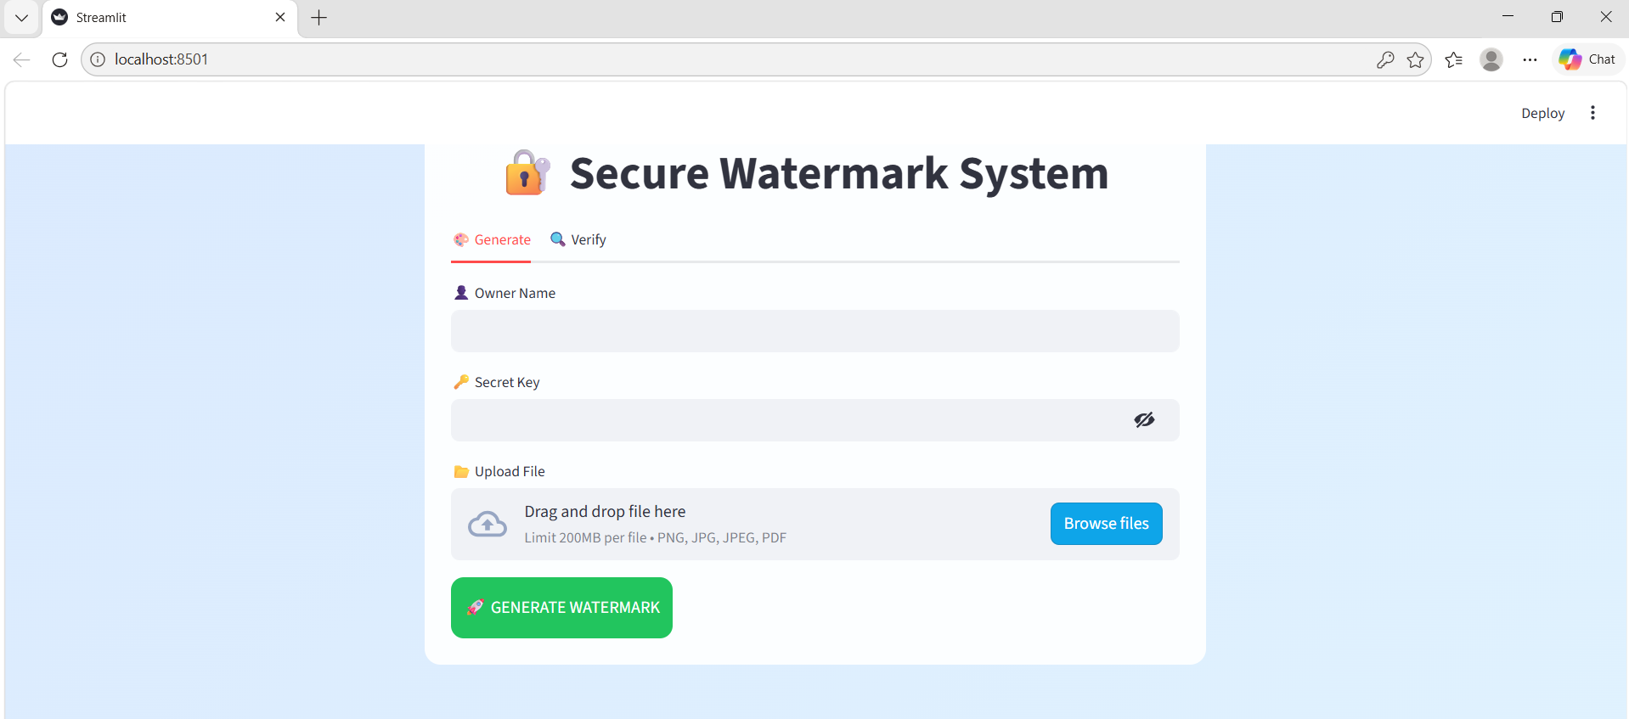

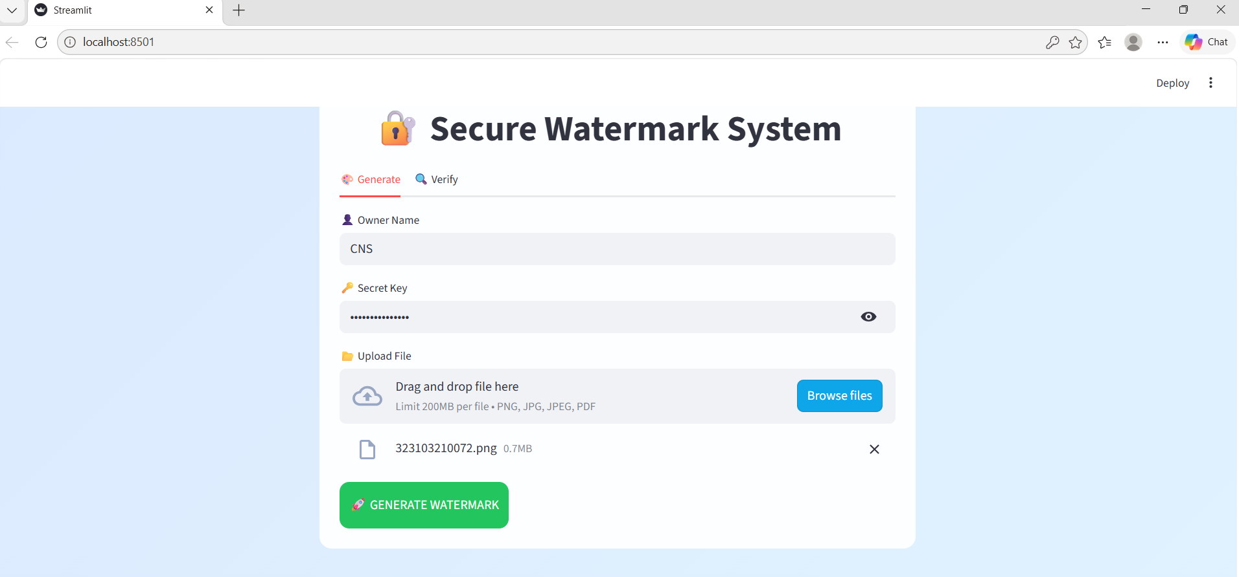



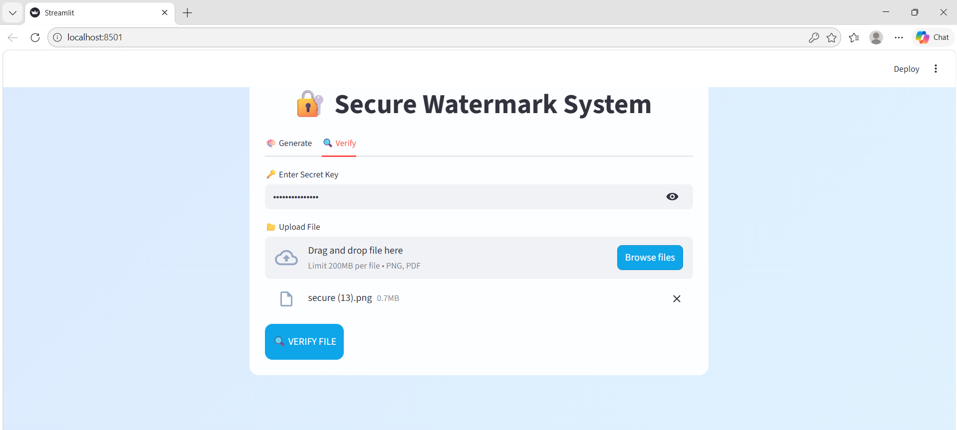

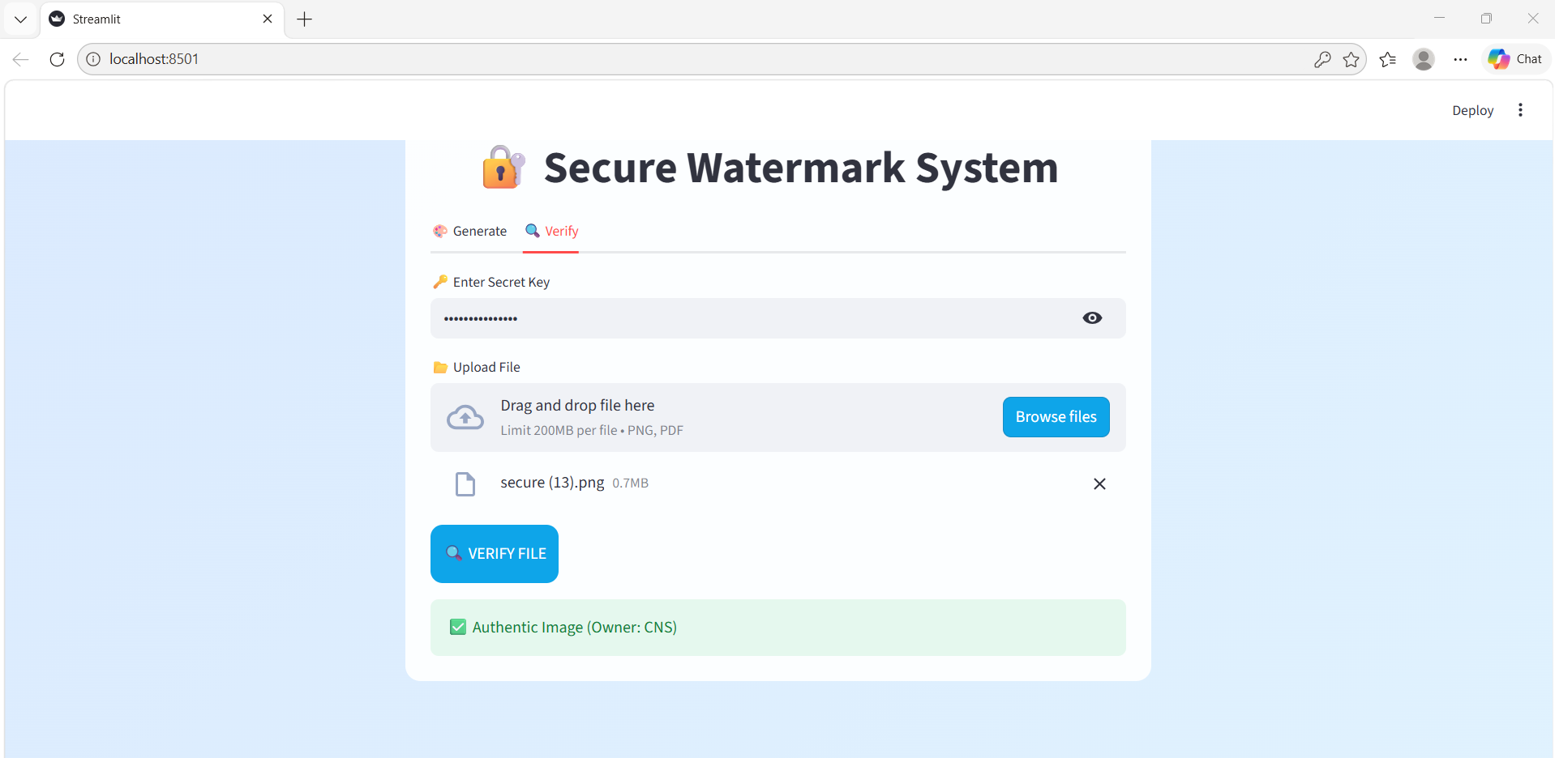

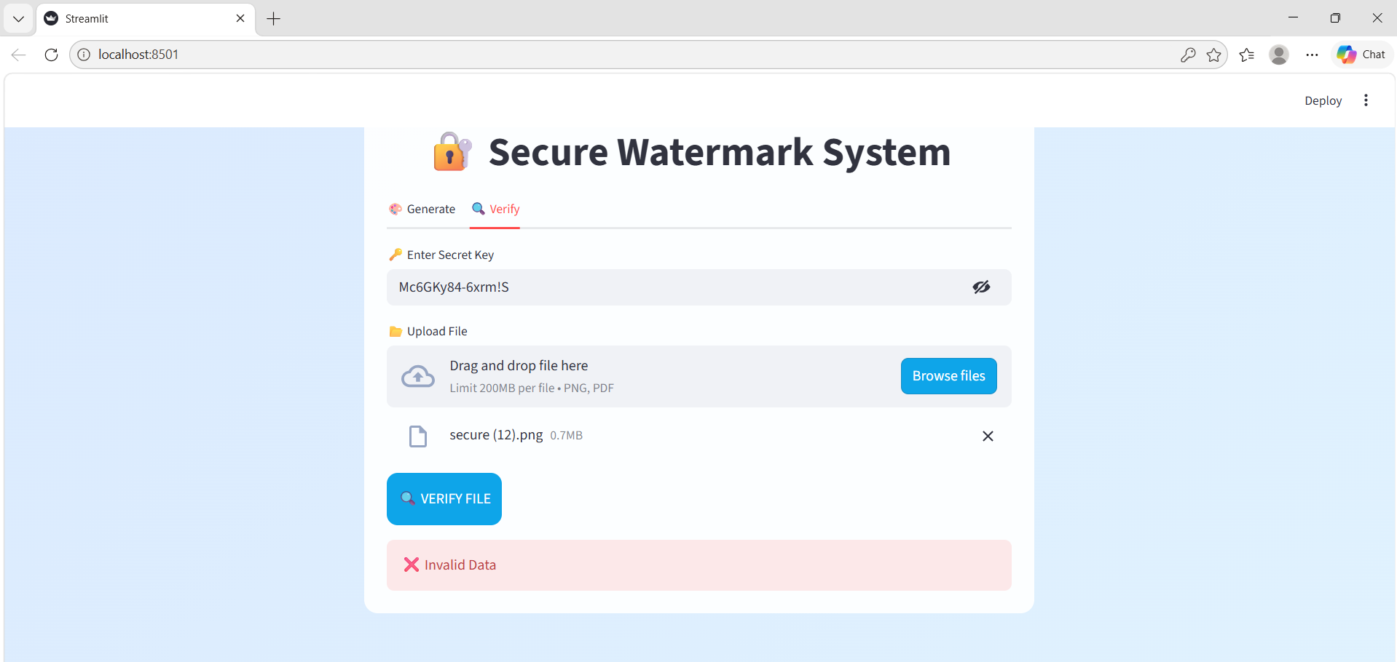

- CONCLUSION
The Secure Watermark Verification System provides a reliable solution for protecting digital images and PDF documents from unauthorized modification and forgery. The system integrates cryptographic techniques such as SHA-256 hashing and LSB steganography to ensure data integrity and secure embedding of watermark information, making it difficult to tamper with files without detection.
A unique digital signature is generated using a secret key and embedded within image pixels or PDF metadata. During verification, the system recomputes the signature and compares it with the embedded data to confirm authenticity. The use of Streamlit provides a simple and user-friendly interface, while libraries such as PyPDF2 enable efficient processing of PDF files.
Overall, the system reduces the risk of data tampering, eliminates the need for manual verification, and enhances trust in digital content sharing. This project demonstrates how cryptography and steganography can be effectively combined for applications such as document authentication, copyright protection, and secure data distribution.

6.FUTURE SCOPE

Although the current Secure Watermark Verification System is functional and secure, it can be further enhanced with the following improvements:
1. Database Integration
• Store watermark details, owner information, and signatures in a database (MySQL/SQLite) instead of temporary storage
• Enables better data management and scalability
2. User Authentication System
• Implement secure login sessions for users and administrators
• Add role-based access (admin, user, verifier)
• Use encryption techniques for password protection
3. Advanced Security Techniques
• Strengthen security using advanced cryptographic methods such as SHA-256 enhancements
• Encrypt secret keys and sensitive data
• Add timestamp validation and ownership tracking
4. Improved Steganography Methods
• Enhance watermarking beyond LSB Steganography
• Improve resistance against image compression and attacks
• Support multi-layer watermark embedding
5. Mobile Application
• Develop Android/iOS application for real-time watermark generation and verification
• Allow users to verify files directly using mobile devices
• Improves accessibility and usability
6. Cloud Deployment
• Deploy the system on cloud platforms such as AWS, Azure, or Render
• Makes the system globally accessible
• Improves performance and scalability
7. Bulk File Processing
• Allow uploading multiple images or PDFs at once
• Generate and embed watermarks in batch

7. REFERENCES

• William Stallings, Cryptography and Network Security: Principles and Practice, Pearson Education
• Streamlit Official Documentation: https://streamlit.io
• PyPDF2 Documentation: https://pypdf2.readthedocs.io/
• Python Imaging Library (PIL) Documentation: https://pillow.readthedocs.io/
• Python Hashlib Documentation: https://docs.python.org/3/library/hashlib.html
• National Institute of Standards and Technology (NIST), Secure Hash Standard (SHA-256)
• Research papers and online resources on digital watermarking and steganography techniques

