AES Based Secured Cloud Storage
A PROJECT REPORT SUBMITTED IN FULFILMENT OF THE REQUIREMENTS FOR THE AWARD OF THE DEGREE OF
BACHELOR OF TECHNOLOGY IN
COMPUTER SCIENCE AND ENGINEERING


By
Batch – 3

G. Gayatri (323103210067) G. Deekshitha (323103210069)
G. Bhavani (323103210078) G. Mahimitha (323103210079)

Under the esteemed guidance of
Dr. N. Sharmili
Professor
CSE Department

Department of Computer Science and Engineering

GAYATRI VIDYA PARISHAD COLLEGE OF ENGINEERING FOR WOMEN
[Approved by AICTE NEW DELHI, Affiliated to Andhra University, Visakhapatnam]
[Accredited by National Board of Accreditation (NBA) for B. Tech. CSE, ECE & IT – valid from 2019-22 and 2022-25] [Accredited by National Assessment and Accreditation Council (NAAC) with A Grade-Valid from 2022-2027]
Kommadi, Madhurawada, Visakhapatnam – 530048

2025 – 2026

GAYATRI VIDYA PARISHAD COLLEGE OF ENGINEERING FOR WOMEN

DEPARTMENT OF COMPUTER SCIENCE AND ENGINEERING



CERTIFICATE
This is to certify that the Project report titled “AES Based Secured Cloud Storage” is a
bonafide work of following III B.Tech. –II Sem. students in the Department of Computer Science and Engineering, Gayatri Vidya Parishad College of Engineering for Women affiliated to Andhra University, Visakhapatnam during the academic year 2025-26, in fulfilment of the requirement for the award of the degree of Bachelor of Technology of this university.

G. Gayathri (323103210067) G. Deekshitha (323103210069)
G. Bhavani (323103210078) G. Mahimitha (323103210079)

Signature of the Guide Signature of the HOD
Dr. N. Sharmili _{MTech.,} _{Ph.D.} Dr. P. V. S. L. Jagadamba _{MTech, Ph.D}
Professor, Professor,
Dept. of CSE Dept. of CSE

External Examiner

ABSTRACT
This project presents a secure cloud storage system using AES (Advanced Encryption Standard) encryption technique to protect user data. The system allows users to register, login, upload files, and access them securely using passwords. Each uploaded file is encrypted using AES algorithm and can only be accessed, downloaded, or deleted by providing the correct password. If an incorrect password is entered, the system displays an error message ensuring security. The application prevents unauthorized access by restricting login to registered users only. This system ensures data confidentiality, integrity, and secure file management in cloud environments.

1.SYSTEM REQUIREMENTS

Software Requirements

S.No | Category | Software / Tool | Purpose
1 | Programming Language | PHP | Backend development and server-side processing
2 | Markup Language | HTML | Structure of web pages
3 | Styling Language | CSS | Designing and layout of user interface
4 | Scripting Language | JavaScript | Client-side validation and interactivity
5 | Database Language | SQL | Managing and querying database
6 | Database Management Tool | MySQL | Storing user data and file details
7 | Web Server | Apache (XAMPP) | Running PHP applications locally
8 | Development Tool | XAMPP | Integrated environment for Apache and MySQL
9 | Code Editor | Visual Studio Code | Writing and editing code
10 | Cryptography Library | OpenSSL (PHP) | Encryption and decryption of files
11 | Web Browser | Chrome / Edge | Running and testing the application

Table 1. Software Requirements

Front End Packages used

S.NO | Libraries Used | Description
1. | HTML | Structure
2. | CSS | Styling
3. | JavaScript | Validation & UI
4. | Bootstrap | Responsive design
Table 2. Front end Packages

Hardware Requirements

The below Table 3 shows the minimum hardware requirements of our project.

Minimum Hardware Requirements:

S.No | Hardware Component | Specification
1. | Processor | Intel i3
2. | RAM | 4GB
3. | Hard Disk | 500GB
4. | System Type | 64-bit
5. | Internet | Required
6. | Keyboard & Mouse | Standard
Table 3. Minimum Hardware Requirements

2.METHODOLOGY

2.1 SYSTEM ARCHITECTURE

System works in following flow:
- User registers into system
- User logs in with credentials
- User uploads file with password
- File is encrypted using AES
- File stored in database/cloud
- User enters password to download/delete
- If password wrong → error message

2.2 DESCRPTION & ALGORITHM
The AES-based secured cloud storage system is designed to provide secure storage and access of user files using encryption techniques. In this system, users must first register before accessing any features. After successful registration, users can log in using their credentials.
Once logged in, users can upload files to the system. During file upload, the user provides a password, which is used to encrypt the file using the AES (Advanced Encryption Standard) algorithm. The encrypted file is then stored securely in the system.
Whenever the user wants to access the file, they must provide the correct password. The system uses this password to decrypt the file. If the entered password is correct, the file is successfully downloaded. If the password is incorrect, the system displays an error message such as “Wrong Password”.
Similarly, file deletion is also protected by a password. Users must enter the correct password to delete a file. This ensures that only authorized users can access or modify their data.
The system also prevents unauthorized access by not allowing login without registration. If a user tries to log in without registering, the system displays a “User not registered” message.
Overall, the system ensures data confidentiality, security, and controlled access using AES encryption and password protection.

ALGORITHM Step-by-Step Process:
- Start
- User registers with username and password
- User logs into the system
- If user not registered → show error message
- After login, user selects file to upload
- User enters password for file
- System generates encryption key
- File is encrypted using AES algorithm
- Encrypted file is stored
- For download:
- User selects file
- Enters password
- If password correct → decrypt and download
- Else → show "Wrong Password"
- For delete:
- User selects file
- Enters password
- If correct → delete file
- Else → show error
- Stop

3. IMPLEMENTATION

Source code :
login.php:

<?php
session_start();
include "config.php";
$error = "";
if ($_SERVER["REQUEST_METHOD"] == "POST") {
$username = $_POST['username'];
$password = $_POST['password'];
$stmt = $conn->prepare("SELECT * FROM users WHERE username=?");
$stmt->bind_param("s", $username);
$stmt->execute();
$result = $stmt->get_result();
if ($result->num_rows > 0) {
$row = $result->fetch_assoc();
if (password_verify($password, $row['password_hash'])) {
$_SESSION['user_id'] = $row['id'];
$_SESSION['username'] = $username;
header("Location: dashboard.php");
exit();
} else {
$error = "Wrong Password!";
}
} else {
$error = "User not found!";
}
}
?>
<!DOCTYPE html>
<html>
<head>
<title>Login</title>
<style>
body {
margin:0;
font-family: Arial;
background: linear-gradient(135deg,#1e3c72,#2a5298);
display:flex;
justify-content:center;
align-items:center;
height:100vh;
}
.box {
background:white;
padding:40px;
border-radius:10px;
width:350px;
text-align:center;
}
input {
width:100%;
padding:10px;
margin:8px 0;
}
button {
width:100%;
padding:10px;
background:#1e3c72;
color:white;
border:none;
}
a { text-decoration:none; color:#1e3c72; }
</style>
</head>
<body>
<div class="box">
<h2>Login</h2>
<?php if($error) echo "<p style='color:red;'>$error</p>"; ?>
<form method="POST">
<input type="text" name="username" placeholder="Username" required>
<input type="password" name="password" placeholder="Password" required>
<button type="submit">Login</button>
</form>
<br>
<a href="register.php">Create Account</a>
</div>
</body>
</html>

register.php:
<?php
error_reporting(E_ALL);
ini_set('display_errors', 1);
include "config.php";
$message = "";
if ($_SERVER["REQUEST_METHOD"] == "POST") {
$username = trim($_POST['username']);
$password = trim($_POST['password']);
if (!empty($username) && !empty($password)) {
$check = $conn->prepare("SELECT id FROM users WHERE username=?");
$check->bind_param("s", $username);
$check->execute();
$check->store_result();
if ($check->num_rows > 0) {
$message = "Username already exists!";
} else {
$hashed = password_hash($password, PASSWORD_DEFAULT);
$stmt = $conn->prepare("INSERT INTO users (username, password_hash) VALUES (?, ?)");
$stmt->bind_param("ss", $username, $hashed);
if ($stmt->execute()) {
$message = "Registration Successful!";
} else {
$message = "Registration Failed!";
}
$stmt->close();
}
$check->close();
} else {
$message = "All fields are required!";
}
}
?>
<!DOCTYPE html>
<html>
<head>
<title>Register</title>
<style>
body {
margin:0;
font-family: Arial;
background: linear-gradient(135deg,#1e3c72,#2a5298);
display:flex;
justify-content:center;
align-items:center;
height:100vh;
}
.box {
background:white;
padding:40px;
border-radius:10px;
width:350px;
text-align:center;
}
input {
width:100%;
padding:10px;
margin:8px 0;
}
button {
width:100%;
padding:10px;
background:#1e3c72;
color:white;
border:none;
}
</style>
</head>
<body>
<div class="box">
<h2>AES Secure Cloud</h2>
<?php if($message) echo "<p>$message</p>"; ?>
<form method="POST">
<input type="text" name="username" placeholder="Username" required>
<input type="password" name="password" placeholder="Password" required>
<button type="submit">Register</button>
</form>
<br>
<a href="login.php">Login</a>
</div>
</body>
</html>
test.php:
<?php
error_reporting(E_ALL);
ini_set('display_errors', 1);
include "config.php";
$message = "";
if ($_SERVER["REQUEST_METHOD"] == "POST") {
$username = trim($_POST['username']);
$password = trim($_POST['password']);
if (!empty($username) && !empty($password)) {
$check = $conn->prepare("SELECT id FROM users WHERE username=?");
$check->bind_param("s", $username);
$check->execute();
$check->store_result();
if ($check->num_rows > 0) {
$message = "Username already exists!";
} else {
$hashed = password_hash($password, PASSWORD_DEFAULT);
$stmt = $conn->prepare("INSERT INTO users (username, password_hash) VALUES (?, ?)");
$stmt->bind_param("ss", $username, $hashed);
if ($stmt->execute()) {
$message = "Registration Successful!";
} else {
$message = "Registration Failed!";
}
$stmt->close();
}
$check->close();
} else {
$message = "All fields are required!";
}
}
?>
<!DOCTYPE html>
<html>
<head>
<title>Register</title>
<style>
body {
margin:0;
font-family: Arial;
background: linear-gradient(135deg,#1e3c72,#2a5298);
display:flex;
justify-content:center;
align-items:center;
height:100vh;
}
.box {
background:white;
padding:40px;
border-radius:10px;
width:350px;
text-align:center;
}
input {
width:100%;
padding:10px;
margin:8px 0;
}
button {
width:100%;
padding:10px;
background:#1e3c72;
color:white;
border:none;
}
</style>
</head>
<body>
<div class="box">
<h2>AES Secure Cloud</h2>
<?php if($message) echo "<p>$message</p>"; ?>
<form method="POST">
<input type="text" name="username" placeholder="Username" required>
<input type="password" name="password" placeholder="Password" required>
<button type="submit">Register</button>
</form>
<br>
<a href="login.php">Login</a>
</div>
</body>
</html>
logout.php:
<?php
session_start();
session_destroy();
header("Location: login.php");
exit();
?>
upload.php:
<?php
session_start();
include "config.php";
if ($_SERVER["REQUEST_METHOD"] == "POST") {
$user_id = $_SESSION['user_id'];
$file_password = $_POST['file_password'];
$file_tmp = $_FILES['file']['tmp_name'];
$original_name = $_FILES['file']['name'];
$key = hash('sha256', $file_password, true);
$cipher = "AES-256-CBC";
$iv_length = openssl_cipher_iv_length($cipher);
$iv = openssl_random_pseudo_bytes($iv_length);
$data = file_get_contents($file_tmp);
$encrypted = openssl_encrypt($data, $cipher, $key, OPENSSL_RAW_DATA, $iv);
$final_data = $iv . $encrypted;
$stored_name = time() . "_" . basename($original_name);
file_put_contents("uploads/" . $stored_name, $final_data);
$hashed_password = password_hash($file_password, PASSWORD_DEFAULT);
$stmt = $conn->prepare("INSERT INTO files (user_id, file_name, stored_name, file_password) VALUES (?, ?, ?, ?)");
$stmt->bind_param("isss", $user_id, $original_name, $stored_name, $hashed_password);
$stmt->execute();
header("Location: dashboard.php");
}
?>
download.php:
<?php
session_start();
include "config.php";
if ($_SERVER["REQUEST_METHOD"] == "POST") {
$user_id = $_SESSION['user_id'];
$stored_name = $_POST['file'];
$password = $_POST['file_password'];
$stmt = $conn->prepare("SELECT * FROM files WHERE stored_name = ? AND user_id = ?");
$stmt->bind_param("si", $stored_name, $user_id);
$stmt->execute();
$result = $stmt->get_result();
if ($result->num_rows > 0) {
$row = $result->fetch_assoc();
if (!password_verify($password, $row['file_password'])) {
die("Wrong password!");
}
$file_path = "uploads/" . $stored_name;
$cipher = "AES-256-CBC";
$key = hash('sha256', $password, true);
$data = file_get_contents($file_path);
$iv_length = openssl_cipher_iv_length($cipher);
$iv = substr($data, 0, $iv_length);
$encrypted = substr($data, $iv_length);
$decrypted = openssl_decrypt($encrypted, $cipher, $key, OPENSSL_RAW_DATA, $iv);
if ($decrypted === false) {
die("Decryption failed!");
}
header("Content-Type: application/octet-stream");
header("Content-Disposition: attachment; filename=\"" . $row['file_name'] . "\"");
echo $decrypted;
exit();
} else {
echo "File not found!";
}
}
?>
delete.php:
<?php
session_start();
include "config.php";
$file = $_POST['file'];
$password = $_POST['file_password'];
$result = $conn->query("SELECT * FROM files WHERE stored_name='$file'");
$row = $result->fetch_assoc();
if(password_verify($password,$row['file_password'])){
unlink("uploads/".$file);
$conn->query("DELETE FROM files WHERE stored_name='$file'");
}
header("Location: dashboard.php");
?>
db.php:
<?php
$conn = new mysqli("localhost", "root", "", "secure_cloud");
if ($conn->connect_error) {
die("Connection failed: " . $conn->connect_error);
}
?>
dashboard.php
<?php
session_start();
include "config.php";
if (!isset($_SESSION['user_id'])) {
header("Location: login.php");
exit();
}
?>
<!DOCTYPE html>
<html>
<head>
<title>Dashboard</title>
<style>
body { font-family: Arial; background:#f4f6f9; }
.header { background:#1e3c72; color:white; padding:15px; text-align:center; }
.card {
background:white;
width:600px;
margin:20px auto;
padding:20px;
border-radius:10px;
}
button { padding:8px; background:#1e3c72; color:white; border:none; }
</style>
</head>
<body>

<div class="header">
<h2>Welcome <?php echo $_SESSION['username']; ?></h2>
<a href="logout.php" style="color:white;">Logout</a>
</div>
<div class="card">
<h3>Upload File</h3>
<form method="POST" action="upload.php" enctype="multipart/form-data">
<input type="file" name="file" required>
<input type="password" name="file_password" placeholder="File Password" required>
<button type="submit">Upload</button>
</form>
</div>
<div class="card">
<h3>Your Files</h3>
<?php
$user_id = $_SESSION['user_id'];
$result = $conn->query("SELECT * FROM files WHERE user_id=$user_id");
while($row = $result->fetch_assoc()){
echo "<p><strong>".$row['file_name']."</strong></p>";
echo "<form method='POST' action='download.php'>
<input type='hidden' name='file' value='".$row['stored_name']."'>
<input type='password' name='file_password' placeholder='Password'>
<button>Download</button>
</form>";
echo "<form method='POST' action='delete.php'>
<input type='hidden' name='file' value='".$row['stored_name']."'>
<input type='password' name='file_password' placeholder='Password'>
<button>Delete</button>
</form><hr>";
}
?>
</div>
</body>
</html>
config.php:
<?php
$host = "localhost";
$username = "root";
$password = "";
$database = "secure_cloud";
$conn = new mysqli($host, $username, $password, $database);
if ($conn->connect_error) {
die("Database Connection Failed: " . $conn->connect_error);
}
?>

4. RESULTS

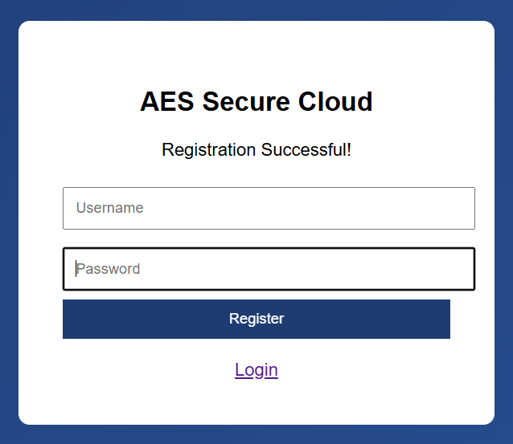
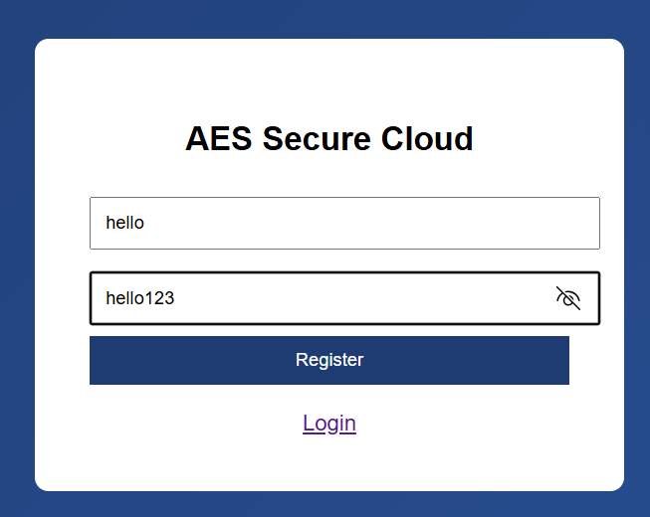
Output Screens:
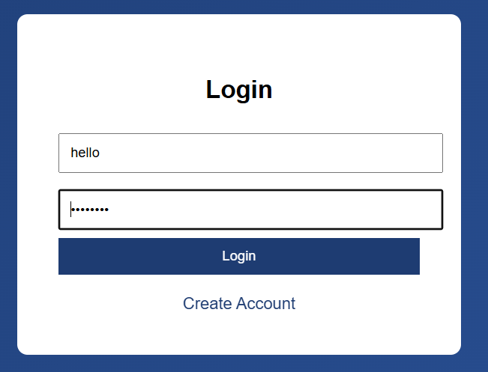

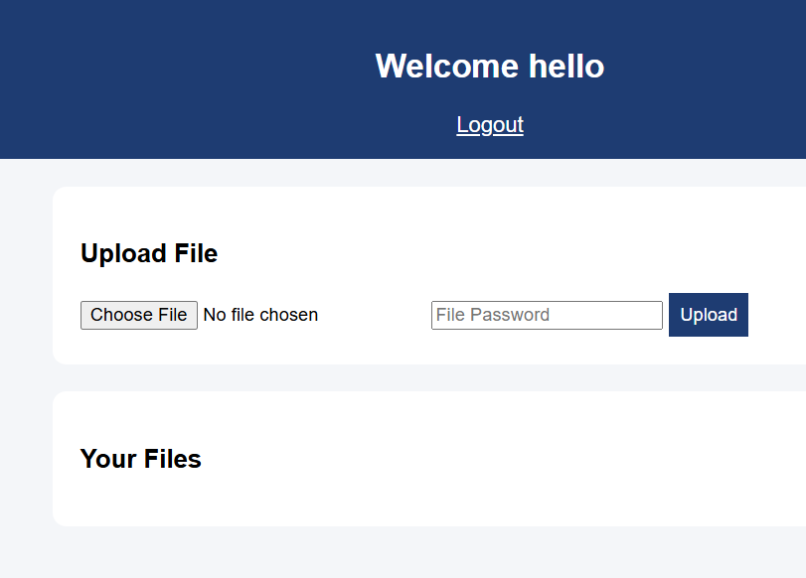
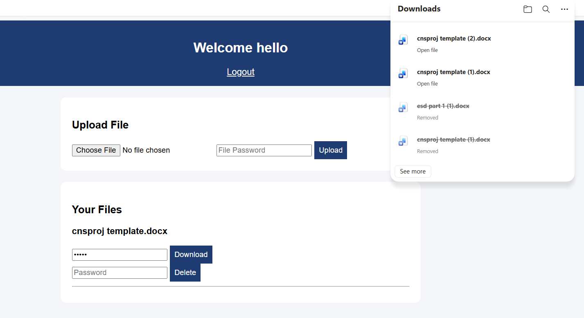
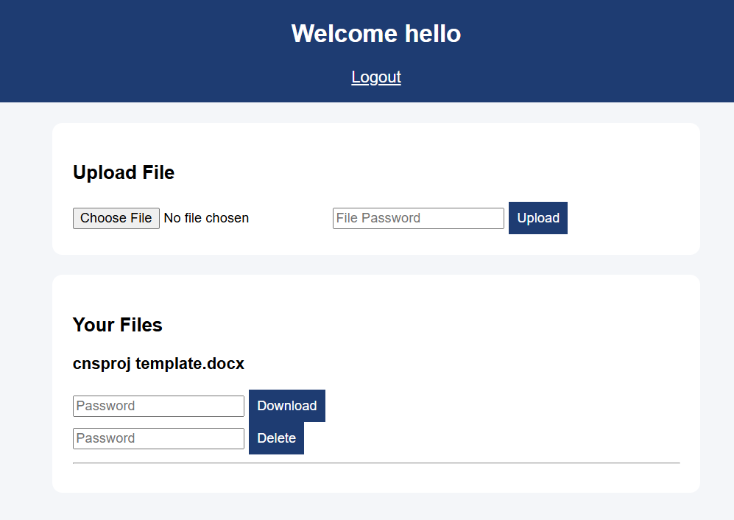
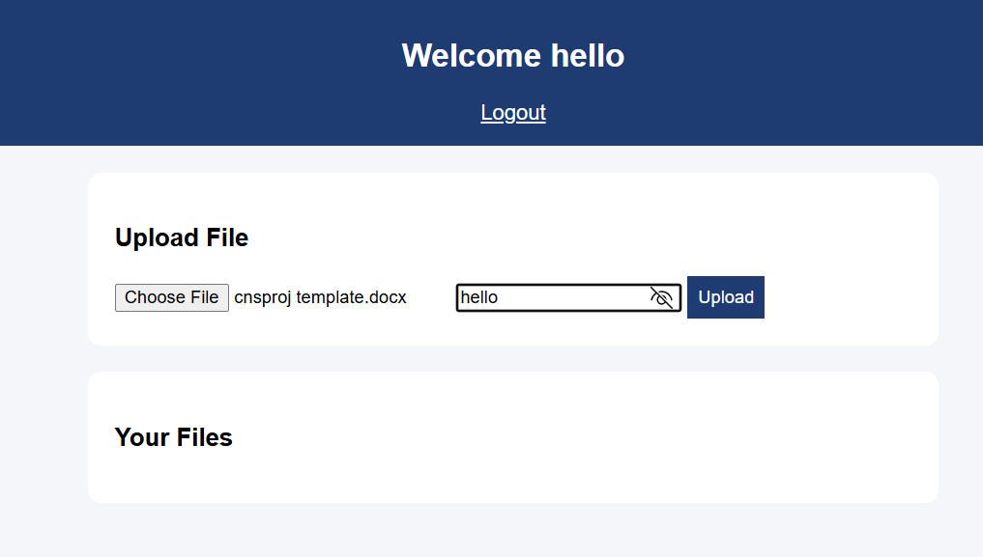
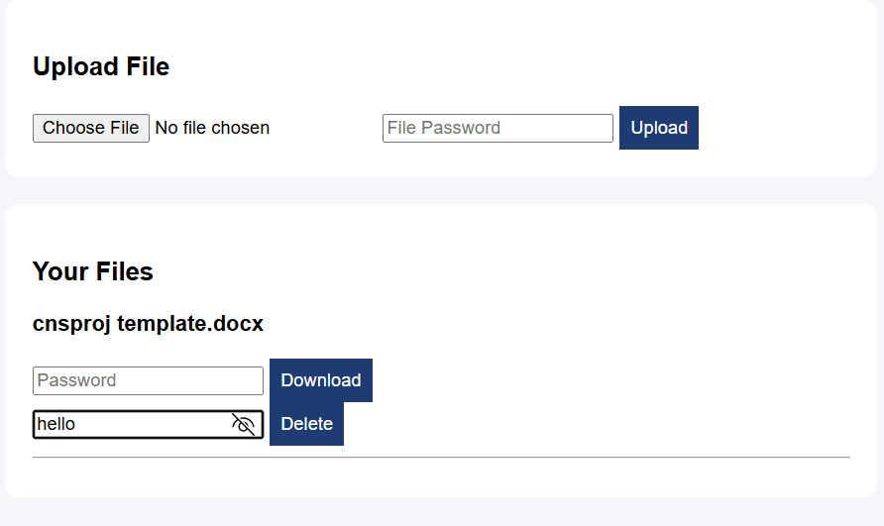


5.CONCLUSION

The Secure Cloud File Storage System developed in this project successfully demonstrates the practical implementation of cryptographic techniques to ensure data confidentiality, integrity, and controlled access. By integrating password-based encryption using advanced algorithms such as AES, the system ensures that files are securely encrypted before being stored on the server. This prevents unauthorized users, including system administrators, from accessing sensitive data directly from storage. The project also incorporates user authentication, password-protected file upload and download mechanisms, and secure deletion features, thereby providing a multi-layered security approach.
One of the key highlights of this system is that files stored in the server remain unreadable in their encrypted form and can only be accessed through proper decryption using the correct password. This ensures that even if the storage medium is compromised, the data remains protected. Additionally, the system enforces strict access control by allowing only authenticated users to manage their files, ensuring user-specific data privacy. The inclusion of password verification during file deletion further strengthens security by preventing unauthorized removal of files.
However, the project also highlights an important trade-off between security and usability. Since the encryption relies entirely on user-provided passwords, forgetting the password results in permanent loss of access to the encrypted files. This reflects real-world secure systems where strong encryption eliminates the possibility of unauthorized access but also removes recovery options without proper key management. Therefore, this system emphasizes the importance of careful password handling and awareness among users.

6.FUTURE SCOPE

The AES-based secured cloud storage system can be further enhanced by integrating advanced security features and improving overall functionality. In the future, the system can be extended to support real-time cloud storage platforms such as AWS, Google Cloud, or Azure for better scalability and accessibility. Additional authentication mechanisms like OTP verification or biometric authentication can be implemented to strengthen security. The system can also be upgraded to allow secure file sharing between users using encrypted links. Enhancing the user interface and adding features like file preview, search functionality, and activity logs can improve user experience. Furthermore, implementing multi-level encryption and AI-based threat detection can make the system more robust and resistant to cyber-attacks.
Future Enhancements:
- Integration with cloud platforms (AWS, Google Cloud)
- OTP-based or biometric authentication
- Secure file sharing between users
- Advanced encryption techniques (multi-layer security)
- Improved UI/UX design
- File preview and search functionality
- Activity logs and monitoring system
- AI-based security and threat detection

7.REFERENCES

- National Institute of Standards and Technology (NIST), Advanced Encryption Standard (AES), FIPS PUB 197, 2001.
- GeeksforGeeks, Cryptography and AES Tutorials, Available: https://www.geeksforgeeks.org/
- OWASP Foundation, Web Security Guidelines, Available: https://owasp.org/
- Mozilla Developer Network (MDN Web Docs), HTML, CSS, JavaScript Documentation, Available: https://developer.mozilla.org/
- W3Schools, Web Development Tutorials, Available: https://www.w3schools.com/
- Google Cloud Documentation, Available: https://cloud.google.com/docs
- Amazon Web Services Documentation, Available: https://aws.amazon.com/documentation/

