**RESULTS AND ANALYSIS**

**User Registration Module**

**1)Doctor Registration**

The doctor registration process involves entering the doctor's name, and designation. When the "Register" button is clicked, a MetaMask prompt appears requesting transaction confirmation. Upon confirming through MetaMask, the entered details are securely stored on the blockchain. A success message is then displayed, indicating that the doctor's information has been successfully registered on the blockchain.



Fig 1: Doctor Registration

**2)Patient Registration**

The patient registration process requires entering the patient's name, age, date of birth (DOB), relation (e.g., father, mother, etc.), blood pressure (BP), cholesterol level, and resting electrocardiogram (restecg) results. When the "Register" button is clicked, MetaMask prompts the user to confirm the transaction. Once confirmed, the patient's details are securely recorded on the blockchain. A success message is then displayed, indicating that the patient has been registered successfully on the blockchain.

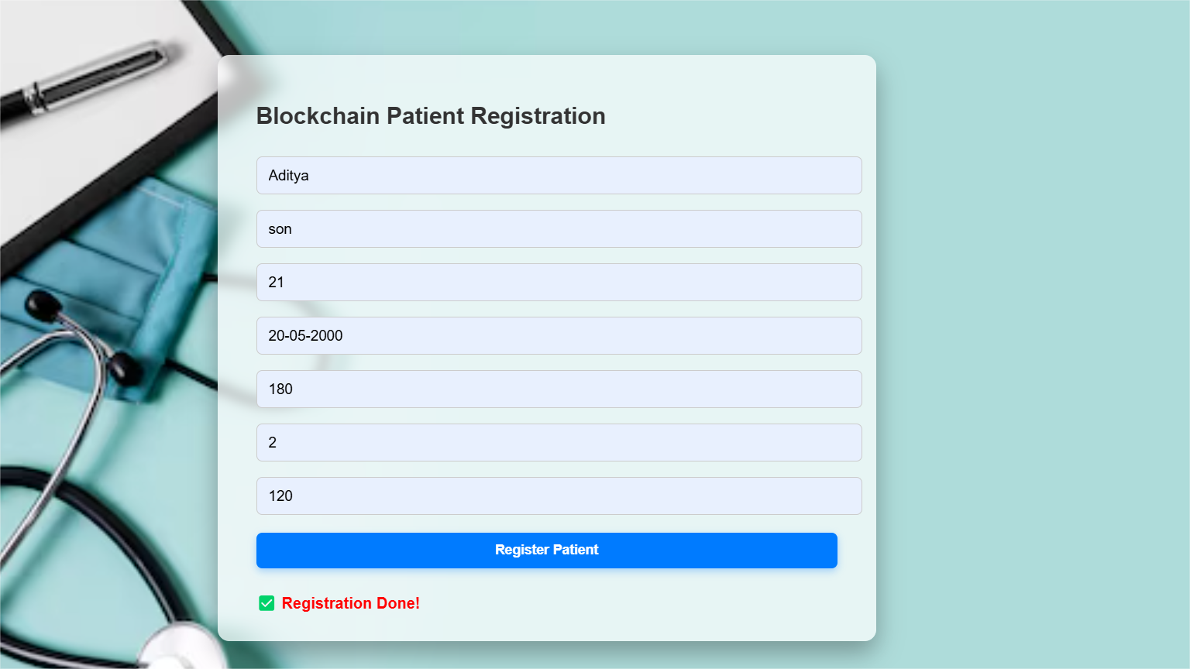

Fig 2: Patient Registration

**Blockchain Data Storage Module**

**3)Patient Data Storage**

Patient data is securely stored on Ganache using Blockchain.

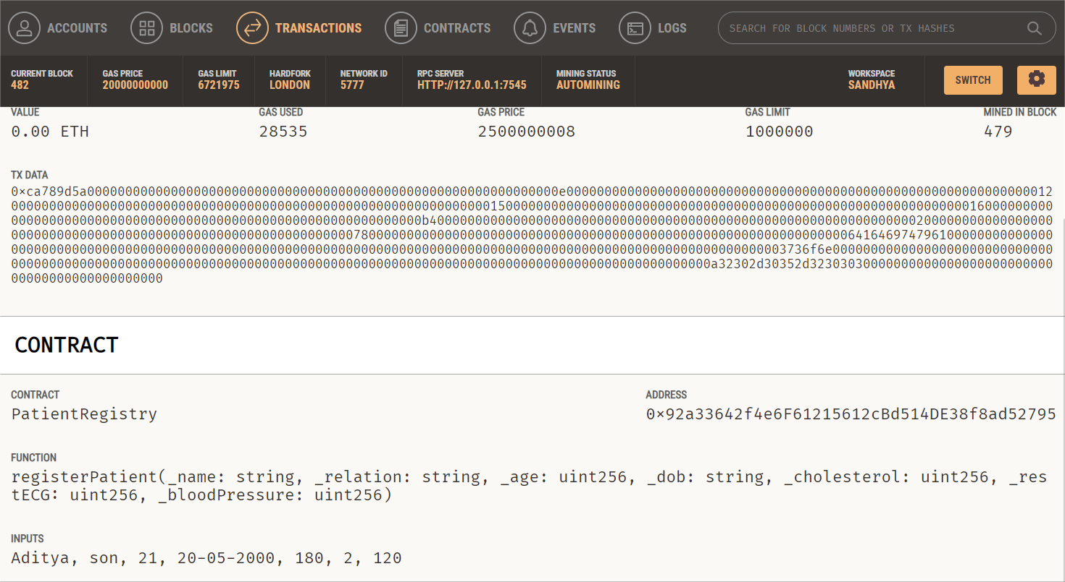

Fig 3: Patient Data

**4)Doctor Data Storage**

Doctor data is securely stored on Ganache using Blockchain.

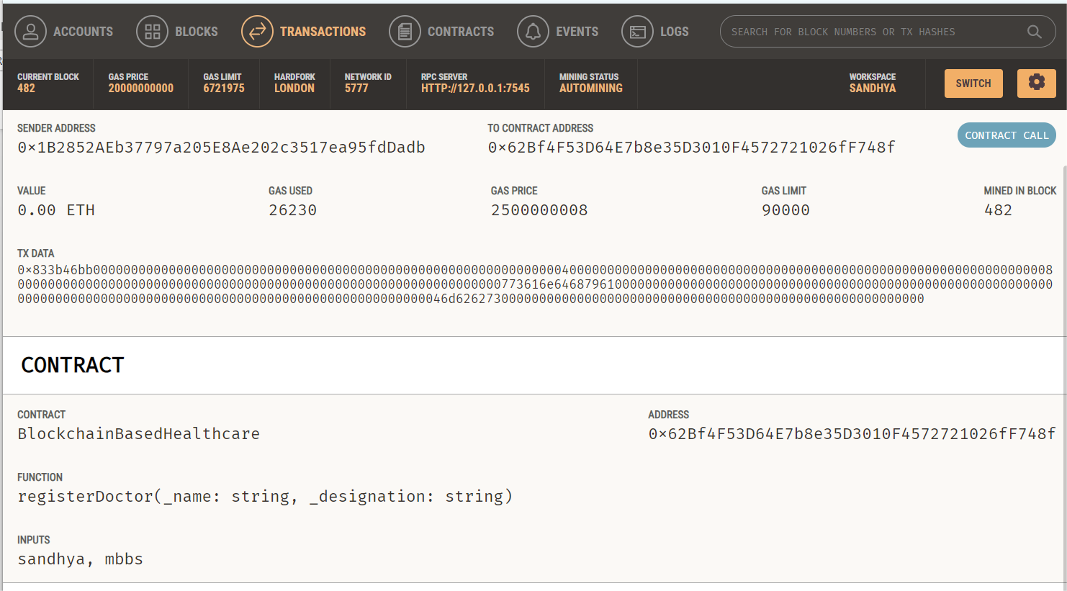

Fig 4: Doctor Data

**Secure Data Retrieval Module**

**5)View Grandparent Details**  
To retrieve grandparent details from the blockchain, the user enters the grandparent's name into the input field and clicks the "Retrieve" button. The system then queries the smart contract to search for the corresponding grandparent's data based on the provided name. If a match is found, the stored details—such as age, relation, blood pressure, cholesterol, and restecg—are fetched and displayed on the screen. This allows users to securely and quickly access grandparent health records directly from the blockchain.



Fig 5: Retrieving Grandparent Details

**6)View Parent Details**To retrieve parent details from the blockchain, the user enters the parent's name into the input field and clicks the "Retrieve" button. The system then queries the smart contract to search for the corresponding parent's data based on the provided name. If a match is found, the stored details—such as age, relation, blood pressure, cholesterol, and restecg—are fetched and displayed on the screen. This enables users to securely and efficiently access parent health records directly from the blockchain.



Fig 6: Retrieving Parent Details

**7)View Present Generation Details**

To retrieve present generation patient details from the blockchain, the user enters the patient's name into the input field and clicks the "Retrieve" button. The system then queries the smart contract to search for the corresponding patient's data based on the provided name. If a match is found, the stored details—such as age, relation, blood pressure, cholesterol, and restecg—are fetched and displayed on the screen. This allows users to securely and conveniently access the current generation patient's health records directly from the blockchain.

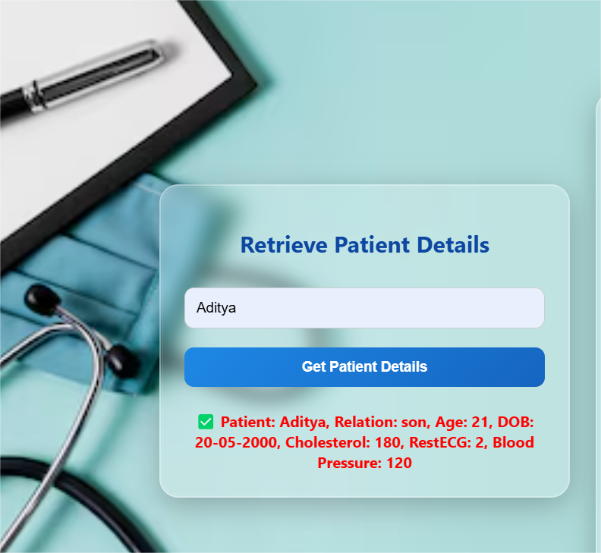

Fig 7: Retrieving Patient Details

**8)View Doctor Details**

To retrieve doctor details from the blockchain, the user enters the doctor's name into the input field and clicks the "Retrieve" button. The system then queries the smart contract to search for the doctor's information based on the provided name. If a match is found, the stored details such as Ethereum address, name, and designation—are fetched and displayed on the screen. This allows users to securely and easily access doctor information directly from the blockchain.



Fig 8: Retrieving Doctor Details

**9)Ganache Contracts**

Under the smart contracts deployed on Ganache, both patient and doctor details are registered and stored through blockchain transactions. When a user submits the registration form, a transaction is created and sent to the smart contract, which securely records the provided details such as the patient's ID, health data, or the doctor's name, address, and designation. These transactions are processed and stored on the local blockchain, ensuring that all registered information is immutable, transparent, and verifiable within the Ganache environment.

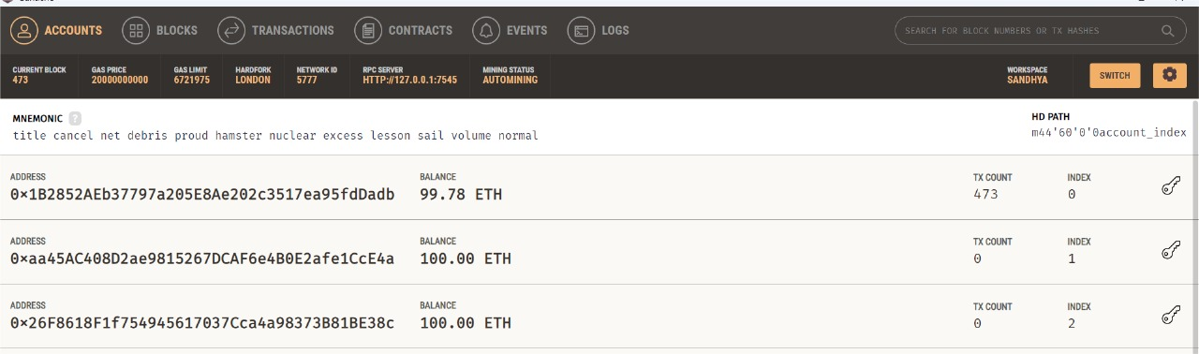

Fig 9: Ganache Contracts

**10)Solidity File**

In the Solidity smart contract file, there are dedicated functions for both patient and doctor registration. The patient registration function allows storing details such as unique ID, name, age, date of birth, relation, blood pressure, cholesterol, and restecg. Similarly, the doctor registration function is used to store the doctor’s Ethereum address, name, and designation. When these functions are called through transactions, the input data is securely recorded on the blockchain, enabling reliable storage and future retrieval of both patient and doctor information.

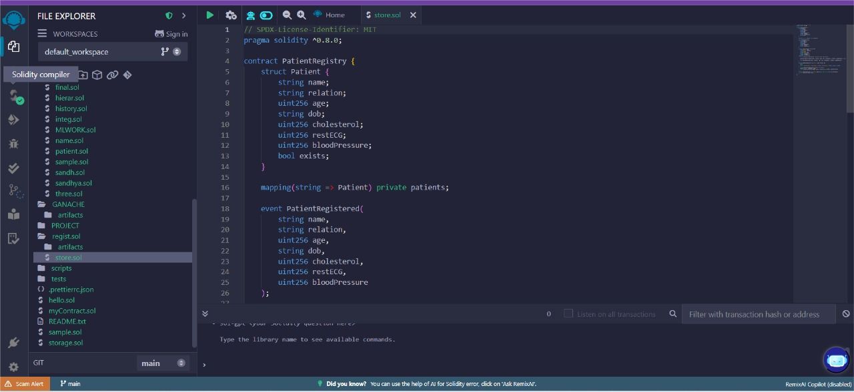

Fig 10: Ganache Contracts

**The Intelligent Risk Prediction for Cardiovascular Diseases Module**

**11)View Personal Risk**

The "View Personal Risk" feature allows users to assess their heart disease risk based on health data retrieved from the blockchain. Once the patient's, parent's, and grandparent's medical details are fetched from the smart contract, the system inputs this data into trained machine learning models such as Random Forest and XGBoost. These models analyze patterns across generations, considering factors like blood pressure, cholesterol, restecg, and relation, to accurately predict the patient's risk level. The prediction is then displayed on the screen, providing a data-driven, AI-powered health risk assessment directly from blockchain-stored records.

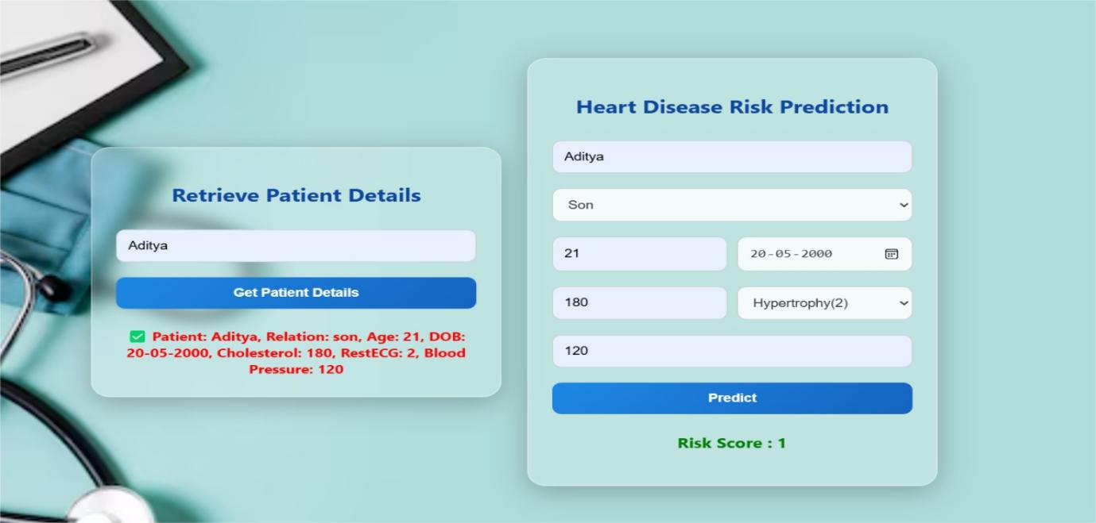

Fig 11: View Personal Risk

**12)View Hereditary Risk**

The "View Hereditary Risk" feature enables users to evaluate the potential genetic risk of heart disease based on multi-generational health data stored on the blockchain.

When the medical details of the patient, along with those of their parents and grandparents, are retrieved from the smart contract, the system feeds this information into machine learning models such as Random Forest and XGBoost.

These models analyze hereditary patterns, considering attributes like blood pressure, cholesterol, restecg, and familial relationships, to estimate the inherited risk of heart disease.

The result is then presented on the screen, personalized hereditary risk assessment derived from blockchain-secured data.

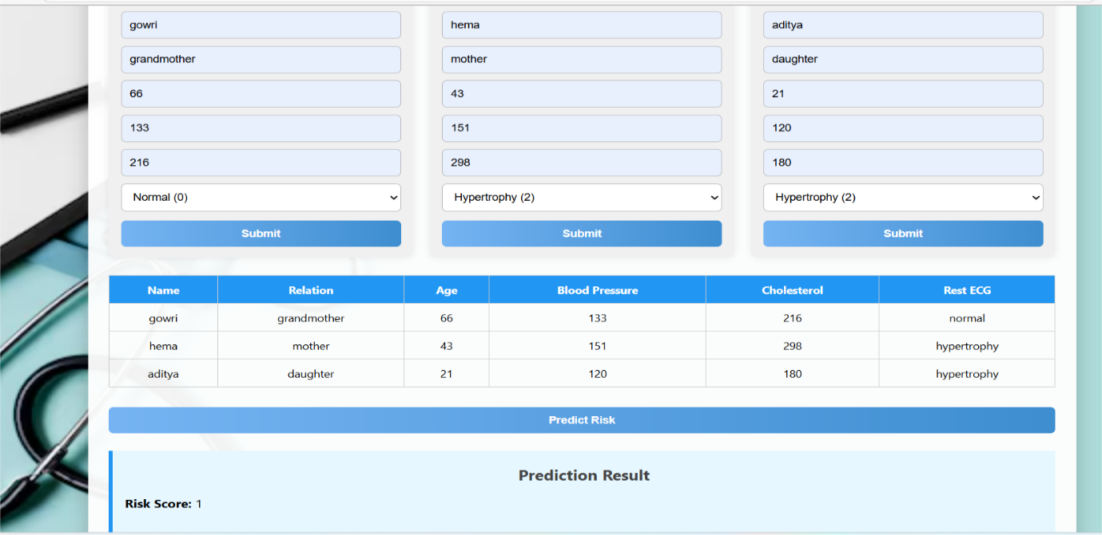

Fig 12: View Hereditary Risk

**13)Visualize Risks**

The "Visualize Risk for Three Generations" feature provides a graphical representation of heart disease risk across the patient, parent, and grandparent generations. After retrieving medical data for all three generations from the blockchain, the system processes this information using trained machine learning models like Random Forest and XGBoost. The predicted risk levels for each generation are then visualized using intuitive charts or graphs, allowing users to clearly understand how heart disease risk evolves within the family. This feature helps in identifying hereditary patterns and supports better health awareness and preventive care through a clear, AI-powered visual summary.

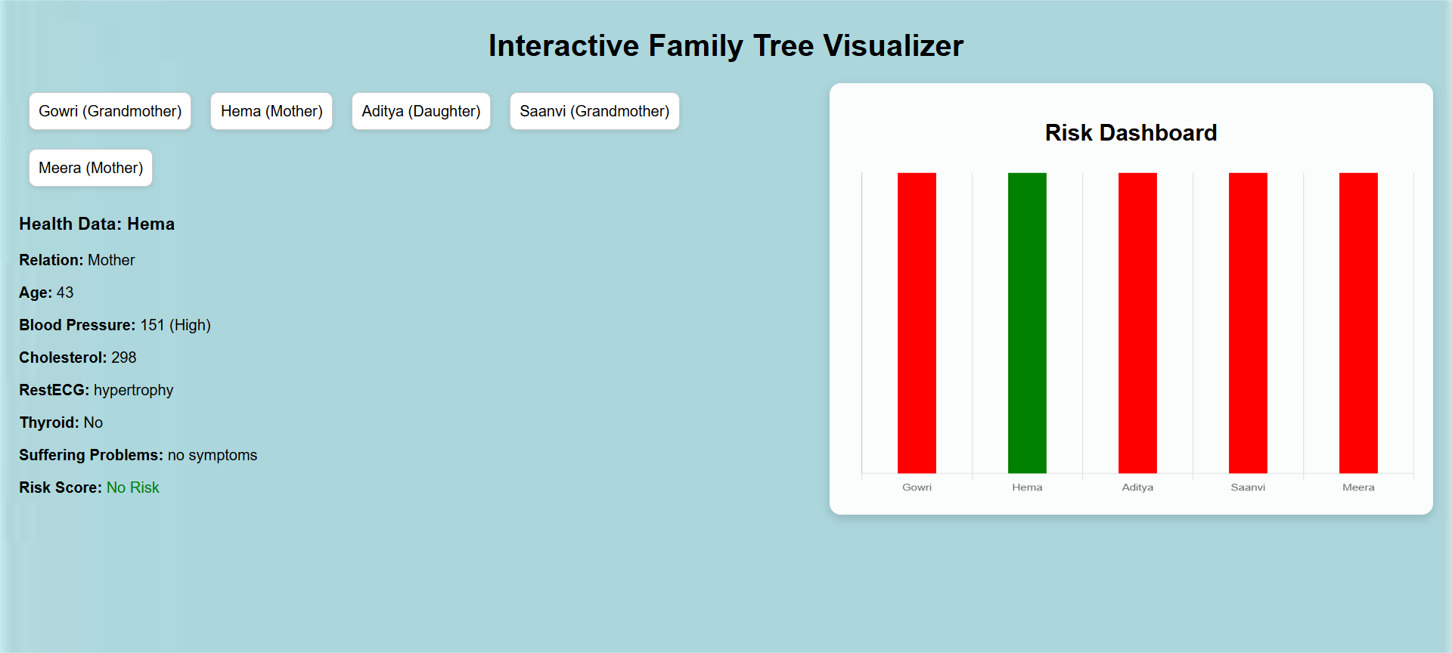

Fig 13: Visualizing Non-Risk Page

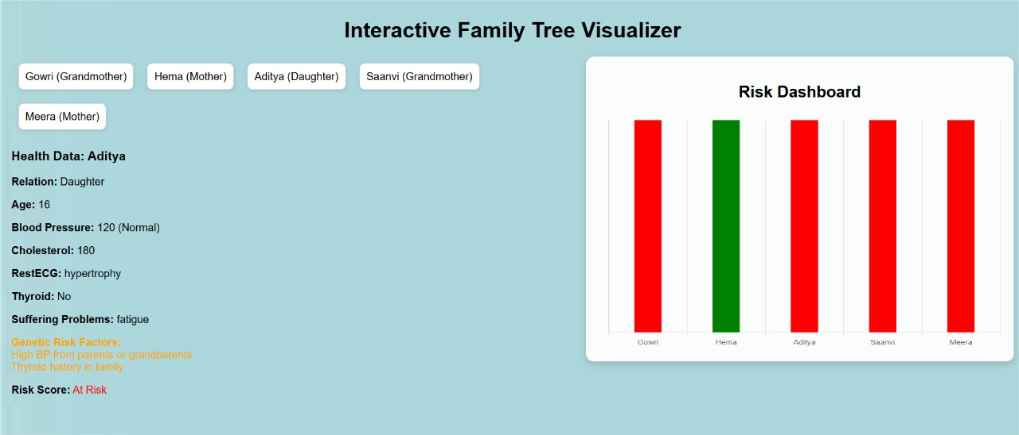

Fig 14: Visualizing Risk Page

**7.Performance Analysis and Evaluation**

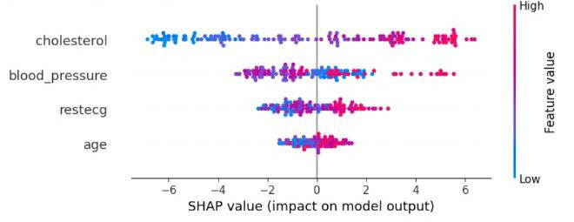

Fig.1.SHAP Summary Plot: Feature Impact on Model Predictions

Fig.1. SHAP Summary Plot illustrates the contribution of each feature to the model's predictions. Cholesterol and blood pressure have the most significant impact, with both high and low values influencing the output in different directions. Resting ECG and age also show notable influence, though with slightly lesser impact. The mix of red (high value) and blue (low value) across the SHAP axis shows how feature values affect the prediction positively or negatively.

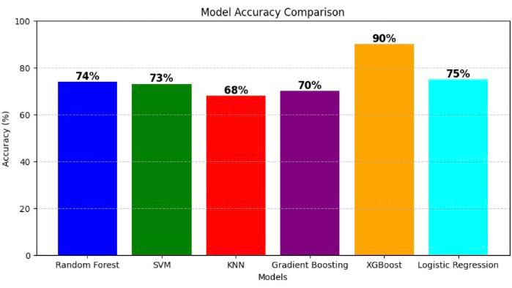

Fig.2. Model Accuracy Comparision

The accuracy comparison shows that **XGBoost** achieved the highest accuracy at **90%**, making it the most effective model for heart disease prediction. **Logistic Regression** and **Random Forest** followed with **75%** and **74%** respectively. Other models like **SVM, Gradient Boosting,** and **KNN** performed slightly lower, with accuracies ranging from **73% to 68%.** This highlights the strength of ensemble methods, especially XGBoost, in handling complex health data

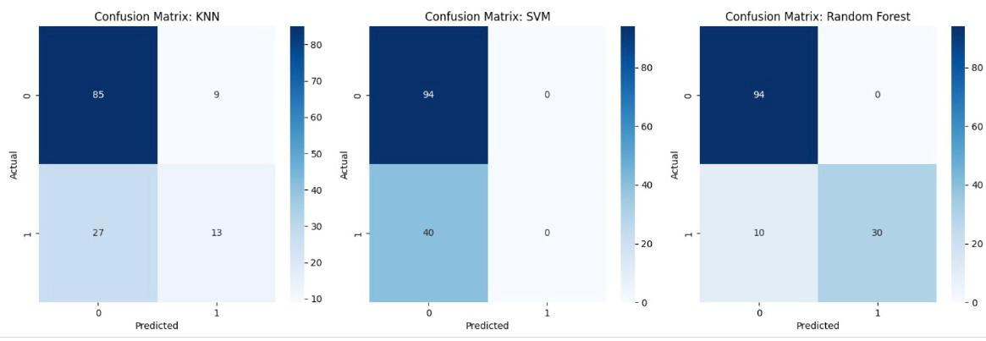

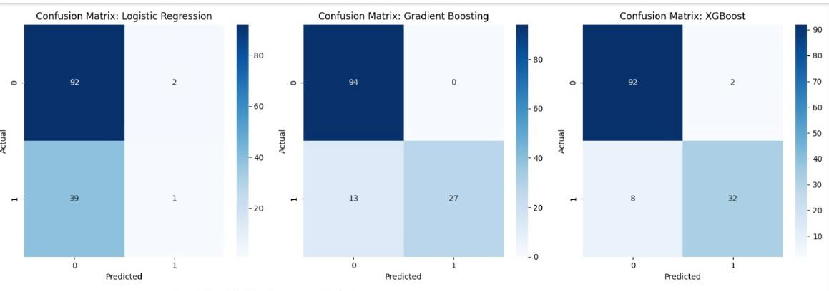

Fig.3. Confusion Matrix Comparision

Fig.3. Among all models, **XGBoost** performs the best with high true positives and low errors, followed closely by **Gradient Boosting** and **Random Forest**. These ensemble models show balanced and accurate predictions. In contrast, **KNN** and **Logistic Regression** struggle with detecting positive cases, while **SVM** fails completely by predicting only the negative class. Overall, ensemble methods are the most reliable for this task.

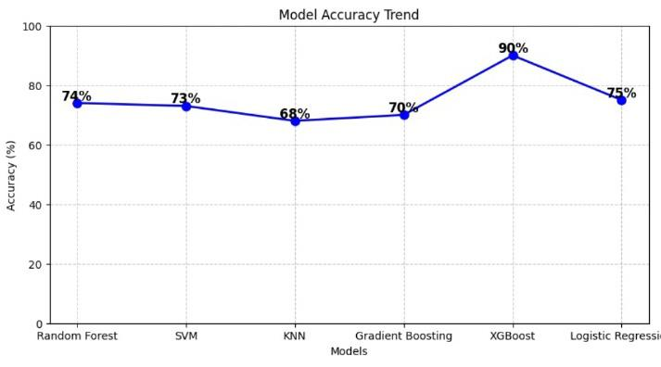

Fig.4. Model Accuracy Trend

This graph shows the **accuracy comparison** of different machine learning models used for prediction. Among all, **XGBoost achieved the highest accuracy of 90%,** proving to be the most effective model. Other models like **Logistic Regression (75%)** and **Random Forest (74%)** also performed reasonably well. **KNN had the lowest accuracy (68%),** indicating it is less suitable for this dataset. Overall, **XGBoost outperformed all other models in terms of accuracy.**

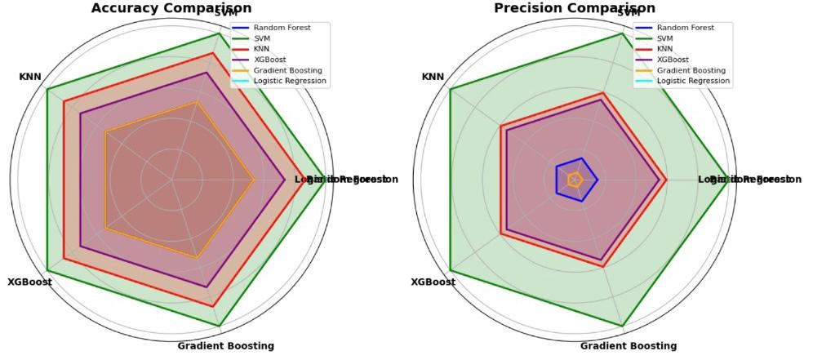

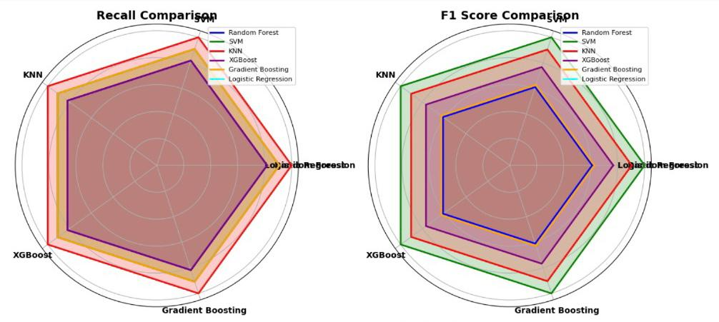

Fig.5. Model Accuracy Trend

Fig.5.The radar graphs clearly highlight that **XGBoost** and **Gradient Boosting** consistently outperform other models across all metrics—**accuracy, precision, recall, and F1 score**. These ensemble models show strong and balanced performance, making them reliable for classification tasks. **Random Forest** also performs well but slightly trails behind. In contrast, **SVM** and **Logistic Regression** lag in most metrics, especially in precision and recall**. KNN** shows moderate performance but is not as robust as the ensemble models. Overall, ensemble methods dominate in both effectiveness and consistency.

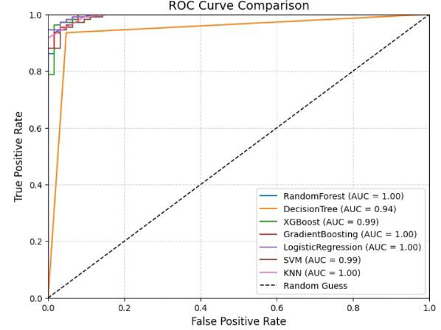

Fig.6.ROC CURVE

The ROC curve compares the performance of different classifiers—TabPFN, CatBoost, XGBoost, HGB, DecisionTree, and RandomForest—based on their true positive and false positive rates. The AUC values indicate predictive capability, with TabPFN achieving the highest (0.48) and XGBoost the lowest (0.40). The dashed line represents a random guess baseline.

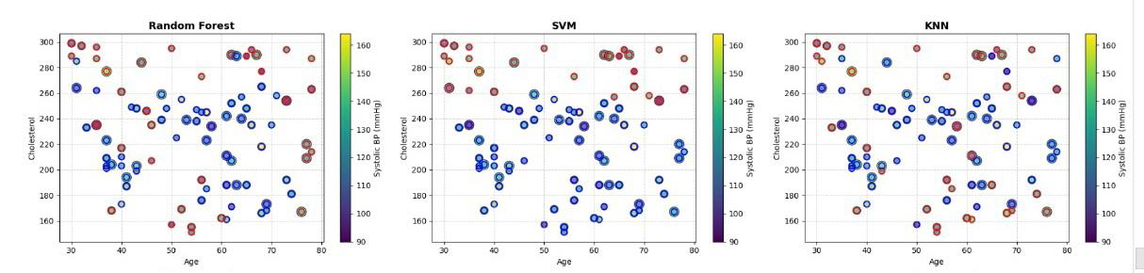

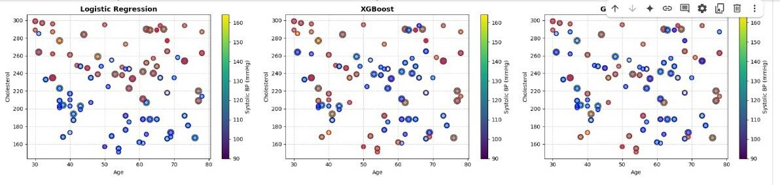

Fig.7. Scatter Plot Comparison

Fig.7.The scatter plots compare model-wise predictions based on age, cholesterol, and systolic blood pressure. Gradient Boosting and XGBoost display more distinct clustering and color consistency, indicating stronger correlation and predictive power. In contrast, models like Logistic Regression and KNN show more scattered and overlapping points, reflecting weaker pattern recognition.

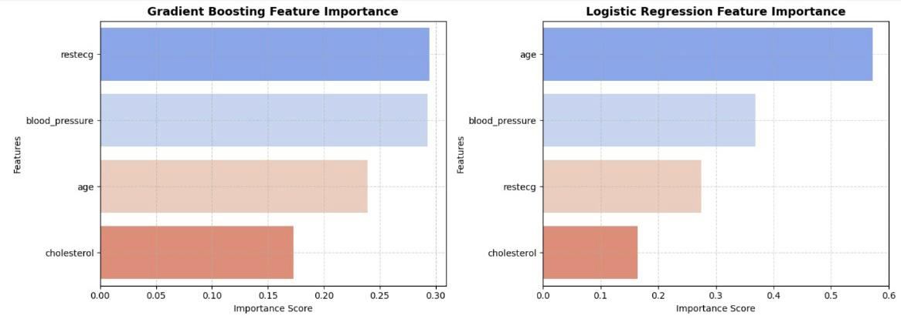

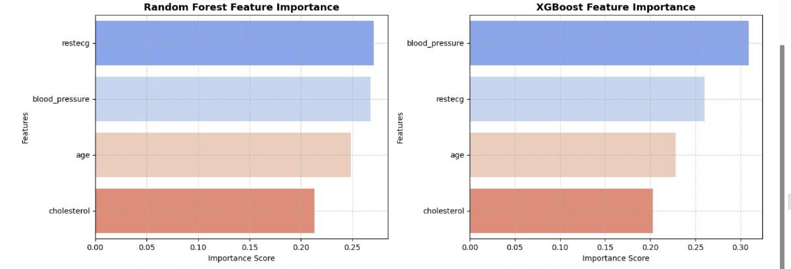

Fig.8.Feature Importance Analysis: Comparison Across ML Models

Fig.8. The feature importance plots reveal that **blood pressure** and **restecg** are consistently top contributors across Random Forest, XGBoost, and Gradient Boosting models. XGBoost gives the highest importance to **blood pressure,** while Logistic Regression highlights **age** as the most influential factor. This indicates that while tree-based models prioritize cardiovascular signals like blood pressure and ECG results, linear models may weigh demographic features like age more heavily.

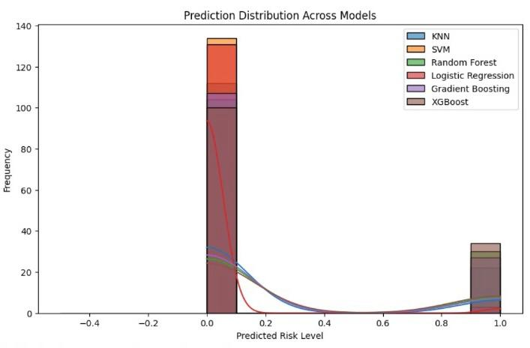

Fig.9. Predicted Risk Level

Fig.9. The prediction distribution plot shows that most models, including XGBoost and Logistic Regression, predict risk levels that are clearly polarized around 0 and 1, indicating strong confidence in classifying patients as low or high risk. KNN and SVM show slightly more spread, suggesting softer boundaries in prediction. Overall, the consistent bimodal distribution reflects good model performance with distinct risk classification.