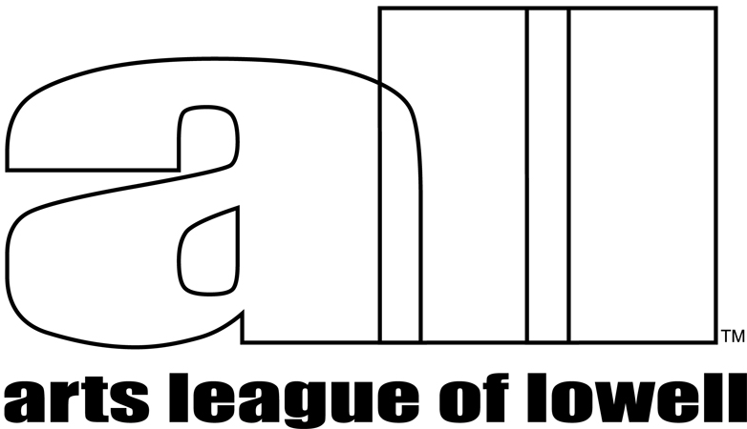 | Show Prospectus  FROM ALL SIDES

The Arts League of Lowell (ALL) presents

FROM ALL SIDES

A Juried Exhibition of 3D Art

April 27 Through June 10, 2018

Wednesdays-Saturdays, Noon-6pm, Sundays Noon-4pm
ARTIST RECEPTION - Saturday, May 12, 4:00p.m. – 6:00p.m.

ALL Arts Gallery, 307 Market St., Lowell, MA 01852

ELIGIBILITY
A Juried exhibition of three-dimensional work, either wall-hung (relief) or self-standing, open to all New England artists.

Typical 2D work (paintings, drawings, photographs, etc.) is not eligible for this exhibition. Student work done under direct supervision is not eligible.

WORK REQUIREMENTS
This is a juried exhibition. Work will be juried using an online application and uploaded images. Artists may enter 1 to 3 works. Works chosen for this show must be securely and professionally presented. Hanging reliefs must be wired and ready to hang. Reliefs must be actual bas-reliefs, not just thick paint or quilted fabric. No saw-tooth or keyhole hangers will be accepted. If your work is not properly prepared to hang, or otherwise install, it will be rejected, even if it was juried into the show. Maximum height of any work is 10 feet. For self-standing work, maximum size is 10’ high x 4’ wide x 4’ long. Work over 40 pounds and work requiring special installation or handling must be installed by the artist. Several pedestals are available for artists’ use. Proposals will also be considered for installations, which must be set up by the artist, in a space agreed upon ahead of the installation schedule. There is one octagonal glass case available for small works – max. size per piece: approximately 8x8x8 inches. Please call or e-mail Steve Syverson, curator, (978-973-1144 steve@vangoghsgear.com) if you have questions about the suitability of your entry, or if you have special installation requirements.

VOLUNTEERING REQUIREMENTS
ALL member artists, with work in this show, are required to gallery sit. Non-member artists are encouraged to gallery sit with a member partner. The Gallery depends upon the help of all participating artists to gallery sit.

ENTRY DEADLINE
All entries must be completed online before midnight, Saturday, April 7, 2018.

APPLICATION AND ENTRY FEE
Please apply for this show using an online application and complete by paying the entry fee. You may enter up to 3 works for the show with 1-3 images per work entered.
Images must be .jpg or .jpeg format and less than 2 Megabytes. File names should not include any spaces or special characters other than underscores or dashes. Please prepare your images before starting the application.
Go to this location to access the application:
www.artsleagueoflowell.org/gallery/showentry/AllSides2018

The application will be considered complete after you pay the entry fee online with credit/debit card or PayPal account (if you have one). If you have a problem completing the application or uploading images, please contact Steve Syverson (steve@vangoghsgear.com).
ENTRY FEE
Members - $30.00. Nonmembers $45.00. Entry fees are non-refundable and do not guarantee acceptance of your work in the exhibition. Entries will not be considered without accompanying entry fee. Non-member artists entering this show are welcome to join ALL ($45.00/year) and pay the members’ entry fee. Members who cannot gallery-sit are welcome to enter this show as a non-member and pay the associated fee and commission (40%).

JUROR
Lindley Briggs received her B. A. from Connecticut College, New London Connecticut in 1967. She continued studying sculpture at the Boston Museum School of Fine Arts and The Skowhegan School of Painting and Sculpture. Throughout her career, Lindley has had numerous shows featuring her sculpture, drawings, collages and prints. Her work has been featured in national publications such as - YANKEE MAGAZINE, FINE WOODWORKING and THE NEW YORK TIMES. Her sculpture is currently represented in 10 galleries throughout the country. Lindley’s bronze medallions have been juried into 5 international museum exhibitions in recent years - at the Hunterian Museum in Glasgow Scotland, The Museum of Fine Arts in Tampere Finland and The Archaeological Museum in Sofia Bulgaria to name a few. A book about Lindley’s sculpture – VISIONARY REALMS – is currently available on Amazon. Her work can also be viewed at: www.lindleybriggssculpture.com.

DELIVERY OF WORK
Deliver accepted work to the ALL Arts Gallery, 307 Market St, in Lowell, on Sunday, April 22nd, 4:00p.m. – 6:00p.m. or Monday, April 23rd, 12:00p.m. – 2:00p.m. Other arrangements may be made IN ADVANCE if you cannot drop off your work at these times. Delivery of work that is different from that in the images submitted for the Juror’s consideration will be rejected. If you intend to ship your work, you must contact Steve Syverson to arrange delivery location and receipt time/date.

SALES
ALL takes a 25% commission for ALL members’ artwork sold and 40% commission for non-members’ artwork sold. Artists are encouraged to show work that is for sale. Payment for work sold will be made no later than 15 days after the close of the exhibit.

INSURANCE AND LIABILITY
Every reasonable precaution will be taken to ensure the protection and careful handling of work. The Arts League of Lowell carries insurance to cover any damage to artwork while it is on the premises of the ALL Arts Gallery. If your work is in the show and you prefer to mark it “NFS” – Not For Sale – please include an insurance value for each piece, on the entry form.

PICK UP OF WORK
Work may be picked up after the show closes, Sunday, June 10th, from 4:00p.m. – 6:00p.m. or Monday, June 11th, 12:00p.m. – 2:00p.m.
Please make alternative arrangements IN ADVANCE if you cannot pick up at these times. We will try to accommodate you. We have no safe space to store work. Work left beyond the pickup date is subject to a $5.00 per day holding fee. Work left 30 days beyond the show closing date will be considered abandoned and will become the property of the Arts League of Lowell and will be used or disposed of as deemed appropriate by the curator.

QUESTIONS? - Call the curator Steve Syverson (978-973-1144) or email steve@vangoghsgear.com

CALENDAR
ENTRY DEADLINE Saturday, April 7, 2018.
Notification of accepted/declined work Saturday, April 14, 2018
DELIVERY of accepted work Sunday, April 22nd, 4:00p.m. – 6:00p.m.
Monday, April 23rd, 12:00p.m. – 2:00p.m.
SHOW OPENS Friday, April 27th, 2018.
ARTIST RECEPTION Saturday, May 12th, 4:00p.m. – 6:00p.m.
SHOW CLOSES Sunday, June 10th, 4:00p.m.
PICK UP of work Sunday, June 10th, 4:00p.m - 6:00p.m
Monday, June 11th, 12:00p.m. – 2:00p.m.
SHOW LABELS, PLEASE ATTACH TO WORK
CUT ALONG DOTTED LINES
======================================================
FROM ALL SIDES
Artist Name_________________________________________________

Phone__________________________Email________________________________

Title______________________________________Entry #_____________
======================================================
FROM ALL SIDES
Artist Name_________________________________________________

Phone__________________________Email________________________________

Title______________________________________Entry #_____________
======================================================
FROM ALL SIDES
Artist Name_________________________________________________

Phone__________________________Email________________________________

Title______________________________________Entry #_____________
=====================================================

